**Herbal Face Wash Gel**

Shivam Arun Wagh1*, Rohit Rajendra2 Yeole, Rutuja Chaudhari3, Mr.Muhammad Awais4, Dr.Gajajanan Daphal5

CONTENTS

|  |  |  |
| --- | --- | --- |
| Sr. No | CONTENTS | Page No |
| 1. | ABSTRACT | 6 |
| 2. | INTRODUCTION | 7 |
| 3. | CLASSIFICATION OF SKIN CARE | 7 |
| 4. | SKIN CARE PREPARATION FOR FACE | 8 |
| 5. | FACE WASH | 8 |
| 6. | ADVANTAGES OF HERBAL COSMETICS | 10 |
| 7. | VARIOUS HERBS USED IN COSMETICS | 11 |
| 8. | FORMULATION HERBAL FACE WASH | 19 |
| 9. | PREPARATION OF FACE WASH | 21 |
| 10. | EVALUTION | 22 |
| 11. | CONCLUSION | 25 |
| 12. | REFERENCES | 26 |

# ABSTRACT

Face is sensitive part of our body so care of face is one of the important task for human beings. There are several preparations are available for face care, from which face wash plays important role for improving appearance as well as for treating several facial skin conditions.

Face washes prepared by herbal ingredients are better than the synthetic ingredients to avoid skin irritation and other side effects. In the present work an attempt was made to formulate & evaluate face wash with antioxidant, antibacterial and antiseptic properties which are necessary to keep the skin, smooth and attractive.

Herbal Face wash is made from, neem leaves, Tulsi extract, orange peel extract for anti-acne activity and to improve the skin and enhance beauty. Face wash improves circulation and cleanse the entire face. Prepared face wash evaluated for colour, Odour, Consistency, PH, spread ability, Wash ability, Grittiness, Foamability.

## II. INTRODUCTION

## 1) Skin care preparations

The use Skin care preparations has grown phenomenally over the years. People utilize a range of Skin care preparations, from lipsticks to complexion creams, from mouth wash to foot powers and so on, in the hope of developing a charming personality, protecting their bodies and avoiding bad smell. Skin care preparations are described as article intended to be rubbed, poured, sprinkled, or sprayed on, introduced into or otherwise applied to human body or any part thereof, for cleansing, beautifying, promoting attractiveness or altering the appearance. Ayurveda describes the role of various herbs like Amla, Haldi in cosmetic preparations. ladies of eighteenth century, Europe, whitened their faces with lead carbonate without knowing what harm they were doing to themselves-many of them died from lead poisoning1.

## 2) Classification of sk~~i~~n care preparation

### 1. Skin cream and lotions

* Cleansing creams and lotions
* Night and massage creams
* Vanishing and foundation creams
* Hand creams and lotions
* All-purpose creams
* Moisturizing creams and lotions
* Gels
* Oily gels

### 2. Suntan and anti-sunburn preparations 3. Skin bleach creams 4. Astringent and skin tonics 5. Antiperspirants and deodorants 6. Face powders

Compact powders Rouges

### 7. Body powders 8. Face packs and masks 9. Bath preparations

Bath salts

Bath powders

Foam bath

Bath oils

Aerosol bath preparations

### 10. Lipsticks

Transparent lipsticks

Lip rouges

Lip jellies

Lip salves

Lip glosses

Lip balms

## 3) Sk~~i~~n care preparation for face

Cleansing creams and lotions

Compact powders

Rouges

Face packs and masks Face washes.2 4) Face wash

### a) Definition

A cleanser is a facial care product that is used to remove makeup, dead skin cells, oil, dirt, and other types of pollutants from the skin of the face.This helps to unclog pores and prevent skin conditions such as acne. A cleansercan be used as part of a skin care regimen together with a toner and moisturizer. b) Advantages of face wash

* It helps to remove dead skin cells that helps new skin cells replace old one It helps to keep skin fresh and healthy.
* It makes the skin to look radiant
* The mixture of dead skin cells and excessive oil clog pores, which can lead to acne white heads, blackheads and total weary appearance. Exfoliating the pores regularly, avoids all the above skin problems.
* Removing dead skin cells that means your skin will develop wrinkles at a slower pace.
* The exfoliation accelerates the blood circulation and promotes skin regeneration and rejuvenation.
* Facial pores and Oily skin is caused by over secretion of sebum by sebaceous glands which clogs the makes the skin oilier.
* Oily skin requires cleansers with herbs and botanicals which will clean the pores and reduce oil buildup. These exfoliating cleansers contain anti-inflammatory agents and antioxidants that improve and nourish the damaged skin.
* Known for its beneficial properties, Herbal Face Wash is used to treat acne and pimples. Containing rich plant-based ingredients like feverfew and neem,

Herbal Face Wash removes excess oil without removing nutrients from the skin.

1. Properties of facewash: -
   * It should be stable and should have a good appearance.
   * It should soften on application to the skin.
   * It should spread easily without dragging.
   * During application it should not have oily or greasy feel.
   * After evaporation of water the cream residue should not become viscous.
   * Its physical action should be that of flushing on the skin and pore opening rather than absorption.
   * A thin emollient film should remain on the skin after its use2.
2. Formulation of face wash

## 1. Categories of therapeutic agents used ~~i~~n face wash

### Antibacterial

In its broadest definition, an antibacterial is an agent that interferes with the growth and reproduction of bacteria. While antibiotics and antibacterials both attack bacteria, these terms have evolved over the years to mean two different things. Antibacterials are now most commonly described as agents used to disinfect surfaces and eliminate potentially harmful bacteria3.

Examples; alcohols, chlorine, peroxides, and aldehydes.

### Anti~~-~~acne

Different types of antiacne drugs are used for different treatment purposes, depending on the severity of the condition.For example, lotions, soaps, gels, and creams containing substances called benzoyl peroxide or tretinoin may be used.4

### 2. Advantages of Herbal Cosmetics over Synthetic cosmetics

Herbal cosmetics are the modern trend in the field of beauty and fashion. These agents are gaining popularity as nowadays most women prefer natural products over chemicals for their personal care to enhance their beauty as these products supply the body with nutrients and enhance health and provide satisfaction as these are free from synthetic chemicals and have relatively less side-effects compared to the synthetic cosmetics. Following are some of the advantages of using natural cosmetics which make them a better choice over the synthetic ones:

Synthetic chemicals and have relatively less side-effects compared to the synthetic cosmetics.

### 1. Compatible with all skin types

Natural cosmetics are suitable for all skin types. No matter if you are dark or fair, you will find natural cosmetics like foundation, eye shadow, and lipstick which are appropriate irrespective of your skin tone. Women with oily or sensitive skin can also use them and never have to worry about degrading their skin condition. Coal tar-derived colours are used extensively in cosmetics, Coal tar is recognized as a human carcinogen and the main concern with individual coal tar a color (whether produced from coal tar or synthetically) is they can cause cancer. But natural colours that are obtained from herbs are safer.

### 2. Wide selection to choose from

Natural cosmetics may still be a new type in the beauty industry, but they already offer a variety of beauty products for all make up crazy people out there to choose from. One will find a variety of foundation, eye shadow, lipstick, blush, mascara, concealer and many more which are all naturally formulated. Furthermore, one will find locally made natural cosmetics or those made by famous designers worldwide. There exist a large variety of herbal extracts, to name a few AndrographisPaniculata (Kalmegh), Asparagus Racemosus (Shatawari), BoswelliaSerrata (Salai Guggal), Asphalt (Shilajit) etc.

### 3. Fits your budget

Natural cosmetics are not that expensive. In fact, some of these products are more affordable than synthetic ones. They are offered at discounted prices and are sold for a cheap price during sales. Just need to survey enough to look for great deals. An estimate of WHO demonstrates about 80% of world population depends on natural products for their health care, because of side effects inflicted and rising cost of modern medicine. World Health Organization currently recommends and encourages traditional herbal cures in natural health care programs as these drugs are easily available at low cost and are comparatively safe.

### 4. Not tested on animals

Some cosmetics are initially tested on animals to ensure that they are safe and effective to use for human. However, natural cosmetics need not be tested on animals. These natural formulations are tested by experts in laboratories using state of the art equipment with no animals involved.

### 5. No side effects

The synthetic beauty products can irritate your skin, and cause pimples. They might block your pores and make your skin dry or oily. With natural cosmetics, one need not worry about these. The natural ingredients used assure no side effects; one can apply them anytime, anywhere. For example, herbal cosmetics are free from parabens that are the most widely used preservative in cosmetics and can penetrate the skin. And are suspected of interfering with hormone function.to clear up mild to moderately severe acne. Isotretinoin (Accutane) is an oral drug that is prescribed only for very severe, disfiguring acne.5

## 3. Various herbs used ~~i~~n cosmetics

### ➢ Aloe (Aloe vera)

The pulp of Aloe (Aloe vera) is an exceptional skin cleanser. Juice of the plant counteract infection and promote healing. Split off a portion of Aloe vera leaf and rub the pulp directly on the skin.

Amaranth (Amaranthusspinosus)

Make a tea from Amaranth (Amaranthusspinosus) seeds and use as a face wash.

To make the tea bring 3 cups of water to boil, add 2 teaspoons of seeds. Cover and boil for five minutes;

➢ Neem (Azadirachtaindica)

Neem (Azadirachtaindica) is valued in Ayurvedic medicine for its varied healing properties due to its antibacterial, antifungal, and antiviral capabilities. For acne, fresh 5 leaves everyday taken in the morning helps in removing stubborn acne. Lemon (Citrus Limon)

Clean your skin and apply Lemon (Citrus Limon) juice with a cotton ball. The acid in Lemon helps flush out the pores and keeps the skin looking beautiful. Another method using Lemon juice is to "steam clean" the face by putting it over a pan of boiling water with a towel over your head to trap the steam. This will loosen the dirt and oil. Then apply a cotton ball to remove the dirt and oil buildup. Use this method once a week.

Basil (Ocimumbasilicum)

Make an infusion of Basil (Ocimumbasilicum) leaves. Put two to four teaspoons of dried Basil leaves in a cup of boiling water, steep for 10 to 20 minutes, cool, and apply to the acne.

Cucumber (Cucumissativus)

Liquefy a peeled Cucumber (Cucumissativus) in a blender and apply the juice to the acne. Another variation of this remedy is to drink four or five cups of Cucumber juice daily for a week. This is said to purify the blood and lymphatic system, resulting in a clearer skin.

➢ Grape (Vitisvinifera)

Grape (Vitis vinifera) seed extract is a powerful allaround antimicrobial agent and is an excellent disinfectant. Make a solution of 440 drops in four ounces of water and apply to the affected areas with a cotton ball two or three times a day.

Chickpea (Cicerarietinum)

Wash your face with Chickpea (Cicerarietinum) paste (mix one teaspoon of chickpea flour with a little water). Dry with a clean towel. This is also a good remedy to cure acne.

Beet (Betavulgaris)

Use a blend of one part Beet (Betavulgaris) root juice, three parts Carrot (Daucus Carota) juice and two parts of water to stimulate the liver and to cleanse the system.6

## 4. Additives used ~~i~~n face wash

### Antioxidants

Antioxidants are manmade or natural substances that may prevent or delay some types of cell damage. Antioxidants are found in many foods, including fruits and vegetables. They are also available as dietary supplements. Examples; Lycopene, Vitamin A, Vitamin C, Vitamin E.7

### Gelling agent

Gelling Agents are ingredients that will turn your water, or oil, phase into a gel, which is thickened but, without stiffness. Emulsions thickened with Gelling Agents will be more mobile, and fluid, than rather than stiff. Some of these gels will thin when force is applied (thixotropic) and return to viscosity when the force is removed. These gels make it possible to create thick products that can be shaken, or stirred under high shear, for easier bottling, or for spraying. Examples; carbopol940, carbopol934.8

### Preservative

The primary reason for using preservatives is to make foods safer by eliminating the influence of biological factors. The greatest threat to consumers is that of food being spoiled, or from becoming toxic by the effect of microorganisms (e.g. bacteria, yeast, moulds) occurring in them.

Some of these organisms can secrete poisonous substances (“toxins”), which are dangerous to human health and can even be fatal. Examples; methyl paraben, propylparaben.9

## Humectants

The humectants are a hygroscopic substance used to keep things moist; it is the opposite of a desiccant. It is often a molecule with several hydrophilic groups, most often hydroxyl groups; however, amines and carboxyl groups, sometimes esterified, can be encountered as well (its affinity to form hydrogen bonds with molecules of water is the crucial trait). They are used in many products, including food, cosmetics, medicines and pesticides.

The humectants attract and retains the moisture in the air nearby via absorption, drawing the water vapor into and/or beneath the organism/object's surface. Examples; Propylene glycol, hexylene glycol, and butylene glycol.10

### Foaming agent

A foaming agent is a material that facilitates formation of foam such as a surfactant or a blowing agent. A surfactant, when present in small amounts, reduces surface tension of a liquid (reduces the work needed to create the foam) or increases its colloidal stability by inhibiting coalescence of bubbles. A blowing agent is a gas that forms the gaseous part of the foam.

Examples; Sodium Lauretha sulphate, azodicarbonamide, titanium hydride.11

e) Evaluation of face wash

Colour, Odour, Consistency, Spread ability, Washability, Foamability, Grittiness. etc. are the important evaluation parameters of the face wash formulation.

Evalution of any formulation gives the quality of that formulation. f) Uses of facewash

* To remove all traces of makeup every day.
* For cleansing the skin.
* Anti-aging.
* Bath and renewal keeping the skin clean and shiny.
* Stimulate there generation of the skin cells and their renewal.
* Help plug the pores clear.12

## ACNE

Acne is a skin disorder that leads to an outbreak of lesions called pimples Acne usually starts shortly after puberty and begins because of hormonal changes and increased oil secretion.

Acne develops when hair follicles, the site of acne, get plugged with dead skin cells. It is common to see patients (particularly women) in their 30s, 40s, and 50s with adult onset

Types of acne lesions~~:~~

* Blackhead (open come done): Oil and dead cells leave a black plug on the skin surface.
* Whitehead (closed come done): Oil and dead skin cells leave a plug below

the skin surface.

* Papules (red pimples) and white pustules: The material in the plugged hair follicle seeps through the walls of the follicle and causes redness and tenderness.
* Cyst: A very deep, ruptured, inflamed follicle.

Acne treatment:

* Therapy should help lessen the severity and reduce the amount of scarring, which could result from acne if left untreated. Different combinations of medications may need to be tried to determine which combination is best for you. It will take 8 to 12 weeks to see results in most people. Medications only suppress acne. If you stop your therapy, your acne is likely to recur.
* Topical antibiotics (clindamycin, erythromycin): These helps decrease or kill skin bacteria.
* Oral antibiotics (tetracycline, doxycycline, minocycline, erythromycin, and others): Help decrease redness and kill bacteria. These are most helpful for red papules and cysts.
* Retinoids (Retina, Differin, Avita, Tazorac): These unclog pores to eliminate blackheads and whiteheads.
* Benzoyl peroxides (Triaz, Brevoxyl): These unclog pores and prevent bacteria growth. They help prevent antibiotic resistance.
* Finacea, Azelex: These unclog pores and may help decrease bacteria.
* Accutane: This is our most potent acne medication. It has many possible side effects and is usually reserved for severe acne or for when other medications are not working well. Sk~~i~~n care~~:~~
* Wash your face two times per day with a mild soap or soap-free cleanser. (Dove, Oil of Olay Foaming Face Wash, Cetaphil Cleanser, Neutrogena or Purpose cleansers for sensitive skin.)
* DO NOT use harsh soaps and do not scrub vigorously.
* Wash gently but thoroughly twice daily with the recommended cleanser. Avoid harsh scrubs, masks, and other non-prescription products.
* ∙Glycolic acid products aid in reduction of comedowns (whiteheads and blackheads). These may be used as an after-cleansing step, before benzoyl peroxide, Differin or Retin-A, or topical antibiotics once or twice daily.
* To keep the skin free from acne, it should have antioxidants, smoothing and moisturizing property. Antioxidants will help to reduce the presence of free radicals which prevent ageing and inflammatory effects of skin. Moisturizing property will keep the skin smooth and impart cooling effect and prevent from dehydrating the skin.13

# III. OBJECTIVES

## This study was carried out with the following objectives

To study the ideal characteristics of face wash formulation.

To develop skill of making face wash formulation.

To formulate herbal face wash containing tulsi, neemand orange peel extracts.

To evaluate herbal face wash for colour, odour, consistency, pH, spread ability, wash ability, grittiness, foam ability.

# IV. PLAN OF WORK

1. Literature survey.
2. Selection of herbal drugs.
3. Selection of excipients.
4. Selection of method of preparation for herbal face wash.
5. Preparation of face wash.
6. Evaluation of face wash.

# V. FORMULATION OF FACE WASH

a) HERBAL MEDICINES

## 1. Tuls~~i~~

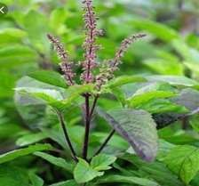

Figure no. 1

Synonym: Krishna Tulsi.

Biological source: Ocimumbasilicum.

Family; Lamiaceae.

Chemical constituent: Fixed Oil, Essential oil, Mineral Contents, Alcoholic Extract.

Use:

It is used as Antibacterial.

It is used as Antifungal.

It is used as anti-Anticancer.

## 2.Neem

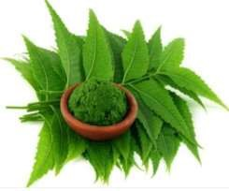Figure no. 2

Synonym: margosa

Biological source: Azadiractaindica

Family: Meliaceous

Chemical constituent: Azadirechtin

Nimbin

Nimbidin

Nimbendiol

Trisulphides

Tetrasulphides

Use: Insecticide

Antifeedan

Antimicrobial agent

Insect repellant

Nematicide

Seed oil having spermicidal activity

Important commercial neem products:

Neem oil- spermicidal agent

N

e

e

m

c

a

k

e

-

a

n

t

i

-

n

e

m

a

t

o

d

e

s

3

.

O

r

a

n

g

e

p

e

e

l

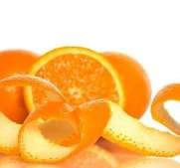

F

i

g

u

r

e

n

o

.

3

Synonym: Orange cortex

Biological source: Citrus Aurantium Linn

Family: Rutaceae

Chemical constituent: Vitamin c,

Pectin,

Volatile oil,

Hesperidin,

Iso-hesperidin,

Neohesperidin,

Aldehydes, Citral

Use: Antioxidant,

Orange peels are used as carminative, aromatic, stimulant. Flavouring agent.14

## b) EXCIPIENT PROFILE

1. Carbapol STRUCTURE:

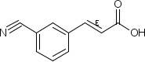

IUPAC name:

Poly (acrylic acid) Other names:

PAA, PAAc, Acrysol, Acumer. Chemical formula:

(C3H4O2)n Molar mass:

variable

USES: Polyacrylic acid and its derivatives are used in disposable diapers,ion exchange resins and adhesives. They are also popular as thickening, dispersing, suspending and emulsifying agents in pharmaceuticals, cosmetics and paints.

2.Methyl paraben STRUCTURE:

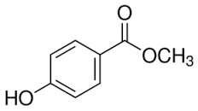

IUPAC name:

Methyl 4hydroxybenzoate Other names:

Methyl paraben Chemical Formula:

C8H8O3

Molar mass: 152.15 g·mol−1 Uses:

Methyl paraben is an antifungal agent often used in a variety of cosmetics and PersonalCare products.

It is also used as a food preservative.

Methyl paraben is commonly used as a fungicide in Drosophilafood media. C) FORMULATION OF HERBAL FACE WASH

In our formulation we have selected active agents like Tulsi leaves extract, neem leaves extract and orange peel extract to achieve anti-acne property. We were formulated face wash gel for that purpose carbapol was used as gelling agent. Methyl and propyl paraben were used as preservatives. Triethanolamine was used as alkalizing agent to achieve good stability. Propylene glycol was added it also gives emollient effect on skin. Sodium lauryl sulphate was added to produce foam. While is application. The formulation ingredient and its concentration shown in table no.1

### Table no. 1~~:~~ formulation table for herbal face wash

|  |  |  |  |
| --- | --- | --- | --- |
| Sr.No. | Name of ingredients | Quantity for 100 ml | Property |
| 1 | Aloe Vera Gel | 1 gm | Moisturizer, Healing |
| 2 | extract of Tulsi | 1 gm | Antibacterial |
| 3 | Ethanolic extract of neem leaves | 1 gm | Kills acne causing bacteria |
| 4 | Ethanolic extract of orange peel | 1 gm | Antioxidant |
| 5 | Carbopol 940 | 1.5gm | Gelling agent |
| 6 | Methyl paraben | 1gm | Preservative |
| 7 | Propyl paraben | 0.5gm | Preservative |
| 8 | Triethanolamine | 0.4 ml | Neutralizer |
| 9 | Propylene glycol | 2 ml | Humectant |
| 10 | Sodium lauryl sulphate | 2 gm | Foaming agent |
| 11 | Distilled water | Q.S. | Vehicle |

### Method for preparation of herbal face wash

Mature Neem leaves, orange peel is selected. They were washed and sundried for 3 days and subsequently crushed mechanically via the use of a manual grinder to particulate sizes of 2mm to obtain a larger surface area. Finally, resulting samples were artificially dried using a tray drier at a temperature of 50°C for two hours.

### Preparation of face wash

1. A little quantity of water was added with preservatives
2. Then propylene glycol and sodium lauryl sulphate were dissolved well in above solution.
3. To the above solution carbapol was added little by little and stirred well until a gel like dispersion was obtained.
4. To this the extracts were added one by one to get a complete gel like consistency.
5. Then triethanolamine was added finally.

Face Wash Formulation:

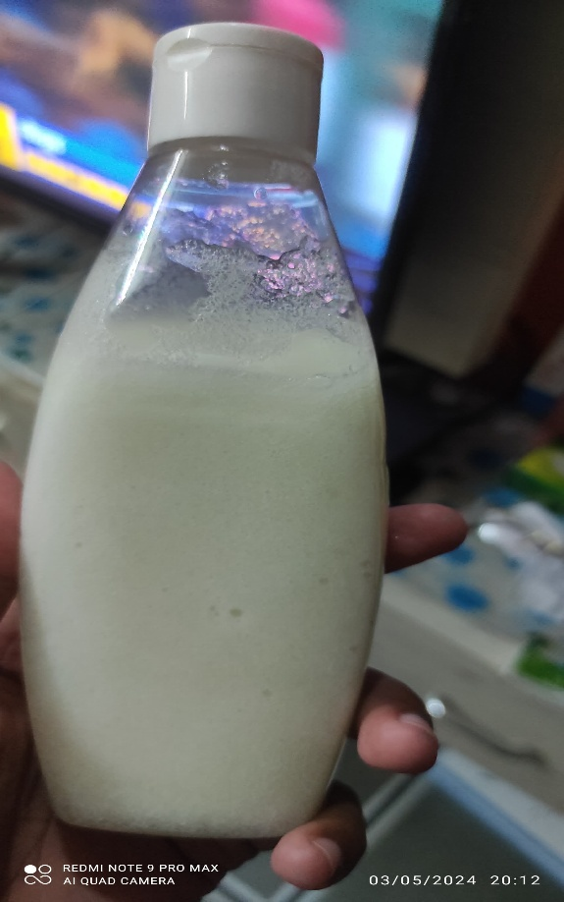

Figure no.5

### VI. EVALUATION

The prepared face wash formulation was evaluated for following parameter

C

o

l

o

u

r

:

T

h

e

c

o

l

o

u

r

o

f

t

h

e

f

a

c

e

w

a

s

h

f

o

r

m

u

l

a

t

i

o

n

w

a

s

c

h

e

c

k

e

d

v

i

s

u

a

l

l

y

.

O

d

o

u

r

:

T

h

e

f

o

r

m

u

l

a

t

i

o

n

w

a

s

e

v

a

l

u

a

t

e

d

f

o

r

i

t

s

o

d

o

u

r

b

y

s

m

e

l

l

i

n

g

i

t

.

C

o

n

s

i

s

t

e

n

c

y

:

I

t

w

a

s

d

e

t

e

r

m

i

n

e

d

m

a

n

u

a

l

l

y

.

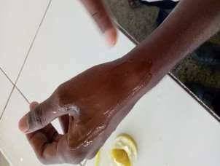

F

i

g

u

r

e

n

o

.

6

Spread ability: The spread ability of the formulation was found manually by applying the gel on the skin with gentle rub.

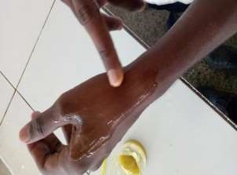

Figure no.7

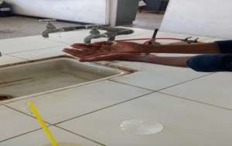

Figure no. 8



Washability:

The product was applied on hand and showed under running water.

Foamability:

Small amount of gel was taken in a beaker containing water. Initial volume was noted, beaker was shaken for 10 times and the final volume was noted.

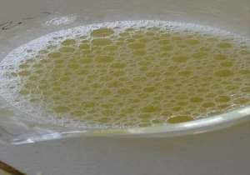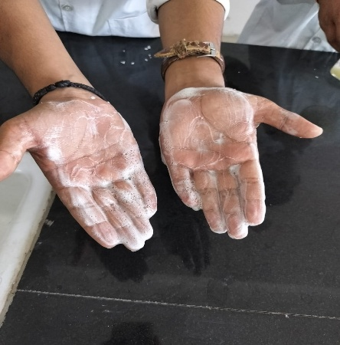

Figure no. 9

Grittiness:

The product was checked for the presence of any gritty particles by applying it on

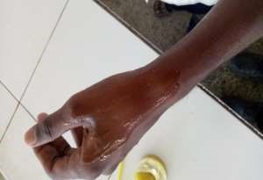

Figure no. 10

# VII. CONCLUSION

Herbal face wash gel containing, neem leaves extract, Tulsi leaves extract, orange peel extract was formulated successfully by using carbapol as a gelling agent. Prepared formulation was evaluated for colour, odour, consistency, PH, spread ability, washability, grittiness, foam ability studies and it shows acceptable results. So performed studies it can conclude that prepared formulation may effectively use for facial care still further studies related to effectiveness and adverse effect of formulation are required to perform before to bring it in real use.

Herbal face wash gel containing Cynodon dactylion extract was formulated successfully by using carbapol 940 as gelling agent. Three batches were formulated, out of that, batch F2 shows better results for formation of the gel. Evaluation tests were carried out for batch F2 as colour, consistency, pH, spread ability, washability and foamability it showed compatible results. So, from the studies it was concluded that the prepared formulation can be effectively used for facial care.

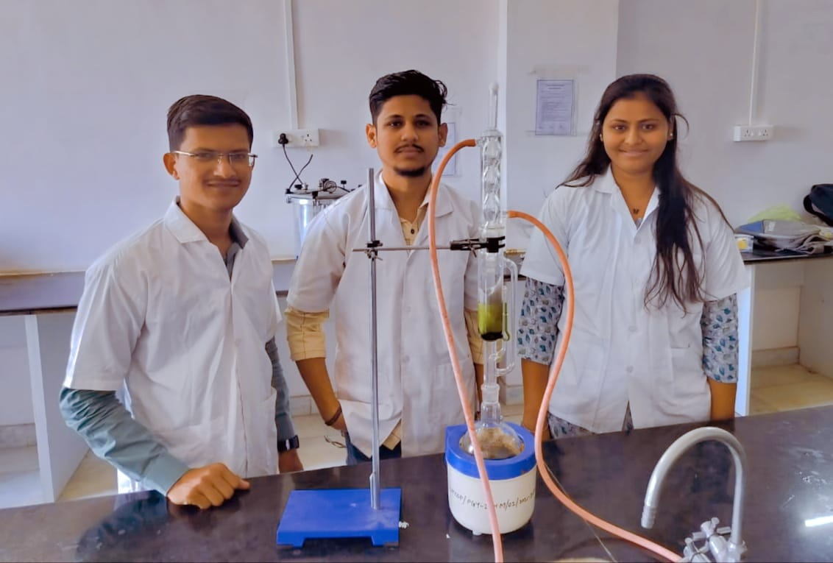

Project On Herbal Face Wash Made By (Rutuja Chaudhari, Shivam Wagh, Rohit Yeole)

## VIII. REFERENCE

1. Sanjunanda, arunnanda, roop k. khar.cosmatics technology birla publication first edition2006-2007 Page no. 243
2. P.P. sharmacosmetics-formulation, manufacturing and quality control by m. pharm.

Vandana publication third edition page no. 142.

1. http://www.tufts.edu/med/apua/about_issue/agents.shtml.
2. McNally, Robert A. Skin Health Information for Teens: Health Tips about Dermatological Concerns and Skin Cancer Risks. Detroit

(/topic/Detroit.aspx), MI: Omnigraphics, 2003.

1. Sharma A, Shanker C, Tyagi LK, Singh M, RaoChV (2008) Herbal Medicine for Market Potential in India : An overview. Academic Journal of Plant Sciences 1: 2636.
2. http://www.greenmedinfo.com/blog/11herbsusedtraditionalacneremedies 7) https://www.nlm.nih.gov/medlineplus/antioxidants.html.
3. http://www.ingredientstodiefor.com/category/Thickeners_Polymers_Rheol ogyModifi ers/c36
4. http://www.eufic.org/article/en/foodsafetyquality/foodadditives/artid/pres ervativesfoo dlongersafer.

10)What is a humectant

(http://www.wisegeek.org/whatisanhumectant.htm), wisegeek.org

11)Compendium of Chemical Terminology 2nd Edition (1997) 1972, 31, 612IUPAC 12) https://storify.com/ASEEM_SOOD/benefitsofherbalfacewash.

13)The Face and Skin Center at University of Mississippi Health Care • 601-815 -3374 • www.thefaceandskincenter.com

14)C.k.kokate, a.p.purohit, s.b.gokhalepharmacognosyniraliprakashan 43rd edition,

12.10, 4.4, 20.5.

15)https://en.wikipedia.org/wiki.

16)Dr.vallabhchandegara,junagadh agriculture university book Dec 2012

17)Barry,B. W, Dermatological Formulations, Marcel Dekker. Inc. New York, Basel, vol- 1983; 18: 96-115.

18)Simons, Rae. For All to See: A Teen's Guide to Healthy Skin. Broomall, PA: Mason Crest, 2005.

19)Sanju nanda, arun nanda, roop k. khar. “Introduction and design of the study,cosmetics technology”, birla publication first edition2006- 2007 Page no. 243.

20)P.P. sharm “cosmetics-formulation, manufacturing and quality control” by Vandana publication third edition page no. 142.

21)https://storify.com/ASEEM_SOOD/ benefitsofherbalfacewash 22) https://en.wikipedia.org/wiki.

1. https://www.nlm.nih.gov/medlineplus/ antioxidants.html.
2. http://www.ingredientstodiefor.com/category/

Thickeners_Polymers_RheologyModifiers/c36

1. http://www.eufic.org/article/en/foodsafetyquality/foodadditives/artid/ preservativesfoodlongersafer.
2. What is a humectant (http://www.wisegeek.org/ whatisanhumectant.htm), wisegeek.org
3. Compendium of Chemical Terminology 2nd Edition (1997) 1972, 31, 612IUPAC
4. Sharma A, Shanker C, Tyagi LK, Singh M, Rao ChV“Herbal Medicine for Market

Potential in India : An overview”. Academic Journal of Plant Sciences 1,(2008): 26-36.

1. Ekta chandel* and Bhupender kumar, “Antimicrobial activity and phytochemical analysis of Cynodon dactylon:A Review”, World journal of pharmacy & pharmaceutical sciences volume 4 2015,(2015), page no. 515530.
2. https://en.wikipedia.org/wiki
3. S. Abdullah, J. Gobilik and K. P. Chong.“In Vitro Antimicrobial Activity of Cynodon dactylon (L.) Pers. (bermuda) Against Selected Pathogens”.
4. Seema Yuvraj Mendhekar*, Pratik Bharat Thorat, Nikita Nivruti Bodke, Jadhav S. L, “Formulation and evaluation of gel containing neem, turmeric, aloe vera, green tea and lemon extract with activated charcoal and honey” European journal of pharmaceutical and medical research,2017, 4(12), page no. 439 -443.
5. Harsharan Pal Singh*1, Neeraj Samnhotra1,2, Sumeet Gullaiya3, Ishpreet Kaur4,“Anti-acne synergistic herbal face wash gel: formulation evaluation and stability studies”, World journal of pharmaceutical research, volume 4,(2015), page no. 12611273.
6. Lalit Kumar1*, Ruchi Verma2 ,” In vitro evaluation of topical gel prepared using natural polymer”, International journal of Drug Delivery 2 (2010) page no. 58-63.
7. Kartikey Pandey*, C. S. Singh, Raj K. Prasad, A. K. Singh and M. K. Mishra,“Studies of anti-microbial activity using leaf extract of Cynodon dactylon,” Scholar research library , der pharmacia letter,(2016), 8(3):page no.325 -330.
8. Vipin Kumar Garg* and Sarvesh Kumar Paliwal ,”Studies of antiinflammatory activity of extract of plant Cynodon dactylon”, International journal of pharmacology,(2011) 7 (3): page no.370-375
9. Mitusi T. New Cosmectic Science; Elsevier Science B.V., the

Netherlands;1sted; 148149 Indian standard -6608- 1978; Govt of India 1997: 4-5

1. Dureja H., Kaushik D., Gupata M., Kumar V., Lather V., Cosmeceuticals: An Emerging Concept, Indian Journal of Pharmacology, 2005; 37(3): 155-159.
2. Rasheed A., Reddy G., Mohanalakshmi S., Kumar CK., Formulation & Comparative evaluation of Poly-herbal anti-acne face wash gel, Pharmaceutical Biology, 2011; 49(8): 771-774.
3. Ashawat MS., Banchhor M., Herbal Cosmetics: Trends in skin care formulation Pharmacognosy Rev., 2009; 3(5): 82-89.
4. Ahmed, S.A. and M. Grainage, Use of indigenous plant resources in rural development, potential of neem tree. Int. J. Dev. Technol., 1985; 3: 123-130.
5. Kapoor V.P., Joshi H., Chaubey M., Applications of seed gums in pharmaceutical formulations, J Med Arom Plant Sci. 2000; 22/4A & 23/1A: 42-44.

## Thankyou