ANTICIPATING ACTIVITIES IN SMART HOME ENVIRONMENT

# Dr. CH. Vijaya Kumar1, Jujjuri Poojitha2, Annareddy Shreya Sree3, Gadde Nikhitha4, Soogoor Sai Praneetha5

1Associate Professor, Computer Science and Engineering, ACE Engineering College, Ghatkesar, Telangana, India

2,3,4,5Student, Computer Science and Engineering, ACE Engineering College, Ghatkesar, Telangana, India

# ABSTRACT

Human Activity Recognition (HAR) is one of the essential building blocks of so many applications like security monitoring the internet of things and human-robot interaction. The research community has developed various methodologies to detect human activity based on various input types. However, most of the research in the field has been focused on applications otherthan human-in-the-centre applications. Human activity recognition (HAR) based on multimodal sensors has become a rapidly growing branch of biometric recognition and artificial intelligence. However, how to fully mine multimodal time series data and effectively learn accurate behavioural features has always been a hot topic in this field. Practical applications also require a well-generalized framework that can quickly process a variety of raw sensor data and learn better feature representations. This paper focused on optimizing the input signals to maximize the HAR performance from wearable sensors. A model basedon Invariant Learning Network has been proposed and trained on different signal combinations of three Inertial Measurement Units that exhibit the movement. The proposed Invariant Learning Network optimizes input signals from three Inertial Measurement Units to enhance HAR performance from wearable sensors

# INTRODUCTION

Human Activity Recognition (HAR) is a burgeoning field within mobile wearable and pervasive computing, vital for automating the detection and classification of human activities based on sensor data. HAR has gained prominence due to its multifaceted applications across various domains, including health monitoring, behavior analysis, skill assessment, and sportscoaching. Its ability to interpret human actions from sensor inputs has led to the development of innovative solutions that enhance user experiences and improve quality of life.

**Significance of HAR in Various Domain**s: In health monitoring, HAR serves as a powerful tool for tracking daily activities, enabling early detection of health anomalies, and providing insights into individuals' physical well-being. Behavior analysis benefits from HAR by deciphering patterns and trends in human behavior, facilitating personalized interventions and behaviormodification strategies. Similarly, HAR aids in skill assessment and sports coaching by offering real-time feedback and performance evaluation, thereby enhancing training regimens and athletic performance..

**Challenges in Traditional HAR Approaches:** Traditional HAR approaches often grapple with the complexities of feature engineering and the limitations of conventional machine learning algorithms. Designing effective features tailored to different activities can be time-consuming and may not generalize well across diverse tasks and environments. Moreover, the reliance on handcrafted features poses challenges in capturing nuanced aspects of human activities, hindering the overall performance and scalability of HAR systems.

**Rise of Deep Learning in HAR:** The advent of Deep Learning (DL) techniques has revolutionized HAR by enabling automaticfeature learning from raw sensor data. DL models, such as Convolutional Neural Networks (CNNs), Recurrent Neural Networks (RNNs), and Long Short-Term Memory (LSTM) networks, have demonstrated remarkable capabilities in extracting high-levelrepresentations, thereby reducing the need for manual feature engineering. This paradigm shift has led to significant improvements in HAR accuracy, robustness, and scalability across various applications.

**Applications of Sensor-based HAR:** Wearable sensors, including accelerometers, gyroscopes, and magnetometers, have proliferated the applications of HAR in diverse domains. These sensors, integrated into smartphones, smartwatches, and otherwearable devices, provide rich streams of data for activity recognition tasks. In health management, sensor based HAR facilitates continuous monitoring of physical activities, aiding in the diagnosis and management of chronic diseases such as

cardiovascular conditions and diabetes. Similarly, in behavior analysis, sensor-based HAR enables real-time tracking of daily routines, helping individuals make informed decisions about their lifestyle choices and habits.

**Imbalanced Datasets in HAR:** Imbalanced datasets present a significant challenge in HAR, where certain activity classes may be overrepresented or underrepresented. This imbalance can lead to biased models that favor dominant classes, compromising the accuracy and generalizability of HAR systems. Addressing class imbalances requires careful data collection strategies, augmentation techniques, and algorithmic approaches such as resampling and cost-sensitive learning. By mitigating class imbalances, researchers can develop more robust and reliable HAR models that perform well across diverse activity classes and user populations.

**User Variability in HAR:** Variability in how individuals perform activities due to personal characteristics and behaviors posesa significant challenge for HAR. Factors such as age, gender, fitness level, and cultural differences can influence the way activities are executed, leading to variations in sensor data patterns. Addressing user variability is crucial for developing HARmodels that generalize well across diverse user populations. Techniques such as personalized modeling, transfer learning, and domain adaptation can help account for individual differences and improve the robustness and adaptability of HAR systems.

**Data Quality Issues in HAR Datasets:** The quality of HAR datasets directly impacts the performance and reliability of HARmodels. Common data quality issues include noise, missing data, sensor drift, and labeling errors. Noise and sensor errors canintroduce artifacts into the data, affecting the accuracy of activity recognition. Missing data and sensor drift can lead to inconsistencies in the dataset, making it challenging to train robust models.

**Interpretability of HAR Models:** Understanding the decisions made by HAR models is essential for trust and transparency. Interpretable models and post-hoc analysis techniques help in understanding the features driving classification decisions.

**Scalability of HAR Systems:** Scalability is crucial for real-world HAR systems as sensor data volume rises. Efficient algorithms, scalable infrastructure, and distributed computing ease computational burdens, ensuring real-time processing. Optimized data storage solutions manage large datasets, while scalable architectures enable integration across diverse environments like smart homes and healthcare facilities.

**Privacy and Ethical Considerations in HAR:** Privacy and ethical concerns arise from the collection and analysis of sensor data for HAR. Ensuring data privacy, obtaining consent, and adhering to ethical guidelines are essential for responsible HAR deployment.

# METHODOLOGY

This section details the methodology employed in our project to anticipate activities within a smart home environment. We leverage Human Activity Recognition (HAR) principles, but with a focus on sensor data collected from the home itself, rather than wearable sensors.

## Data Preprocessing & Feature Extraction

The collected sensor data will likely be raw and require preprocessing for effective analysis. This involve:- Data cleaning: Removing noise or outliers from the sensor readings.

Segmentation: Dividing the continuous data stream into smaller time windows representing potential activities.

Feature extraction: Identifying relevant characteristics from each time window that best represent the occurring activity. These features could be statistical measures (e.g., average temperature change) or frequency-domain analysis.

## Activity Recognition Model

A machine learning model will be trained to recognize activities based on the extracted features. These are approaches:-

Classification algorithms: Supervised learning models like Random Forests or Support Vector Machines (SVMs) can be trained on labeled data where each time window is associated with a specific activity (e.g., cooking, watching TV).

Deep learning models: Recurrent Neural Networks (RNNs) or Convolutional Neural Networks (CNNs) can be particularly adept at handling sequential data like sensor readings.

## Model Training & Evaluation

The chosen model will be trained on a portion of the collected data. The remaining data will be used for evaluation purposes: Training: The model learns to identify patterns between the features and the corresponding activities.

Evaluation: The model's performance is assessed using metrics like accuracy, precision, and recall. This helps identify any weaknesses requiring further training or model adjustments.

## Activity Anticipation

Once a well-performing model is established, it can be used for activity anticipation. New, unseen sensor data from the smart home will be fed into the model. Based on the extracted features, the model will predict the most likely activity about to occur or currently underway.

This section provides a basic framework for the methodology. Specific details on the chosen sensors, feature extraction techniques, model architecture, and evaluation metrics will depend on the specific application and desired functionalities within your smart home environment.

# MODELING AND ANALYSIS

MODULE 1: Exploratory Data Analysis

In this activity recognition project, the data analysis aims to uncover insights and patterns from sensor data to facilitate accurate activity classification. The analysis involves exploring the dataset's structure, identifying data quality issues like missing values or duplicates, and visualizing feature distributions across different activities. By examining relationships between features and activity labels, we seek to understand the underlying patterns that can inform the development of robust machine learning models. Through statistical analysis and visualization techniques, this data analysis phase sets the foundation for effective feature engineering and model training for activity recognition.

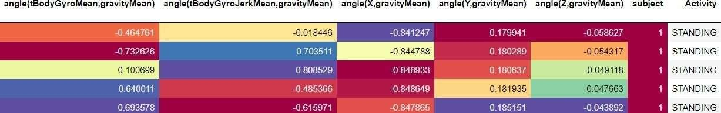

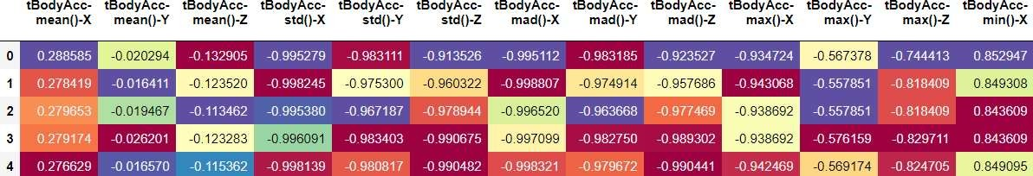

**Figure 1:** Train Data Set

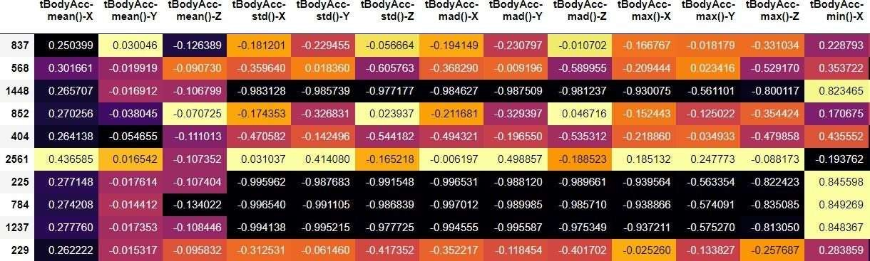

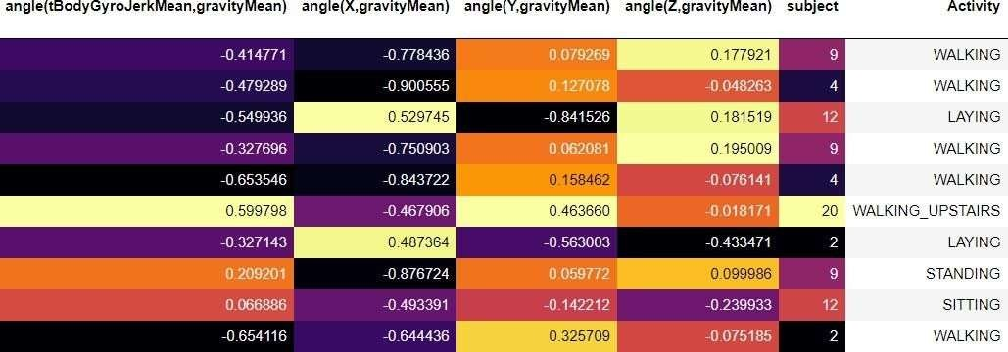

**Figure 2**: Test Data Set

# RESULTS AND DISCUSSION

1. **Graphs:**

The graph illustrates the distribution of various activities among individuals, showcasing the engagement levels in activities such as walking, standing, descending stairs, ascending stairs, and lying down. The graph illustrates the distribution of activities across each individual, where each person is represented along the x-axis, and the y-axis indicates the count of activities performed by each person.

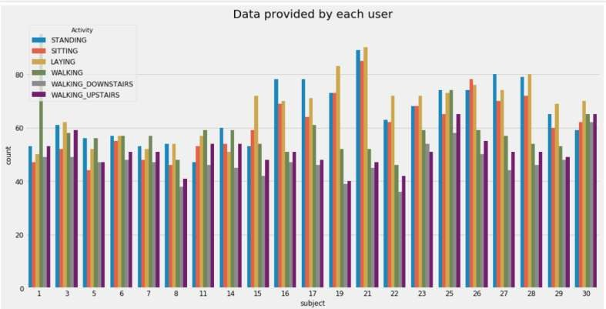

**Figure 3:** Data provided by user

# Mathematical Formula:

* 1. Normalization:

Normalize the accelerometer data to have zero mean and unit variance, ensuring consistency in scale across features .

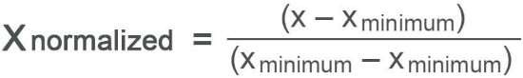

* 1. Feature Engineering (e.g., Mean, Standard Deviation):

Calculate statistical features from accelerometer data, such as mean and standard deviation, to capture relevant characteristics of the motion patterns.

* 1. Model Training (e.g., Logistic Regression):

Train a logistic regression model to predict the probability of each activity class based on features extracted from accelerometer data.

* 1. Evaluation Metrics (e.g., Accuracy):

Compute accuracy to assess the effectiveness of the model in accurately classifying human activities.

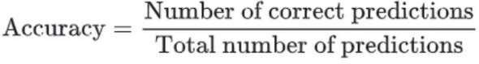

* 1. Confusion Matrix:

Construct a confusion matrix to visualize the performance of the model by comparing predicted and actual activity labels.



# Comparison with existing system:

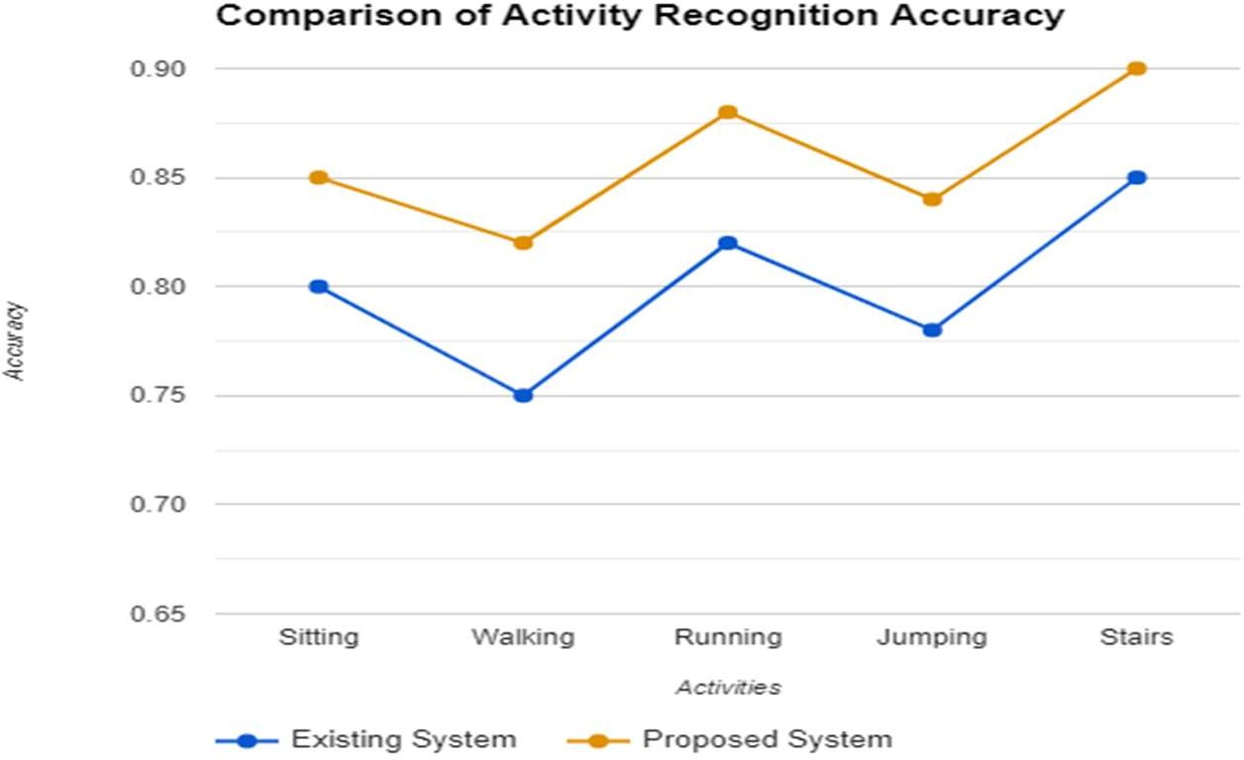

1. **Activities Predicted:**

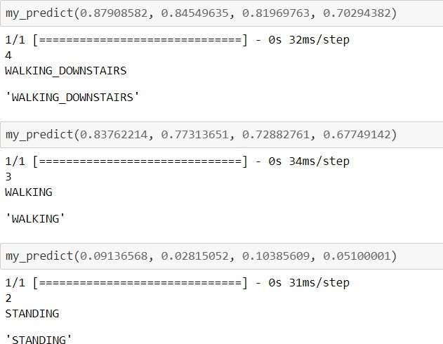

# CONCLUSION

In conclusion, the utilization of energy harvesting edge devices for increasingly complex tasks like Human Activity Recognition (HAR) necessitates targeted efficiency-maximizing optimizations in both system and node designs. This paper proposes a novel approach using a Generative Adversarial Network (GAN) framework to generate human activity sensor data, which is then employed to balance existing datasets. By incorporating an autoencoder to provide prior knowledge for all activity classes andintroducing conditional constraints for generating activity data for specific classes, the framework enhances the stability of thetraining process. Experiments conducted on two public human activity datasets demonstrate a significant improvement in HARclassifier performance after dataset balancing. This research highlights the potential of advanced machine learning techniques to address challenges in HAR and offers valuable insights for optimizing edge device performance in energy- constrained environments.

# REFERENCES

[1]. Ultra-Wideband Radar-Based Activity Recognition Using deep Learning: Farzan M. Noori , Md. Zia Uddin and

Jim Torresen(2021) https://ieeexplore.ieee.org/document/9558753

[2]. Hu man Activity Recognition Based on Improved Bayesian Convolution Network to Analyze Health Care Data Using Wearable IoT Device: Zhiqiang Zhou , Heng Yu and Hesheng Shi (2020)https://ieeexplore.ieee.org/document/90 86799

[3]. LSTM-CNN Architecture for Human Activity Recognition: Kun Xia, Jian Guang Huang and Hanyu Wang (2020) https://ieeexplore.ieee.org/document/9043535

[4]. Design and Implementation of a Convolutional Neural Network on an Edge Computing Smartphone for Human Activity Recognition: Tahmina Zebin

[5]. Developing a Lightweight Rock-Paper- Scissors Framework for Human Robot Collaborative Gaming: HeikeBrock , Javier Ponce Chulani , Luis Merino , Deborah Szapiro and Randy Gomez (2020)

[6]. Efficient Human Activity Recognition Solving the Confusing Activities Via Deep Ensemble Learning: Ran Zhu,

Zhuoling Xiao , Ying Li , Mingkun Yang, Yawen Tan , Liang Zhou , Shuisheng Lin and Hongkai Wen (2019)

[7]. A Deep Learning Approach to on-Node Sensor Data Analytics for Mobile or Wearable Devices: Daniele Rav,

CharenceWong , Benny Lo and GuangZhong Yang (2017)

[8]. Performance Analysis of Smartphone-Sensor Behavior for Human Activity Recognition: Yufei Chen and ChaoShen [2017]

[9]. "Real-time food intake classification and energy expenditure estimation on a mobile device, D. Ravi, B. Lo, and G.-Z.

Yang

[10]. An agent-based smart home, D. J. Cook etal.,

[11]. An Efficient Activity Recognition Framework: Toward Privacy-Sensitive Health Data Sensing: Samer Samarah ,Mohammed Gh. Al Zamil , Ahmed F. Aleroud , Majdi Rawashdeh , Mohammed Alhamdi and Atif Alamri [2017] [12]. Accurate and privacy preserving cough sensing using a low-cost microphone, E. C. Larson, T. Lee, S. Liu,

[13]. Convolutional neural networks for human activity recognition using mobile sensors,M. Zeng, L. T. Nguyen, B.

Yu, O. J.Mengshoel, J. Zhu, P. Wu, and J. Zhang

[14]. The opportunity challenge: A benchmark database for on-body sensor-based activityrecognition, Pattern Recognition R.

Chavarriaga, H. Sagha, A. Calatroni, S. T.Digumarti, G. Trster, J. D. R. Milln, and D.Roggen

[15]. A hybrid FMCW-interferometry radar for indoor precise positioning and versatile life activity monitoring, G. Wang, C.

Gu,T. Inoue, and C. Li

[16]. Unobtrusive sensing and wearable devices for health, Y.-L. Zheng et al. [17]. Social cycling and conditional responses, Z. Wang, B. Xu, and H.-J. Zhou

[18]. "Detection of daily activities and sports with wearable sensors in controlled and uncontrolled, M. Ermes, J. Prkk, J. Mntyjrvi, and I. Korhonen