**A New Era of Web Development Using MERN Stack**

**DEEPANSHU PARIYANI, Dr. VISHAL SHRIVASTAVA2, Dr. AKHIL PANDEY3, Prof. RAHUL SHARMA4**

1B.TECH. Scholar, 2,3Professor, 4Assistant Professor

Computer Science & Engineering

Arya College of Engineering & I.T. India, Jaipur

[1pariyanideepanshu@gmail.com](mailto:1pariyanideepanshu@gmail.com) , [2](mailto:2vishalshrivastava.cs@aryacollege.in)[vishalshrivastava.cs@aryacollege.in](mailto:2vishalshrivastava.cs@aryacollege.in),3[akhil@aryacollege.in](mailto:akhil@aryacollege.in), 4rahulsharma.cs@aryacollege.in

**Abstract**

Welcoming you to the fascinating MERN stack development world! We'll dig into the four sections that make up this powerful innovation in this study paper and checking out by any means of its benefits. It's basic now like never before to stay aware of the fast advancement of web improvement. You will have the resources necessary to develop cutting-edge, scalable apps if you grasp the MERN stack. then let's get going!

**Keywords**

Caching Single Page Application, Node Package Manager, Scalability, Open Source, Virtual Dom ,Event Driven , NOSQL ,Replication.

**Contractions and Abbreviations**

Hypertext Markup Language (HTML),Cascading Templates (CSS), Graphical Client Interface(GUI), Application Program Connection point (Programming interface), Hypertext Move Convention (HTTP), Open Framework's Interconnection (OSI),Structured Inquiry Language (SQL), Non Concurrent Java Content and XML (AJAX), Extensible Markup Language (XML), Area Naming Framework (DNS), Java Content Item Documentation (JSON), UI (UI, Social Data set Administration Framework (RDBMS).

**INTRODUCTION**

In the dynamic and consistently developing domain of web improvement, the coming of the MERN (MongoDB, Express.js, Respond, and Node.js) stack has catalyzed a groundbreaking change in the manner present day web applications are imagined, planned, and fabricated. This notable innovation stack has introduced another period of web improvement, offering designers a hearty, adaptable, and profoundly proficient tool compartment to make intuitive and responsive web applications. This exploration paper dives into the complex parts of MERN stack advancement and its significant effect on the web improvement scene.

These four parts together make up the MERN stack, which has grown in favor among programmers because to its adaptability, usability, and capacity for handling complicated applications. Using the MERN stack, developers can build web apps that are strong and effective, freeing them up to concentrate on providing the greatest user experience.

**Benefits of Using MERN Stack**

The flexibility of the MERN stack is one of its primary advantages. Designers can pick what parts to use in view of their singular necessities in light of the fact that every part might be utilized independently or together. For instance, in the event that an undertaking demands ongoing information changes, engineers might construct a consistent client experience by involving Node.js for server-side delivering and React.js for client-side delivering.

1. Another advantage of the MERN stack is its scalability. MERN stack allows developers to effortlessly add and remove components as a project expands in size and complexity. This makes the project easier to manage and upgrade throughout time. Furthermore, because the MERN stack employs JavaScript throughout the development process, reusability improves.
2. Large Support Community:- Because the MERN stack is highly popular, there are several online resources, tutorials, and an active developer community to assist you if you want assistance or want to learn more about these technologies. This will help the new developers to learn and understand the MERN Stack in depth.
3. Real Time Capabilities;- As Node.js is event-driven, it is ideal for developing real-time and chat apps. You may construct responsive real-time features in your apps by combining them with technologies like as Web-Sockets.
4. Rapid Development:- MERN stack promotes a rapid development process because of its simple use and obtainable of third-party modules . You may construct responsive real-time features in your apps by combining it with technologies like as Web-Sockets.

**Evolution of Development**

Online development has progressed from static HTML pages to dynamic and interactive online apps throughout the years. Simple HTML pages delivered by web servers typified the early days of the web. As the web turned out to be more well known, engineers started to explore different avenues regarding new strategies for building more intelligent and dynamic sites.

With the presentation of JavaScript, sites turned out to be more powerful, considering more prominent client contribution and a superior client experience. With the presentation of AJAX (Non-concurrent JavaScript and XML), web applications could be made that could refresh content without requiring a page invigorate. This was a critical achievement in web improvement, making ready for the production of contemporary online applications. With the appearance of innovations, for example, React.JS Angular.JS, web advancement has arrived at new levels. Using a component-based design, React.JS and Angular.JS allows developers to create sophisticated user interfaces. Not only this there are various other alternatives nowadays like Vue.js, Elm , Svelte, Preact, etc. can be used for the development of the best User Interface depending upon the development and design requirements.

**Front-end Development**

It is the process of applying design on the web. The pages of a site are made out of various layers, including structure, information, plan, content, and usefulness. The part of the frontend development is important for the user’s point of view as the user always want’s a simple, attractive and user friendly interface thus the development of the UI and UX should be according to the targeted user’s ease.

Front-end dialects incorporate HTML, CSS, JavaScript, and other programming dialects. Front-end libraries incorporate AngularJS, React.js, jQuery, Backtalk, and more systems and libraries.

**React-Js**

React is an library of Javascript developed by Jordan Walke (Software Engineer) designed at Facebook or Meta in 2011 but available to public in May 2013.It is Open source Javascript Library means it is available free of cost anyone who wants to develop fronted can use it by just installing it in the system. It is quite popular nowadays due to its component based architecture. Component is nothing but just a function written in JSX that is used more than 1 time according to our need and the design. There are various big firms or companies that uses React like Netflix, YouTube, Instagram, Myntra etc. This Single page provides the faster rendering of the different components depends upon the path specified but the user’s are not aware about that they are on the same page they thing they have navigated to the different pages that optimizes the speed of the web application. Respond has arisen as the go-to structure for creating on the web and portable applications. Its versatility and dexterity have moved it to the front of the ongoing web advancement climate.

**Creating a React-Js application**

You, most importantly, will require NPM (or, alternatively, Yarn). We should involve NPM for instance.

In the event that you don't as of now have it introduced, go to the authority Node.js site to download and introduce Hub, which additionally contains NPM (Hub Bundle Administrator).

Begin your terminal/order brief in the wake of downloading and introducing Hub and run hub - v and npm - v to check which adaptations you have. Because create-react-app needs that we have NPX installed, your NPM version should be at least 5.2.0 or newer. To upgrade an earlier version of NPM, use the following command: **npm I –g npm .**

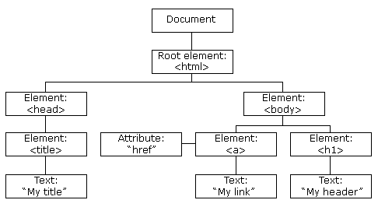

Fig. DOM

**What is create-react-app?** We don't want toconfigure React manually because it's hard and time-consuming. create-react-app is a much simpler method that performs all of the configuration and package installation for us and launches a new React app locally, ready for work.

One more advantage of using make respond application is that it disposes of the need to manage Babel or Webpack arrangements. Make respond application will deal with all of the vital arrangement for you.

As per the Respond documentation, one of the authoritatively supported strategies for making single-page applications in Respond is make respond application. Different choices might be seen as here.

**command:** **npx create-react-app newname.**

After running it , When it's finished, you will see a folder with the name you have given to your app appear in your workspace.if you are on mac you have to be super user first by using the **sudo** command.

After the installation navigate to the directory you have created through the command by using **cd directory_name** (used with create-react-app) and then finally run command **npm start** to see it on your local host. Now your react app is ready to use.

**Features of React**

1. Declarative:- Respond adopts an explanatory strategy to building UIs.Engineers depict what the UI ought to resemble, and Respond deals with the fundamental updates and delivering.This decreases the gamble of bugs connected with changeable state.
2. Component Support:- Respond is worked around the idea of reusable parts.Parts typify the way of behaving and presence of explicit pieces of the UI.This particular methodology works on advancement, support, and code association.
3. Cross-stage Versatile Applications (Respond Local):- When you use React-JS in your undertaking, you get a reward: Respond Local. You can utilize Respond Local to make cross-stage applications for Android and iOS. Expect you've made a site for your business. After some time, you may additionally support it with a mobile app built with React Native. Of course, you will not be able to reuse the code you developed. Far and away superior, you will actually want to plan the portable application utilizing a similar design and strategy.
4. Virtual DOM :- Respond utilizes a virtual portrayal of the Record Item Model (DOM).At the point when changes are made to the UI, Respond refreshes the Virtual DOM and computes the most proficient method for refreshing the genuine DOM.This approach limits expensive re-renders, further developing execution.

**Summary**

Respond, the JavaScript library created by Facebook, offers a scope of strong highlights that have upset web improvement. At its center is a part based engineering that energizes reusability and modularization, improving on code the board. JSX, a sentence structure expansion, improves code clarity by permitting designers to compose UIs in a configuration suggestive of HTML.The Virtual DOM limits re-renders, further developing application execution. Its extensive lifecycle strategies work with customization during part lifecycles.Server-Side Delivering (SSR) further develops Website design enhancement and introductory page load execution. Its DevTools give significant experiences to troubleshooting and profiling, while Respond Local stretches out its abilities to local versatile application advancement for iOS and Android stages. These elements by and large settle on Respond a main decision for web designers, offering a productive and viable method for making UIs for current web applications.

**Back-end Development**

In the steadily advancing scene of web improvement, the meaning of backend advancement couldn't possibly be more significant. Frequently stowed away from the client's view, the backend fills in as the motor controlling web applications, overseeing information, rationale, and security. While frontend improvement centers around making the UI that clients associate with, backend advancement manages the in the background parts of web applications. The backend fills in as the extension interfacing the UI to the information stockpiling, guaranteeing the consistent recovery, handling, and conveyance of data.

At the core of backend advancement lies server-side programming, where engineers work with dialects and structures explicitly intended to deal with the server's capabilities. This incorporates overseeing information bases, taking care of client validation, handling solicitations, and serving dynamic substance to the frontend.

Backend improvement ordinarily includes working with information bases, which act as the information stockpiling and recovery component for web applications. It envelops social data sets like MySQL and PostgreSQL as well as NoSQL data sets like MongoDB and Cassandra. Proficient data set plan and the board are essential for guaranteeing information respectability and application versatility.

Security is one more fundamental worry in backend improvement. Carrying out verification and approval instruments, shielding against security dangers, and safeguarding touchy client information are vital parts of the backend engineer's liabilities. This incorporates using encryption, access controls, and information approval strategies.

To work with correspondence between the frontend and backend, web APIs (Application Programming Points of interaction) assume an essential part. These APIs characterize the principles and conventions for how different programming parts ought to interface. Relaxing and GraphQL APIs are famous decisions for building proficient correspondence channels.

Besides, the rise of serverless figuring has presented a change in outlook in backend improvement. Serverless stages like AWS Lambda, Sky blue Capabilities, and Google Cloud Capabilities empower designers to zero in on code as opposed to server the executives, further smoothing out backend improvement.

**Node.JS**

In the consistently advancing scene of web improvement, Node.js has arisen as a groundbreaking power, rethinking the manner in which engineers imagine and fabricate server-side applications. This examination paper sets out on an inside and out investigation of Node.js, revealing insight into its beginnings, center ideas, and its significant effect on current server-side JavaScript advancement.

Node.js, frequently basically alluded to as Hub, is an open-source, cross-stage runtime climate that empowers designers to execute JavaScript code on the server-side. What recognizes Node.js from conventional server-side innovations is its non-hindering, occasion driven design, which is especially appropriate for building exceptionally adaptable, continuous, and information concentrated applications.

Node.js was brought into the world from the acknowledgment that JavaScript, customarily saved for client-side prearranging, could be tackled on the server-side also. Created on the V8 JavaScript motor by Google, Node.js carried JavaScript to the server, binding together the improvement stack and advancing full-stack JavaScript advancement.

**Internal Structure Node.js:-**

V8 is a Google-made open-source project. The objective of this open-source project is to run JavaScript code beyond the program. It gives admittance to the hidden systems administration of the hub and helps the hub in managing simultaneousness issues. (We as a whole realize that Node.js is about simultaneousness). This undertaking's code is written in C++ 70% of the time and JavaScript 30% of the time.

**Libuv:-** It's an abstraction layer that sits on top of c-ares (for DNS), iocp (for Windows asynchronous-io), and libeio, libev. LibUv controls and maintains the event pool's Input-Output and events. If I were to explain it simply, libuv allows your JavaScript code to execute I/O operations such as networking or file operations. This library handles all file/system operations as well as TCP level communication. This library is entirely written in C++.

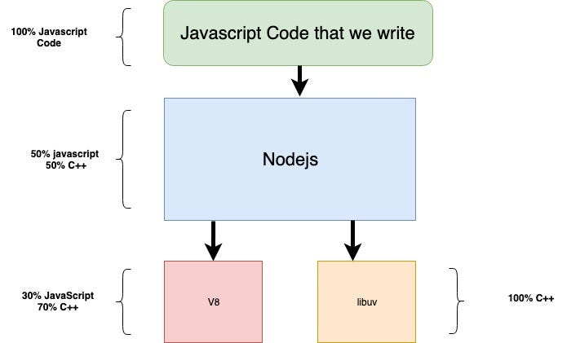

Fig. Internal Structure of Node.JS

**Npm tool(Node Package Manager):-**

Node.js consolidates worked in help for pack the leaders through NPM, a program that is consolidated with each Node.js foundation. The chance of NPM modules is like that of Ruby Valuable stones: a blend of energetically open, reusable parts that can be truly introduced through a web vault, including rendition and reliance the bosses.

An all out overview of packaged modules may a large part of the time be gotten on the npm site or by using the npm CLI(command line interface) instrument, which is presented with Node.js. Everybody is welcome in the module environment, and anyone can distribute their own module, which will be highlighted in the npm storehouse. Some of the commonly used modules are:- express, bluebird, connect, moment, mongodb, etc

**Creating Node.JS Application**

Node.js is commonly run with nvm. It empowers you to just change Node.js forms and put in new renditions to test and rollback assuming something comes up short. It's likewise smart to test your code with more established Node.js adaptations.

The site is sufficiently modern to decide your working framework, so on the off chance that you are utilizing Windows, you will in all likelihood get a page like the one above. Solidly in the center, two buttons show the most successive download choices, as well as the latest ones.

To find out about the latest Hub highlights, click the symbol on the right. Most people, nonetheless, are encouraged to utilize the Drawn out Help rendition, which prompts the button on the left.When you select one of them, an.msi document will be downloaded to your PC. The following step is to click on it, after which the installation will commence.

Next, click. On the next screen, read (you did read it, right?) Node's EULA, accept its conditions, and click Next again. The next box allows you to specify the destination folder for Node.From here, as said, you simply click Install to begin the installation.

You may launch either Windows Powershell or the Command Prompt to see if Node (and npm) were correctly installed on your PC. In any folder, execute node -v to see what version of Node you're running. As an aside, you may be wondering why we can check this in any folder. One of the custom configuration choices (which we left alone) was to add Node to PATH. This allows us to access it from anywhere while browsing through the directories.

**Features of Node.JS**

1. **Event-Driven and Asynchronous**:- Node.js utilizes an occasion driven, non-hindering I/O model, making it productive for taking care of simultaneous connections.This highlight permits applications to perform undertakings behind the scenes without hindering different activities, which is great for continuous applications and adaptability. This functionality not only reduces memory use but also makes it possible for Node.js to manage many concurrent connections effectively. The runtime environment is used by programmers to carry out routine operations such as reading from or writing to databases, making file system or network connections, etc.
2. **Single-Threaded**:- Node.js works on a solitary strung model, upheld by an occasion circle, which proficiently oversees undertakings and occasions. This engineering diminishes above and upgrades execution by permitting the server to deal with numerous concurrent associations without the requirement for extra strings. A significantly higher number of requests may be handled by Node.js's single-threaded application in comparison to more conventional servers such as Apache HTTP Server.
3. **No Buffering**:- The callback function concept is what allows the Node.js software to emit data in blocks. Because the complete activity is not delayed, the user receives the information more quickly and is ready. It shortens processing times, like those for uploading audio or video files. They never utilize a cushion to store any information.
4. A capability that is passed as a contention to one more capability is known as a callback capability. When anything turns out badly, a callback capability gets blunder as its most memorable boundary, which is checked. Data is passed in with the second parameter. The callback function can accept extra parameters in order to deliver data.
5. **Caching**:- One significant benefit of Node.js is caching. It facilitates module caching. A Node.js module gets cached in the application RAM upon its initial request. Because caching enables the program to load web pages more quickly and respond to user input more quickly, we won't need to re-execute the scripts.
6. **Robust Nature**:- Developers utilizing Node.js may benefit from a trustworthy package management such as npm. Not only is npm reliable, quick, and consistent, but it also makes declaring and installing project dependencies easier. Simultaneously, it maintains the project dependencies distinct to minimize the likelihood of version conflicts. Users may further benefit from JavaScript's robust file streams features by utilizing popular task runners like grunt in conjunction with tools like broccoli, gulp, and brunch.

**Summary**

Node has revolutionized JavaScript's usability and evolved into a full programming language. Node has been used in browsers as well as server-side scripting outside of browsers enabled the release of a runtime environment, a collection of beneficial, free modules that may be imported by utilizing NPM, an integrated tool. Event-driven I/O and non-blocking asynchronous programming are used by Node.js to be both effective and lightweight. In essence, every company By using Node, you may need fewer servers and less engineers and mitigation of page load delays.

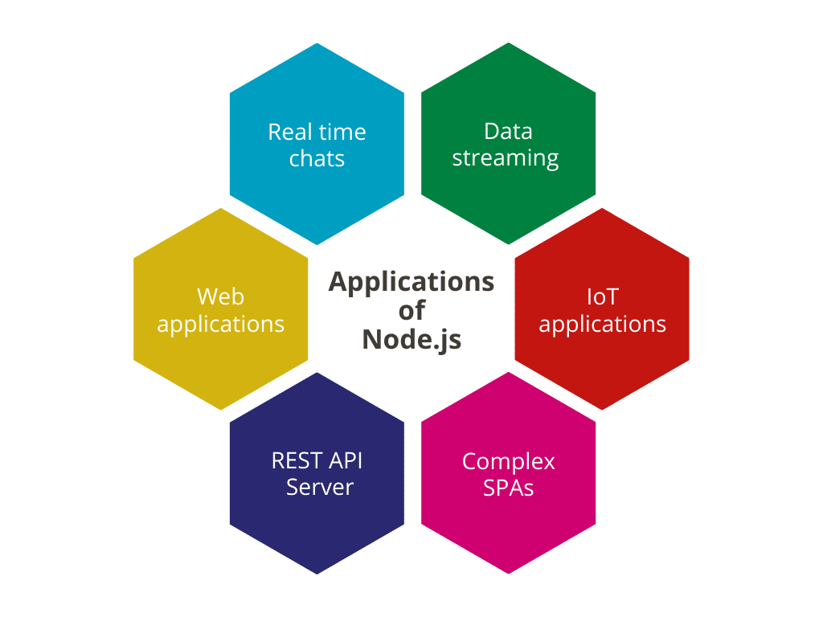

**Fig. Applications of Node.JS .**

**Introduction of Express JS**

In the consistently advancing scene of web improvement, the decision of a reasonable structure assumes a urgent part in molding the proficiency, versatility, and generally progress of a web application. The coming of Express.js, a negligible and adaptable Node.js web application system, has presented a change in perspective in how web engineers configuration, fabricate, and convey applications. Express.js, frequently alluded to as just "Express," offers a smoothed out way to deal with server-side programming, settling on it a sought-after decision for web improvement undertakings of different sizes and intricacies.

In the steadily advancing scene of web improvement, the mission for easier, more effective, and versatile arrangements has been a main thrust for the production of systems that work on the strenuous undertaking of building web applications. Express.js, ordinarily alluded to as Communicate, remains as a demonstration of the responsibility of the web improvement local area to smooth out the advancement cycle and tackle the force of JavaScript across the whole stack.

1. **Verifiable Setting:**

The foundations of Express.js can be followed back to the presentation of Node.js, a server-side JavaScript runtime, in 2009. Express.js was considered as a solution to the requirement for a lightweight, effective, and unopinionated web application structure that could flawlessly coordinate with Node.js. Created by TJ Holowaychuk and delivered in 2010, Express immediately acquired fame for its moderate plan and adaptability, offering a particular and middleware-based way to deal with building web applications.

1. **Outstanding Achievements**:

The development of Express.js has been accentuated by a few striking achievements. In 2014, the task changed to being kept up with by the Node.js Establishment, a demonstration of its developing importance inside the Node.js biological system. It has kept on advancing, with successive updates and upgrades. The presentation of elements, for example, the Express 4.0 delivery, which brought upgraded steering and middleware capacities, further hardened its situation as a main web application system.

1. **Local area and Open Source Cooperation**:

Express.js has flourished as an open-source project, and its prosperity can be credited to the dynamic local area of engineers and givers who have lifted up it. This open coordinated effort has prompted a large number of outsider middleware and expansions, extending Express' capacities and permitting designers to incorporate extra usefulness into their applications without any problem.

1. **The Contemporary Importance:**

Today, Express.js keeps on being a central participant in web improvement. Its adaptability, execution, and strength go with it a favored decision for an extensive variety of web applications, from little ventures to huge scope frameworks. It has been instrumental in spearheading the advancement of APIs and microservices, permitting engineers to make lightweight and effective server-side applications.

In this part of our exploration paper, we have investigated the authentic setting and the vital achievements in the advancement of Express.js. It is obvious that the structure has not just stayed up with the always changing requests of web advancement however has additionally set new principles, impacting the plan and improvement of web applications in the contemporary computerized scene. The following segments will dive further into the center ideas, benefits, and commonsense executions of Express.js, offering a complete perspective on this powerful web application system.

**Architecture and Core Concepts**

The design of a web application system is the establishment whereupon engineers fabricate powerful, versatile, and productive applications. Express.js, with its moderate plan and secluded structure, offers a compositional system that engages designers to make web applications with spryness and accuracy. In this part, we dig into the essential design and center ideas that support the Express.js system.

1. **Secluded and Middleware-Based Design:**

At the core of Express.js lies its secluded and middleware-based structure. This design is vital to its straightforwardness, adaptability, and the fast advancement of web applications. Express.js utilizes a middleware design where each capability (or middleware) in the stack handles a particular part of the solicitation reaction cycle, like verification, directing, blunder dealing with, or information handling. This approach permits engineers to form applications from an assortment of measured, reusable structure blocks.

1. **HTTP Solicitation Taking care of:**

Express.js succeeds in its capacity to deal with HTTP demands effectively. It utilizes a switch to decide how an application answers client demands. Courses, addressed by URLs, characterize the solicitation endpoints and the relating capabilities that ought to execute when a specific course is gotten to. This directing framework works on the association of an application and gives a reasonable construction to taking care of approaching solicitations.

1. **Middleware Execution:**

Middleware capabilities in Express.js are executed consecutively in the request in which they are characterized, with the capacity to pass control to the following middleware or end the solicitation reaction cycle. This middleware execution model considers fine-grained command over the solicitation dealing with process. It is the center of Express.js' capacity to process and control information at different phases of the solicitation stream.

1. **Solicitation and Reaction Items**:

Vital to the center ideas of Express.js are the solicitation and reaction objects. These items embody the approaching HTTP demand and the server's reaction. The solicitation object gives admittance to demand boundaries, headers, and information, while the reaction object is utilized to send information back to the client, set headers, and deal with the reaction.

1. **Express Switch**:

Express.js integrates a strong steering framework worked with by the Express Switch. The switch permits designers to characterize and coordinate courses in an organized way, making it more straightforward to oversee complex applications. It empowers the formation of sub-switches, which helps segment courses into isolated modules or parts.

In this part, we have divulged the compositional standards and center ideas that shape the Express.js structure. The secluded and middleware-based structure, the steering framework, and the solicitation reaction cycle are the foundations whereupon Express.js enables engineers to proficiently construct web applications. These ideas work with the formation of adaptable, coordinated, and elite execution applications. The resulting areas will additionally investigate the benefits of utilizing Express.js, its reasonable execution in certifiable situations, and its job in current web improvement.

**Advantages of Express.JS**

Express.js, a generally taken on web application system, offers a large number of benefits that have added to its conspicuousness in the web improvement scene. In this part, we investigate the key benefits that settle on Express.js an appealing decision for engineers and associations while making web applications and APIs.

* **Effective Middleware:**

Express.js influences middleware, permitting engineers to embed capabilities that can interaction solicitations and reactions at different phases of the solicitation reaction cycle. This middleware-driven engineering smoothes out the advancement of highlights like verification, demand parsing, and mistake taking care of. It advances spotless, particular code and empowers engineers to alter the solicitation dealing with cycle to suit their particular necessities.

* **Elite Execution and Versatility:**

The nonconcurrent, occasion driven design of Node.js, whereupon Express.js is assembled, adds to elite execution and versatility. Express.js can productively deal with an enormous number of simultaneous associations, pursuing it an incredible decision for applications that request ongoing correspondence or need to help high traffic loads.

* **Dynamic People group and Assets:**

Express.js benefits from a lively and steady local area of engineers and an abundance of online assets. Engineers can get to an extensive variety of documentation, instructional exercises, and discussions, empowering them to look for help and remain refreshed on prescribed procedures. This cooperative climate improves the structure's flexibility and versatility.

* **Flexibility and Versatility**:

Express.js is profoundly flexible and versatile. From limited scope ventures to huge, complex frameworks, Express.js can oblige assorted improvement needs. Its adaptability permits it to act as the establishment for web applications, APIs, microservices, and that's only the tip of the iceberg.

* **Spearheading Microservices and APIs:**

Express.js has played a spearheading job in the improvement of microservices and APIs. Its particular and lightweight plan settles on it an optimal decision for making the backend of microservices, empowering engineers to plan and convey autonomous, administration arranged parts.

**Summary**

Express.js, with its rich straightforwardness and measured design, has re-imagined the manner in which engineers approach web application advancement. The meaning of Express.js couldn't possibly be more significant, and its part in current web improvement is unequivocal. This examination paper has offered an extensive perspective on the structure's engineering, center ideas, benefits, and reasonable applications. Express.js isn't just an innovation; it is a demonstration of the steady quest for greatness in web improvement. As we close, we underscore that the excursion with Express.js is nowhere near finished. Its advancement proceeds, and its impact continues, making ready for the following part in the consistently developing scene of web application improvement.

**Introduction of MongoDB**

In the huge and dynamic scene of data set administration frameworks, MongoDB has arisen as an extraordinary power, changing how information is put away, recovered, and handled. MongoDB, frequently portrayed as a NoSQL data set, remains a demonstration of the development of information in the computerized age. In a period where information has become the backbone of organizations and applications, the requirement for an adaptable, versatile, and elite execution data set arrangement has never been more principal. This examination paper sets out on an investigation of MongoDB, digging into its verifiable setting, building underpinnings, and its critical job in current data set administration.

The journey for more proficient and versatile data set arrangements was the catalyst that prompted the beginning of MongoDB. In the mid-2000s, as conventional social data sets battled to adapt to the requests of progressively perplexing and information-escalation applications, another methodology was required. MongoDB, first created and delivered in 2009 by 10gen (presently known as MongoDB, Inc.), presented an original approach to overseeing information, one established in a pattern-less, report-situated worldview. With MongoDB, information is put away in adaptable, JSON-like records, making it conceivable to deal with a wide cluster of information types and designs.

**Architecture of MongoDB**

MongoDB's engineering is recognized by its NoSQL, report situated approach, making it a strong player in present day information the board. The data set stores information in adaptable, JSON-like reports coordinated into assortments. Ordering upgrades inquiry execution, permitting productive information recovery. MongoDB's high accessibility is accomplished through an imitation set design, involving an essential server and optional servers. Information is recreated from essential to auxiliary servers for adaptation to non-critical failure. For enormous datasets and high loads, MongoDB utilizes sharding, conveying information across various servers. The inquiry handling utilizes a question organizer and agent to improve inquiries. MongoDB's conglomeration system upholds complex information changes. Pluggable capacity motors, as WiredTiger and MMAPv1, are answerable for information capacity and recovery. Security highlights include confirmation, approval, encryption, and inspecting. Official and outsider drivers and connectors work with combination with different stages, upgrading MongoDB's flexibility for information the board difficulties. MongoDB's engineering supports its capacity to address present day information the board needs, consolidating adaptability, versatility, and execution.

**Features of MongoDB**

**1) Guide lessen based Conglomeration Structure**: This component of MongoDB is like the 'Gathering By statement presented in MySQL. MongoDB utilizes MapReduce worldview to perform accumulation. A guide is essentially a technique for separating and arranging information while decrease technique plays out a synopsis activity (Eg counting the quantity of individuals standing in a line). Map Reduce is for the most part used to handling enormous volume of information parallely by disseminating it across bunches.

2**) Pattern Less Information base**: The diagram alludes to the structure in which the information ought to be put away. In the instance of social information bases such construction is characterized

utilizing tables. By construction less we are alluding to powerfully composed mapping instead of statically

composed blueprints in Social Data sets. Eg XML permits you to determine XSD whenever required anyway BSON can acknowledge a shifted kind of

information. Since there is no imperative on the information and each report in the assortment can have various characteristics from each different we call it pattern less.

3**) Impromptu Questioning**: MongoDB upholds SQL like complex questions including regex. Also, we can likewise compose inquiries to get information not exactly or more prominent than a worth or utilize customary articulations for design coordinating.

4) **Replication and come up short over help**: Mongo-DB upholds replication by disseminating information over different bunches, this is accomplished utilizing copy set which is basically a gathering of occasions facilitating similar information. In a reproduction set, one hub is characterized as the essential hub while any remaining hubs arrange as auxiliary. All compose activities are appointed to the essential hub (for example the expert hub) while the auxiliary hubs may perform read tasks.

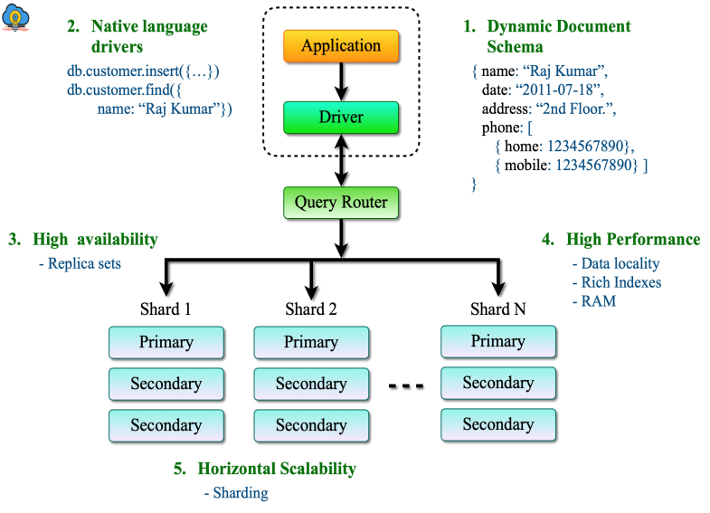

**Conclusion**

In the consistently developing scene of web improvement, the coming of the MERN stack has introduced another period of advancement and effectiveness. This thorough stack, made out of MongoDB, Express.js, Respond, and Node.js, brings together the advancement interaction and engages designers to make dynamic, versatile, and responsive web applications. The stack's authentic setting, including the development of web innovations and the vital job of JavaScript, makes way for figuring out its importance. MongoDB, with its NoSQL data set, offers adaptability and flexibility in information taking care of. Express.js improves on server-side turn of events, while Respond alters frontend UIs. Node.js, with its occasion driven engineering, fills in as the spine for server-side tasks.

The benefits of the MERN stack are various, including code reusability, a bound together language (JavaScript), and the capacity to make intuitive, ongoing applications. True contextual analyses exhibit its common sense and adequacy in assorted applications. In any case, recognizing the difficulties of versatility and support that designers might encounter is critical. Looking forward, the MERN stack is ready to keep molding the fate of web advancement, adjusting to arising patterns and necessities. As it smoothes out improvement cycles and upgrades client encounters, the MERN stack remains at the front of web advancement, driving development and introducing another time where building modern web applications is more available and effective than any other time in recent memory.

**Refrences**

* Security Analysis of MongoDB by Sahib Singh
* “An Emerging frontend Javascript Library” By Pratik Sharad Maratkar
* “ReactJS: A Modern Web Development Framework” by Prateek Rawat
* “An​ ​Analysis​ ​and​ ​Overview​ ​of​ ​MongoDB​ ​Security” By Matthew Trudeau and Joshua Kolodny
* “Role of Node.js in Modern Web Application Development” By Ghansham Jadhav