INDUSTRIAL RESEARCH PROJECT

Report On overview project on Jio

Submitted to

Dr. Pratiksha Jha

Submitted by: YASH YADAV

Enrollment no. 21041110050

Admission No. 21GSOB1110053

BBA(BFSI)



Galgotias University Greater Noida –

201310, U.P., INDIA

# Acknowledgement

It is matter of pride and privilege for me to have done a “**Industrial Research Project”** and I am sincerely thankful to them for providing thid opportunity to me.

I am thankful **Dr. Pratiksha Jha** mam for guiding me through this project and continuously encouraging me. It would not have been possible to complete this project without her support.

Finally, I am grateful to my family and friends for their unending support.

# Abstract

Reliance Jio Infocomm Ltd (popularly known as Jio), is an Indian mobile network operator launched commercially on September 5, 2016. Owned by Reliance Industries, the entry of Jio revolutionised the telecommunication sector. In this project the success story of this recent entrant and management principles adopted by the company were analysed on the basis of researches and studies conducted in these fields. The organisational structure, planning and marketing strategy, staffing and recruitment, SWOT analysis, PEST analysis, promotional strategy, the impact of Jio launch, Government policies, controversies surrounding Reliance Jio, its ventures, collaborations and future projects were also discussed in detail.

# Contents

**Introduction**

* 1. Introduction
  2. Jio logo
  3. Technology
  4. Network

1. **History** 
   1. Beta launch
   2. Commercial launch
   3. Non-compete pact
2. **Organisational Structure-Key Executives**
3. **Planning and Marketing Strategy**

1. **Staff Recruitment and Training** 
   * 1. Recruitment Process
     2. Staff Training
2. **SWOT Analysis 23**
   1. Strengths of Reliance Jio
   2. Weaknesses of Reliance Jio
   3. Opportunities of Reliance Jio Threats of Reliance Jio

**PEST Analysis**

* 1. Political factors affecting Reliance Jio
  2. Economic factors affecting Reliance Jio
  3. Social factors affecting Reliance Jio
  4. Technological factors affecting Reliance Jio

1. **Promotional Strategy**
2. **Impact of Jio Launch** 
   1. Impact on CitizensImpact on the Economy and Telecom Industry
3. **Government policies** 
   1. Digital India
   2. TRAI Regulations
4. **Controversies Surrounding**

**Reliance Jio**

* 1. Issue with incumbentsAlleged subscriber data breach
  2. Call Drop
  3. Auction for Spectrum
  4. PM Modi on Jio Ad Campaign
  5. Alleged Government Patronising
  6. Favouritism by TRAI
  7. False Advertisements

1. **Ventures, Collaborations**

**and Future Projects**

* 1. JIO Apps
     1. Apps owned by JIO
  2. Smart phones and other caller devices
     1. LYF smartphones
     2. Jiophone .
  3. Other service
     1. 4G Broadband services
     2. Jionet
     3. Jio Giga Fiber .
     4. Jiofi
  4. Other Collaborations
     1. Star India
     2. Google
     3. Cisco
     4. Alliance
  5. Future Projects
     1. Jio DTH
     2. Jio GigaTV
     3. Jio 5G Network
     4. Jio Phone 3
     5. More Content With Jio (Disney Marvel Tie Up)
     6. Jio Enterprise Services
     7. Jio Smart Home
     8. Jio VoWi-Fi service

1. **Conclusion**

# Introduction

## 1.1 Introduction

Reliance Jio Infocomm Limited, popularly known as Jio, is an Indian mobile network operator. Owned by Reliance Industries and headquartered in Mumbai, Maharashtra, it operates a national Long-Term Evolution (LTE) network with coverage across all 22 telecom circles. Jio does not offer 2G or 3G service, and instead uses Voice over LTE (VoLTE) to provide voice service on its network. The launch of Reliance Jio has caused a revolution in the telecom industry. Now, Jio claims to be the world’s largest data network, based on mobile data consumption.

According to the Telecom Regulatory Authority of India (TRAI), as of February 2019, there are 1.17 billion mobile-phone subscriptions in India, an increase of roughly 140 million subscriptions since August 2016—the month before Jio launched. The growth is especially pronounced in rural areas, where there are now over 500 million wireless subscriptions, roughly 80 million more than there were before the company formally began its operations. As more Indians gain phone subscriptions, more are coming online. A 2017 report by the Internet and Mobile Association of India estimated that nearly 50 million Indians gained internet access between December 2016 and December 2017, allowing many of them to surf the web, send

WhatsApp messages and stream videos for the first time.

## 1.2 Jio logo

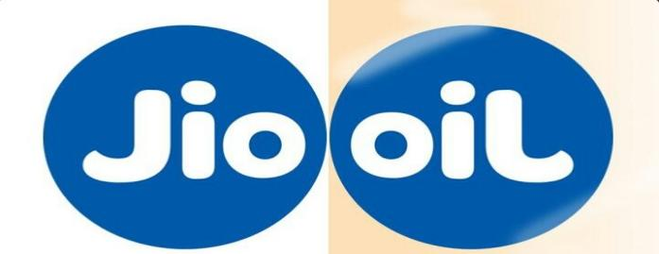

Figure 1.1: The hidden symbolism in Jio logo

The logo of Reliance Jio has a hidden symbolism in it. When you flip the Jio logo around, it is read ’oil’. The Jio logo seems to represent the past and future of Reliance. Oil is what had propelled Reliance to become India’s biggest company in the 20th century. When flipped over into the 21st, it’s probably going to be Jio.

## 1.3 Technology

Jio High Speed Internet service is the fourth generation (4G) mobile technology that enables the delivery of high-speed internet services. It uses voice over LTE to provide voice service on its network. LTE refers to Long Term Evolution of telecom technology that enables High Definition voice and high-speed internet access.

## 1.4 Network

Jio owns spectrum in 850 MHz and 1,800 MHz bands in India’s 22 circles, and also owns pan-India licensed 2,300 MHz spectrum. The spectrum is valid until 2035. Jio shares the spectrum with Reliance Communications. The sharing deal is for 800 MHz band across seven circles other than the 10 circles for which Jio already owns. In September 2016, Jio signed a pact with BSNL for intra-circle roaming which would

enable users of the operators to use each other’s 4G and 2G spectrum in national roaming mode. In February 2017, Jio announced a partnership with

Samsung to work on LTE - Advanced Pro and 5G.

# History

Jio soft launched on 27 December 2015 (the eve of what would have been the 83rd birthday of Reliance Industries founder Dhirubhai Ambani), with a beta for partners and employees, and became publicly available on 5 September 2016. As of 31 January 2019, it is the third largest mobile network operator in India and the ninth largest mobile network operator in the world with over 289.44 million subscribers.

The company was registered in Ambawadi, Ahmedabad, Gujarat on 15 February 2007 as Reliance Jio Infocomm Limited. In June 2010, Reliance Industries (RIL) bought a 95% stake in Infotel Broadband Services Limited (IBSL) for Rs. 4,800 crore (US$670 million). Although unlisted, IBSL was the only company that won broadband spectrum in all 22 circles in India in the 4G auction that took place earlier that year. Later continuing as RIL’s telecom subsidiary, Infotel Broadband Services Limited was renamed as Reliance Jio Infocomm Limited (RJIL) in January 2013.

In June 2015, Jio announced that it would start its operations all over the country by the end of 2015. However, four months later in October, the company’s spokesmen sent out a press release stating that the launch was postponed to the first quarter of the financial year 2016–2017.

Later, in July, a PIL filed in the Supreme Court by an NGO called the Centre for Public Interest Litigation, through Prashant Bhushan, challenged the grant of a pan-India licence to Jio by the Government of India. The PIL also alleged that Jio was allowed to provide voice telephony along with its 4G data service, by paying an additional fee of just Rs 165.8 crore (US $23 million) which was arbitrary and

unreasonable, and contributed to a loss of Rs 2,284.2 crore (US $320 million) to the exchequer.

The Indian Department of Telecommunications (DoT), however, refuted all of CAG’s claims. In its statement, DoT explained that the rules for 3G and BWA spectrum didn’t restrict BWA winners from providing voice telephony. As a result, the PIL was revoked, and the accusations were dismissed.

## 2.1 Beta launch

The 4G services were launched internally to Jio’s partners, its staff and their families on 27 December 2015. Bollywood actor Shah Rukh Khan, who is also the brand ambassador of Jio, kick-started the launch event which took place in Reliance Corporate Park in Navi Mumbai, along with celebrities like musician A R Rahman, actors Ranbir Kapoor and Javed Jaffrey, and filmmaker Rajkumar Hirani. The closed event was witnessed by more than 35000 RIL employees some of whom were virtually connected from around 1000 locations including Dallas in the US.

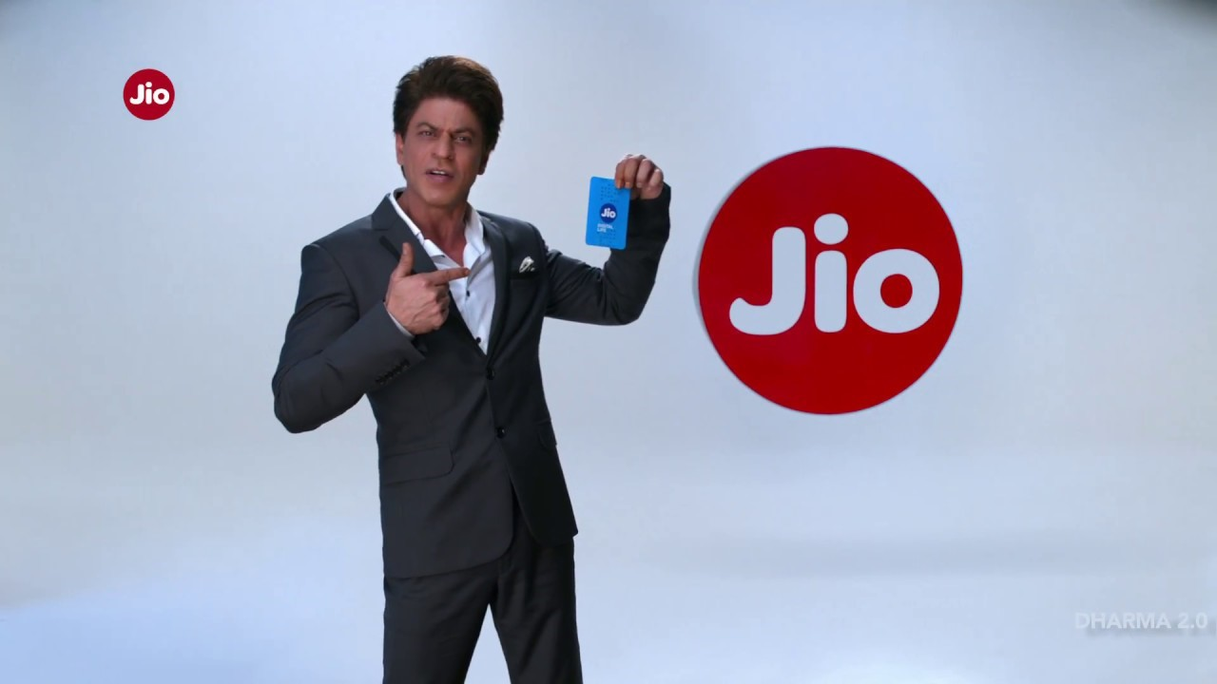

Figure 2.1: Bollywood actor Shah Rukh Khan promoting Jio

## 2.2 Commercial launch

The company commercially launched its services on 5 September 2016. Within the first month, Jio announced that it had acquired 16 million subscribers. This is the fastest ramp-up by any mobile network operator anywhere in the world. Jio crossed 50 million subscriber mark in 83 days since its launch, subsequently crossing 100 million subscribers on 22 February 2017. By October 2017 it had about 130 million

subscribers.

”The idea of Jio was first seeded by my daughter, Isha, in 2011. She was a student at Yale (in the US) and was home for holidays. She wanted to submit some coursework and she said, ’Dad, the internet in our house sucks’,” Mukesh Ambani recalled lately in press.

On 5 July 2018, fixed line broadband service named Gigafiber, was launched by the Reliance Industries Limited’s chairman Mukesh Ambani, during the company’s Annual General Meeting.

## 2.3 Non-compete pact

In contract law, a non-compete clause (often NCC), or covenant not to compete (CNC), is a clause under which one party (usually an employee) agrees not to enter into or start a similar profession or trade in competition against another party (usually the employer). Some courts refer to these as ”restrictive covenants.” As a contract provision, a CNC is bound by traditional contract requirements including the consideration doctrine.

Amabani brothers, Mukesh Ambani and Anil Ambani were on a non-compete pact since the death of their father Dhirubhai Ambani in 2002. The pact was officially scrapped by the brothers in 2010. Jio was a hue entry on Mukesh Ambani into the telecom industries clearly taking the pact cancellation into hand. Jio also paved way for the Ambani brothers first collaboration after splitting their father’s business enterprise eight years ago, with Mukesh Ambani, the chairman of Reliance Industries, agreeing to use his Anil Ambani’s optic fibre network to launch Jio mobile venture. Later in 2018, RCom industries had declared to improve their focus in Real-estate industry rather than telecom with the successful expansion of Jio.

# Planning and Marketing Strategy

Reliance Jio Infocomm Limited revolutionised the telecom sector. The scenario of Indian telecom market before JIO entered it was:

* There were more than 1 billion mobile users in India, out of which only 34% were connected to the internet.
* Only 12% from these 1 billion used 3G data or above

Then came Jio which took the market by storm by offering Data Centric plans and free promotional data.

The Biggest difference between JIO and others is its Optical Fibre Network. An optical fibre is a wire that converts your data signal into light and transfers them at the speed of light. Reliance Jio has the longest fibre optic network in the country, ranging over 2,50,000 km and 90,000 eco-friendly 4G Towers to provide the greatest 4G Coverage in all of India’s 22 telecom circles. Reliance Jio invested Rs 150,000 crore to put this in perspective – this is more than two times the combined investment of Airtel, Idea, and Vodafone in the 4G Segment.

The success of Jio can be mainly attributed to its clear operational planning which can be summarised into five distinct steps:

1. **Step One:** Undercut the market price by giving attractive discounts and free promotional Data.
2. **Step Two:** Let everyone switch to Jio or at least buy a Jio sim to experience data for free.
3. **Step Three:** Unleash the power of fibre optic network to give super fast internet and make people realise that 1GB data is not really much.
4. **Step Four:** Grow your subscriber base by having good customer care and awesome plans.
5. **Step Five:** Recover your investment using the large number of users accumulated

Once the fibre optic network is laid down, the cost of operating is not very huge. On the contrary, the network can be at minimal cost; therefore the only focus was to get more internet users. If 60% of the people in India use 1 GB internet per month then Jio can recover the initial investment in 3 years. The company also plans to rake in profits from its mobile apps which include a variety of services which are described in subsequent sections.

# Staff Recruitment and Training

## 5.0.1 Recruitment Process

The selection procedure in Reliance Jio is completed in following three steps:

* Written test (Aptitude): It analyses the skills in topics like ratio, simple logics, comparisons, analogy etc.
* Technical written test: It analyses the knowledge of the candidate in fields of electronics and networking subjects.
* Technical and HR interview : This being the final step is based on national merit test. It tests the technical and personality skills of the candidate.

## 5.0.2 Staff Training

About 10 to 20 training programs are scheduled for the employees in a year, although the organisation does not give much importance to it. Most of the training is given on the bases of requirement of employees and organisational work schedule. The training method used in the organisation is based on conference/discussion held time to time according to the work and situations. Training given to the new recruitment in the organisation is based on the requirement that whether it is necessary or not and what is the duration.

Surveys show that most of the employees agreed that the training sessions conducted in the organisation are useful to the employees. Usually 1-2 days were taken to implement the training process in the organisation because of the work demand.

It has been observed by studies in this field that the organisation has to put more inputs in training and development of every employee for better growth and productivity of the organisation in an effective manner. There are gaps between the training sessions organised by the company because of which trainees lose touch with training.

**Recommendations By Various Studies**

Responses to surveys conducted by studies in this field are given below[1]:

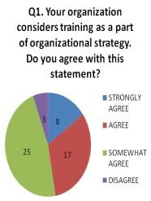

Figure 5.1: Responses in surveys

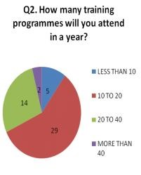

Figure 5.2: Responses in surveys

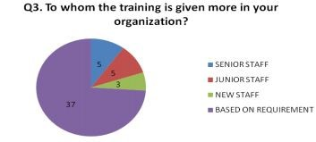

Figure 5.3: Responses in surveys

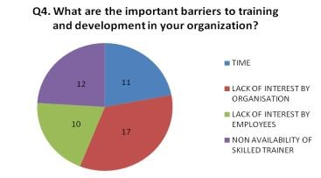

Figure 5.4: Responses in surveys

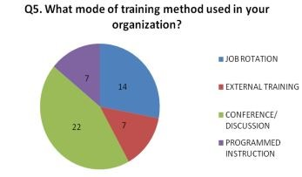

Figure 5.5: Responses in surveys

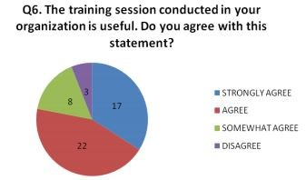

Figure 5.6: Responses in surveys

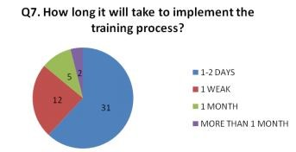

Figure 5.7: Responses in surveys

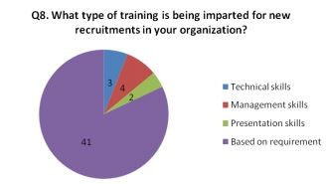

Figure 5.8: Responses in surveys

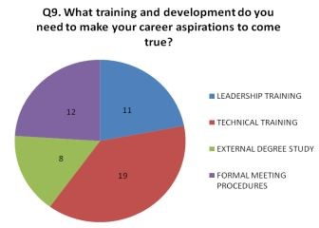

Figure 5.9: Responses in surveys

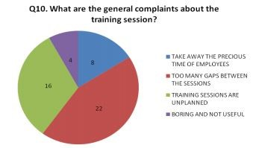

Figure 5.10: Responses in surveys

Some recommendations based on these studies are:

* Studies suggest that the organization should pay much attention to the training of employees based on specific departments to enrich their skills and to achieve organizational goals.
* Studies also suggest that the organization should also emphasize on out bond trainings for healthy working environment.
* Company should practice modern HR techniques during the recruitment process for selecting desired resource for the job.
* Company should give appraisals and motivate employees for achieving individual targets.

# SWOT Analysis

SWOT Analysis is a well-established technique for the audit and analysis of the overall strategic position of a business and its environment. Its key purpose is to identify the strategies that will create a specific business model that will best align an organisation’s resources and capabilities for the achievement of its objectives in the environment in which it operates.SWOT is an acronym for Strengths, Weaknesses, Opportunities and Threats. By definition, Strengths (S) and Weaknesses (W) are considered to be internal factors over which there is some measure of control. Opportunities (O) and Threats (T) are considered to be external factors over which there can be essentially no control.

The framework of SWOT Analysis is credited to Albert Humphrey, who tested the approach in the 1960s and 1970s at the Stanford Research Institute. Developed for business and based on data from Fortune 500 companies, the SWOT analysis has been adopted by organisations of all types as an aid to making decisions.

## 6.1 Strengths of Reliance Jio

Strengths are defined as what each business does best in its gamut of operations which can give it an upper hand over its competitors. They are internal attributes and resources that support a successful outcome and can be used for competitive advantage. The following are the strengths of Reliance Jio:

* **Strongest Customer Acquisition strategy** – Reliance Jio probably has the best customer acquisition strategy till date. The brand offered their services

for free for 3-6 months to all their users. This resulted in millions of users using Reliance Jio and resulted in one of the best customer acquisition strategy in the history of telecom.

* **Strong backing by parent company**-Jio is a subsidiary of Reliance Industries Limited which is high on its finance and can act as a backup for innovative future ventures. Reliance is a popular brand with a pan-Indian presence and has high trust amongst customers.
* **Innovative technology**-Jio currently uses the latest 4G LTE technology which is one of the world’s best technologies for the future. This is supported by Voice over LTE which makes it scalable and supportive of 5G and 6 G technologies which are expected to be the future in wireless communication.
* **Strong customer base**-Jio boasts of a whopping 100 million subscribers in the first 170 days of its launch a record which no other provider has been able to register. This has also made Reliance Jio India’s largest Internet Service Provider.
* **Market share**-First mover advantage in making data cost more affordable. Forced other operators to slash charges by winning a huge market share.
* **Brand management and advertising strategies**-The reason for the huge customer base of Reliance Jio is the brand management strategies that it has adopted. Most of the advertising campaigns are lively and are targeted at millennials which proved a winning strategy. The right promotion backed by lucrative offers and credible brand ambassadors like Shah Rukh Khan and Amitabh Bachchan have helped in building connectivity with the customers.
* **Fast and wide network**-Reliance Jio has a presence in all 22 telecom circles in India and is known to be a robust and fast network with fewer connectivity

issues.

* **Multiple offerings under a single name**-Reliance Jio offers a variety of services like movies, games, shopping, chats, and messenger etc. giving the customer a lot of options to choose from.
* **LYF Smartphones**-Affordable smartphones will make the brand more popular among the masses, even in rural areas and pave way for future growth. It would also boost the brand Reliance Jio.

## 6.2 Weaknesses of Reliance Jio

Weaknesses are internal attributes and resources that work against a successful outcome. It is used to refer to areas where the business or the organisation needs improvement.

* **Late entry into the market**-Reliance Jio has made a late foray into the market which already had established players like Airtel and Vodafone who had occupied a place in the minds of the customer. It would be challenging to increase market share significantly since the competitors are strong MNC’s where cash wouldn’t be a barrier to keep Jio at check
* **Activation Issues**-Reliance Jio faced numerous gestation issues owing to not being able to contain the huge volumes of customers it had acquired. On such was delays in SIM Card activation during the period that followed its launch.
* **High dependency on data**- Reliance Jio is highly dependent on data charges since call charges are free.
* **Pricing Controversies** - Reliance Jio was criticised for having lowered its prices beyond what was ethical to penetrate into the market and this stirred allegations like corruption and money laundering against them.
* **Too many freebies**-Reliance Jio currently offers many services for free and this was one reason for share increase in sales. However, the company may not be able to afford all of them in the long run which may affect the business

negatively.

* **Poor data connection**-The data connection is many times poor from Reliance Jio and the range is less, causing slower loading speeds in selected re-

gions.

* **The ad campaign of Reliance Jio showing the PM was controversial**Jio used the photograph of the Prime Minister in their full page advertisements contravening the ‘prior permission’ stipulated under the Emblems and Names (Prevention of Improper Use) Act of 1950, which bars use of Prime Minister’s name and picture for commercial use. They have apologised for their “inadvertent mistake”
* **Issues in calls**- There were several issues with calls from and to jio sims and lyf smartphones. This had influenced customers to consider other service providers as more reliable.
* **Will not support 3G**- 3G was in common use during the launch of Reliance Jio. It did not support 3G.

## 6.3 Opportunities of Reliance Jio

Opportunities are classified as external elements that the entity can capitalise on or use to its advantage to achieve its goals. These arise when an organisation can take benefit of conditions in its environment to plan and execute strategies that enable it to become more profitable.

* **Future driven technology** -Reliance Jio uses VoLTE 4G network which is scalable to accommodate 5G and 6G technologies.This offers numerous avenues to Jio or future expansion of bandwidth.
* **Apps**- Reliance Jio has VoLTE which has a lot of scope in terms of bandwidth.Thus they can offer apps to customers which are chargeable or even free initially and pay per use later.
* **Competitive Pricing Strategies**-Reliance Jio prides itself on being a lowcost Internet service provider and mobile operator. This can be used as a positioning to target more markets and grow their market share since most of their competitors’ cannot afford their prices.
* **Expansion to other countries**- Currently Reliance Jio is operational only in India. There is, however, a lot of scope for expansion to foreign countries at least in the neighbouring regions.
* **Data for billion people**-The core opportunity is data and speed of data. Millennials are hugely involved in various platforms. The government push for digitisation is making data a necessity rather than privilege.
* **Smartphones**- Smartphones are becoming hugely popular. Affordable smartphones are a huge opportunity for boosting the brand.
* **Focus on customer service and MNP**-More focus on customer-based services and Mobile Number Portability can increase th inflow of new customers and persuade customers to prefer Jio over other operators.
* **Partnerships and collaborations**-Partnering with digital entrepreneurs accelerate their growth but also give them opportunity to form strategic part-

nerships.

* **Focus on 3G customers also**-Now, Jio benefits 4G users only, so they have opportunity to concentrate on 3G users also to increase the number of customers.
* **Television**-Opportunities in related segments like television can be thought

of.

## 6.4 Threats of Reliance Jio

Threats arise when conditions in external environment jeopardise the reliability and profitability of the organisation’s business. These external factors could gravely affect the success of the business venture.

* **Risk of loss of customers**-Customers prefer Jio primarily because of the low prices that they offer. At a stage when the company increases its price there may be a loss of customers. Customer loyalty is a challenge.
* **Removal of free services**-Jio currently is associated with a lot of freebies.

Once these are removed there may be a drop in sales for the company.

*S*

* **Loyal customer base of existing players**- The existing competitors have a strong presence in the market. A late entrant like Jio will have a challenge in convincing loyal customers of other operators since people prefer more stable and reliable operators.
* **Criticism and negative image** -Reliance Jio has been embroiled in a lot of controversies from the time it was started. These have resulted in a negative brand image for the company.
* **Poor Code of ethics** -Many of the strategies adopted by Reliance Jio such as the low pricing, free bandwidth and market penetration strategies have been showcased as unethical and this may affect the goodwill of the business in the long run.
* **Technology**-Technology is always a threat for any technology-driven business field. Technology upgradations are fast and capital intensive. Telecom sector is witnessing 5G and 6G upgradations. Pricing advantage is not a long-lasting

strategy.

* **Government policies**-Predatory pricing is when an operator with over 30 percent market share in any circle drops prices in order to gain an upper hand over other operators in that circle. TRAI regulations says being found guilty of predatory pricing could lead to a penalty of up to Rs 50 lakh per circle. This prevents Jio from further slashing prices.
* **Mergers and collaborations of competitors**-The biggest telecom merger between Vodafone India and Idea Cellular happened after the launch of Jio. Airtel and Vodafone-Idea are likely to team up in the optical fibre space. There are also reports suggesting that Airtel & Vodafone-Idea may join forces, create a new company to fight Reliance Jio.

# PEST Analysis

PEST analysis (political, economic, socio-cultural and technological) describes a framework of macro-environmental factors used in the environmental scanning component of strategic management. It is a strategic tool for understanding market growth or decline, business position, potential and direction for operations. It’s a way of understanding how external forces impact your business. PEST can help you identify significant changes in the political, economic, social, and technological landscape. And these landscapes will affect your business in the future. It was created by Harvard professor Francis Aguilar in 1967. It should be included in every business plan, in addition to a SWOT analysis, as it is part of risk management and strategy design.

Firms should track their political environment. Change in the political factors can affect business strategy. Government legislations, tax regulations come under these political factors. Political stability and economic policy of the government are important factors in any business. Economic factors are connected with goods, services, and money. Despite directly affecting businesses, these variables refer to financial state of the economy on a greater level — whether that be local or global. The reason for this is that the state of the economy can decide many of the important details that come up in an operating company, including topics such as consumer demand, taxes and asset value. Socio-cultural factors of the country which it operates should be taken into consideration for any business. Technology is a very important factor. For a technology-driven business field, it is the most important.

Existing technology and possible upgradations should be closely watched.

**7.1 Political factors affecting**

## Reliance Jio

TRAI frames the rules and regulations for telecom industries. The rapid growth of Jio made the competitor to disturb the schemes and offers of Jio. The competitors appeal their rights in TRAI. The TRAI came under sharp criticism from the rest of the telecom industry for allowing RIL to test the connectivity of its network for 253 days. The regulator also raised eyebrows for eliminating data share from its definition of what constitutes ’significant market power’ not long after Jio became India’s largest data provider. Predatory pricing is when an operator with over 30 percent market share in any circle drops prices in order to gain an upper hand over other operators in that circle. TRAI regulations says being found guilty of predatory pricing could lead to a penalty of up to Rs 50 lakh per circle. This prevents Jio from further slashing prices. Jio has always tried to link the growth of Jio with the government’s Digital India initiative. Favouritism from the part of government had always been in the news. TRAI has also imposed fines on Jio for slipping on various service quality benchmarks

**7.2 Economic factors affecting**

## Reliance Jio

In the current economic situation it is a very difficult task to run the business in the telecom industry as already there is a large number of network operators but Jio is providing free services with minimum charges to its service like call rate, minimum price of their products. The people more economical in a developing country like India, where the pricing is focused. The strategy has cashed in on that. Affordable smartphones has become popular in rural areas.

**7.3 Social factors affecting**

## Reliance Jio

India has the largest population of youth in the country. Jio mainly focuses on millennials who are active on various networking platforms and have made them addicted to data. Their pricing schemes and advertising strategies mainly attract the Indian middle classes and youth. There have been an overwheming response from young people. People are in general inclined cheaper and affordable options. The growth in subscriptions and data consumption are all proof of Jio’s transformative social power. By offering service at almost no cost, and at first for free, the company argues that Jio will ’democratise the digital culture in India’.

**7.4 Technological factors affecting**

## Reliance Jio

The advanced 4G technology has been adopted by Jio at a cheaper rate. They are the leader in the 4G market. This is supported by Voice over LTE which makes it scalable and supportive of 5G and 6 G technologies which are expected to be the future in wireless communication. Technology upgradations are fast and capital intensive. Telecom sector is witnessing 5G and 6G upgradations.

# Promotional Strategy

Jio had appointed 50 customer acquisition and relationship managers who are hiring teams to target to sign up 1 million users each in the first two months. Mukesh Ambani thought ”globally consumers pay for either calls and texts, or data- they do not pay for both” Based on this promotional strategies adopted by Jio are given below:

• With every Reliance Jio sim, regardless of the package, the following are ab-

solutely free:

1. Unlimited free voice calling to any other network, any other number (local and

STD)

1. No roaming charges, same price is applicable all over India
2. Jio applications will provide Internet surfing, music, movies, programs free of

cost.

* Jio targets customers ranging from high end to mid and low range segments by offering all services at reasonable prices
* LYF smartphones are priced between Rs. 4000 to Rs.19000 which provides maximum off take, therefore helping JIO derive high returns
* If you buy a monthly plan worth Rs. 500 or more, you will get the following

additional benefits:

1. Unlimited SMS (STD and local)
2. High speed 4G internet- unlimited at night
3. If you have a student registered SIM ID, you will receive 25% extra data usage

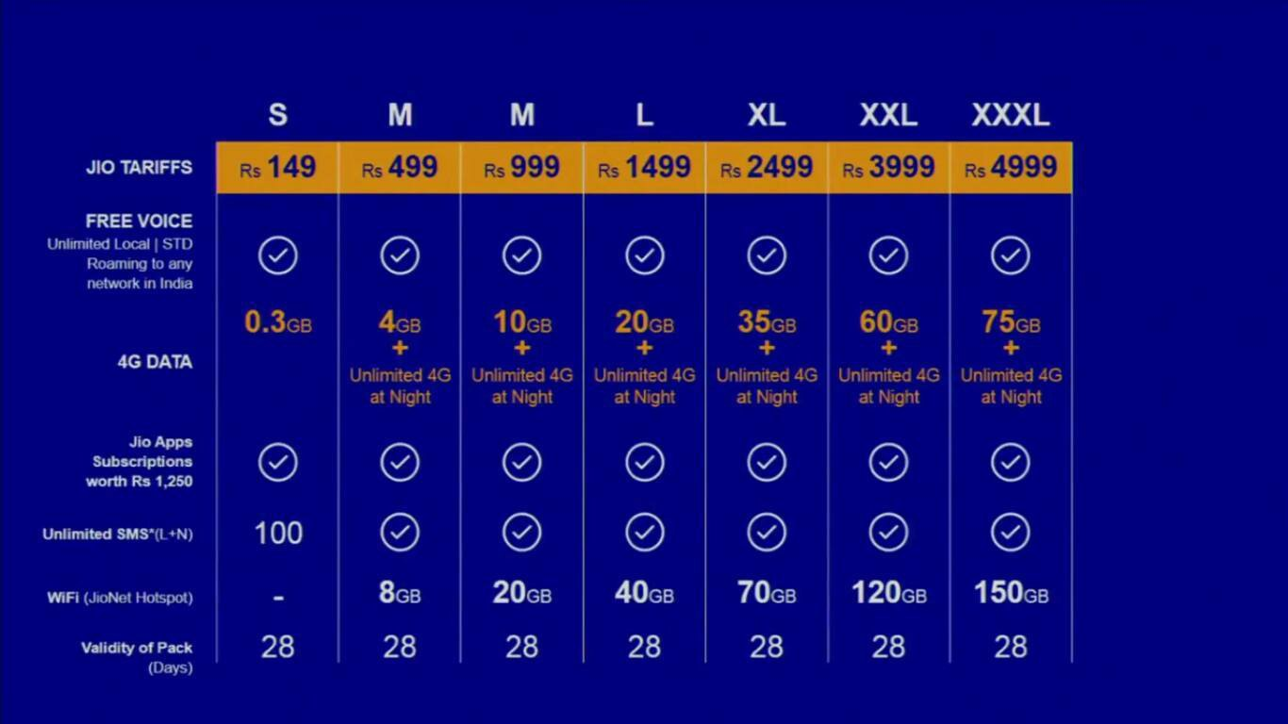

Figure 8.1: Rates of Reliance Jio data packs

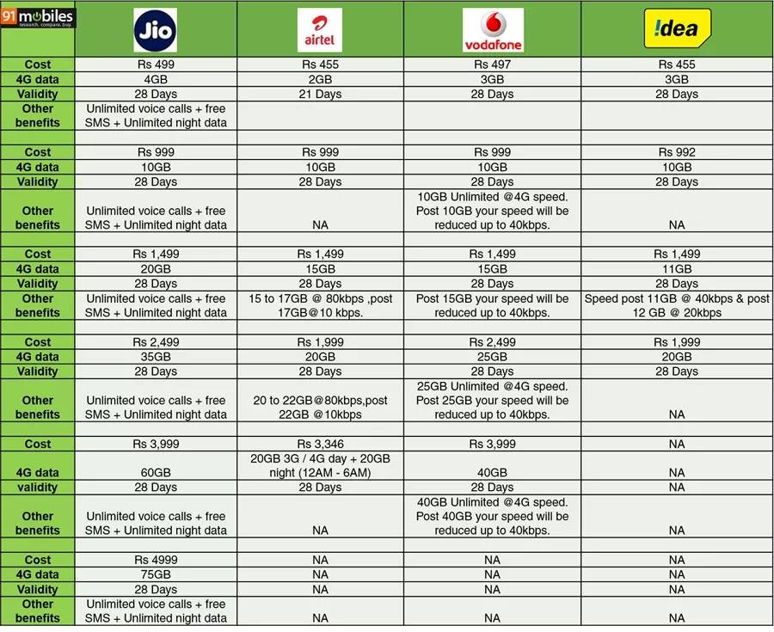

Figure 8.2: Comparison of Jio services with other competitors

# Impact of Jio Launch

Over a very short span of time, Reliance Jio became a phenomenon in India. Reliance’s shares, having languished for several years, took off in early 2017 after it said Jio would emerge from its trial period and begin charging for service. The shares have almost doubled since then (Fig. 9.1) [6].

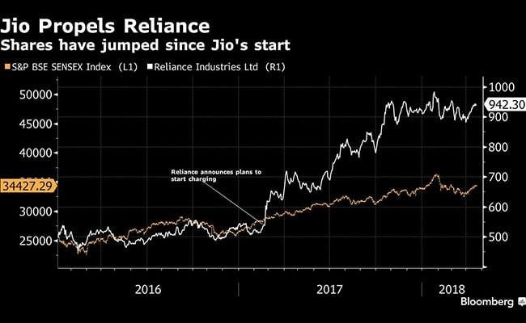

Figure 9.1: Reliance’s shares have have almost doubled since early 2017.

A price war arose between telecommunication operators and people were able to access services at very cheap rates. The impacts of the Jio launch are described below.

## 9.1 Impact on Citizens

1. People suddenly had access to unlimited free voice call, 4G data, messagingand related services. Jio spread out like a phenomenon in the nation, acquiring about 1000 customers per minute. Within 83 days of its launch, it crossed the 50-million subscriber milestone, which had taken Airtel 12 years, and Vodafone and Idea 13 years .
2. 77% of the population of upper triangle of the country use Jio services of which 83% belongs to youth (20-40 age groups).
3. Data consumption has increased drastically after Jio and people are moreaware about services like entertainment, education, shopping, payment and booking, etc.
4. From a nationwide survey, the result showed that 86.3% people consumedmobile data up to 10 GB only, before Jio came into the Indian market whereas the contribution of people with more than 10+ GB data consumption was only 13.7%. After Jio entrance, the mobile data consumption of more than 10 GB, increased drastically by 383% with market share increased from 13.7% to 65.9% clearly showing the effect of Jio towards the usage of the internet services [9].
5. India is now the top country in data consumption compared to 155th before Jio launch.
6. Many government processes are now completely digitazed, leading to decreasedexpenditure and time spent.
7. There has been accusations of data breach due to increased AADHAR usage.
8. Aggressive ad campaign of reliance Jio may also affect the industry’s scenario.It will difficult for otherplayer to grow their consumer base and it will lead to high promotional expenses.

**9.2 Impact on the Economy**

## and Telecom Industry

1. Market shares of other major players in the industry, such as Airtel, Vodafoneand Idea fell abruptly. They were forced to re-think and reduce their tariffs. Cost of data cut down to less than Rs. 15/GB from at least Rs. 250/GB.
2. Bharti Airtel, Vodafone and Idea Cellular petitioned a plea to TRAI regardingthe tariff rates set by Jio. TRAI dismissed the motion.
3. The state-run telecom operator, Bharat Sanchar Nigam Limited (BSNL) alsocut down their rates in an unprecedented move. They also started to use their underutilised 7 lakh kilometres of fibre network and reduced internet usage charges .

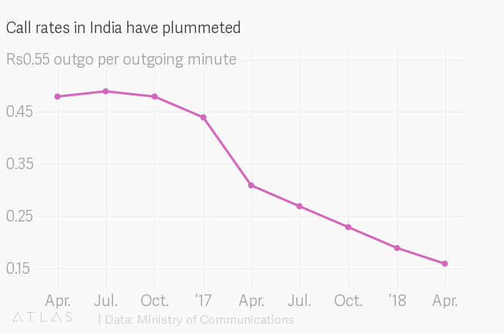

Figure 9.2: Dropping call rates

1. As the rivals were forced to lower their prices, the industry-wide monthlyaverage revenue per user (ARPU) fell by roughly a third. This had a negative effect on the revenue of the sector. In March 2017, TRAI reported that the turnover from the telecom industry (including the fixed segment) had fallen by INR 100 billion between June 2016 and March 2017

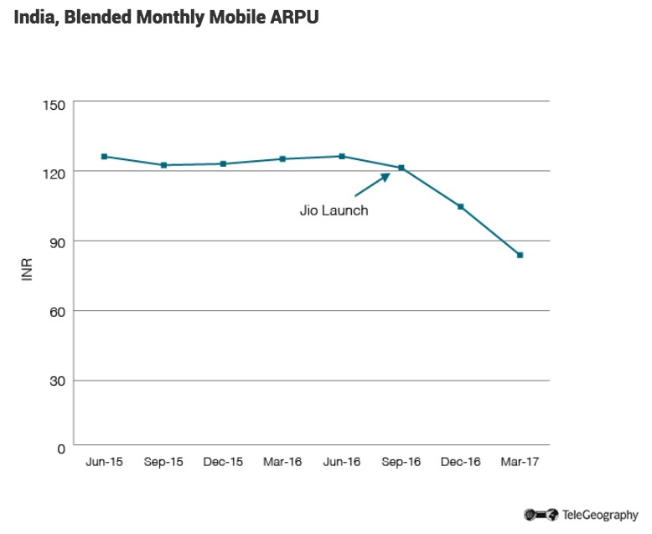

Figure 9.3: Blended monthly mobile ARPU

1. Jio’s explosive growth did not have a negligible impact on the overall take-uprates of existing companies, although new subscriptions for 3G and 4G services slowed down somewhat. Large operators continued to expand their bases with roughly the same pace, while the smaller providers saw a slight downturn. The trend suggests that many of Jio’s subscribers had signed up to their services alongside plans with other providers to capitalize on the free services while they were available.
2. To keep up with the competition, mergers and consolidations took place amongplayers. The major shareholders reduced from about twelve into three large private players — Reliance Jio, Bharti Airtel and Vodafone Idea — accounting for more than 90% of revenue and 80% of spectrum holding [8].
3. Apart from declining financial health of incumbents, there have been massivejob losses owing to mergers and sector consolidation. Experts estimate the number of job losses to be around 12,000-15,000 in the last two years, with a major shedding from Vodafone and Idea Cellular duo.
4. There has been declining average revenue per user (ARPU) and margins withhigh debt levels. Together, the telecom industry has a cumulative debt of Rs 3.6 lakh crore.
5. The monthly data usage per smartphone (GB/month) in India is expected togo up to 13.7 GB by 2023 from 5.7 GB in 2017. The total mobile data traffic per month in India expected to grow five times from 1.9 EB to 10 EB by 2023, according to data from Ericsson. The adoption of 4G has been made possible only after the arrival of Reliance Jio [9].
6. Almost all smartphones now shipped are 4G - VoLTE enabled.
7. There has been a increase in investment and revenue for video-streaming websites such as Hotstar and Netflix.

# Government policies

## 10.1 Digital India

Digital India is an amalgamation of various projects, aimed at increasing connectivity in the country. Promoted by government officials as an attempt to bridge the divide between “digital haves and have-nots,” the initiative has been pitched as an ambitious modernising measure. According to the Digital India website, its various projects are all unified by a three-part vision: making online infrastructure available to every Indian, providing government services on demand and the “digital empowerment of citizens.”

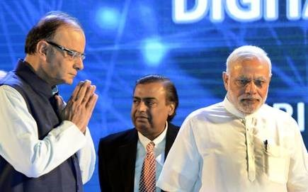

Figure 10.1: Mukesh Ambani at the launch of Digital India Week

During the launch of the government’s Digital India initiative, Ambani promised to partner with the government and invest over Rs 250,000 crore, or $39.29 billion, in its projects. He pledged to lay out a next-generation wireless network across all Indian states, create a nationwide cellular distribution network involving 150,000 retailers, encourage phone manufacturers to set up shop in the country, and help small start-ups. When Jio formally launched over a year later, Indians woke up to front-page advertisements for the company in the Times of India and the Hindustan Times that featured a large image of Narendra Modi below the Jio logo. “Jio is dedicated to realising our Prime Minister’s Digital India vision for 1.2 billion Indians,” it read. In almost every public statement about the company, Ambani has continued to reference Digital India, claim credit for the country’s growing internet usage and promise even bigger gains.

## 10.2 TRAI Regulations

Telecom Regulatory Authority of India (TRAI) regulates the telecommunication sector in India. A series of suspiciously timed changes in regulations by the TRAI have allowed the company Jio to sail towards the top. It has undermined the health of its competitors by offering prices that many analysts argue are predatory, despite laws meant to monitor and restrict anti-competitive activities.

They started by acquiring a small, obscure firm that had won an auction for national wireless spectrum.According to the spectrum licence, the firm was only permitted to provide internet service. But three years later, the government allowed that firm, by then renamed Jio, to upgrade to a “full mobility” licence and offer every kind of cellular service for a fraction of what its full-mobility licences should have cost.

The TRAI came under sharp criticism from the rest of the telecom industry for allowing RIL to “test” the connectivity of its network for 253 days. The regulator also raised eyebrows for eliminating data share from its definition of what constitutes

“significant market power” not long after Jio became India’s largest data provider. This allowed Jio to sidestep competition laws and stricter regulatory scrutiny. Only companies that have significant market power, the TRAI wrote, could be viewed as engaging in monopolistic behaviour.

Infotel, by contrast, participated only in the country’s broadband wireless auction, which offered spectrum designed for internet service. The company was not even licensed to provide cellular service.In April 2012, the TRAI recommended letting companies with internet-only licences upgrade to unified-access licences. In February

2013, the department of telecommunications began allowing companies to do so. RIL was the first provider to take advantage of the department’s decision. It was also, for Reliance, a money saver. The entry fee for the internet-only auction was substantially lower than the fee for the unified-services auction, and the government charged Jio a comparatively modest amount to upgrade.The national exchequer lost over Rs 20,000 crore, or approximately $4 billion, in the process.

Until October 2017, a telecom company had to pay a competitor 14 paise for every minute that their customers called someone who subscribed to the competitor’s network. But Jio protested that these payments unfairly advantaged its opponents, all of whom had a larger customer base and a more developed network and, as a result, carried more incoming telephone traffic than Jio did. Incumbent operators, including Airtel and Vodafone, countered that the fees were necessary and fair, given the costs incurred to maintain their infrastructure. The TRAI sided with Jio.

**Controversies Surrounding**

# Reliance Jio

## 11.1 Issue with incumbents

In September 2016, the Telecom Regulatory Authority of India (TRAI) summoned Jio and the country’s existing telecom operators like Airtel, Vodafone, and Idea Cellular to meet and discuss an issue regarding interconnection between the operators. This was a result after Jio complained to TRAI and Department of Telecom (DoT) about other operators not honoring their commercial agreements to let Jio use their network resources. The company further added that the operators are trying to sabotage its entry into the telecom scene. However, DoT dismissed the request and directed TRAI to help settle the dispute amicably. Moreover, the Cellular Operators Association of India (COAI) requested TRAI to include all the operators in the discussion instead of the three.

The incumbent operators had previously approached the country’s PMO to reiterate their stance they ”are in no way obliged or in any position to entertain Jio’s requests for interconnection points as they do not have either the network or the financial resources to terminate the latter’s humongous volumes of potentially asymmetric voice traffic.” Responding to this, Mukesh Ambani, owner of Jio, said, ”All operators have publicly said last week that they will provide this (interconnect and MNP). So, we are waiting. These are all great companies. They have their own reputations to protect. I am confident they won’t violate the law.” Commenting about number portability, he added, ”The number belongs to the consumer. No operator can cause trouble if they want to change operators.” However, on 12 September.

In 2016, Idea Cellular agreed to allow Jio to use 196 of its interconnection access points.

## 11.2 Alleged subscriber data breach

On July 10, 2017, Reliance Jio’s customer data was allegedly leaked on the website magicapk.com. The website was suspended shortly after the news of the breach broke out.

## 11.3 Call Drop

Over 12 crore calls were failing between Jio and other networks due to inadequate Points of Interconnection (PoI). Each operator provided only 400-600 PoIs against the required 4000-5000. The failure was 80-90% while the allowed was only 0.5%. TRAI asked the operators to sit for a meeting together and provide the requires

## 11.4 Auction for Spectrum

Another serious allegation levelled against Reliance is the improper means that were used to win the auction of the use of spectrum. This detailed investigation by Paranjoy Guha Thakurta, published in the EPW finds that a forged bank guarantee document was used by the winning company, Infotel Broadband Services Private Limited (IBSPL) in 2010, and was soon after acquired by Reliance.

However, when the Center for Public Interest Litigation filed a case asking questioning the manner in which Jio obtained the license; the Supreme Court did not take many of the irregularities into account. Moreover, the final CAG report too did not contain many of the issues included in the draft stage.

## 11.5 PM Modi on Jio Ad Campaign

A day after the Reliance Jio launch, full-page advertisements were printed on the first page of many national dailys in India, featuring Prime Minister Narendra Modi

(Fig. 11.1). “In the journey of time, there come a few life changing moments. Our honourable Prime Minister’s inspiring vision of a Digital India is one such movement. Jio is dedicated to realising our Prime Minister’s Digital India vision for 1.2 billion Indians. Jio Digital Life will give the power of data to each Indian, to fulfil every dream and collectively take India to the global digital leadership...,” read a paragraph of text just below the image of Modi in dark blue jacket, which is incidentally the same colour as Jio’s logo. Opposition leaders and many other hit out at the Prime Minister, some calling him a “stooge” of the richest man in India.

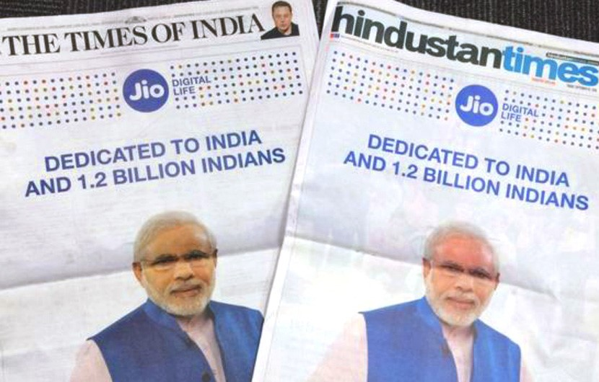

Figure 11.1: The Modi-Reliance Jio advertisement in newspapers.

Later on the day, a ninety-second clip also featuring the PM was released on television and other platforms. The final portion of the video links Reliance Jio’s aims specifically with Digital India, and talks of how the service will connect India’s 1.2 billion people with free voice calls. The ad campaign was accused to be a clever play, endorsing the product as a blessing to the nation.

A debate rose online and otherwise on the legality of using the PM on a private

product campaign. According to the National Emblems and Names (Prevention of Improper Use) 1950 - No person shall, except in such cases and under such conditions as may be prescribed by the Central Government use, or continue to use, for the purpose of any trade, business, calling or profession, or in the title of any patent, or in any trade mark or design, any name or emblem specified in the Schedule or, any colourable imitation thereof without the previous permission of the Central Government or of such officer of Government as may be authorised in this behalf by the Central Government. This law suggests that written permission is required.

In December 2016, the information and broadcasting minister, Rajyavardhan Singh

Rathore, told the parliament in a written reply that the government was aware that RIL had used Modi’s image, but that it had not granted the company permission to do so. In March 2017, RIL apologised for putting the prime minister’s face in its ads. In an editorial, the Economic and Political Weekly suggested that beyond legality, “the question to be asked is why it suits both—Reliance and Modi—to be seen as sharing a vision and what implications that has for RJIO’s future.”

## 11.6 Alleged Government Patronising

Employee unions of BSNL blamed Reliance Jio for financial woes of the telecom sector, and alleged that the government was favouring the latest entrant over other firms. The employee unions claimed that the government has not allotted spectrum for 4G services to BSNL in order to prevent it from competing against Reliance Jio. Reliance Jio has not commented on the allegations.

All Unions and Associations of BSNL (AUAB) alleged that with its huge financial muscle, Reliance Jio is offering services at ‘below-cost’ rates. It said that private telecom companies like Aircel, Tata Teleservices, Anil Ambani-owned Reliance Communications and Telenor have already closed their mobile service businesses. It alleged that Reliance Jio will steeply raise call and data tariffs once the entire competition is wiped out.

AUAB said that the public sector firm has been demanding allotment of 4G spectrum but “the government has turned a deaf ear to this demand, with the ulterior motive of preventing the public sector company from putting up an effective

competition to Reliance Jio”.

It also alleged that whosoever tried to act against Reliance Jio had to pay the price, including former telecom secretary J S Deepak. “JS Deepak wrote to the Trai demanding action on Reliance Jio, for adopting predatory pricing. As a result, JS Deepak was instantaneously shunted out of the DoT... This was a clear signal given by the Narendra Modi government, as to what would happen to any one who dares to speak against Reliance Jio,” the unions alleged. [15]

Vodafone Group CEO Nick Read pointed out that the outcomes of the telecom regulator’s decisions over the past two years have hurt all carriers, except Reliance Jio Infocomm, adding to the acrimony between the country’s older carriers on one side, and the regulator and the Mukesh Ambani-owned Jio on the other. He sought a level field of play in India. TRAI and the new entrant though have rejected all such allegations.

Some of the controversial decisions and regulations include a 57% cut in interconnect usage charge (IUC) to 6 paise a minute that had hurt revenue of older incumbents, while lowering costs for Jio. Then, the regulator’s recommendation to slap penalties of Rs 3,050 crore on Bharti Airtel, Vodafone India and Idea Cellular for allegedly denying adequate points of interconnect (PoIs) to Jio, has been challenged by Vodafone in court.

Then, a TRAI order that changed the rules to identify predatory pricing, and also mandated reporting of all segmented offers, was decried by older companies as one which would stymie their competitiveness against Jio.

**Ventures, Collaborations**

# and Future Projects

Jio is a company which has launched and continues to launch new ventures every time into the market and be in the nascence of the market and thus extract the initial boom of consumer response at the most all the time. This chapter deals the present running projects, services, collaborations and future projects to be launched.

## 12.1 JIO Apps

A mobile app or mobile application is a computer program or software application designed to run on a mobile device such as a phone/tablet or watch. Apps were originally intended for productivity assistance such as Email, calendar, and contact databases, but the public demand for apps caused rapid expansion into other areas such as mobile games, factory automation, GPS and location-based services, ordertracking, and ticket purchases, so that there are now millions of apps available. Apps are generally downloaded from application distribution platforms which are operated by the owner of the mobile operating system, such as the App Store (iOS) or Google Play Store. Some apps are free, and others have a price, with the profit being split between the application’s creator and the distribution platform.

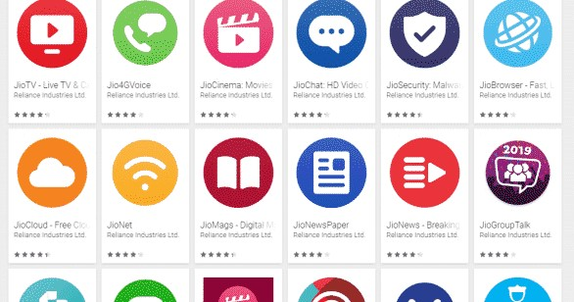

Figure 12.1: JIO apps

### 12.1.1 Apps owned by JIO

In May 2016, Jio launched a bundle of multimedia apps on Google Play as part of its upcoming 4G services. Many apps were launched late too. While the apps are available to download for everyone, a user will require a Jio SIM card to use them.

Additionally, most of the apps are in the beta phase. Notable apps include:

1. **JioChat** - instant messaging app.
2. **JioXpressNews** - e-news app.
3. **JioNewsPaper** - News paper app.
4. **JioNet** - App connecting to Jio wifi.
5. **JioHealth Hub** - Free accssto tests, doctors and reports.
6. **JioTv (Formerly Known as JioPlay)** - Jio users can watch 642 Tv channels free with JioTv.
7. **JioCinema** - Online HD video library.

*OTHER CALLER DEVICES*

1. **JioMoney** - Online payments/wallet app.
2. **JioSaavn (earlier, JioMusic)** - For online and offline music streaming in English and Indian languages.
3. **JioSecurity** - Security app.
4. **Jio4GVoice (earlier, JioJoin)** - VoLTE phone simulator
5. **MyJio** - Manage Jio account and digital services associated with it.

**12.2 Smart phones and**

## other caller devices

Jio has released some phones extensively with lots of offers aiming average common man and has grabbed market .

### 12.2.1 LYF smartphones

In June 2015, Jio entered into an agreement with domestic handset maker Intex to supply 4G handsets capable of voice over LTE (VoLTE). However, in October 2015, Jio announced that it would be launching its own mobile handset brand named LYF.

On 25 January 2016, the company launched its LYF smartphone series starting with Water 1, through its chain of electronic retail outlets, Reliance Retail. Three more handset models have been released so far, namely Water 7, Earth 1, F1 Plus, F1S and Flame 1.

### 12.2.2 Jiophone

On 21 July 2017, Jio introduced its first affordable 4G feature phone, powered by KaiOS, named as JioPhone. The price announced for it is Rs. 0 with a security deposit of Rs. 1500 which can be withdrawn back by the user by returning the JioPhone at Jio stores only after three years. This phone was released for beta users on 15 August 2017 and pre-booking for regular users started on 24 August 2017.

**JioPhone 2:** A second model with a QWERTY keyboard, as well as Facebook,

WhatsApp and YouTube applications, was released in July 2018 for Rs:2,999.

## 12.3 Other services

Various services are also put up by Jio. Following are them.

### 12.3.1 4G Broadband services

The company launched its 4G broadband services throughout India in September 2016. It was slated to release in December 2015 after some reports said that the company was waiting to receive final permits from the government. Jio offers fourthgeneration (4G) data and voice services, along with peripheral services like instant messaging and streaming movies and music.

The company has a network of more than 250,000 km of fiber optic cables in the country, over which it will be partnering with local cable operators to get broader connectivity for its broadband services. With its multi-service operator (MSO) licence, Jio will also serve as a TV channel distributor and will offer television-ondemand on its network.

### 12.3.2 Jionet

Prior to its pan-India launch of 4G data and telephony services, Jio has started providing free Wi-Fi hotspot services in cities throughout India including Surat, Ahmedabad in Gujarat, and Visakhapatnam in Andhra Pradesh, Indore, Jabalpur, Dewas and Ujjain in Madhya Pradesh, select locations of Mumbai in Maharashtra, Kolkata in West Bengal, Lucknow in Uttar Pradesh, Bhubaneswar in Odisha,

Mussoorie in Uttarakhand, Collectorate’s Office in Meerut, and at MG Road in Vijayawada among others.

In March 2016, Jio started providing free Wi-Fi internet to spectators at six cricket stadiums hosting the 2016 ICC World Twenty20 matches. Jionet was made available in Wankhede Stadium (Mumbai), Punjab Cricket Association IS Bindra Stadium (Mohali), Himachal Pradesh Cricket Association Stadium (Dharamshala), Chinnaswamy Stadium (Bengaluru), Feroz Shah Kotla (Delhi), and Eden Gardens

(Kolkata) in India.

### 12.3.3 Jio Giga Fiber

Jio launched Jio Giga Fibre on 15 August 2018 which offers high speed broadband, landline and DTH services at reasonable prices.

**12.3.4 Jiofi**

Jio has also launched Wi-Fi routers by the name JioFi.

## 12.4 Other Collaborations

### 12.4.1 Star India

Reliance Jio and Star India have signed a 5-year partnership in 2018 to broadcast all televised cricket matches (T20, one-day international and test matches and BCCI’s domestic competitions) on JioTV and Hotstar. The service will be free to Jio prime users, but customers of Hotstar will have to purchase a premier membership, which costs Rs 199 per month or Rs 999 per year to watch this content.

This deal will finally enable Jio to telecast cricket content on its platform after it failed to secure the TV broadcast and digital rights for all international and domestic cricket played in India. At that auction held in April, Star India outbid Jio and Sony to secure these media rights for a whopping Rs 6,138.1 crore for five years.

### 12.4.2 Google

Reliance Jio has partnered with Google to manufacture affordable 4G handsets. These phones will run exclusively on Jio network. The two companies are also working on developing software for smart-TV services.

### 12.4.3 Cisco

Jio has embraced mass-scale automation during the build phase of the network using a robust, scalable, microservices-based purpose-built platform by Cisco for network rollout. By further building a complete automation stack for full lifecycle management using various best-in-class tools and integrating the same with the

build platform as well as OSS/BSS, Jio and Cisco have together achieved the desired outcomes. The framework also became a proof point of how mass-scale automation can help service providers stay competitive, while profitably adding new services and subscribers, thus leading the curve in a rapidly changing technology landscape.

### 12.4.4 Alliance

In February 2016 Jio announced a global alliance of Mobile Network Operators which include:

1. BT Group
2. Deutsche Telekom
3. Millicom
4. Orange S.A.
5. Rogers Communications
6. MTS
7. Telia Company
8. Telecom Italia

## 12.5 Future Projects

Following are the speculated future projects expected from Jio.

### 12.5.1 Jio DTH

Up next the company is expected to launch the Jio DTH services with Jio GigaFiber. Reliance Jio is offering a special Jio GigaTV box with its broadband service, which is expected to its next unannounced service. The company will roll out its DTH services once the GigaFiber is fully connected across all the homes. The company aims to power up more than 50 million users in its first leg.

### 12.5.2 Jio GigaTV

Reliance Jio will offer its Jio GigaTV with the Jio Suite when the broadband services are offered. The platform will use the bandwidth from its fibre network to offer TV channels which offer 4K support, video calling and added other services. The GigaTV set-top box will support voice commands with access to 600 TV channels, free collection of movies and millions of songs.

### 12.5.3 Jio 5G Network

Reliance Jio is already building a 5G ready network for the future, which may start as early as 2019. 5G is still years away to be available at a mass scale, but Reliance Jio has been working on the next-generation network for its consumers. A few reports suggest that the company may launch 5G services as soon as six months once the 5G spectrum is auctioned out to offer 5G-ready LTE networks.

### 12.5.4 Jio Phone 3

The successor to the Jio Phone 2 is expected at the Reliance Jio AGM in July. The third generation Jio Phone 3 may see a major jump in terms of hardware and software over the existing Jio Phone models. Reliance Jio have sold more than 40 million original Jio Phone units till June 2018 and holds more than 11 percent of the total worldwide feature phone shipments in the last quarter.

### 12.5.5 More Content With Jio (Disney Marvel Tie Up)

Reliance Jio has tied up with a number of content companies to boost its content offerings. Reliance Jio is already a partner Star India for cricket, Zee for TV channels and AltBalaji and Eros for the web series and online entertainment content. With Jio GigaFiber on the way, we hope to see more content on Jio’s radar. The company also tied up with online music streaming major Saavn to launch of JioSaavn .

Jio users will soon get free access to Disney Classics and Pixar animation. You can also watch free movies from Marvel and Star Wars with a host of international films as well as locally created content with Jio in 2019.

### 12.5.6 Jio Enterprise Services

Reliance Jio up next will enter the enterprise server market. The pilot launch has already happened, and the company will officially launch it by next year. Reliance Jio will offer enterprise services for small and medium-sized businesses. Among the top upcoming Reliance Jio services in 2019, the enterprise services will include unified communications, cloud services, managed video conferencing, cyber security and more.

### 12.5.7 Jio Smart Home

Reliance Jio will soon launch its much-touted Jio Smart Home with Jio GigaFiber and GigaTV services . The company will bring a complete connected home platform to offer services connecting smart speakers, Wi-Fi extenders, smart plugs, door sensors, TV cameras, audio/ video dongles, smart locks and various connected cameras. Jio Smart Home platform will allow you to connect all your smart devices and control nearly every appliance at your home from an application.

### 12.5.8 Jio VoWi-Fi service

Reliance Jio will launch its voice over Wi-Fi (VoWi-Fi) service in 2019. The trails are on and will start with Andhra Pradesh, Kerala, Madhya Pradesh, and Telangana. Among the top upcoming Reliance Jio services in 2019, the Reliance Jio VoWi-Fi is in the first list. It will offer Wi-Fi calling to help users stay connected even without any cellular signal. BSNL already offers VoWi-Fi in select circles.

# Conclusion

Reliance Jio Infocomm Limited, known as Jio, is an Indian mobile network operator. Owned by Reliance Industries and headquartered in Mumbai, Maharashtra, it operates a national LTE network with coverage across all 22 telecom circles. Jiodoes not offer 2G or 3G service, and instead uses voice over LTE to provide voiceservice on its network. The launch of Reliance Jio has caused a revolution in thetelecom industry. Now, Jio claims to be the world’s largest data network, based onmobile data consumption.

In this project, a complete analysis of the upcoming of Jio and its sudden success story was looked into. The organizational structure, planning and marketing strategy, staffing and recruitment, SWOT analysis, PEST analysis, promotional strategy, the impact of coming of Jio, Government policies, controversies surrounding Reliance JIO, its ventures and collaborations and future projects were discussed in detail. In this process efforts were made to bring in data and informations from various researches and studies conducted in these fields. The management principles adopted by the company were also analysed and studied in this project.

# Bibliography

1. Kanika Maheshwari- *”Training and Development- Study on Reliance Jio”*, www. sgsrjournals.co.in
2. *”SWOT Analysis”*, www.managementstudyguide.com
3. *Reliance Jio SWOT Analysis, Competitors & USP*, www.mbaskool.com
4. DWAPP, 14 April 2018, *”Jio Swot Analysis: Detailed report for professionals and students”*, https:// digitalwale.com/jio-swot-analysis/
5. Yash Vardhan Lodhia, 10 Jan 2017, *”Reliance Jio Infocomm Ltd.”*, https: // www.slideshare.net
6. Greg Farrell, Matt Robinson and Bhuma Shrivastava, 23 April 2018, *”Is Jio Really Profitable? Audit To Answer Doubts And Controversies”*, www.ndtv.com
7. Tanya Daga et. al., *”Effect of Reliance Jio on Digital India”*,
8. Pete Bell, 10 Aug 2017, *”The Jio Effect: How the Newcomer Made an Impact in India”*, https:// blog. telegeography. com
9. Mansi Taneja, 7 Sep 2018, *”Reliance Jio impact: 15,000 people lost jobs, just 3 companies left in 2 years”*, www.zeebiz.com
10. Jain, Upasana, 12 September 2016. ”*Idea agrees to give Reliance Jio interconnection points*”.
11. The Indian Express, 10 July 2017, ”*Reliance Jio data breached: Why it matters, what it means for you, and everything to know*”
12. Meghna Sukumar, 8 Sept 2016, ”*A look at the controversies surrounding Reliance Jio*”
13. The Wire Staff, 3 Sept 2016, *”The Reliance Jio-Modi Newspaper and TV*

*Campaign: Illegal or Improper?”.*

1. TNM Staff, 2 Sept 2016, *”PM Modi in Reliance Jio ad: Right or wrong, the debate is on”*
2. PTI, 29 Nov 2018, *”BSNL unions allege government patronising Reliance Jio”.*
3. Devina Sengupta, 26 Feb 2019, *”Trai’s decisions over past two years have hurt all barring Jio: Vodafone CEO”*
4. Navadha Pandey, 11 June 2018, *”Airtel accuses Reliance Jio of making false claims in ad, moves ASCI”*, www.livemint.com
5. Daniel Block, 1 Feb 2019, *”How government decisions are helping Reliance Jio monopolise the telecom sector”*, www. caravanmagazine.in

[View publication stats](https://www.researchgate.net/publication/332529159)