SMART WORK JACKET FOR COAL MINERS
MallammaCG¹,Deeksha Reddy M R², Manisha Rao N³, Monisha C⁴, Mididoddi Upendra⁵
¹Asst Professor, Dept. Of Cse, Sambhram Institute Of Technology, Bengaluru-560097
^{2,3,4,5} Eight Semester, Dept. Of Cse, Sambhram Institute Of Technology, Bengaluru-560097, India

ABSTRACT

The safety of human life is a crucial consideration.In order to increase life safety, numerous systems have been created. Since a coal mine is an underground tunnel, safety is a crucial component of the working environment.Since the coal mining industry began in 1882, people all over the world have relied mostly on it for their electricity. The procedure of extracting coal from underneath the surface of the ground is quite risky, and mining workers have encountered difficulties.The most common causes of worker difficulties are gas leaks discovered during coal extraction.These gasses pose a serious risk to human health, and the main issue facing the coal mining industry is methane gas explosions.The project's main goal is to install a surveillance jacket that communicates with an Android app
keyword—SAFETY,JACKET ,COAL MINING,GAS LEAKS

INTRODUCTION

In previous years, between 1984 and 1993, there were 55 fatalities and numerous injuries from underground coal mine explosions.37 people died as a result of coal mine explosions and fires between 1993 and 1999. [1] People can die from suffocation when there is an excessive concentration of methane in the air.When the temperature in an underground coal mine reaches a certain point, the coal will spontaneously burn. This is because the oxygen supply in those areas is limited, which leads to inadequate combustion and the formation of a huge amount of CO, which has a strong attraction to hemoglobin. When carbon monoxide (CO) enters the respiratory system, it can result in anoxemia, histanoxia, and the suppression of tissue respiration, which can induce asphyxia death. Both CO and mash gas have characteristics that make them explosive and harmful to human health. The Jacket detects and transmits environmental factors including temperature and the presence of hazardous and poisonous gasses as soon as it arrives at the explosive coal mine site.[3] A coal mine worker is provided with safety when they wear a jacket that has multiple sensors installed to detect distinct toxic gases. If the value of these gases exceeds a certain level,

PROBLEM STATEMENT

In the past, there have been 55 fatalities and 37 injuries from underground coal mine explosions and fires between 1984 and 1999. Suffocation in a coal mine underground can result in death when methane concentrations in the air are extremely high. A coal mine worker is provided with safety when they wear a jacket that has multiple sensors installed to detect distinct toxic gases. If the value of these gases exceeds a certain level, the system activates.

4. SYSTEM DESIGN

Cloud
Micro
controller
ATMEGA 328
LCD DISPLAY
Temperature sensor
Sort Circuit sensor
Gas sensor
Methane , CO
Humidity sensor
Wi-Fi module
Mobile app

Fig. 1. System design

5 METHADOLOGY
According to the project setup, the local site's hardware consists of an ATMEGA 8A microcontroller, a Wi-Fi module transceiver, sensors (such the LM35 for temperature detection, the CO2 gas sensor, and the MQ135 for carbon dioxide gas detection), a driver integrated circuit, an RS-232 connector PC monitor display, and an alert buzzer. [1] ADC is used to provide digital output to the microcontroller ATMEGA 328A from analog measurements of various parameters taken at the site, such as carbon monoxide, temperature. Other sensors include the MQ135 and the temperature and sort circuit sensor. This digital sensor data is transmitted over Wi-Fi to the remote monitoring site, which is 30 meters away from the local site as far as possible. As seen in figure 3, wireless can be used within mines at the router. continuous sensor monitoring from a remote monitoring location (PC). When temperature, carbon monoxide, or water level sensor data surpasses predetermined thresholds, the distant monitoring site's Wi-Fi module sends a continuous buzzer alarm to the local site. In the under Coal Mine Section, the parameters temperature, Methane gas and gas are measured by means of respective sensors and the output voltage measured by them is directly connected to the ADC of the ATMEGA 8A, as the output voltage never exceeds 5V, there is no need of connecting a signal conditioning circuit. The number of people inside the coalmine is monitored by the help of IR sensor,LM35,MQ135sensor. During a hazard this information will be useful to know whether there are any people remained inside the coalmine. Information regarding the safety measures like wearing oxygen helmets etc., will be already given to the workers so that they can save their life. If any of the received parameters are beyond the set limit, then a Buzzer will be ON, giving warning to the people.

6.SOFTWARE AND HARDWARE REQUIREMENTS

1. Arduino Mega 2560 With the ATmega2560 as its foundation, the Arduino Mega 2560 is a microcontroller board. It contains 16 analog inputs, 4 hardware serial ports, a 16 MHz crystal oscillator, 54 digital input/output pins, 15 of which may be used as PWM outputs, a USB port, a power connector, an ICSP header, and a reset button. It also has a 16 MHz crystal oscillator.
2 Smoke & Gas Detection Sensor
Metal Oxide Semiconductor MQ2 Gas Sensor (MOS). The MQ2 Gas Sensor Module consumes around 800mW and operates on 5V DC. It has a 200-10,000 ppm detection range for LPG, smoke, alcohol, propane, hydrogen, methane, and carbon monoxide. [6].
3. Methane and LPG Detection Sensor
Liquefied petroleum gas (LPG) concentrations in the air may be detected with the MQ-6, aneasy- to-use LPG sensor. LPG is mostly made of propane and butane. Gas concentrations between 200 and 10,000 ppm may be detected using the MQ-6, This sensor offers a quick reaction time and great sensitivity.
4. GY-MAX30100 Heart Rate and Pulse Oximeter Sensor
It is an optical sensor that derives its readings from emitting two wavelengths of light from two LEDs a red and an infrared one then measuring the absorbance of pulsing blood through a photodetector. Input voltage: 3V to 5V DC
5. ESP8266-01 - Wifi Module The ESP8266 is a low-cost Wi-Fi board, that you can easily wire to a microcontroller, and connect any project you build to the internet. The board is used to send sensor data to ThingSpeak.

7.PROTOTYPE
This method helps the workers in coal mines. This jacket offers data on several gasses while navigating dangerous settings. This prototype system has an ATMEGA 8A alert that sounds when the level of hazardous gas rises. Coal mine workers' life safety is increased by employing MQ135 and LM 35 sensor jackets to detect the environment in underground mines by monitoring physical parameters and parameters are recorded using monitor status log and
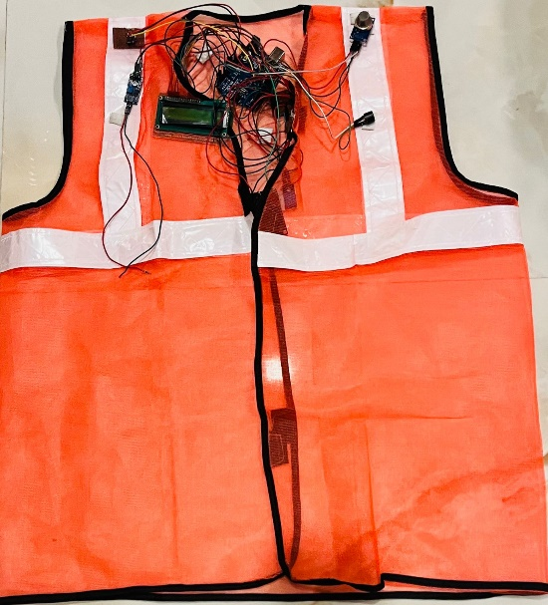

8. CONCLUSION AND FUTURE SCOPE
This method helps the workers in coal mines. This jacket offers data on several gasses while navigating dangerous settings. An ATMEGA 8A alert is provided by this prototype system when the level of dangerous gas increases. Coal mine workers' life safety is increased by employing MQ135 and LM 35 sensor jackets to detect the environment in underground mines by monitoring physical parameters and parameters are recorded using monitor status log and display.
the installation of a surveillance jacket that communicates with an Android app to identify environmental and air quality factors.to quantify and identify the issues brought on by gas leaks that occur when drilling is being done to recover coal for the purpose of producing power.A surveillance jacket can be used to monitor areas like underground drainage systems and coal mines in order to prevent harm.

9. REFERENCES
[1] Liu Xiaoli, GuoLiwen and Zhang Zhiye, “Statistics Analasis of deth Accident in Coal Mines from January 2005 to 2009”, IEEE 2010.
[2] T.S.Kumar Reddy; G.Balasiva Krishna; “Hazardous gas detecting rescue Jacket in coal mines”, International Journal of Mechanical and Production Engineering, ISSN:2320-2092, volume2, Issue-5, May-2014.
[3] P.Raghuram, VeramuthuVenkatesh; “Enhancing mine safety with wireless sensor networks using Zigbee technology”, Journal of Theoretical and Applied Information Technology (JATIT), 31st March 2012, Vo1.37No.2
[4] Mr. SabarishChakkath, S.HariharaSiddharth, B.Hemalatha; “Mobile Jacket in Coal Mine Disaster Surveillance”, IOSR Journal of Engineering, (IOSRJEN), e-ISSN:2250-3021, Volume-2, Issue 10, October 2012.
[5] PratimaBhagat,kishoriBirdawadc, KomalAmle; “Rescue Jacket for hazardous coal mines”, International Journal of Technology and Science, Issue-2, Vol.1, May 2014
[6] M. Thamrin N., Rosman R, and SATMEGA 8Aawi D. S, ”Design andAnalysis of Wireless Controller Panel using RF Module’s for Jacket ic Wheelchair” IEEE 2011.

