**"Role of AI in different streams - A study"**

**Dr. Tejashwini K C**

Assistant Professor,

GMS Academy First Grade College,

GM University,

Davangere - 577006

**Email:** tejashwinikc8@gmail.com

**Dr. Krupa A**

Assistant Professor,

CRESTA School of Management, Science and Arts,

Mysuru - 570028

**Email:** krupaas@yahoo.com

**Abstract**

Artificial intelligence is the engineering and science of creating intelligent devices, particularly computer programmes. While the aim of utilizing computers to comprehend human intelligence is similar, artificial intelligence (AI) is not limited to techniques that may be observed through biological means. Although there isn't a universally accepted definition for artificial intelligence (AI), it's generally understood to be the study of algorithms that enable perception, reasoning, and action. The amount of data produced nowadays—by both humans and machines—far exceeds our capacity to comprehend, analyse, and draw conclusions from such data. All computer learning is based on artificial intelligence, which is also the foundation for all complicated decision-making in the future. This research looks at the characteristics, definitions, history, applications, development, and accomplishments of artificial intelligence.

**KEYWORDS:** Artificial intelligence, Natural language processing, deep learning, neural networks, machine learning, and knowledge base systems

**I. Introduction**

The field of computer science known as artificial intelligence (AI) studies the intelligence of machines. An intelligent agent is a system that makes decisions to increase its chances of success. The study of concepts is what makes computers capable of doing actions that give the impression of intelligence. Reasoning, knowledge, planning, learning, communication, perception, and the capacity to move and manipulate objects are among the fundamental ideas of artificial intelligence. It is the engineering and science of creating intelligent devices, particularly computer programmes.

**II. Methods of Artificial intelligence**

The methods of Artificial intelligence as follows:

* **Machine learning:** This is an example of an artificial intelligence application where computers are naturally trained to learn from experience rather than having specific jobs explicitly coded into them. A branch of machine learning called "Deep Learning" uses artificial neural networks for predictive analysis. Numerous machine learning algorithms exist, including Reinforcement Learning, Supervised Learning, and Unsupervised Learning. The algorithm in unsupervised learning does not respond upon categorized data in the absence of explicit direction. With supervised learning, a function is inferred from the training set, which consists of a collection of the intended output and an input object. Machines employ reinforcement learning to determine the best option that should be considered by taking appropriate activities that improve the reward.
* **Natural Language Processing(NLP):** The way in which computers are programmed to process natural languages is through their interactions with human language. When it comes to interpreting human languages, machine learning is a dependable technology for natural language processing. In NLP, a machine records the audio of a human speaking. Following the audio to text exchange, the text is handled so that the audio data is converted. After that, the computer responds to people by using the audio. Applications of natural language processing include word processors like Microsoft Word for grammatical correction, IVR (Interactive Voice Response) systems used in contact centres, and language translation programmes like Google Translate. However, due to the rules that are required in information transfer using natural language and which are difficult for computers to comprehend, the nature of human languages makes natural language processing challenging. Thus, natural language processing (NLP) employs algorithms to identify and abstract natural language rules, enabling the conversion of unstructured data from human languages into a machine-understandable format.
* **Automation and Robotics:** The objective of automation is to have machines complete boring and repetitive jobs, increasing productivity and yielding more economical and effective outcomes. Neural networks, machine learning, and graphs are widely used in automation in many organizations. By utilizing CAPTCHA technology, such automation can stop fraud concerns during online financial transactions. Robotic process automation is designed to carry out repetitive, high-volume activities that can adjust to changing conditions.
* **Machine Vision:** Machines are capable of gathering and analyzing visual data. Here, the visual information is recorded using cameras, the image is converted to digital data using analogue to digital conversion, and the data is processed using digital signal processing. A computer receives the resultant data after that. Two essential components of machine vision are resolution—the distance at which the machine can discern objects—and sensitivity—the computer's capacity to detect weak impulses. Machine vision is used in picture analysis for medical purposes, pattern recognition, and signature detection, among other applications.
* **Knowledge based systems (KBS):** A knowledge-based system (KBS) is a computer programme that uses the expertise of a human expert to provide recommendations in a specific field. Separating the information—which can be expressed in a variety of forms, including rules, frames, or cases—from the inference engine or algorithm that uses the knowledge base to reach a conclusion is one of KBS's key characteristics.
* **Neural networks:** NNs are biologically inspired systems made up of a massively interconnected network of layered computational "neurons." NNs can be "trained" to approximate nearly any nonlinear function to the necessary level of accuracy by varying the network's weights. Usually, NNs are given a set of example input and output values. In a sort of learning known as supervised learning, a learning algorithm (such as back propagation) would then be used to modify the network's weights in order to get the desired output.

**III. Applications of AI in different streams**

The modern world can benefit from artificial intelligence in many ways. Given that it can effectively address complicated issues in a variety of sectors, including healthcare, entertainment, finance, and education, it is quickly becoming indispensable in the modern world. Artificial Intelligence is streamlining and expediting our daily lives. Several sectors are using artificial intelligence, including the following:



**Source:** https://www.javatpoint.com/application-of-ai

* **AI in Astronomy:** An extremely helpful tool for resolving complicated cosmos problems is artificial intelligence. AI technology can be useful in comprehending the universe, including its origins and workings.
* **AI in Healthcare:** Over the past five to ten years, artificial intelligence has become increasingly beneficial to the healthcare sector and is expected to have a big impact on it. AI is being used by the healthcare industry to diagnose patients more quickly and accurately than humans. AI can assist medical professionals in diagnosing patients and alert them when their condition worsens, allowing for prompt delivery of medical care and avoidance of hospitalization.
* **AI in Transport:** The travel industry is starting to require more and more AI. AI is able to do a variety of travel-related tasks, including booking reservations and recommending to clients the best hotels, flights, and routes. AI-powered chatbots are being used by the travel industry to engage with clients in a human-like manner for quicker and more accurate responses.
* **AI in Agriculture:** Agriculture is a field that needs a variety of resources to provide the greatest results, including labour, money, and time. AI is starting to appear in agriculture as it becomes more digitalized nowadays. AI is being used in agriculture through robotics, predictive analysis, and solid and crop monitoring. Farmers can benefit greatly from AI in agriculture.
* **AI in Education:** Grading can be automated by AI, giving the tutor more time to instruct. As a teaching assistant, an AI chatbots can converse with students. AI has the potential to serve as a convenient, anytime, anywhere personal virtual tutor for pupils in the future.
* **AI in E-Commerce:** AI is giving the e-commerce sector a competitive edge, and it is becoming more necessary for e-commerce enterprises. AI is assisting consumers in finding related products with suggested brand, colour, and/or size.
* **AI in Entertainment:** In the context of media and entertainment, artificial intelligence (AI) is the use of sophisticated algorithms and machine learning techniques to produce, improve, or customize content for a variety of platforms, including TV, video games, music, and film.
* **AI in Robotics:** Robotics has a fantastic role for Artificial Intelligence. Typically, conventional robots are programmed to carry out certain repetitive duties; however, with the use of artificial intelligence (AI), we may construct intelligent robots that can carry out activities based on their own experiences rather than being pre-programmed. The best examples of artificial intelligence in robotics are humanoid robots. Recently, two intelligent humanoid robots, Erica and Sophia, were created that have human-like speech and behaviour.
* **AI in Automotive:** AI is being used by some automotive companies to give users virtual assistants for improved performance. For instance, intelligent virtual assistant TeslaBot was unveiled by the company. Many industries are actively working on creating self-driving automobiles that can increase the security and safety of the travels.
* **AI in Social media:** There are billions of user profiles on social media platforms like Facebook, Twitter, and Snapchat, all of which require extremely effective storing and management. Massive volumes of data can be managed and organised by AI. AI is capable of analyzing large amounts of data to determine the most recent hashtags, trends, and user requirements.
* **AI in Data security:** Every business must prioritize data security, yet in the digital age, cyber attacks are becoming more frequent and more sophisticated. AI can be used to increase the security and safety of your data. AEG bot and AI2 Platform are two examples of tools that are used to more accurately identify software bugs and cyber attacks.
* **AI in Finance:** The banking and AI sectors make the most sense together. Financial procedures are being automated, chatbots are being used, machine learning, adaptive intelligence, and algorithm trading are being used by the banking industry.
* **AI in Gaming:** AI is useful in video games. In strategic games like chess, where the machine must consider a wide range of options, AI machines are capable of playing.

**IV. Some other Applications of AI**

* **Fraud detection:** Artificial intelligence is used by the financial services sector in two ways. AI is used in the first credit scoring process to determine creditworthiness. In order to track and identify fraudulent credit card transactions in real time, more sophisticated AI engines are utilised.
* **Virtual customer assistance (VCA):** Outside of human interaction, call centres employ VCA to anticipate and answer client inquiries. The first point of contact in a customer support query is voice recognition combined with simulated human dialogue. Higher-level questions are sent to an actual person.
* **Medicine:** AI systems can be used by a medical clinic to arrange beds, rotate staff, and offer medical data. AI is also used in the disciplines of neurology (MRI), cardiology (CRG), embryology (sonography), and intricate internal organ procedures, among others.
* **Heavy Industries:** The manual maintenance and operation of large machineries entails risk. Thus, it becomes essential for them to have a safe and effective operating agent.
* **Telecommunications:** Heuristic search is used by several telecom businesses to manage their workforces. For instance, BT Group uses heuristic search in a scheduling tool that gives work schedules for 20,000 engineers.
* **Music:** Researchers are attempting to simulate the actions of a proficient musician on a computer. Sound processing, performance, composition, and music theory are a few of the main topics that artificial intelligence and music research is concentrating on. For instance, Orchextra, Chucks, SmartMusic, etc.
* **Antivirus:** The role of artificial intelligence (AI) techniques in antivirus detection has grown. Certain key artificial intelligence methods used in antivirus detection are currently It enhances antivirus detection systems' effectiveness, encourages the development of new AI algorithms, and finds applications in antivirus detection that combine AI with antivirus detection.

**V. Results and Discussions**

Artificial Intelligence (AI) has the potential to revolutionize global economic productivity and GDP. To make that happen, strategic investments in various forms of AI technology are required. As businesses look to "augment" the productivity of their labour force using AI technology and automate some jobs and functions, advances in labour productivity will drive initial GDP growth.

**Table 1: Global Artificial intelligence Software market revenue**

|  |  |
| --- | --- |
| **Year** | **Revenue** |
| 2018 | $10.11 billion |
| 2019 | $14.69 billion |
| 2020 | $22.59 billion |
| 2021 | $22.59 billion |
| 2022 | $22.59 billion |
| 2023 | $70.94 billion |
| 2024 | $94.41 billion |
| 2025 | $126 billion |

**Figure 1: Global Artificial intelligence Software market revenue**

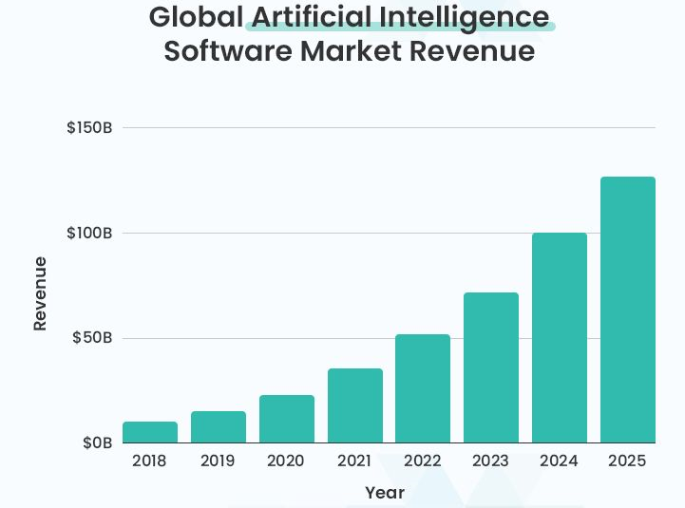

**Source:** https://www.statista.com/statistics/1298932/india-ai-market-size-by-industry/

By 2030, product improvements will generate 45% of all economic gains and increase customer demand. This is due to the fact that AI will eventually lead to a wider range of products that are more affordable, individualized, and beautiful. China (whose GDP is expected to increase by 26% by 2030) and North America (whose GDP is expected to increase by 14.5% by 2030) would benefit the most economically from AI, contributing a combined $10.7 trillion to the global economy. Currently, the AI software market generates about $100 billion in revenue globally.

In 2023, the AI market in India was valued at around 4.1 billion US dollars. With a share of 2.7 billion dollars, machine learning held the highest position among all the segments. The technology sector has seen significant changes as a result of artificial intelligence, which has the potential to significantly increase productivity through automation and process simplification. It is also a crucial component and one of the cornerstones of Industry 4.0.

**Figure 2: Size of artificial intelligence market in India in 2023, by sector(in million U.S. dollars)**

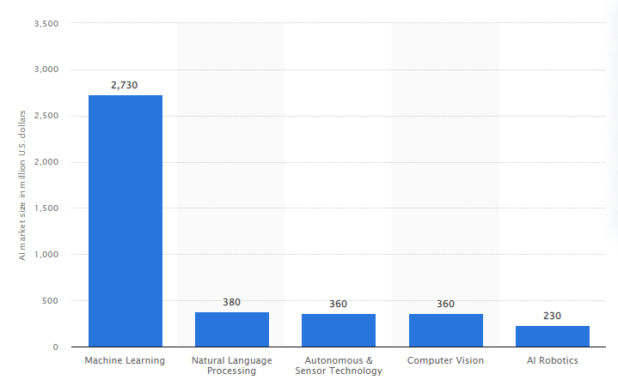

**Source:** https://www.statista.com/statistics/1298932/india-ai-market-size-by-industry/

* It is anticipated that AI will create about 20 million employment in India by 2025 in fields like software development, testing, support, and upkeep.   
  More than half of Indian companies had used artificial intelligence in some capacity by 2021.
* A total of $762.5 million was invested in the Indian AI sector in 2019, a 44% increase from the year before.
* The AI market in India was estimated to be worth $6.3 billion in 2021.   
  India is implementing AI at a rate of about 25% as of 2022, which is less than the 37% global average.
* The Indian AI market is projected to be worth $9.6 billion by 2026.   
  As of 2021, 30% of AI solutions in use in India were developed domestically.
* An estimated $957 billion, or 15% of India's current gross domestic product, would be added by AI by 2030. When it comes to excellent research articles on artificial intelligence, India comes in third place globally.   
  In India, 65% of businesses anticipate raising their AI budgets by 2020.   
  The number of AI companies increased 30-fold between 2014 and 2018, according to the Indian AI Task Force.
* With over 22% of all AI jobs in India, Bengaluru is the city with the most chances for employment in this field.
* Almost 5000 Indian firms were active in the AI space by the end of 2021.   
  Twenty percent of Indian AI firms closed their doors for lack of funding in the 2020 fiscal year.
* AI may boost India's yearly growth rate by 1.3% by 2035.   
  87% of Indian IT leaders, according to a 2021 Sales force survey, believe AI should be a top focus for their data strategy.
* Due to a lack of competent people in India, almost 50,000 positions in the fields of data science and artificial intelligence remain unfilled annually.
* By 2022, around 40% of Indian businesses expect AI to result in a loss of jobs.   
  In India, about 32% of businesses intend to use AI to enhance customer support and services.

India is not the only country where artificial intelligence (AI) is making major progress in a variety of areas. The most recent data and patterns regarding AI in the Indian business sector, providing insight into the technology's uptake and effects. AI is changing corporate operations and decision-making processes in India, from healthcare to banking to retail. It's critical to comprehend the crucial data influencing this quickly changing environment. Investigate the possibilities of AI in the Indian sector by delving into the data. Artificial intelligence is clearly changing the Indian industry environment quickly. Organizations in India stand to benefit from increased efficiency, innovation, and competitiveness as a result of growing acceptance and investment in AI technologies. Businesses must use AI to its full potential in order to be competitive in the digital era and take advantage of the many opportunities it presents.

**VI. Future of AI**

We may choose to stick with artificial intelligence given its features and broad range of applications. Is the world of the future getting more artificial as artificial intelligence develops? Since biological intelligence is based on an outdated and established paradigm, it cannot be changed; nevertheless, the field of non-biological computing and intelligence is expanding rapidly. It is likely that the human brain can store approximately ten thousand million binary digits in memory. However, the majority of information undoubtedly goes towards recalling visual cues and other somewhat inefficient uses. Therefore, given the limitations and volatility of natural intellect, it is possible that the world will increasingly rely on computers to function properly. In the upcoming years and decades, artificial intelligence (AI), a genuinely breakthrough achievement in computer science, is expected to be a fundamental part of all software. Both a threat and an opportunity are presented by this. Artificial Intelligence will be used to support both offensive and defensive cyber operations. Furthermore, new methods of cyber attack will be developed to exploit the unique flaws in AI technology. Lastly, AI's voracious appetite for massive volumes of training data will increase the value of data and redefine our approach to data protection. Careful global governance will be necessary to guarantee that this revolutionary technology will result in widely distributed prosperity and safety.

**VII. Net App and Artificial intelligence (AI)**

NetApp recognizes the importance of data access, management, and control in its role as the hybrid cloud's data authority. A single data management environment that spans edge devices, data centres, and several hyper scale clouds is offered via the NetApp data fabric. Organizations of all sizes may expedite vital applications, obtain data visibility, simplify data security, and boost operational agility with the use of the data fabric. The following fundamental components serve as the foundation for NetApp AI solutions:

* + AI and deep learning are made possible by ONTAP software, both on-site and in the hybrid cloud.
  + AI and deep learning workloads are accelerated and performance constraints are eliminated by AFF all-flash systems.
  + ONTAP Select software makes use of Internet of Things (IoT) devices and aggregation points to facilitate effective edge data collection.
  + Cloud Volumes allow AI data to be moved to and from the cloud and can be used to quickly prototype new projects.

**VIII. Conclusion**

Artificial intelligence has been briefly covered up to this point. Its applications, accomplishments, and a few of its guiding concepts have all been covered. Most challenges or tasks that are beyond the direct capabilities of humans are what institutions and scientists working on AI hope to address. The world's circumstances will undoubtedly alter as computer science advances, and it is currently the duty of the upper echelons of the engineering community to do so.

**IX. References**

* + - 1. http://en.wikibooks.org/wiki/Computer_Science:Artificial_Intelligence
      2. http://www.howstuffworks.com/arificialintelligence
      3. http:// www.google.co.in
      4. http://www.library.thinkquest.org
      5. https://www.javatpoint.com/application-of-ai
      6. https://www.educba.com/artificial-intelligence-techniques/
      7. https://www.cigionline.orgw/articles/cyber-security- battlefield/?utm_source=google_ads&utm_medium=grant&gclid=EAIaIQobChMIsdz9qLSF_AIVzQ0rCh1bNQylEAA YAiAAEgI40_D_BwE