# DEMAT AND ONLINE TRADING GUIDE FOR STUDENTS

# SUBMITTED BY :- SUMIT SHA(21GSFC1010042 )

**ARYAN GUPTA (21GSFC1010037)**

# UNDER THE GUIDANCE OF:- DR. NUPUR MISHRA

**Abstract**

This guide unveils the potential of Demat accounts and online trading for students, while urging caution due to inherent limitations. It explores knowledge gaps, emotional influences, capital constraints, time demands, and risk management challenges students might encounter. The importance of financial literacy is stressed, along with alternative options like long-term investing and paper trading. By acknowledging these limitations and exploring alternatives, students can make informed decisions about online trading's suitability for their financial goals and circumstances, ultimately empowering them for responsible participation in the financial world.

**Chapter 1: Introduction**

Understand Demat Accounts A demat account is a digital account that allows you to hold and trade securities such as stocks, bonds, and mutual funds in an electronic format instead of physical certificates. Understanding the purpose and benefits of a demat account is the first step in your journey towards online trading as a student. Learn Online Trading Basics Online trading refers to the process of buying and selling financial instruments like stocks, commodities, and currencies through an online platform.

Familiarizing yourself with the fundamental concepts of online trading, such as order types, market mechanics, and trading strategies, will empower you to make informed investment decisions.

Develop Investment Goals Before diving into online trading, it's crucial to establish your investment goals. Consider factors like your risk tolerance, investment horizon, and financial objectives. This will help you select appropriate investment instruments and develop a personalized trading plan that aligns with your unique needs and preferences as a student. Online trading has gained immense popularity in recent years, offering a convenient platform for students to invest in financial instruments such as stocks, bonds, and commodities through the internet. Unlike traditional trading methods that require physical presence at stock exchanges or brokerage firms, online trading allows students to trade from the comfort of their homes using computers or mobile devices. It provides easy access to global markets and a wide range of financial products, making it an attractive option for those looking to start investing with limited resources. Opening a demat account is the first step towards engaging in online trading. A demat account, short for dematerialized account, is an electronic account that holds your securities in a digital format, eliminating the need for physical share certificates. This account is linked to your bank account and trading account, allowing for seamless transfer of funds and securities during trading activities. Students can easily open a demat account through various financial institutions or online brokerage firms by submitting required documents and completing the verification process. When it comes to online trading, students should familiarize themselves with the basics of stock markets, investment strategies, and risk management techniques. It is essential to conduct thorough research on companies and industries before making investment decisions, understanding the factors that influence stock prices and market trends. Additionally, students should practice disciplined trading habits, setting realistic financial goals, and staying updated with market news and developments to make informed investment choices. Demat and online trading present valuable opportunities for students to learn about financial markets, investment principles, and wealth creation strategies. By opening a demat account

and engaging in online trading, students can gain practical experience in managing their finances, building a diversified investment portfolio, and planning for their future financial goals.

With the right knowledge ,discipline, and guidance, students can leverage the benefits of online trading to enhance their financial literacy and secure a strong financial foundation for the future.

**Research Objectives**

**1. Define Your Trading Goals and Risk Tolerance:**

* **Investment Horizon:** Are you looking for short-term gains, long-term growth, or a combination?
* **Risk Tolerance:** How much are you comfortable losing on a trade?

**2. Develop Trading Strategies:**

* **Research:** Identify market inefficiencies or exploitable patterns.
* **Backtesting:** Test your strategies on historical data to assess their effectiveness.
* **Examples:**
  + **Trend Following:** Capitalize on upward or downward trends.
  + **Mean Reversion:** Buy assets that fall below their historical average and sell when they rise above.
  + **Arbitrage:** Exploit price discrepancies between similar assets in different markets.

**3. Algorithmic Implementation:**

* **Learn a Programming Language:** Python is a popular choice for algorithmic trading.
* **Trading Platforms:** Many platforms offer API access for algorithmic execution.
* **Focus on Logic:** Clearly define the rules and conditions for your trades.

**4. Risk Management:**

* **Stop-Loss Orders:** Automatically exit positions when losses reach a predefined limit.
* **Position Sizing:** Allocate a specific percentage of your capital to each trade.
* **Backtesting with Transaction Costs:** Account for commissions and fees in your testing.

**5. Diversification and Monitoring:**

* **Multiple Strategies:** Employ a combination of uncorrelated strategies to reduce overall risk.
* **Regular Reviews:** Monitor your algorithms' performance and adjust as needed.
* **Paper Trading:** Test your algorithms with simulated capital before risking real money.

**Additional Tips:**

* **Start Simple:** Begin with a basic strategy and gradually increase complexity.
* **Focus on Process:** Discipline and consistency are key to long-term success.
* **Emotional Detachment:** Let the algorithms make decisions, not emotions.

**Further Exploration:**

* Online Courses and Tutorials on Algorithmic Trading
* Algorithmic Trading Communities and Forums
* Paper Trading Platforms

**Remember:** Algorithmic trading can be complex and requires ongoing learning and adaptation. There's no guaranteed path to consistent returns, but this approach offers a structured and data-driven alternative to emotional manual trading.

**Chapter 2: Literature Review**

## Deep Dive into the Three Pillars of Successful Algorithmic Trading**:**

You're absolutely right, in the realm of automated trading, **knowledge is the ultimate weapon**. Let's delve deeper into the three foundational elements you mentioned:

**1. Financial Markets:**

* **Technical Analysis:** This approach focuses on price and volume data to identify trading opportunities.
  + **Chart Patterns:** Recognizable formations on price charts that may signal future price movements (e.g., head and shoulders, double tops/bottoms).
  + **Indicators:** Mathematical calculations based on price and volume data that can suggest trends, momentum, or overbought/oversold conditions (e.g., moving averages, Relative Strength Index (RSI)).
  + **Market Dynamics:** Understanding how economic events, news, and investor sentiment impact prices.
* **Fundamental Analysis:** This method evaluates a company's financial health, industry trends, and overall economic conditions.
  + Not as relevant for short-term algorithmic strategies, but valuable for understanding broader market movements.

**2. Programming:**

* **Python:** A popular choice due to its readability, extensive libraries for data analysis and algorithmic development and large online community for support.
* **R:** Another powerful option, particularly strong in statistical analysis and data visualization.
* **Key Skills:**
  + Variables, data structures, control flow (if/else statements, loops)
  + Functions to define reusable code blocks
  + Working with financial data libraries (e.g., NumPy, pandas for Python)
  + Backtesting frameworks (e.g., Zipline for Python)

**3. Risk Management:**

* **Stop-Loss Orders:**
  + Automatic order to sell when the price reaches a specific level to limit potential losses.
  + Essential to protect your capital from unexpected market swings.
* **Position Sizing:**
  + Allocate a predetermined percentage of your capital to each trade.
  + Prevents overexposure and helps manage portfolio risk.
* **Backtesting with Transaction Costs:**
  + Factor in commissions, fees, and market impact when evaluating your strategy's profitability.
  + Realistic backtesting provides a clearer picture of potential performance.
* **Risk Management Metrics:**
  + Understand and monitor metrics like Sharpe Ratio and Sortino Ratio to assess risk-adjusted returns.

**Additional Considerations:**

* **Data Quality:** The foundation of your algorithms. Ensure your data is accurate and reliable.
* **Overfitting:** Avoid creating strategies that work well on historical data but fail in real-time markets.
* **Constant Monitoring:** Markets are dynamic. Regularly review your algorithms and adjust as needed.

By mastering these three pillars, you'll be well-equipped to navigate the algorithmic trading landscape. Remember, success requires dedication, continuous learning, and a disciplined approach.

**Chapter 3: Research Methodology**

Effective automated trading requires a solid understanding of financial markets, programming, and risk management. Begin by researching the various trading strategies, from trend-following to mean-reversion, and determine which aligns with your trading goals and risk tolerance. Familiarize yourself with programming languages such as Python, R, or C++, which are commonly used in developing automated trading algorithms. Additionally, study the fundamentals of technical analysis, including indicators, patterns, and market dynamics, to build a robust trading system.

**Data Collection**

Gather historical market data, including pricing, volume, and other relevant metrics, to train and back test your trading algorithms. This data will form the foundation of your automated trading system.

**Algorithm Development**

Use your programming skills to design and implement trading algorithms that can identify market opportunities, execute trades, and manage risk. Test and refine your algorithms using historical data to ensure their effectiveness and consistency.

**Live Testing and Optimization**

Once your automated trading system is developed, conduct live testing in a simulated trading environment to assess its performance and make any necessary adjustments. Continuously monitor and optimize your system to adapt to changing market conditions.

Effective automated trading demands mastery of three key areas: financial markets, programming, and risk management. The journey begins with understanding various trading strategies, like trend-following (capitalizing on upward or downward trends) or mean-reversion (buying undervalued assets expecting a rise), and selecting one that aligns with your risk tolerance and financial goals. Next, equip yourself with a programming language like Python, R, or C++, as these will be the building blocks for your trading algorithms. Delve into the world of technical analysis, where you'll learn to interpret chart patterns, technical indicators (like moving averages or RSI), and understand how news and economic factors influence price movements. This knowledge will be crucial for designing robust algorithms. To train and test these algorithms, gather historical market data (pricing, volume, etc.) - the foundation of your automated system. Now, with your programming skills sharpened, use them to design algorithms that can identify trading opportunities based on your chosen strategy and incorporate risk management techniques like stop-loss orders and position sizing. However, the work isn't done yet. Backtesting, where you run your algorithms on historical data, is essential to assess their effectiveness and consistency. Remember, factor in transaction costs for a realistic picture of potential returns. Once you're confident, conduct live testing in a simulated environment, mimicking real-world trading to further refine your algorithms before risking real capital. The final piece of the puzzle is continuous monitoring and optimization. Financial markets are dynamic, so regularly assess your system's performance and adapt your algorithms as needed. Remember, successful automated trading is a marathon, not a sprint, requiring ongoing learning and adjustments to stay ahead of the ever-evolving market landscape.

**Chapter 4: Analysis and Interpretation**

How old are you?

18-25,25-40 ,40-60

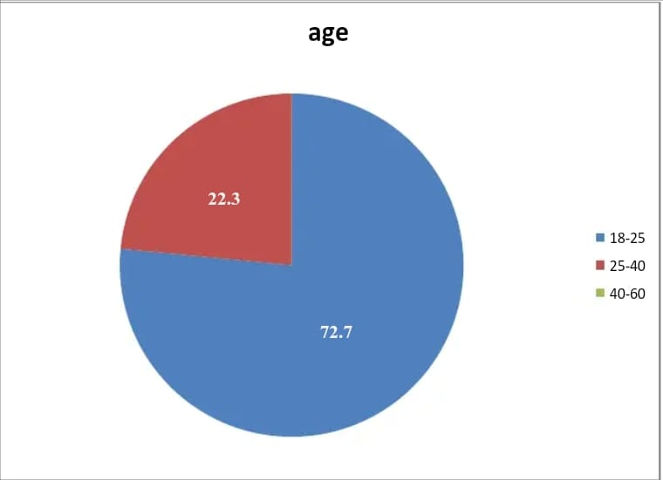

Interpretation: In above pie diagram majority of population selected are from 18-25 age groups that is seventy two.7% and 22.3% are of 25-40 age institution

* **Red (18-25 years old):** 22.3%
* **Blue (25-40 years old):** 72.7%
* **Green (40-60 years old):** Not enough data to determine the percentage (although it appears to be the smallest slice)

**Total:** 100%

It's important to note that the data doesn't reveal the total number of people represented in the pie chart.

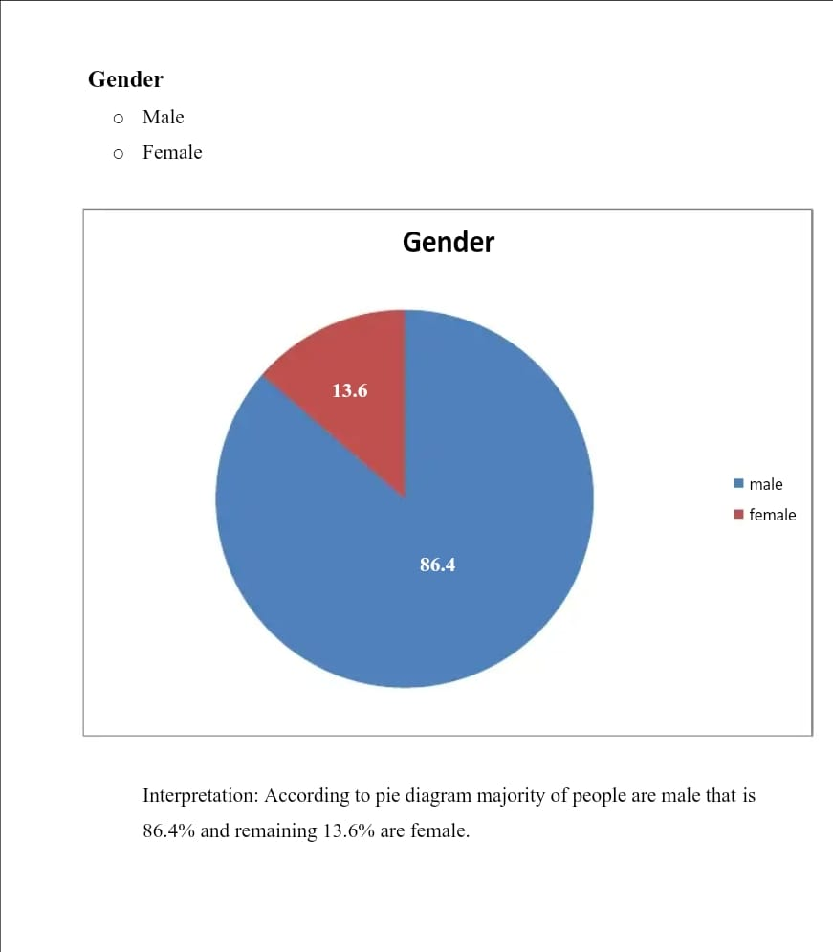

* **Male:** 86.4%
* **Female:** 13.6%

The total adds up to 100%, so it likely represents the distribution of people by gender.

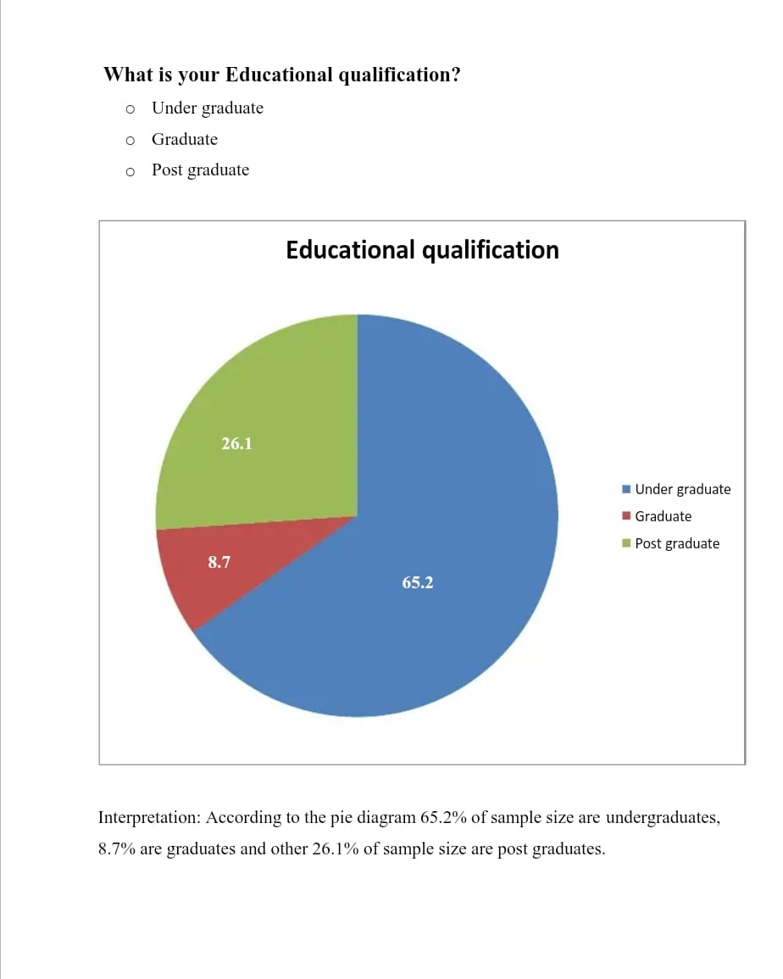

The data according to the pie chart shows the distribution of educational qualifications of a sample population. Here's a breakdown of the information according to the colors in the pie chart:

* **Under Graduate:** 65.2%
* **Graduate:** 8.7%
* **Post Graduate:** 26.1%

The text label accompanying the pie chart further clarifies that it represents the educational qualification according to the sample size. It is important to note that the pie chart title "What is your Educational qualification?" and the text label "Educational qualification" do not provide any details about the sample size or the population from which the sample was drawn. Therefore, we cannot determine if this represents the educational qualifications of a specific country, age group, or any other demographic.

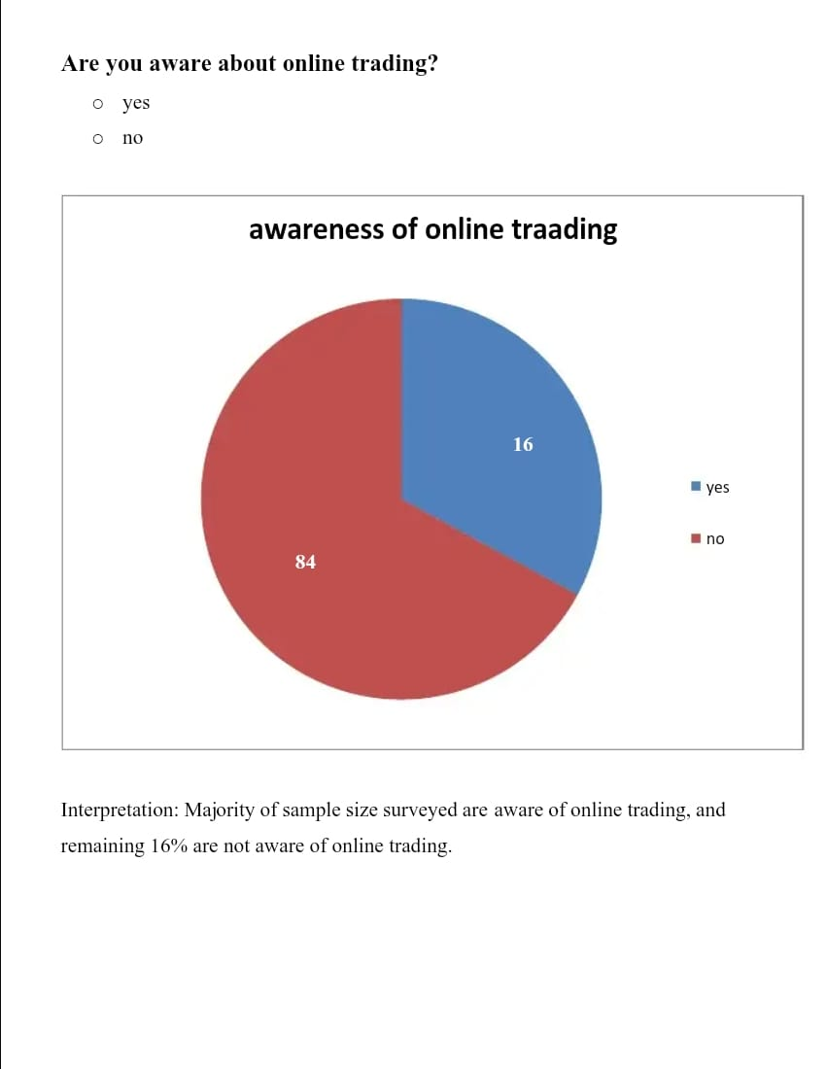

The data according to the pie chart shows the awareness of online trading among a sample population. Here's a breakdown of the information:

* **Aware:** 72% (16 out of a sample size of 24)
* **Not Aware:** 28% (8 out of a sample size of 24)

The text label accompanying the pie chart further clarifies that it represents awarness of online trading according to a sample size of 24. It is important to note that the pie chart title Are you aware about online trading?" does not provide any details about the demographics of the sample population. Therefore, we cannot determine if this represents the awareness of online trading among a specific country, age group, or any other demographic.

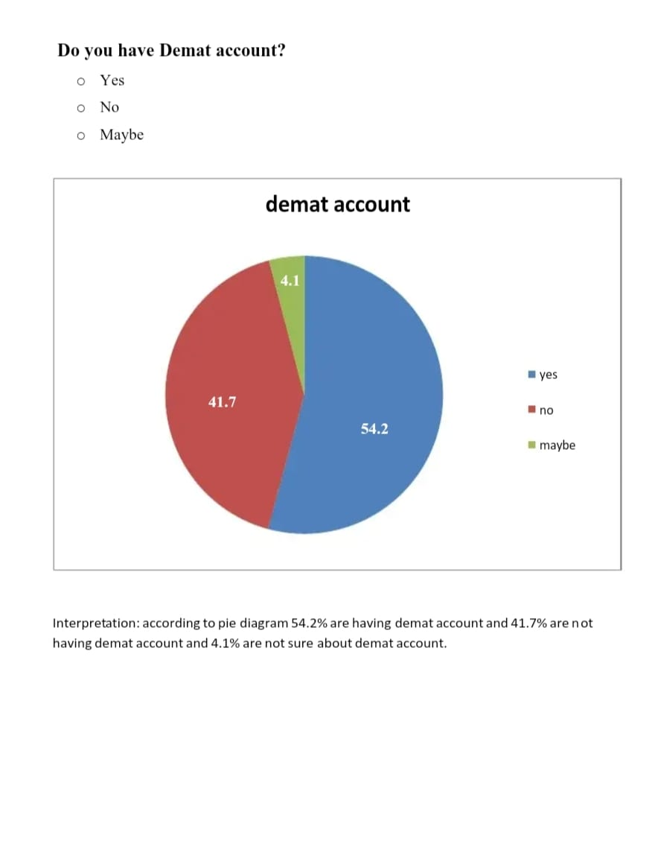

The data according to the pie chart shows the following:

* **Yes:** 54.2%
* **Maybe:** 4.1%
* **No:** 41.7%

The pie chart title asks "Do you have a demat account?" and the slices represent yes, no, and maybe. However, it is important to note that the data doesn't reveal the total number of people represented in the pie chart.

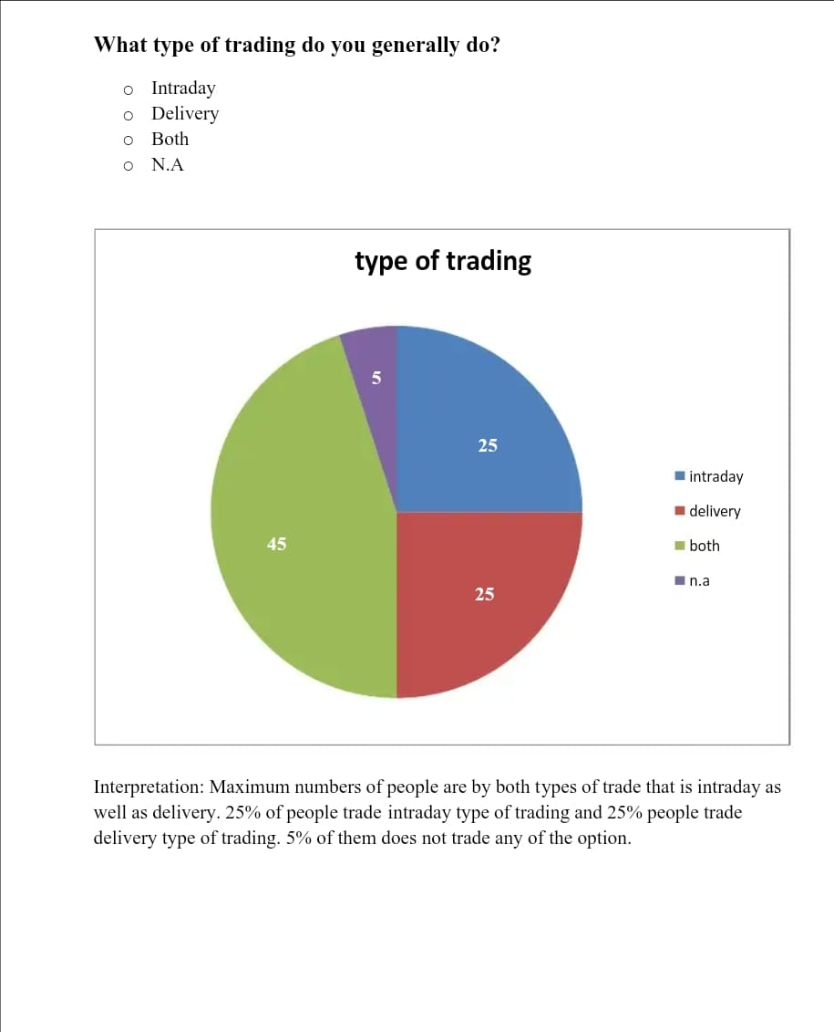

The data according to the pie chart shows the following:

* **Intraday:** 25%
* **Delivery:** 25%
* **Both:** 45%
* **N.A.:** 5%

The title of the pie chart asks "What type of trading do you generally do?" and the slices represent intraday, delivery, both, and N.A. (not applicable).

It appears that the most popular choice among those surveyed is to trade both intraday and delivery (45%), followed by those who only trade intraday (25%) and delivery (25%) each. There is also a small percentage (5%) who did not answer the question or said it is not applicable to them.

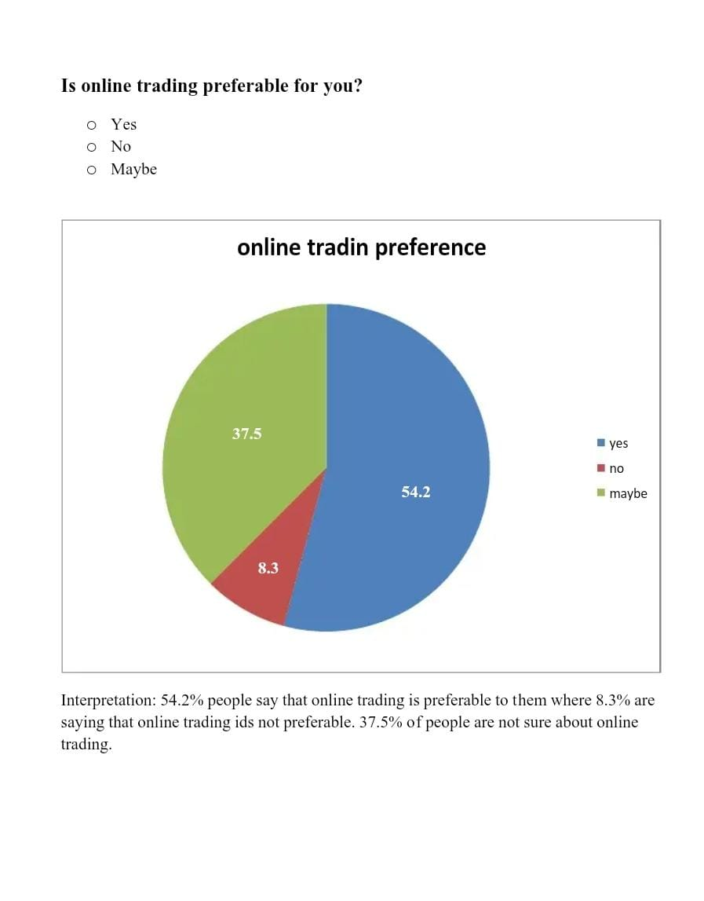

The data according to the pie chart you sent shows the following:

* **Yes (prefer online trading):** 54.2%
* **Maybe:** 8.3%
* **No (prefer not to trade online):** 37.5%

The text label accompanying the pie chart further clarifies that it represents people's preference for online trading. It is important to note that the pie chart title "Is online trading preferable for you?" does not provide any details about the sample size or the population from which the sample was drawn. Therefore, we cannot determine if this represents the preferences of people in a specific country, age group, or any other demographic.

**Limitations**

While Demat accounts and online trading platforms might seem alluring, students face several limitations before diving in. The complexity of financial markets can expose them to knowledge gaps, potentially leading to bad investment decisions and losses. The emotional rollercoaster of trading can cloud judgment, making students susceptible to impulsive choices driven by fear or greed. Limited capital can be a significant hurdle, as effective trading often requires a substantial investment, and losing money can have a harsh impact on a student's financial well-being. Balancing academic commitments with the time demands of dedicated research, analysis, and market monitoring can be challenging for students. Understanding and managing risk can be particularly tricky. Students might underestimate their risk tolerance, leading them to take on positions that are too risky for their situation. The allure of quick gains can also be a trap, with FOMO (fear of missing out) and impatience leading to chasing trends or making decisions based on emotions rather than a well-defined strategy. Instead of jumping into online trading, students should consider alternative avenues like long-term investing through mutual funds or ETFs, which offer a more balanced and less time-consuming approach. Additionally, paper trading platforms provide a valuable learning experience by allowing students to practice trading strategies with simulated funds before risking real capital. The most important step for students is to invest time in financial education, learning about the intricacies of financial markets, investing principles, and risk management strategies before venturing into the world of online trading. By understanding these limitations and prioritizing responsible financial literacy, students can make informed decisions about whether or not online trading aligns with their goals and circumstances.

**Future Research**

The world of Demat accounts and online trading is constantly evolving, and to create a more well-rounded guide for students, future research should explore several key areas. One avenue is to investigate how gamified trading platforms and educational tools can improve student engagement and encourage responsible trading habits. This could involve analyzing the effectiveness of interactive simulations, quizzes, and reward systems in building financial literacy. Another area of research is student-specific risk management strategies. This might involve creating tools and educational resources focused on stop-loss orders, position sizing, and other techniques to help students manage risk with their limited capital and risk tolerance. The potential of Artificial Intelligence (AI) and robo-advisors is also worth exploring. Research could delve into how AI can guide students towards investment decisions that align with their risk profiles and how AI-driven tools can personalize learning experiences and manage risk exposure for young investors. Furthermore, integrating Demat accounts and online trading platforms with existing financial literacy programs could be immensely beneficial. This would involve developing age-appropriate curriculums that combine theoretical knowledge with practical experience using simulated trading environments. The psychological impact of online trading on students is another crucial area. Research could focus on understanding how factors like FOMO and overconfidence influence student behavior and how to mitigate these biases to promote responsible trading. Regulatory considerations and age restrictions are also important to explore. This might involve analyzing how regulations surrounding young adults and online trading are evolving and finding solutions for students to gain practical experience in simulated environments under proper supervision. Finally, to understand the long-term impact, researchers could conduct studies to assess how early exposure to online trading platforms influences students' financial behavior and investment habits over time. By investigating these various areas of future research, we can create a more comprehensive and effective Demat and online trading guide that empowers students to make informed decisions and participate in the financial markets with greater knowledge and confidence.

**Chapter 5: Conclusion and Recommendations**

**Conclusion**

➤ most people are privy to online buying and selling.

➤ The majority of purchasers still cite poor brokerage company services as their primary source of buying and selling difficulties.

➤ Most of people are having demat accounting and online trading account.

➤50% of my pattern sizes are not making an investment in share market.

➤ identical numbers of people in pattern length do intraday and shipping trading and most of them do each intraday as well as shipping buying and selling.

➤ according to my decided on pattern of group, 75% humans opt to make investments less than 10k and some of them opt to make investments extra than 10k but much less than 20k.

➤ Many humans of my sample institution would invest cash for 1 month, a few for three months, and a few for extra than 6 months and very few for three to six months.

➤ more than 50% of me sample length thinks that on-line buying and selling is premier..

➤ lack of knowledge and studies is the biggest hassle confronted by using an trader at the same time as doing online trading.

➤ Many people get right facility via their buying and selling company or agency.

➤ nearly each humans of decided on sample organization say that on line trading is useful.

**Recommendations**

➤ As on-line trading is useful human beings should begin doing on-line buying and selling.

➤ each people should have know-how and experience in online trading.

➤ people ought to have Demat account for online trading.

➤ humans have to start doing on line buying and selling.