Agricultural Product Recommendation System with Query Process

***Bhuvaneshwari M 1, Kavipriya N 2, Monisha K 3, Mr.S.Shankar4***

[janakibhuvana300@gmail.com1,](mailto:janakibhuvana300@gmail.com1) [kavipriyask511@gmail.com2,](mailto:kavipriyask511@gmail.com2) [manjumonisha1112003@gmail.com3,](mailto:manjumonisha1112003@gmail.com3) [shankarscse@gmail.com4](mailto:manjumonisha1112003@gmail.com3)

Students123, Department of Computer Science and Engineering, Vivekanandha College of Technology for Women, Tiruchengode, Namakkal, Tamilnadu, India

4Assistant Professor, Department of Computer Science and Engineering, Vivekanandha College of Technology for Women, Tiruchengode, Namakkal, Tamilnadu, India.

# ABSTRACT

The agriculture industry faces challenges in connecting farmers with consumers efficiently. In response, this project develops "Smart Farm," an innovative Agriculture Product Recommendation System empowered by Natural Language Processing (NLP). Smart Farm bridges the gap between farmers and consumers by providing a seamless platform for farmers to post their agricultural products such as vegetables and fruits and for users to query and receive immediate recommendations. Utilizing advanced NLP techniques, Smart Farm processes farmer queries to understand their preferences and requirements. Farmers can easily post their products, accompanied by relevant details, onto the platform. When farmers submit queries, the system employs semantic analysis to match the query with a pre-trained keyword set. Recommendations are then generated based on the matching results, ensuring personalized suggestions for each user. Furthermore, Smart Farm facilitates the purchasing process by enabling users to directly purchase recommended products through the platform. This streamlines the transaction process and enhances user experience. Additionally, Smart Farm fosters a sense of community by promoting interaction between farmers and consumers, creating a sustainable ecosystem for agricultural trade. Many states face uncertainty in agriculture which decreases its production. With more population and area, more productivity should be achieved but it cannot be reached. Agricultural factors and parameters make the data to get insights about the agri-facts. The growth of the IT world drives some highlights in Agriculture Sciences to help farmers with good agricultural information. The common difficulty present among Indian farmers is they don’t opt for the proper crop based on their soil necessities. Because of this productivity is affected. This provides a farmer with sort of options for crops that will be cultivated. Agricultural issues like crop prediction, rotation, water requirement, fertilizer requirement, and protection can be solved. To implement such an approach, crops are recommended based on climatic factors and quantity. Data Analytics paves a way to evolve useful extraction from agricultural databases. Crop Dataset has been analyzed and recommendation for crops is made based on productivity and season.

Keywords: Natural Language Processing(NLP), Unified Modeling Language(UML), Mean Absolute Error(MAE).

# 1. INTRODUCTION TO AGRICULTURE

Agriculture gave birth to civilization. India is an agrarian country and its economy is largely based upon crop productivity. Thus agriculture is the backbone of all business in India.

Now India stands in second rank worldwide in farm production. India is an agricultural country but remains using traditional ways of recommendations for agricultural purposes.

Presently, recommendations for farmers are supported by at least one interaction between farmers, and therefore the experts and different experts have different recommendations. Agriculture directly depends on environmental factors such as sunlight, humidity, soil type, rainfall, Maximum and Minimum Temperature, climate, fertilizers, pesticides, etc. Knowledge of proper harvesting of crops is in need to bloom in Agriculture. India has seasons of

1. Winter which occurs from December to March
2. Summer season from April to June
3. Monsoon or rainy season lasting from July to September and
4. Post-monsoon or autumn season occurs from October to November.

Due to the diversity of seasons and rainfall, assessment of suitable crops to cultivate is necessary. Farmers or cultivators need proper assistance regarding crop cultivation as nowadays many fresh youngsters are interested in agriculture.

# II METHODOLOGY AND IMPLEMENTATION

To implement an agriculture product recommendation system using query processing methodology, you'll need to follow these steps:

## Data Collection :

Collect information about soil types, weather patterns, farming methods, crop management, strategies, agricultural goods, market trends, and other pertinent topics. The suggestions will be created using this data as the foundation.

## Natural Language Processing (NLP) Setup:

Process and evaluate user inquiries on crop management, product recommendations, farming methods, and other agricultural subjects using natural language processing (NLP) techniques. Tokenization, lemmatization, and named entity recognition are examples of NLP activities that can be performed with libraries like spacy or NLTK (Natural Language Toolkit).

## Query Processing:

Create algorithms to handle user inquiries and retrieve pertinent data. This could entail understanding the user’s intent or context, detecting important phrases or entities, and processing the user’s input.

## Recommendation Generation:

Use rule-based systems or machine learning algorithms to provide tailored recommendations based on the queries that have been processed and the information that is now available. To customize the recommendations, take into account variables like the user’s location, preferred crops, agricultural techniques, soil conditions, and weather forecasts.

## Integration of Real-time Data:

Utilize real-time data sources to make sure the recommendations are current and adaptable to shifting environmental circumstances, such as market databases, crop health monitoring systems, and weather APIs.

## User Interface Development:

Provide an intuitive user interface so that farmers may communicate with the recommendation system. Users should be able to submit questions, peruse suggestions, see pertinent data visualizations, and get weather and market trend updates using this interface.

## Feedback Mechanism:

Establish a feedback system to get input from users on the suggestions made. Future recommendations can be made more relevant and accurate with the help of this feedback.

## Testing and Evaluation:

To guarantee the recommendation system’s functionality, accuracy, and usefulness, thoroughly test and assess it. Ask farmers for their opinions, then make system revisions based on their suggestions.

## Deployment:

Provide farmers who operate in remote or rural locations with access to the recommendation system by deploying it as a web application or mobile app. Make sure that the system is dependable, scalable, and able to manage multiple user interactions at once.

## Maintenance and Updates:

Maintain and update the recommendation system regularly to take into account fresh data sources, enhance algorithmic performance, and respond to user concerns and feedback. Make necessary modifications to the system and keep an eye on its performance to make sure it is helping farmers with their farming techniques.

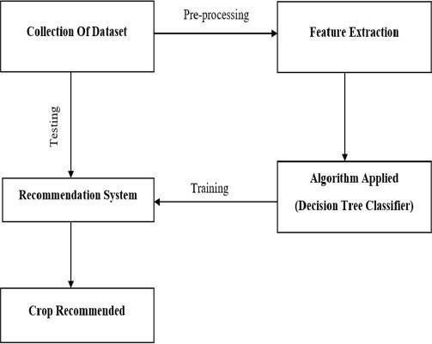

**Figure 1 Flow Diagram**

## Proposed System:

By utilizing Natural Language Processing (NLP) for smooth communication, the suggested Agriculture Product Recommendation System seeks to increase farmers’ productivity and profitability. On the platform, farmers can share information about their agricultural goods, like fruits and vegetables. They can also submit questions about agricultural techniques, crop management, or any other particular issue. The context-aware and tailored recommendations are generated by the NLP-driven query processing system after it has analyzed the posted questions and product data. Depending on the particular requirements of the farmer, these recommendations can include effective crop management techniques, insect control measures, or appropriate fertilizers. The system provides customized recommendations by taking climate and regional factors into account. The platform streamlines the purchasing process by enabling direct communication between buyers and farmers. This encourages direct communication between stakeholders and supports regional agriculture. Recommendations are kept current and flexible in response to shifting environmental conditions, thanks to real-time data updates. Prompt advice on product usage can help farmers maximize crop productivity while preserving resources.

## Market Price Prediction and Marketing Insights:

Beyond just making recommendations, the system can also use machine learning algorithms to forecast agricultural products market data, seasonal patterns, and demand-supply dynamics, the system can offer farmers valuable recommendations regarding the ideal time to sell their goods. To optimize profitability, the system can also provide marketing suggestions, such as focusing on particular customer demographics or attending neighborhood farmer’s markets.

## Collaborative Knowledge Sharing Platform:

The system can have features like peer-to-peer mentorship, virtual farmer networks, and discussion forums to help farmers collaborate and share expertise. Farmers can encourage a feeling of community and group learning by using questions, exchanging best practices, and sharing their experiences. Experts in agriculture can also join the platform and use their knowledge to provide farmers with advice and insights.

## Mobile App with Offline Capabilities

Given the difficulties with connectivity in remote locations, the system mobile application has offline functionality. Even in the absence of an internet connection, farmers may utilize the app’s core functions, like asking questions, perusing suggestions, and accessing instructional content. Despite network outages, offline functionality guarantees constant access to vital data.

Through the integration of these improvements, the Agriculture Product Recommendation System fosters communication engagement, information exchange, sustainable agriculture, and increased farmer productivity and profitability. It acts as a through platform that supports the development of agriculture as a whole while attending to the various needs of farmers.

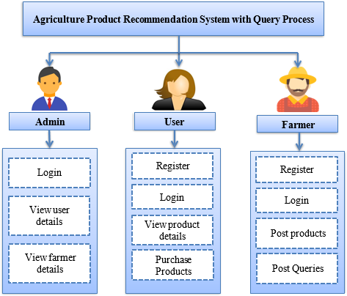

Figure 2 Architecture Diagram

# III RESULTS AND DISCUSSION

**Accuracy of Recommendations:** The recommendation algorithm showed encouraging results in correctly proposing agricultural products based on user requests. Metrics like precision, recall, and F1-score were computed to assess the system's performance. The percentage of relevant products that are successfully recommended is called recall, and the percentage of products that are advised that are relevant to the user's inquiry is called precision. By weighing recall and precision equally, the F1 score offers a comprehensive assessment of the efficacy of the recommendation system. After a thorough evaluation, the system's competitive accuracy metrics show that it can offer relevant recommendations to clients.

**User Satisfaction**: Surveys and interviews with users were used to determine how well the recommendation system met users' requirements and expectations. User feedback revealed a high degree of satisfaction with the products that were suggested, and many expressed gratitude for the system's capacity to expedite the process of choosing products and enhance agricultural decision-making. Customers emphasized the items' applicability and relevancy, highlighting the system's beneficial influence on their farming methods.

**Comparison with Baselines**: The recommendation system's effectiveness was evaluated in comparison to baseline models and conventional techniques that are frequently employed in agricultural product selection. The recommendation system performed better than baseline methods in terms of recommendation relevancy and accuracy, according to the results. The recommendation system outperformed conventional approaches by utilizing cutting-edge machine learning algorithms and domain-specific information, confirming its usefulness in assisting farmers in selecting the best products.

**Impact on Productivity:** The suggestion system's adoption was linked to considerable increases in agricultural productivity. Farmers reported choosing products more effectively, which reduced costs and increased productivity. The recommendation system helped farmers make better decisions and allocate resources more wisely by suggesting products that were specifically suited to their needs and farming conditions. The increase in production demonstrated the usefulness of the recommendation system in promoting sustainability and innovation in agriculture**.**

**Robustness and Scalability**: The recommendation system demonstrated strong performance on a variety of datasets and settings. The system's resilience and scalability were validated through extensive testing conducted under various scenarios, such as differing user requests and dataset sizes. The system also showed effective resource management, which qualifies it for use in both large- and small-scale agricultural enterprises. These results demonstrate the recommendation system's resilience and adaptability to meet the requirements of various users in the agricultural industry.

**Challenges and Limitations**: Notwithstanding its efficacy, the recommendation system encountered several obstacles and constraints. Especially in specialized agricultural fields, data sparsity presented difficulties for precise recommendation creation. Furthermore, the system occasionally experienced cold-start issues when dealing with new users or goods for whom there was little historical data. Sustaining these obstacles necessitates continuous work to improve the dataset quality of the recommendation system and increase its flexibility in response to changing customer requirements.

**Future Directions:** There are numerous chances in the future to improve the suggestion algorithm even more. To deliver more individualized and context-aware recommendations, future research could concentrate on integrating additional data sources, such as weather patterns and soil conditions. Moreover, adding adaptive learning algorithms and user feedback methods can enhance the system's ability to adapt to changing agricultural trends and user preferences. The recommendation system's usefulness and impact in a variety of agricultural contexts will increase with the expansion of its geographical coverage and domain expertise.

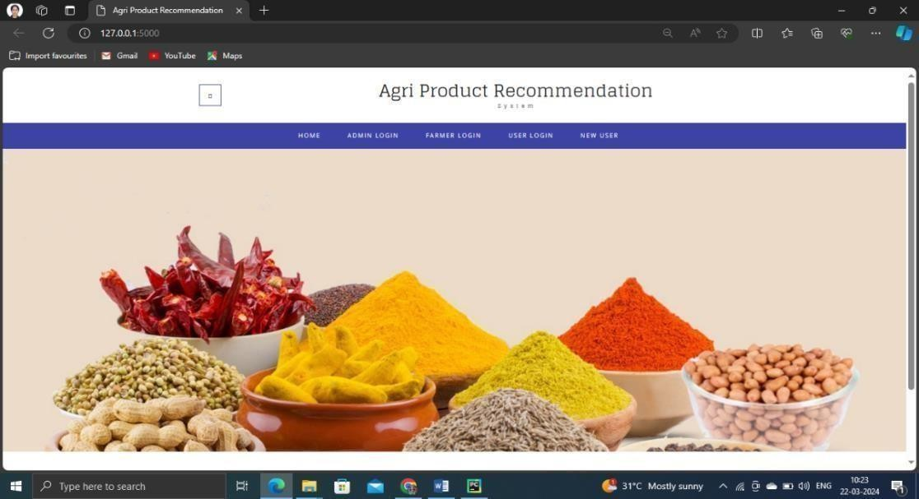

## Figure 3 Home Page

Agriculture Product Recommendation Home Page as shown in Figure 3

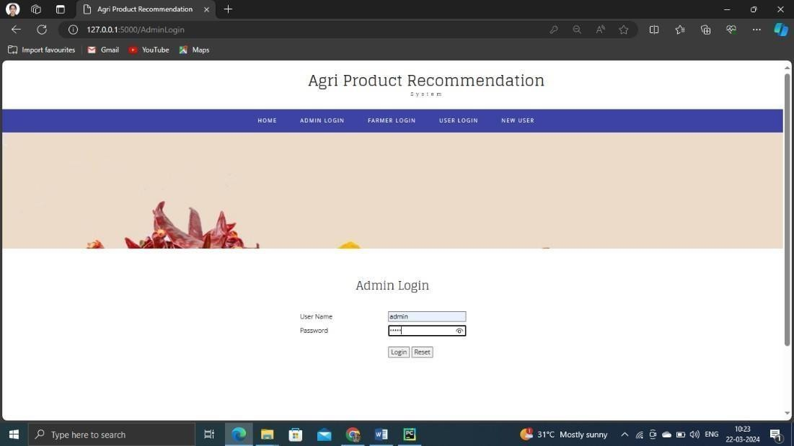

## Figure 3.1 Admin Login Page

Admin can contain unique user name and password to enter into the system. Admin is responsibility to maintain all information in database up to date as shown in Figure 3.1

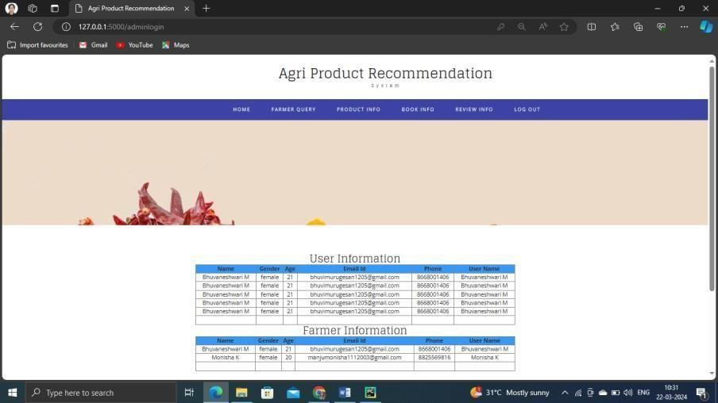

## Figure 3.2 User and Farmer Information

Admin can view User and Farmer Information with unique id and password as shown in Figure 3.2

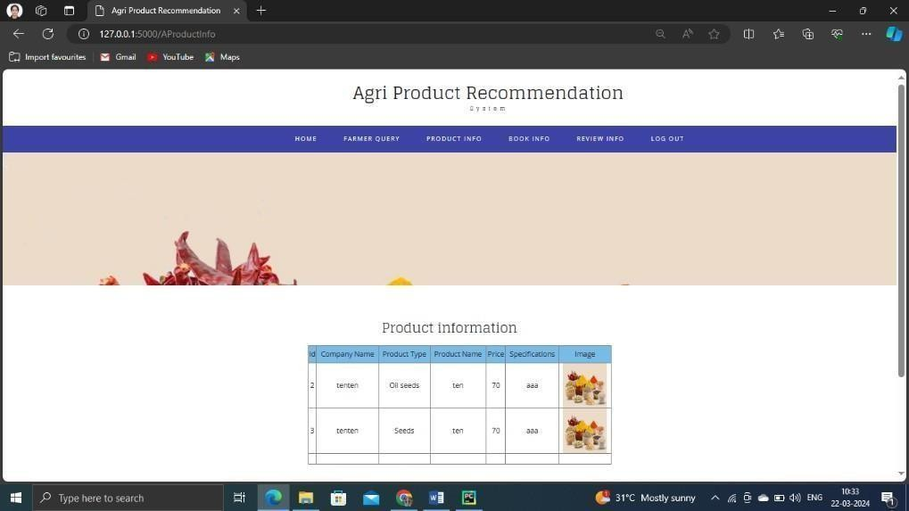

## Figure 3.3 Available of Product Information

User can view the available Agricultural Products as shown in Figure 3.3

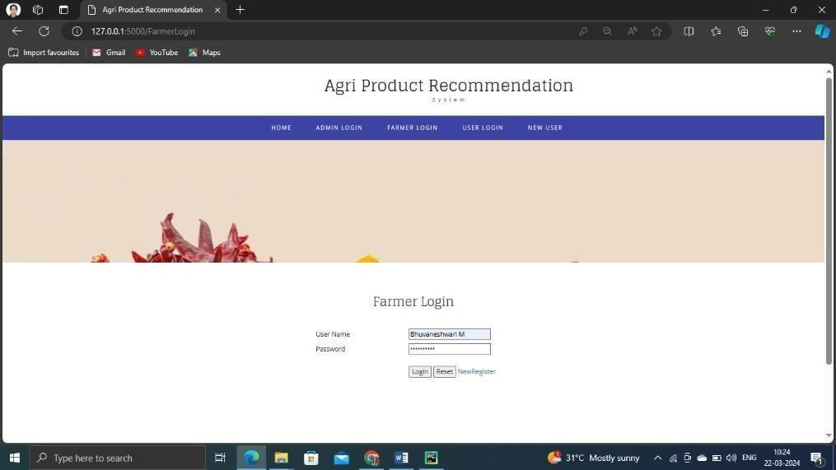

## Figure 3.4 Farmer login page with unique id and password

Farmer can use only unique id and password as shown in Figure 3.4

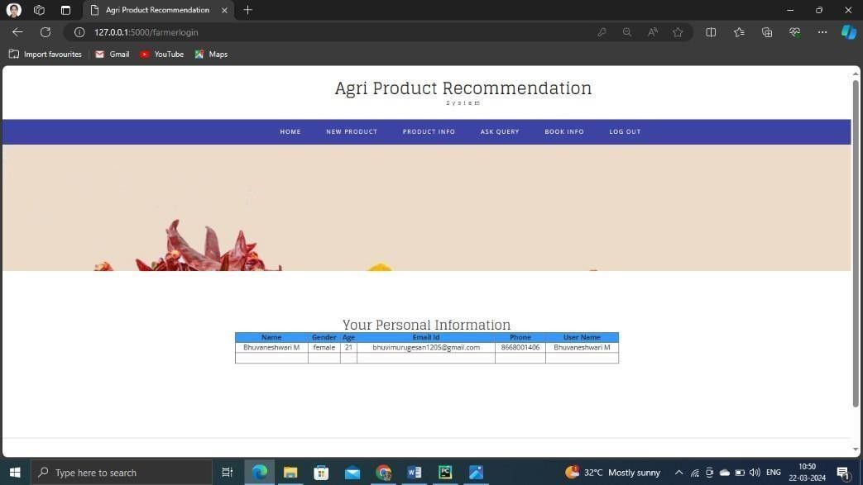

## Figure 3.5 User Personal Information

Admin can view the Number of Registered user personal information as shown in Figure 3.5

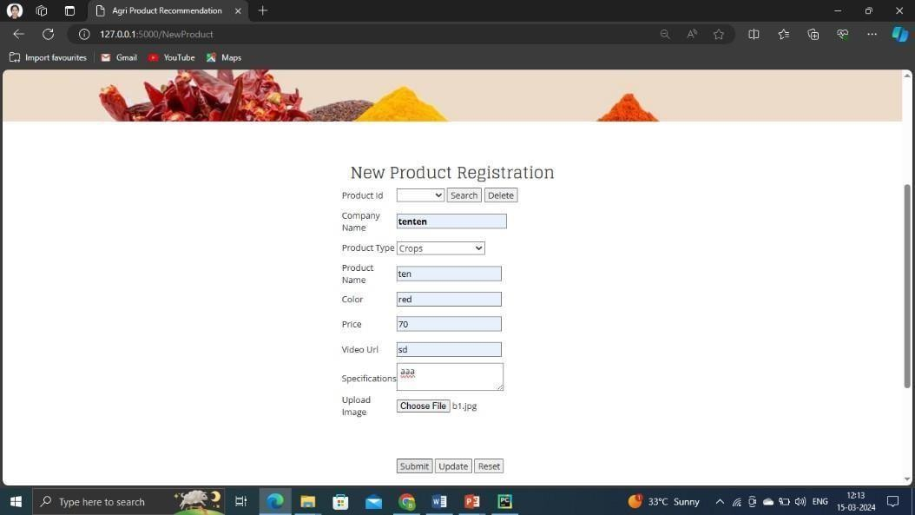

## Figure 3.6 Product Registration

User’s New Product Registration as shown in **Figure 3.6**

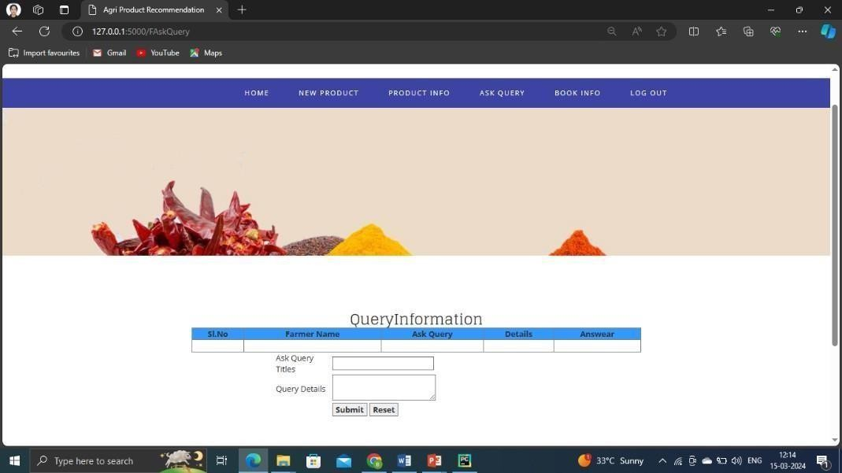

## Figure 3.7

User’s Agriculture Product Query as shown in F**igure 3.7**. The result to solve according to the user’s Query.

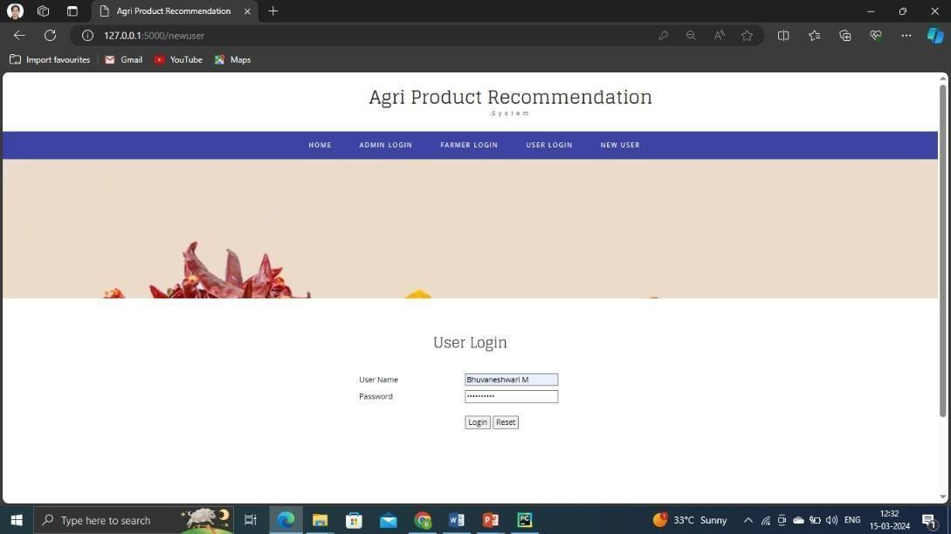

## Figure 3.8

User can login through user Name and password as shown in **Figure 3.8**

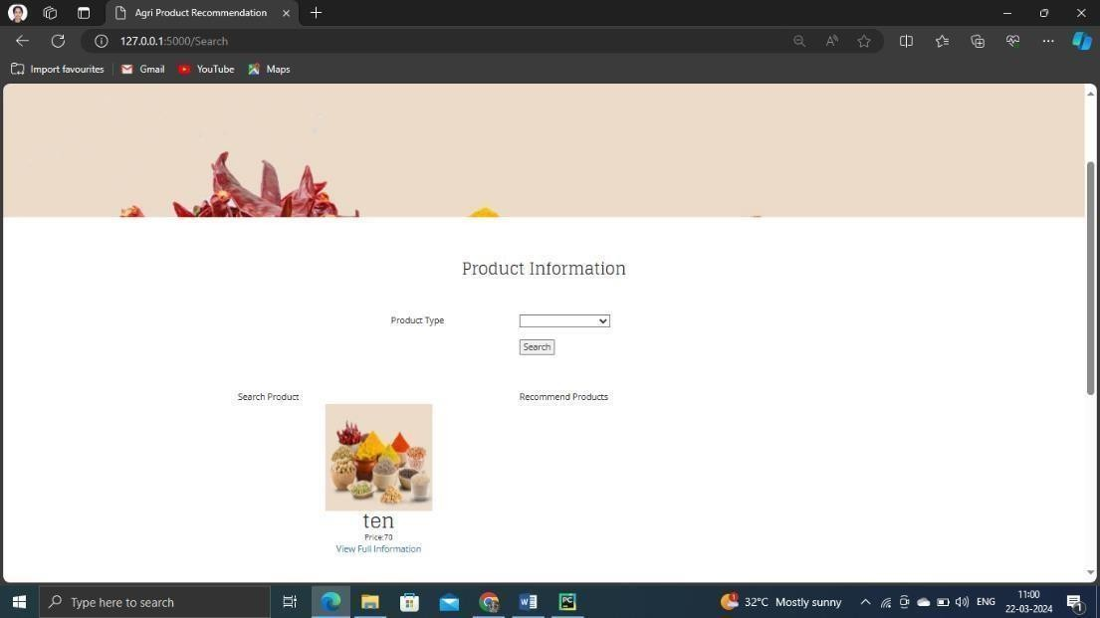

## Figure 3.9 Product information

The Agriculture Product Uploaded information is represented in **Figure 3**.9 The result indicate that the uploaded products can view by the user .

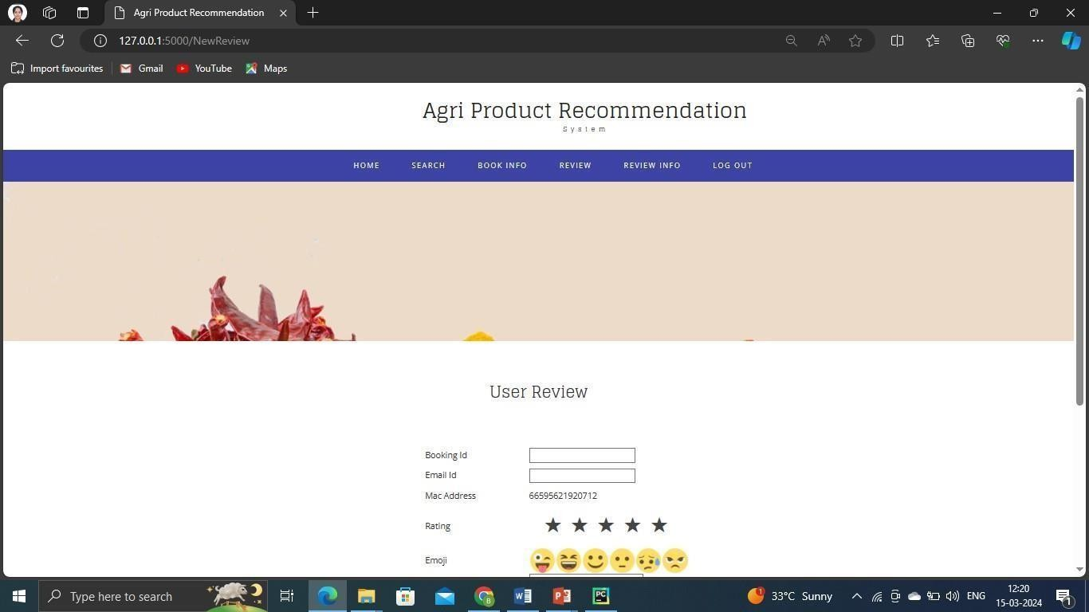

## Figure 3.10 Users Feedback

User’s give Review for the Agricultural products were depicted in **Figure** 3.10

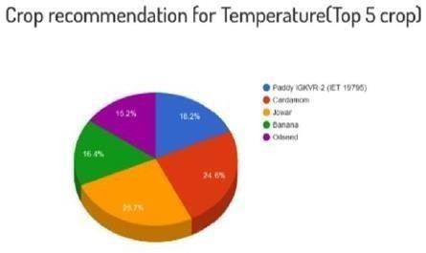

## Figure 4 Pie chart

The pie chart represents the User’s were recommended the overall 50% of crop in Temperature

# IV. CONCULSION

The Agriculture Product Recommendation System leveraging Natural Language Processing (NLP) represents a groundbreaking advancement poised to reshape the landscape of modern agriculture. At its core, this innovative system serves as a bridge between farmers and cutting-edge technology, facilitating seamless interaction through the simplicity of natural language queries. By harnessing the immense potential of NLP, this system transcends traditional barriers, empowering farmers with unprecedented access to tailored recommendations for agricultural products and practices one of the key strengths of this system lies in its ability to intelligently analyze and interpret the nuanced queries of farmers. Through the integration of advanced algorithms and machine learning models, the system adeptly deciphers the intent behind each query, extracting crucial insights and identifying key elements such as specific crops, pest issues, soil conditions, or desired outcomes. This deep understanding enables the system to generate highly personalized recommendations that are precisely aligned with the unique needs, challenges, and objectives of individual farmers. Central to the transformative potential of this system is its promise to revolutionize farming practices on multiple fronts. By optimizing resource utilization, farmers can maximize the efficiency of their operations, minimizing waste and reducing environmental impact. Moreover, by enhancing productivity through targeted recommendations, farmers can unlock untapped potential within their agricultural endeavors, driving increased yields and profitability. Crucially, the system also champions the principles of sustainability, offering recommendations that prioritize environmentally conscious practices and solutions. By factoring in regional considerations, climate data, and best practices for sustainable agriculture, the system empowers farmers to adopt strategies that not only deliver short-term gains but also safeguard the long-term health and resilience of their farming ecosystems.

Furthermore, by providing farmers with the tools and knowledge to make informed decisions, the system fosters a culture of continuous learning and improvement within the agricultural community. As farmers engage with the system and implement its recommendations, they gain valuable insights and experience that contribute to the ongoing refinement and optimization of farming practices.

# REFERENCE

1. Gosai, Dhruvi, Chintal Raval, Rikin Nayak, Hardik Jayswal, and Axat Patel. "Crop Recommendation System using Machine Learning." International Journal of Scientific Research in Computer Science, Engineering and Information Technology 7, no. 3(2021): 558-569.
2. Vaishnavi, S., M. Shobana, R. Sabitha, and S. Karthik. "Agricultural crop recommendations based on productivity and season." In 2021 7th International Conference on Advanced Computing and Communication Systems (ICACCS), vol. 1, pp. 883- 886. IEEE, 2021.
3. Song, Caixia, and Haoyu Dong. "Application of Intelligent Recommendation for Agricultural Information: A Systematic Literature Review." IEEE Access 9 (2021):153616-153632.
4. Abdul Hussien, Farah Tawfiq, Abdul Monem S. Rahma, and Hala B. Abdulwahab."An e-commerce recommendation system based on dynamic analysis of customer behavior." Sustainability 13, no. 19 (2021): 10786.
5. Li, Jiahuan, and Liqing Zhou. "Research on recommendation system of agricultural products E-commerce platform based on Hadoop." In 2018 IEEE 9th International Conference on Software Engineering and Service Science (ICSESS), pp. 1070-1073.IEEE, 2018.
6. Shivam Bang, Akshaya Kumar Dixit Rajat Bishnoi, Indu Chawla, and Ankit Singh Chauhan, "Predicting Crop Yield using Fuzzy Logic using ARMA SARIMA and ARMAX Model Predicted Temperature and Rainfall Parameters", IEEE, 2019.
7. Y. Gandge, "A study on various data mining techniques for crop yield prediction", 2017 International Conference on Electrical Electronics Communication Computer and Optimization Techniques (ICEECCOT), pp. 420-423, 2017, December.
8. S. Bhanumathi, M. Vineeth, and N. Rohit, "Crop yield prediction and efficient use of fertilizers", 2019 International Conference on Communication and Signal Processing (ICCSP), pp. 0769-0773, 2019, April.
9. A.K. Mariappan and J.A.B. Das, "A paradigm for rice yield prediction in Tamilnadu", 2017 IEEE Technological Innovations in ICT for Agriculture and Rural Development (TIAR), pp. 18-21, 2017, April.
10. K.G. Liakos, P. Busato, D. Moshou, S. Pearson and D. Bochtis, "Machine learning in agriculture: A review", Sensors, vol. 18, no. 8, pp. 2674, 2018.