**Customer Relationship Management**

**Miss Anushka Sharma *1, Miss Divya Pawar*2, Mr Naman Baveja*3,**

**Prof Deepak Kumar Yadav*4**

*1,2,3Student, Computer Science And Engineering, Shri Shankaracharya Technical Campus,

Bhilai, Chhattisgarh, India.

*4Professor, Computer Science And Engineering, Shri Shankaracharya Technical Campus,

Bhilai, Chhattisgarh, India.

**ABSTRACT**

Customer Relationship Management (CRM) primarily involves the strategic shift that businesses must make from being "product-centric" to focusing on enhancing customer satisfaction and loyalty. This shift is crucial for enterprises to adapt to the evolving market demands and modern management principles. By embracing CRM, companies can enhance their core competitiveness and refine their business management practices. At its core, CRM revolves around the customer-centric marketing approach, leveraging advanced information technology to streamline the interaction between businesses and customers. This proactive management of customer relationships aims to expand customer base, nurture existing relationships, boost customer loyalty, and ultimately drive profitability to its peak.

**Keywords:** Customer Relationship Management, Relationship Marketing, Literature Review, Classifications.

**INTRODUCTION**

Organizations across various industries are increasingly prioritizing the establishment of enduring relationships with their customers to ensure stability within the competitive market environment. This objective is often achieved through the implementation of customer relationship management (CRM) strategies. While CRM is not a novel concept, it remains a compelling area of study for researchers due to its significant impact on business success. As businesses evolve, CRM continues to solidify its position as a critical component that enhances customer relationships, reduces operational costs, and boosts overall productivity and profitability.

Customer Relationship Management (CRM) is a technological solution that emerged in the 1970s as a tool for companies to automate the management of the company's internal sales force It has experienced exponential growth since 2010 in terms of its deployment in companies in all sectors and in terms of interest as a focus of scientific research.

In today's competitive business landscape, Customer Relationship Management (CRM) has emerged as a critical strategy for organizations aiming to thrive in an era defined by customer-centricity. At its essence, CRM revolves around the principle of nurturing and managing interactions with customers throughout their journey with the company. This involves leveraging technology, data analytics, and customer insights to understand and anticipate customer needs, deliver personalized experiences, and foster long-term loyalty. The significance of CRM lies not only in its ability to drive revenue growth but also in its potential to cultivate lasting relationships that transcend individual transactions.

As businesses increasingly recognize the value of customer retention and advocacy, CRM has evolved from being merely a software solution to becoming a strategic imperative that permeates all aspects of the organization. From marketing and sales to customer service and support, CRM encompasses a holistic approach to customer management that prioritizes the delivery of seamless and memorable experiences across multiple touchpoints

**METHODOLOGY**

Implementing a Customer Relationship Management (CRM) module is a complex endeavor that demands meticulous attention to detail and a well-defined methodology. It begins with a deep dive into the organization's needs, encompassing a thorough analysis of existing customer management processes and identification of pain points. This phase often involves extensive collaboration among stakeholders from various departments, including sales, marketing, and customer service. Through interviews, workshops, and surveys, key objectives and goals for the CRM implementation are crystallized, setting the stage for subsequent actions.

The selection of the CRM solution marks a critical juncture in the process. It requires careful evaluation of available options in the market, considering factors such as functionality, scalability, customization capabilities, and alignment with organizational goals. This decision-making process typically involves cross-functional teams working in tandem to ensure that the chosen CRM platform meets the diverse needs of the organization.

Customization and configuration of the CRM system come next, where the selected solution is tailored to fit the organization's specific requirements. This involves defining custom fields, workflows, and user permissions to align with existing business processes. Collaboration between CRM administrators, IT personnel, and end-users is essential to ensure that the configured system meets the needs of different departments and user roles.

Data migration represents a significant challenge in CRM implementation, requiring careful planning and execution to ensure the seamless transition of customer data from legacy systems to the new CRM platform. Data cleansing, de-duplication, and mapping processes are critical to maintaining data integrity and consistency throughout the migration process. Rigorous testing and validation procedures are employed to verify the accuracy and completeness of migrated data, minimizing the risk of errors or discrepancies.

User training and adoption are pivotal to the success of CRM implementation. A comprehensive training program is developed to educate users on how to effectively utilize the CRM system, encompassing both basic functionalities and advanced features relevant to their roles. Ongoing support and resources are provided to address user questions and concerns, fostering a culture of adoption and engagement across the organization.

Testing and quality assurance efforts are conducted rigorously to ensure that the CRM module functions as intended and meets the organization's requirements. This involves the creation of test cases and scenarios to validate various aspects of the CRM system, including data entry, reporting, and integration with other systems. User acceptance testing (UAT) is conducted to solicit feedback from end-users and stakeholders, ensuring that the CRM meets their expectations before deployment.

Deployment of the CRM module requires careful planning and coordination to minimize disruptions and ensure a smooth transition. Effective communication strategies are employed to keep stakeholders informed and engaged throughout the rollout process. Depending on the organization's preferences and requirements, deployment may occur in phases or all at once, with appropriate training and support provided to facilitate user adoption.

Post-deployment, continuous monitoring, and improvement efforts are essential to optimize the performance and effectiveness of the CRM module over time. Key performance indicators (KPIs) and metrics are established to track the impact of the CRM on business outcomes, with feedback gathered from users and stakeholders to identify areas for enhancement. Iterative refinements are made based on this feedback, evolving the CRM system to meet the evolving needs of the organization.

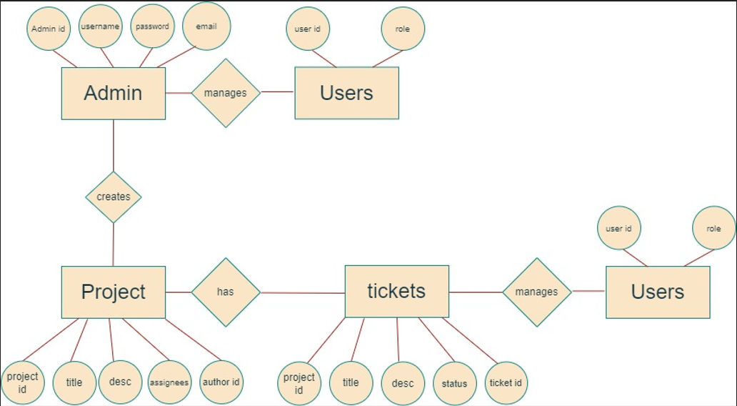

**RESULTS AND DISCUSSION**

The primary aim of this research paper is to develop a research model that can effectively measure and evaluate the impact of implementing and utilizing Customer Relationship Management (CRM) on the performance of companies operating in specific sectors, functional areas, or geographical regions. The desired outcome of this study is to establish a framework that can quantify the influence of CRM adoption on firm performance.

Drawing upon previous studies that have explored the measurement of organizational performance resulting from the implementation of CRM technology, as well as contemporary insights derived from research on innovation capacity and customer knowledge management, a comprehensive research model has been proposed. This model possesses universal applicability and can be applied to various productive environments, aligning with the primary objective of this investigation.

The suggested approach in this study involves employing appropriate research methodologies tailored to different groups of companies. By utilizing the research model presented in this paper and the accompanying questionnaire provided in the Annex, it is anticipated that a comprehensive assessment of the impact of varying levels of CRM adoption on firm performance can be efficiently conducted. Future studies will further validate and enhance the findings of this research by applying the proposed model to diverse sectors or groups of companies.

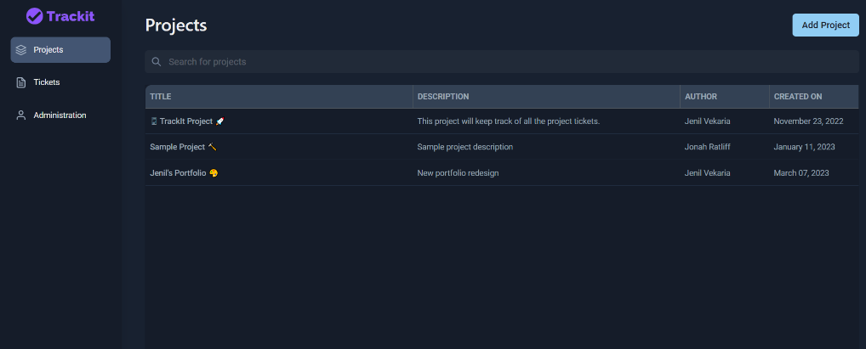

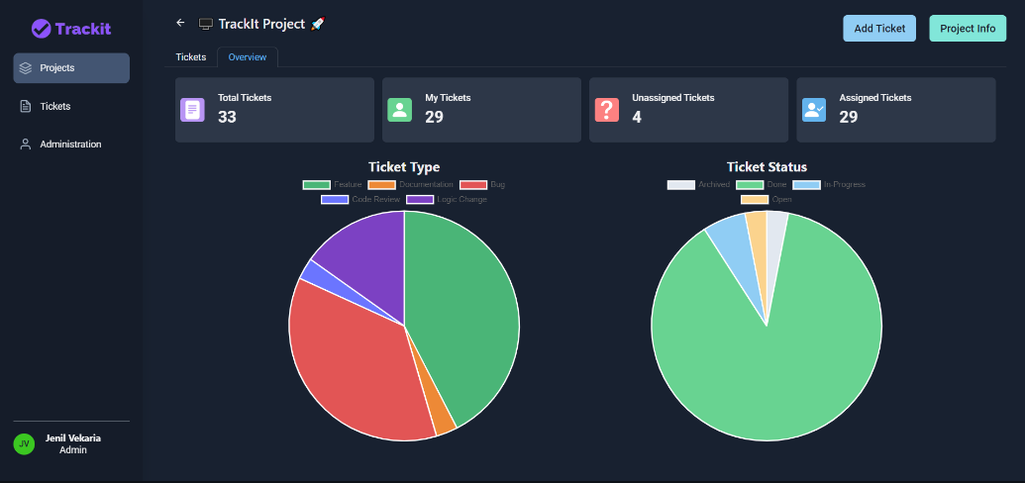

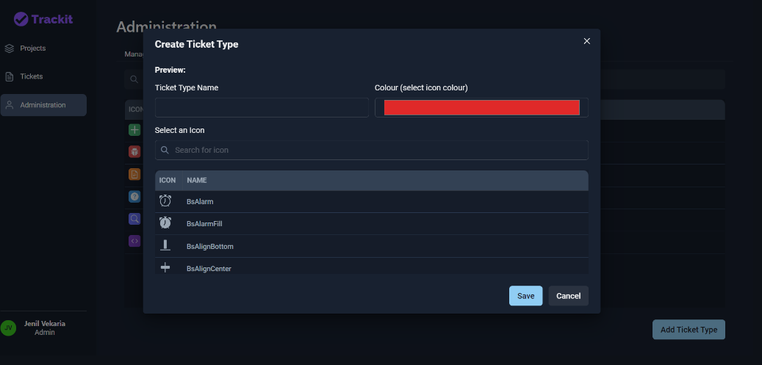

**APPLICATIONS**

1. Customer Data Centralization: CRM modules serve as centralized repositories for storing and managing customer data, including contact information, purchase history, preferences, and interactions. This centralized database enables organizations to gain a comprehensive view of each customer, facilitating personalized engagement and targeted marketing campaigns.
2. Sales Pipeline Management: CRM modules streamline the sales process by providing tools for managing leads, opportunities, and deals. Sales representatives can track the progress of prospects through the sales pipeline, prioritize follow-ups, and forecast revenue more accurately. Automated reminders and notifications help ensure timely and efficient sales interactions.
3. Marketing Campaign Automation: CRM modules support the automation of marketing campaigns, allowing organizations to create, schedule, and track campaigns across multiple channels. Marketers can segment customer lists based on various criteria, personalize messaging, and analyze campaign performance in real-time. This automation improves efficiency, effectiveness, and ROI for marketing initiatives.
4. Customer Service and Support: CRM modules enhance customer service and support by providing tools for managing inquiries, resolving issues, and tracking customer interactions. Service agents can access customer data and interaction history to provide personalized assistance and expedite resolution times. Integration with other communication channels, such as email and social media, enables omnichannel support delivery.
5. Customer Engagement and Retention: CRM modules enable organizations to proactively engage with customers throughout their lifecycle, from acquisition to retention and advocacy. By analyzing customer behavior and preferences, organizations can identify opportunities for upselling, cross-selling, and loyalty program participation. Personalized communications and targeted offers foster stronger relationships and encourage repeat business.
6. Forecasting and Analytics: CRM modules provide robust reporting and analytics capabilities, allowing organizations to track key performance indicators (KPIs), analyze trends, and forecast future sales and revenue. By leveraging data-driven insights, organizations can make informed decisions, identify growth opportunities, and optimize resource allocation for maximum impact.
7. Workflow Automation: CRM modules support workflow automation by automating routine tasks and processes, such as data entry, lead assignment, and follow-up reminders. This automation improves productivity, reduces manual errors, and frees up valuable time for sales and service teams to focus on higher-value activities, such as relationship-building and strategic planning.
8. Integration with Third-Party Applications: CRM modules often integrate seamlessly with other business applications, such as email marketing platforms, e-commerce systems, and ERP (Enterprise Resource Planning) software. This integration enables data sharing, streamlines processes, and ensures consistency across the organization's tech stack, enhancing overall efficiency and effectiveness.
9. Mobile Accessibility: Many CRM modules offer mobile applications or responsive web interfaces, allowing users to access CRM data and functionality on-the-go. This mobile accessibility enables sales representatives, marketers, and service agents to stay connected and productive, whether in the office or in the field, facilitating faster decision-making and response times.
10. Customer Feedback and Surveys: CRM modules support the collection and analysis of customer feedback through surveys, forms, and feedback mechanisms. Organizations can gather insights into customer satisfaction, preferences, and pain points, enabling continuous improvement and informed decision-making based on customer sentiment and feedback.

**FUTURE WORK**

1. AI and Predictive Analytics: The integration of artificial intelligence (AI) and machine learning algorithms into CRM systems holds significant promise for enhancing customer insights, predictive analytics, and decision-making. Future work may explore how AI can be leveraged to automate routine tasks, personalize customer interactions, and uncover valuable patterns and trends in customer data.
2. Omni-channel Integration: With the proliferation of communication channels and touchpoints, future CRM systems are likely to focus on seamlessly integrating interactions across various channels, including social media, messaging apps, and IoT (Internet of Things) devices. Research may delve into strategies for orchestrating omnichannel customer experiences and maintaining consistency and coherence across channels.
3. Customer Experience (CX) Optimization: As customer experience emerges as a critical differentiator in competitive markets, future CRM efforts may prioritize CX optimization through journey mapping, sentiment analysis, and continuous feedback mechanisms. Research could explore innovative approaches to enhancing CX at every touchpoint and across the entire customer lifecycle.
4. Personalization and Hyper-segmentation: Future CRM systems are expected to place greater emphasis on hyper-personalization and micro-segmentation, catering to individual customer preferences, behaviors, and needs. This may involve leveraging advanced analytics and real-time data to deliver highly tailored products, services, and communications.
5. Ethical Data Management: With growing concerns around data privacy and ethics, future CRM research may focus on developing frameworks and best practices for responsible data management and usage. This could include strategies for obtaining customer consent, ensuring data security, and promoting transparency and accountability in data handling practices.
6. Customer Lifetime Value (CLV) Optimization: Future CRM efforts may prioritize maximizing customer lifetime value (CLV) by identifying and nurturing high-value customer segments, reducing churn, and fostering long-term loyalty. Research may explore innovative strategies for CLV optimization, such as personalized loyalty programs and proactive churn prevention initiatives.
7. Voice and Conversational Interfaces: As voice assistants and conversational interfaces become increasingly prevalent, future CRM systems may incorporate voice-enabled capabilities for customer interactions, support queries, and product recommendations. Research may investigate the potential of voice technology to enhance user engagement and satisfaction within CRM contexts.
8. Blockchain and Decentralized CRM: The adoption of blockchain technology may introduce new possibilities for decentralized CRM solutions, enabling secure, transparent, and immutable customer data management. Future research could explore the feasibility and implications of blockchain-based CRM systems for enhancing trust, privacy, and data ownership rights.
9. Collaborative CRM: Future CRM efforts may emphasize collaboration and co-creation between organizations and customers, fostering deeper engagement and partnership-based relationships. This may involve integrating social CRM features, crowdsourcing customer feedback, and empowering customers to co-design products and services.
10. Continuous Learning and Adaptation: Finally, future CRM systems are likely to evolve towards continuous learning and adaptation, leveraging feedback loops, experimentation, and iterative improvements to refine customer interactions and business processes dynamically. Research may explore methodologies for agile CRM implementation and agile customer-centric culture development.

**CONCLUSION**

Customer Relationship Management (CRM) is a fundamental strategy for businesses to manage interactions with customers effectively. It enables personalized engagement, drives customer satisfaction, and fosters long-term loyalty. As technology evolves and customer expectations shift, future CRM efforts will focus on leveraging AI, optimizing omnichannel integration, and prioritizing ethical data management. By embracing CRM as a strategic imperative, organizations can differentiate themselves, drive revenue growth, and thrive in a customer-centered marketplace.

**REFERENCES**

[1]https://www.researchgate.net/publication/349609303_Customer_Relationship_Management_Research_from_2000_to_2020_An_Academic_Literature_Review_and_Classification

[2] https://link.springer.com/article/10.1007/s11365-022-00800-x#Sec16

[3] https://www.tandfonline.com/doi/full/10.1080/1331677X.2020.1836992

[4] IJRASET17289

[5]https://www.researchgate.net/publication/47654981_An_integrated_methodology_for_customer_relationship_management_customization