**[STUDY OF BLOCKCHAIN TECHNOLOGY IN FARMER’S](http://127.0.0.1:8000/index/) PORTAL**

Prof. Abhishek Nachankar1, Swaraj Pawar2, Tejaswini Potdukhe3, Dhanashree Zade4, Aniket Kamble5, Sejal Ramteke6, Mrunali Wanjari7*

**1Assiatant Professor, Department Of Computer Science & Engineering, KDK College Of Engineering, Nagpur**

**2,3,4,5,6,7Students, Department Of Computer Science & Engineering, KDK College Of Engineering, Nagpur**

**1Email: [swarajgpawar@gmail.com](mailto:swarajgpawar@gmail.com) 2Email: tejaswinipotdukhe12@gmail.com**

**ABSTRACT**

Blockchain is a way to confirm unbiased bids in memory of cryptocurrencies. the statistics are stored horizontally in several computer systems related to the peer-to-peer community. Contracts, transfers and documents related to the pastoral economy. They set obstacles and provide security to the method. This composition presents the use of blockchain technology in farm doors, the push for blockchain stability, and integrated terrain management alternatives that control the dealer and statistics center. The result uses Python as a programming language to integrate with the blockchain gadget that is required to store records approximately farmers, providers and employment contracts. that is, it is used to store information regarding merchants, shoppers, trade offers related to products, and all alternative prices. Blockchain is a machine in which the rationale for change is held by cryptocurrency. The document is maintained diagonally and connects many computers in a peer to see network. Contracts, offers and their facts indicate the country's profit machine. They set limits and add security to the method. thinking about blockchain's capabilities analogously to the balance and keeping of pictures of business information, this paper highlights the workings of the blockchain era with a farmer gateway that keeps pictures of promoting and purchasing plant statistics. The proposed result uses python as a programming language in integration with the blockchain machine on the way to benefit farmers or traders and is individualized by means of keeping the agreement of alternatives. The farmer interface is designed using the python programming language along with generating a blockchain that is used to store information associated with the provider, buyer, trading and purchasing of the item and general transaction costs.

**Keywords:** Blockchain, Digitization, Cryptography, Volatility, Public Account, ICT, Farmer Portal.

1. **INTRODUCTION**

They experience every movement, agreement between individuals, communities, partnerships, and nations. In this age of digital ion, the way we store and store this type of data must be changed, it is fundamentally secure, and blockchain is a consequence of this. In the era of information and communication technology, gateway farmers always provide multi-faceted assistance to farmers, providing farmers with value for money and information. Thus, the Government of India has taken a multi-disciplinary enterprise. similar portals Krishijagran.com, farmer.gov.in, agricoop.nic.in and agriwatch.com etc. less popular than this shopping site; FERT.nic.in and enam.gov. etc. Verbs that apply directly to the block are marked with an insert. 1. The application of blockchain technology in this field can create a decentralized computing and information platform, which will allow many companies that do not trust each other to cooperate, agree and unite in rational decision-making, and can create reliable information records. system. can contribute to development in the agricultural area. Since the blockchain is publicly available, it can be considered to provide many different aspects such as incentive protocols to ensure that every transaction from visitors is realized and understood. Alignment ensures that the original is consistent and organized. The film must be verified. Do not forget that the client can make a bad impression or take a risk. isolation and authenticity of data or transactions will come differently; must guarantee isolation and authenticity. Cryptography is the first part of how blockchain technology works. Public key encryption is the root of blockchain transactions and commerce, providing cryptographic hash functions and stability features, and Merle trees allow blockchain to be more efficient. Considering the following aspects, a lot of work has been done in the field of blockchain. Donations are offered through the gate. It can secure a secure platform for farmers to trade electronically with visitors. The main purpose of this research is to record a reliable contract between the dealer and the buyer. This can support farmers to get legal credit for their facts. The system facilitates a single transaction to record individual transactions. Gaps and information gaps are important points to get optimal results in time. Directly, the development of ICT makes it easier to get information from the global repository (internet). Accordingly, many people are physically deprived of Internet intelligence due to technical innocence and English language. The record is worse in developing countries like India, where about 76% are illiterate. In addition, the physical fortune of English-speaking people can not meet the exact demand from the physical database of the Internet due to the lack of complete knowledge of the English language. Indian farmers are turning to the same non-technical and non-essential species in English.

**2. Aim**

Blockchain technology helps improve food safety by enabling information traceability in the food chain. It provides a reliable way to store and manage data, streamline processes and use knowledge-based innovation for better agriculture and better agricultural insurance.

3. Purpose

Contract Protocol: Ensures that all secure transactions from the recipient are sent and stored on the blockchain for a limited time. Tamper proof. Please note that customers may be injured or harmed. Confidentiality and authenticity must be guaranteed.

**4. Literature review**

1. Krishi- Bharat I is a social worker in India. The World Health Organization sleeps in a digital vault. Uneducated people cannot reap the benefits of the ICT revolution. Important information about farming is really useful for farmers to make good calls, which is why we like to produce special bow services.
2. Krishi Ville- Android - has given complete results for agriculture in India. This includes the skillful use of ICT in a pastoral setting. Advances in information and communication technology are used to provide farmers with accurate, timely and relevant information and services, thereby increasing agricultural productivity. This composition describes the highly structured practices of farmers that can improve agriculture. We want to discover Chrissy Will, Puppy Dog - a mobile application that allows you to check the latest updates, updates and new agricultural news about colorful agricultural products. Tool aimed at keeping Indian agriculture in mind.
3. Blockchain is the basic history of decentralized agriculture for work sharing. The local part of the cast is varied and complete. thus, the assembly process is transparent and reliable, and manufacturing is delicate. Blockchain technology can be used not only in manufacturing, but also in the history of agriculture.
4. Krishi-Bharat, India Planter author Gosh, Somalia, A.B. Garg, Sayan Sarcar, PSVS. Sridhar, Ojasvi Maleyvar and Raveesh Kapoor The rapid growth in ICT helps humanity's entry fields - agriculture, education, health, etc. - until the digital society is limited specifically to ICT processes. live in a digital pocket. Uneducated people - gardeners, shopkeepers etc. They do not reap the benefits of the ICT revolution. According to the UNESCO report, the same number of people in this field is 64 or not suitable to use technology as language or special hedgehog. This opportunity should also flourish in the developing world environment. Basic farm information is really useful for farmers to take operational decisions, so we decided to develop a targeted interface integrated with land trade in Indian language. The interface under study was criticized by translators from unknown Indian countries. The evaluation results prove the robustness of the provided interface.
5. Krishi Ville - Agriculture in India AUTHORS Singhal, Manav, Kshit IJ Verma and Anupam Shukla An Android-based solution for information and communication technology (ICT) leads to improved agricultural and pastoral development in India. This includes expert practice using ICT in pastoral care. ICT development can be used to provide farmers with accurate and timely information and services, thereby facilitating profitable farming. This article describes a mobile soil application for farmers to support them in farming situations. We offer a mobile app for Android - Krishi Ville which cares about unknown agriculture updates, rainfall updates, agriculture news. This practice is intended to reflect Indian agriculture.
6. Evidence-Based Blockchain for Agricultural Distribution Platforms and Authors Hua, Jing, Xuan Wang, Mengzhen Kang, Haio Wan, and Fei, Transferred and Contributed, is essential to disrupt food security. However, stakeholders (farmers, planters, traders, etc.) are numerous and physically dispersed, making it difficult to obtain data and information centrally. As a result, the product process remains unclear and difficult to trust. In this paper, we propose an agricultural verification system based on decentralization, shared custody, contractual trust, and a blockchain-based blockchain pathway to break the limits of trust in the power chain of products. Recorded data includes tasks (pouring, irrigation, etc.) with a specific data structure. Using agricultural product verification methods not only expands the scope of blockchain's work, but also supports building a safe community among anonymous stakeholders around agricultural products.
7. A Special Study on Bitcoin and other Decentralized Digital Currency author Tschorsch, Florian, and Björn Scheuermann In addition to attracting a billion bone scams, Bitcoin has revolutionized the digital currency industry and informed many areas. This has also attracted significant scientific interest. In this study, we explore and formulate some effects and research directions. From there, you have to explore the project room, acting with charity and influence. At this stage, we conclude with the abecedarian structure and sensibility in the guts of the Bitcoin protocol and operations. As we have shown, many key ideas can be applied to various other areas, so their impact extends far beyond Bitcoin.
8. Using ICT to improve the flow of information to improve farming sustainability in AUTHOR SL, Sri Lanka. N. De Silva, J.S. Goonetillake, G.N. Vikramanayake and A. Ginger farmers need information at all stages of the farm life cycle to make optimal decisions. The required information includes not only prior knowledge, but also real-time (dynamic) information such as demand prices and current product availability. Some of the valuable information required by farmers is produced by government associations and is available in unknown formats in unknown places. Although crops are the most important aspect of agriculture, there is no significant problem in providing essential information to farmers in real time. The lack of information creates many problems for farmers because it is not suitable to give an accurate opinion about the farming situation. Through field research, we link the information needed by farmers at different stages of the farming cycle with validated sources from which this information is available. We then developed an information flow model that linked color information sources with growers' information needs. Based on this decision, we are currently developing a mobile phone-based information system to deliver real-time information to farmers.

**5. The existing system**

Today's farming system, like agriculture, is the basis of life. Much research is being done to improve agriculture by developing technologies that directly and indirectly support agriculture. Research shows that with various advances in information and communication technology (ICT), farmers can make better use of inputs and get better yields for their crops. A system that benefits farmers by providing information on advances in agricultural technology. There are many opportunities in agriculture, there are many opportunities in agriculture, especially in the food industry and in supply chain management. Agricultural cell technology licensing changes the way agricultural products are processed by reducing the need for data verification.

Disadvantages of the system: Work depends on third parties

6. Formulation of the Problem

Creating a project using blockchain on the farmer portal will meet the needs of farmers, provide them with jobs and information, and also provide a platform where they can volunteer and sell their produce at a low price. The use of Blockchain technology in this area can provide an algebra and data sharing platform that can collaborate, manage and collaborate in decision-making in various trustless domains and provide a secure record system. can be made. . produced. Contribute to development. The seller can be a farmer or his representative or assistant. Registered users log in with valid credentials. Users can access the portal/interface. Users can view crop and seed items with prices.

**7. The proposed system**

The concept of an agricultural portal is a portal for e-commerce in crops. The user experience of the portal can be customized according to the user's preferences. One accessible site, everything is in one place and the only thing that needs to be verified is the user's login ID. everything. They can add products to their shopping cart. Signatures and runtimes are linked to the blockchain, ensuring that no user can deny their work.

**8. Algorithm**

Algorithm for timeout when something is added to the system:

Step 1: - START

Step 2:- New Active Item:

Step 3:- If the user does not authenticate the seller:

Step 4: - Back - Login with Seller Account -

SellerUserRegisterActions (request)

SellerUserHome (request) > SellerAddItemsForm (request)

SellerAddItemsAction (request)

SellersCommodities (request) <br> SellerUpdateProducts (request)

SellerDeleteProducts (request)

Step 5:- If HTTP request is POST

Step 6: - Json Packet = { Name: > Step 7: Enter the product - Upload the Json packet to the blockchain. = request.POST.get('cvv') cardexpiry = request.POST.get('cardexpiry')

Step 8: - Add a new element to the database

Step 9:- Go back to the Switch Product list page

Step 10: - FINISH

Use the recording time algorithm when trading:

Step 1: - START <br> Step 2: - Buy Products in Shopping Cart Function: <br> Step 3: - If HTTP request method is POST:

Step 4:- Select all the items in the cart

Step 5:- Set the flag to 0

Step 6: - In the product cart:

Step 7:- If product price is not available:

Step 8:- Set the flag to 1

Step 9:- If the flag is 1:

> Step 10: - Return - Product deficiency -

Step 11: - For the product in the shopping cart: Json Package = {Name: PurchaseName, Quantity: Purchased Product Quantity, Buyer: BuyerName, Price: Total<br>Transaction Value};

Step 12:- Add JSON package for blocking operation. - Returns - Thank you for your purchase -

Step 15: - FINISH

**9. APPEARANCE:**

**MODULE:**

**Seller**

**Buyer**

**Admin**

**Blockchain**

**MODULE Description:**

**Merchant (Seller):**

The seller can register the mason first. At the time of registration, the correct sender is required and it can be copied for the next send. After the author is registered, the administrator can also add vendors. After the admin activates the dealer, he can access our system. Dealers can add new items, improve features, and increase inventory. It will increase the availability of requests and also eliminate middlemen.

**Buyer:**

The seller can register the mason first. At the time of registration, the correct sender is required and it can be copied for the next send. After the rock record registration, the administrator can upgrade the merchant. After the admin activates the dealer, he can access our system. Buyers can purchase products and check any product they want. They can add products to the wine and remove the plant from the plant. After finalizing the product for purchase, the mason can inspect it.

**Admin:**

Can login using admin credentials. Once inside, it can increase the number of traders and buyers. A powered stone crusher is only included in our operation. Seller admin can see all sales made by buyer sellers. In the dashboard, one can see all blockchain transactions with previous block details and hash values.

**Blockchain:**

Each attempt to insert a new item and cut something is counted as a sale, and the result is added to the block with a precise digital hand and time stamp, so that any stoner can not get the job done. All these transactions are visible to everyone on the network. Blockchain is a peer-to-peer transaction based on a decentralized system through encryption of data, time, and contracts. Since the channel is transparent and public, it makes the gateway more secure in terms of data.

**10.MATHEMATICAL MODEL Calculation of various processes:**

Use this formula: (n/2)(first number + last number) = total,

where n is the number type. Python module is used to create this program. This research is used to improve the back-end features of the portal, especially routing, template generation, frame routing, and session configuration. it can be used directly in applications such as business portals that use e-commerce or business processes. This portal is used to connect SQL directly to the web application and perform the required tasks. The modules associated with the interface are SHA224, SHA256, SHA384, SHA512 and RSA MD5. Comparison of average time (MS) and cost (%) of blocking using RSA-DS. The author found that encryption using RSA-DS is commercial. However, RSA-DS does not include hash values ​​and is therefore more secure. The recommended protocol uses SHA256. It usually produces a hash that includes the directory, transaction, timestamp, previous hash, and published block.

JSON is a common data exchange format for requesting data in JSON format. Our work on capturing business success milestones has become popular. In our business, we are used to taking chances when everything works out. In our work, it is used to determine the type of system, directory, and other variables that the system application should be directed to.

**11. System Architecture**

**Description:**

Users: Users can be buyers or sellers. The seller can be a farmer or his representative or assistant. Registered users log in with valid credentials. If the user successfully logs in. The user will enter the portal / interface. Users can view products such as plants and seeds and their prices.

**Advantages:**Trading blockchains use public records and persistent records that only authorized members can access. The chain significantly reduces administrative and transaction costs and reduces or eliminates third parties or intermediaries that confirm transactions.

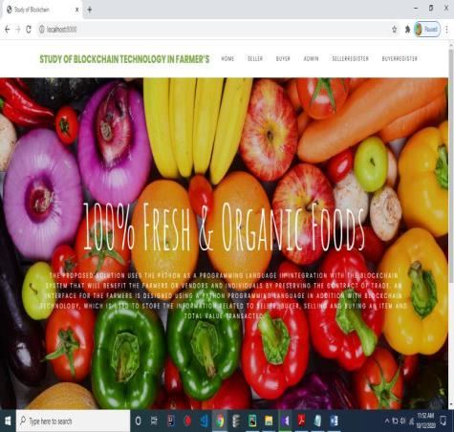

**Figure : Home Page**

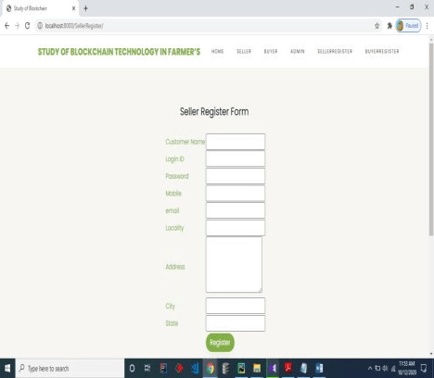

**Figure : Seller Registration Page**

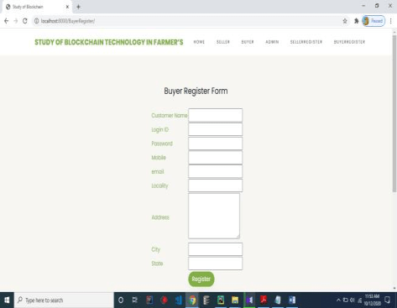**Figure : Buyer Registration Page**

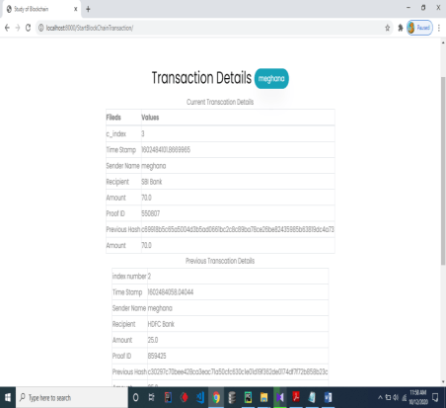

**Figure : Blockchain Transaction**

1. **CONCLUSION**

So, we tried to use the paper of Rahul Talreja, Rohan Chuksey and Sushma Verma IEEE 2020 "Research on Blockchain Technology in Employee Portal". As a result, honeycomb technology will be revised to be transferable to agriculture. There are plans to create a portal with a blockchain contract where a planter can register and sell their products. The merchant records the details of the plant, the shipment to be purchased and the quantity of the plant to be purchased. Blockchain technology in Agriculture can bring revolutionary advances in areas such as secure farmer data, seed quality monitoring, soil moisture monitoring, crop yield data and crop demand and transportation. In this process, the crop screen is protected to deal with the effect of crop demand and trade load, and a fair load of crops is taken. For this, there is a gate where the farmer can register and sell his crops by notifying the sale at a time where he is obliged to buy. This salesperson can report the details of the plant, the plant purchased and the quantity of plant purchased. The flexible nature of this Blockchain technology will help growers reduce the cost of buying and selling crops while obtaining a legal image of their crops and assimilating them to traditional standards.

1. **Online license transfer**

All authors are required to complete the Progeria Exclusive License Agreement before publishing their composition, which can be done online. This transfer agreement allows Elsevier to cover its copyright material for the author, but does not waive the author's personal birthright. The trademark includes the exclusive right to reproduce and distribute the composition, including reproduction, reprints, photographic reproduction, microfilm or other reproduction of a similar nature and reproduction.

**References**

* Rahul Talreja, Rohan Chuksey, Sushma Verma- Blockchain Technology Research at Daihan Portal-, IEEE 2020. "The Truth About Blockchain." Harvard Business Review 95 (2017) 118- 127. "2017 Global Blockchain Benchmark Study." Public at SSRN 3040224 (2017). "
* Blockchain Technology Research in IoT Applications and Security (2019) 100107.
* AB Garg, Sayan Sarcar, S. Eindhoven, Sridhar, Ojashwi Maliwal, and Ravish Kapoor. "Krishi-Bharti Sausage to Indian Farmers." 2014 IEEE Student Conduct. "
* RKrishi Ville - Android affects agriculture in India.
* "Lockdown in Agriculture". Popular at SSRN 3397786 (2019).
* Aki Lakhani, KarimR., M. Iansiti. "Heart About Blockchain." Harvard Business Review 95 (2017) 118-127.
* 2) Hilleman, Garrick and Michelle Rauchs. "2017 Global Blockchain Assessment Survey." Public at SSRN 3040224 (2017).
* 3) Mohanta, BhabenduK., Debasish Jena, SoumyashreeS. Panda and Srichandan Sobhanayak. "Survey of Blockchain Technology, Applicat ions and Film Isolation Challenges." Internet of Things (2019) 100107.
* 4) Adadav, Vinay Surendra and A.R. Singh. "A Systematic Literature Review of Blockchain Technology in Agriculture."
* 5) Ghosh, Soumalya, A.B. Garg, Sayan Sarcar, PSVS. Sridhar, Ojasvi Maleywar and Ravesh Kapoor. "Krishi- Bharat i Interface for Indian Farmers." In Proceedings of the 2014 IEEE Pundits Technology Symposium, p. 259– 263. IEEE, 2014.
* 6) Singhal, Manav, Kshit ij Verma and Anupam Shukla. "Crisis Ville - Android releases sol ion for Indian agriculture." 2011 IEEE Fifth International Conference on Advanced Telecommunication Systems and Networks (ANTS), p. 1– 5. IEEE, 2011.
* 7) Potts, Jason. "We are in agriculture." Popular at SSRN 3397786 (2019).
* ) in 2018 IEEE Symposium on Intelligent Devices (IV), p. 97– 101. IEEE, 2018.
* 9) Zhu, Sinxiong and Dong Wang. "Discovery of Blockchain Applicat ions for Commerce, Finance and Energy." In IOP Conference Series Earth and Environmental Sciences, Vol. 252, no. 4, p. 042126. IOP Publishing, 2019.
* 10) Tschorsch, Florian and Björn Scheuermann. "Technical Analysis of Bitcoin and Decentralized Digital Currencies." IEEE Test Letters and Tutorials 18, No. 3 (2016) 2084- 2123.