**ADVANCES IN NANOSTRUCTURED LIPID CARRIERS: FORMULATION STRATEGIES, APPLICATIONS, AND FUTURE PERSPECTIVES**

**Aman P. Sutarkar1, Vaishnavi G. Bahe2, Shagufta A. Khan3**

1,2,3Department of Pharmaceutics, Institute of Pharmaceutical Education and Research, Wardha, Maharashtra, India.

**ABSTRACT**

Nanostructured lipid carriers (NLCs) have emerged as versatile nanocarriers in the field of drug delivery, offering promising solutions to various challenges encountered in conventional formulations. This review provides a comprehensive overview of recent advances in NLC formulation strategies, highlighting their role in enhancing drug solubility, stability, and bioavailability. We discuss the diverse applications of NLCs in delivering a wide range of therapeutics, including poorly water-soluble drugs and biologics, as well as their potential for targeted drug delivery and combination therapy. Moreover, we explore the future perspectives of NLCs in biomedical imaging, vaccine delivery, regenerative medicine, and personalized medicine. Emphasis is placed on the biocompatibility and safety considerations of NLCs, along with efforts to scale up production and address regulatory challenges for clinical translation. This review aims to provide insights into the current state-of-the-art in NLC research and the promising directions for future development in this rapidly evolving field.

**Keywords:** nanostructured lipid carriers (NLC’s), nanoparticles production, nanomedicine, drug delivery system.

1. **INTRODUCTION**

Nanomedicines seeks to detect and cure illnesses more accurately with the least amount of side effects. Due to its effectiveness in delivering medications and other bioactives more precisely to the specific tissues, nanomedicine has grown in popularity. (1,2) These drug delivery methods use colloidal drug carrier systems called nanocarriers, which have submicron particle sizes, usually less than 1000 nm. Drugs' fundamental characteristics and bioactivity can be altered by nanocarriers because of their high surface area to volume ratio. Additionally, they enable improved pharmacokinetics and biodistribution of the drugs, enhanced bioavailability, (3–5) controlled drug releasing profiles, prolonged blood circulation times, enhanced intracellular penetration; and site- and organ-specific targeted delivery. They also enable drug protection from different environmental conditions like humidity, pH changes and presence of enzymes, etc.

Nanoparticles have been made from a variety of materials, mostly polymeric, lipid, and inorganic components. Lipid nanocarriers distinguish amongst different nanoparticles because of their low toxicity, biodegradability, biocompatibility and delivery of both hydrophilic and lipophilic medicines in regulated and targeted manner. (6,7) Additionally, these carriers may penetrate through physiological barriers like the intestinal epithelium and the blood-brain barrier.(8) Furthermore, hybrid nanoparticles can be created to enhance the characteristics of lipid-based nanoparticles by combining the benefits of several materials. For instance, a novel strategy based on modifying the lipid matrix with polymers to create a lipid–polymeric matrix that traps the drugs might be created.(9–11)

Lipids are generally described as hydrophobic or amphipathic molecules that are soluble in organic solvents but insoluble in water.(12) Lipids have the potential to transport water-insoluble active substances via several modes of administration in the pharmaceutical industry.(13) Their physicochemical properties and processing flexibility have facilitated the development of more specialized active delivery systems, thereby preventing some of the drawbacks associated with emulsions, liposomes, polymeric nanoparticles, and other conventional pharmaceutical forms based on lipids, such as low load capacity, instability issues, or the use of toxic substances that restrict their commercial development.(14)

Among these are the so-called Solid Lipid Microparticles (SLM), which were created in the 1980s and made via spray congealing or spray drying methods. Subsequently, biocompatible and biodegradable lipids in the submicron range were used to produce aqueous dispersions of solid lipid nanoparticles (SLN).(7,15) A surfactant, the concentration of which ranges between 0.5% and 5% w/w, stabilizes the aqueous dispersions of SLN, which comprise solid lipids with concentrations ranging from 0.1% to 30% w/w.(14,16)

The SLN has been noted as having a number of qualities that make them fascinating for use in pharmaceutical product design. These include the active ingredient's good loading capacity, the ability to encapsulate hydrophilic and hydrophobic substances with a range of physicochemical and pharmacological properties, the potential to create "stealth" particles that can evade the reticuloendothelial system (RES), and the ability to control how the active ingredient releases.(7,17,18)

However, solidifying and crystallizing the lipid from the dispersed phase in the SLN causes the expulsion of active compounds, posing a significant instability issue.(19) Lipid molecules gradually crystallize into more stable forms, leading to larger particles and decreasing loading capacity.(16,20)

To solve the problem of instability, a new colloidal system called Nanostructured Lipid Carriers (NLC) was created by replacing a portion of the solid lipid with a liquid lipid or mixture of liquid lipids.(21) This allows the particle to remain solid at room and body temperature. The NLC has a higher loading capacity than the SLN, allowing for more active molecules to be stuck in particle imperfections and escape early expulsion. Similarly, NLCs offer superior stability since they do not enable the recrystallization of solid lipids, hence the size remains essentially identical during storage.(16,22)

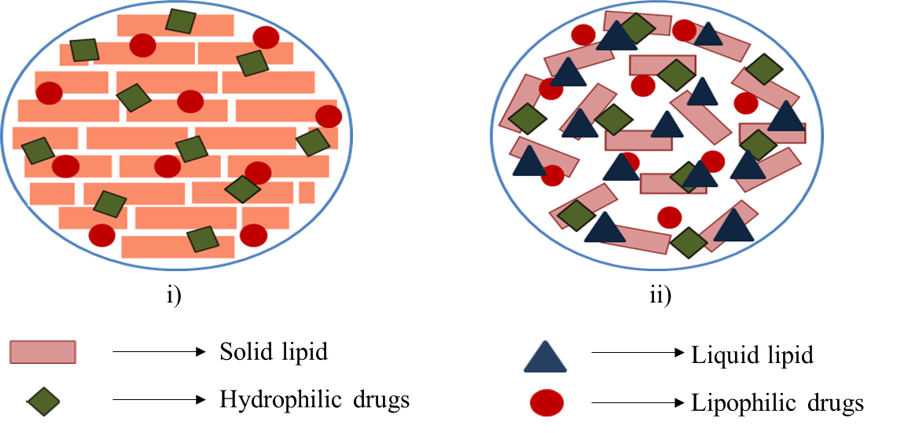

**Figure 1:** i) Solid lipid nanoparticle, ii) Nanostructured lipid carriers

However, in addition to the utilization of entirely biodegradable and biocompatible natural excipients, the SLN and NLC release systems are particularly appealing due to their ease of industrial manufacturing.(23) Drugs can be designed for targeted delivery and administered through different routes.(7) Also, they have demonstrated their potential in parenteral formulations.(14,24–26) When used for peroral administration of water-insoluble medicines, they create monoglyceride micelles with bile salts, retaining the active ingredient. Their absorption through the lymphatic system can mitigate the first-pass effect.(10) Furthermore, dermal administration of these carriers enhances penetration, creates an occlusive effect, and decreases side effects.(16,22) SLN and NLC are ideal for pulmonary applications due to their low toxicity and compact size, which allows for efficient delivery to alveolar sacs.(20,27) Administration via nasal, ocular, and cerebral routes has also been examined.(28–30)

1. **ADVANTAGES OF NLC’s**

* Increased physical stability
* Ease in scaling up and preparation
* Enhanced aqueous media dispersibility
* High entrapment of hydrophilic and lipophilic medications
* Regulated particle size
* A very sophisticated and effective carrier system for lipophilic compounds
* Increased occlusion of the skin
* Prolonged drug release
* Because their lipid components are approved or are excipients in commercially accessible topical cosmetic or pharmaceutical preparations, one of the preferred carriers for medications used topically
* The stratum corneum is kept in close contact by the small size of the lipid particles, which improves medication penetration into the skin or mucosa.
* Because of their solid lipid matrices, which are also widely acknowledged as safe or to have a regulatory-accepted status, these carriers are very effective systems.(3)

1. **LIMITATIONS OF NLC’s**

* Effects of cytotoxicity associated with matrix type and concentration.
* Certain surfactants have an irritating and sensitizing effect.
* It is still necessary to better explore the application and efficacy of gene delivery methods and protein and peptide medicines.
* Inadequate preclinical and clinical research on these nanoparticles in the context of bone regeneration.(3)

1. **STARTING MATERIALS USED FOR PREPARATION OF NLC’s**

The composition and the process variables significantly affect particle size, drug entrapment efficiency, and release profile. The researchers effectively used process parameters and composition to get desired results. Muchow et al. found that small-sized NLCs (200 nm) had better area under curve values than larger NLCs (600 nm) when administered orally to rats. This is owing to their higher mucoadhesion capabilities. The degree of crystallization of lipids utilized in formulation impacts drug entrapment and loading capacity.

1. **Lipids**

Lipid nanoparticles are mostly made up of lipids, which play a significant role in determining their properties. NLCs are prepared using a precise ratio of liquid and solid lipids, as well as surfactants. Materials used for production should be biocompatible, well-tolerated, non-toxic, and biodegradable. The lipid has a key role in NLC stability, drug loading capacity, and controlled release. NLCs are made from various lipids, including as fatty acids, waxes, and glycerides.

Table no. 1 shows the several lipids which are frequently used in the preparation of NLC’s. However, stearic acid, glyceryl behenate, tripalmitin, cetyl palmitate, glyceryl monostearate and tristearin altogether make up about 70% of the most used solid lipids. Also, oleic acid and caprylic/capric triglycerides are the most common liquid lipids used. Canola stearin and myristyl myristate have also been used to lesser extent.(31)

**Table 1:** Lipids frequently used in preparation of NLC’s

|  |  |
| --- | --- |
| Lipids | References |
| **Triglycerides**  Tricaprin, (Dynasan® 110)  Trilaurin (Dynasan® 112)  Trimyristin (Dynasan® 114)  Tripalmitin (Dynasan® 116)  Tristearin (Dynasan® 118)  **Fatty acids**  Stearic acid  Oleic acid  Palmitic acid  Behenic acid  **Monoglycerides**  Glyceryl monostearate (Imwitor® 900, Geleol®)  Glyceryl behenate (Compritol® 888 ATO)  Glyceryl palmitostearate (Precirol® ATO 5)  **Mixtures**  Witepsol® W35 (a mixture of 65–80% of triglycerides,  10–35% of diglycerides and 1–5% of monoglycerides)  Witepsol® H35 (triglycerides with portions of max. 15% of diglycerides and max. 1% of monoglycerides)  Medium-chain triglycerides caprylic/capric (Miglyol®  812)  **Fatty alcohols**  Stearyl alcohol  Cetyl alcohol)  Lauryl alcohol  **Waxes**  Cetyl palmitate  Beeswax  Carnauba wax | (32)  (33)  (34)  (35)  (36)  (37)  (38,39)  (39)  (39)  (38)  (38)  (38)  (40)  (19)  (41)  (42)  (42)  (42)  (43)  (44)  (44) |

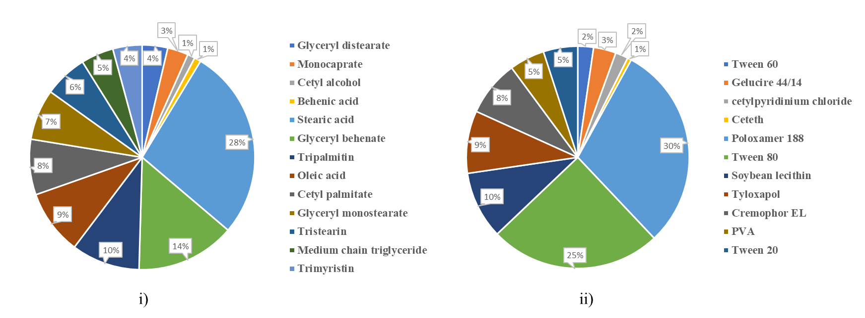

**Figure 2**: i) Distribution of the most used lipids for the preparation of NLC’s. ii) Distribution of the most used stabilizing agents for the preparation of NLC’s.

1. **Stabilizing agents**

Stabilizing agents, primarily surfactants, are utilized in the manufacturing process of NLC as they can lower the interfacial energy between the lipid phase and the aqueous phase during the preparation of the particles, this is because of their natural tendency to gather at the binding interface and form a layer surrounding the particles that supports the dispersion's physical stability throughout storage.

According to the study, the stabilizing agent affects the particles' crystalline structure and controls a variety of aspects of their electrokinetic activity. The most often employed non-ionic stabilizing agents are Tyloxapol, Tween 20, and Poloxamer 188, although soy or egg lecithin seems to be the preferred amphoteric stabilizing agents in the majority of research. Catalytic lipid nanoparticle productions have also been done using quaternary ammonium surfactants. Furthermore, polyvinyl alcohol (PVA) is often chosen as a substitute stabilizer.(31)

1. **Other Components**

Other additives, such as glucose, fructose, and sorbitol, are used as cryoprotectants in lyophilized formulations; chitosan has been reported as a coating material; and parabens or thiomersal are included as antimicrobial preservation agents for particle dispersions, in addition to the lipid components and stabilizing agents used to prepare SLN and NLC. Additionally, several commercial preservatives have been employed that were made from phenoxyethanol, potassium sorbate, pentylene glycol, benzyl alcohol, tocopherol, and others.(31)

1. **Active molecules incorporated in NLC’s**

Many medications are possibilities for incorporation into these types of nanoparticles due to their lipophilic properties and low solubility in water. As of right now, these have included antipsychotics, antibiotics, anti-parasitic, antiretrovirals, analgesics, antipyretics, anxiolytics, anaesthetics, and antihypertensive medications. Additionally, studies on the encapsulation of peptides and nucleic acids in lipid particles have been published.(31)

1. **TYPES OF NLC’s**

Different varieties of NLCs are produced depending on the composition of the lipid blends and the various production procedures used. The main idea is to give the lipid matrix a specific nanostructure in order to improve the loading of active moieties and decrease compound expulsion during storage. Different types of NLC’s can be summarized as:

1. The imperfect type,
2. Amorphous type, and
3. Multiple types.

The lipid crystal's formation limits the amount of drugs that may be loaded into SLNs. The NLC type 2 demonstrates that drug ejection can be prevented by avoiding crystallization, as drug expulsion has been shown as a result of a continuing crystallization process towards a perfect concentration.   
The lipid matrix is amorphous, despite being solid and not crystalline. This can be accomplished by combining particular lipids with iso-propyl myristate, such as hydroxyoctacosanyl hydroxystearate. The third type of NLC incorporates fine droplets in the form of a multiple system, which is similar to w/o/w emulsions, or oil-in-solid lipid-in-water dispersions. There are microscopic liquid oil nano-compartment particles in the solid lipid matrix. This kind of NLC makes use of the fact that a large class of medications are more soluble in oils than in solid lipids.(3)

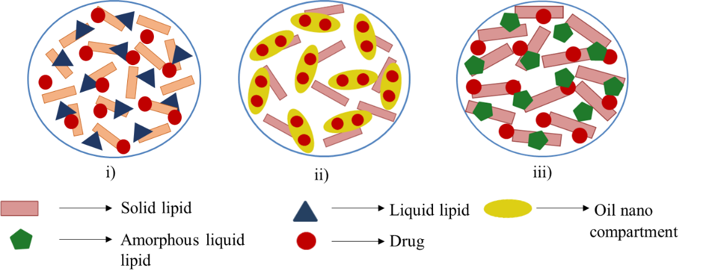

**Figure 3:** Different types of NLC’s i) imperfect, ii) multiple, and iii) amorphous

1. **PREPARATION METHODS OF NLC’s**

There are several methods of preparation for nanostructured lipid carriers. Some of them are mentioned below(3)

1. **High pressure homogenization**

Parenteral emulsions, SLNs, NLCs, and lipid drug conjugates have all been produced on a large scale using HPH technique which is a dependable and effective method. High pressure (100–2000 bars) is applied to the lipid, causing it to undergo extreme shear stress and particle breakup down to the submicrometer or nanometer range. Lipid levels typically vary from 5% to 10%. Unlike other preparation methods, high pressure homogenization exhibits no scaling up issues. Homogenization can be carried at below room temperature or at a higher temperature (hot homogenization).

1. **Hot homogenization technique**

This method involves dispersing the medication and melting lipid in an aqueous surfactant solution at room temperature while continuously swirling the mixture with a high shear device. After homogenizing the pre-emulsion with a piston gap homogenizer, the resulting nanoemulsion is cooled to room temperature, which causes the lipid to recrystallize and produce nanoparticles.

1. **Cold homogenization technique**

Cold homogenization is carried out with the solid lipid-containing drug. In order to deal with the issues with the hot homogenization approach, such as temperature-mediated, rapid drug payload degradation, drug partitioning and subsequent loss of drug into the aqueous phase during homogenization, cold homogenization was developed. Both the heat and cold homogenization processes start with the same stage. The drug-containing melt is then quickly cooled with ice or liquid nitrogen to distribute the medication throughout the lipid matrix. The sample's temperature exposure is reduced by cold homogenization.

1. **Microemulsion technique**

This method involves melting the lipids and injecting the medication into the molten lipid. The surfactant, co-surfactant(s), and water are combined and heated to the same temperature as the lipids and added to the lipid melt while gently stirring. Combining the components in the right ratios to generate microemulsions results in a transparent, thermodynamically stable system. Therefore, the foundation for the production of nanoparticles with the necessary size is the microemulsion.   
The hot microemulsion is then gently mechanically mixed with water in a ratio of 1:25 to 1:50 to disperse it in a cold aqueous media. The oil droplets quickly recrystallize as a result of this dispersion in a cold aqueous media. Among the surfactants and co-surfactants are alcohols like butanol, lecithin, and biliar salts. Because of their regulatory restrictions, excipients like butanol are utilized less frequently. A sizable temperature-controlled tank is used to create the microemulsion, which is subsequently pumped into a cold water tank for the precipitation process.

1. **Solvent emulsification-evaporation technique**

The lipophilic substance and hydrophobic medication are dissolved in a water immiscible organic solvent and emulsified in an aqueous phase using a high speed homogenizer in the solvent emulsification-evaporation process. Immediately passing the coarse emulsion via a microfluidizer increases the fine emulsification's efficiency. Additionally, the organic solvent is removed by mechanical stirring in a rotary evaporator at room temperature and low pressure, resulting in the precipitation of lipid nanoparticles.

1. **Melting dispersion method**

This method can be utilized in both the aqueous and oily phases, provided that the solvent used is at least somewhat miscible with water. In the beginning, the solvent and water are mutually saturated to maintain the two liquids' initial thermodynamic equilibrium. The saturation step is carried out at the same temperature as the heating operation to solubilize the lipid. Subsequently, the medication and lipid were dissolved in this organic phase and a solvent saturated with water. The solvent emulsification and evaporation is done by stirring with a mechanical stirrer. Water is introduced to the system at a typical ratio of 1:5 to 1:10 after the o/w emulsion has been formulated. This allows solvent diffusion into the continuous phase, which causes the lipid in the NLC's. While the diffusion process is carried out at room temperature, both phases must be kept at the same high temperature.

1. **Melting dispersion method**

The drug and solid lipid are melted in an organic solvent known as the oil phase in the melting process, while at the same time the water phase is heated to the same temperature as the oil phase. The oil phase is then combined with a little amount of water phase, and the resulting emulsion is agitated vigorously for a few hours. Ultimately, room temperature is reached to produce nanoparticles.

1. **High shear homogenization and ultrasonication method**

This process is one of the least explored ways to create lipid nanoparticles. Initially, the material is melted, then phospholipids and an aqueous media are added, and lastly the molten material is dispersed at a higher temperature using mechanical stirring or ultrasonication. Ultrasonic energy is used to reduce the particle size of the soy lecithin-based core lipid emulsion.

1. **Solvent injection method**

The solvent injection method and the solvent diffusion method have a similar basic idea. When injecting a solvent using an injection needle, lipids are rapidly injected into an aqueous surfactant solution after being dissolved in a water-miscible solvent (such as acetone, isopropanol, and methanol) or water-miscible solvent combination. This method's advantages include its simple handling and quick production process, which eliminates the need for technically complex equipment (such a high-pressure homogenizer). However, using organic solvents is the primary drawback.

1. **Double emulsion technique**

The medicine (mostly hydrophilic pharmaceuticals) is dissolved in an aqueous solution and then further emulsified in melting lipid in the double emulsion process. Stirring and filtering are done after adding stabiliser that has been distributed in an aqueous phase containing hydrophilic emulsifier to stabilize the original emulsion. By using the double emulsion process, lipid does not need to be melted in order to generate peptide-loaded lipid nanoparticles. Additionally, the surface of the nanoparticles can be altered to incorporate lipid and sterically stabilize them- Derivatives of PEG

**7. FUTURE PERSPECTIVES**

In the future, nanostructured lipid carriers (NLCs) are expected to play a crucial role in advancing drug delivery systems. They offer several advantages such as improved drug solubility, stability, and bioavailability, making them ideal for delivering a wide range of therapeutics, including poorly water-soluble drugs and biologics.NLCs can be engineered to target specific tissues, cells, or organelles, reducing off-target effects and enhancing therapeutic efficacy. They also allow for the co-delivery of multiple drugs or therapeutic agents, enabling synergistic effects and personalized treatment approaches.

In addition, NLCs can be functionalized with imaging agents, targeting ligands, or stimuli-responsive elements, enabling simultaneous diagnosis and therapy (theranostics). They show promise for improving the stability and efficacy of vaccines, particularly for antigen delivery and immune response modulation. Further research aims to optimize the biocompatibility and safety profile of NLCs, ensuring their clinical applicability and minimizing adverse effects. Efforts are also ongoing to scale up the production of NLCs and address regulatory challenges to facilitate their translation from the laboratory to clinical practices.

1. **CONCLUSION**

Nanostructured lipid carriers (NLCs) have emerged as a promising platform for drug delivery, offering numerous advantages over conventional delivery systems. This review has highlighted the recent advances in the formulation strategies, applications, and future perspectives of NLCs.

Formulation strategies play a crucial role in enhancing the performance of NLCs. One of the key strategies is the use of a combination of solid lipids and liquid lipids, which helps to overcome the limitations of each lipid type. Solid lipids provide stability and control over drug release, while liquid lipids improve the loading capacity and bioavailability of poorly soluble drugs. The ratio of solid to liquid lipids can be optimized to achieve the desired drug release profile and stability. Additionally, the incorporation of surfactants and co-surfactants can further enhance the stability and drug loading capacity of NLCs.

NLCs have been successfully applied in various therapeutic areas, including cancer therapy, gene delivery, and vaccine delivery. In cancer therapy, NLCs have shown great potential for the delivery of chemotherapeutic agents, allowing for targeted and controlled release of drugs to the tumor site while minimizing systemic toxicity. In gene delivery, NLCs have been used to deliver nucleic acids, such as siRNA and plasmid DNA, offering a promising approach for the treatment of genetic disorders and other diseases. In vaccine delivery, NLCs have been explored as adjuvants to enhance the immune response and improve the efficacy of vaccines.

Looking ahead, several future perspectives can be envisioned for NLCs. One area of future research is the development of multifunctional NLCs that can deliver drugs, imaging agents, and targeting ligands simultaneously. This would allow for theranostic applications, where diagnosis and therapy can be combined in a single platform. Another area of interest is the development of stimuli-responsive NLCs that can release drugs in response to specific triggers, such as pH, temperature, or enzymatic activity. This would enable targeted and on-demand drug release, enhancing the efficacy and reducing side effects.

Furthermore, the development of NLCs for personalized medicine is an exciting prospect. By tailoring the composition and properties of NLCs to individual patient needs, personalized treatment strategies can be developed, leading to improved therapeutic outcomes. Additionally, the scale-up and commercialization of NLCs will be an important focus for future research, as the scalability and cost-effectiveness of NLC production will determine their widespread adoption in clinical practice.

In conclusion, NLCs represent a versatile and promising platform for drug delivery, with numerous formulation strategies and applications. Future research efforts should focus on optimizing NLC formulations, exploring new applications, and overcoming the challenges associated with scale-up and commercialization. With continued advancements in this field, NLCs have the potential to revolutionize drug delivery and improve patient outcomes across a wide range of therapeutic areas

1. **References**

1. Soares S, Sousa J, Pais A, Vitorino C. Nanomedicine: Principles, properties, and regulatory issues. Vol. 6, Frontiers in Chemistry. Frontiers Media S.A.; 2018.

2. Patra JK, Das G, Fraceto LF, Campos EVR, Rodriguez-Torres MDP, Acosta-Torres LS, et al. Nano based drug delivery systems: Recent developments and future prospects. Vol. 16, Journal of Nanobiotechnology. BioMed Central Ltd; 2018.

3. Jaiswal P, Gidwani B, Vyas A. Nanostructured lipid carriers and their current application in targeted drug delivery. Vol. 44, Artificial Cells, Nanomedicine and Biotechnology. Taylor and Francis Ltd.; 2016. p. 27–40.

4. Alexis F, Rhee JW, Richie JP, Radovic-Moreno AF, Langer R, Farokhzad OC. New frontiers in nanotechnology for cancer treatment. Vol. 26, Urologic Oncology: Seminars and Original Investigations. 2008. p. 74–85.

5. Din FU, Aman W, Ullah I, Qureshi OS, Mustapha O, Shafique S, et al. Effective use of nanocarriers as drug delivery systems for the treatment of selected tumors. Vol. 12, International Journal of Nanomedicine. Dove Medical Press Ltd.; 2017. p. 7291–309.

6. Akel H, Ismail R, Katona G, Sabir F, Ambrus R, Csóka I. A comparison study of lipid and polymeric nanoparticles in the nasal delivery of meloxicam: Formulation, characterization, and in vitro evaluation. Int J Pharm. 2021 Jul 15;604.

7. Ghasemiyeh P, Mohammadi-Samani S. Solid lipid nanoparticles and nanostructured lipid carriers as novel drug delivery systems: applications, advantages and disadvantages [Internet]. Vol. 13, Research in Pharmaceutical Sciences. 2018. Available from: http://journals.lww.com/rips

8. Khosa A, Reddi S, Saha RN. Nanostructured lipid carriers for site-specific drug delivery. Vol. 103, Biomedicine and Pharmacotherapy. Elsevier Masson SAS; 2018. p. 598–613.

9. Sgorla D, Bunhak ÉJ, Cavalcanti OA, Fonte P, Sarmento B. Exploitation of lipid-polymeric matrices at nanoscale for drug delivery applications. Vol. 13, Expert Opinion on Drug Delivery. Taylor and Francis Ltd; 2016. p. 1301–9.

10. Liu Y, Jiang Z, Hou X, Xie X, Shi J, Shen J, et al. Functional lipid polymeric nanoparticles for oral drug delivery: Rapid mucus penetration and improved cell entry and cellular transport. Nanomedicine. 2019 Oct 1;21.

11. Sgorla D, Lechanteur A, Almeida A, Sousa F, Melo E, Bunhak É, et al. Development and characterization of lipid-polymeric nanoparticles for oral insulin delivery. Expert Opin Drug Deliv. 2018 Mar 4;15(3):213–22.

12. Fahy E, Subramaniam S, Murphy RC, Nishijima M, Raetz CRH, Shimizu T, et al. Update of the LIPID MAPS comprehensive classification system for lipids. Vol. 50, Journal of Lipid Research. 2009.

13. Rosiaux Y, Jannin V, Hughes S, Marchaud D. Solid lipid excipients - Matrix agents for sustained drug delivery. Vol. 188, Journal of Controlled Release. Elsevier; 2014. p. 18–30.

14. Joshi MD, Müller RH. Lipid nanoparticles for parenteral delivery of actives. Vol. 71, European Journal of Pharmaceutics and Biopharmaceutics. 2009. p. 161–72.

15. Date of Patent: 11) 45) (54) (76) (21) 22 (51) (52) (58) (56) METHOD FOR PRODUCING SOLID LIPID MICROSPHERES HAVING ANARROWSIZE. 1993.

16. Pardeike J, Hommoss A, Müller RH. Lipid nanoparticles (SLN, NLC) in cosmetic and pharmaceutical dermal products. Vol. 366, International Journal of Pharmaceutics. 2009. p. 170–84.

17. Mehnert W, Mäder K. Solid lipid nanoparticles: Production, characterization and applications. Vol. 64, Advanced Drug Delivery Reviews. 2012. p. 83–101.

18. Zur Mühlen A, Schwarz C, Mehnert W. Solid lipid nanoparticles (SLN) for controlled drug delivery-Drug release and release mechanism. 1998.

19. Westesen K, Bunjes H, Koch MHJ. Physicochemical characterization of lipid nanoparticles and evaluation of their drug loading capacity and sustained release potential. Vol. 48, Journal of Controlled Release. 1997.

20. Weber S, Zimmer A, Pardeike J. Solid Lipid Nanoparticles (SLN) and Nanostructured Lipid Carriers (NLC) for pulmonary application: A review of the state of the art. Vol. 86, European Journal of Pharmaceutics and Biopharmaceutics. 2014. p. 7–22.

21. Jenning V, Thü Nemann B AF, Gohla SH. Characterisation of a novel solid lipid nanoparticle carrier system based on binary mixtures of liquid and solid lipids [Internet]. Vol. 199, International Journal of Pharmaceutics. 2000. Available from: www.elsevier.com/locate/ijpharm

22. Müller RH, Petersen RD, Hommoss A, Pardeike J. Nanostructured lipid carriers (NLC) in cosmetic dermal products. Vol. 59, Advanced Drug Delivery Reviews. 2007. p. 522–30.

23. Gasco MR. Lipid nanoparticles: perspectives and challenges. Vol. 59, Advanced Drug Delivery Reviews. Elsevier; 2007. p. 377–8.

24. Bunjes H. Lipid nanoparticles for the delivery of poorly water-soluble drugs. Vol. 62, Journal of Pharmacy and Pharmacology. 2010. p. 1637–45.

25. Kim JK, Park JS, Kim CK. Development of a binary lipid nanoparticles formulation of itraconazole for parenteral administration and controlled release. Int J Pharm. 2010 Jan 4;383(1–2):209–15.

26. Lee MK, Lim SJ, Kim CK. Preparation, characterization and in vitro cytotoxicity of paclitaxel-loaded sterically stabilized solid lipid nanoparticles. Biomaterials. 2007 Apr;28(12):2137–46.

27. Pilcer G, Amighi K. Formulation strategy and use of excipients in pulmonary drug delivery. Vol. 392, International Journal of Pharmaceutics. 2010. p. 1–19.

28. Attama AA, Reichl S, Müller-Goymann CC. Diclofenac sodium delivery to the eye: In vitro evaluation of novel solid lipid nanoparticle formulation using human cornea construct. Int J Pharm. 2008 May 1;355(1–2):307–13.

29. Gastaldi L, Battaglia L, Peira E, Chirio D, Muntoni E, Solazzi I, et al. Solid lipid nanoparticles as vehicles of drugs to the brain: Current state of the art. Vol. 87, European Journal of Pharmaceutics and Biopharmaceutics. Elsevier; 2014. p. 433–44.

30. Yasir M, Sara UVS. Solid lipid nanoparticles for nose to brain delivery of haloperidol: In vitro drug release and pharmacokinetics evaluation. Acta Pharm Sin B. 2014 Dec 1;4(6):454–63.

31. Gordillo-Galeano A, Mora-Huertas CE. Solid lipid nanoparticles and nanostructured lipid carriers: A review emphasizing on particle structure and drug release. Vol. 133, European Journal of Pharmaceutics and Biopharmaceutics. Elsevier B.V.; 2018. p. 285–308.

32. Domb AJ. intemational journal of pharmaceutics Long acting injectable oxytetracycline-liposphere formulations. Vol. 124, International Journal of Pharmaceutics. 1995.

33. Lim SJ, Kim CK. Formulation parameters determining the physicochemical characteristics of solid lipid nanoparticles loaded with all-trans retinoic acid [Internet]. Vol. 243, International Journal of Pharmaceutics. 2002. Available from: www.elsevier.com/locate/ijpharm

34. Lee MK, Lim SJ, Kim CK. Preparation, characterization and in vitro cytotoxicity of paclitaxel-loaded sterically stabilized solid lipid nanoparticles. Biomaterials. 2007 Apr;28(12):2137–46.

35. Olbrich C, Kayser O, Mü RH. Lipase degradation of Dynasan 114 and 116 solid lipid nanoparticles (SLN)-effect of surfactants, storage time and crystallinity [Internet]. Vol. 237, International Journal of Pharmaceutics. 2002. Available from: www.elsevier.com/locate/ijpharm

36. Akanda MH, Rai R, Slipper IJ, Chowdhry BZ, Lamprou D, Getti G, et al. Delivery of retinoic acid to LNCap human prostate cancer cells using solid lipid nanoparticles. Int J Pharm. 2015 Aug 18;493(1–2):161–71.

37. Lombardi Borgia S, Regehly M, Sivaramakrishnan R, Mehnert W, Korting HC, Danker K, et al. Lipid nanoparticles for skin penetration enhancement—correlation to drug localization within the particle matrix as determined by fluorescence and parelectric spectroscopy. Journal of Controlled Release. 2005 Dec;110(1):151–63.

38. Yasir M, Sara UVS. Solid lipid nanoparticles for nose to brain delivery of haloperidol: In vitro drug release and pharmacokinetics evaluation. Acta Pharm Sin B. 2014 Dec 1;4(6):454–63.

39. Battaglia L, Gallarate M, Cavalli R, Trotta M. Solid lipid nanoparticles produced through a coacervation method. J Microencapsul. 2010;27(1):78–85.

40. Westesen K, Siekmann B, Koch MHJ. Investigations on the physical state of lipid nanoparticles by synchrotron radiation X-ray diffraction. Int J Pharm. 1993 May;93(1–3):189–99.

41. Kovacevic A, Savic S, Vuleta G, Müller RH, Keck CM. Polyhydroxy surfactants for the formulation of lipid nanoparticles (SLN and NLC): Effects on size, physical stability and particle matrix structure. Int J Pharm. 2011 Mar 15;406(1–2):163–72.

42. Sanna V, Caria G, Mariani A. Effect of lipid nanoparticles containing fatty alcohols having different chain length on the ex vivo skin permeability of Econazole nitrate. Powder Technol. 2010 Jul;201(1):32–6.

43. Kovačević AB, Müller RH, Savić SD, Vuleta GM, Keck CM. Solid lipid nanoparticles (SLN) stabilized with polyhydroxy surfactants: Preparation, characterization and physical stability investigation. Colloids Surf A Physicochem Eng Asp. 2014 Mar 5;444:15–25.

44. Kheradmandnia S, Vasheghani-Farahani E, Nosrati M, Atyabi F. Preparation and characterization of ketoprofen-loaded solid lipid nanoparticles made from beeswax and carnauba wax. Nanomedicine. 2010 Dec;6(6):753–9.