**QR SCAN RIDE: SMART BUS PASSENGER TICKETING SYSTEM**

**Ashok K*1, Sanketh B M*2, Shashank M A*3, Tanush K N*4, Varun R*5**

*1Professor, Department of Information Science and Engineering, Bapuji Institute of Engineering and Technology, Davangere, Karnataka, India.

*2,3,4,5 Student, Department of Information Science and Engineering, Bapuji Institute of Engineering and Technology, Davangere, Karnataka, India.

# ABSTRACT

Bus travel is revolutionized by the QR-Enabled Smart Transit System, which incorporates QR codes for entry, exit, and ticketing. After paying, users can obtain the tickets via a website and receive a unique QR code. When scanned at bus entry points to gain admittance to the doors, this QR code serves as the boarding pass. Passengers must rescan the QR code to exit after arriving at their destination. An alert alerts the driver to impose a fine if a passenger goes beyond the distance specified on the ticket. In order to ensure prompt exits, travelers can opt to receive stop notifications via the app or bus announcements. The travel process is streamlined, equitable payment for the distance traveled is guaranteed, and travelers are kept informed at every stage of the trip. Payment gateways, door scanners, QR code creation, distance monitoring, and alerting systems are all implemented during development. This project provides a useful application of technology to improve public transportation, resulting in increased effectiveness and a better traveler experience.

# 

# INTRODUCTION

A major development in the field of public transportation is signaled by the launch of the QR-Enabled Smart Transit System, which promises commuters ease, economy, and equity in the coming years. This novel method promises to transform bus travel by seamlessly incorporating QR codes into the ticketing, boarding, and departing processes. The days of searching for exact change or paper tickets are long gone; today, travelers may easily access their tickets on an easy-to-use website and receive a special QR code after making a purchase. They can enter the train doors by scanning this QR code at entry points, which functions as their virtual boarding pass. In addition, the system guarantees fair compensation based on the distance covered, notifying travelers in the event that they go above the distance specified on their ticket incur penalties as a result.

In addition, the integration of stop alerts, via a specific app or in-flight announcements, notifies travelers and guarantees prompt departures at scheduled times. The construction of this system requires the integration of multiple components, such as notification systems, door scanners, QR code generators, payment gateways, and distance monitoring. The QR-Enabled Smart Transit System is a useful example of technology applied to improve the effectiveness and passenger experience of public transportation, even with its intricate implementation. As a result, it has the potential to completely alter the face of urban transportation and provide a window into a time when traveling is a pleasurable and seamless experience rather than just a way to go from point A to point B.

# LITERATURE SURVEY

1. X. Wang, Z. Wei, Y. Song, H. Liu, Y. Sheng,

**"The research and implementation of GPS intelligent transmission strategy based on onboard Android smartphones"**.

*Computer Science and Network Technology (ICCSNT) 2013 Third International Conference on, pp. 1230-1233, 2013,*

With the widespread integration of GPS receivers into smartphones, precise vehicle position data may be obtained at no additional expense. Traditionally, location-based services (LBS) applications use the Hypertext Transfer Protocol (HTTP) to upload vehicle locations at a set frequency to central servers. In this study, we utilize a clever GPS sensing and transmission approach. We specifically put in place a mechanism to get GPS data from cars in real time. In a car, a typical Android smartphone acts as the GPS sensor. Software for client applications is made to produce GPS After it runs, the location refreshes with flexible time stamps. In the last comparison, mobile traffic is effectively reduced by integrating MQTT push technology with GPS transmission.

1. Chen and Kunz,

**"Performance evaluation of IoT protocols in a constrained wireless access network,"**

*2016 International Conference on Selected Topics in Mobile & Wireless Networking (MoWNeT), pp. 1-7.*

One of the challenges for today's Internet of Things (IoT) is to properly handle machine-to-machine communication when the remote sensors and gateway devices are connected via low bandwidth, unreliable, or intermittent wireless communication networks. In this study, we quantitatively assess the performance of four IoT protocols: MQTT (Message Queuing Telemetry Transport), CoAP (Constrained Application Protocol), DDS (Data Distribution Service), and a proprietary UDP-based protocol in a medical scenario. The performance of the protocols was examined using a network emulator, which allowed us to simulate a low bandwidth, high system latency, Higher bandwidth utilization than MQTT, as well as greater performance in terms of data latency and dependability, make it an appealing solution for medical IoT and other applications.

1. K. Tanaka and K. Naito,

**"Demo: Implementation of an Unconscious Bus Location Sensing System with Smartphone and Beacon Devices,"**

*13th IEEE Annual Consumer Communications & Networking Conference (CCNC), 2016, pp. 280-281.*

This research presents a novel unconscious sensing mechanism for bus location. Our technology is a novel sort of application built on participative sensing technologies. However, it is capable of doing sensing operations without the need for user intervention. As a result, we can use the method to implement practical applications such as bus location systems. Our sensing solution includes a beacon device, a smartphone app, and a cloud service. The beacon device is placed on a bus to activate the smartphone application. When the smartphone app identifies a bus location, it can upload it to the cloud Beacon gadget. The cloud service handles and distributes bus location data for smartphone applications. The demonstration illustrates a prototype bus positioning system based on the novel participative sensing mechanism.

# PROBLEM STATEMENT

The QR-Enabled Smart Transit System is a comprehensive solution that uses QR codes for entry, exit, and ticketing operations to overcome a number of issues with traditional bus travel. The goal of this cutting-edge technology is to improve passenger satisfaction and overall system efficiency in the public transportation sector. First off, a dedicated website makes it easy for users to access tickets through the system. Users receive a unique QR code as their boarding pass after completing the payment process. Passengers can quickly and securely enter doors by scanning this QR code at bus entry points. Interestingly, the voyage involves two uses for the QR code. In order to get off the bus when they get at their destination, passengers must rescan the QR code. Accurate tracking is ensured by this procedure.

# EXISTING SYSTEM

At the moment, the majority of bus systems still employ cash rates or paper tickets for ticketing. Tickets can be purchased from the driver directly or at designated locations. There isn't much tracking of distances traveled or equitable remuneration according to the length of the trip. It's also possible that stop alerts won't work, which would lead to some passengers missing their stops. But bus travel will significantly improve if the QR-Enabled Smart Transit System is put into place. Through a website, customers may easily purchase tickets, and after making a payment, they will receive unique QR codes. These codes can be scanned to gain admission and exit, acting as digital passes. In order to ensure equitable payouts, the system will track distances traveled and notify drivers if someone goes beyond the designated distance. The bus announcements will notify passengers of their stops, which will improve their travel experience.

# PROPOSED SYSTEM

The QR-Enabled Smart Transit System is a comprehensive solution that uses QR codes for entry, exit, and ticketing operations to overcome a number of issues with traditional bus travel. The goal of this cutting-edge technology is to improve passenger satisfaction and overall system efficiency in the public transportation sector. First off, a dedicated website makes it easy for users to access tickets through the system. Users receive a unique QR code as their boarding pass after completing the payment process. Passengers can quickly and securely enter doors by scanning this QR code at bus entry points. Interestingly, the voyage involves two uses for the QR code. In order to get off the bus when they get at their destination, passengers must rescan the QR code. Accurate tracking is ensured by this procedure.

# SYSTEM ARCHITECTURE

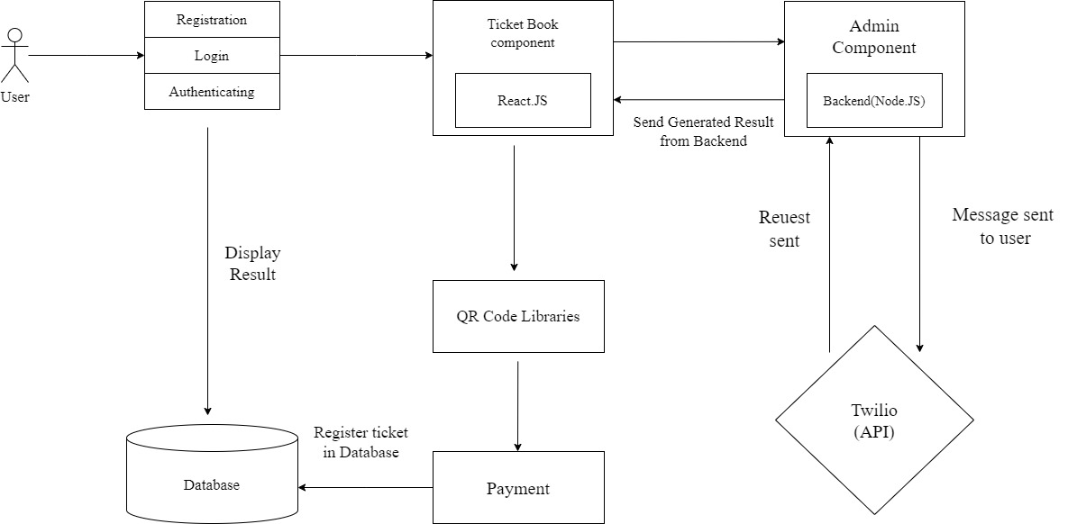

The bus ticketing system's architecture includes a client-side React.js interface for user interactions, such as login and Google authentication. It allows customers to view routes, book tickets, cancel bookings, and make secure payments. The search option makes it easier to find routes and buses. Admin functionalities include report generation, user management, administrator addition, and location and route management. On the server side, the system uses Node.js and Express.js, with MongoDB serving as the database for user data, booking details, and administrative settings. Integration with third-party services improves functionality, while cloud deployment provides scalability and stability. Security methods such as authentication, authorization, and encryption protect user data. This architecture provides a smooth and fast bus ticketing experience for both users and administrators.

# FLOWCHART

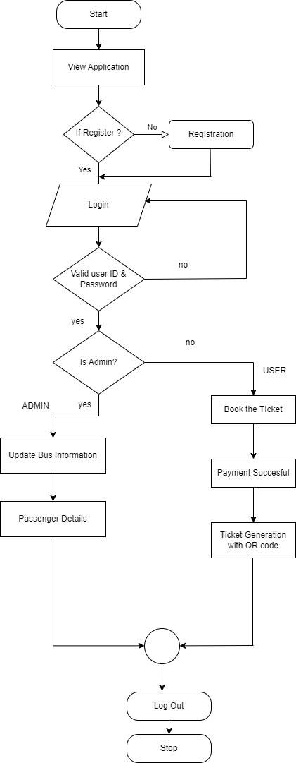

When users sign up for or book tickets through the bus ticketing system, their information is sent to the system's server. All of the data on this server is stored in a database. Administrators can create reports based on this information. Users can also ask the server for information about buses and routes. So, the system works as follows: users input their information and booking requests to the server, which saves everything in a database. Administrators can then construct reports based on this information. In addition, users can request bus and route information from the server at any time. This procedure ensures that everyone can utilize the system effectively and obtain the information they require.

# IMPLEMENTATION

**Requirements Understanding:**

- Verify that you fully understand the project's requirements with reference to the functionality and user experience of the ticketing system.

**Research and Planning:**

- Look into related technologies and systems.

Plan the project's duration, resources, and scope in light of the information acquired.

**Design Phase:**

- Create user-friendly, simple user interfaces (UIs) for administrators and customers.

- Create a database schema with MongoDB to ensure scalability and data integrity.

- Create system architecture using React.js for frontend development and Node.js for backend development.

**Development:**

-Use Node.js to provide backend logic, including booking administration and user authentication.

- Create front-end interfaces by integrating back-end APIs with React.js.

- Set up a MongoDB database for storing and retrieving data.

**Testing:** - To verify individual components, run unit tests.

- Conduct integration tests to make sure the frontend and backend work together seamlessly utilize UAT to gather user input and improve system performance.

**Deployment:**

- Install the system on a server and set up the performance and security settings.

- Put in place CI/CD pipelines for deployment that is automated.

**QR Code Integration:**

- To expedite ticket tracking and validation, incorporate the development of QR codes for tickets.

**Documentation:**

- Create technical documentation and user guides for system upkeep and usage.

**Training and Support:**

- Offer continuous system management support as well as administrator training sessions.

**Final Review and Handover:**

- Verify that all requirements have been completed by conducting a final review.

- Give stakeholders access to the system along with the required paperwork and assistance.

# RESULTS

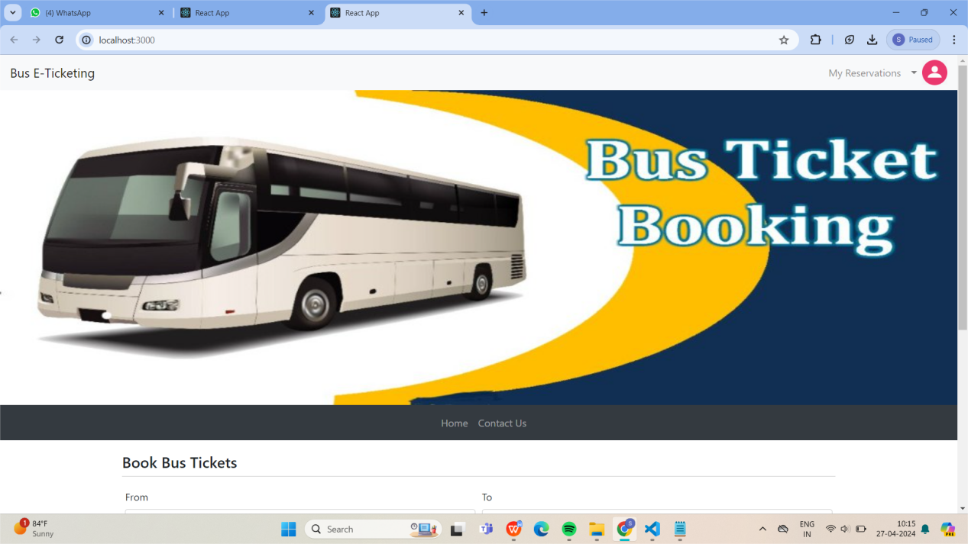

**Fig: Home Page For User**

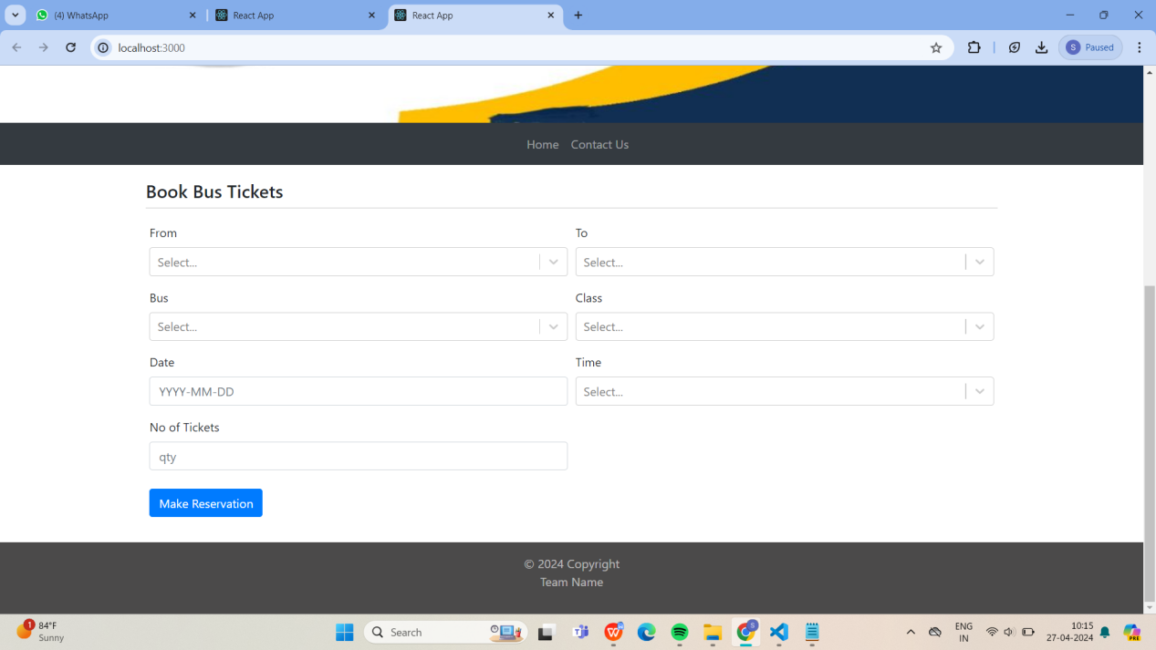

**Fig: Passenger Ticket Booking Panel**

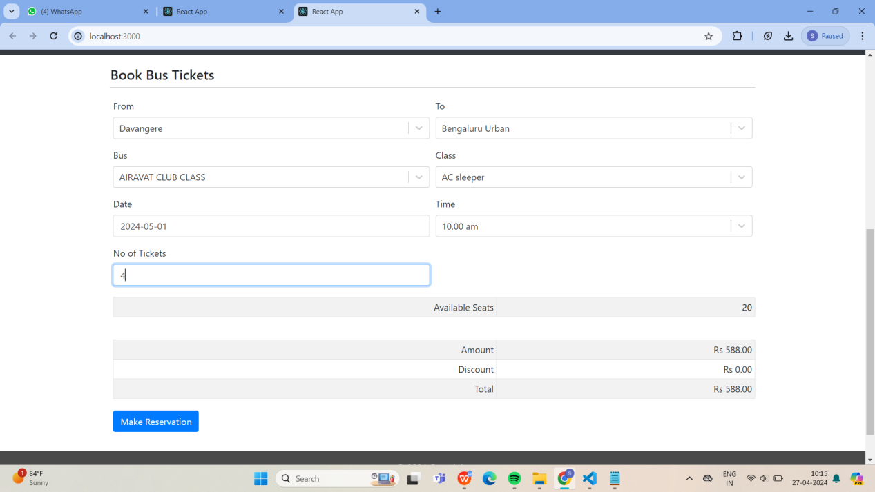

**Fig: Booking Of Ticket Based On Passenger Requirements**

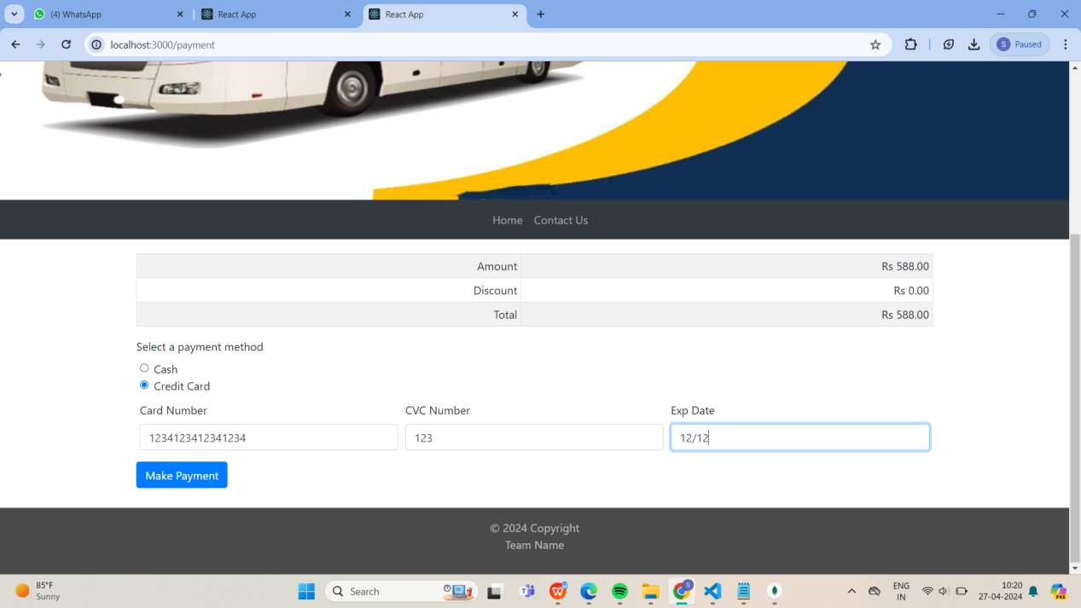

**Fig : Payment Through Credit Card Or Cash**

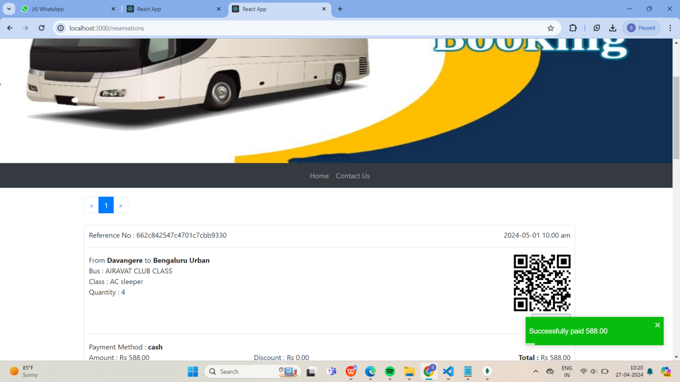

**Fig: Bus Ticket Issued With QR-Code**

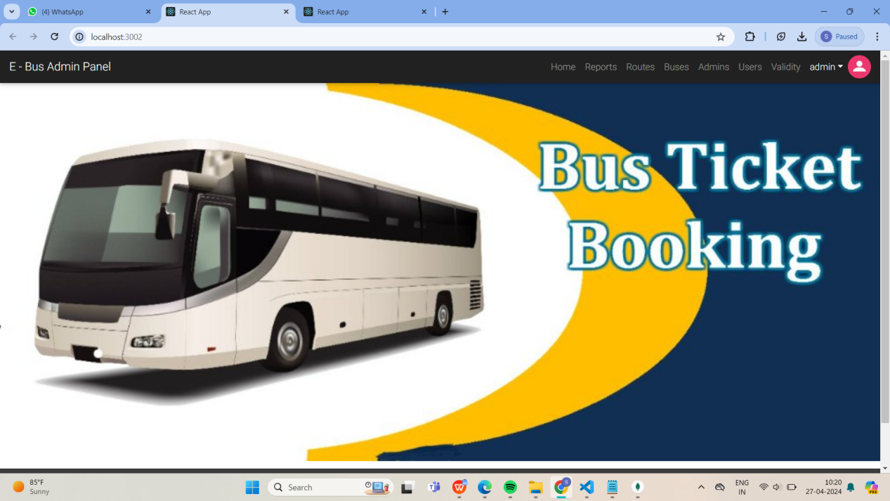

**Fig : Home Page For Admin**

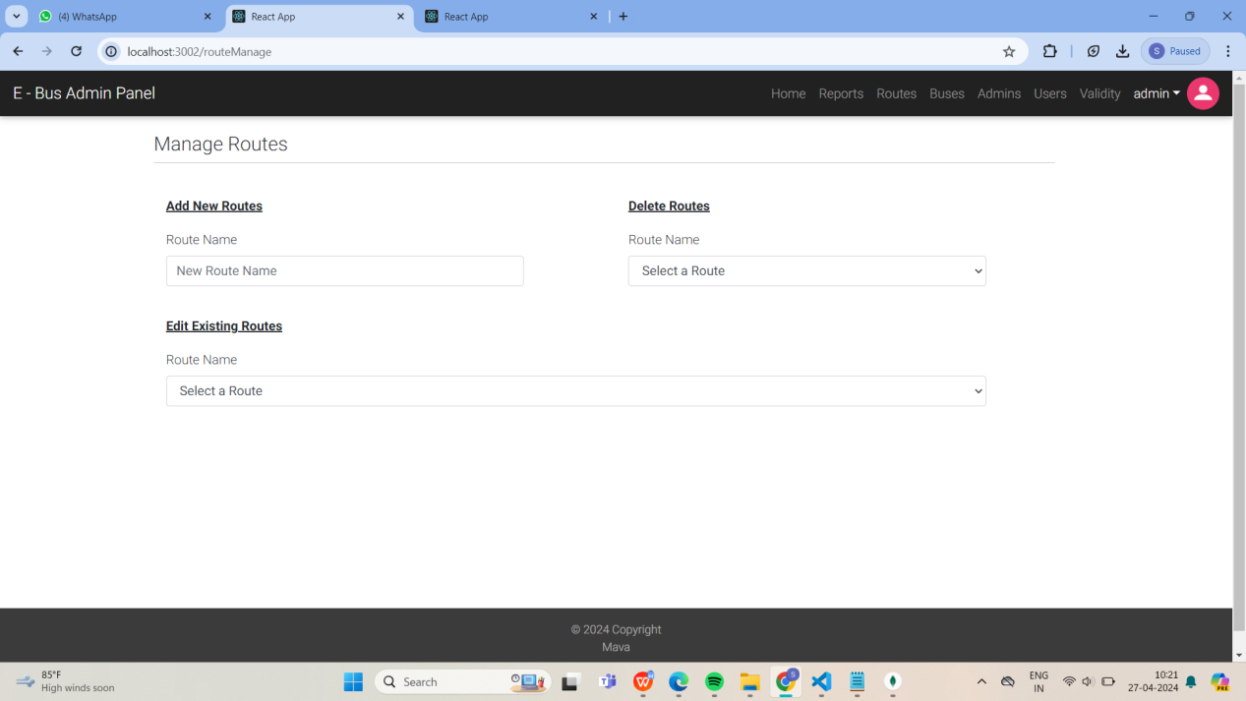

**Fig : Adding Routes By Admin**

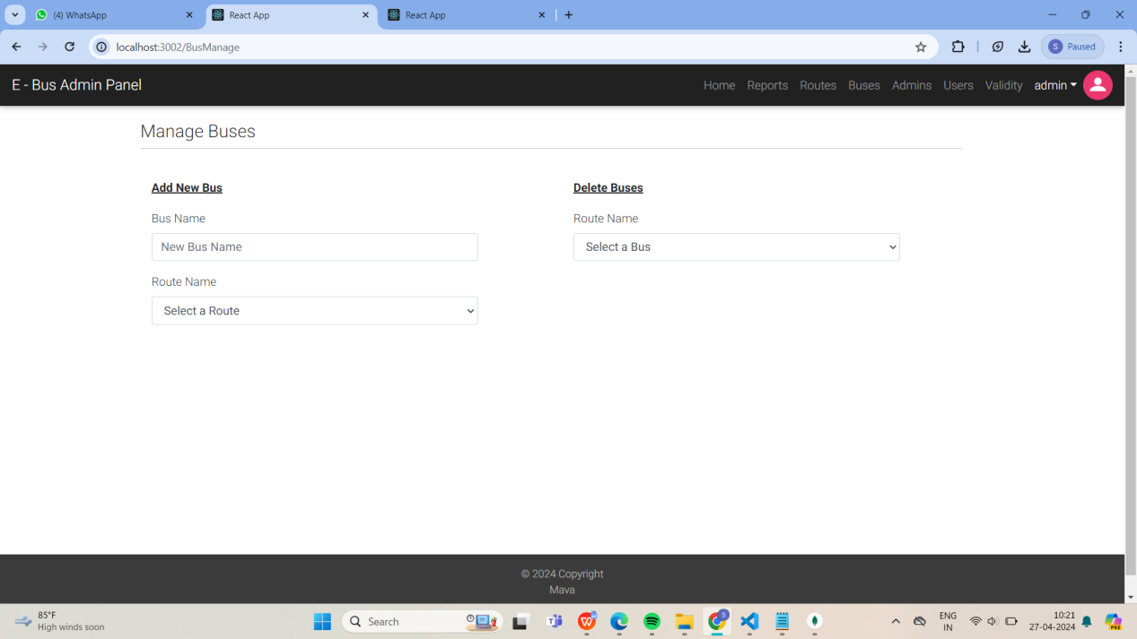

**Fig : Adding Bus By Admin**

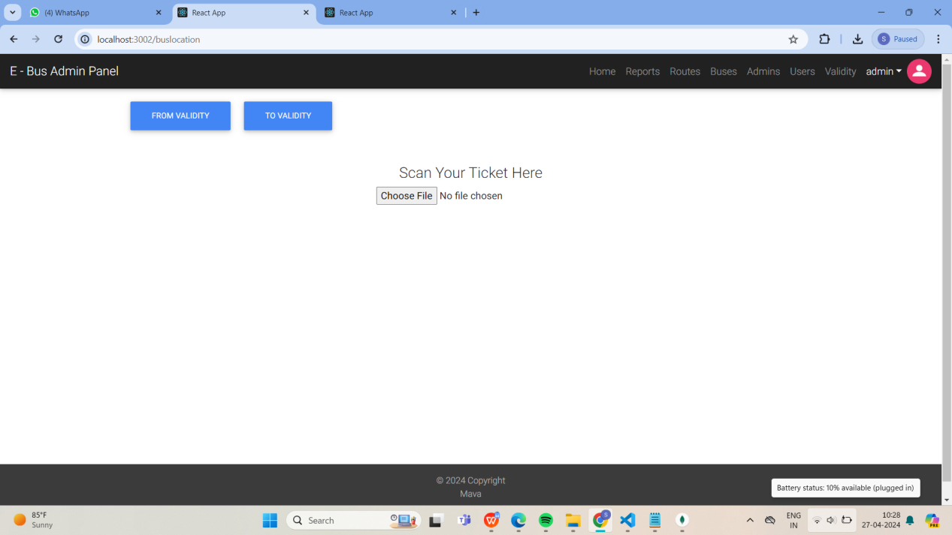

**Fig : Panel For Checking The Ticket is Valid Or Invalid**

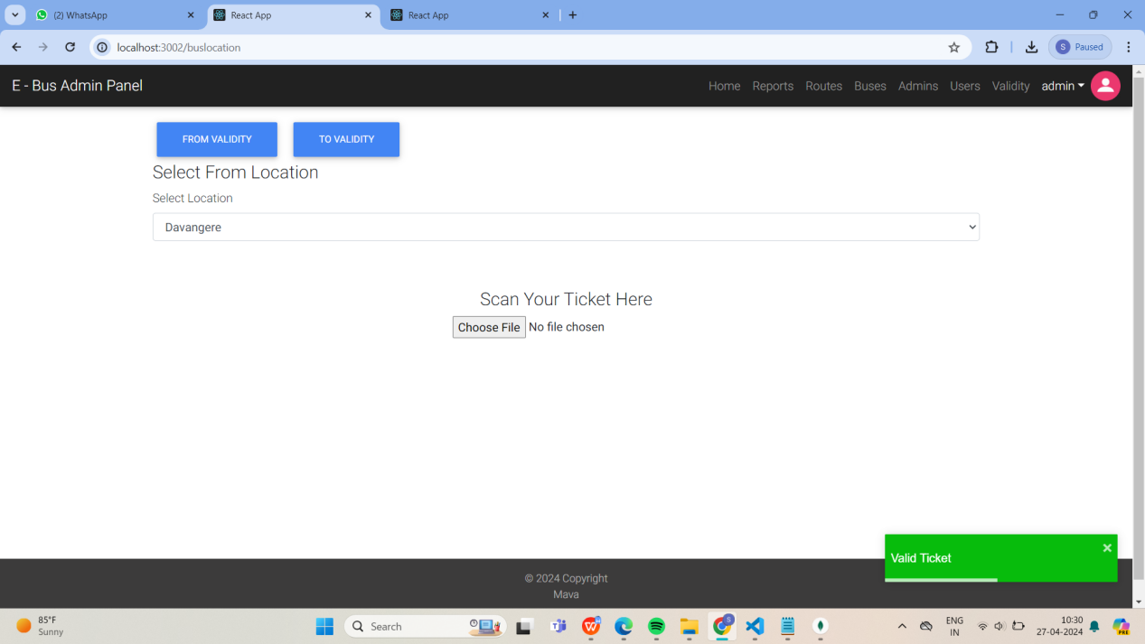

**Fig : Gives Pop-up Message When Ticket is Valid Or Invalid For From Location**

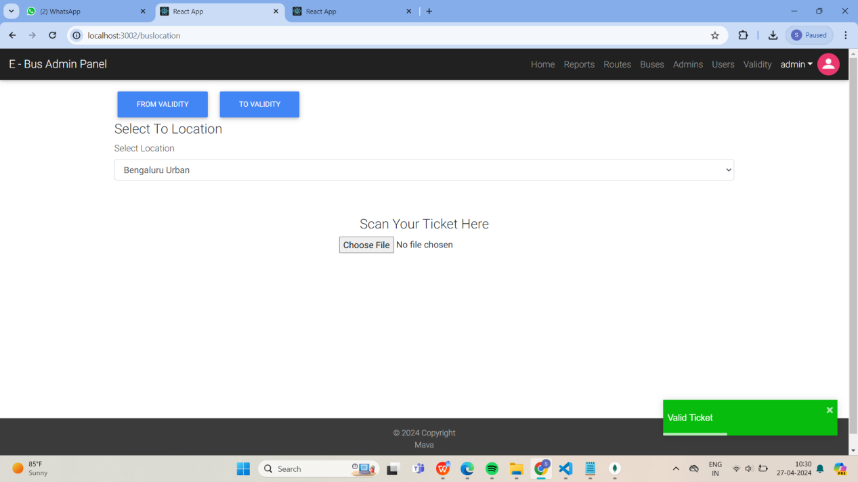

**Fig : Gives Pop-up Message When Ticket is Valid Or Invalid For To Location**

# CONCLUSION

To sum up, the bus ticketing system offers a smooth way for customers to purchase transport tickets and effectively handle bookings. Accessing pertinent bus and route information, users can easily plan excursions with simple registration, booking, and cancellation processes. Convenience and security are improved by the integration of technologies like Google authentication. Functionalities like report generating and user administration help administrators ensure smooth system operations. Based on cutting-edge technologies such as Node.js, MongoDB, and React.js, the system guarantees dependability and scalability. On the other hand, the addition of QR code capabilities transforms the way people travel by making ticketing procedures simpler and improving security. Digital ticket access is convenient for users, while real-time tracking and streamlined procedures are advantageous for administrators. Overall, both systems place a high priority on operational effectiveness and user pleasure, which represents notable improvements in the field of transport technology.

# REFERENCES

* <https://iopscience.iop.org/article/10.1088/1757-899X/590/1/012036>
* <https://www.researchgate.net/publication/373801215_Bus_Ticket_Booking_System_using_QR_Code_with_AES_Encryption>
* <https://iopscience.iop.org/article/10.1088/1757-899X/590/1/012036/pdf>
* <https://www.researchgate.net/publication/336567245_Bus_Ticket_System_for_Public_Transport_Using_QR_Code>
* <https://ieeexplore.ieee.org/document/8697591>