**SOLAR WATER DISTILLATION**

**Prof C Parkhi, Shrushti S Daurewar, Aniket M Gedam, Dikshita M Telang, Siddhant H Lonare, Aachal S Makode**

*Department of Electrical Engineering*

*Rajiv Gandhi College of Engineering and Technology,Chandrapur, India*

**Abstract:**

The purpose of this project is to fabricate a solar water distillation system that can purify the water, which is impure by using a systematic arrangement must have low cost for manufacturing and works based on renewable energy of solar. There is less amount of water only left on earth that is safe to drink without purification after 20-25 years from today. 99% of Earth's water is in a solid state and other impure form and the remaining is in liquid form. Due to this reason, water purification is necessary. Because of this, purposes the solar still is constructed which will convert the impure water into pure water using the renewable solar energy. The incoming solar radiation from the sun is heating the water, which placed in the basin in impure form, and this water gets evaporated and condensed into pure drinkable water.

**Introduction:**

Distillation is a process wherein a liquid or vapour mixture of two or more substances is separated into its component fractions of desired purity, by the application and removal of heat. Process of vaporizing a liquid, condensing the vapor, and collecting the condensate in another container. The incident solar radiation is transmitted through the glass cover and is absorbed as heat by a black surface in contact with the water to be distilled. The water is thus heated and gives off water vapour. The vapour condenses on the glass cover, which is at a lower temperature because it is in contact with the ambient air, and runs down into a gutter from where it is fed to a storage tank. A solar still [distills water](https://en.wikipedia.org/wiki/Distillation) with substances dissolved in it by using the [heat of the Sun](https://en.wikipedia.org/wiki/Solar_energy) to evaporate water so that it may be cooled and collected, thereby purifying it. They are used in areas where drinking water is unavailable, so that clean water is obtained from dirty water or from plants by exposing them to sunlight. Still types include large scale [concentrated solar stills](https://en.wikipedia.org/wiki/Concentrated_solar_still) and condensation traps. In a solar still, impure water is contained outside the collector, where it is evaporated by sunlight shining through a transparent collector. The pure [water vapour](https://en.wikipedia.org/wiki/Water_vapour) condenses on the cool inside surface and drips into a tank. Distillation replicates the way nature makes rain. The sun's energy heats water to the point of evaporation. As the water evaporates, its vapour rises, condensing into water again as it cools. This process leaves behind impurities, such as salts and heavy metals, and eliminates microbiological organisms. The end result is pure (potable) water

**Types of Solar Water Distillers:**

Solar distillation systems can be classified as passive and active. Solar radiation is the input energy of the passive solar stills, but the efficiency of the system is low. Attempts have been made to increase the efficiency and productivity by preheating the saline water in solar stills. This method is called active solar distillation. In the case of active solar distillation, an additional source of thermal energy is required for faster evaporation inside the same passive solar still. The additional source may be a solar-energy-based system or thermal energy contained in hot water which is discharged by other industries. There are many different ways to make a solar still and different materials that can be used. A crucial design challenge is making sure that the stills are airtight. If they are not airtight, efficiency drops severely. Listed are the different types of passive solar water distillers.

Single-effect Stills: These are the most common and simplest stills. Only one interface is necessary to convey the energy and collect the condensate.

Multi-effect Stills: They require double the effort in regards to ensuring tight seals and can be more difficult to clean, but they can significantly increase the production of distilled water.

Basin-type Stills: They contain the water in an impervious material that is a component of the entire enclosure and these are the most common type.

Wick Stills: Use cloth-like materials that use capillary action to propagate the water through the system.

Multi-wick Stills: These stills, like wick and multi-effect stills, greatly increase the productivity by increasing the influenced surface area exponentially.

Diffusion Stills: They use the ideas introduced by the multi-effect and wick stills and are a further advancement of both. They consist of a series of closely space parallel partitions in contact with saline-soaked wicks and they have great potential because of their high productivity and simplicity.

**Construction:**

The base of the solar still is made of G.I. box of dimension (100 x 100 x 50 cm). This box is embedded into another box of wood shown in figure. Here length L, Breath B, Height H and at opposite side . This also contains same box of thermocol inside it between the G.I box and wooden box. The channel is fixed such thatthe water slipping on the surface of the glass will fall in this channel under the effect of gravity. glass can rest on G.I plate .This completes the construction of the model. The holes for the inlet of water, outlet of brackish water and outlet of pure water is made as perthe convenience. We have made the outlet of brackish water at right bottom of the model (seeing from front of the model), outlet of the pure water at the end of the channel and inlet at the left wall above the outlet.

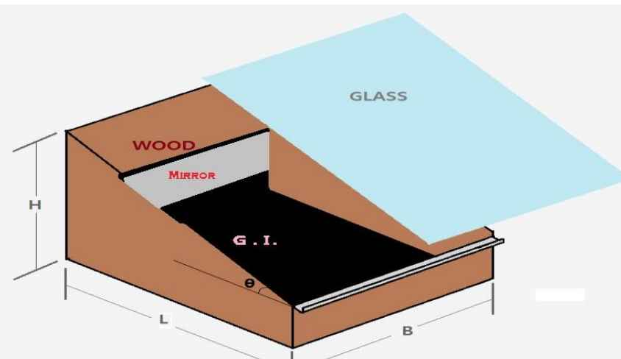

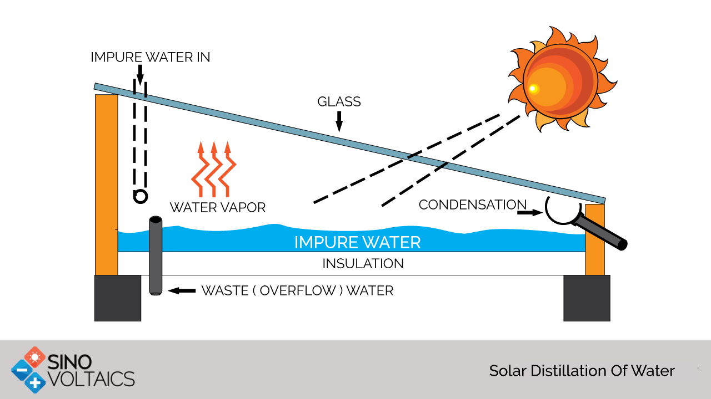

**Hardware Components:**

**Basin** :It is the part of the system in which the water to be distilled is kept. It is therefore essential that it must absorb solar energy. Hence it is necessary that the material have high absorbtivity or very less reflectivity and very less transmitivity. These are the criteria’s for selecting the basin materials. The basin materials that can be used are as follows: 1. Leather sheet, 2. Ge silicon, 3. Mild steel plate, 4. RPF (reinforced plastic) 5. G.I. (galvanized iron).

**G.I Plate Basin**

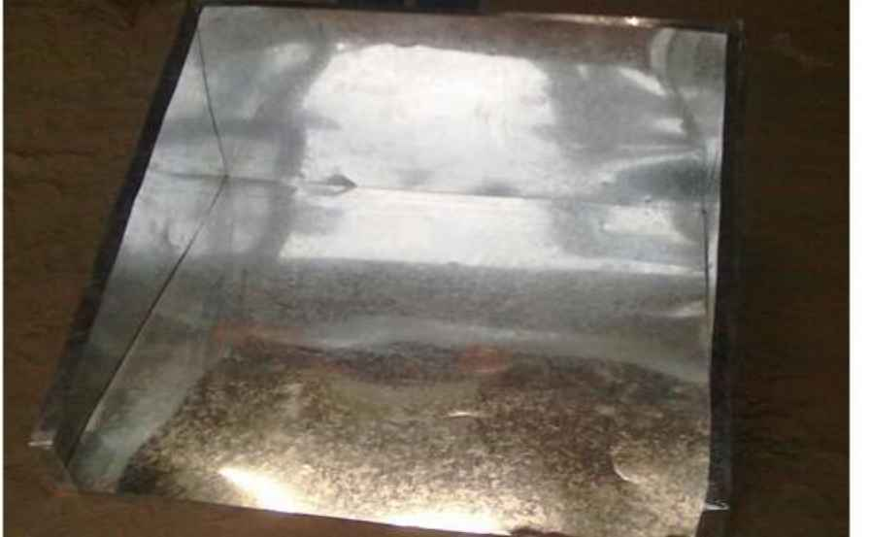

**Side Walls**

It generally provides rigidness to the still. But technically it provides thermal resistance to the heat transfer that takes place from the system to the surrounding. So it must be made from the material that is having low value of thermal conductivity and should be rigid enough to sustain its own weight and the weight of the top cover. Different kinds of materials that can be used are:

* 1) wood,
* 2) Concrete,
* 3) Thermocol,
* 4) RPF (reinforced plastic).
* For better insulation we have used composite wall of Thermocol (inside) and wood (outside).

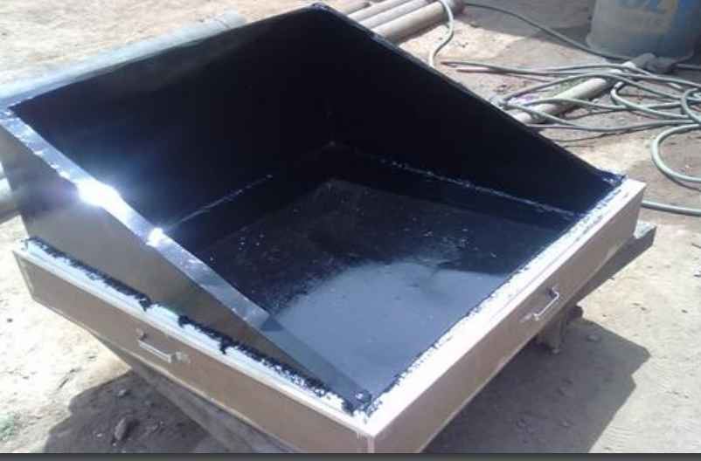

**Top Cover**

The passage from where irradiation occurs on the surface of the basin is top cover. Also it is the surface where condensate collects. So the features of the top cover are:

1) Transparent to solar radiation,

2) Non absorbent and Nonadsorbent of water,

3) Clean and smooth surface.

The Materials Can Be Used Are:

• 1) Glass

• 2) Polythene.

We have used glass.

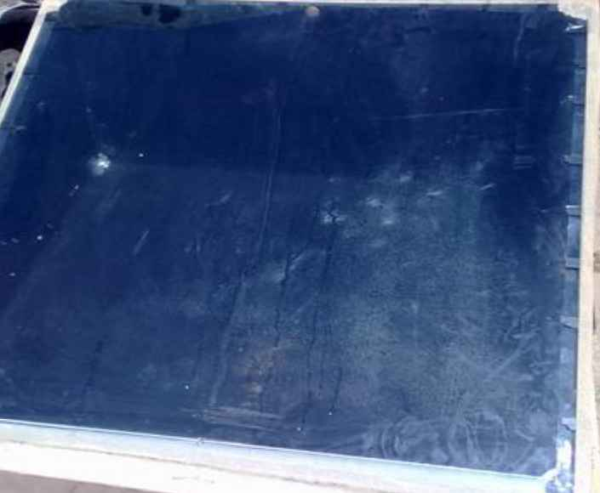

**Flow Chart**

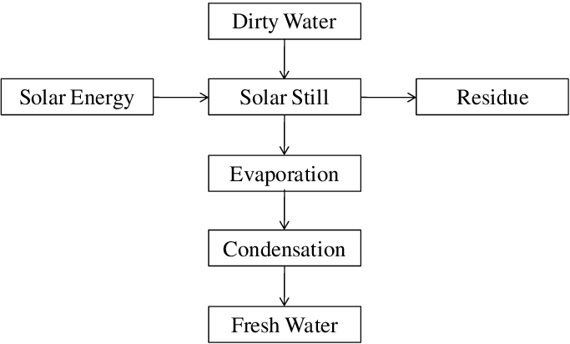

**Working:**

Water to be cleaned is poured into the basin. The glass cover allows the solar radiation to pass into the basin, which is mostly absorbed by the blackened base. This interior surface uses a blackened material to improve absorption of the sunrays. The water begins to heat up and the moisture content of the air trapped between the water surface and the glass cover increases. The heated water vapor evaporates from the basin and condenses on the inside of the glass cover. In this process, the salts and microbes that were in the original water are left behind. Condensed water trickles down the inclined glass cover to an interior collection trough and out to a storage bucket. Feed water should be added each day that roughly exceeds the distillate production to provide proper flushing of the basin water and to clean out excess salts left behind during the evaporation process.

**Advantages**:

Solar Stills have got major advantages over other conventional.Distillation / water purification /de- mineralisation systems as follows:

1. Produces pure water
2. No prime movers required
3. No conventional energy required
4. No skilled operator required

**Conclusion**:

Distillation of water using solar still basin is the most economical method to get portable drinking water. Salt, bacteria and other impurities are contaminated which are to be removed completely in the distillation process. The solar stills are best technology for living beings and environment because they do not need electricity for processing, no running water is required, lifetime is more and easy to maintain. In the experiment it has found that the black coated solar still is more effective when compared with the white coated solar still.

**Future Scope**:

In past few years, development of various desalination technologies in India is really appreciable. Chennai has two desalination plants based on RO process. RO process may be a reliable technique to supply fresh water, but it is far from being the most sustainable solution because of high rejection rate. Alternatives such as use of solar energy can be a better solution as it is sustainable in nature. India, being a tropical country, is blessed with plenty of sun shine. The average daily solar radiation varies between 4 and 7 kWh per square meter for different part of the country. There are on an average 300 clear sunny days a year. Thus, it receives about 5000 trillion kWh of solar energy in a year. The highest annual global radiation is received in Rajasthan and northern Gujarat which promises huge potential for solar desalination plant in these areas.

**References**:

[1].Malik, M.AS, Tiwari, G.N., kumar, A., and Sodha, M.S. Solar Distillation. Pergamon press Ltd, 1982, 20-150.

[2].G. Mink, M. Aboabbous and E. Karmazsin, “Design parameters, performance testing and analysis of a doubleglazed, air-blown solar still with heat recycling, Solar Energy”, 62 (1998) 309–317.

[3].Coffrin, Stephen; Frasch, Eric; Santorella, Mike; and Yanagisawa, Mikio, "Solar powered water distillation device". Mechanical Engineering Undergraduate Capstone Projects.Paper 95, 2007.

[4].Brenidorfer B, Kennedy L, Oswin Bateman CO, Trim DS (1985). Solar dryer; their role in post-harvest processing, text book, first edition, 133 Int. J. Sci. Technol. Educ. Res. Commonwealth Secretariat Marlborough house, London, Swly 5hx.p.237.

[5].Kumar S, Tiwari GN, “Performance evolution of an active solar distillation system”. Energy-an. Int. J., 21(9): Pages 805- 808, 1996.

[6].Donald R. Rowe, Isam Mohammed Abdel-Magid, Handbook of Wastewater Reclamation and Reuse, CRC Press,Jul 25, 1995, Page 205.

[7].Anil,K,Rajvanshi., 1981.Effect of various dyes on solar distillation. Solar Energy Vol. 27, pp: 51-65.

[8].Bilal, A, Akash.,Mousa, S, Mohsen., Omar Osta., YaserElayan., 1998. Experimental Evaluation of a single basin solar still using different absorbing materials. Renewable Energy, Vol. 1, Nos.1-4, pp: 307-310.

[9].HimaBinduBanoth.,BhramaraPanithapu., Ravi Gugulothu., Naga SaradaSomanchi., Devender, G.,Devender, V.,BanothuKishan., 2014.A Reviewon Performance of Solar Still with Different Techniques. Proceedings of International Conference on Renewable Energy and Sustainable Development (ICRESD 2014), pp: 393-398.

[10].NagasaradaSomanchi.,HimaBinduBanoth., Ravi Gugulothu., Mohan Bukya., 2014. A Review on Performance of Solar Still Coupled with Thermal Systems. Proceedings of 2014 1st International Conference on Non Conventional Energy (ICONCE 2014), pp: 114-118.