STUDY ON ANALYSIS OF SYMMETRIC AND ASYMMETRICAL BUILDING

## Nisar Mulla1 ,Ajinkya Yadav1,Satyajit Patil1,Shubham Babar1,Nitin Kadam1 ,Akshay Kumbhar 2,

1U.G. Students, Civil Engineering Departmen[t,](http://www.unipune.ac.in/) [SSIET, Ghogaon, India.](http://www.unipune.ac.in/)

2Assistant Professor, Civil Engineering Departmen[t,](http://www.unipune.ac.in/) SSIET,Ghogaon, India.

# ABSTRACT

It is very important to find out the behavior of the buildings and the damage that originates from the places of structural weak levels in the building systems, which is due to the different shape of the building, ie. rectangular, square, L-shaped and T. -shaped building. The contribution of the lateral load resistance system, the number of layers, the type and the different types of analysis method must be properly evaluated to avoid the twisting effect and collapse of the structure. The behavior of a building during an earthquake depends significantly on its overall shape, size and geometry. Buildings with irregular geometries react differently to seismic impact. The geometry of the design is the parameter that determines its performance under various load conditions. The effects of irregularity (plan and shape) on the structures were performed using the structural analysis software ETABS 2018.The aim of the study is to compare the seismic performance of Equivalent Static Method, Response Spectrum Method and Push Over. Analytical method using soil as medium. G+24 floor structures are located in earthquake zone III. All frames are designed with the same gravity. The response spectrum method and the thrust analysis method are used for seismic analysis. ETABS software is used and the results are compared. of. The results were obtained in the form of Earthquake Displacement, Story Force, Base Shear and Modal Mass Participations.

**Keywords:** ETABS, Earthquake Load, Torsion, Response Spectrum, Push Over Modal Mass Participation.

# INTRODUCTION

### General Introduction

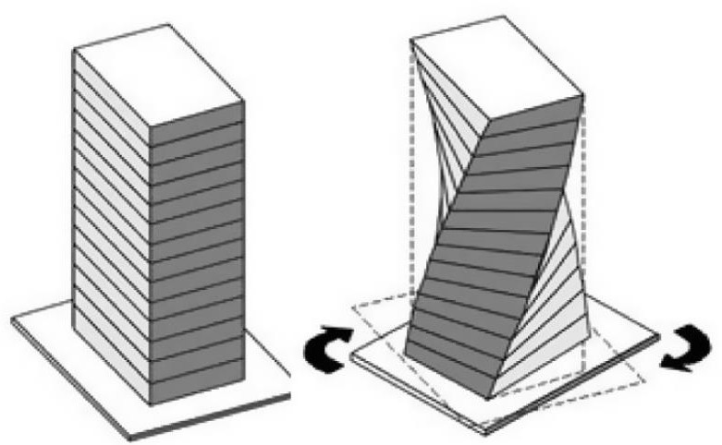Recent earthquakes have shown that uneven distribution of mass, stiffness and strength can seriously damage structural systems. Structures become asymmetric for a number of reasons. The asymmetry of structures makes the analysis of seismic behavior difficult. Seismic demand for edge elements is increasing. Even distribution of the load is disturbed. The torsional behavior of an asymmetric building is one of the most common causes of structural damage and failure under strong ground motions. The torsional reactions of structures arise from two sources: Eccentricity in the mass and stiffness distribution, which causes a torsional reaction together with a translational reaction; and torsion due to random causes, including uncertainties in masses and stiffnesses, differences in the connection of the structural foundation to the subsoil or rock, and the effect of wave propagation on seismic motion that causes torque input to the ground, and torsional motion during an earthquake to ground himself..

**Fig 1:** Tortional Moment in Structure.

Seismic damage surveys and analyses conducted on modes of failure of building structures during past severe earthquakes concluded that most vulnerable building structures are those, which are symmetrical and asymmetric in nature. Asymmetric-plan buildings, namely buildings with in-plan asymmetric mass and strength distributions, are systems characterized by a coupled torsional-translational seismic response.

Torsion in buildings during earthquake shaking may be caused from a variety of reasons, the most common of which are non-symmetric distributions of mass and stiffness.

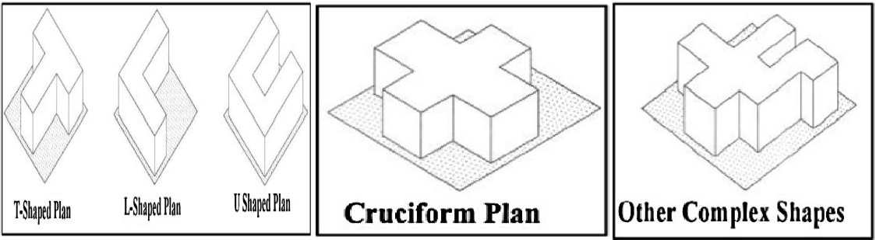Earthquake load acts at the center of mass of the structure. However, resisting force acts at a point called center of rigidity on the structure, which is the center of lateral resistance. Torsional problems take place when the mass center and center of rigidity are not located at the same place. By increasing distance between center of mass and center of rigidity, building is forced to twist around the rigid structural section (rigid core) and subjected to great torsional moments. The lateral-torsional coupling due to eccentricity between center of mass (CM) and center of rigidity (CR) in asymmetric building structures generates torsional vibration even under purely translational ground shaking. During seismic shaking of the structural systems, inertia force acts through the Centre of mass while the resistive force acts through the Centre of rigidity.

**Fig 2:** Structural Asymmetry

# RESEARCH OBJECTIVE

Based on the literature review presented in Chapter 2, the salient objectives of the Present study have been identified as follows

1. Analysis of G+24 story building with IS456-2007 Design of Concrete structure using ETABS 2016.
2. To study behavior of RCC building G+24 story with different shape of plan using equivalent statics method, response spectrum method and pushover analysis method.
3. To study the effect torsional analysis of symmetrical and asymmetrical building, study on the influence of the torsional moment effects on the behavior of structure is done by using Response spectrum method.
4. Then simplified nonlinear pushover analysis has been used to find structural descriptors required in seismic vulnerability assessment.

# PROJECT STATEMENT

The study will give more knowledge which result into benefits for future implementation with the help of RCC building actual design. To study the effect of shape and position of shear wall on structural behavior.

### Response Spectrum Method

A response spectrum is simply a plot or steady-state response (displacement, velocity or acceleration) of a series of oscillators of varying natural frequency that are forced into motion by same base vibration. The resulting plot can then be used to pick off the response of any linear system, given its natural frequency of oscillation. One such use is in assessing the peak response of building to earthquake. The science of strong ground motion may use some values from the ground response spectrum for correlation with seismic damage.

In technical terms it can be said that it is the representation of the maximum response of idealized single degree of freedom having certain period and damping during earthquake ground motion. The maximum response is plotted against the undammed natural period and for various damping values can be expressed in terms of maximum relative velocity or maximum relative displacement. The characteristics of seismic ground vibrations expected at any location depends upon the magnitude of earthquake, its depth of focus, distance from the epicenter, characteristics of the path through which the seismic waves travel, and soil strata on which

the structure stands. The random earthquake ground motions, which cause the structure to vibrate, can be resolved in any three mutually perpendicular directions.

### Non-Linear Static Push-over Analysis

The pushover analysis of a structure is a static nonlinear analysis under permanent vertical loads and gradually increasing lateral loads. The equivalent static lateral loads approximately represent earthquake induced forces. A plot of the total base shear versus top displacement in a structure is obtained by this analysis that would indicate any premature failure or weakness. The analysis is carried out up to failure, thus it enables determination of collapse load and ductility capacity. On a building frame, plastic rotation is monitored, and lateral inelastic forces versus displacement response for the complete structure are analytically computed. This type of analysis enables weakness in the structure to be identified.

The decision to retrofit can be taken in such studies. Two key elements of a performance-based design procedure are demand and capacity. Demand is a representation of the earthquake ground motion. Capacity is a representation of the structures ability to resist the seismic demand. The performance is dependent on the manner that the capacity is able to handle the demand. In other words, the structure must have the capacity to resist the demands of the earthquake such that the performance of the structure is compatible with the objectives of the design. Once the capacity curve and demand displacement are defined, a performance check can be done. A performance check verifies that structural and non-structural components are not damaged beyond the acceptable limit of the performance objective for the forces and displacements implied by the displacement demand. In this study, nonlinear static pushover analysis was used to evaluate the seismic performance of the structures.

# PROBLEM FORMULATION

Multi-storied ferroconcrete, moment defying space frame are anatomized using professional software ETABS2016. Model G+24 of erecting frame with three kudos in vertical and three kudos in side direction is anatomized by Response spectrum method.

The plan confines of structures are shown in table below.

The plan view of structure, elevation of colorful frames is shown in numbers below.

**Table No 1:** Detail Features of Building G+24 Story

|  |  |
| --- | --- |
| Type of structure | Frame structure |
| Moment-Resisting frame | SMRF |
| Type of soil | Medium |
| No of Stories | G+24 |
| Height of each story | 3m |
| Height of ground story | 5m |
| Thickness of slab | 150mm |
| Thickness of outer wall | 150mm |
| Thickness of inner wall | 150mm |
| Grade of reinforcing steel | Fe 415 |
| Concrete Poisons ratios | 0.2 |
| Density of concrete | 25 kN/m3 |
| Density of wall | 20 kN/m3 |
| Grade of concrete in slab | M35 |
| Beam size | 300x450mm |
| Response reduction factor | 3 |
| Damping | 5% |

|  |  |
| --- | --- |
| Grade of concrete in beam | M35 |
| Grade of concrete in column | M35 |
| Grade of concrete in footing | M35 |
| Seismic zone | 3 |
| Seismic intensity | 0.16 |
| Analysis type | Dynamics (Response Spectrum Analysis) |

### Different building shape plan

* + 1. **Rectangular shape building**

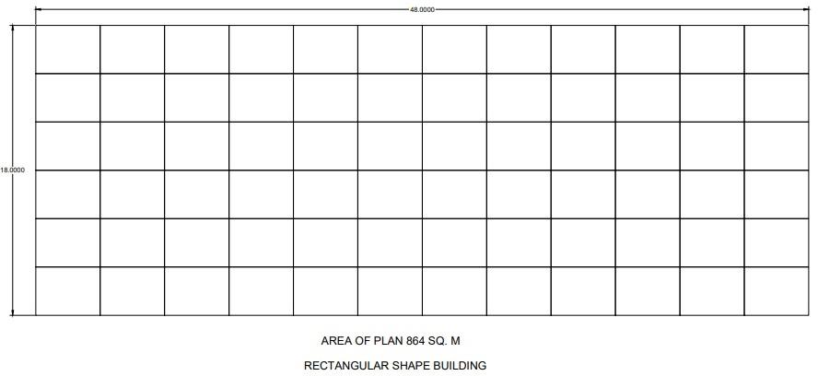

**Fig.** G+24 Story Rectangular Building Plan

### Square Shape Building Plan:



**Fig.** G+24 Story Square Shape Building

### T-shape building

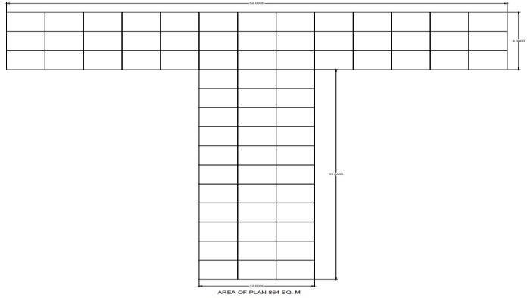

**Fig.** G+24 Story T-Shape Building Plan

### L- Shape Building Plan:

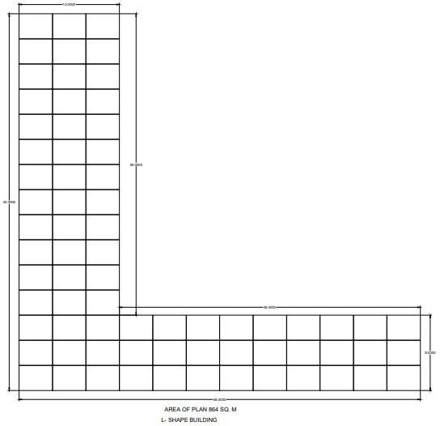

* + - 1. **Base Shear Results**

**Fig.** G+24 Story L- Shape Building

# RESULTS

**Table 1.** Base Shear Different Shape of Building in Equivalent and Response Spectrum Analysis method

|  |  |  |  |  |  |  |  |  |  |  |  |  |  |
| --- | --- | --- | --- | --- | --- | --- | --- | --- | --- | --- | --- | --- | --- |
| TABLE: Load Pattern Definitions - Auto Seismic - IS 1893 2002 | | | | | | | | | | | | | |
| Name | | | Base Shear (KN) | | | Base Shear (KN) | | Base Shear (KN) | | Base Shear (KN) | | | |
|  | | | Rectangular | | | Square | | T-shape | | L-shape | | | |
| EQ+X | | | 2044.7012 | | | 2435.2058 | | 2706.8163 | | 2441.5662 | | | |
| EQ+Y | | | 1623.2175 | | | 2321.9512 | | 2356.4383 | | 2336.0909 | | | |
| EQ-X | | | 2044.7012 | | | 2435.2058 | | 2706.8163 | | 2441.5662 | | | |
| EQ-Y | | | 1623.2175 | | | 2321.9512 | | 2356.4383 | | 2336.0909 | | | |
|  | Base shear  3000  2500 | | | | | | | | | | | |  |
|  | | | | | | |  |  |  |  | |
| 1500  1000  500 |  | |  |  | |  |  |  |  |
|  | |  | |  |  |
|  | |  | |  |  |
|  | |  | | |  |  |
| 0  Rectagulalar Square T-Shape L-Shape | | | | | | | | | | | |

2000

**Graph 1**: Base Shear Vs. Different Shape of Building

### Earthquake Displacement Results

**Table 2.** Earthquake Displacement Vs. Different Shape of Building in Response Spectrum Analysis Method

|  |  |  |  |  |  |
| --- | --- | --- | --- | --- | --- |
| TABLE: Diaphragm Center of Mass Displacements | | | | | |
| Story | Load Case/Combo | UX (mm) | UX (mm) | UX (mm) | UX (mm) |
|  |  | Rect. | Square | T-shape | L-shape |
| Story25 | EQ+X | 39.633 | 45.59 | 53.997 | 44.777 |
| Story24 | EQ+X | 39.277 | 45.147 | 53.157 | 44.225 |
| Story23 | EQ+X | 38.73 | 44.439 | 52.115 | 43.494 |
| Story22 | EQ+X | 37.964 | 43.441 | 50.735 | 42.491 |
| Story21 | EQ+X | 36.983 | 42.164 | 49.031 | 41.219 |
| Story20 | EQ+X | 35.805 | 40.622 | 47.023 | 39.693 |
| Story19 | EQ+X | 34.447 | 38.808 | 44.721 | 37.906 |
| Story18 | EQ+X | 32.927 | 37.031 | 42.45 | 36.137 |
| Story17 | EQ+X | 31.263 | 35.139 | 40.053 | 34.256 |
| Story16 | EQ+X | 29.473 | 33.123 | 37.525 | 32.257 |
| Story15 | EQ+X | 27.571 | 30.989 | 34.869 | 30.146 |
| Story14 | EQ+X | 25.575 | 28.75 | 32.101 | 27.935 |
| Story13 | EQ+X | 23.496 | 26.418 | 29.24 | 25.637 |
| Story12 | EQ+X | 21.349 | 24.008 | 26.31 | 23.268 |
| Story11 | EQ+X | 19.142 | 21.533 | 23.327 | 20.843 |
| Story10 | EQ+X | 17.075 | 19.02 | 20.363 | 18.378 |
| Story9 | EQ+X | 14.985 | 16.536 | 17.504 | 15.949 |
| Story8 | EQ+X | 12.876 | 14.048 | 14.673 | 13.521 |
| Story7 | EQ+X | 10.759 | 11.573 | 11.904 | 11.112 |
| Story6 | EQ+X | 8.648 | 9.138 | 9.232 | 8.75 |
| Story5 | EQ+X | 6.566 | 6.785 | 6.711 | 6.476 |
| Story4 | EQ+X | 4.555 | 4.574 | 4.413 | 4.349 |
| Story3 | EQ+X | 2.689 | 2.604 | 2.439 | 2.464 |
| Story2 | EQ+X | 1.114 | 1.029 | 0.93 | 0.968 |
| Story1 |  |  | 0 | 0 | 0.093 |
| Story0 |  |  |  |  | 0 |
| Earthquake Displacement  200  150  100  50  0  1 2 3 4 5 6 7 8 9 10 11 12 13 14 15 16 17 18 19 20 21 22 23 24 25 26  Rectangular  Square  T-Shape  L- Shape | | | | | |

**Graph 2:** Earthquake Displacement Vs. Different Shape of Building in Response Spectrum Analysis

**Table 3.** Story Force Results Response Spectrum Analysis Method

|  |  |  |  |  |  |
| --- | --- | --- | --- | --- | --- |
| TABLE: Story Forces | | | | | |
| Story | Load Case/Combo | P (kN) | P (kN) | P (kN) | P (kN) |
|  |  | Rect. | Square | T-shape | L-shape |
| Story25 | 1.5(DL+LL) | 7827.995 | 11392.21 | 9473.724 | 8006.3687 |
| Story24 | 1.5(DL+LL) | 25057.66 | 32066.3 | 29004.89 | 28494.0274 |
| Story23 | 1.5(DL+LL) | 42287.33 | 52740.38 | 48536.06 | 48981.6862 |
| Story22 | 1.5(DL+LL) | 59516.99 | 73414.46 | 68067.23 | 69469.3449 |
| Story21 | 1.5(DL+LL) | 76746.66 | 94088.55 | 87598.4 | 89957.0036 |
| Story20 | 1.5(DL+LL) | 93976.32 | 114762.6 | 107129.6 | 110444.6623 |
| Story19 | 1.5(DL+LL) | 111206 | 136676 | 128042.4 | 132314.7681 |
| Story18 | 1.5(DL+LL) | 128435.7 | 158589.3 | 148955.3 | 154184.8738 |
| Story17 | 1.5(DL+LL) | 145665.3 | 180502.7 | 169868.2 | 176054.9796 |
| Story16 | 1.5(DL+LL) | 162895 | 202416 | 190781 | 197925.0853 |
| Story15 | 1.5(DL+LL) | 180124.6 | 224329.3 | 211693.9 | 219795.1911 |
| Story14 | 1.5(DL+LL) | 197354.3 | 246242.7 | 232606.7 | 241665.2968 |
| Story13 | 1.5(DL+LL) | 214584 | 268156 | 253519.6 | 263535.4026 |
| Story12 | 1.5(DL+LL) | 231813.6 | 290069.4 | 274432.5 | 285405.5083 |
| Story11 | 1.5(DL+LL) | 250147.7 | 311298.4 | 295079.9 | 306734.451 |
| Story10 | 1.5(DL+LL) | 268481.7 | 334108.7 | 318522.4 | 330018.0955 |
| Story9 | 1.5(DL+LL) | 286815.8 | 356919 | 341964.9 | 353301.7338 |
| Story8 | 1.5(DL+LL) | 305149.8 | 379729.3 | 365407.5 | 376585.3802 |
| Story7 | 1.5(DL+LL) | 323483.8 | 402539.6 | 388850 | 399869.0226 |
| Story6 | 1.5(DL+LL) | 341817.9 | 425349.9 | 412292.5 | 423152.665 |
| Story5 | 1.5(DL+LL) | 360151.9 | 448160.3 | 435735 | 446436.3073 |
| Story4 | 1.5(DL+LL) | 378486 | 470970.6 | 459177.5 | 469719.9497 |
| Story3 | 1.5(DL+LL) | 396820 | 493780.9 | 482620 | 493003.5921 |
| Story2 | 1.5(DL+LL) | 415154 | 516591.2 | 506062.5 | 516287.2345 |
| Story1 | 1.5(DL+LL) | 423865.3 | 525913.6 | 516387.6 | 529506.2011 |



Story Force

2500000

2000000

1500000

1000000

500000

0

1 2 3 4 5 6 7 8 9 10 11 12 13 14 15 16 17 18 19 20 21 22 23 24 25

Rectangular

Square

T- Shape

L-Shape

**Graph 3:** Story Force Vs. Story in Response Spectrum Analysis

In the present study, Relative Analysis of RCC structure with different shape of building i. e Rectangular, Square, T- Shape and L-shape building with G+24 story building.

The structures are analyses for earthquake zone III with medium soil and Results Compare. It has been made on different structural parameters viz. base shear, Earthquake displacement, story force and modal mass participations etc. Grounded on the analysis results following conclusions are drawn.

* + - * 1. Analysis of RCC building with different shape of structure i.e. Rectangular, Square, T- shape and L- shape with medium soil condition at zone III. the base shear in x- direction, square, T- shape and L- shape building structure base shear is increased 1.2435, 1.2706,1.24 and 1.24 times increased as compare to rectangular

shape building.

1. The Structure, Square, T-shape and L- shape structure with analysis at zone III. But results indicate that variation of base shear increase or drop in Square, T- shape and L-shape nearly close as compare to rectangular shape building.
2. Comparing The modal mass participating results in Response spectrum analysis method with rectangular shape building in 1st mode shape mass participant 73% and 2nd mode shape in z-direction means building are in torsion, rectangular shape building failed in mass participant check as compare to Square And L-Shape building, Square and L-shape building 1st and 2nd mode are translation and 3rd mode shape are in torsion as compare to rectangular shape and T- shape building, but Square and T-shape building are good performance torsion

# REFERENCES

1. Lucchini, G. Monti and S. Kunnath (2008) “A simplified pushover method for evaluating the seismic demand in asymmetric-plan multi-storey buildings” The 14 th World Conference on Earthquake Engineering October 12-17, 2008, Beijing, China
2. Benavent-Climent L. Morillas B, D. Escolano-Margarit B (AUGUST 2014)- “Inelastic torsional seismic response of nominally symmetric reinforced concrete frame structures: Shaking table tests”
3. J. I. Ramos (JULY 1993)- “Torsional oscillations in symmetrical structures”
4. Hong Hao (JAN 1996) - “Torsional response of building structures to spatial random ground excitations”
5. J.C. Correnza,G.L.Hutchinson A.M. Chandler (1992)-“A review of reference models for assessing inelastic seismic torsional effects in buildings”
6. M. Chandler, G. L. Hutchinsonin (JUNE 1985) - “Torsional coupling effects in the earthquake response of asymmetric buildings”
7. K. M. DEMPSEY, W. K. TSO (1982)- “An alternative path to seismic torsional provisions”
8. Carlos E. Seguin, Jose L. Almazan, Juan C. De la Llera (AUGUST 2012)- “Torsional balance of seismically isolated asymmetric structures”

### Code Used

1. IS 13920,” Ductile detailing of concrete structure subjected to seismic forces code of practice”, 1993.
2. IS 875(part 1-5)-code of practice for structural safety of Building loading standards.
3. IS 875, “Code of practice for design loads (other than earthquake) for building and structures - Part 2: Imposed loads”, Bureau of Indian Standards, New Delhi, 1987.
4. IS 456, “Indian Standard Code of Practice for Plain and Reinforced Concrete”, Bureau of Indian Standards, New Delhi, 2000.
5. IS 1893 (Part I), “Criteria for Earthquake Resistant Design of Structures”, Bureau of Indian Standards, New Delhi, 2002.