**DEEP LEARNING-BASED AUTOMATIC DETECTION OF BIKE RIDERS WITH NO HELMET**

**Puneeth S P*1, Siddartha K G*2, T C Deepak*3, Venkatesh U*4, Vinayak N Mattur*5**

*1Asst. Professor, Department of Information Science and Engineering, Bapuji Institute of Engineering and Technology, Davangere, Karnataka, India.

*2,3,4,5 Student, Department of Information Science and Engineering, Bapuji Institute of Engineering and Technology, Davangere, Karnataka, India.

# ABSTRACT

Now-a-days two wheelers is the most preferred mode of transport. It is highly desirable for bike riders . This paper uses image processing technique by which motorcyclists without helmet will be detected. In this project moving vehicles can be detected using the input as image or a video and then classified into motorcyclists and non-motorcyclists by background removal and based on size of the image being detected. If in case motorcyclist is detected without a helmet, the vehicle details with the person(s) on vehicle and the number plate is captured in the form of an image. An algorithm is designed to recognize number plates of motor cyclists using images or videos taken by camera. Recognition of number plates characters using image processing algorithms, storing in the database with the image as the proof with date and time recorded. A database will be designed with the proof stored with the offence to identify every offender accurately and arrest the suspect’s vehicle and hence imposing violation fine by sending mail to detected vehicle. This paper compares the Existing systems properties with the our project properties and In this paper our project is compared with five existing Systems and overcomes the drawbacks of it.

**Keywords:** motorcyclists without helmet, number plate recognition, image processing, Sending a Mail

# INTRODUCTION

A helmet is essential for preventing traumatic brain injuries caused by impact and even death in a fatal accident. The negligence of the biker to not wear a helmet due to personal and other reasons may end up in serious injuries if meet with an accident. To reduce the risk of any type of head injury or even death due to an accident bike riders must be encouraged to wear a helmet for their safety. And the law must be very strict to fine who fail to do so. A system through deep learning an automatic helmet detection system has been proposed.

At present in India bikers without a helmet are fined manually by pulling them at checkpoints and check their documents for identification such as RC book, license card, insurance, etc., then the police officials would asking them the reason for not wearing a helmet while driving a two-wheeler. Since wearing a helmet while driving is a law, their reasons would not be taken for justification. Then they will be issued a receipt for the fine they have received for not wearing a helmet. They will also be given a choice to pay the fine on the spot through a

debit/credit card or cash payment method or pay the fine in court within a particular period. So to eliminate the workload of the traffic officials and to implement strict law this proposed method can be used. So that bikers will be forced to wear the helmet while driving. This would also reduce the work of the traffic management department and provide safety for motorbike riders.

# LITERATURE SURVEY

* **Romuere R.V.e Silva, Kelson R.T. Aires, Rodrigo de M. S. Veras** “Detection of Helmet on MotorCyclists

In this paper, the process of classification and descriptors are used to detect the vehicles and then detect the persons with 2 wheelers and detect if they are wearing the helmet or not. The processes used in this projects are:

**Vehicle segmentation and classification:**

**Detection of the background-**

A reference of the road as background is considered so that the motion of the vehicle can be detected with respect to the stable object (road).

**Segmentation of moving objects-**

Using background subtraction, the moving objects(vehicles) are differentiated with the background which gives only an image of the vehicles and the background will be eliminated.

**Vehicle classification-**

The vehicles are classified as motorcycles or non-motorcycles and a feature vector is obtained for each generated image and passed on to random forest classifier to categorize vehicle as motorcycle or a non- motorcycle.

**Detection of helmet:**

**Determining RoI-**

This step is performed so that only the region of interest is chosen which reduces the processing time and increases processing time.

**Extracting the features-**

A sub-window is formed in the above generated RoI and the main part of the image(head in this case)

is extracted and passed as input for the classifier to check if the biker has put on his helmet or not.

This project/paper does mainly deal with helmet detection. For it to be used in surveillance system, it

should be able to detect the number plate of the vehicle to impose fines on the rider which lacks in this project.

* **Lokesh Allamki, Manjunath Panchakshari, Ashish Sateesha, K S Pratheek** “Helmet detection using machine learning and Automatic Number Plate recognition”[2] 

This paper does the process of extracting the objects from the image using YOLO object detection and has 3 3segments in the entire process

* 1. **Helmet detection** - Annotated images are given to YOLOv3 model for training and the actual input for detection is given after training the model.
  2. **License plate Extraction** – once the person without helmet is detected then the class with respect to person and corresponding vehicle and its number plate is detected and the number plate is cropped and saved.
  3. **License plate recognition** – The extracted number plate detected previously is passed on to OCR(Optical Character Recognition), the module outputs the string of numbers and alphabets with the accuracy percentage of the string recognized.

This paper does not deal with the ability to detect the difference between motorcycle and a non- motorcycle and this project cannot be implemented for input as videos since the input given through OCR is images only.

* **Felix Wilhelm Sieberta, Hanhe Linb** “Detecting motorcycle helmet use with deep learning”[3] 

There are 3 divisions in this project in which the data is collected in the form of videos, preprocessed and used in detecting the riders of motorcycle with and without helmets.

1. **Dataset creation and annotation -** Random data in the form of videos is collected from Myanmar and is preprocessed to each video of 100 frames each and object detection is done through YOLO9000 algorithm with pre trained weights and the recognized vehicle with person is bounded using boxes.
2. **Helmet use detection algorithm -** For object detection, the single stage approach of RetinaNet is used to detect the helmets. ResNet50 as backbone initialized with pre-trained weights from ImageNet. The models were implemented using python keras library with tensor flow as backend
3. **Results -** The helmet use detection results of the algorithm on the test set, using the optimal model developed on the validation set (where it obtained 72.8% weighted mAP)

The limitation for this project is that in many instances there will be 2 persons travelling in the motor-cycle and this model does not recognize is the pillion is wearing the helmet or not. This can detect only one person with a helmet or not and the accuracy is low for a CNN network.

* **M**. **Swapna**, **Tahniyath Wajeeh**, **Shaziya Jabeen** “A Hybrid Approach for Helmet Detection for Riders Safety”[4] 

In this model various previous methods related to automatic helmet detection has been taken into consideration and the new model has been given. This is a technique of automatic helmet detection , where the input is of either the video which has been recorded or it might be a video through a web camera. This method includes 4 different steps in it.

1. **Image procurement** - This is the very first step of any vision system , where cameras are used to capture images of riders on road.
2. **Preliminary processing technique -** This step is mainly focused on elimination of background noise , enhancement of contrast and image binarization.
3. **Vehicle classification -** This step is mainly focused on vehicle classification based on two main parameters

i.e aspect ratio and size of the particular vehicle and then the vehicle are classified.

1. **Helmet detection -** This step includes extraction of head part from the classified image and providing it to ROI where the matching of ROI and trained features happen to determine whether helmet is there or no.

This model gives a idea of the number of people who violate the traffic rules. It is also cost effective as we use open source technology like OpenCV , etc. for development purpose. Further this model can be used to detect people talking on phone while driving and to identify people driving at a high speed.

* **C. Vishnu**, **Dinesh Singh**, **C. Krishna Mohan and Sobhan Babu** “Detection of Motorcyclists without Helmet in Videos using Convolutional Neural Network”[5] 

This model tells us that since the motorcycles are affordable, people use it for daily transportation. Due to this increased use the occurance of accidents are high . Major of the accidents include head injury, which is due to helmet violation by the motorcycle users. As many cities have surveillance system for safety purpose , we can use it for detecting non helmet riders which would be a cost effective approach. This approach uses a machine learning technique , CNN(Convolution Neural Network) for getting good images inspite of various problems like illumination, climate changes , etc. There are four different steps included in the process of this model:

1. **Background modeling and object detection**: This step is basically used for applying adaptive background subtraction to get the images properly and of same quality no matter what ever the conditions might be whether its day time, night or rainy , etc. To separate various factors not needed we use Gaussian mixture model.
2. **Object detection using Convolution neural network:** This technique is basically a type of feed forward neural network using back propagation network. The idea of using this technique was due to the ability to extract interdependent data from the images. This technique involves various levels for detecting the object , where in each level we get the data and in final level the entire image is finally formed.
3. **Recognizing motorcycle from moving objects:** We use bounding boxes technique for the identification of the motorcycle from other objects. These boxes are evaluated by providing them as an input to the CNN model , which in reference to the various data in test model gets to know motorcycle and other .
4. **Recognizing motorcyclists with helmet**: To identify motorcyclists we apply cropping for the top one fourth of the image, cause that’s the position where the head of the motorcyclists would always be. Then we find the doing subtraction of the binary image of the same. Then CNN is applied to get the output.

This model gives a well defined way of dealing with helmet detection and various way of getting rid from the problem. Thus this is a new approach using machine learning apart from the previous approach which used image processing and other old technologies.

# PROBLEM STATEMENT

There are several serious problems with the existing techniques for helmet detection in traffic incidents. Although current systems make use of targeted characteristics based on object recognition, LTP, and threshold segmentation, they suffer from a variety of issues. The elimination of backgrounds from greyscale photos presents a challenge for thresholding segmentation, which is implemented in OpenCV and Python. Even though the local ternary pattern is used in texture classification, it is limited by things like light variations and picture noise. Computer vision techniques such as object recognition are not always successful in identifying specific items under limited circumstances. These drawbacks reduce the overall efficacy of the systems in use, calling for a more sophisticated and reliable method of helmet detection. By utilizing cutting-edge techniques, the suggested system seeks to overcome these obstacles and provide real-time helmet detection with improved accuracy and precision.

# EXISTING SYSTEM

Many techniques have been used in the present helmet recognition systems landscape to recognize motorcycle riders wearing helmets in real-time or from input footage. However, under various circumstances, several current techniques have run into problems. Techniques like threshold segmentation, local ternary pattern (LTP), and object recognition-based focused features are frequently utilized in frameworks. Thresholding segmentation is a popular technique in OpenCV and Python that makes it easier to remove items from their backgrounds by assigning pixel values in proportion to predetermined thresholds. The local ternary pattern uses a values histogram to combine nearby pixels after thresholding. Notwithstanding its application in texture categorization, LTP encounters problems with illumination and noise in images. Although it is limited in some circumstances, object recognition—a computer vision approach for finding and identifying objects—has also been used.

# PROPOSED SYSTEM

The suggested system, which uses deep learning to automatically identify bike riders who are not wearing helmets, has several cutting-edge characteristics that make it dependable and effective for tracking traffic surveillance. Neural networks and deep learning are its foundation. when the system makes use of novel techniques, formulas, etc. Helmet detection is part of the system's design. When the system starts up, it looks for or detects an object. After that, the object's features are extracted and cross-checked against the reference databases, a pertained dataset. Real-time or test data is the term used to describe the extracted data. Using a feature descriptor—a method designed to characterize an object's features—the features are extracted. Cross-checking the test data with the reference data and output.

Feature Matchmaking is the process approach wherein the final classification of the item is determined by comparing its features with those of reference datasets, which are pre-trained. Deep Neural Network-classifier performs the final classification by comparing the features of test data and pre-trained datasets. This is used to identify an individual and the helmet. This can be used to identify bikers both with and without helmets.

# SYSTEM ARCHITECTURE

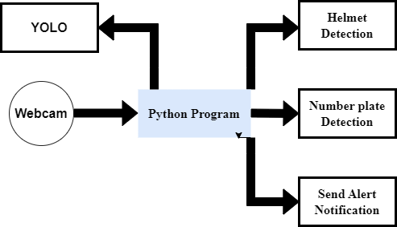

* **YOLO** stands for "You Only Look Once," which is a state-of-the-art real-time object detection system. Developed by Joseph Redmon et al., YOLO revolutionized the field of computer vision by significantly speeding up object detection tasks while maintaining high accuracy.
* **Helmet Detection:** Helmet detection refers to the process of automatically identifying the presence or absence of helmets worn by individuals in images or video frames. It is a computer vision task that typically involves the use of algorithms and techniques to analyze visual data and recognize helmets within a given scene.
* **Number Plate Detection:** Number plate detection refers to the process of automatically identifying and localizing license plates within images or video frames captured by cameras.
* **Send Alert Notification:** "Send Alert Notification" refers to the process of informing relevant parties or systems about an event or condition that requires attention or action. This notification can be delivered through various communication channels such as email, SMS, mobile app push notifications, phone calls, or integration with other systems.
* **Webcam:** A webcam, short for "web camera," is a type of digital camera commonly used to capture video and sometimes audio in real-time, allowing users to communicate visually over the internet.

# IMPLEMENTATION

import cv2

# Load the Haar cascade classifier for license plate detection

nPlateCascade = cv2.CascadeClassifier("haarcascades/haarcascade_russian_plate_number.xml")

# Parameters

frameWidth = 640

frameHeight = 480

minArea = 800 # Adjust the minimum area for more accurate detection

color = (255, 0, 255)

# Video capture setup

cap = cv2.VideoCapture(0)

cap.set(3, frameWidth)

cap.set(4, frameHeight)

cap.set(10, 150)

while True:

success, img = cap.read()

if not success:

break

# Convert frame to grayscale

imgGray = cv2.cvtColor(img, cv2.COLOR_BGR2GRAY)

# Detect license plates

numberPlates = nPlateCascade.detectMultiScale(imgGray, scaleFactor=1.1, minNeighbors=5)

# Process detected license plates

for (x, y, w, h) in numberPlates:

area = w * h

if area > minArea:

cv2.rectangle(img, (x, y), (x + w, y + h), color, 2)

cv2.putText(img, "Number Plate", (x, y - 5), cv2.FONT_HERSHEY_COMPLEX_SMALL, 1, color, 2)

# Extract and show the region of interest (ROI)

imgRoi = img[y:y + h, x:x + w]

cv2.imshow("ROI", imgRoi)

# Display the processed frame

cv2.imshow("Result", img)

# Check for key presses

key = cv2.waitKey(1)

if key == ord('s'): # Save the detected license plate

cv2.imwrite("NoPlate_{}.jpg".format(count), imgRoi)

print("Image saved as NoPlate_{}.jpg".format(count))

count += 1

elif key == ord('q'): # Quit the application

break

# Release resources

cap.release()

cv2.destroyAllWindows()

This Python code utilizes the OpenCV library for real-time license plate detection in a video stream. It employs a Haar cascade classifier specifically trained for recognizing Russian license plates. The script begins by setting up the video capture from a camera, defining parameters such as frame dimensions and minimum area for detection accuracy.

Within the main loop, each frame from the video stream is read and converted to grayscale. The Haar cascade classifier is then applied to detect potential license plate regions. Detected regions are processed to ensure they meet a minimum area requirement, after which a bounding box is drawn around them on the original frame.

Additionally, the script allows for the extraction and display of the detected region of interest (ROI), typically containing the license plate. Users can save the extracted license plate images by pressing 's' and quitting the application by pressing 'q'. Finally, the resources are released upon exiting the loop.

This code serves as a foundation for license plate recognition systems, enabling developers to build upon it for various applications such as vehicle tracking, parking management, and security systems.

# RESULTS

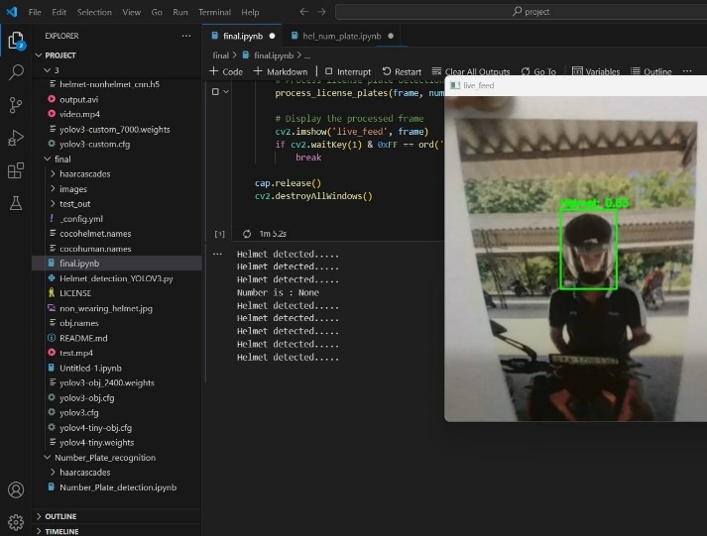 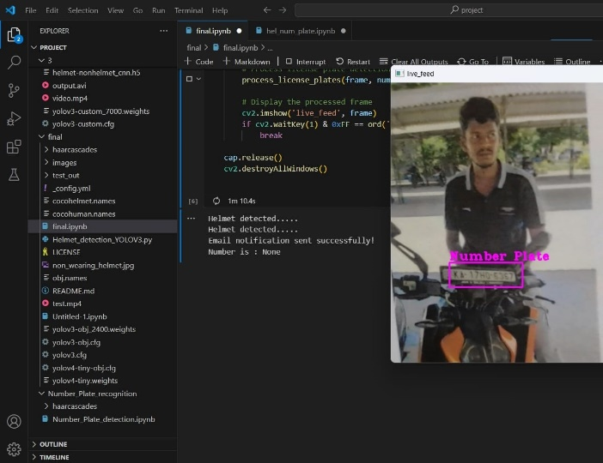

**Fig: Detection of Helmet Fig: Extracting the information from the number plate**

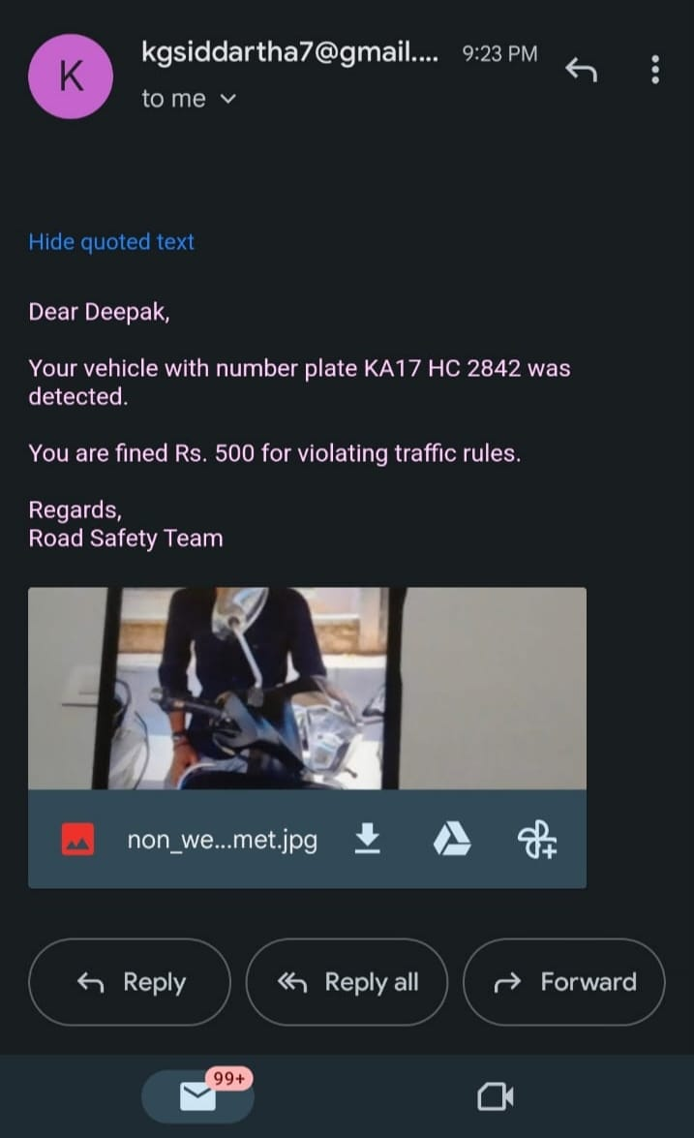 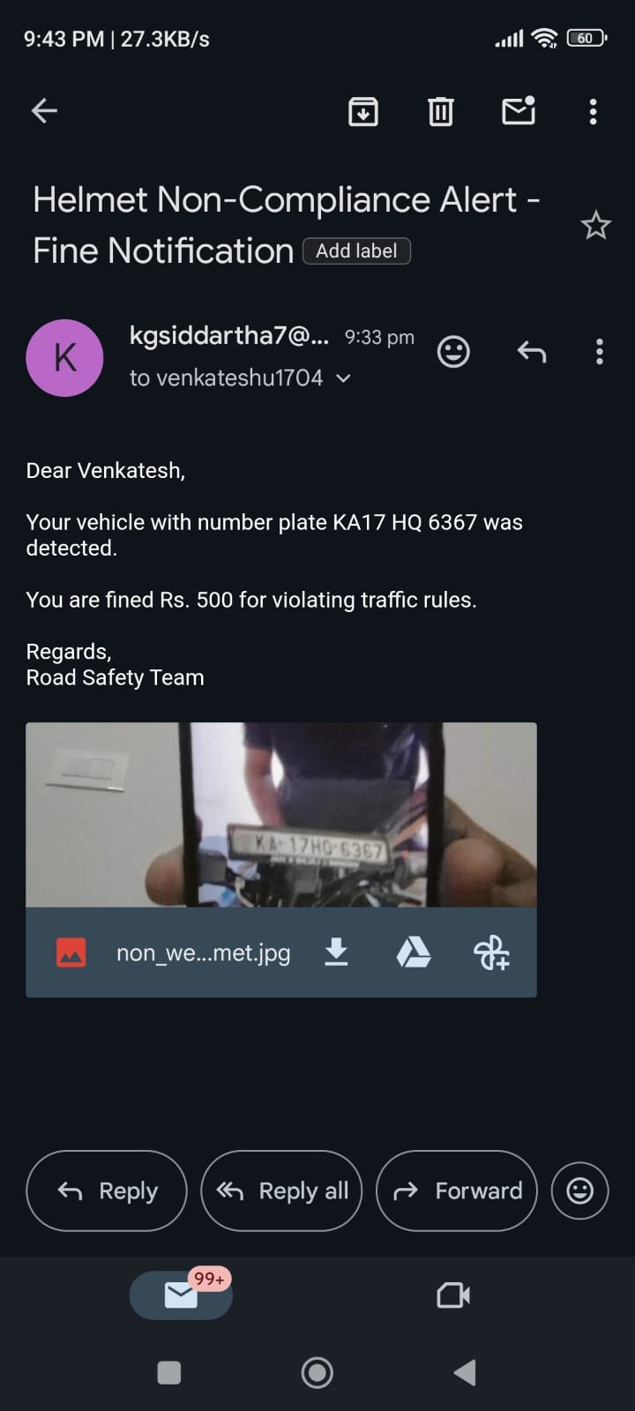

**Fig: Penalty to the Bike riders Who are not waiting the Helmet through E-mail**

# CONCLUSION

To improve roadway safety and assist in ensuring the implementation of helmet-wearing laws, the project set out to establish an extensive system for helmet recognition as well as number plate recognition that would also interface with a computerized email warning system. The goals were to identify and classify vehicles with related number plates, identify people riding without helmets, and send alerts via email to the proper authorities along with additional proof as soon as possible.

# REFERENCES

1. Detection of helmets on motorcyclists. By Remuera R.V.e Silva, Kelson R.T. Aires, Rodrigo de M. S. Veras,[2018].
2. Helmet Detection using Machine Learning and Automatic License Plate Recognition. By Lokesh Allamki, Manjunath Panchakshari, Ashish Sateesha, K S Pratheek(BNMIT, Bangalore).
3. Detecting motorcycle helmet use with deep learning. By Felix Wilhelm Sieberta, Hanhe Lin (Department of

Psychology and Ergonomics, Technische Universit¨at Berlin, Marchstraße 12, 10587 Berlin Germany),[2020].

1. A Hybrid Approach for Helmet Detection for Riders Safety using Image Processing, Machine Learning, Artificial Intelligence. By M.Swapna, Tahniyath Wajeeh, Shaziya Jabeen, Volume 182 – No. 37, January 2019.
2. C. Vishnu, Dinesh Singh, C. Krishna Mohan and Sobhan Babu Visual Intelligence and Learning Group (VIGIL), Department of Computer Science and Engineering Indian Institute of Technology Hyderabad, Kandi, Sangareddy-502285, India