AUTOMATIC SOLAR PANEL TILTING SYSTEM

# Neha Mariya Tomy1, Nidha Susan Mathew2, Nirald Lansan3 Godwinraj D4,Ranjitha Rajan5

## 1,2,3,Students, Electronics & Communication Engineering, Amal Jyothi College of Engineering, Kottayam, India.

4Associate Professor,5Assistant Professor, Electronics &Communication Engineering, Amal Jyothi College of Engineering, India.

# ABSTRACT

The goal of our project is to increase solar panel efficiency. We aim to develop an automated solar panel tilting mechanism that uses a stepper motor to modify the panel's orientation in response to varying solar radiation levels. The mechanical structure that will enable the solar panel to tilt and the microcontroller such as an Arduino that will precisely manage the system based on input parameters like sunlight angle or time of day are what we have built to do this. To guarantee precise panel orientation, our team is creating algorithms for the best solar monitoring and putting safety precautions in place to avoid any mishaps. For even more ease, the system can be watched over remotely. We are increasing the efficiency of solar energy harvesting by combining all of these elements, which will eventually lead to a more sustainable future.

**Keywords:** Arduino UNO, Stepper motor, Solar panel, Gear

# 1. INTRODUCTION

Solar tracking is a technique used to keep solar collectors, such as photovoltaic (PV) or photothermal systems, perpendicular to the solar radiation throughout the day. This increases the collected energy and ensures maximum solar radiation. A solar tracking system is a mechanism designed to align solar panels or solar collectors to the sun to optimize their energy production. The main purpose of a solar tracking system is to increase the efficiency of solar energy collection by ensuring that the panels always face the sun as they move across the sky during the day. There are different types of solar energy monitoring systems. Single-axis tracking systems move solar panels along a single axis, either horizontally or vertically, to track the sun's daily east-west path across the sky. Dual-axis tracking systems move solar panels along two axes, usually both horizontally and vertically, allowing them to track the sun's daily path as well as its seasonal changes. Active tracking systems use motors and sensors to continuously adjust the position of the solar panels based on the position of the sun throughout the day. Passive tracking systems, on the other hand, use mechanical structures that automatically adjust the position of solar panels according to changes in temperature or sunlight intensity without motors or sensors. Although solar tracking systems can significantly increase solar energy production, especially in areas with abundant solar resources, they also increase the complexity and cost of the system. Therefore, their suitability depends on several factors, such as the size of the available space, the budget and the desired energy production efficiency. As part of this project, we designed gear shafts with a specific form and function. We made a half gearbox connected behind the solar panel and a rotary gearbox connected to a stepper motor. When the motor is activated, it causes the gear shaft to rotate. As a result, the half-shaped gear shaft also starts to rotate, because the two gears are connected. This mechanism enables efficient energy transfer and is an important part of the overall design of the project. Gear shaft mechanisms are commonly used in solar tracking systems to facilitate the movement of solar panels or collectors. These mechanisms offer several advantages, including reliability: Gear mechanisms are known for their reliability and durability. They withstand harsh weather conditions and long continuous use without major wear or maintenance issues. Accuracy: Gear shaft mechanisms provide precise control of the movement of the solar panels, enabling accurate tracking of the sun's position throughout the day. This precision ensures optimal solar energy capture and maximizes the efficiency of the solar system. Mechanical Advantage: Gears provide a mechanical advantage by allowing heavy solar panels or arrays to move smoothly and efficiently. This mechanical advantage reduces the energy required for tracking, making the system more energy-efficient overall. Versatility: Gear shaft mechanisms can be adapted to a variety of solar tracking systems, including single-axis and dual-axis tracking devices. They can also be adapted for different sizes of solar installations, from small residential to large commercial applications. Cost-effectiveness: Although gear shaft mechanisms may have a higher initial cost compared to other tracking systems, they offer long-term savings due to their reliability and efficiency. They generally require little maintenance and have a long life, resulting in lower life cycle costs. Adaptability: Gear shaft mechanisms can be integrated into different types of drive systems, including electric motors, hydraulic drives or even manual cranks. This adaptability allows flexibility in design and implementation to accommodate various site-specific requirements and preferences. In general, the use of gear shaft mechanisms in solar tracking systems increases energy production, and improves reliability and efficiency, making them a popular choice for many solar cells.

### PROBLEM STATEMENT

To produce the maximum amount of energy, solar energy systems require the optimal direction of sunlight. However, solar panels have several challenges related to directing sunlight that can affect energy production.

• One of the biggest challenges is suboptimal energy production, which occurs when solar panels are not properly oriented to effectively capture sunlight. To maximize exposure to sunlight throughout the day, solar panels should ideally face south in the northern hemisphere and north in the southern hemisphere.

• Shading is another key problem that can reduce energy production. Even partial shading on a solar panel can significantly reduce total output. Therefore, careful site selection and regular maintenance to mitigate shading problems are essential to maximize energy production.

• Sunlight angle variation is also a challenge that solar cells must face. The angle of sunlight varies during the day and in different seasons due to the tilt and orbit of the earth's axis. Fixed solar panel installations may not be optimized to capture sunlight from different angles, which reduces energy production, especially in the morning, evening and winter months.

• Single-axis solar tracking systems can improve energy production by adjusting the tilt of solar panels. to follow the path of the sun through the sky. However, they may not fully take into account the changes in the angle of sunlight in different seasons, which leads to inefficiency. Dual-axis solar tracking systems offer greater accuracy by adjusting both azimuth and elevation angles to more accurately track the sun's position, but are more complex and expensive to install and maintain compared to single-axis systems.

• Efficiency can reduce solar tracking mechanisms. from mechanical wear, engine failures, or sensor inaccuracies that cause energy losses. Therefore, regular maintenance and monitoring is necessary to ensure the proper and efficient operation of monitoring systems. Determining the optimal orientation and angle of inclination of solar panels for a given location requires careful consideration of factors such as latitude, climate, electrical demand patterns and financial constraints. Although tools and software exist to optimize the placement of solar panels, achieving perfect orientation may not always be possible or cost-effective.

To meet these challenges, solar installers must conduct thorough site assessments, consider local climate conditions and energy demand patterns, and select appropriate solar panel orientation and tracking systems to maximize energy production and return on investment. Continued research and technological advances in solar energy monitoring, panel efficiency, and system design also help improve the performance and reliability of solar energy systems.

# 2. LITERATURE SURVEY

# _______________________________________________________________________________

"Design and Implementation of a Dual-Axis Solar Tracking System" is the title of the relevant publication [1].

The first publication, which was released in 2023, details the planning and execution of a dual-axis solar tracking system that tracks the sun's movement using the photoelectric technique. The structure of the system is described in depth in the article, emphasizing its creative yet straightforward design. By comparing the theoretical values of solar radiation between the planned system and a fixed panel system, it was possible to determine that the suggested system is more effective at gathering solar radiation. According to the experimental data, the suggested system outperformed the fixed system in terms of energy collection by 24.6%.

The work [2], titled "Design for manufacture and assembly of an intelligent single axis solar tracking system," has been mentioned.

The second publication, which came out in 2020, details a study that was done to come up with a clever single-axis solar tracking system. The study details the three ideas examined and how the binary dominance matrix was used to determine which option was best. After that, the selected design was created and refined to tilt the solar panel so that it is always perpendicular to the sun's rays, maximizing its efficiency. Because locally accessible materials were used in its development, the solar tracker was both practical and affordable. With a notable 25% boost in efficiency, the technology has the potential to revolutionize Zimbabwe's solar energy sector.

The [3] paper suggests a dynamic two-axis tracking system that utilizes specialized microcontroller-based technology to track the sun’s position and optimize solar energy. This article was published in 2016 and contains a detailed description of the hybrid hardware and software system. The article explains how to use the solar panel itself as a sensor to determine the optimal location where the panel receives the most energy from the sun. The system uses two M42SP-7 stepper motors, two ULN2003 stepper motor controllers, two gearboxes and a 10W 12V monocrystalline solar panel to align the panel to the position of the sun. The system is automated with control software so that the solar panel receives maximum solar energy throughout the day..

The study "Tilt angle optimization to maximize incident solar radiation" [4] has been referred to.

The fourth study, which was released in 2013, talks about how important it is to figure out how to tilt solar panels at the ideal angle to enhance energy output. The research and uses of numerous approaches for figuring out the ideal tilt angle of solar panels utilizing various optimization techniques are reviewed in this study. The study emphasizes the importance of precisely determining the ideal tilt angle, which fluctuates according to the sun's daily, monthly, and yearly journey and is strongly influenced by the particular site where the system is situated. In the article [5] titled "Analytical and Experimental Analysis of the Optimal Tilt Angle of Solar Energy Systems. The fifth article published in 2020 contains a detailed analytical and experimental analysis of the optimal tilt angle of PV panels concerning the horizontal plane. The paper highlights various factors affecting the optimal tilt angle such as local atmospheric conditions, and a thorough analysis of the results obtained from experimental measurements. The paper also emphasizes the importance of accurately determining the optimal tilt angle to maximize energy production and its potential for the wider deployment of solar energy systems.

The article "Solar Tracking Design System" (2010) [6] mentions that the United States is the second largest. energy consumer in the world and most of the energy comes from fossil fuels which are limited resources. Therefore, the use of renewable energy is encouraged. Our team is tasked with designing and building a solar tracking system that allows us to compare power generation with and without tracking. In addition, we were required to analyze the life cycle costs of the solar system with and without a tracer. The project has a budget of $2,000 and is being implemented by Dr. Thomas Acker and the Environmental Education and Technology Development Consortium (WERC). To satisfy the customer's needs, we evaluate his requirements based on the list of technical requirements and prioritise them accordingly. The team created five original concepts consisting of one- and two-axis designs. We did a preliminary analysis to evaluate the concepts and chose the Rotisserie design based on the decision matrix. This model is a single fixed second-axis tracker that provides an efficient, simple and cost-effective solution. After choosing the plan, we did a complete technical analysis of the two plans mentioned above. Both designs met the requirements, but the Rotisserie design was cheaper. The energy consumption required to use the grill model is estimated at 0.4615 kWh/year. Based on the technical analysis, the total cost of components to build this design is $268.39. If subscribers approve this plan, the team will move into the construction phase next semester..

The paper [7] calls it "Improved Photovoltaic Energy Harvesting in Cloudy Conditions Using a Solar Tracking System"

It was published in 2009 and investigates the optimization of solar energy harvesting under changing weather conditions, especially cloudiness. period This takes into account how traditional solar tracking systems, where solar modules are typically pointed directly at the sun, may not be the most efficient solution in cloudy weather when solar radiation is mainly diffuse radiation that is evenly distributed across the sky. The research proposes an innovative tracking algorithm that adjusts the orientation of solar panels according to prevailing weather conditions. Especially during cloudless periods when there is plenty of direct sunlight, solar panels use 2-axis tracking to maximize energy recovery. However, under cloudy conditions dominated by diffuse radiation, the arrays move to a horizontal configuration facing the zenith to capture the greatest amount of isotopically distributed sky radiation. Research indicates that solar energy is collected in clouds by implementing a horizontal module orientation, which is almost 50% more efficient than traditional 2-axis solar tracking systems. This approach has important implications for the practical use of solar energy, especially in applications such as the refueling of fuel-cell electric vehicles or long-distance charging of electric vehicles. Increasing energy recovery on days when direct sunlight is limited, helps mitigate problems associated with hydrogen production and reduces the overall size and cost of the system. In conclusion, the paper provides valuable information on optimizing solar energy harvesting under changing weather conditions and demonstrates the potential benefits of adaptive tracking algorithms to improve energy efficiency and usability in real-world applications.

[8] The maximum amount of solar energy that can be harvested can utilize different solar tracking systems.

2010. published in 2011, it examines the effectiveness of various solar tracking systems in maximising solar input and electrical output. The study compares different tracking methods, including fixed systems, vertical axis trackers, 6-degree tilt axis trackers and dual axis trackers. Throughout the study, each tracking system was equipped with microprocessors to control their movements and photovoltaic systems to convert solar energy into electricity. For a year, the study utilized solar radiation input and electrical output to evaluate various monitoring systems. The results of the study show that solar tracking systems are more efficient than fixed systems in terms of both solar energy collection and electricity generation. Of the tracking systems tested, the dual-axis tracker showed the greatest growth, followed by the vertical-axis tracker and then the 6-degree inclined-axis tracker. These results indicate that more complex tracking mechanisms capable of adjusting both azimuth and elevation angles are more effective in maximizing solar energy harvesting compared to simpler tracking systems. Overall, the paper emphasizes the importance of using solar monitoring systems to improve the efficiency and capacity of solar energy systems. It provides valuable information on the comparison of different monitoring methods and provides guidance for the design and deployment of solar energy systems to maximize energy production.

# 3. PROPOSED SYSTEM

# _______________________________________________________________________________

A solar tilting system that tracks the sun throughout the day can be achieved through the use of two gear shafts and a stepper motor. The stepper motor rotates the gear shafts based on signals received from a controller or sensor that detects the position of the sun. This rotation adjusts the solar panel's tilt angle, allowing it to face the sun optimally for increased energy generation. The gear shafts' movement results in the angular movement of the solar panel, which follows the sun's path precisely. The stepper motor's precise control ensures accurate tracking, maximizing the solar panel's efficiency. Overall, the system is an effective way to optimize solar panel orientation for increased energy generation.

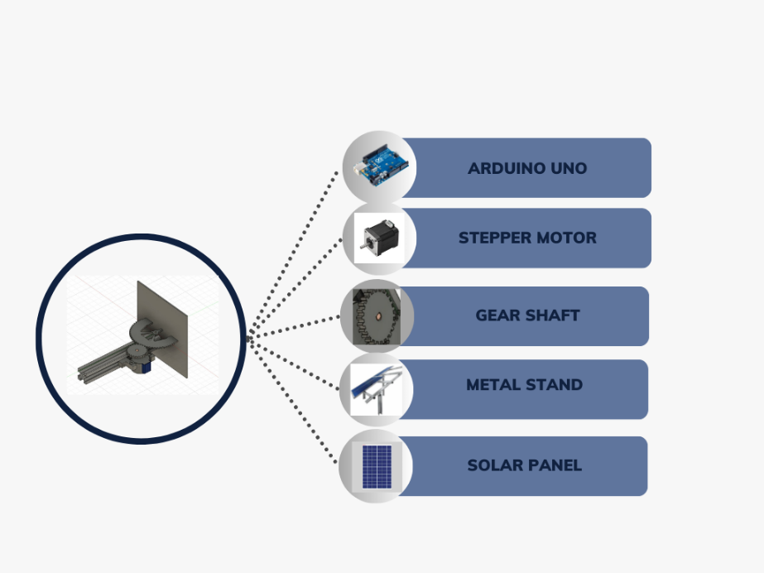

**Fig.1 Proposed Diagram of Automatic Solar Panel Tilting System**

**3.1 BLOCK DIAGRAM**

_______________________________________________________________________________________________

The stepper motor is a crucial component of a solar panel tilting system. It operates by converting electrical pulses into precise rotational movements and consists of coils and a rotor with permanent magnets. The controller, often an Arduino Uno or a similar device, sends specific sequences of electrical pulses to the motor windings, causing the rotor to move in defined steps.

To adjust the solar panels' tilt angle, the stepper motor connects to a mechanism responsible for the task. The controller calculates the optimal tilt angle based on environmental factors like the sun's position, time of day, or light intensity. Once the optimal tilt angle is determined, the controller sends the appropriate signals to the stepper motor to rotate the panels to the desired position.

The stepper motor's precise increments allow for accurate adjustments, ensuring that the solar panels capture the maximum amount of sunlight, improving overall energy efficiency.

A rotating gear shaft connects to the stepper motor in a solar panel tilting setup. When the motor receives signals from a controller, like an Arduino Uno, indicating the need to change the tilt angle of the solar panels, it starts rotating the shaft. This rotation causes the attached half-shaped gear shaft to rotate, tilting the solar panel along a predetermined axis. It provides a mechanical linkage between the motor and the solar panels, allowing for controlled and precise adjustments in response to environmental factors.

A quarter-shaped gear is a specific type of gear often used with a motor, like a stepper motor, to achieve controlled rotational movement. This type of gear may also be part of the gearing system connected to a motor responsible for adjusting the tilt angle of the solar panels.

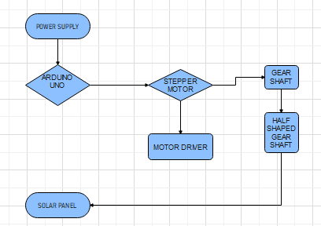

**Fig. 2 Block Diagram of Automatic Solar Panel Tilting System**

**3.2 CIRCUIT DIAGRAM**

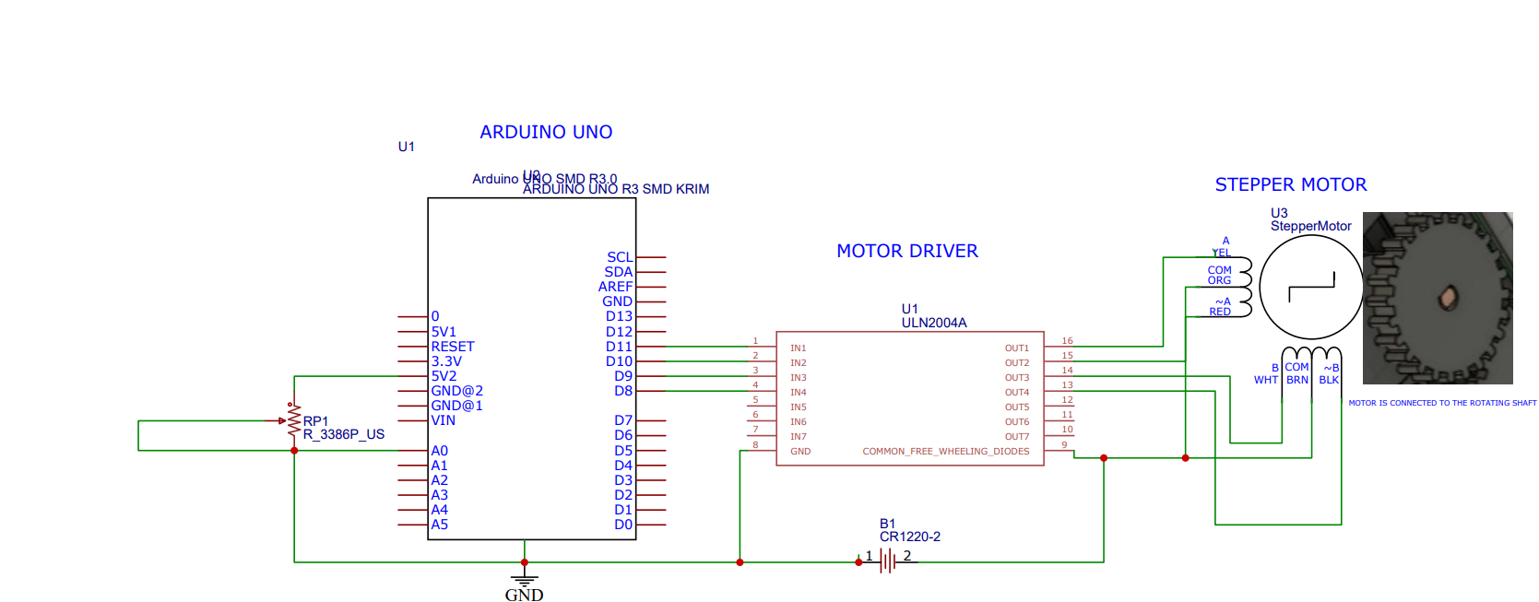

**Fig 3 Circuit Diagram Of Automatic Solar Panel Tilting System**

**4. CONCLUSION**

**_______________________________________________________________________________**

In conclusion, solar panel tilting using a gear shaft and time delay mechanism is an innovative approach that offers a sophisticated and effective solution for enhancing energy capture. By optimizing panel angles in response to the sun's movement, this approach ensures consistent and efficient sunlight exposure, which significantly contributes to the overall energy capture of solar panels. The precision offered by the gear shaft, coupled with the timely adjustments facilitated by the time delay, collectively maximizes energy output from solar panels, making the system a promising advancement in solar technology.

**5. REFERENCE**

**_________________________________________________________________________________**

[1] N.H. Helwa, A.B.G. Bahgat, A.M.R. El Shafee, E.T.El Shenawy “Maximum Collectable Solar Energy by Different Solar Tracking Systems”

[2] Nelson A. Kelly, Thomas L. Gibson “Improved photovoltaic energy output for cloudy conditions with a solar tracking system”

[3] Mohamad Fakir Naen, Muhamad Hariz Muhamad Adnan, Nurul AdilahYazi,Chee Ken Nee , "Development of

Attendance Monitoring System with Artificial Intelligence Optimization in Cloud",

[4] Muhammad Farhan Siddiqui, Waqas Ahmed Siddique, Mushtaq Ahmedhand Awais Khan Jumani, "Face Detection and Recognition System for Enhancing Security Measures Using Artificial Intelligence System"

[5] Hashem Bukhamsin, Angelo Edge, Roger Guiel, Dan Verne “Solar Tracking Structure Design”

[6] Anu George, Robins Anto “Analytical and experimental analysis of optimal tilt angle of solar photovoltaic systems”

[7] Amit Kumar Yadav, S.S. Chandel“Tilt angle optimization to maximize incident solar radiation: A review”

[8]Erwin Normanyo, Awingot Richard Akparibo “A Solar Radiation Tracker for Solar Energy Optimisation”

[9] Ömer Gönül a b, Fatih Yazar a, A. Can Duman a b, Önder Güler“A comparative techno-economic assessment of manually adjustable tilt mechanisms and automatic solar trackers for behind-the-meter PV applications”

[10] Ömer Gönül, A. Can Duman, Burak Barutçu, Önder Güler,“Techno-economic analysis of PV systems with manually adjustable tilt mechanisms”