**PLANNING AND SCHEDULING OF RESIDENTIAL BUILDING BY USING MICROSOFT PROJECT SOFTWARE**

Vilas Lanjewar*1, Vaibhav Suryawanshi*2, Vaibhav Rodge*3, Prof. Jayesh Tandulkar*4,

# [harshaldange757@gmail.com](mailto:harshaldange757@gmail.com)

**[vilas.lanjewar22@gmail.com](mailto:vilas.lanjewar22@gmail.com)**

*1,2,3,4,Civil Engg. Dept, Nagarjuna Institute of Engg, Technology & Management, R.T.M.N.U

Satnavari Village Nagpur, Maharashtra, India

**ABSTRACT:** This thesis discusses the use of Microsoft Project software and construction management techniques for planning and scheduling a residential building project. The project involves building from scratch, which requires careful planning and scheduling to ensure timely completion within the allocated budget. The objective of the project is to create a comprehensive project plan that covers all aspects of the construction process, including demolition, work sanctioning, site preparation, foundation, framing, roofing, electrical, plumbing, and finishing, etc. The construction management information provides a comparison between traditional project management techniques providing various insights and modern software tools in terms of cost, time, and quality. This thesis aims to demonstrate the benefits of using project management software for residential construction project. The project plan will include a Gantt chart that shows the timeline of tasks and dependencies, a resource sheet that lists all the resources required for the project, and a cost sheet that outlines the estimated costs of the project. The project plan will be regularly updated to track progress and identify any potential issues or delays, ensuring that the project is completed on time and within budget. The thesis also discusses the use of construction management techniques, such as risk management, quality control, and resource allocation, to monitor the project's progress and ensure that it stays on track. Overall, this project aims to demonstrate the importance of effective project planning, scheduling, and tracking in the successful completion of a construction project.

**I.INTRODUCTION**

The construction industry is an integral part of the country's infrastructure and economic development. The construction industry faces many challenges that need to be addressed. It includes time and cost overruns due to poor design, poor planning, lack of commitment and quality control during completion. Analysts estimate that, on average, projects cost 30 percent more than budgeted costs. A study shows that management skills are important to complete the work on time in financial forecasting and allocation of resources. Projects with good planning, proper organization, and adequate resources will not automatically turn out as expected. There should be some kind of reporting mechanism that regularly reminds the organization of its success and failure. The industry is the second largest economy in India and the growth of this industry varies across the country. Rural areas need tools for economic development, land use and environmental planning in response to urban development. The time available to achieve this goal is running out. So, the solution to this problem can be using the newly introduced software for getting the work done in a quick manner.

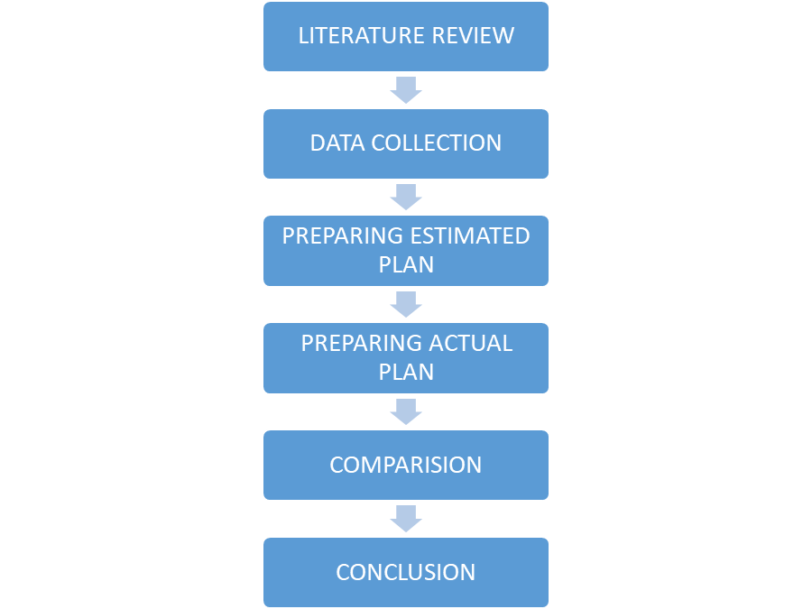

**Figure 1: Current Cloud Scenario**

**II.LITERATURE REVIEW**

Literature survey related to Planning and Scheduling of Residential Building by Using Microsoft Project that aims to reduce the total duration, ease of work for the Labor, Planning and scheduling of residential building, to prepare a realistic schedule and set baseline, to prepare the graph of the planning and scheduling.

**Vittal Anantatmula, Planning Techniques for Academic Advising and Learning, (2010), Journal of Engineering Research and Applications www.ijera.com ISSN: 2248-9622, Vol. 4, Issue 6(Version 5)**

**Description: -** Found out that Similar to a traditional project, managing an academic degree is related to the triple constraints of time, cost, and scope. It is concluded that by applying project management concepts, tools, and techniques, undergraduate degree program advising and planning can be improved after comparing the planning aspects of a conventional business project with the planning of an academic degree.

**R. Prabhahar and G. Ravichandran, Optimal planning and scheduling in multi-storied building, (2014), Journal of Mechanical and Civil Engineering (IOSR)**

**Description: -** Analysed that; Construction planning is an important part of the overall management process. The planning and management include organizing the work, executing the work, correlating plan and progress information and controlling the work, the three inter-related factors of time, money and quality need to be managed in a proper way. Completion of many of the projects nowadays is not in estimated duration.

**Hoang, Nhat Minh Shrestha, Swastik, Project management software and its utilities (2014), Lahti University of Applied Sciences Degree Programme in Business Information Technology**

**Description: -** Hinted that the main function of a software is to offer help, and enhance the quality of output with less effort than manual ways. A project has disparate requirements and the aim of the adopted software is to fulfil those requirements effectively in terms of time and cost. In 7 addition, the issues of scheduling, tracking and physical element must be considered while adopting the project management software.

**Minh Shrestha Optimal planning and scheduling in multi-storied building, (2014), International Journal of Innovative Research in Science, Engineering and Technology (IJIRSET)**

**III.METHODOLOGY OF PROPOSED SURVEY**

**MICROSOFT PROJECT**

Microsoft Project is a project management software program developed and sold by Microsoft to assist project managers with planning, allocating resources, tracking progress, managing budgets, and reviewing projects.

Project budgets based on operating and resource costs. When resources are assigned to a task, the program calculates a cost equal to the time spent on the cost rounded up to the task level, then the task level, and finally the work stage. Identification of resources (work, materials and equipment) can be shared between projects using shared resources. Each resource can have its own calendar that defines the days and times on which it occurs. Resource rates are used to calculate resource assignment costs. Each resource can be assigned to multiple tasks in multiple projects and each task can be assigned numerous resources. The execution of the scheduled task work based on the resource availability as defined in the resource calendars. All resources can be defined in Work, Material and Cost. Therefore, it cannot estimate how many finished products can be obtained with a given amount of raw material. This makes Microsoft Project unsuitable for solving problems of available materials constrained production.

The software creates critical path schedules, and critical chain and event chain methodology third party plugins are also obtainable. Schedules can be resource leveled, and task networks are visualized in a Gantt chart. Additionally, Microsoft Project can identify divergent classes of the users. These different classes of users can have differing access levels to projects, views, and other data. Customization of aspects in Microsoft Project such as calendars, views, tables, filters, and fields are stored in an enterprise global which is accessible by all users.

**SOFTWARE BASED METHODOLOGY**

The methodology of the project is divided into two phases:

Phase I: Planning and Scheduling

Phase II: Resource Allocation, Assign resources to tasks, Resource Levelling

**PHASE I**

**PLANNING:**

The First part is to prepare a process plan. In this process plan work breakdown structure is prepared, i.e. how your project will go, after one activity which is the next activity to be performed. And the scope of the project is defined.

1. Scope of work: With a definite project scope, managers can easily stay on track and ensure that all the deadlines are being followed throughout the project life cycle.
2. Data Gathering: Drawings are gathered as part of the data collection process. It is important to gather all architectural drawings, CAD drawings as well as a summary of all the actions involved.
3. Work breakdown structure: WBS is a deliverable oriented breakdown of a project into smaller component for completing complex, multistep project. The goal of a WBS is to make a large project more manageable. Breaking it down into smaller chunks means work can be done simultaneously by different team members, leading to better team productivity and easier project management. In WBS the list of the activities and their sequence is finalized.
4. Quantity Surveying: Calculating quantities from the obtained drawings for each and every item is a part of quantity surveying.

**SCHEDULING:**

Second step is to develop the schedule of the project.

Following is the scheduling process: Making a new project plan, assigning a calendar, setting project information, entering task, establishing WBS, scheduling activities, resource allocation and levelling in MS-Project are all steps in the process. Before we develop a schedule, it is very important to have a proper detailed scope of the project. Second step is to develop the schedule of the project.

|  |
| --- |
| 1. Create a new blank project |
| 1. Add project Information |
| 1. Add task name |
| 1. Enter task duration |
| 1. Create milestone |
| 1. Linking task |
| 1. Prepare resource sheet |
| 1. Assign resources to task |

Fig. 2. Scheduling Process

1. **CREATE A NEW BLANK PROJECT**

MS project will display a list of options. From the list of available templates click blank project.

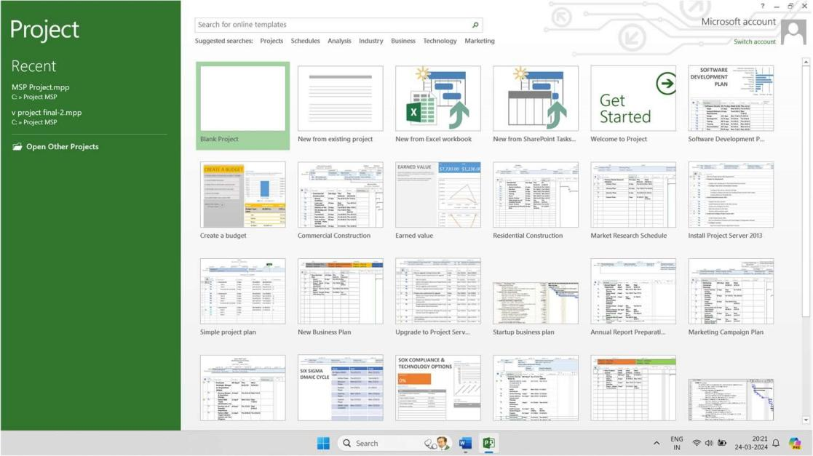

Screenshot No. 1. Create new project

1. **ADD PROJECT INFORMATION**

In this we changed the project start date and add some more information.

Step 1: Start Date

Click Project tab → Properties Group → Project Information.

A dialog box appears. In the start date box, click start date or click the down arrow to display the calendar, select date. Click OK to accept the start date.

Step 2: Set Up Calendar

Click Project tab → Properties Group → Project Information.

Click the arrow on the Current Date dropdown box. A list appears containing three base calendars

1. 24 Hour − A calendar with no non-working time.
2. Night Shift − Covers 11 PM to 8 AM, night shifts covering all nights from Monday to Friday, with 1 hour break.
3. Standard − Regular working hours, Monday to Friday between 8 AM to 5 PM, with one hour break.
4. Create new Calendar for project Calendar and named as V calendar. Click “Cancel” or “OK” to close the dialog box.

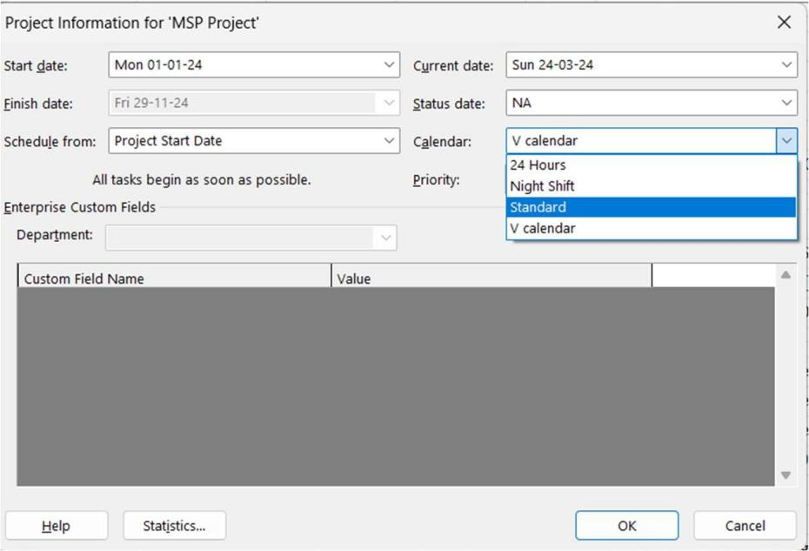

Screenshot No. 2. Project Information

1. **CREATE NON-WORKING DAYS**

Adding exceptions are used to modify a Project calendar to have a non-standard workday or a non-working day. We can also allot unique working hours for a particular resource as well. Click Project tab → Properties Group → Click change Working Time.

The change working dialog box appear. Click the down arrow for the “For Calendar” dropdown box. Select the resource for whom you want to change work schedule. We have chosen V calendar again. Click “Work Weeks” tab. Double-click the [default] cell below the Name column heading. Under “Selected Day(s)” choose any day you want to change the work schedule. Click any day (we have chosen Sunday) and use the radio button “Set days to nonworking time”. Click OK to close the Dialog box. You will now see all Sunday are greyed out in the calendar.

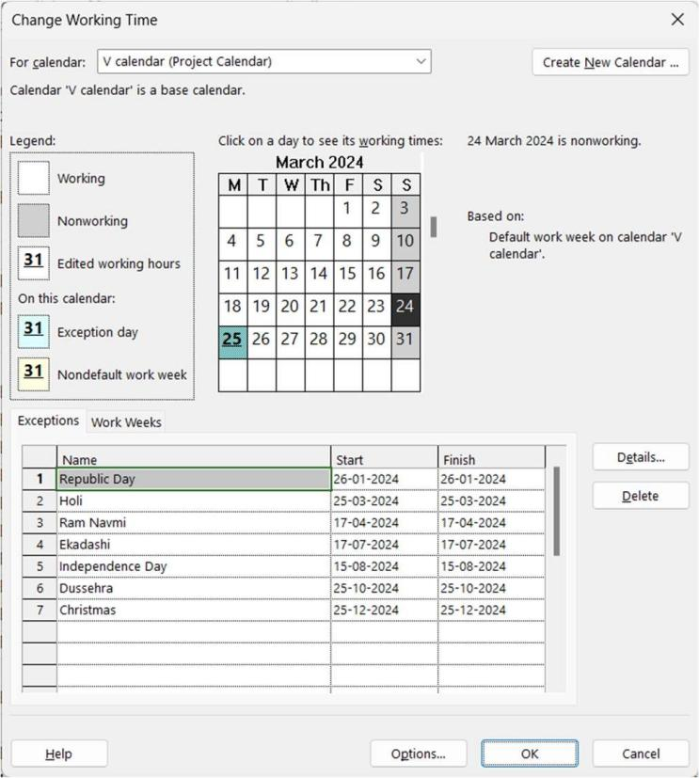

Screenshot No. 3. Project Calendar

1. **ESTABLISHING A WORK BREAK DOWN STRUCTURE**

A WBS shows the hierarchy of a project's component parts. Using the work breakdown structure, a project called home structures is created. This creates various other activities in sequence inside of it. Project breakdown structures such as excavation and earthwork, foundation, superstructure, reinforcement, concreting, brick work including doors and windows frame, lintel work, interior plaster, waterproofing work, external plaster, finishing work, painting and service work are then produced inside this home structures.

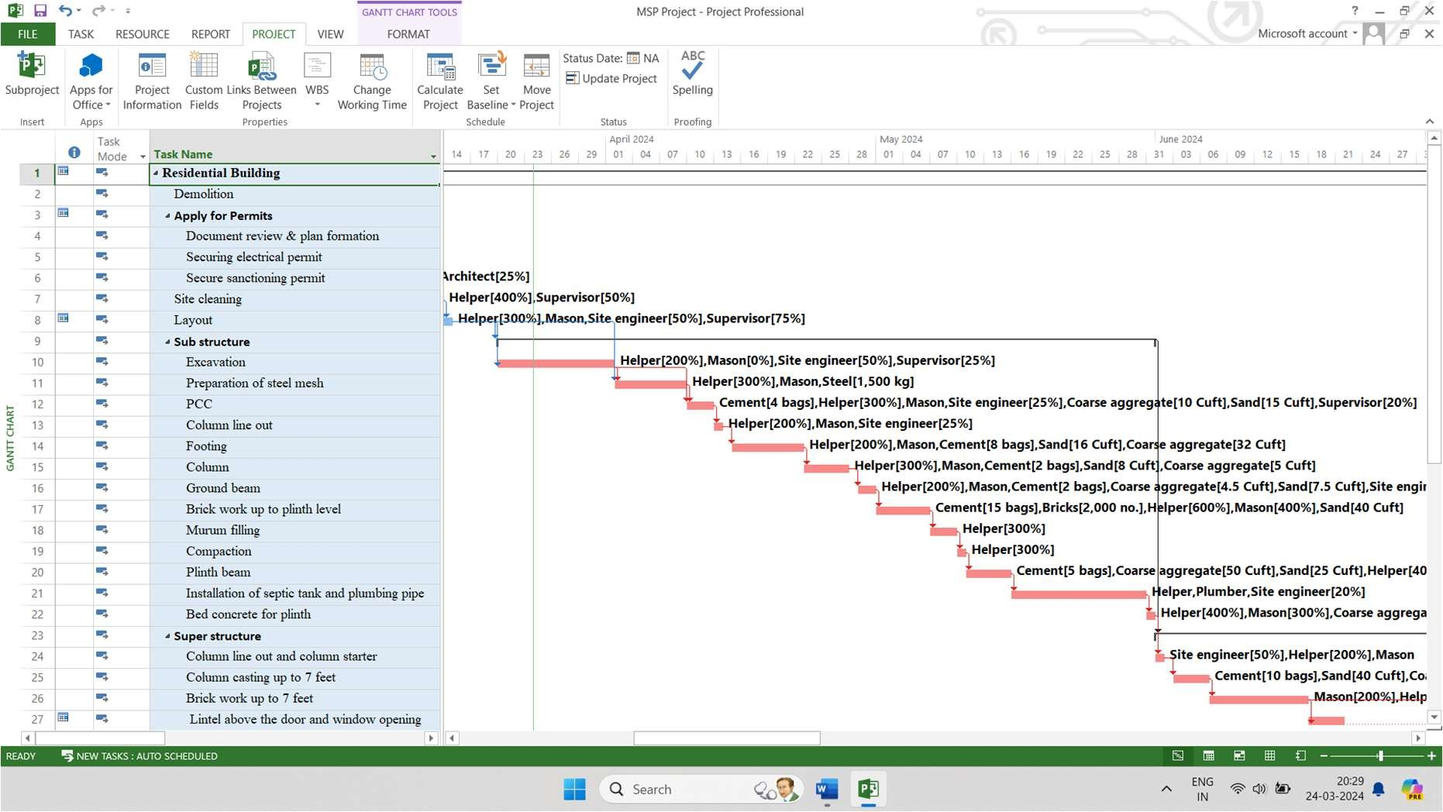

Screenshot No. 4. Work Breakdown Structure

1. **CREATE MILESTONE**

In Project Management, Milestones are specific points in a project timeline. They are used as major progress points to manage project success and stakeholder expectations. They are primarily used for review, inputs and budgets. Mathematically, a milestone is a task of zero duration. And they can be put where there is a logical conclusion of a phase of work, or at deadlines imposed by the project plan. There are two ways you can insert a milestone.

Method 1: Inserting a Milestone.

Click name of the Task which you want to insert a Milestone Click Task Tab → Insert Group → Click Milestone.

MS Project names the new task as with zero-day duration.

Click on to change its name.

Method 2: Converting a Task to a Milestone

Click on any particular task or type in a new task under the Task Name Heading. Under Duration heading type in “0 days “.

1. **LINKING TASK**

Once you have a list of tasks ready to accomplish your project objectives, you need to link them with their task relationships called dependencies. In MS Project, the first task is called a predecessor because it precedes tasks that depend on it. The following task is called the successor because it succeeds, or follows tasks on which it is dependent. Any task can be a predecessor for one or more successor tasks. Likewise, any task can be a successor to one or more predecessor tasks. There are only four types of task dependencies.

a. Finish to Start (FS)

1. Finish to Finish (FF)
2. Start to Start (SS)
3. Start to Finish (SF)

In MS Project you can identify the Task Links −

1. Gantt Chart − A Gantt chart is used to create the project schedule for identifying the order of construction. These activities were given resources (manpower). Resource Levelling has been done after considering the actual resources that are accessible on the construction site. In Gantt Chart and Network Diagram views, task relationships appear as the links connecting tasks.
2. Tables − In Tables, task ID numbers of predecessor task appear in the predecessor fields of successor tasks.

**IV.CONCLUSION AND FUTURE WORK**

**CONCLUSION**

1. MS Project is a user-friendly software that has helped improve decision-making and productivity in our work.
2. We used MS Project to plan and schedule labour for a construction project, which gave us information about start and end times, labour requirements, and project duration.
3. We identified critical activities and critical path duration that required more time than the software estimated.
4. Manpower, Material, and Machinery were allocated for each activity, but overallocated resources included masons, helpers.
5. Resource levelling was conducted for resource-constrained analysis, including architects, site engineers, supervisors, masons, helpers, plumbers, and electricians. Duration was extended in exchange for fewer resource restrictions.
6. Resources such as Manpower, Material and Machinery are allocated for each and every activity according to the requirement. The overallocated resources are Mason, helper.

**FUTURE SCOPE**

Planning, Scheduling and Tracking of a residential bungalow by using MSP is an effective way to manage construction process from start to finish. It provides a framework to define the project scope, create a work breakdown structure and assign task to team members .MSP also allows for the creation of project schedule, which can be used to track progress and identify any potential delays.

The future scope of Planning, Scheduling and Tracking of Residential Building using Microsoft project is expected the construction industry to evolve and become more complex and technically advanced.

**REFERENCES**

1. Ms. Darshana P. Khandare, Dr. M.R. Nagare - Prepare Project Schedule using Microsoft Project, -International Journal of Research Publication and Reviews.
2. S. T. Gavde1, Kanase Swapnali, Mulani Apreen, Jadhav Varsha, Mane Mayuri- Planning & Scheduling of Residential Building Using MS Project- International Journal of Science and Research (IJSR) ISSN: 2319-7064 ResearchGate Impact Factor (2018): 0.28 | SJIF (2018): 7.426
3. Prajna Ganesh Gunaga Geena George PG Student, Associate Professor Department of Civil Engineering, EPCET, Visvesvaraya Technological University, Bengaluru, Karnataka, India-Planning, Scheduling and Cost Estimation of Villa Project Using Microsoft Project-International Journal for Research in Applied Science & Engineering Technology (IJRASET) ISSN: 2321-9653; IC Value: 45.98; SJ Impact Factor: 7.538 Volume 10 Issue IX Sep 2022- Available at www.ijraset.com
4. Shubhashree P. Deshmukh Akshay V. Sagale Dr. Manish M. Bais - Study of Scheduling in Microsoft Project Software - International Journal of Scientific Research & Engineering Trends Volume 5, Issue 2, Mar-Apr-2019, ISSN (Online): 2395-566X
5. T.Subramani, T.M.Karthick - Study on Time and Resource Management in Construction Projects Using MS Project- International Journal of Engineering & Technology, (2018) Website: www.sciencepubco.com/index.php/IJET
6. Rhuta Joshi, Prof. V. Z. Patil - Resource Scheduling of Construction Project: Case Study - International Journal of Science and Research (IJSR) ISSN (Online): 2319-7064
7. LDRP Institute of Technology and Research, Gandhinagar, Gujarat - Planning and scheduling for multi-story building using M.S project - International Journal of Advance Research, Ideas and Innovations in Technology.