**SOLAR GRASS CUTTER ROBOT**

**Prof S.B.Martiwar , Tejas Badki, Pratik Sarangdhar, Ketan Khangar,Anshul Nandurkar, Pratham Waghmare,Sakshi Dasarwar**

*Department of Electrical Engineering*

*Rajiv Gandhi College of Engineering and Technology Chandrapur(MS), India*

**Abstract**: Due to the continuous increase in the cost of fuel and the effect of emission of gases from the burnt fuel into the atmosphere, this necessitate the use of the abundant solar energy from the sun as a source of power to drive a lawn mower. A solar powered lawn mower was designed and developed, based on the general principle of mowing. The designed solar powered lawnmower comprises of direct current (D.C) motor, a rechargeable battery, solar panel, a stainless steel blade and control switch . Mowing is achieved by the D.C motor which provides the required torque needed to drive the stainless steel blade which is directly coupled to the shaft of the D.C motor. The solar powered lawnmower is operated by the switch on the board which closes the circuit and allows the flow of current to the motor which in turn drive the blade used for mowing. The battery recharges through the solar charging controller. Performance evaluation of the developed machine was carried out with different types of grasses. No significant difference was observed with the height of grasses at 5% confidence level. The system will have some automation work for guidance and other obstacle detection. The system will have a power source that is battery and a solar panel will be attached on the top of the robot. Moving the grass cutters with a standard motor powered grass cutters is an inconvenience, and no one takes pleasure in it. Cutting grass cannot be easily accomplished by elderly, younger, grass cutter moving with engine create noise pollution due to the loud engine, and local air pollution due to the combustion in the engine. Also, a motor powered engine requires periodic maintenance such as changing the engine oil. Even though electric solar grass are environmentally friendly, they too can be an inconvenience. Along with motor powered grass cutter, electric grass cutters are also hazardous and cannot be easily used by all. Also, if the electric grass cutter is corded, mowing could prove to be problematic and dangerous. The prototype will also be will be charged from sun by using solar panels.

**Keywords: Atmega 328p microcontroller, 18560 Rechargeable Battery, Solar Panel, Ultrasonic Sensor**

**Objectives**:

The objective of this project to avoid energy crisis in India and reduces the human efforts, operating cost and maintenance cost. Also solar based grass cutter keeps the environment clean and healthy. It is used for cutting different types of grasses for various applications. The Solar grass cutter is a grass-cutting robot that is powered by the sun. The system uses 12V batteries to power the car's moving engines and a lawn mower

**Introduction:**

The fully automated solar grass cutter is a fully automated grass cutting robotic vehicle powered by solar energy that also avoids obstacles and is capable of fully automated grass cutting without the need of any human interaction. The system uses 6V batteries to power the vehicle movement motors as well as the grass cutter motor. We also use a solar panel to charge the battery so that there is no need of charging it externally. The grass cutter and vehicle motors are interfaced to an 8051 family microcontroller that controls the working of all the motors. It is also interfaced to an ultrasonic sensor for object detection. The microcontroller moves the vehicle motors in forward direction in case no obstacle is detected. On obstacle detection the ultrasonic sensor monitors it and the microcontroller thus stops the grass cuter motor to avoid any damage to the object/human/animal whatever it is. Microcontroller then turns the robotic as long as it gets clear of the object and then moves the grass cutter in forward direction again. Personal lawns, public parks, gardens are a major recreational places but require a lot of maintenance to keep them operational. The major maintenance activity involved here is grass cutting and weed removal. This requires a lot of time and effort on a regular basis to maintain the lawn.

Also the problem with lawn movers and motorized cutters are that they need to be moved by a human thus requiring human effort and moreover depend on either furl or electric charging. These devices involve recurring cost of either fuel or electric charging to keep running. Well we here solve all these problems with an automated robotic grass cutter that can cut grass of any lawn/garden without human effort as well as it charges itself using solar power without the need of fuel or electric charging. The robotic vehicle uses a set of geared motors with wheels, metal robotic frame, ultrasonic sensors , controller circuitry, battery along with a solar panel to achieve this mechanism. The system uses the control circuitry with ultrasonic motors to help move easily through gardens and lawns. The robotic vehicle is mounted with 4 x Geared motors to deliver the desired torque that will be required to move through lawns and gardens. We use 4 large size rubber wheels to motor shafts that wont get stuck in grass and weeds.

The robotic body is a mild steel chassis that is integrated with 4 Drive motors below it. Also we make a hole in the center of the frame to mount the grass cutter motor in the middle. The high torque high speed motor in the center is used to move the tool that cuts grass. The grass cutter tool is then attached to the motor shaft so that blades can cut grass below.  
The cutter motor mount allows user to loosen the screw and vary the height of cutter motor which allows to define the desired grass cutting height. All these motors are powered by a battery which is charged automatically using a solar panel mounted on top of the robotic frame. This allows for a smart and automated solar powered grass cutter system.

**Block Diagram**

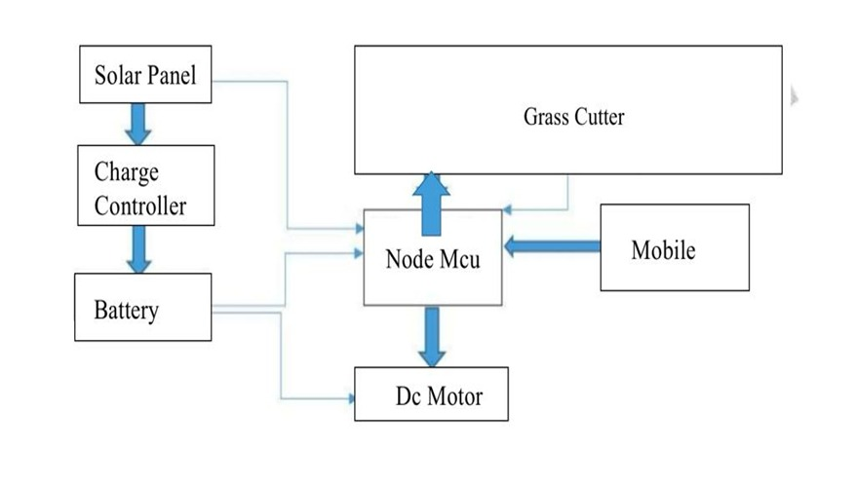

**Advantages:**

• It can cut grass with ease using high powered motor

• Variable head to define the grass cutting height

• Heavy Duty body, wheels and drive motors to navigate offroad

• Autonomous motion with obstacle avoidance using ultrasonic

• Motorized drive using DC motors

• Solar powered machine for self charging

**Result**

It consumes non renewable energy like solar energy available at free. It means that, air pollution, environmental hazardous gas powered lawn mower and reduces human effort. There is no killed worker is required to operate machine. The machine can be controlled by simple programming and at less time. It is high accurate compared to other projects because it detects the obstacle and stop or changes the direction it will perform as per the instructions given. Therefore equipment should be protected from damage and also reduces risk. By adjusting mechanism we have achieved the different length of grass

**Conclusion:**

This project provides a design method of an automated grass cutter operated on solar power, whose task is to cut grass with no need of user interaction. This task is expected to be made possible by using sensors to provide an Arduino with controlling. The obstacle is automatically avoided, here for obstacle avoidance the ultrasonic sensor is used. The system also provides power backup by using inverter. The proposed system will be cost efficient with higher reliability.

**Future Scope:**

We completed our project successfully with the available sources. But the results and modifications are not up to the expectations. This can be further improved by incorporating the following modifications to obtain better results. The mechanism which we used i.e. scotch yoke mechanism does not given excepted efficiency. This efficiency can be increased by using some other mechanism. and speed of motor is reduce because we have used heavy material and this material can be replaced by using light weight material .and design of blades should be done based on types of grass is used to cut. The project which we have done surly reaches the average families because the grass can be trimmed with minimum cost and with minimum time Finally this project may give an inspiration to the people who can modify and can obtain better results

**References:**

[1]. Sujendran S. and Vanitha p., Smart Lawn Mower for Grass Trimming, International Journal of Science and Research, Vol.3, 2014, 2319-7064.

[2]. Praful P. Ulhe, Manish D. Inwate, Fried D. Wankhede and Krushankumar S. Dhakle, Modification of Solar Grass Cutting Machine, International Journal for Innovative Research in Science and Technology, Vol.2,2016,2349-6010.

[3]. Yogita D. Ambekar, Abhishek U. Ghate, “Solar Based Grass Cutter”, Second International Conference on latest trend in engineering, science, humanitiesand management, Page no. 322-326, Feb-2017

[4]. Bulski, P., Yu, S. and E.D., D. (2008) ‘Investigation of sound induced by grasscutting blades’.Journal of Engineering and applied science ,3,pp.290-298

[5]. Ms. Lanka Priyanka, Mr. Prof. J. Nagaraju, Mr. Vinod Kumar Reddy, Fabrication of Solar Powered Grass Cutting Machine, International Journal and Magazine of Engineering, Technology, Management and Research, Vol. 2, 2015, 386-390

[6]. Kumar, D. P. et al., n.d. Design and Fabrication of Smart Solar Lawn Cutter, s.l.: university B D T college of engineering.

[7]. K, V., K, P., R, S. & A, S., 2015. Fabrication and Analysis of Lawn Mower. International Journal of Innovative Research in Science, Engineering and Technology, 4(6), p. 606.

[8]. Mohammad, M. S., Ahmad & Prof, 2018. Design and fabrication of two-wheeler operated sickle bar mower. International Research Journal of Engineering and Technology, 05(10), p. 530.

[9]. M, S. M. & Ahmad, P. K., 2018. Design and fabrication of two-wheeleroperated sickle bar mower. International Research Journal of Engineering and Technology, 05(10), p. 530.

[10]. Ogiemudia, O., 2016. Design and Improvement of a Solar Powered Lawn Mower from Locally Sourced Material. ELK Asia Pacific Journals, 2(1), p. 1.

[11]. P, B. et al., 2017. Design and Implementation of Automatic Solar Grass Cutter. International journal of advanced research in electrical, electronics and instrumentation engineering, 6(4), p. 2433