**“STUDY ON DEMAT ACCOUNT AND ONLINE TRADING”**

**BACHELOR OF COMMERCE**

**SCHOOL OF FINANCE AND COMMERCE**

**YEAR 2021-2024**

**SUBMITTED**

**IN PARTIAL FULFILLMENT OF THE REQUIREMENT**

**FOR THE AWARD OF**

**DEGREE OF BACHELORS OF COMMERECE (HONOURS)**

**SCHOOL OF FINANCE AND COMMERCE**

**BY**

**SUMIT SHARMA, ARYAN GUPTA**

**ADMISSION NO. 21GSFC1010042 , 21GSFC1010037**

**UNIVERSITY ADDRESS :-**

**GALGOTIAS UNIVERSITY**

**YAMUNA EXPRESSWAY , GREATER NOIDA , GAUTAM BUDDH NAGAR , UTTAR PRADESH , INDIA – 201310.**



**DECLARATION**

I SUMIT SHARMA , student of GALGOTIAS UNIVERSITY, studying in Bachelor of commerce (HONOURS), Semester VI, hereby declare that I have completed the

Project on “

Study on demat account and online trading

” in the year

2021-2024

The information submitted is genuine and practical to the best of my knowledge

SIGNATURE OF STUDENT

SUMIT SHARMA & ARYAN GUPTA

ADMISSION NO. 21GSFC1010042, 21GFSC1010037

**ACKNOWLEDGEMENT**

I would really like to thank the Galgotias university for giving me this opportunity of taking on any such challenging mission which more advantageous my know-how about demat account and on line trading.

i'm very thankful to Dr. Nupur Mishra below whose guidance i was efficaciously capable to finish my assignment. I desire to thank her for all of the hints and steerage on the associated topics of my paintings. I am grateful to Her due to her friendly technique and kindness to me.

i would also like to thank the Librarian of our university for imparting me relevant facts and books within the library.

**STUDY ON DEAT ACCOUNT AND ONLINE TRADING**

**INDEX**

|  |  |  |
| --- | --- | --- |
| **Sr. No.** | **Title** | **Pg No.** |
| **1** | **Chapter 1:- Introduction** |  |
|  | **1.1) Demat account** |  |
|  | **1.2) Online trading** |  |
| **2** | **Chapter 2:- research and methodology** |  |
|  | **2.1) Objective of research** |  |
|  | **2.2) Scope** |  |
|  | **2.3) Significance** |  |
|  | **2.4) Limitation** |  |
|  | **2.5) Sampling research** |  |
| **3** | **Chapter 3:- Review of literature** |  |
| **4** | **Chapter 4:- Analysis of data** |  |
| **5** | **Chapter 5:- Conclusion and suggestion** |  |
|  | **5.1) Conclusion** |  |
|  | **5.2) Suggestion** |  |
| **6** | **Chapter 6:- Bibliography** |  |

**Introduction**

**DEMAT ACCOUNT**

What is Demat Account? Trading inside the stock marketplace could be very common nowadays. Increasingly people are indulging in trading and investing inside the stock market. The reason for such increase within the participation in the inventory marketplace is the possibility to make good returns. Consequently, the primary question that involves the mind of the newbie within the stock marketplace is the way to exchange in the stock marketplace. The solution to this question is demat account. To put it any other way. Demat Account acts as a method to exchange or spend money on shares or securities. Without it, no transaction in stocks or securities is feasible. In this newsletter, you will recognize the primary concept of demat account and plenty greater.

Investing in securities is one of the few potential areas where you can invest and grow your money with only a little bit of sensible effort. To do so, you need to know and follow a set of rules and regulations. One of the key components of understanding the stock market and the art and science of investing is by understanding the concept of dematerialization. Technology and digitalization have modified how we paintings and live. Even money-making activities have modified significantly, and we've got benefitted from it. inventory exchanges have advanced too and stock trading has moved from bodily percentage certificate and difficult replica ledgers to dematerialized (or demat) accounts.

**Which means of Demat Account**

Demat account or dematerialized account is an account that holds the shares and securities of an person in an digital shape. Whilst a character indulges in trading or making an investment in shares or securities all of the transactions are done through the Demat account. to place it any other manner, just like the banks preserve the money of the individuals. Similarly, the Demat account holds the stocks and securities of the character inside the account. The investor opens a demat account at the time of registration with the financing broking or sub-broking. To facilitate digital settlements, this account is preferred for stock purchases and sales. Almost all shareholders must have this account in order to make stock changes in accordance with Securities and Exchange Board of India (SEBI) regulatory requirements. It is not possible to trade stocks without a functional demat account.

**ONLINE TRADING**

In recent times, there's no need to go to a financial institution or submit office, or even leave your house for that count number you could virtually trade on-line the use of your house laptop or cell phone. Online trading is virtually shopping for and promoting assets via a brokerage's internet-primarily based proprietary buying and selling platforms. The use of 8db290b6e1544acaffefb5f58daa9d83 trading extended dramatically in the mid- too late-'90s with the creation of less highly-priced immoderate-tempo pc systems and net connections. Shares, Bonds, Mutual price range. Trade rate variety (ETF), alternatives, futures, and currencies can all be traded online. Also called e-shopping for and promoting or self-directed making an investment.

in recent times, with the appearance of the net within the virtual technology, an increasing number of consumers are the use of on-line buying and promoting platforms supplied through way in their retailers for DIY (do-it-yourself) making an investment. The net buying and selling structures characteristic a hub with a couple of gear for the investor or provider. The investor can region purchase and sell orders; place market, restriction, forestall, forestall-loss, and stop- restriction orders; take a look at the recognition of an order; view actual-time stock costs; have a look at news on organizations; view the list of securities presently held through the dashboard; and so on. An investor can also get admission to his or her funding statements, affirmation statements, and funding tax bureaucracy using the net system. Maximum cut price brokerages which can be affiliated with banks additionally offer brought convenience for their virtual clients by using linking their bank debts to their funding debts. This way, an investor can without difficulty provoke a switch amongst money owed hold underneath the identical monetary organization.

**Meaning of online trade**

The act of buying and selling financial goods online is known as online buying and selling. The trader uses an online trading platform to purchase and sell. Online trading may also include trading in foreign currencies, bonds, equities, futures, and other financial instruments.

Numerous financial transactions have been made possible by online trading. Due to the easy access provided by the internet, purchasing and selling inventory, exchanging currencies, and other buying and selling devices have grown in popularity. Simple stockbrokers used to have access to records on the purchase and sale of stocks. More and more people are becoming interested in online trading as they discover knowledge on the internet.

**The Development of Online Trading and Demat Accounts**

We belong to a brand new technology where transformation and alternate are the handiest constants. it may additionally be adequately reiterated that verbal exchange and expertise-pushed era are the ruling orders of the day. It additionally applies to India, that is now gambling a significant role within the worldwide market and is expected to be one of the most powerful and quickest growing economies within the foreseeable future. In different phrases, what became as soon as a predominantly agricultural financial system is all set to convert right into a virtual one.

The Indian capital marketplace has continually been a vibrant one and contributed largely to the country's financial development and growth. that is obvious from the quantity of transactions carried out each day at the Bombay inventory trade (BSE) and the country wide stock trade (NSE) which continuously entice potential traders to sign up for the share buying and selling fraternity to attain huge advantages, both for the fast or long term.

The Indian stock market started out its adventure within the past due 18th century even as East India enterprise commenced to transact loan securities. Throughout the 1830s, trading in stocks of financial institution and cotton presses had started out in Bombay [now Mumbai]. When the American Civil war broke out within the one year 1861, the stock marketplace started out to flourish. Because the war ended, the marketplace had at the least 250 retailers collaborating. The dealers constituted "The neighbourhood percent and Stockbrokers affiliation', an informal group, which become later renamed as the "Bombay inventory change' [BSE] in the yr 1875. The BSE changed into set up under the steerage and with the assist of Premchand, Roychand, who have become one of the main stockbrokers of that factor. Inside the initial days, the investors and shareholders of the Bombay stock change traded for his or her shares and stocks through manner of calling out the expenses of the stocks and/or shares to buy or promote such stocks and stocks. One finishing touch of such alternate, share certificates had been exchanged for cash. Maintaining a track of the stocks and stocks involved massive manual paperwork and converting the transactions into respective agreement have become complex. There was a put off in receipt of securities and the confined infrastructure in the banking and postal segments made it hard to control and manage the wide form of programs and the storage of such percentage certificates.

Moreover, proceeding to dematerialization, a minimum hole of three months modified into required among the date of software and listing of stocks.

Submit 1991, even as the winds of change started out blowing at some stage in the Indian sub-continent, the Indian capital market began undergoing modernization, in particular inside the spheres of buying and selling & agreement. It all commenced with the arrival of the Demat – a fully automatic mechanism for getting and selling. Due to the truth nowadays investor absolute confidence is tech-savvy, the Demat gadget had ensured sheer transparency in the method of buying and promoting at the same time as additionally removing risks related that had hitherto been related to lousy deliveries. Moreover, Demat, which in other terms is the transformation of shares held in paper form to digital shape, has removed huge hundreds of unnecessary paperwork. There has been moreover the hazard of loss or robbery of percent certificates which no longer exists.

However, as time went on, the idea of dematerialization of accounts gained traction in the middle of the 1990s with the passage of the Depository Act of 1996.

**Demat's birth**

From the time the Bombay Stock Exchange (BSE) was established in 1875 until much later in the 1900s, buyers and sellers would publicly announce the prices of the equities they preferred to purchase and sell. Coins may be traded using certificates, which are tangible receipts. As a result, there was a lot of paperwork that required time. Extended paper-based procedures also resulted in delayed settlements because each client and dealer had to provide a certificate before the changeover could be started.

At the beginning of the present Dematerialization process, the stockholder opened a Demat account through his broker. These now resemble opening a bank account in that his physical certificate needs to be transformed into a digital format that is fungible and maintained with his Demat account. Furthermore, its stability may lack any form of differentiating ability. Since its creation, the Demat account has significantly eliminated problems related to forgeries, shares that have been stolen, strong and mismatched signatures, mutilation and duplication of percentage certificates, and extraordinary transfer issues that previously resulted in multiple arbitration hearings and various investor disputes.

The Indian government, seeing depositories and display-based buying and selling as the answer to all investor problems, pushed a highly automated and highly technical model for all stock exchanges with the Depository Ordinance of 1995. Furthermore, the Depositories Act of 1996's implementation has guaranteed the realization of the depository concept in India's capital markets, making trading and agreement—which was previously a laborious and cumbersome process—possible with a single button click.

**Dematerialization: Concept Denotation**   
The process of converting physical shares into digital format is known as dematerialization. An investor wants to register a DEMAT account with a depository participant in order to dematerialize his stocks. The investor receives electronic shares in his DEMAT account upon surrendering his physical stocks.  
Therefore, the fundamental concept of dematerialization is to save the account holder's shares, securities, and share certificates digitally rather than maintaining the aforementioned stocks, securities, and proportionate certificate in physical form.

The nation-wide Securities Depository Limited, India's first and biggest depository device, served a crucial role because its main goal was to establish a platform that would be comparable to the global market's norms for the dematerialization of debt. In addition to utilizing cutting-edge technologies to guarantee the stability and security of the Indian capital market, the National Securities Depository Limited also develops solutions for agreements that boost productivity by reducing risk and raising pricing.

In February of 1999, the Bombay inventory trade sponsored the establishment of Critical Depository Services (India) Ltd. It became an attempt to form a cooperative project with nationalized banks such as Housing Development Finance Organization, Bank of India, Union Financial Institution of India, Bank of India, Kingdom Financial Institution of India, and Standard Chartered Financial Institution. The primary objective of Imperative Depository Services (India) Ltd. is to provide customers with reasonably priced, dependable, appropriate, and confident depository services.

Nowadays, almost all nationalized banks as well as private banks give investors the option to open a dematerialization account. As per the guidelines provided by the Securities Exchange Board of India, the regulatory body overseeing the US inventory market, all investors must have a Dematerialization Account.

**The Indian Depository gadget: an overview**

The dialogue on dematerialization remains incomplete if one ignores the characteristic performed in it with the aid of the national Securities Depository Ltd (NSDL), India's first and biggest depository, set up in 1996. The NSDL, modified into promoted by means of sure countrywide institutions which have been especially accountable for the US's monetary improvement. Its excessive purpose changed into to installation and maintains an infrastructure that matched worldwide standards for dealing in securities in demat form. by using way of using bendy and modern technology systems, NSDL ensures the stability and safety of the Indian capital market. It additionally develops appropriate settlement solutions consequently, developing performance, minimizing danger and lowering fees. NSDL additionally lets in the processing of securities transactions through manner of book entries. A DP or Depository player, the NSDL's agent offers depository offerings to all customers. As in keeping with SEBI guidelines, banks, financial institutions, stockbrokers and custodians are eligible for being Depository individuals (DP). The investor additionally called the BO or beneficial proprietor opens a account with any Depository participant (DP) to dematerialize his holdings and to alternate in and/or transfer them ultimately. The imperative Depository services (India) Ltd (CDSL) came next in February 1999, with the BSE Ltd as its principal promoter. It turned into a collaborative effort with the nation's top nationalized banks, SBI, Bank of Baroda, Financial Institution of India, and Union Bank of India, General Chartered Financial Institution, and HDFC Financial Institution.

The most important intention of the CDSL is to offer dependable, handy & comfortable depository services to traders at lower priced expenses. It’s also linked with all different major Indian inventory exchanges including the BSE Ltd: NSE & the MCX inventory exchange. The stability shown inside the investor's account which is maintained and recorded with the CDSL is offered from the DP. The DP presents an account statement to the investor periodically and these offers out details of his holdings as also transactions.

**The 1996 Depositories Act**

The Depositories Ordinance was added throughout 1995, and on January 7, 1996, it was promulgated as part of the Depositories Act of 1996 (henceforth referred to as the "Act"). The Act's goal was to provide guidelines for depositories to register ownership details in the format required for e-book access.

The Act not only established these rules but also made significant changes to the enactments that followed, including the Groups Act of 1956. Act of 1992, Securities and Trade Board of India   
  
The 1899 Indian Stamp Act. The 1961 Income Tax Act. The 1988 Benami Transactions (Prohibition) Act.   
The primary objective of the Act is to facilitate the swift and easy transition of securities while ensuring accuracy and security by allowing public companies to freely swap their securities. The transfer of such securities is subject to a few exceptions, though, which include restricting the organization's ability to switch securities effectively and requiring the presentation of the switch deed and other requirements in accordance with the provisions of the Companies Act.

The Depositories Act, 1996 become formulated and enacted for imparting regulation for the depositories and distinctive allied subjects connected thereto.

The terminologies that we typically come upon at the same time as discussing the problem of dematerialization of shares are categorically described underneath the Depositories Act, 1996.

As constant with phase 2 (a) of the Act, "useful proprietor" way someone whose call is recorded as such with a depository. A beneficial owner holds all of the benefits of the dematerialized stocks.

As in keeping with segment 2 (b) of the Act, "Board" approach the Securities and exchange Board of India installation below segment three of the Securities and trade Board of India Act, 1992 (15 of 1992).

As in keeping with section 2 (e) of the Act, "Depository" way a commercial enterprise organization long-established and registered below the companies Act, 1956 (1 of 1956) and which has been granted a certificates of registration beneath sub-segment (1A) of phase 12 of the Securities and change Board of India Act, 1992 (15 of 1992).

As in line with phase 2 (g) of the Act, "participant" way someone registered as such under sub-phase (1A) of section 12 of the Securities and alternate Board of India Act, 1992 (15 of 1992).

**Depository:**

The concept of Depository is understood to the sector for the reason that 1949 while the primary depository was set up in Germany. There were 112 depositories in operation through the yr 2001. Every depository operates underneath a rustic's unique regulation and law which will make sure safety, liquidity, rights and liabilities to the safety holders.

A depository is an employer in which the securities of an investor are held in electronic form. A depository may be in comparison to a bank. To avail of the services of a depository, an investor has to open an account with the depository thru a depository participant, just as he opens an account with the financial institution. Holding shares in the account is a family to maintaining money in the financial institution

At present, India has simplest depositories-national Securities Depository Ltd. (NSDL) and significant Depository offerings Ltd (CDSL).

NSDL is the first depository inside the county, which is promoted with the aid of three major financial establishments. Unit trust of India, commercial improvement financial institution of India and countrywide inventory exchange of India constrained. The second depository of the United States (CSDL) is installation in 1999 via the Bombay inventory change and financial institution of India.

But, most of the offerings provided by way of each these depositories are similar. Nowadays nearly all of the organizations indexed in dematerialized from with NSDL are available with CDSL.

Bank Depositories hold funds in their accounts. Maintains securities in accounts   
Transfers of funds between accounts Exchanges without the oversight of securities   
Money holding Maintaining security

**Depository participant:**

An agent designated by the depository may present depository offerings to any buyer; this is known as a depository player. The depository does not allow investors to open Demat accounts directly. An investor can only open an account with a DP. In turn, the DP opens the depository account. In turn, the DP assumes responsibility for maintaining the accounts and updating them in accordance with the investor's periodic instructions. Whenever the investor requests it, the DP creates and provides the holdings statement. As a result, the DP functions as the investor and depository's interface.

A beneficiary owner is a person who has a Demat account. If there is a joint account, the account holders may also be the joint account's beneficiaries. The BO identity is the beneficiary holder(s)' Demat account number. The diverse range of depository players assigned by the depository constitutes a DP identity.

**Capabilities of Depository:**

Within the depository machine, securities are held in depository bills that are more or less just like retaining finances in bank account. Transfer of possession of securities is performed via clean account transfers. This technique does away with all of the dangers and hassles usually related to office work. Consequently, the fee of transacting in depository surroundings is drastically decrease compared to transacting in certificates. The depository device moreover allows distribution of dividends thru the RBI's ECS device, whenever the taking element company has agreed to such offerings. Distinctive entitlements along with bonuses, break up USA are also at once tormented by the depository into the investor's account. The following may be held within the depository (digital) shape: stocks (listed or unlisted), stocks Bonds Debentures RBI relief Bonds authorities Securities (thru a primary supplier), units of Mutual budget industrial Paper cash market devices and so on.

**DEMATERIALIZATION ACCOUNT OPENING (DEMAT A/C)**

A dematerialized account is referred to as demat. To buy or sell stocks, we need to open a demat account, just like we need to open an account with a financial institution to maintain cash on hand, pay checks, etc. Thus, it is extremely similar to a bank account where shares are used to exchange actual money. Remember that the DPs are similar to bank branches, thus we should approach them to open our demat account.

With a demat account, you can buy, sell, and trade shares without having to deal with a ton of paperwork or wait times. It's convenient, safe, and safe as well.

Shall we accept? Our portfolio consists of 100 shares of Satyam, 50 shares of Suzlon, 20 shares of ICICI Bank, 50 shares of Tech Mahindra, and 100 shares of TCS. We'll see some of these on our demat account. Thus, we are not required to possess a tangible certificate attesting to our ownership of those shares. They might all be kept on file in our account electronically. Our account may be changed as we buy and sell the stocks. The DP will provide you with periodic declarations of holdings and transactions, much like a bank passbook or assertion.

**Opening a Demat Account:**

A demat account may be opened without a stocks in any respect. It does no longer require any minimal balance. Step one in the direction of establishing a demat account is to select a Depository participant, fill up the account establishing shape, and publish the file. Having a PAN card is a compulsory requirement for establishing a demat account. The rest of the stairs are defined right here.

.once you submit the shape, you'll get a replica of rules and guidelines, terms of settlement, and the prices you may incur.

. An in-man or woman verification is also vital. A member of the DP group of workers will touch the individual to affirm the information supplied inside the account commencing shape.

. After the verification, the DP person will offer an account number or client identity. you can additionally take a look at these details by checking your account info on-line.

. An annual maintenance rate is paid for a demat account. This fee covers the account transaction costs. The rate is levied for debiting securities to and from the account on a month-to-month basis. The costs are difficulty on your desire of the DP. a few DPs rate as in step with the amount of the transaction while the others charge a flat price that is same for each transaction. The price also can range at the kind of transaction (buying or selling). There can be another charge for changing the share into bodily form or vice-versa.

**A: manner for buying dematerialized securities**

The transactions regarding purchase of securities are:

1. The investor purchases securities through a dealer.

2. He can pay the dealer who then arranges rate to the clearing organization on the pay- in day.

3. The broking gets credit score of securities in his clearing account (clearing member pool account) at the pay-out day.

4. Broking gives commands to its DP to debit clearing account and credit the investor's account.

5. The investor receives shares into his account. If popularity commands are not given on the time of setting up the account, the investor has to offer 'Receipt commands' to the Depository participant for receiving credit score.

6. The investor has to make sure that the broker transfers the securities from his clearing account to the investor's depository account earlier than e-book closure. If the securities stay inside the clearing account of the broker. The employer would possibly offer company advantages (dividend or bonus) to the broker. In that case, the investor will must accumulate the company blessings from the broking.

**B: Procedure for sale of dematerialized securities**

1. The investor uses a broking service to sell the securities on any stock market connected to the National Securities Depository Restricted (NSDL).

2. He needs to train his Depository Player (DP) to debit his account using the clearing account for credit score broking and the range of securities available.

3. The investor must use the shipping training slips that he received from the DP when he opened his demat account to submit the transport training to his DP.

4. The investors' broker provides instructions to its DP for transfer to the clearing organization prior to the pay-in day.

5. The broker provides the investor with the price for the selling of securities.

**Benefits OF DEMATERIALIZATION ACCOUNT**

**Primary benefits:**

1- Safety: If we're protective our shares, bonds and many others in bodily (paper) form, there are possibilities of its robbery, mutilation, and loss. Furthermore, we are also uncovered to the risks of fake papers, horrific-shipping or delays at the time of transfer of physical securities. But, in DEMAT bills; we are able to preserve our prolonged-time period investments safely and securely.

2- Convenience: while we need to sell our dematerialized stocks or redeem our debentures in DEMAT account; there are no hassles of filling up switch forms, sending redemption requests or some other messy, 8261261b8ee23b46c3c262a065603e2e and time-ingesting paper work. We can quite really transfer our securities through digital transfers or absolutely through signing one 'transport schooling Slip", that is nothing however our cheque 7451f44f4142a41b41fe20fbf0d491b7 is for DEMAT payments.

3- Commonplace economic organization: Dematerialization does now not best assist in shopping for and selling shares. it sincerely works for debt instruments like bonds in addition to mutual price range. An investor can maintain all his investments in a unmarried demat account.

4- Automatic Updates: in spite of being a commonplace account for all your securities transactions, you do now not have to offer your statistics whenever you deal with a organization. Your demat account represents you and has all of the vital data regarding the transaction.

5- Regular-Lot problem Resolved: This have become a large obstacle in resolving the settlements as stocks have been offered in hundreds. Customers and sellers couldn't transact a single or peculiar range of securities. Demat account has solved this problem and investors can alternate any quantity of stocks they want.

6- Shipping dangers: and no longer had the usage of a office work concerned, the danger of faux shares, theft, and incorrect deliveries have moreover been removed. That is perhaps one of the most essential blessings of the digital shopping for and selling approach. The device will usually credit score rating securities within the proper demat account mechanically, regardless of amount and kind of shares. that is relevant to unique percent transactions which include inventory splits and stock bonuses as well.

7- Fee reduction: A demat account does not require stamp duty for securities. This has caused massive price reduction. In advance, the stamp obligations grow to be zero. Five % for each stock that could now be averted absolutely through dematerialisation.

8- Easy to preserve: Paper certificate are vulnerable to severa styles of bodily damage which include water damage, hearth, pests, and so on. Even a minor harm can charge you a fortune. But, this isn't always the case with demat account your demat account business organisation bears the obligation of retaining and safeguarding your account. This is the amazing way to preserve securities. The demat account additionally has a nomination facility in case the account holder passes on. The securities and their authority is automatically transferred to the nominee.

9- Exclusive advantages: other than the protection and comfort, there are lot extra blessings of setting out Demat money owed. Right here are few of the maximum necessary motives for having a Demat account.

➤We can park maximum of our investments which consist of shares, bonds, debentures, Gold gadgets, NSC and bonds in our DEMAT account. We won't right now apprehend the advantages of getting all of the investments in DEMAT form. for instance, if we change our house, we simply have to write to the DP (Depository player), which robotically gets our new deal with registered with all of the agencies wherein we've got invested our coins.

➤We do now not must recollect the due dates of maturity of bonds. NSC and debentures, because the redemption proceeds are mechanically credited to our financial group account, which is connected with our DEMAT account.

➤ We collect all the dividends and hobbies right away in our related monetary institution account.

➤ In case of bonus, rights, cut up, merger or some other enterprise moves, the whole thing takes place robotically. We do not want to do something except to record the physical intimation letters sent with the aid of way of the Registrar and transfer dealers.

➤ nowadays with the arrival of on line shopping for and promoting, we will carry out 8db290b6e1544acaffefb5f58daa9d83 all of the sports associated with purchase, promote and switch of stocks.

➤ With a single nomination on your DEMAT account, we are nominating our jail heirs to all of the investments held via us.

➤ for many public troubles of bonds and debentures of reputed and simple companies, it's far vital to have a DEMAT Account, due to the fact the companies do not allot securities in paper form.

➤ when you consider that most of the method of buying and promoting dematerialized securities is virtual, there aren't any probabilities of signature mismatch.

➤ elimination of problems related to selling securities on behalf of a minor.

➤ elimination of problems related to change of cope with of investor, transmission and so on.

**Obstacles OF DEMATERIALIZATION ACCOUNT**

➤ trading in securities may additionally become uncontrolled in case of dematerialized securities.

➤ it's miles incumbent upon the capital marketplace regulator to preserve a close to watch at the shopping for and promoting in dematerialized securities and notice to it that shopping for and selling does no longer act as a detriment to investors.

➤ For dematerialized securities, the function of key market gamers in conjunction with stock-agents desires to be supervised as they've got the functionality of manipulating the marketplace.

➤ a couple of regulatory frameworks need to be conformed to, which include the Depositories Act, recommendations and the numerous Bye-laws of various depositories. Agreements are entered at various levels within the manner of dematerialization. Those also can reason issues to the investor desirous of simplicity.

➤ There can be no provision to shut a demat account, this is having illiquid stocks. The investor can not close the account and he and his successors should move on paying the expenses to the participant, like annual folio costs and so on.

➤ after liquidating the holdings, many Indian buyers do not near their depository player account. They’re unaware that Depository participant rate even on dormant money owed.

Types of Demat Account:

1. Normal Demat Account: shoppers who are living in India use this sort of account. prior to BSDA, all buyers were required to open each day Demat Account. The expenses and offerings of normal Demat offerings are extra in comparison to BSDA. AMC are levied on all training of customers from small to excessive-value buyers.

2. BSDA (easy services Demat Account): This account type is designed for small buyers. It offers restrained essential services to small buyers with decreased prices. Any person who has Demat Account or plans to open an account wherein he's the most effective holder can open an account underneath BSDA. Below this plan, BSDA holders are not charged AMC if the cost of securities is under Rs. 50000 and if the price of securities is within the type of Rs. 50000-200000; it would trap AMC of Rs 100. Whatever above Rs 200000, then the account may be handled as everyday Demat Account and fees could be levied as an end result.

3. Reparable Demat account: that is a Demat account this is useful to the Non-Resident Indians because it lets in fund transfers overseas. One of these Demat account requires an associated NRE financial institution account.

4. Non-Repairable Demat account: This account, too, is for the Non-Resident Indians. but, in this situation, price range cannot be transferred foreign places, and this account requires an related NRO hank account.

**Online trading:**

Alternate is the regulation of nature". There have been times at the same time as guy changed into a Wanderer or a everyday. He himself had to pass vicinity to vicinity searching for meals, water and now the whole thing is available at your step simply at the press of the mouse. The boom of data generation has affected nearly all sectors of existence. net has enabled us to get each information at our doorstep. Whilst internet has affected all sectors he may additionally need to "inventory markets" the most critical player of the economy, has remained a long manner in the again of? Like several exclusive sectors internet has set its feet within the stock markets additionally. The stock marketplace device gives single, nationwide securities. It lets in LAN traders in one part of the usa of the united states to exchange on the first-rate costs with an investor positioned in some other part of the united states via the participants of the stock alternate and finally clears and settle the exchange in an efficient and rate effective way. The primary goal of the inventory marketplace is to provide clear opportunity to the traders at some point of the usa to alternate any protection irrespective of the size of the order or the broker through whom the order is routed. This gives the energy to execute the purchase order at the lowest price in the inventory marketplace placed anywhere within the united states A with none more fee to the traders There could be no trading ground within the trade. alternatively, each trading member may have a pc at his personal workplace anywhere in India a good way to be connected to the critical pc system at the NSE via leased line or VSATs (very small aperture terminals), for an meantime transition length of 6 months & sooner or later by way of satellite tv for pc hyperlink. VSATs are pretty smaller dishes just like dish antenna for cable television & have the advantage of now not being very expensive. A satellite tv for pc community makes it viable to connect nearly all of the parts of the state quick because it is easy to put in, as against the ground traces along with dial up modems leased lines, that are liable to disruptions, satellite hyperlinks, on the other palms make certain excessive pace, availability and excellent of the relationship. This mode of trading is known as "on-line buying and selling"

**Creation of on-line buying and selling in India**

Online trading started out in India in February 2000 while multiple marketers commenced out imparting on line shopping for and selling platform for their clients

Online trading with the aid of NSE & BSE:

The number one pc located on the exchange is hooked up to the workstations of the dealers via satellite using Very Small Aperture Terminals (VSATs). Orders positioned at based on fee and time priority. both the exchanges have transformed from the open outcry trading gadget to a very computerized automatic mode of purchasing and promoting known as BOLT (BSE 8db290b6e1544acaffefb5f58daa9d83 buying and promoting) and NEAT (countrywide alternate automated shopping for and promoting) machine. It permits greater green processing, computerized order matching, faster execution of trades and transparency. The scrip traded at the BSE had been categorized into 'A', 'B1', 'B2', 'C', 'F' and 'Z' companies. The 'A' institution shares represent those, which is probably in the bring in advance device (Badla). The 'F' organisation represents the debt market (fixed income securities) section. The 'Z' enterprise scrip are the blacklisted groups. The 'C' organization covers the peculiar lot securities in 'A', 'B1' & 'B2' companies and Rights renunciations. Key regulator governing stock Exchanges, marketers, Depositories, Depository members. Mutual finances, FIIs and different members in Indian secondary and primary market is the Securities and alternate Board of India (SEBI) Ltd.

**Goals of gift trading device:**

➤ lessen and get rid of operational inefficiencies inherent in guide system.

➤ improved buying and selling ability in inventory marketplace enhance marketplace transparency.

➤ get rid of unmatched trades and delayed reporting offer for 8db290b6e1544acaffefb5f58daa9d83 and stale-8db290b6e1544acaffefb5f58daa9d83 monitoring manipulate and surveillance of the marketplace.

➤ promote equity and fast matching easy market operations using technology at the identical time as retaining the ability of traditional treading practices.

➤ installation numerous limits, 8db290b6e1544acaffefb5f58daa9d83 and controls centrally.

➤ Consolidate the trades information on digital media to interface will the provider's lower returned workplace device.

➤ provide public facts on scrip prices, indices for all customers of the machine.

➤ provide analytical records for use of stock marketplace.

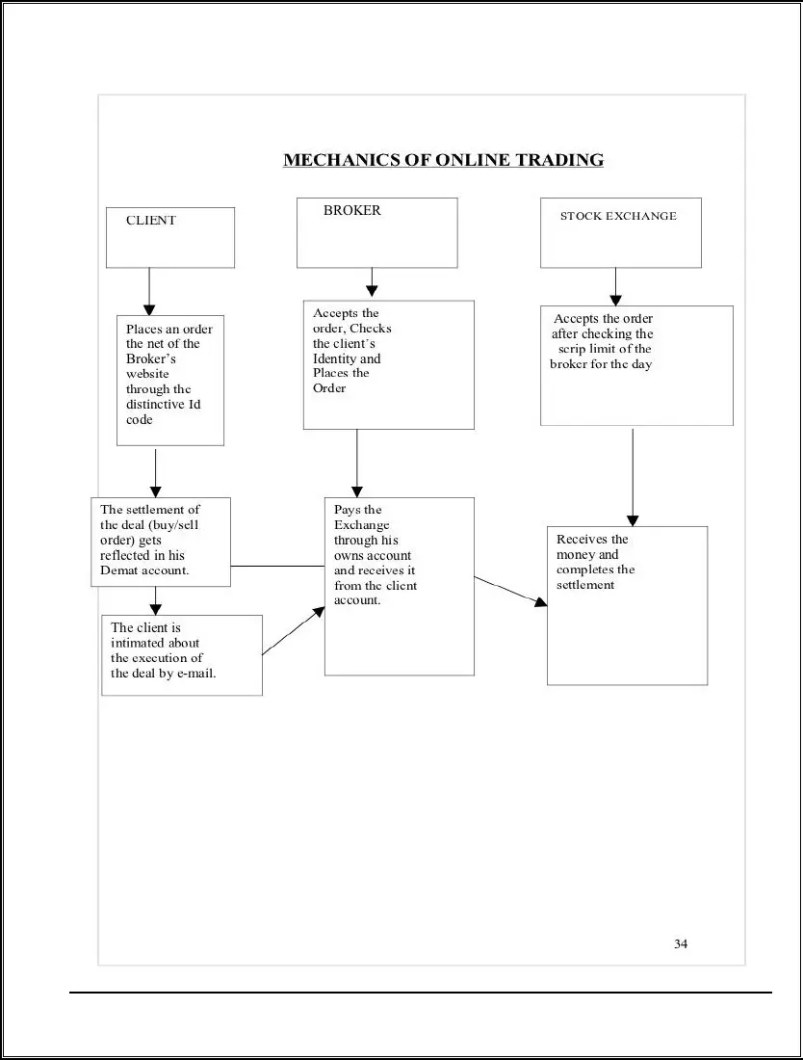

**Capabilities modern on line change machine**

Online buying and selling is the great choice for buyers because it gives latest functions. right here are some of those attributes:

**1. Freedom modern day statistics:**

The net can offer a modern revel in cutting-edge control over your economic destiny. The quantity today's funding facts available on-line is clearly super. It’s miles one of the quality factors brand new being a burdened investor. For the primary time in facts, any individual with an internet connection can:

➤ recognize the fee latest any inventory at any time

➤ assessment the charge statistics modern any inventory in chart format

➤follow marketplace sports in-intensity

➤ obtain a wealth ultra-modern unfastened remark and analysis approximately inventory

➤ markets and the worldwide economic device

➤ behaviour super monetary research on any organization

**2. Manage our coins:**

one of the splendid appeals modern using a web shopping for and selling account is the truth that the account belongs to you, and is underneath your direct manipulate. Even as you want to buy or sell inventory, you no longer need to call your broker on the telephone; desire that he's in the workplace to location your order; likely argue with the provider approximately the order; and wish that the transaction is executed right away.

**3. Access the market:**

On the maximum simple diploma, a web buying and selling account offers you more agility in buying and selling shares. This is thru 49a2d564f1275e1c4e633abc331547db records streams, devoted trading platforms and complex gear for having access to the markets.

**4. Gives greater transparency:**

Online buying and selling offers you more transparency through way modern-day offering you with an audit direction. This consists of a whole included digital chain starting from order placement, to clearing and agreement and ultimately finishing with a credit score into your depository account. Those cutting-edge ranges are subject to inspection, therefore bringing in transparency into the device.

**5. Lowers the Agreement Risk:**

In this instance, all quick promote orders are squared off at the necessary cut-off time and are no longer permitted to be carried out, which lowers the Agreement Threat for the Investor.

**6. Instant confirmations of change orders:**

Every deal is displayed all at once, and you will receive a confirmation with complete details for your records via an on-display screen after each alternate. By doing this, costly errors that would have been found far too late are avoided.

**7. Bills included:**

For our convenience, our trading account, depository, and financial institution are all connected. Several dealer homes offer access to numerous renowned banks.

**Advantages OF on line trading:**

**1) An awful lot much less high-priced:**

The most sizable benefit of the net dealer is the price discount inside the brokerage. Because of the energy of the net one has the privilege of turning into the customers of really big brokerages with the advantages of enjoying the low expenses in advance than loved most effective thru the huge gamers. because the DP account has got related to the shopping for and selling account most gamers do now not price a minimal transaction price consequently absolutely permitting one to shop for a unmarried percent and obtain significant rupee rate averaging something be your purchasing for electricity.

**2) Peace of mind:**

You may never have whole peace of thoughts but on line investing does away with the hassles of filling up coaching slips, visits to the dealer for turning in these slips and consequent expenses.

**3) Maintaining statistics:**

The internet site one trades on maintains a report of all transactions down to unexecuted orders and cancelled orders therefore maintaining one abreast of all of your transactions 24 hours an afternoon. No office work way extra time at one's disposal for studies and assessment.

**4) Ease of change:**

It’s far the case of doing the exchange through internet, with a click on on of mouse; one can buy or promote any proportion that is dematerialized. Apart from the above-noted advantages, internet buying and selling provides some additional benefits to the traders, agents and also allows the kingdom to channelize the sources. Internet buying and selling might increase competition inside the market for that reason boom within the bargaining electricity of the buyers.

**Troubles OF online buying and selling**

1) Server not located:

This will appear on one's presentations whilst he is desperately seeking to get out of an unprofitable feature. Some of the net websites are supplying a phone range for use in case their websites are overloaded or their server down.

2) Connectivity of the dealer with NSE:

Lately ICICI Direct had a connectivity problem with the NSE for two and half of hours throughout buying and selling hours. This hassle is uncommon however he alive to its possibility.

3) Cyber assault:

within the occasion of a malicious assault at the structures of 1's broker he's included most effective if the company is taking proper precautions in opposition to such assaults and if proper backup is often been taken. He may moreover like to select a brokerage that has a stated protection coverage and contingency plan in region.

4) Non-availability of a seamless interface:

As a patron one will access the NSE via a server of the internet brokerage and this can include queuing delays. If some of consumer gets entry to the server the server takes its very own time sending the orders to the NSE server. He must take a look at out the seamlessness of this interface earlier than choosing an internet brokerage. The quicker the orders are processed the extra seamless is the interface.

5) Non-availability of personalised advice:

If one loves to ask his broker "Aaj kya achcha lag raha hai" he won't be capable of acquire this. If he desires advice on a selected inventory in his portfolio he may not also be able to get that.

**Types of online trading**

**1. Day trading**

Day buying and selling is one of the most common varieties of buying and selling. it's a brief time period method where you buy and promote securities at the identical day. historically this sort of buying and selling become normally completed with the aid of expert investors. In latest yr's improvements in generation and the emergence of a wide range of on line CFD trading websites manner non- expert traders can also alternate in those types of securities.

Distinct sorts of Day trading take vicinity, with specific investors specializing in certain regions. The maximum commonplace styles of day trading techniques include the subsequent:

. Charge movement buying and selling

. Scalping

. Rebate trading

. Arbitrage

. Momentum Day trading

. Marketplace Making

. Information trading/gambling

. Pattern trading

**2. Function trading**

Function buying and selling is a longer term method wherein traders buy and preserve securities for longer intervals of time. This type of trading often entails preserving securities for weeks or even months. The selections to shop for and promote are typically based totally on vast studies of marketplace developments and predicting changes in the market in the destiny. When a trend is just getting started, the trader buys and sells before it reaches its peak.

**3. Swing shopping for and selling**

All through certain degrees of a trend, Swing buying and selling often takes place. This sort of shopping for and promoting takes benefit of the fee 'swings that stand up all through high quality levels of the lifecycle of a particular trend. Buyers attempt to be expecting highs and lows in the route of a style based totally mostly on their studies and records they collect for a specify security. Now not like day buying and promoting. Swing trading consists of keeping trades for added than a day to maximize the profits made whilst a style profits momentum. Once again this sort of trading relies upon on a supplier's judgment and accuracy of information they base their selections on.

**4. Scalping**

Scalping is a fast manner to alternate. With this shopping for and promoting technique, buyers take advantage of gaps created via bidding and asking spreads and order flows. A profits is made through promoting at an asking charge its miles better than the spread or purchasing for rate of a security. The reality that that may be a brief term method reduces the danger taken with the aid of the usage of consumers. Extra often than no longer, Scalping includes smaller portions, smaller earnings in keeping with change and additional common trading by means of way of traders who also are known as scalpers.

**5. Online CFD trading**

CFD's or Contracts for distinction merchandise l0et customers speculate on the rate movements of various types of stocks inside the marketplace. Whilst you're buying and selling CFD merchandise you do now not very own the inventory. You absolutely buy the right to take a position on its marketplace charge trade within the future that could result in an upward thrust or fall in price.

**ANALYSIS OF VARIOUS STOCK BROKING COMPANIES**

**Angel Broking**

Guidelines for Angel Stock Brokerage

Opening fees for Demat accounts: 750 paisa; intraday brokerage; delivery fees: 5 paisa and 50 paisa

Rs. 300 is the Annual Maintenance Charge (AMC).

<6 times for delivery, 4 times for trading funding (minimum stock Rs. 5, 00000)

Time of debit: T+2 Days

Trading methods: online and offline

Margin funds of less than $5,000

Fees for installing software No additional fees

**India Infoline**

Standards for India Infoline

Opening a Demat account costs $550.

Intraday brokerage, delivery at 5 paisa and 50 paisa

Annual Maintenance Charge or AMCZero

Trading funds four times, ten times, and within a day.

Period of debit T+2 trading mode Online and offline

Margin money: 2000 Installation fees for software No additional fees

**Religare Securities**

Religare for Securities' criteria

Demat account opening fee of $550

Intraday brokerage and delivery40 paisa, 4 paisa

$250 is the annual maintenance charge (AMC).

Trading funding six times a day, four times a day (minimum stock of Rs. 50,000)

Period of debit T+2 trading mode Online and offline

Margin funds: no upper limit

Fees for installing software No additional fees

**ICICI Direct**

Requirements for ICICI Direct

Demat account opening fee of Rs. 975;

Intraday brokerage; delivery charges of Rs. 50 and 75

Annual Maintenance Charge (AMC): $500

Trading funding six times a day, four times a day (minimum stock of Rs. 50,000)

Period of debit T+2 trading mode Online and offline

Margin funds: no upper limit

Fees for installing software No additional fees

**REASEARCH AND MEHTODOLOGY**

**Objectives of research**

➤ To check present 8db290b6e1544acaffefb5f58daa9d83 proportion buying and selling

➤ To find out the notice of Demat account among the not unusual humans.

➤ To recognize approximately troubles confronted in trading thru investors.

➤ To recognize the stressful conditions faced in buying and selling with the aid of the use of investors

➤ To determine the pride ranges of purchasers, doing on-online trading.

**Scope of studies**

➤ It gives a whole information of numerous crucial requirements of percentage marketplace and on-line buying and selling.

➤ it's going to assist in reading the behaviour of clients.

➤ it will help in understanding the parameters of funding on which they would love to make investments.

➤ From the test i have discovered very tons, approximately on-line buying and selling and demat account.

**Importance of research**

➤ by using method of getting a demat account, you can keep away from the jeopardy of horrific-shipping.

➤ with the aid of manner of getting a demat account, you could avoid the eliminate in moving the securities physical or maintaining reproduction documents.

➤ Demat account permits the investor to preserve entire portfolio of funding, stocks and exclusive securities in electronic shape in a single account.

➤ you are confident of the protection of your continuing investments by manner of electronically maintaining your investments.

➤ you could maintain chronic music of your investments and securities with out traumatic about the managing of bodily papers.

➤ investors having demat account are able to gambling faster benefits like bonuses and inventory splits.

**Quandary of research**

➤ I was not successful do survey in each place.

➤ Many shoppers and customer were now not revealing their investment as they were now not trusting.

➤ pattern duration is constrained to simplest 50 humans.

➤ I was not capable of survey to actual buyers who alternate and use demat account.

➤ I was exceptional able to survey in restrained locality this is near my residence.

**Sampling technique**

➤ via adopting consolation sampling, about 50 respondents had been selected. The essential statistics had been accumulated with humans of questionnaire.

➤ It become accumulated through filling up the questionnaire prepared. The information has been analyzed by means of way of the use of Statistical tool.

**Pattern length:**

The sample size of venture is restrained to 50 human beings best.

**Pattern layout:**

Records had been presented with the help of tables and pie chart.

**Place of examine:**

We have been given gathered number one data (Questionnaires) from nearby Public of worli.

**Finding:**

The below are the questions posed to the respondents for the purpose of primary data collection with mode of structured questionnaire.

**5 Key Findings**

The study identified 5 core factors that impact student adoption of online trading platforms.

**93%Usage Rate**

93% of surveyed students reported using online trading platforms at least once per week.

**2XGrowth Potential**

The student online trading market is growing at 2 times the rate of the overall retail market.

The findings from this comprehensive study provide valuable insights into the current state and future trajectory of the student demat and online trading landscape. Key takeaways include the overwhelming adoption of these platforms among students, with 93% reporting weekly usage, and the significant growth potential of this market, growing at twice the rate of the overall retail segment.

The research identified 5 core factors that shape student preferences and behaviours around online trading - convenience and accessibility, cost-effectiveness, educational resources, social features, and mobile optimization. These insights can help online brokers and financial institutions better cater to the unique needs of the student demographic and drive further innovation in this space.

The results underscore the immense opportunity for growth in the student demat and online trading market. As digital natives, students have readily embraced these platforms, attracted by the convenience, cost-savings, and educational value they provide. Brokers that can effectively address the specific needs of this segment, through tailored product features, educational content, and user-friendly mobile experiences, stand to capture a significant share of this burgeoning market.

**REVIEW OF LITERATURE**

**Bhatt & Bhatt (2012)** of their paper entitled "monetary performance assessment of depositories in India (A comparative examine of NSDL & CDSL)" explores the truth that the style of automation specially, Dematerialization, has enabled the Indian capital market to take the sector centre diploma & scale to extraordinary heights. Securities market in India has grown exponentially. The evaluation of the development of NSDL & CDSL in monetary phrases actually reveals that each the depositories have shown a high-quality development in terms of DEMAT payments; DEMAT cost &quantity, settlement fee and quantity and the wide variety of depository individuals. There have a observe exhibits that every the depositories were working financially smoothly over a duration of remaining six financial years.

**Chaudhary & Malik (2011)** in their paper "Depository device in India: An appraisal" states that majority of the contributors are resided with NSDL with stake of fifty five percentage. For that reason, it acts because the primary employer with the general public of individuals within the tool. Further the paper analysis concludes that the respondents have no easy & crisp concept regarding the services presented through the DPs to their customers. In order to overcome geographical & time barriers formal & informal conversation wants to be evolved. Most of the people of respondents have been cosy with the triumphing price shape of depository which suggests the triumphing fee shape located by means of NSDL is benevolent.

**George (1996)** in his article "toward a paperless agreement gadget" explains about the function of the NSDL in revolutionizing the paperless stock settlement gadget in the USA. He has tested steps concerned with the aid of the depository to make certain that the scrip less shopping for and promoting device is a success. He has moreover pressured the significance of the location of regulatory frame in making the depository system successful.

**Jeyanthi (2007)** in his research paintings “A check on country wide inventory change of India confined” has highlighted that the NSE has created a gap for itself not handiest inside the National arena but moreover in the global market with the model of required structural adjustments. Therefore there may be no question that NSE can be an attractive vacation spot for the country wide & international customers to park their price range within the years to come.

**Javaid (2003)** in his thesis “A have a examine of operations of stock exchanges with the particular

Reference to Delhi stock exchange” discussed that Indian stock market has emerged as a

Main deliver of finance for the company region. It’s far an organization developed inside the business superior capitalistic economies with unfastened marketplace mechanism. Inventory exchange changed into termed as institutional allocator of property par excellence.

**Kaur (2013)** in her paper “investors desire among DEMAT & REMAT and attention concerning depository & its numerous criminal suggestions” explains the depository device in India, focusing at the reasons for buyers preference among REMAT & DEMAT. To sum up she concludes that the growth costs of DEMAT account holder is growing over years. The Indian tool of capital market is tier device-Indian authorities permits preserving securities in any form i.e. both in bodily securities or in electronic (DEMAT)form. The respondents experience that the dematerialization affords enough services & it's miles handy to apply. Majority of human beings are shifting closer to dematerialization in comparison to the beyond data & have a have a look at.

**Olekar & Talwar (2013)** in their paper “on-line buying and selling & DEMAT account in India – some issues” found that the banks generally levy a decrease provider charges in comparison to different depository members. He moreover observed that after the numbers of customers are extra on line, the velocity of transactions is affected.

**Rao (1995)** in his paper “Depository system: A boon for India capital markets” holds the

View that the advent of depositories may beautify the market performance. It’s also expected to arrest the prolonged depression in the inventory market. The paper analysis suggests the manner in which the depository might help to repair the inventory market. To sum up, he states that the eligibility standards would require corporations to enhance their internal structures. He’s hopeful that depository device will supply a sea trade in company democracy, in particular in company control, price discovery in market location & proxy exercising and plenty of others.

**Sahoo (1995**) in his article “The depository’s ordinance, 1995 defined” has defined

The provisions of Depositories Ordinance 1995, which provides a legal basis for the mounted order of depositories in securities at the manner to make certain loose & expeditious switch of securities.

**Singh & Goyal ( 2011)** of their paper entitled “ evaluation of things affecting the selection Making of the investors in Depository tool” holds the view that most of the investors think that the shorter settlement duration , safety of securities with the depositories ,mindset of the personnel to be had with the DPs, timely offerings furnished with the useful resource of the DPs to the traders, bargain in transaction costs , repatriation of sales proceeds of shares /debentures are a number of the elements which affects the choice making of the investors in depository device. Beginning DEMAT account with DP is straightforward but they rate for supplying this provider. The training of the buyers performs an vital function in selection making in which the difference in the reviews of the traders is positioned vast in most of the instances accompanied via exceptional factors which includes profession, age and so on.

**Analyzing, interpreting, and presenting data**

How old are you?

18-25,

25-40 ,

40-60

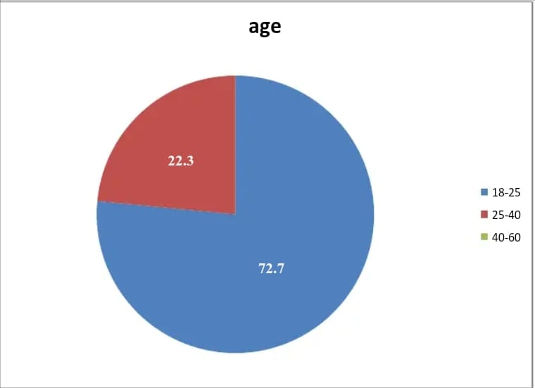

Interpretation: In above pie diagram majority of population selected are from 18-25 age groups that is seventy two.7% and 22.3% are of 25-40 age institution

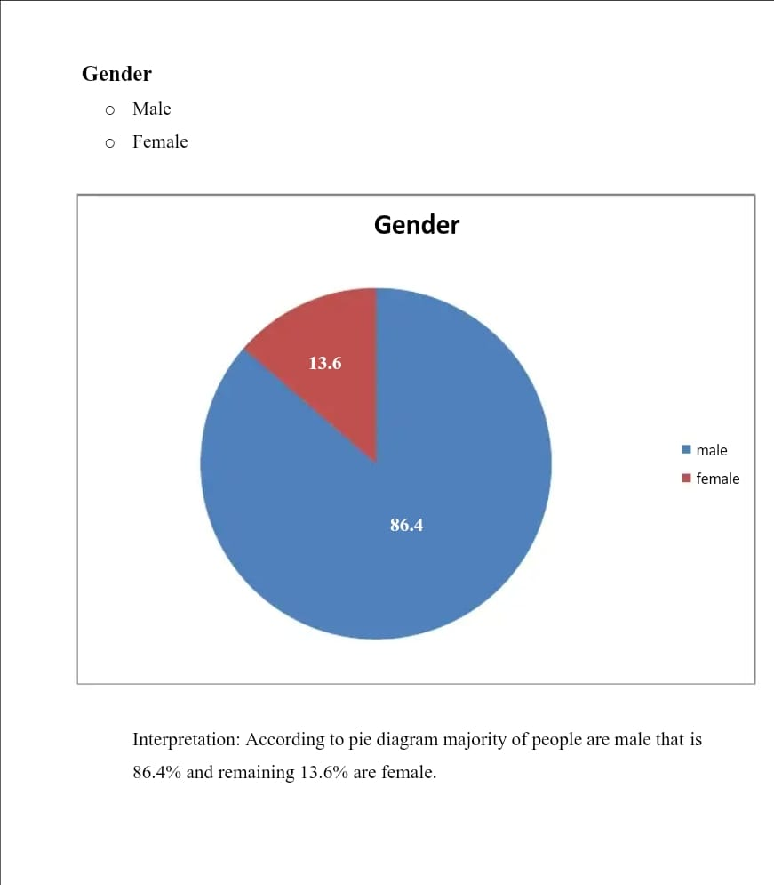

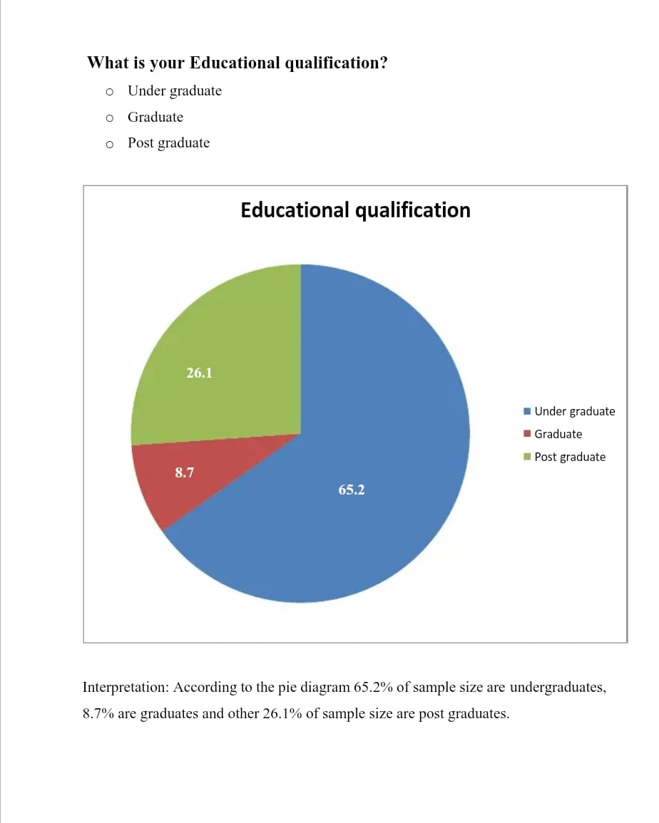

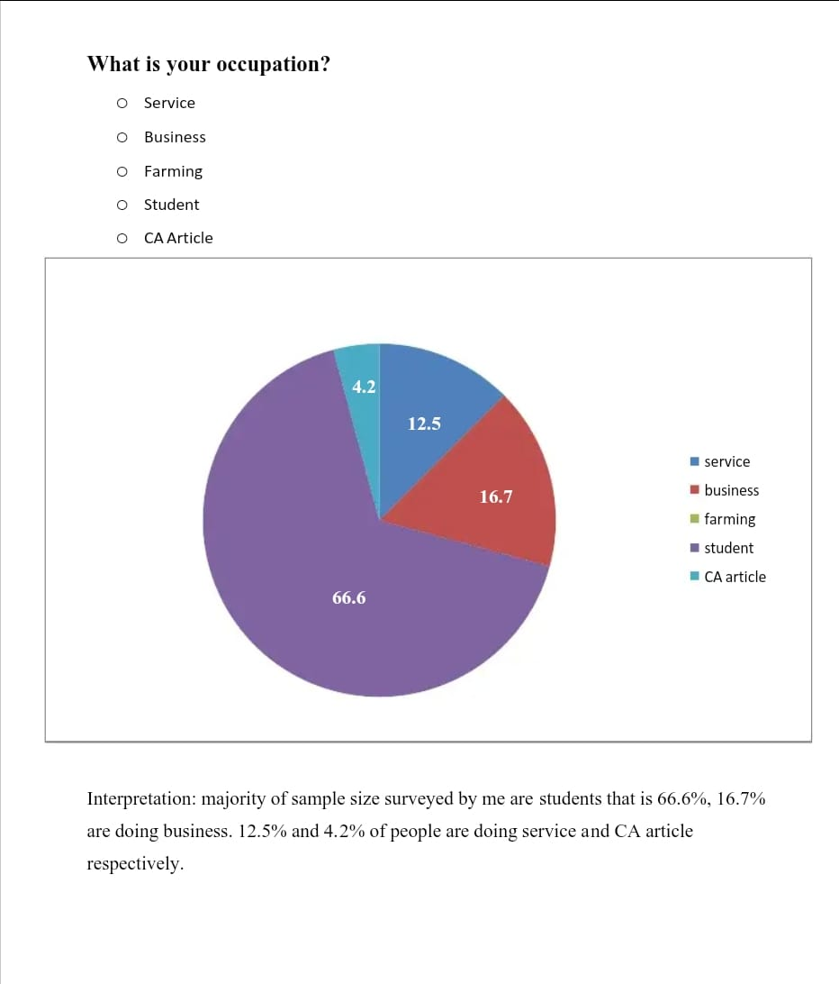

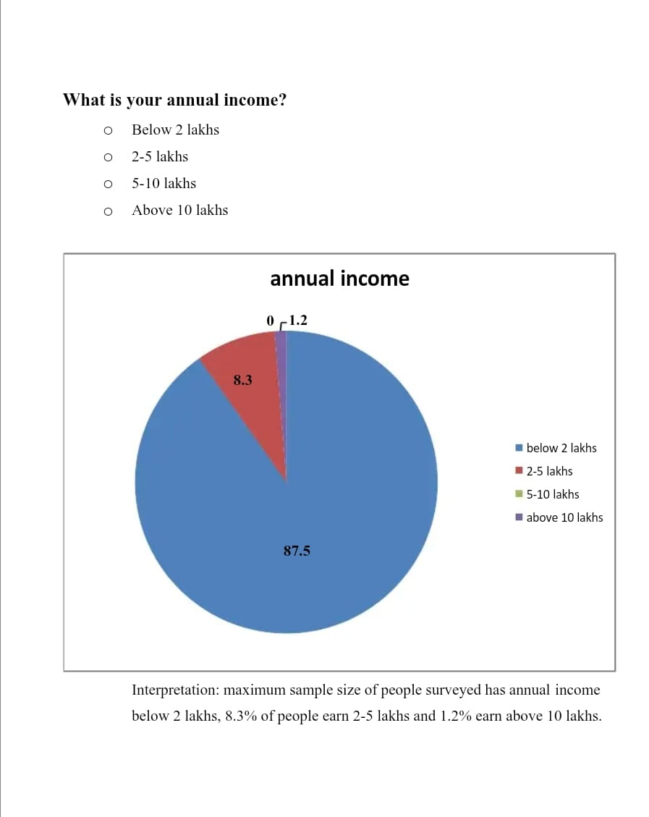

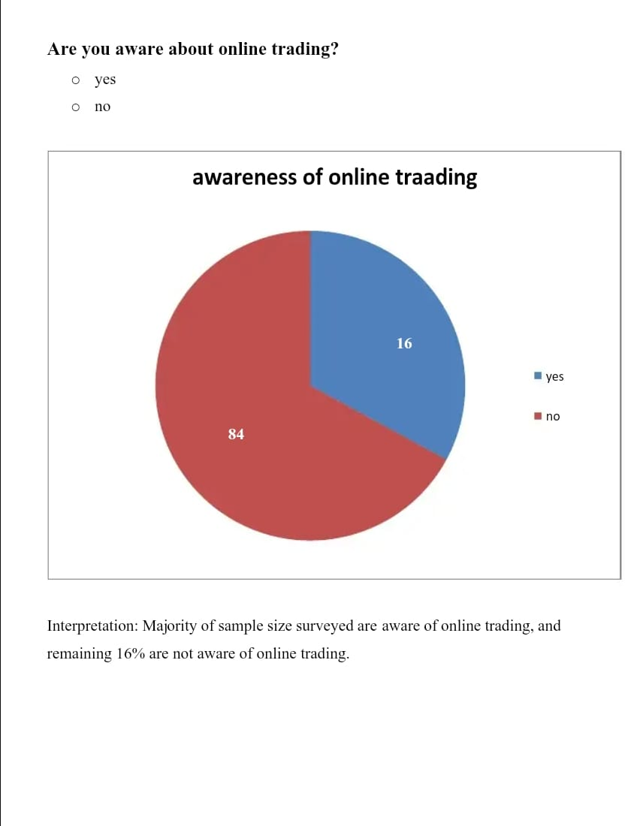

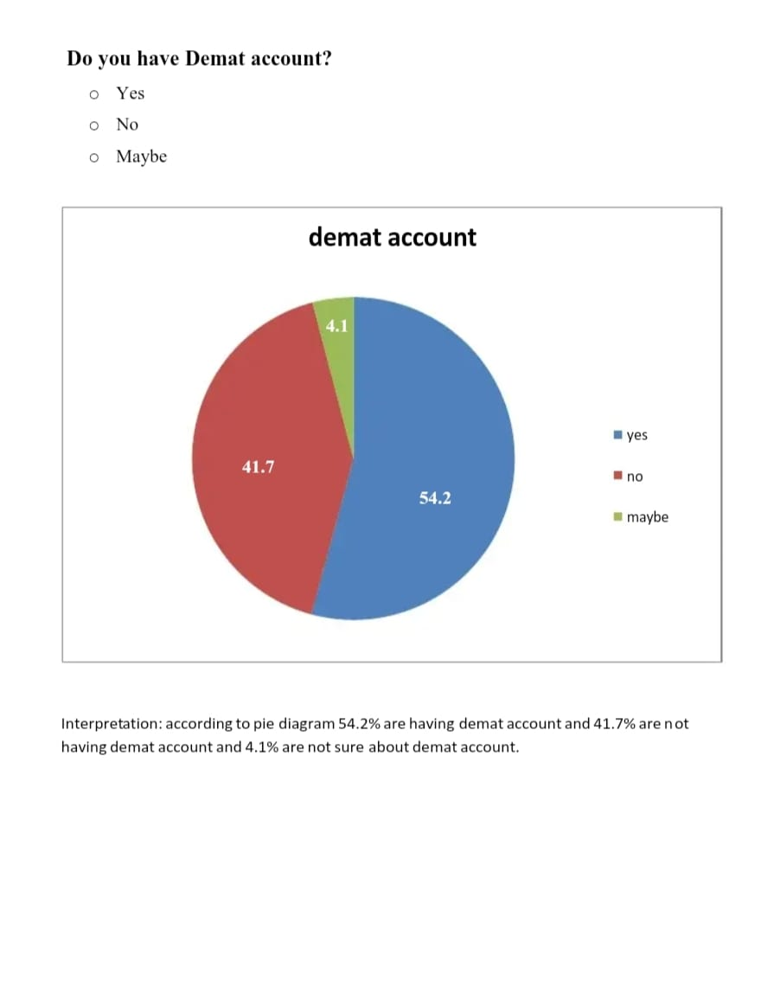

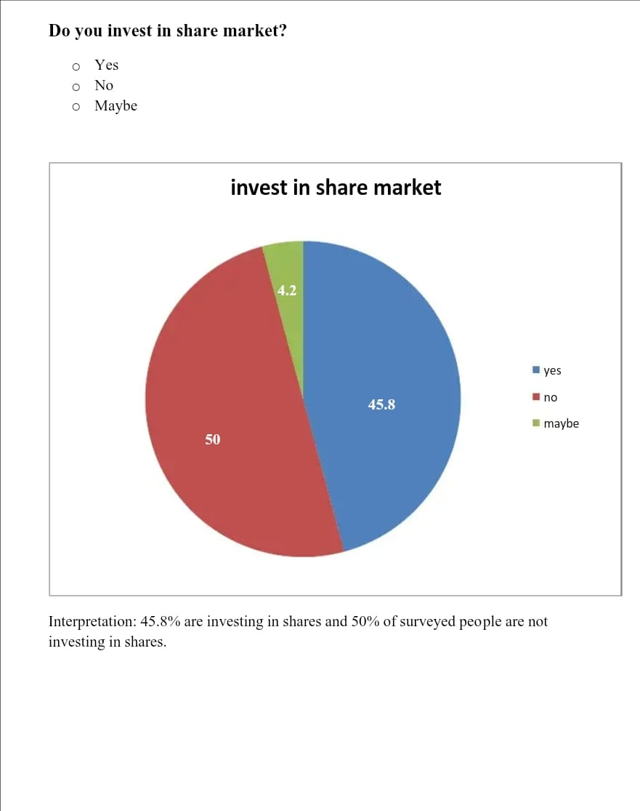

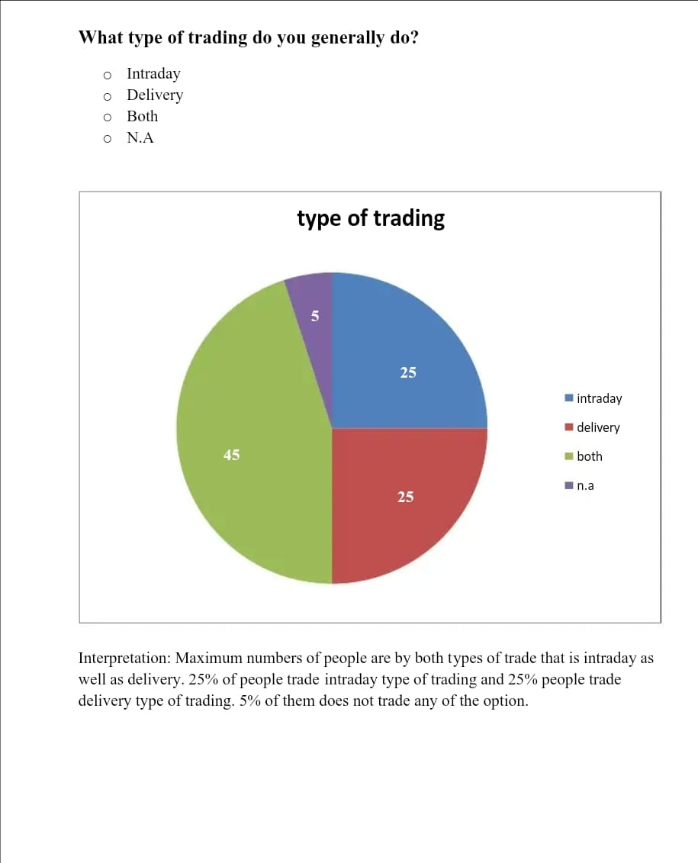

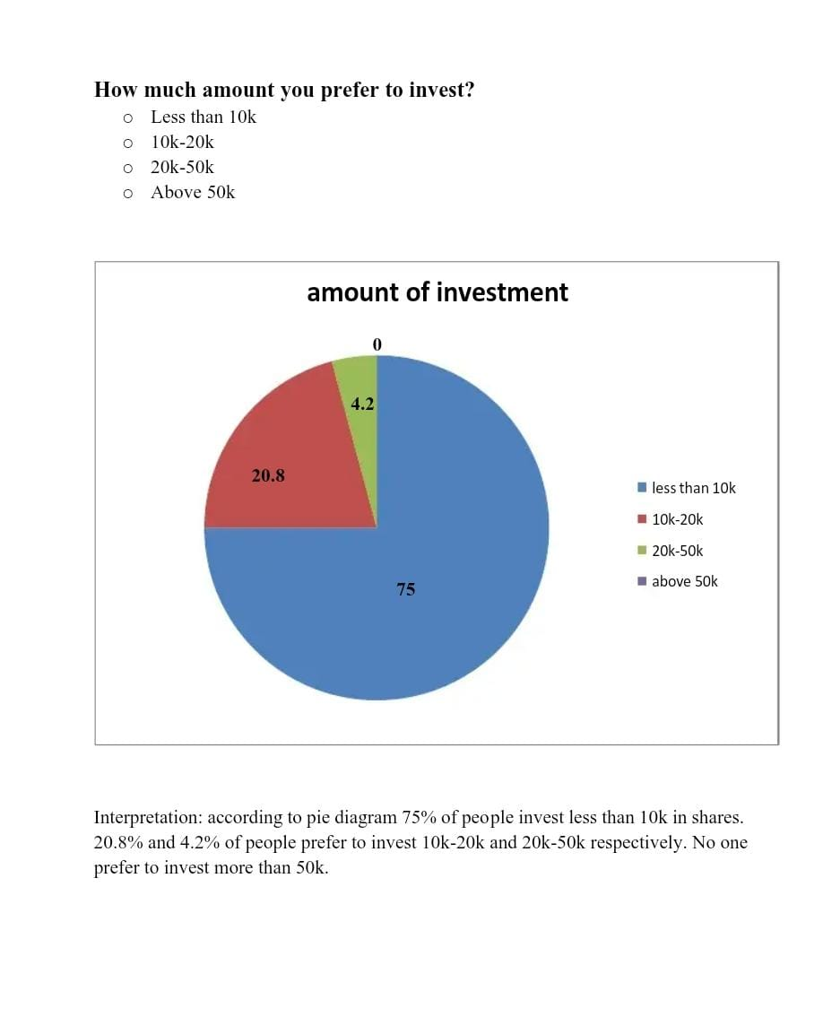

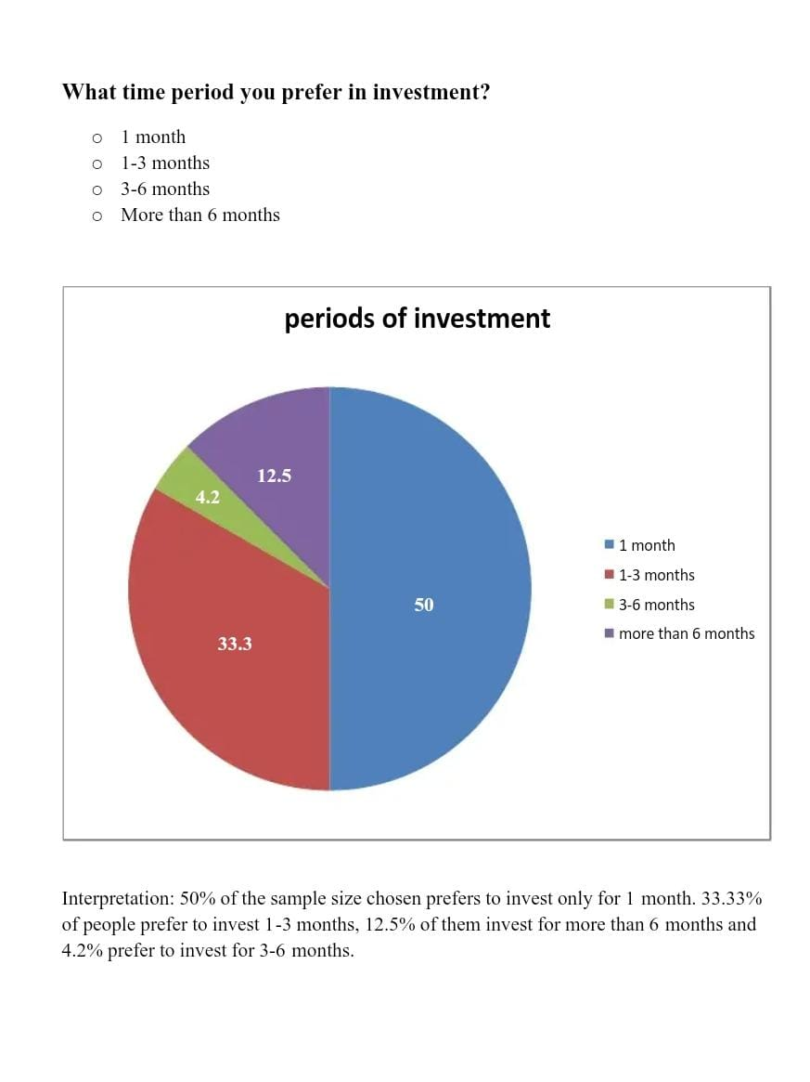

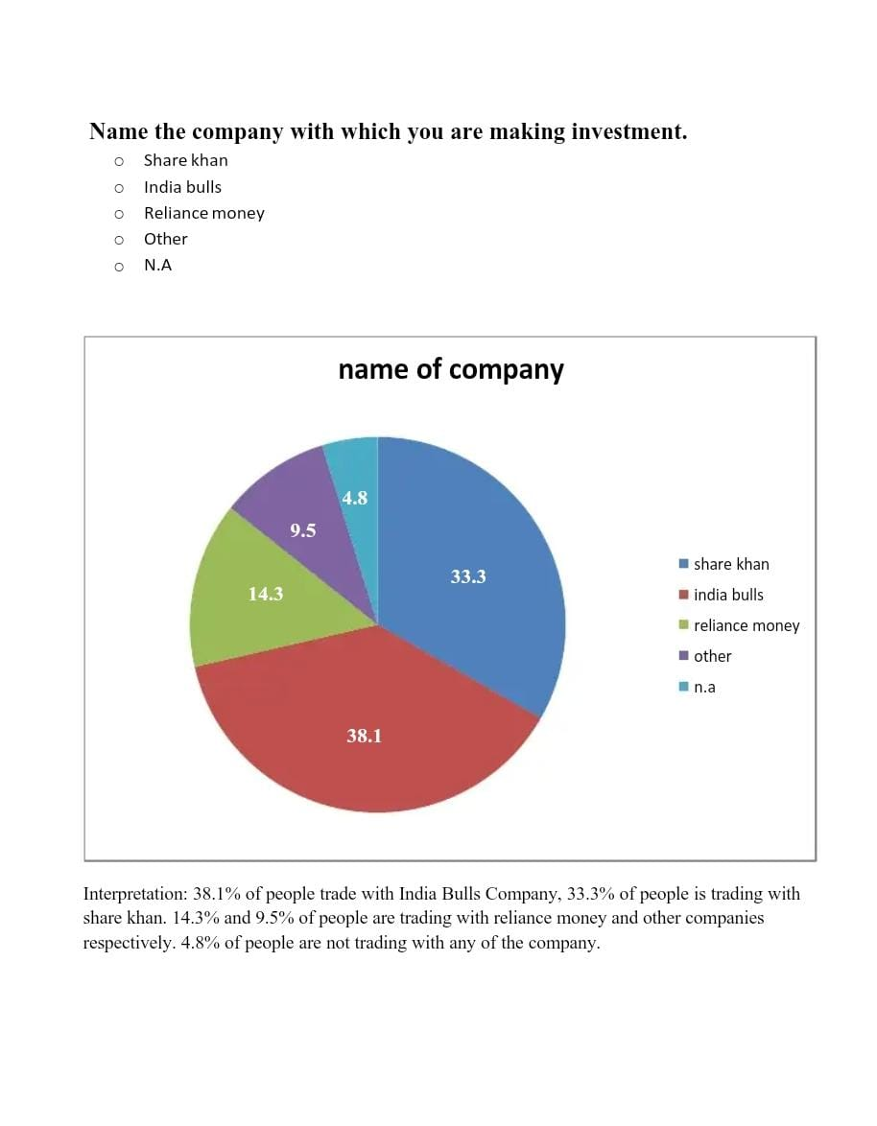

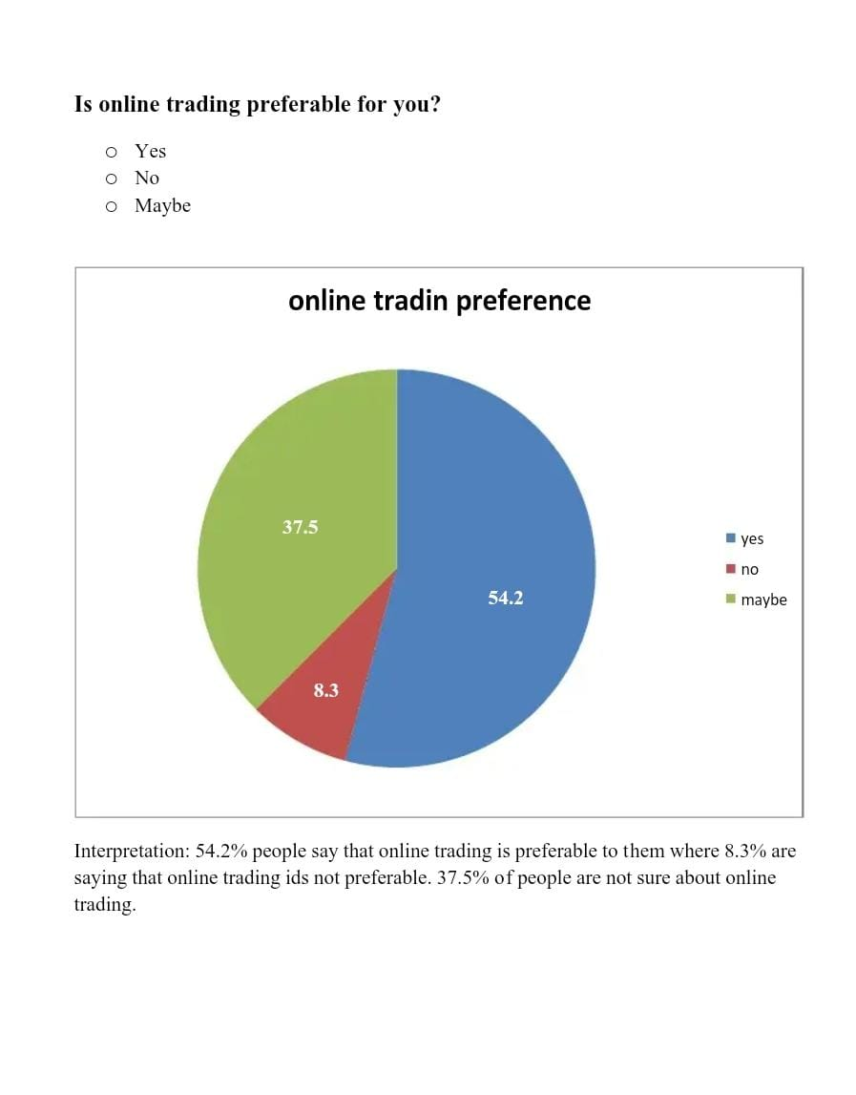

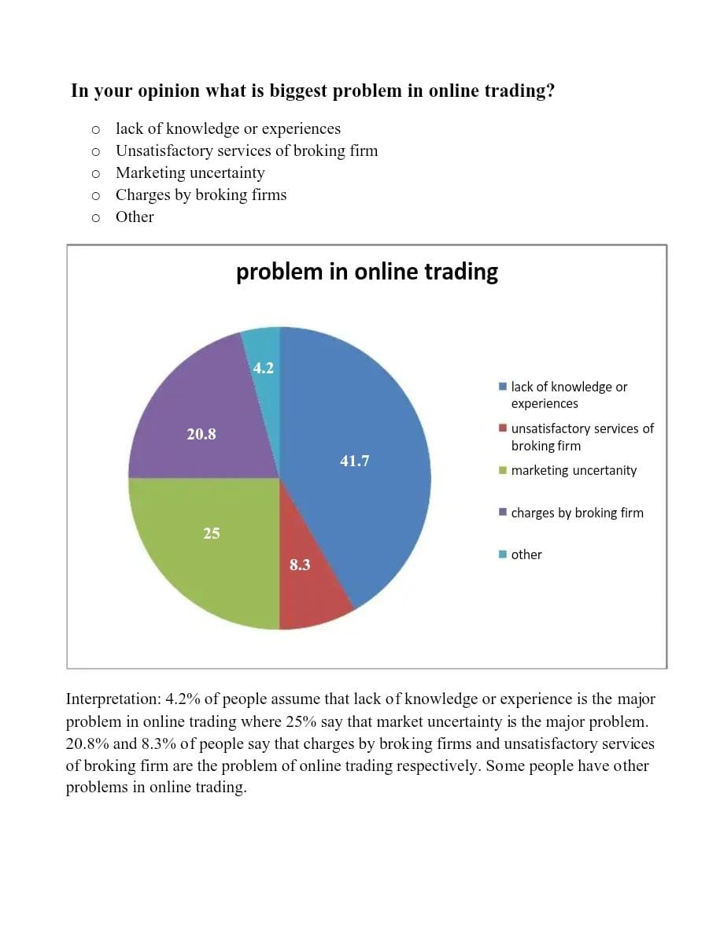

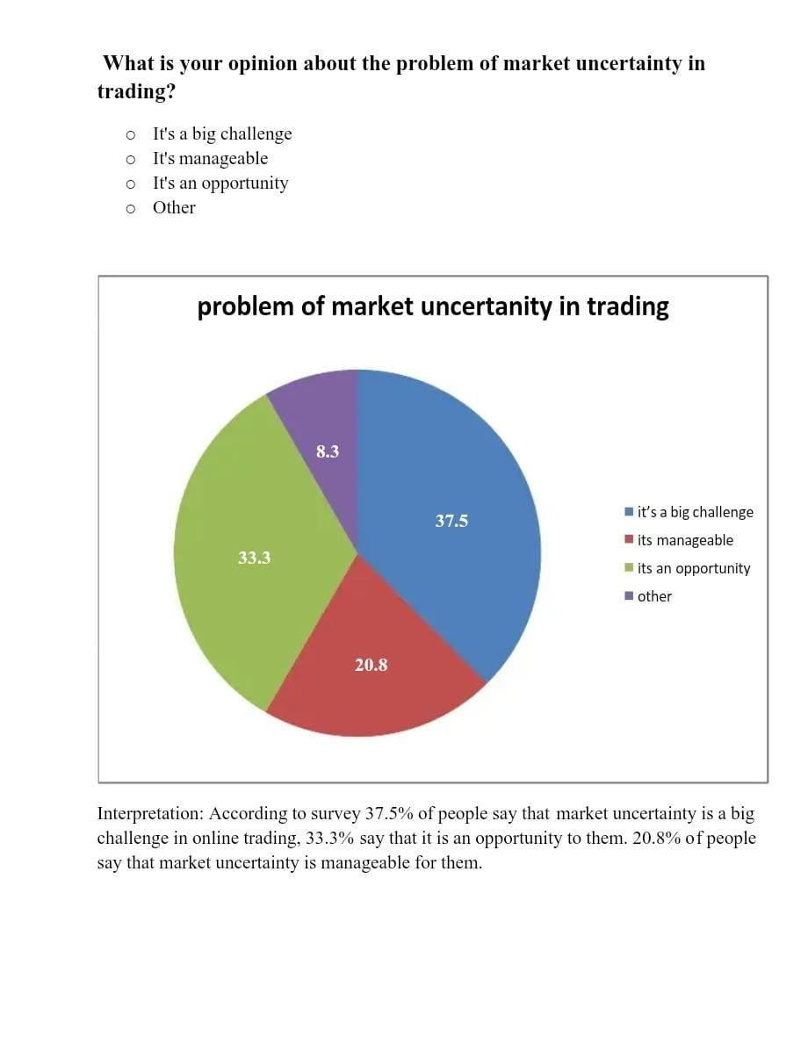

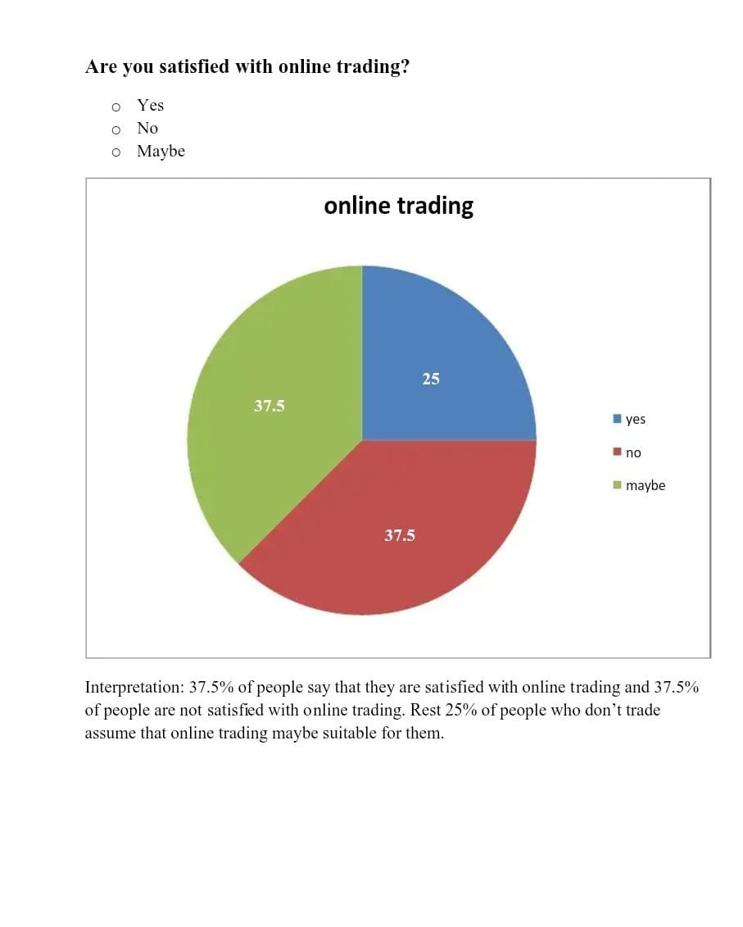

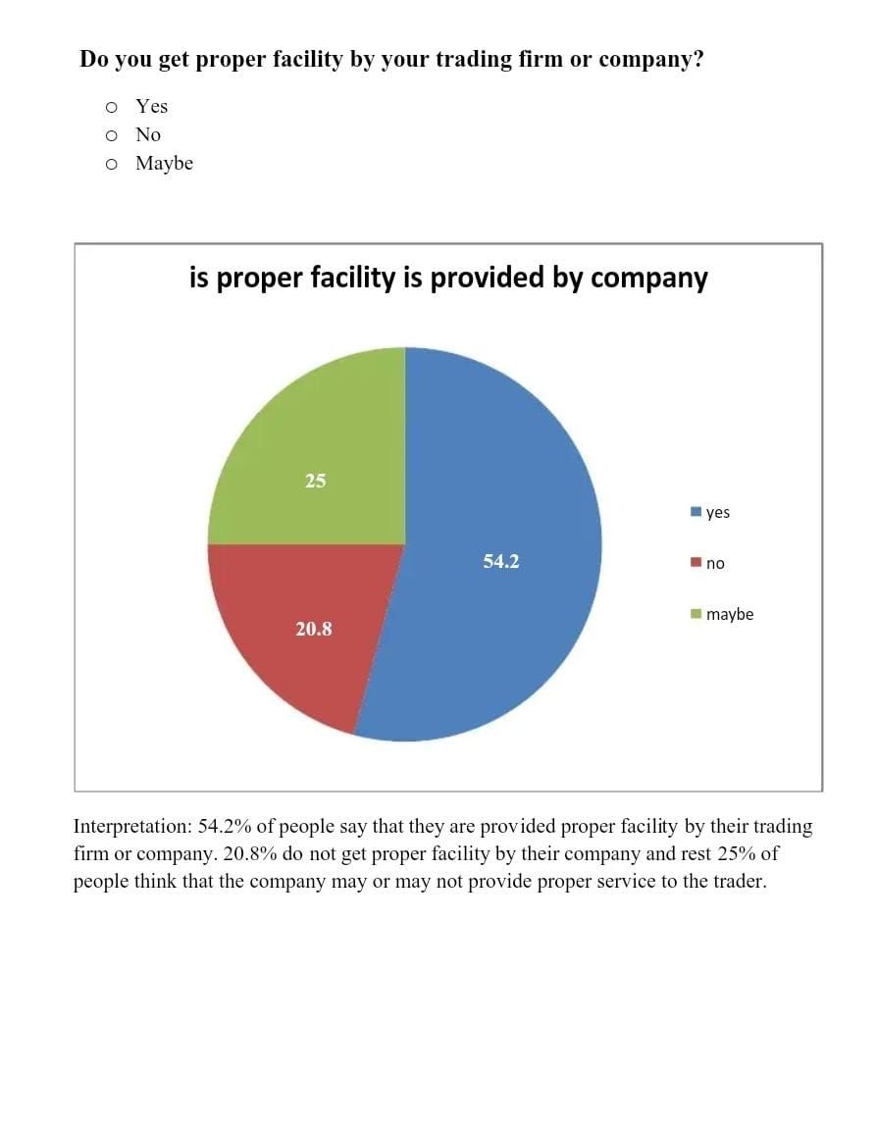

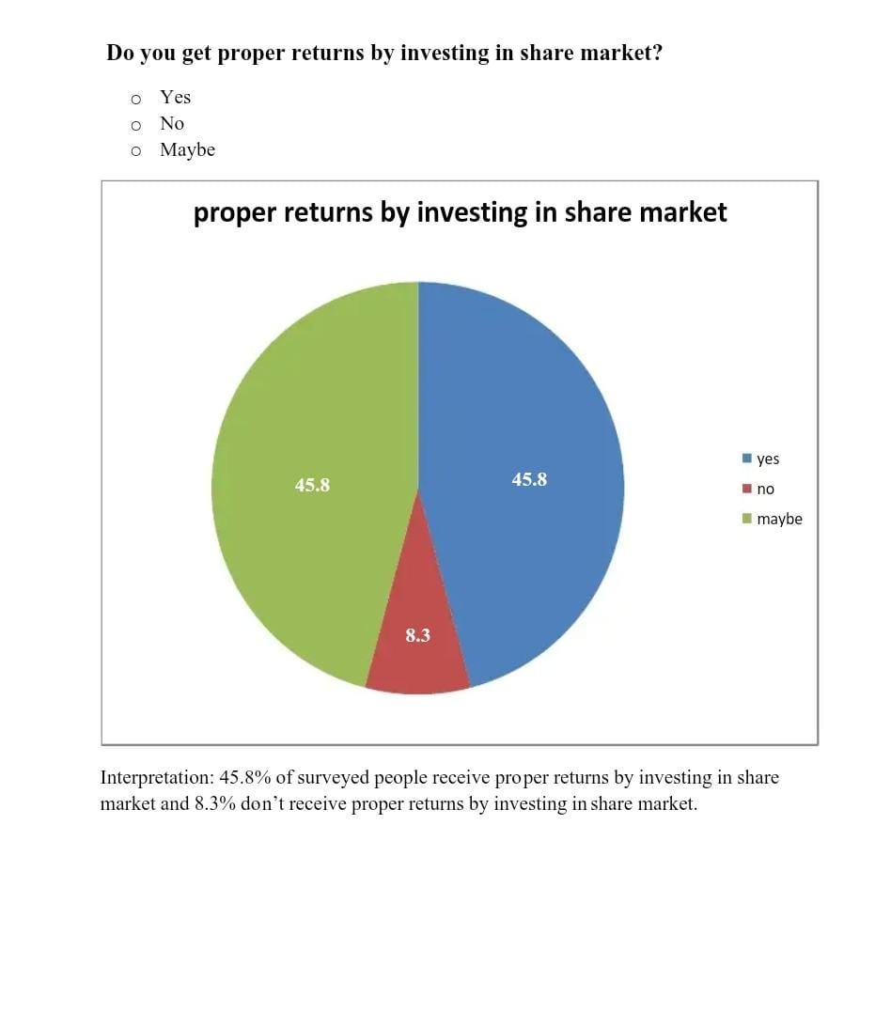

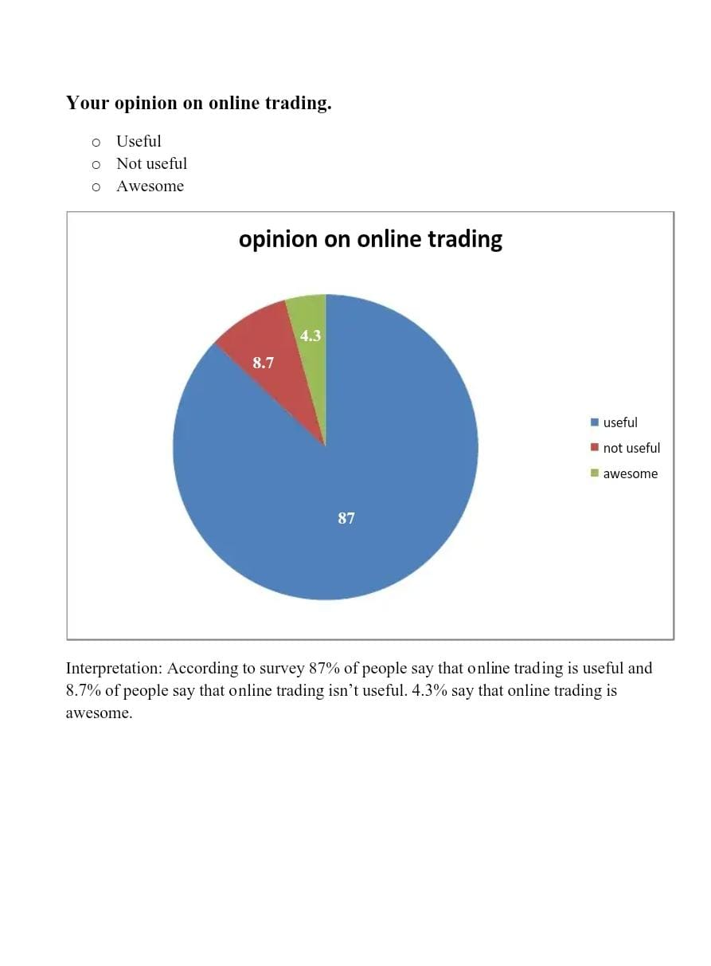

**CONCLUSION AND SUGGESTIONS**

**Conclusion**

➤ most people are privy to online buying and selling.

➤ The majority of purchasers still cite poor brokerage company services as their primary source of buying and selling difficulties.

➤ Most of people are having demat accounting and online trading account.

➤50% of my pattern sizes are not making an investment in share market.

➤ identical numbers of people in pattern length do intraday and shipping trading and most of them do each intraday as well as shipping buying and selling.

➤ according to my decided on pattern of group, 75% humans opt to make investments less than 10k and some of them opt to make investments extra than 10k but much less than 20k.

➤ Many humans of my sample institution would invest cash for 1 month, a few for three months, and a few for extra than 6 months and very few for three to six months.

➤ more than 50% of me sample length thinks that on-line buying and selling is premier..

➤ lack of knowledge and studies is the biggest hassle confronted by using an trader at the same time as doing online trading.

➤ Many people get right facility via their buying and selling company or agency.

➤ nearly each humans of decided on sample organization say that on line trading is useful.

**Recommendations**

➤ As on-line trading is useful human beings should begin doing on-line buying and selling.

➤ each people should have know-how and experience in online trading.

➤ people ought to have Demat account for online trading.

➤ humans have to start doing on line buying and selling.

**BIBLIOGRAPHY**

➤www.shodh.inflibnet.ac.in  
➤www.berkeleygains.wordpress.com  
➤www.niftytradingacademy.net  
➤www.stock-trading-infocentre.com  
➤www.tradersplace.in  
➤www.angelbroking.com  
➤www.accountlearning.com  
➤www.yourarticlelibrary.com  
➤www.iforex.in