**Modernized Shopping Solution Using IOT**

**Mrs. Y. Durga Bhargavi1, Pasham Sravani2, Voleti Chitra3,**

**Bodige Sai Alekhya4, Lagishetty Santhosh5**

*1Associate Professor, CSE Dept, ACE Engineering College, Hyderabad, India*

[@gmail.com](mailto:June.pnancy@gmail.com)

*2Student, CSE Dept, ACE Engineering College, Hyderabad, India*

[pashamsravani63@gmail.com](mailto:pashamsravani63@gmail.com)

*3 Student, CSE Dept, ACE Engineering College, Hyderabad, India*

[chitravoleti25@gmail.com](mailto:voletichitra25@gmail.com)

*4 Student, CSE Dept, ACE Engineering College, Hyderabad, India*

[saialekhya142003@gmail.com](mailto:saialekhya142003@gmail.com)

*5 Student, CSE Dept, ACE Engineering College, Hyderabad, India*

[wwelsjc7799@gmail.com](mailto:wwelsjc7799@gmail.com)

**Abstract:**

**A smart shopping trolley using IoT is a modern solution that aims to take shopping to the next level. This system integrates technology that allows items to be scanned, their prices calculated, and payments processed. Our proposed system eliminates manual checkout and reduces waiting time in queues. This revolutionizes shopping by making it hassle-free and more efficient.With our innovative solution, shoppers can simply place items into the cart, and the system automatically scans and tallies their prices in real time. This not only saves valuable time but also enhances the overall convenience of the shopping journey. Moreover, by eliminating the need for manual checkout, our system reduces the risk of errors and ensures greater accuracy in transactions. As a result, customers can enjoy a smoother, more efficient shopping experience, empowering them to make the most of their valuable time. With the integration of IoT technology, we are poised to revolutionize the way people shop, ushering in a new era of convenience and efficiency in retail.**

**1. INTRODUCTION**

The modern lifestyle has accelerated the pursuit of money, leaving little time for traditional shopping experiences. With an increase in shopping malls offering a variety of daily necessities, the process of waiting in long queues at checkout counters has become a common frustration for shoppers. To address this, we propose an innovative solution: the Intelligent Shopping Trolley for malls. By incorporating RFID technology into the trolley and products, customers can effortlessly scan items as they shop, with prices displayed on an LCD screen. This system not only saves time but also reduces the need for manual labor in malls. Additionally, features like voice prompts for product information and a child unit for added safety enhance the shopping experience. By streamlining the checkout process and improving convenience, this system aims to make shopping more efficient and enjoyable for customers. With the integration of IoT technology, we envision a future where shopping becomes hassle-free..

**2. OBJECTIVES**

In our project there are 4 objectives. They can be listed as:

* Streamlining Shopping Processes
* Minimizing Waiting Times
* Ensuring Accuracy and Reliability
* Enhancing Convenience
* Empowering Customers

**3. METHODOLOGY**

The methodology involves researching and selecting suitable IoT technologies, followed by the development of a prototype smart shopping trolley. These carts will scan items, and figure out the price. We'll try them out in stores to see if they make shopping easier.The refined system is then implemented in select retail environments, with ongoing monitoring to assess effectiveness in reducing waiting times and enhancing convenience.

**4. LITERATURE SURVEY**

**Title:** IoT-Based Smart Shopping Cart Using Radio Frequency Identification.

**Authors:** Mobeen Shahroz, Arif Mehmood–[2020]

Smart Shopping Cart with RFID tags and mobile app for quick checkout, reducing wait times in crowded supermarkets.​

Introduce IoT Smart Shopping Carts for faster checkout. Customers manage lists via app and pay automatically, cutting wait times.

**Title:** A Smart Trolley for Smart Shopping.

**Authors:** Tapan Kumar Das– [2020]

Enhancing the shopping experience through RFID technology, this project automates billing, enables online tracking, and improves shop efficiency for customers, while also reducing staffing requirements and attracting more patrons for shop owners. The purpose is to modernize and simplify the shopping process using RFID technology, offering automated billing, online tracking, and increased shop efficiency to enhance customer experience and attract more patrons.

**Title:**Automated Smart Trolley System Using RFID Technology.

**Authors:** Rahul R – [2023]

The automatic smart trolley, utilizing Node MCU (ESP8266) and RFID tags, employs product scanning and an OLED display to provide real-time item details and total cost, offering a seamless shopping experience. Efficiently addressing time constraints in malls and supermarkets, this innovative trolley minimizes waiting times at billing counters, enhancing customer satisfaction by streamlining the shopping process and saving valuable time.

**Title:** Smart Shopping Trolley Using Raspberry Pi.

**Authors:** D. Pradhan– [2021]

The smart shopping trolley system modernizes retail billing by integrating technology into shopping carts for efficient, secure, and user-friendly transactions.To enhance the shopping experience by streamlining billing processes, increasing efficiency, and promoting technological innovation in retail.

**Title:** Enhancing Shopping Experience with Raspberry Pi and Cloud-Integrated Wireless Sensor Networks for Smart Trolleys in IoT.

**Authors:** Ramakrishnan Raman– [2023]

The IoT technology, like Raspberry Pi and cloud-integrated sensors, creates smart trolleys for retail. These trolleys offer real-time updates on product availability, prices, and personalized suggestions. The system aims to modernize traditional shopping by leveraging IoT to provide personalized, efficient experiences. It offers real-time updates, tailored suggestions, and automated processes like item recognition.

**5. PROPOSED SYSYTEM**

Our smart trolley system uses IoT sensors and scanners for real-time product detection and billing, eliminating manual payment processing. Customers can pay through NFC or online banking, and receive instant updates on their balance and purchases during shopping. Additionally, real-time updates provide customers with instant access to their balance and items purchased while shopping, enhancing interactivity and convenience throughout the shopping journey.

**6. HARDWARE AND SOFTWARE REQUIREMENTS**

**6.1 HARDWARE REQUIREMENTS:**

* Power supply
* RFID module
* Lcd
* GSM
  1. **SOFTWARE REQUIREMENTS:**
* Operating System - Arduino IDE
* Coding language - C++

**7. PACKAGES USED**

**SoftwareSerial.h:**

SoftwareSerial.h is a header file in Arduino IDE used for software serial communication. It allows Arduino boards to create additional software-based serial ports, enabling communication with other devices such as sensors, displays, or other microcontrollers. This library is particularly useful when hardware serial ports are limited or already in use for other purposes.

**LiquidCrystal.h:**

LiquidCrystal.h is a header file used in Arduino programming for interfacing with liquid crystal displays (LCDs). It provides functions and utilities to control the display, including methods for printing text, positioning the cursor, and clearing the screen. This library simplifies the process of working with LCDs, making it easier to create projects that display information in a user-friendly manner.

**8. TECHNOLOGY DESCRIPTION**

C++ is widely used in IoT devices for its efficiency, low-level control, and access to hardware features. It offers a rich ecosystem of libraries for network communication, sensor interfacing, and device management, making it ideal for resource-constrained devices. Overall, C++ enables efficient and robust software development for diverse IoT applications.

**9. SOURCE CODE:**

#include <SoftwareSerial.h>

#include <LiquidCrystal.h>

const int rs = 2, en = 3, d4 = 4, d5 = 5, d6 = 6, d7 = 7;

LiquidCrystal lcd(rs, en, d4, d5, d6, d7);

SoftwareSerial mySerial(9,10);//rx,tx

char input[12];

int count = 0;

int a;

int b=11;

int bill_value;

int p1=0,p2=0,p3=0,p4=0;

int c1=0,c2=0,c3=0,c4=0;

double total = 0;

int count_prod = 0;

void setup ()

{

lcd.begin(16, 2);

pinMode(8, INPUT_PULLUP);

pinMode(b, INPUT_PULLUP);

Serial.begin(9600);

mySerial.begin(9600);

lcd.print(" AUTOMATIC BILL");

delay (2000);

lcd.setCursor(0, 1);

lcd.print("SHOPPING TROLLY ");

delay (2000);

lcd.clear();

lcd.print(" WELCOME ");

lcd.setCursor(0, 1);

lcd.print("PLEASE SCAN ITEM");

}

void loop()

{

count = 0;

bill_value=digitalRead(b);

while (Serial.available() && count <= 12)

{

input[count] = Serial.read();

delay(5);

lcd.clear();

lcd.print(input);

int a=digitalRead(8);

int b=digitalRead(11);

if ((strncmp(input, "1", 1) == 0) && (a == 1))

{

lcd.clear();

lcd.print("Butter Added ");

lcd.setCursor(0, 1);

lcd.print("Price(Rm):4.00 ");

delay(2000);

total = total + 4.00;

count_prod++;

}

else if ((strncmp(input, "1", 1) == 0) && (a == 0))

{

lcd.clear();

lcd.print("Butter Removed!!! ");

delay(2000);

total = total - 4.00;

}

else if ((strncmp(input, "4", 1) == 0) && (a == 1))

{

lcd.clear();

lcd.print("Milk Added");

lcd.setCursor(0, 1);

lcd.print("Price(Rm):6.00 ");

delay(2000);

total = total + 6.00;

count_prod++;

}

else if ((strncmp(input, "4", 1) == 0) && (a == 0))

{

lcd.clear();

lcd.print("Milk Removed!!! ");

delay(2000);

total = total - 4.00;

}

lcd.clear();

lcd.print("total:");

lcd.print(total);

lcd.setCursor(0, 1);

lcd.print("scane next item");

delay(500);

}

if(bill_value==0)

{

lcd.clear();

lcd.print("Requesting Bill");

mySerial.print("YOUR BILL AMOUNT Rs:");//the content of the message

mySerial.println(total);//the content of the message

mySerial.print("Pay to XYZ@UPI");//the content of the message

delay(2000);

        }

}

**10. OUTPUT**



Fig 10.1 Android App Screen

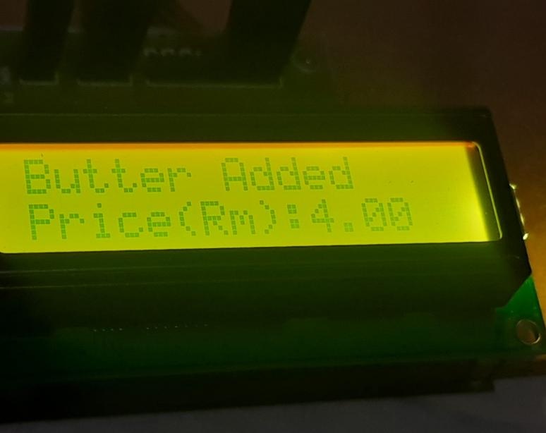

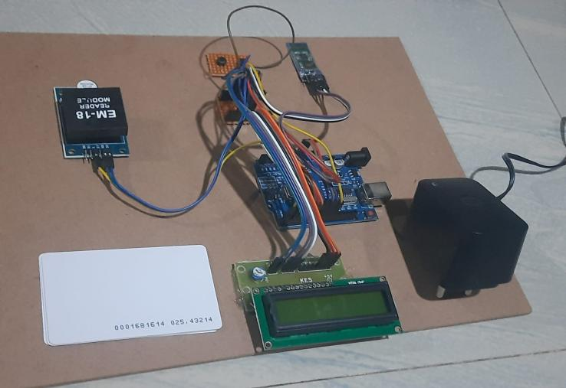

Fig 10.2 Modernized Shopping Solution Using IOT

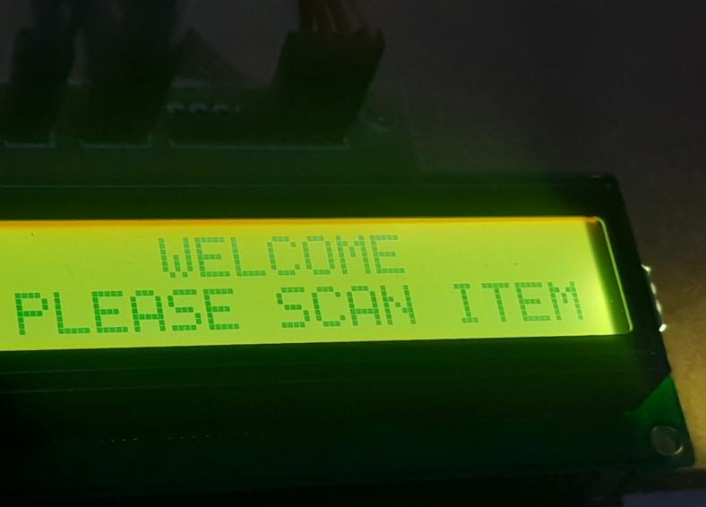

Fig 10.3 Dropping Items in Trolley

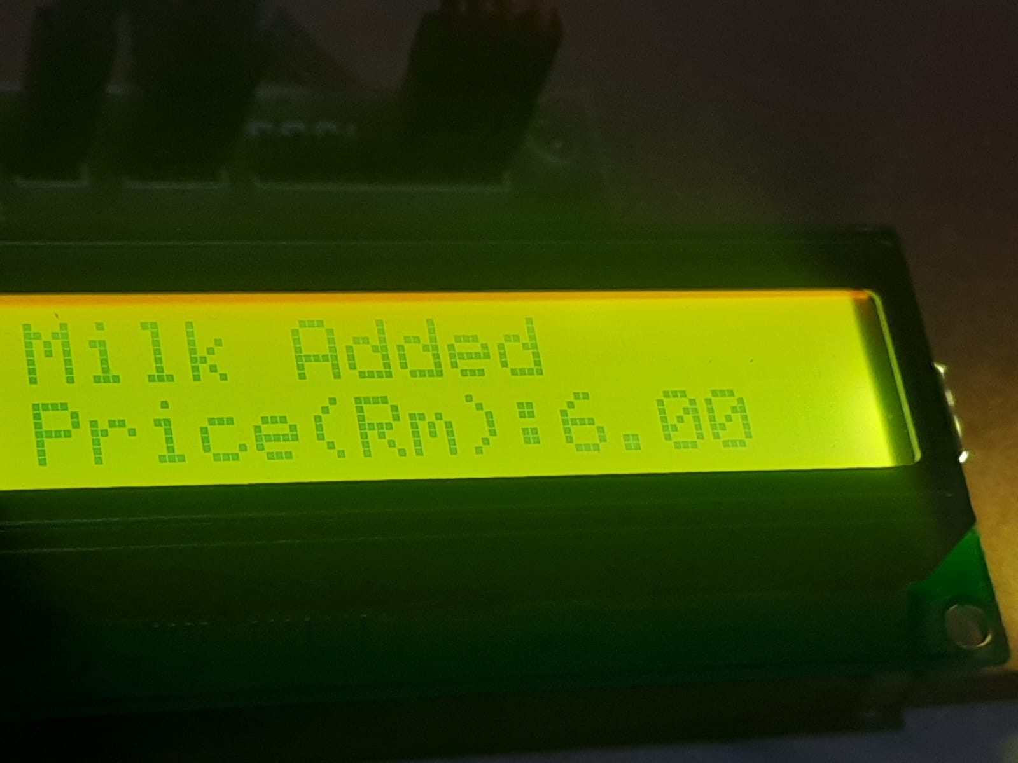

Figure 10.4 Item Added

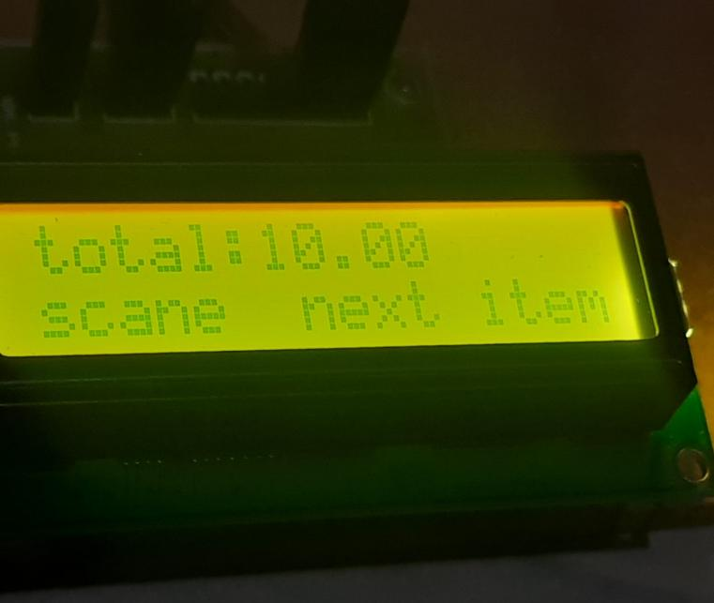

Figure 10.6 Total Amount

**11. CONCLUSION**

In conclusion, The proposed smart shopping trolley using IoT represents a significant advancement in the retail industry, promising to revolutionize the shopping experience for both customers and retailers alike. By seamlessly integrating IoT sensors and scanners, coupled with cashless transaction capabilities, the system ensures a fast, efficient, and hassle-free shopping journey. Customers will benefit from automatic product detection and streamlined checkout processes, leading to enhanced satisfaction levels. Simultaneously, retailers stand to gain from increased operational efficiency, with reduced reliance on manual checkout procedures and shorter queues resulting in higher throughput and potentially increased sales. Furthermore, the wealth of data collected by IoT sensors provides valuable insights into consumer behavior, enabling informed decision-making regarding inventory management, marketing strategies, and store optimization. As a cost-effective and environmentally friendly solution, the adoption of IoT-enabled smart shopping trolleys offers a promising avenue for innovation and sustainable growth in the retail sector.

**12. FUTURE SCOPE**

* Enhanced Personalization: Smart shopping trolleys could use IoT data to offer personalized shopping experiences, suggesting products or promotions based on each customer's purchase history and preferences.
* Integration with AI and Machine Learning: By incorporating AI and ML algorithms, these trolleys could predict demand, optimize inventory, and adjust pricing strategies in real-time, improving efficiency and profitability for retailers.
* Seamless Integration with Online Platforms: Integrating smart trolleys with online shopping platforms would allow customers to switch between in-store and online shopping seamlessly, with features like online order pickup and synchronized shopping lists.
* Expansion of IoT Ecosystem: Future smart trolleys could adopt more advanced IoT technologies, such as NFC or Bluetooth-enabled tags, to enhance product identification and tracking capabilities, offering greater flexibility and functionality.
* Sustainability Initiatives: Smart trolleys could promote sustainability by tracking product lifecycles, calculating carbon footprints, and incentivizing the purchase of eco-friendly products, aligning with consumers' increasing focus on environmental responsibility.

**13. REFERENCES**

1. IoT-Based Smart Shopping Cart Using Radio Frequency Identification, Mobeen Shahroz, Arif Mehmood ,2020

<https://ieeexplore.ieee.org/abstract/document/9060814>

1. A Smart Trolley for Smart Shopping, Tapan Kumar Das, 2020

<https://ieeexplore.ieee.org/document/9262350>

1. Automated Smart Trolley System Using RFID Technology,Rahul R, 2023

<https://ieeexplore.ieee.org/document/10199259>

1. Smart Shopping Trolley Using Raspberry Pi, D. Pradhan, 2021

<https://ieeexplore.ieee.org/document/9641206>

1. Enhancing Shopping Experience with Raspberry Pi and Cloud-Integrated Wireless Sensor Networks for Smart Trolleys in IoT, Ramakrishnan Raman, 2023 <https://librarysearch.aut.ac.nz/vufind/EdsRecord/edseee,edseee.10331668>