“EMERGENCY ALERT SYSTEM WITH GPS AND GSM INTEGRATION FOR REAL-TIME VEHICLE ACCIDENTS”

**Assistant Professor, Ms. S. Gowthami, Department of CSE**

**B. Sneka, R. Suganya, S. Swathi, M.J. Udhaya**

**Final Year Project Members, Bachelor of Engineering,**

**Department of Computer Science and Engineering,**

**Vivekanandha College of Technology for Women, Tiruchengode, Tamil Nadu.**

**ABSTRACT *This project introduces a real-time vehicle accident alert system that seamlessly integrates GPS and GSM technologies. Its key features include immediate accident detection, precise GPS location tracking, and instant alert transmission to authorities and vehicle owners. By significantly reducing response times, this system aims to enhance road safety, save lives, and improve post-accident care. The project's primary objective is to develop an efficient and user-friendly solution for addressing the critical issue of road safety. The system promises to reduce accident-related fatalities and injuries, improve emergency response coordination, and increase accountability for vehicle owners.***

**INDEX TERMS** GPS Module, Accelerometer, Arduino UNO, GSM Module, Buzzer, LED, 10k potentiometer, LCD Accident Detection Algorithm, GPS Tracking Algorithm, Emergency Contacts Database, GSM Communication Protocol.

# INTRODUCTION

The "Emergency Alert System with GPS and GSM Integration for Real-Time Vehicle Accidents" project is a critical endeavor that seeks to revolutionize road safety by harnessing cutting-edge technology. Vehicle accidents are unpredictable and often result in life-threatening situations, necessitating swift and efficient emergency response. This project introduces an innovative solution that combines hardware and software components to automatically detect vehicle accidents in real-time and promptly communicate vital information to emergency services and designated contacts. [1] In a world where motor vehicle accidents remain a leading cause of injuries and fatalities, this project's significance is paramount. [2] The system's key components include advanced accident detection algorithms that differentiate between minor impacts and serious collisions, a GPS tracking system to provide precise location data, and GSM integration for immediate communication with emergency services and designated contacts. [3] This project's primary objectives are to create a robust and reliable system that enhances road safety. [4] It aims to minimize response times during emergencies, thereby reducing the severity of accidents and saving lives. [5] Furthermore, it aligns with the ever-growing trend of leveraging technology to enhance safety and offers peace of mind to individuals and their families while on the road.

In doing so, it aspires to make a meaningful and lasting impact on road safety and emergency response systems, utilizing technology as a powerful tool for preserving lives and mitigating accidents' devastating consequences.ase of an accident.

# OBJECTIVE

Design and implement a comprehensive system that can automatically detect vehicle accidents in real-time, pinpoint the vehicle's location accurately using GPS technology, and promptly initiate emergency alerts through GSM communication.

**Accident Detection:** Develop an algorithm that can accurately detect vehicle accidents in real-time. This algorithm will analyze data from onboard sensors, such as accelerometers, to identify abrupt changes in motion indicative of a collision.

**GPS Integration:** Implement a GPS tracking system that continuously logs the vehicle's location, speed, and heading. This data is crucial for providing emergency services with accurate location information.

**GSM Communication:** Create a communication protocol with a GSM module to enable the system to send alerts to emergency services, healthcare providers, and designated emergency contacts via SMS or voice calls.

**Emergency Contacts Database:** Develop a database to store vital contact information, such as phone numbers and email addresses, of designated emergency contacts. This information will be accessible for alerting in case of an accident.

# LITERATURE SURVEY

## “A Comprehensive Study on IOT Based Accident Detection Systems for Smart Vehicles”

**“Muazzam A. Khan Khattak”**

Human development has resulted in a significant increase in car demand, which has led to an alarming increase in traffic congestion and auto accidents. Both the percentage of traffic deaths and the number of such accidents are rising significantly. However, the delay in emergency assistance is the main reason for the higher risk of fatalities. Effective rescue efforts could save many lives. Traffic jams or erratic contact with the medical units are to blame for the delay. To deliver aid quickly, automatic road accident detection systems must be put in place. (IEEE Access 2020).

## “A novel Internet of Things-enabled accident detection and reporting system for smart city environments sensor’’

**“F. Bhatti, M. A. Shah, C. Maple, and S. U. Islam,”**

Network of Things-capable Intelligent Transportation Systems (ITS) are being discussed extensively in academic research and in the business world as a way to improve traffic safety in smart cities. Road accidents have significantly increased as a result of the ever-growing number of automobiles. Vehicles equipped with a variety of sensors make it possible to not only keep an eye on the surroundings and the vehicle itself in real time, but also make incident detection easier. For instance, a substantial study has been done on the use of information and communication technologies (ICT) for quick and effective rescue operations following accidents. Most of these works offer advanced methods that emphasize speeding up response times.

## [3] “Android application for accident detection and notification.”

**“Khot, I.; Jadhav, M.; Desai, A.; Bangar, V.”**

One consequence of society's quick development is an increase in the number of automobile accidents. An injury occurs in one out of every three motor vehicle accidents, on average. In the majority of nations, traffic accidents are one of the main causes of mortality. As the number of vehicles rises, so does the likelihood of an accident. Even if the frequency of accidents rises as the population grows, the government has implemented a number of measures and engaged in numerous awareness campaigns. Using accelerometer sensors, the proposed system may automatically detect accidents and alert all nearby application users and emergency locations (police station, hospital). **(IRJET) May-2018.**

## [4] “Accident detection using Automotive Smart Black-Box based Monitoring system”

**P. Josephinshermila a, S. Sharon priya b, K. Malarvizhi c, Ramakrishna hegde d, S. GokulPran e, B. Veerasamy f**

Sensor and alarm systems that are dependable and powerful are essential for autonomous cars. The components and operation of an advanced monitoring and alert system for vehicle metrics are covered in this essay. In order to accommodate the massive population, the number of cars has also increased quickly. Additionally, there were more accidents as a result of this. The current accident prevention methods are all outdated and stagnant. There is also no trustworthy accident detection system. The microcontroller in an automobile continuously monitors the vehicle parameters and logs the information into protected digital memory cards and cloud storage. The device actively checks for any sudden vehicle accident detection in addition to periodically recording the vehicle parameters of the car. [Volume 27](https://www.sciencedirect.com/journal/measurement-sensors/vol/27/suppl/C), June 2023, 100721.

## [5] “IOT based framework for the detection of vehicle accident”

**C. Dashora, P.E. Sudhagar, J. Marietta**

The automotive industry has been emerging at a very fast rate, and it is still growing day by day. The Internet of Things (IoT) is one of the reasons behind these changes in the automobile business. The prospects and potential of this innovation are extraordinary. The main enabling factor that provides a promising paradigm is the integration of several technologies and communication solutions. a device is built that can generate an immediate response from the hospital if the vehicle gets into an accident and the driver is helpless to call the ambulance. The aim of this work is to build a device that can increase the safety of drivers and passengers. IoT technology helps us achieve this target of building the device successfully. This project will reduce the time between an accident occurring and the information received by the hospital about the accident. **2019.**

1. **INTERNET OF THINGS**

The application of intelligent sensors, actuators, and other gadgets—like radio frequency identification tags to improve industrial and manufacturing processes is known as the industrial internet of things, or IoT. These gadgets are connected via a network to facilitate data gathering, sharing, and analysis. This process's insights contribute to increased dependability and efficiency. IoT, sometimes referred to as the industrial internet, is utilized in a wide range of sectors, including manufacturing, utilities, oil and gas, and energy management. IoT leverages the data generated by dumb machines that have been in industrial settings for years by utilizing real-time analytics and smart machine capabilities. The underlying principle of IoT is that intelligent robots are superior to humans not only in real-time data capture and analysis but also in transmitting critical information that can expedite and improve the accuracy of business choices. Connected sensors and actuators help businesses identify inefficiencies and issues early on, which saves time and money and supports business intelligence initiatives. IoT specifically has the potential to improve supply chain efficiency overall, traceability of the supply chain, sustainable and green practices,and quality control in the manufacturing sector. IoT is essential to industrial operations, including asset tracking, improved field service, energy management, and predictive maintenance.

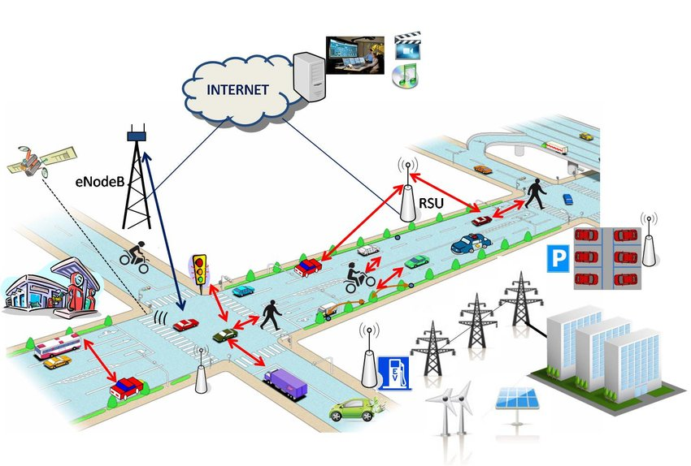

***Figure 1: Internet of Vehicles***

1. **PROPOSED MODEL**

An inventive way to improve road safety and save lives in the event of a vehicle collision is the suggested Emergency Alert System with GPS and GSM integration for real-time vehicle accidents. This device makes use of state-of-the-art GPS technology to locate an accident precisely and guarantee a prompt response from emergency personnel. Its integration of GSM connectivity allows it to immediately communicate vital accident information to first responders and authorities, accelerating the delivery of aid to individuals in need. In order to reduce false warnings, the system uses sophisticated sensors and crash detecting mechanisms to distinguish between accidents and non-emergencies. It may be easily added to cars, immediately notifying emergency contacts and giving accident victims two-way communication. In addition, the system provides data logging capabilities for post-incident analysis and alerts to neighboring vehicles, improving overall road safety. The suggested paradigm guarantees prompt action, effective synchronization with current emergency services, ease of use, and confidentiality of data, ultimately leading to a road environment that is safer and more interconnected.

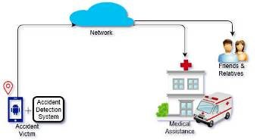

***Figure 2: Proposed System for Vehicle Accident System***

A proposed model for an emergency alert system with GPS and GSM integration for real-time vehicle accidents could include the following components:

1. GPS: Receives the coordinates of the vehicle's location
2. GSM: Sends a series of messages to the Road Security Agency Service (RSAS) containing the link of the vehicle's geographical coordinates
3. Arduino microcontroller: Integrates with the GPS receiver and GSM module to detect vehicle accidents and send SMS notifications with location data
4. Microcontroller: Includes various sensors
5. Signal: Indicates the accident's severity and GPS position
6. Engine health gauge: Gauges the health of the c

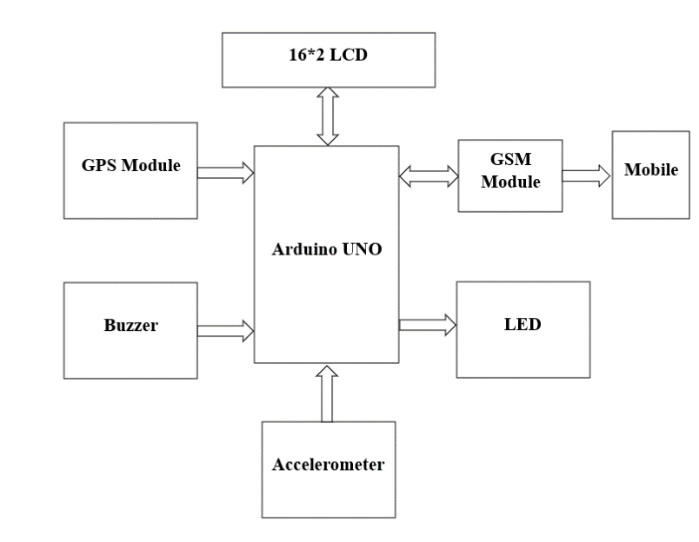**BLOCK DIAGRAM OF ACCIDENT DETECTION SYSTEM**

***Figure 3: Block Diagram of Accident Detection***

The block diagram for this system shows the main elements and how they work together to create a complete emergency alert system that can identify and report car accidents in real time. The hardware of the car is the first place to look, as it has an impact sensor to detect collisions and a GPS module for precise location data.After processing the data, the microcontroller applies preset criteria to determine whether an accident has happened. The GSM module is activated to transmit an emergency alert message to a distant server backend, containing the vehicle's GPS location and accident details, as soon as an accident is detected. Using the Google Maps API, the web application interface of the server shows the locations of accidents in real time on a map, along with timestamps and vehicle identities.

1. **WORKING MODEL**

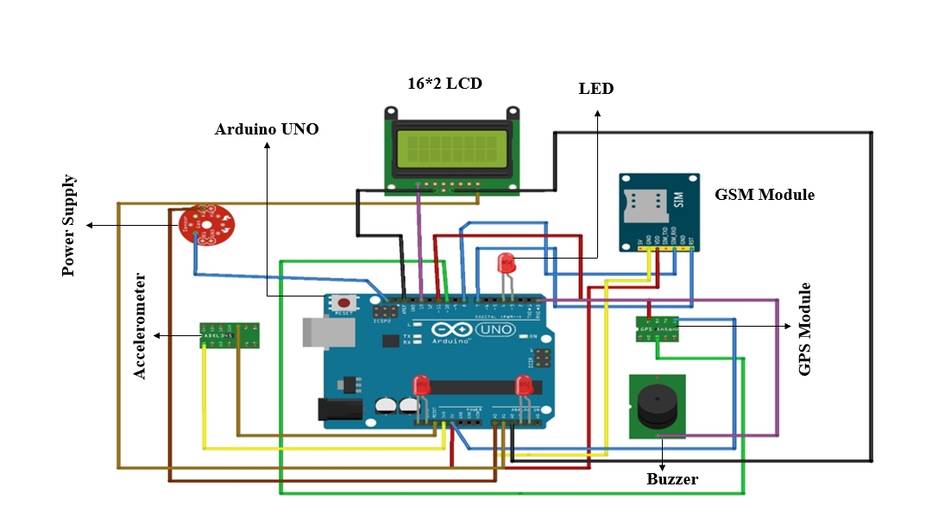**Architectural Design**

***Figure 4: Architecture of Accident Detection***

The architectural design of an "Emergency Alert System with GPS and GSM Integration for Real-Time Vehicle Accidents" is a carefully structured framework that harmonizes hardware and software components to enhance road safety and emergency response. At its core, the system consists of vehicle-mounted hardware, including GPS modules and impact sensors, which continuously monitor a vehicle's movements. The microcontroller processes data from these sensors, applying predefined criteria to identify and confirm accidents. Upon confirmation, the system triggers the GPS module to pinpoint the accident's precise location. Subsequently, an emergency alert, including critical accident details, is generated and transmitted via the GSM module to a remote server. The server backend receives and manages the data, while the web application interface displays real-time accident locations on a map, enabling authorized users to monitor and respond to incidents promptly. This architectural design not only streamlines emergency response but also has the potential to save lives and mitigate accident severity, offering a robust and efficient solution for ensuring road safety. An Emergency Alert System with GPS and GSM Integration for Real-Time Vehicle Accidents operates by continuously monitoring a vehicle's movements through sensors like accelerometers or impact sensors. When a significant impact or collision occurs, these sensors trigger the system to interpret it as a potential accident. A microcontroller processes the sensor data, applying predefined criteria to confirm the accident. If an accident is verified, the system activates the GPS module to acquire the vehicle's precise location, including latitude and longitude. Subsequently, the microcontroller generates an emergency alert that typically contains the accident's timestamp, vehicle identification, and accurate location data. This alert is transmitted via a GSM module to a remote server through SMS or data transmission. The server stores the incoming data, encompassing accident time, vehicle specifics, and exact location. The server's web application interface, often integrated with the Google Maps API, enables authorized users to monitor accidents in real-time and initiate responses, such as dispatching emergency services. This system's streamlined process enhances emergency response times, potentially leading to quicker assistance and improved safety outcomes during vehicle accidents.

**Working for Hardware Components**

**GSM module(SIM900A):** The serves as the communication link in the emergency alert system, enabling real-time transmission of accident alerts and GPS location data from vehicles to a central server. Its purpose is to rapidly notify emergency services and authorized users about accidents, enhancing response time and improving the safety of vehicle occupants. It is made possible via the GPS module's sending pin and the GSM module's reception pin.

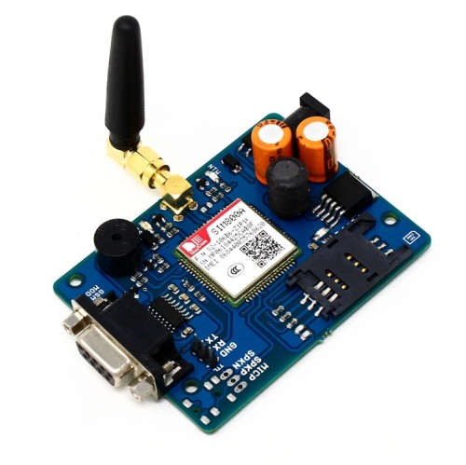

***Figure 5: GSM Module(SIM900A)***

1. **GPS Module (SIM28ML)** The Emergency Alert System provides precise vehicle location data (latitude and longitude), enabling accurate reporting of accident locations in real-time. It ensures rapid response by emergency services, improving the safety of accident victims. Additionally, it aids in post-incident analysis and location tracking for monitoring and rescue operations.

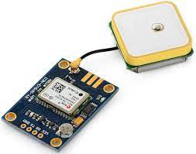

***Figure 6: GPS Module (SIM28ML)***

The SIM28ML supports various location and navigation applications, including: Autonomous GPS QZSS SBAS ranging (WASS, EGNOS, GAGAN, MSAS) DGPS A-GPS The SIM28ML is made with Surface Mount Technology and is an L1 frequency GPS module. It's designed with MTK high sensitivity navigation engine, which allows for high levels of sensitivity, accuracy, and Time-to-First-Fix (TTFF). You can connect 9V~15V DC to the Vin (Input Voltage) and GND (Ground/0V) Pins at male header JP1. You can also power up the modem by sharing voltage level +5V or +3.3V from other circuit boards.

1. **Accelerometer:** The Emergency Alert System with GPS and GSM integration serves the critical purpose of detecting sudden impacts or collisions within a vehicle. When a significant impact is detected, it triggers the system to initiate the transmission of an emergency alert, enhancing the system's ability to promptly respond to real-time vehicle accidents.

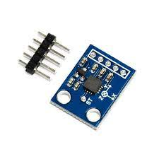

***Figure 7: ADXL335***

1. An accelerometer is a device that measures the vibration or acceleration of motion of a structure.
2. It works by sensing vibration and converting it into the piezoelectric effect. The piezoelectric effect occurs when energy is generated due to pressure and stress. That energy then gets converted into electric voltage. That voltage is used to get velocity and orientation.
3. The basic underlying working principle of an accelerometer is such as a dumped mass on a spring. When acceleration is experienced by this device, the mass gets displaced till the spring can easily move the mass, with the same rate equal to the acceleration it sensed.
4. **16x2 LCD:** (16 characters per line, 2 lines) in an Emergency Alert System with GPS and GSM integration for real-time vehicle accidents serves the following purposes:
   * 1. Display Accident Information: It provides a visual interface to display essential accident details, including the vehicle's ID, location, and time, aiding in quick assessment.
     2. User Interaction: Authorized personnel can use the LCD to interact with the system, acknowledge alerts, and initiate emergency response actions.
     3. System Status: The LCD can also display system status and diagnostics, ensuring proper functionality and readiness for emergency situations.
5. **Power supply:** the Emergency Alert System with GPS and GSM integration for vehicle accidents ensures continuous and reliable electrical power to all system components, including GPS, GSM, and microcontroller, enabling uninterrupted operation and timely accident alerts, enhancing safety on the road.
6. **Connecting Wires:** The purpose of connecting wires in an Emergency Alert System with GPS and GSM integration for real-time vehicle accidents is to establish crucial data communication between the vehicle's hardware components (GPS, accelerometer, microcontroller) and the GSM module. These wires enable the transfer of accident information, including location data, to the server backend, facilitating swift emergency response and enhancing the safety of vehicle occupants.
7. **Ardiuno UNO**: The Arduino UNO in an Emergency Alert System with GPS and GSM integration serves as the central microcontroller for accident detection, data processing, and communication with the GSM module.

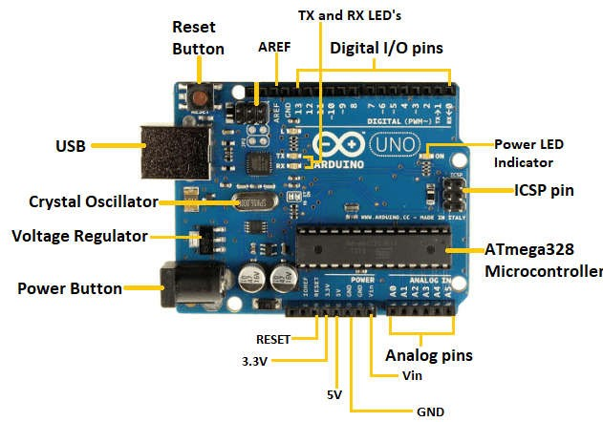

***Figure 8: Arduino UNO***

It facilitates the real-time transmission of accident alerts and location data to a remote server, enabling quick emergency response and enhancing vehicle safety. The Arduino Uno uses a variant of the C++ programming language. The code is written in C++ with an addition of special methods and functions. When you create a "sketch" (the name given to code files in this language), it is processed and compiled to machine language.

**SOFTWARE TOOL**

Embedded Programming (Microcontroller): Software like Arduino IDE or PlatformIO is used for programming the microcontroller, which processes data from sensors, manages the GPS module, and controls the GSM module. This software is essential for configuring the microcontroller to execute accident detection logic and communicate with the hardware components.

**Open Source Arduino Software**

**Arduino**

Arduino is an open-source electronics platform based on easy-to-use hardware and software. Arduino boards are able to read inputs -light on a sensor, a finger on a button, or a Twitter message - and turn it into an output -activating a motor, turning on an LED, publishing something online the work can defined by your board what to do by sending a set of instructions to the microcontroller on the board.

## ARDUINO SOFTWARE(IDE)

The Arduino Integrated Development Environment-or Arduino Software (IDE) - contains a text editor for writing code, a message area, a text console, a tool bar with buttons for common functions and a series of menus. It connects to the Arduino hardware to upload programs and communicate with them.

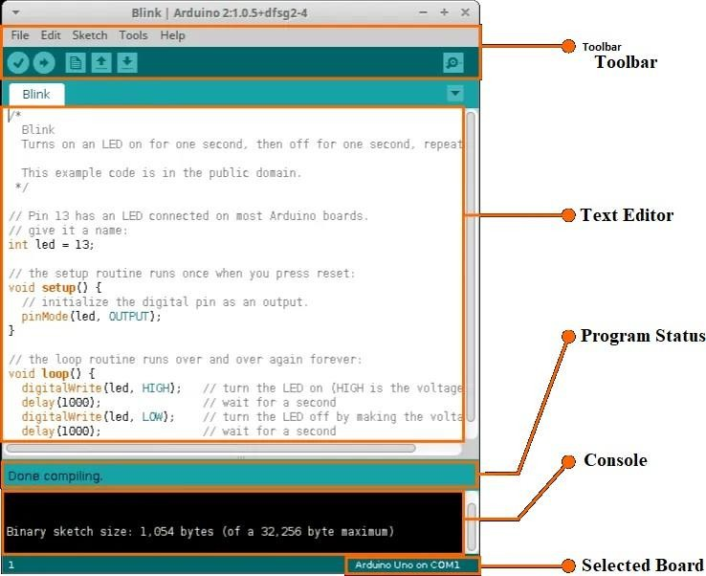

***Figure 9: Arduino UNO Software***

* **Verify** Checks your code for errors
* compiling it.
* **Upload** Compiles your code and uploads it to the configured board. See uploading below for details.
* **New** Creates a new sketch.
* **Open** Presents a menu of all the sketches in your sketch book. Click in gone will open it within the current window over writing its content.
* **Save** Saves your sketch.
* **Serial Monitor** Opens the serial monitor

Additional commands are found within the five menus: File, Edit, Sketch, Tools, Help. The menus are context sensitive, which means only those items relevant to the work currently being carried out are available

## FILE

1. **New** Creates a new instance of the editor, with the bare minimum structure of a sketch already in place.
2. **Open** Allows to load a sketch file browsing through the computer drives and folders.
3. **Open** Recent Provides a short list of the most recent sketches, ready to be opened.
4. **Sketch book** Shows the current sketches within the sketch book folder structure; clicking on any name opens the corresponding sketch in a neweditor instance.
   * **Close** Closes the instance of the Arduino Software from which it is clicked.
   * **Save** Saves the sketch with the current name If the file hasn't been named before, a name will be provided in a "Save as" window.
   * **Save as** Allows to save the current sketch with a different name.
   * **Page Setup** It shows the Page Setup window for printing.

* **Print** Sends the current sketch to the printer according to the settings

1. **SYSTEM DESIGN**

The system design of an "Emergency Alert System with GPS and GSM Integration for Real-Time Vehicle Accidents" is a carefully orchestrated architecture that seamlessly blends hardware and software components to enhance safety on the roads. The system begins with hardware components within the vehicle, including GPS modules and impact sensors. These sensors constantly monitor the vehicle's movements and trigger the system to identify and confirm accidents. A microcontroller processes the data and, upon accident detection, activates the GPS module to pinpoint the vehicle's location. Subsequently, an emergency alert is generated, incorporating essential accident details. The GSM module steps in to transmit this alert to a remote server through SMS or data transmission. The server backend receives, stores, and manages accident data, while the web application interface displays real-time accident locations on a map, aiding authorized users in monitoring and coordinating responses. This comprehensive design not only streamlines emergency response times but also offers the potential to save lives and reduce the severity of accidents by enabling swift assistance during critical situations on the road. Additionally, it opens opportunities for further enhancements such as predictive analytics and automation to improve overall road safety.

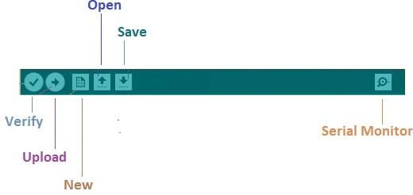

***Figure 10: Arduino UNO Software Tool***

1. **VALIDATION PHASES**
2. **Hardware Testing:** The system's hardware components, such as the GPS module, impact sensors, microcontroller, and GSM module, undergo rigorous testing to ensure they function correctly. This involves hardware calibration, stress testing, and reliability checks to confirm that the sensors can accurately detect accidents and that the communication hardware functions seamlessly.
3. **Software Testing:** The software components, including the embedded code in the microcontroller, server-side programs, and the web application, are subjected to thorough testing. This includes unit testing, integration testing, and system testing to identify and rectify any bugs or issues that might compromise the system's performance.
4. **Simulated Accident Scenarios:** The system is tested in a controlled environment using simulated accident scenarios. This phase helps verify the system's accuracy in accident detection, alert generation, and communication with the server. It also helps fine-tune the predefined criteria for accident confirmation.
5. **Field Testing:** The system is installed in vehicles and subjected to real-world conditions. It is tested in diverse environments, road conditions, and weather situations to ensure it can reliably detect accidents and communicate with the server and emergency services, even in challenging circumstances.
6. **User Testing:** Authorized users, such as emergency responders or system administrators, participate in user testing. This phase validates the usability of the web application interface, ensuring that it effectively displays real-time accident alerts, allows for user interaction, and facilitates rapid response coordination.
7. **Performance Testing:** The system's performance is evaluated under stress conditions, including scenarios with a high volume of accident alerts. This phase assesses its ability to handle a large number of simultaneous incidents while maintaining response times and system stability.
8. **Integration Testing:** Testing of the system's entire end-to-end process, from accident detection to server communication and web application display. This phase ensures that all components work harmoniously together, minimizing potential bottlenecks or communication issues.
9. **Security and Privacy Testing:** Security measures, data encryption, and privacy features are rigorously tested to safeguard sensitive information and protect the system from potential vulnerabilities.
10. **Scalability Testing:** The system is tested to determine its scalability, ensuring it can accommodate an increasing number of vehicles and users as the system grows.
11. **Regulatory Compliance:** The system is validated to meet relevant regulatory and safety standards, ensuring it complies with legal and operational requirements.

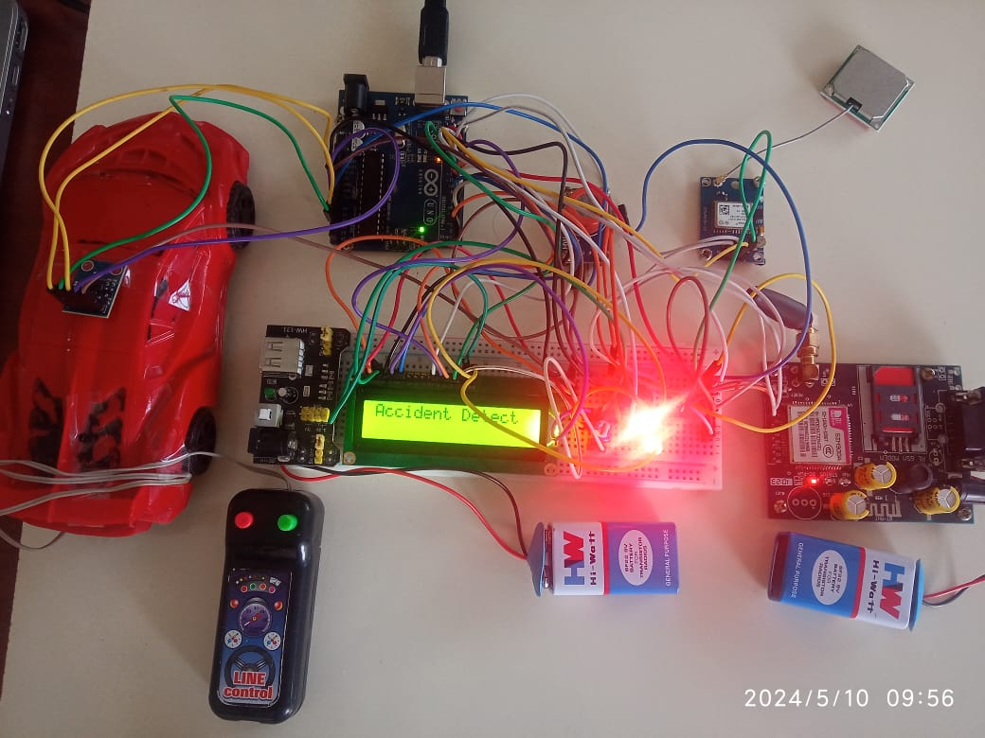**RESULT ANALYSIS**

***Figure 11: Emergency alert system for vehicle accidents***

1. **CONCLUSION**

In conclusion, the "Emergency Alert System with GPS and GSM Integration for Real-Time Vehicle Accidents" is a critical and innovative solution designed to enhance road safety and expedite emergency response in the event of vehicular accidents. This system leverages a combination of hardware components, including GPS modules, impact sensors, and microcontrollers, along with sophisticated software tools, such as server backends and web applications, to create a comprehensive and real-time accident reporting platform.

The system's primary objective is to accurately detect accidents, confirm their occurrence, and swiftly transmit emergency alerts to the appropriate authorities and responders. It achieves this through the collaborative efforts of sensors that monitor vehicle movements, intelligent algorithms that analyze sensor data, and communication technologies that enable seamless connectivity with remote servers and emergency services.

The real-world implications of this system are profound. It has the potential to significantly reduce response times, which can make a critical difference in saving lives and mitigating the severity of accidents. It empowers authorized users to monitor accidents in real-time and take immediate, well-informed actions. Furthermore, the integration of GPS technology ensures that the accident's exact location is transmitted, further enhancing response precision.

However, the success of such a system relies on rigorous validation phases, including hardware and software testing, field testing, and performance evaluation. By thoroughly verifying the system's functionality, reliability, and scalability, we can ensure that it performs effectively in diverse scenarios and maintains the privacy and security of the data it handles.

In summary, the "Emergency Alert System with GPS and GSM Integration for Real-Time Vehicle Accidents" embodies innovation, efficiency, and a commitment to road safety. It represents a powerful tool in modernizing emergency response mechanisms and has the potential to save lives and reduce the impact of accidents on our roads. As technology continues to advance, systems like these play a pivotal role in creating safer and more responsive transportation ecosystems.

1. **REFERENCES**
2. U. Alvi, M. A. K. Khattak, B. Shabir, A. W. Malik and S. R. Muhammad, "A Comprehensive Study on IoT Based Accident Detection Systems for Smart Vehicles," in IEEE Access, vol. 8, pp. 122480-122497, 2020, doi: 10.1109/ACCESS.2020.3006887.
3. Biswaranjan Bhola, Raghvendra Kumar, Ishaani Priyadarshini, Chakchai So-In, Tusharkanta Padhy, Adam Slowik, Amir H. Gandomi, "Internet-of-Things-Based Sensor Module for Respiratory Tracking System", IEEE Sensors Journal, vol.23, no.16, pp.18664-18674, 2023.
4. N. Selvam, M. Sampath, J. Sethu Madhavan, T. Sharmitha, D. Sri Mugesh, "IoT based Smart Communication System for Accident Prevention", 2023 5th International Conference on Smart Systems and Inventive Technology (ICSSIT), pp.562-566, 2023.
5. G.A Senthil, P Suganthi, R. Prabha, M. Madhumathi, S. Prabhu, S Sridevi, "An Enhanced Smart Intelligent Detecting and Alerting System for Industrial Gas Leakage using IoT in Sensor Network", 2023 5th International Conference on Smart Systems and Inventive Technology (ICSSIT), pp.397-401, 2023.
6. G. Thamarai Selvi, Sai Rama Krishnan V, Saranraj A, Jananipriya R, "Advanced Accident Detection System Using Sensor Networks and IoT", 2022 International Conference on Power, Energy, Control and Transmission Systems (ICPECTS), pp.1-5, 2022.
7. G. Thamarai Selvi, R. Prabha, G. A Senthil, Sai Rama Krishnan V, Saranraj A, Jananipriya R, "An Improved Internet of Things Based Accident Detection System Using Sensor Networks", 2022 International Conference on Power, Energy, Control and Transmission Systems (ICPECTS), pp.1-5, 2022.
8. Saswati Kumari Behera, Navin S K, Saran V S, Vasundhara L, Saisudha G, "NEMO-SOS- A Future Trends in Smart Accident Alert Application", 2022 International Conference on Power, Energy, Control and Transmission Systems (ICPECTS), pp.1-5, 2022.
9. M.S.C. Camarillo, O.B. Tolentino, M.A.E Latina, "Integrated Tracking Device & Automated Collision Detection for City Bicycles using Arduino and Global System for Mobile Communication (GSM)", 2022 IEEE 14th International Conference on Humanoid, Nanotechnology, Information Technology, Communication and Control, Environment, and Management (HNICEM), pp.1-6, 2022.
10. Angelos Zacharia, Dimitris Zacharia, Aristeidis Karras, Christos Karras, Ioanna Giannoukou, Konstantinos C. Giotopoulos, Spyros Sioutas, "An Intelligent Microprocessor Integrating TinyML in Smart Hotels for Rapid Accident Prevention", 2022 7th South-East Europe Design Automation, Computer Engineering, Computer Networks and Social Media Conference (SEEDA-CECNSM), pp.1- 7, 2022.
11. Polisetty Swetha V Padmavathi, U. Srilakshmi, D. Venkatesulu, "Accident Detection and Warning Systems in VANET", 2022 IEEE International Conference on Data Science and Information System (ICDSIS), pp.1-4, 2022.
12. V Dankan Gowda, Avinash Sharma, Anil S Naik, Radhey Shyam Meena, Jayashree M Kudari, S Purushotham, "Design and Implementation of a System for Vehicle Accident Reporting and Tracking", 2022 7th International Conference on Communication and Electronics Systems (ICCES), pp.349-353, 2022.
13. C. Nandagopal, P. Anisha, K. Ganga Dharani, N. Kuraloviya, "Smart Accident Detection and Rescue System using VANET", 2022 International Conference on Sustainable Computing and Data Communication Systems (ICSCDS), pp.1111-1116, 2022.
14. Jaffino G, Palaniappan T, Samuel Swamidoss MK, Gugapriya G, Madhu manikya Kumar, J Prabin Jose, "IoT Based Frame work for Automatic accident Intimation System", 2022 8th International Conference on Advanced Computing and Communication Systems (ICACCS), vol.1, pp.1568-1572, 2022.
15. Reem Elfatih Salman, Ayman Alzaatreh, "Market Basket Analysis of Chicago Road Accidents", 2022 Advances in Science and Engineering Technology International Conferences (ASET), pp.1-7, 2022.
16. Saravanan Alagarsamy, M. Malathi, M. Manonmani, T. Sanathani, A. Senthil Kumar, "Prediction of Road Accidents Using Machine Learning Technique", 2021 5th International Conference on Electronics, Communication and Aerospace Technology (ICECA), pp.1695-1701, 2021.
17. Ghulam Fiza Mirza, Ali Akbar Shah, Bhawani Shankar Chowdhry, Tanweer Hussain, Yahya Sameen Junejo, "Road Condition Monitoring Using Axle-Based Acceleration Method and K-Means Clustering Algorithm", 2021 IEEE 18th International Conference on Smart Communities: Improving Quality of Life Using ICT, IoT and AI (HONET), pp.126-131, 2021.