**“ONROAD VEHICLE BREAKDOWN ASSISTANCE”**

**Ms.S.Gowthami1, Athira Nagarajan2,C.Dharsha3,**

**K.Dharshini Priya4, R.Gowri5**

1Assistant Professor, Department of Computer Science and Engineering, Vivekanandha College of Technology for Women, Tiruchengode, Tamil Nadu, India.

2,3,4,5 UG Scholar, Department of Computer Science and Engineering, Vivekanandha College of Technology for Women, Tiruchengode, Tamil Nadu, India.

***Abstract:*** **The scarcity of electric vehicle charging facilities is one of the main problems, especially in some areas or places with dense populations. Due to their rarity, electric vehicle owners find it difficult to locate convenient charging stations, which causes range anxiety and discourages them from buying electric cars. This research presents a novel approach to improving electric vehicle (EV) charging station slot booking systems and on-road vehicle services. Users can easily reserve slots for EV charging stations and access a variety of on-road services, such as car maintenance, repair, and emergency help, using this integrated platform. Through Streamlining reservations for EV charging stations and on-road vehicle services, this platform seeks to improve the entire experience for both car owners and service providers that support urban mobility that is efficient, convenient, and ethical. These devices can provide drivers with a sense of security while driving and solve a widespread issue. Typically, ORVBA systems include a mobile application that lets consumers look for technicians in their area, initiate help requests, and follow the mechanic's progress.**

***Keywords***: Roadside Assistance,

Vehicle Breakdown Service, Emergency

Towing, Mobile Mechanic.

# I.INTRODUCTION

Many people find it difficult to acquire assistance when their car breaks down while they are driving. Since the AutoRestore provider center may be far from their location, many of them lack access to auto repair provider carriers' touch range and are unable to receive assistance. To make this project of aiding those in need when their car breaks down on the side of the road feasible, we are expanding our Android application for consumer assistance, which assists passengers at various points along their street travels. We acknowledge the significant influence Android has had on the technology industry. The fact that Android is freely available has led to devices with necessary hardware being embedded with the operating system In turn, this has made it possible for people to access the internet from even the most remote places. As a result, we will now use this utility, which allows people to use it in the event of a breakdown, and combine it with the different possible help that will be provided along the way.

The majority of people travel using their cars these days. The majority of drivers have problems when their vehicles break down while they are on the road. While more sophisticated systems include the price and real-time availability of stations, charging station mapping services normally provide the location, power, network, and connector type of publicly accessible charging stations. Customers can access maps of their stations provided by large charging networks. a map of household, business, and public charging points compiled by crowdsourcing. The website provides a map of charging places using Google Maps and allows users to filter by charging type using their database. There is a list of domestic charging places, private chargers, and public chargers. Users of iOS and Android devices can find chargers nearby with the help of the service's app.

Viewing private individuals' charging sites requires an account since they are found in Plug share members' residences or places of business. Fast charging, sometimes referred to as rapid charging or quick charging, intends to replenish electric vehicle batteries quickly, much like a conventional vehicle filled with petrol. To charge to 80% capacity with fast charging, it takes roughly 20 minutes. As a result, EVs can travel much farther overall as long as there are enough quick charging stations along the route.

## **II. LITERATURE SURVEY**

**[1]** **ROAD ASSIST MOBILE APPLICATION SYSTEM (ROAD ASSIST)**

**Author: Nor Amanina Binti Zamri**

**Year: 2022**

A smartphone app is intended to assist drivers in notifying their insurance companies of vehicle breakdowns. This gives the driver a dependable and clear way to contact the insurance company for assistance. The system is simple and quick for the driver to utilize, only requiring a few steps to complete with this mobile application. The insurance company will receive an alert on their system as soon as the driver utilizes Road Assist to notify them. The alert can inform the insurance company about the user who experienced a car breakdown. Additionally, Road Assist is using chatbots that are powered by artificial intelligence (AI). A chatbot helps drivers receive assistance from their insurance company more easily. This study paper covers several topics that are crucial to the development of the project during the implementation stage. The study's introduction, which covered the project's background, a review of the literature on domain research, the research techniques used to collect the data, the requirement validation of the data obtained through the research methods, and the research's conclusion are the aspects.

**[2] MOBILE-BASED SOLUTION FOR VEHICLE ASSISTANCE**

**Author: M. A. D. Wickrama**

**Year: 2022**

Currently, private vehicles are used by the majority of people in Sri Lanka for transportation. One of the biggest problems for drivers of vehicles on the road is vehicle breakdown. However, depending on the underlying cause of the malfunction, users may be able to resolve some small issues on their own if they possess the fundamental information that most do not. Should the cars experience a breakdown in an isolated area, obtaining assistance or locating the necessary replacement parts becomes complex. Furthermore, car owners require a platform that allows them to compare insurance policies and organizations offering vehicle insurance simply and concisely. The writers chose to create a smartphone application to help drivers with car maintenance and breakdowns in addition to a few other features as a response to the aforementioned issues. The proposed system's core features include a personal assistant to help with car breakdowns, the ability to forecast when a vehicle will need maintenance, reliable spare part pricing, and the ability to advise the best insurance companies to clients. Several technologies and methods, including sentiment analysis, neural networks, and natural language processing, are employed in the product's development. The survey's findings indicate that customers are quite happy with the product's effectiveness.

**[3] ON ROAD VEHICLE BREAKDOWN ASSISTANCE**

**Author: Mrs. Surekha Khot**

**Year: 2022**

When a person needs assistance with mechanical issues with their car and is in a distant place, On Road Car Breakdown Assistance (ORVBA) is a reliable option. The public who have enrolled will be the ones connecting with the mechanic through the reliable application method. Users of the current system have extremely limited access to their mechanic database. Furthermore, they don't need to know whether their cars are breaking down or experiencing technical problems in far-off places from their trusted mechanic shops. Users of the On Road Vehicle Breakdown Assistance (ORVBA) system can look for a list of mechanics in the area who can assist them at any time by using this highly suggested feature.

**[4]** **FLUTTER-BASED MOBILE APPLICATION FOR ELECTRIC VEHICLE CHARGING**

**Author: Hari Krishna S.M**

**Year: 2023**

The transportation sector's increasing use of electric vehicles (EVs) has brought along difficulties related to charging the vehicle at the charging stations, such as vehicle clustering around a specific station, resulting in higher wait times as a result of the scarcity of charging stations. The EV owners have lost time and energy as a result, and finding a local charging station has become a tedious affair. To address these problems, the paper suggests a mobile application that allows users to reserve a charging port in advance at any available station for EV charging. Details like the location of a charging station, the quantity and kind of chargers it has, and the slots that are available during a given time are all provided to the user by the proposed system. It also keeps track of user feedback and lets consumers reserve a time slot via a secure payment mechanism.

**[5] CLOUD-BASED SMART EV CHARGING STATION RECOMMENDER**

**Author: Sarika P. R, Shivraj. P**

**Year: 2023**

The job of locating appropriate Electric Vehicle Supply Equipment (EVSE) for charging electric vehicles (EVs) is getting harder and harder as the number of EVs with specific charging needs rises. The main goal of this work is to create a customer-focused, cloud-based EV charging station recommender that helps consumers find EV charging stations according to their needs and location. In addition to other user requirements like connector type, accessibility, access time, parking lot, station category, etc., the recommender will gather the position of the vehicle. As inputs to ease slot booking and suggest the most practical charging stations arranged in ascending order of distance from the user's location. The Random Forest Algorithm (RFA), Linear Search Algorithm (LSA), and Haversine formula are used to analyze the charging station dataset to determine which stations are closest to the vehicle location, which is followed by stations that meet user requirements. An end-user cloud application that is implemented in Streamlet Cloud is developed using Streamlet. Future system integrations could include scheduling charging requests and updating the station list with real-time location data.

**[6] NEXT - GENERATION SMART ELECTRIC VEHICLES CYBER-PHYSICAL SYSTEM FOR CHARGING SLOTS BOOKING IN CHARGING STATIONS**

**Author: Suresh Chavhan**

**Year: 2023**

Battery-powered vehicles will undoubtedly replace internal combustion engines due to growing global awareness of the pollution that comes from using fossil fuels. Keeping in mind the challenges the city's economy and people face in adjusting to fully grid-run charging infrastructure, this literature has developed a framework that integrates electric vehicles to everything (EV2X) communication and Charge Slot booking based on data obtained from a conducted survey. The survey's outcomes provide important new information on how to statistically analyze LTE use to support traditional OCPP and advance user control models that are further investigated in this area. For the city, strategies and algorithms for implementing next-generation, efficient EV2X communications have been devised. Additionally, we have prioritized slot reservations and incorporation above charge cycles. In this regard, the introduction of IPMUs using an LTE connection as an adjunct to the traditional OCPP is investigated. In addition, we have developed and optimized the M/M/m EV queuing model for the charging station.

**[7]** **EV CHARGING STATION LOCATOR WITH SLOT BOOKING SYSTEM**

**Author: Rahul George**

**Year: 2020**

Every country is shifting towards sustainable, acceptable, dependable, and efficient green energy sources as a result of the world's fossil fuel shortage. Since the cost of EV components is falling, the technology that powers these vehicles is improving at a rapid pace. Due to the significant environmental impact of conventional automobiles, interest in electric vehicles (EVs) is growing. The State of Charge (SoC) of the EV battery is continuously shown in the proposed work, and the screen displays the closest charging stations. The EV driver's screen will take them to the slot booking website, which displays all of the available slots, from a list of suggested charging stations closest to their location.

**III.SYSTEM ANALYSIS**

**EXISTING SYSTEM**

Users of the current system encounter difficulties when their vehicles break down in remote or distant regions where their known mechanic shops might not be available due to limited access to mechanics in their database. Users don't know if there have been any mechanical problems with their cars in these places. Users may depend on local personal relationships in similar circumstances to ask for assistance, but this is dependent on the willingness and availability of those contacts. In remote areas, finding a qualified mechanic for the necessary service can be a difficulteffort. Because of this, people frequently turn to other modes of transportation in the event of a breakdown and then have to make arrangements for a repair to come to the spot where their car is stuck. These difficulties highlight the necessity for an enhanced on-road car breakdown support management system that can effectively handle these constraints and offer users, wherever they may be prompt assistance.

**PROPOSED SYSTEM**

The suggested methodology presents a novel approach to improving electric vehicle (EV) charging station slot booking systems and on-road vehicle services. By using a cutting-edge platform, users benefit from easy access to a range of on-road services, such as emergency support, car maintenance, and repairs, as well as the capacity to book spots for EV charging stations. By utilizing state-of-the-art technology like automatic scheduling algorithms and real-time GPS monitoring, the platform efficientlyarranges for service providers to be dispatched to users' locations, assuring prompt help and minimizing vehicle downtime. Additionally, the system allows EV owners to quickly plan and manage their charging needs using aneasy-to-use interface for scheduling times at EV charging stations. Thisplatform seeks to greatly enhance on-road car services and EV charging stations.

**V.SYSTEM REQUIREMENTS**

**HARDWARE REQUIREMENTS**

* Processors: Intel® Core™ i5 processor 4300M at 2.60 GHz or 2.59 GHz (1 socket, 2 cores, 2 threads per core), 8 GB of DRAM
* Disk space: 320 GB
* Operating systems: Windows® 10, macOS*, and Linux*

**SOFTWARE REQUIREMENTS**

* Server Side: Python 3.7.4(64-bit) or (32-bit)
* Client Side: HTML, CSS, Bootstrap • IDE: Flask 1.1.1
* Back end: MySQL 5.
* Serve: WampServer 2i
* OS: Windows 10 64–bit or Ubuntu 18.04 LTS "Bionic Beaver"

**VI.MODULE DESCRIPTION**

**ADMIN DASHBOARD MODULE**

The administrative interface module offers comprehensive management capabilities for electric vehicle (EV) charging stations, slots, and user bookings. In general, administrators may better manage EV charging stations, slots, and user reservations with the use of the administrative interface module, which eventually improves the dependability and accessibility of electric vehicle charging services.

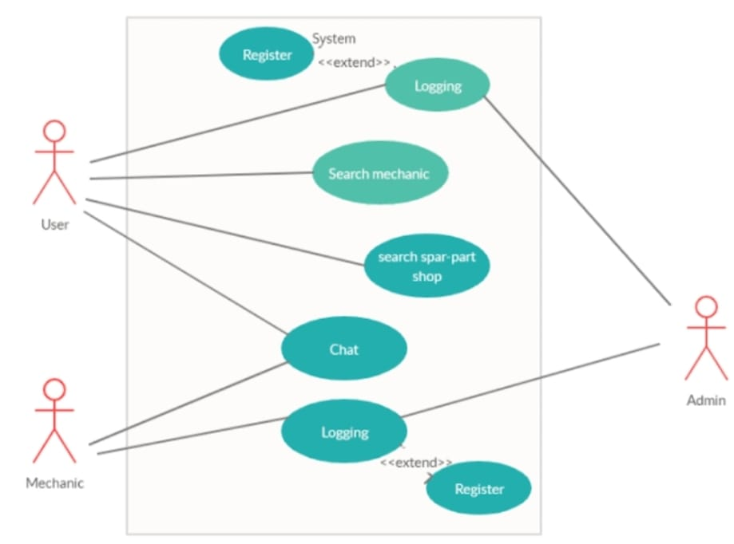

**Fig.1**

In general, administrators may better manage EV charging stations, slots, and user reservations with the use of the administrative interface module, which eventually improves the dependability and accessibility of electric vehicle charging services.

**EV CHARGING STATION MAP MODULE**

This module enhances user experience by seamlessly integrating with mapping APIs to provide a comprehensive map interface displaying the locations of EV Charging stations. Users can conveniently search for nearby stations, facilitating efficient planning for charging stops during their journeys.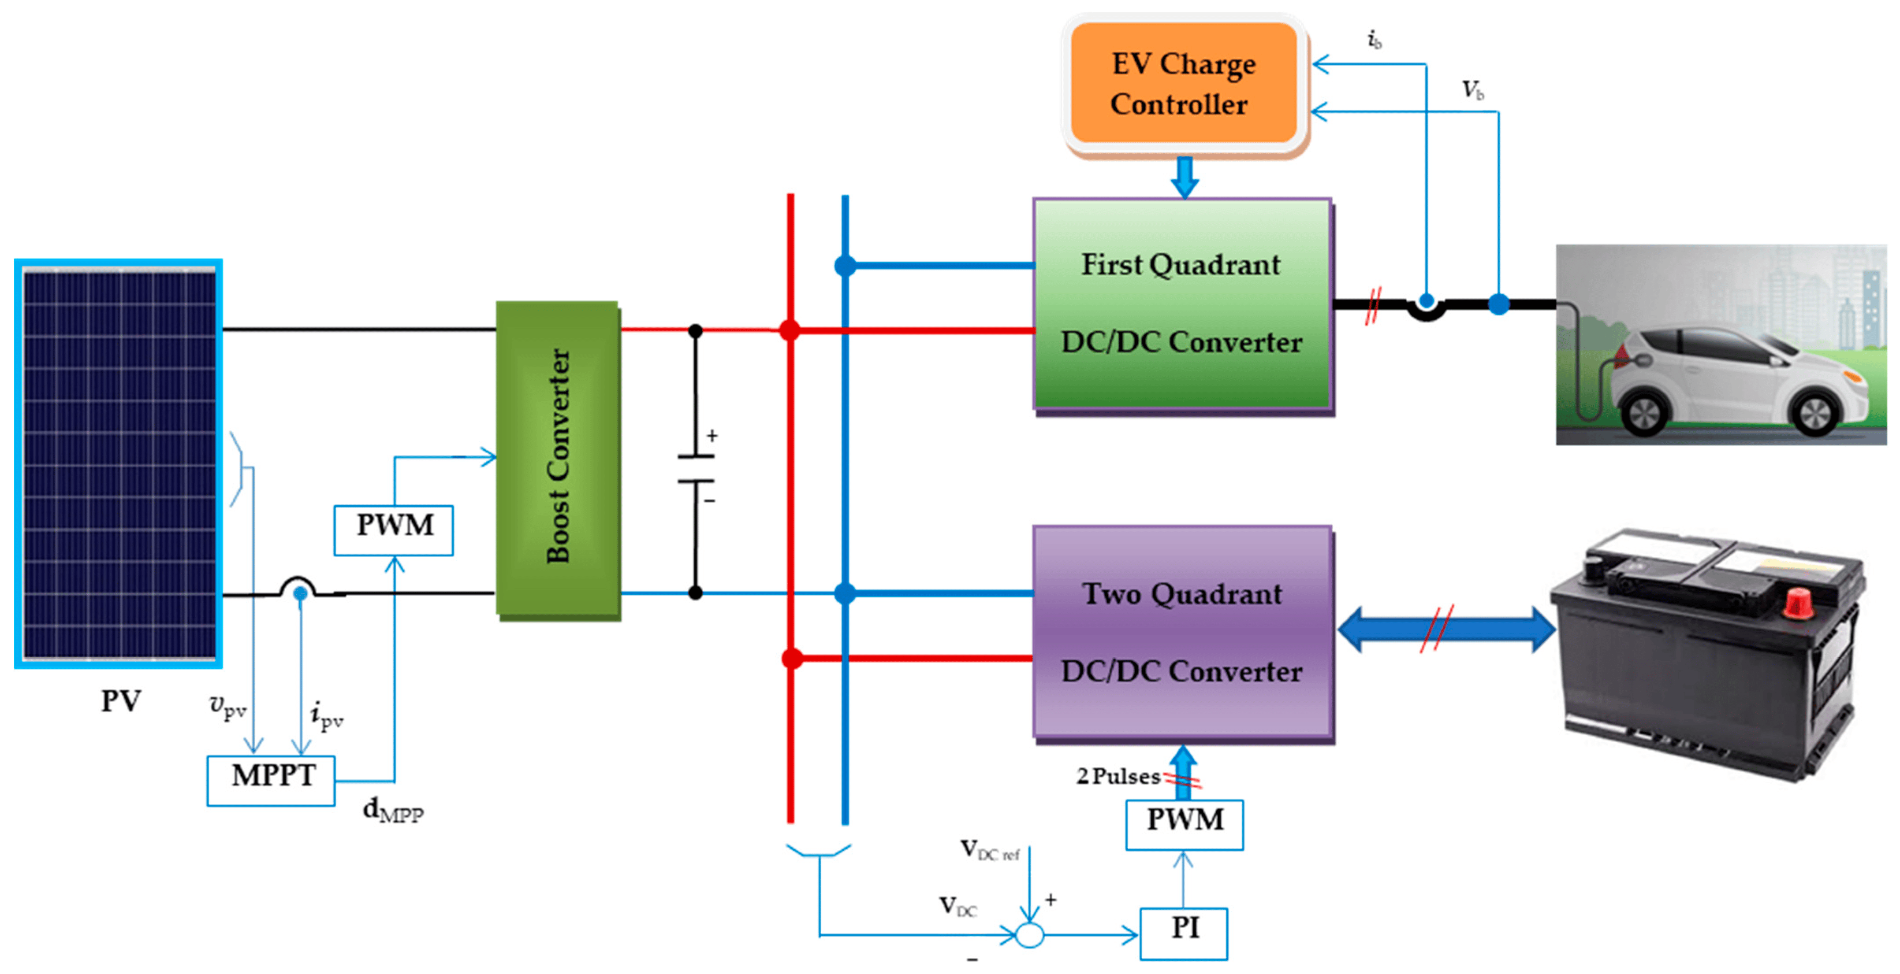

**Fig.2**

**USER AUTHENTICATION MODULE**

This module serves as the backbone for user authentication within the system, providing essential functionality for user registration, login, and account management. Users can securely create their accounts through a registration process, inputting necessary details such as username, email, and password.

**SLOT BOOKING MODULE**

This module offers users the convenience of booking charging slots at their preferred EV charging stations. Through a user-friendly interface, users can easily navigate the platform to select their desired charging station, choose a suitable date and time slot, and confirm their booking with just a few clicks. Additionally, users receive instant confirmation upon successful booking, providing them with peace of mind and certainty regarding their scheduled charging session.

**PAYMENT GATEWAY MODULE**

This feature makes sure that making reservations is easy and quick, which improves the user experience in general.

The module accommodates various payment methods, hence meeting the needs of preferences, taking into account consumers' varying payment method preferences. Increased user satisfaction and increased utilization of the EV charging station slot booking system for electric vehicles. The module accommodates customers with a variety of preferences by providing several payment alternatives, allowing them to choose different payment methods. This accessibility boosts customer satisfaction and motivates more people to schedule slots for electric vehicle charging at EV charging stations.

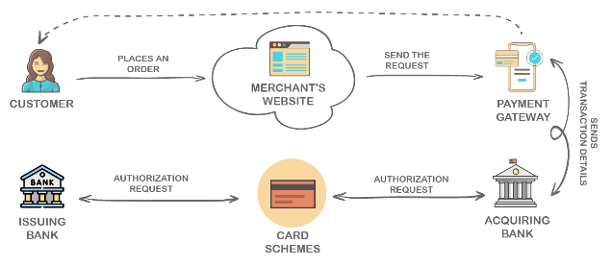

**Fig.3**

**VII.SYSTEM TESTING**

A critical stage of the software development life cycle (SDLC) is system testing, which assesses the functionality of the complete integrated system to make sure it satisfies predetermined standards. In this stage of testing, the system is examined as a whole, ensuring that it complies with the stated criteria and that each component functions as a unit. Before deployment, the main objectives are to find flaws, confirm system dependability, and ensure that it lives up to user expectations.

**FUNCTIONAL TESTING:**

Ensures peace of mind and certainty regarding their scheduled charging session.

makes certain that the system operates by the requirements. It checks how the system's features—such as data manipulation, input validation, and user interface functionality—behave.

**PERFORMANCE TESTING:**

Ensures peace of mind and certainty regarding their scheduled charging session.

evaluates the overall performance, scalability, and responsiveness of the system in a variety of scenarios. This encompasses testing for scalability, stress, and load.

**USABILITY TESTING:**

Makes ensuring that the system is easy to use and satisfies user expectations by concentrating on the user interface and overall user experience.

**SECURITY TESTING:**

Finds weak points in the system and makes sure it can withstand intrusions, data leaks, and other security risks.

**COMPATIBILITY TESTING:**

Confirms that the system functions properly in various settings, on various browsers, on various devices, and various operating systems.

**REGRESSION TESTING:**

Make ensuring that updates to the code don't break any of the current features. After changes, the entire system must be retested.

**ACCEPTANCE TESTING:**

Verifies if the system is prepared for deployment and satisfies user acceptance requirements.

**VIII.CONCLUSION**

The initiative tackles two major issues: the optimization of on-road vehicle services and the scarcity of EV charging facilities. By launching an integrated platform that integrates EV charging stations with on-road vehicle services slot booking systems, the initiative seeks to enhance urban mobility in general and lessen the annoyance experienced by owners of electric vehicles. Using the incorporation of cutting-edge technology like automatic scheduling algorithms and real-time GPS monitoring, the platform guarantees the effective dispatch of service providers to users' locations, leading to prompt support and decreased vehicle downtime. Furthermore, electric car owners can easily organize and handle their charging needs thanks to the simple interface for scheduling times at EV charging stations. This reduces range anxiety and encourages the usage of electric vehicles.

**IX.FUTURE ENHANCEMENT**

The auto repair and spare parts store will ultimately be separated into sections based on the type of vehicle. This helps users find spare parts based on the sort of car they own, saving them time. Then, without requiring the driver to take any action, the breakdown support apps might interface with linked car systems to automatically identify breakdowns and dispatch assistance. Then, drivers facing problems might receive remote visual assistance using augmented reality technology. A driver might be virtually guided through basic repairs or diagnostics processes by a professional. Drones might be employed in remote locations to transport necessary components to stalled cars, cutting down on maintenance wait times.

**XI.REFERENCES**

**[**1]Awasthi.A,Venkitusamy,.Padmanaban. K.S, Selvamuthukumaran. R, Blaabjerg. F and Singh A., "Optimal planning of electric vehicle charging station at the distribution system using hybrid optimization algorithm", Energy, vol. 133, pp. 70-78, Aug. 2017.

[2] Chavhan,.S Gupta.D, Chandana,.B.N , Khanna.A and Rodrigues J.J.P.C, "IoT-based context-aware intelligent public transport system in a metropolitan area", IEEE InternetThings J., vol. 7, no. 7, pp. 6023-6034, Jul. 2020.

[3] Cao. Y, Jiang.T, Kaiwartya. O, Sun.H, Zhou. H and Wang. R, "Toward pre-emptied EV charging recommendation through V2V-based reservation system", IEEE Trans. Syst. Man Cybern. Syst., Jun. 2019.

[4] Gusrialdi, Z. Qu and Simaan M.A, "Distributed scheduling and cooperative control for charging of electric vehicles at highway service stations", IEEE Trans. Intell. Transp. Syst., vol. 18, no. 10, pp. 2713-2727, Oct. 2017.

[5] Kanchan Yadav.C, Divya Solav.M.J, Aniket Budhbaware, Sahil Daronde and Miss. Harsha Supare, "ON ROAD VEHICLE ASSISTANCE SYSTEM", International Research Journal of Modernization in Engineering Technology and Science, vol. 02, no. 04, April 2020.

[6]Moylan. E, Waller. S.T., Dixit. V and Chand.S, "Analysis of vehicle breakdown frequency", A case study of New South Wales Australia, vol. 12, pp. 1-14, 2020.

[7]Obloyorovich Meliyev, Hudoyor Abdukhalilovich, and Ikromov Ikbljon, "Support for vehicle maintenance", Asian Journal of Multidimensional Research (AJMR), Feb 2021.

[8] Savio. D.A, JulietV.A, Chokkalingam. B, Padmanaban.S, Holm- Nielsen. J.B. and Blaabjerg. F, "Photovoltaic integrated hybrid microgrid structured electric vehicle charging station and its energy management approach", Energies, vol. 12, no. 1, pp. 168, Jan. 2019.

[9] Subramaniam. U, Ganesan.S, Bhaskar. M.S, Padmanaban.S, Blaabjerg. F and Almakhles. D.J, "Investigations of AC microgrid energy management systems using distributed energy resources and plug-in electric vehicles", Energies, vol. 12, no. 14, pp.2834, Jul. 2019.

[10]Yash.S, Puraswani.S, Aditya. B, Attal.D, Prasad.S..D, Murhekar. G, et al., "REVIEW PAPER ON”ON ROAD VEHICLE", International Journal of Engineering Applied Sciences and Technology, vol. 4, no. 11, 2020.