**AUTISMVISION: PREDICTIVE ANALYTICS FOR AUTISM SPECTRUM DISORDER**

**Dr.M.Praneesh1, C.V.Shrinithi2**

1Assistant Professor, PG & Research Department of Computer Science,

Sri Ramakrishna College of Arts & Science, India

2UG Student, PG & Research Department of Computer Science,

Sri Ramakrishna College of Arts & Science, India

**ABSTRACT**

Autism Spectrum Disorder (ASD) is a complex Neuro developmental condition characterized by challenges in social interaction, communication, and repetitive behaviors. Early diagnosis and intervention significantly improve outcomes for individuals with ASD. In this study, we propose the development of an autism detection system leveraging facial expression analysis and artificial intelligence (AI) techniques. The system aims to analyze facial expressions captured through images or videos to identify potential indicators of ASD. Data collection involves assembling a diverse dataset comprising facial expressions from individuals diagnosed with ASD and neurotypical individuals. Preprocessing techniques are applied to enhance data quality and prepare it for training. Feature extraction methods extract relevant facial features, such as key points and expression patterns. A machine learning or deep learning model, particularly Convolutional Neural Networks (CNNs), is developed to analyze facial expressions and classify them as indicative of ASD or neurotypical behavior. The model undergoes training using the preprocessed dataset, followed by validation and testing to assess its generalization ability and real-world performance. The trained model is integrated into a user-friendly system capable of receiving input in the form of facial images or videos and providing output indicating the likelihood of ASD. Overall, the proposed autism detection system represents a promising approach to facilitating early diagnosis and intervention for individuals with ASD, potentially leading to improved outcomes and quality of life.

**Keywords:** Autism, VGG19, Convolutional Neural Network (CNN), Feature Extraction

1. **INTRODUCTION**

Autism Spectrum Disorder (ASD) presents a complex array of challenges, spanning social interaction difficulties, communication impairments, and repetitive behaviors. Identifying ASD early is crucial for facilitating timely interventions that can profoundly influence an individual's developmental trajectory and overall well-being. Yet, conventional diagnostic methods often rely on subjective clinical assessments and standardized evaluations, which can be time-consuming, resource-intensive, and susceptible to various biases. However, recent strides in artificial intelligence (AI) and computer vision offer a promising avenue for revolutionizing ASD diagnostics, promising more objective and efficient detection methods. This work proposes an innovative approach to ASD detection, harnessing the power of facial expression analysis alongside AI algorithms. Facial expressions serve as fundamental cues for social interaction and emotional expression, rendering them invaluable for detecting ASD-related behavioral patterns. By employing advanced AI techniques to scrutinize facial expressions, our methodology aims to discern subtle cues indicative of ASD, thus facilitating early intervention and support. Automated facial expression analysis holds significant potential for enhancing diagnostic accuracy, streamlining evaluation processes, and expediting access to interventions and services for individuals with ASD.

1. **RELATED WORKS**

Srividhya Ganesan, Dr. Raju and Dr. J. Senthil(2021) proposed Autism Prediction system that focuses on classification models using VGG16 algorithm of SVM, CNN, Haar Cascade using OpenCV. Madison Beary, Alex Hadsell, Ryan Messersmith, Mohammad-Parsa Hosseini(2020) proposed “Diagnosis of Autism in Children using Facial Analysis and Deep Learning “. This deep learning model uses MobileNet and two dense layers for feature extraction and image classification. Amrita Budarapu, Nara Kalyani, Seetha Maddala (2021) proposed “Early Screening of Autism among Children Using Ensemble Classification Method”. This model is based on Image and Video processing and capable of classifying emotions like Happy, Sad. This model also tracks the eye gaze to know the focus of the child. Suman Raj and Sarfaraz Mazood (2020) “Analysis and Detection of Autism Spectrum Disorder Using Machine Learning Techniques” focuses on early diagnosis of Autism in Adult, Children and Adolescents. The proposed model uses various algorithms like Naïve Bayes, Support Vector Machine, Logistic Regression, KNN and CNN. M. S. Mythili, A. R. Mohamed Shanavas (2014) conducted a study on Autism Spectrum Disorder using Classification techniques. This paper deals with Neural Networks, Support Vector Machine and Fuzzy techniques with WEKA tools are used to analyze the child behavior and their social interaction. Fadi Thabtah, Firuz Kamalov, Khairan Rajab (2018) proposed “A new computational intelligence approach to detect autistic features for autism screening” which involves a computational intelligence method called Variable Analysis (VA) to reduce feature-to-feature correlations.

D P Wall, J Kosmicki, T F DeLuca, E Harstad & V A Fusaro (2012) proposed “Use of Machine Learning to shorten observation-based screening and diagnosis of autism” in which series of machine learning algorithms are used to study the scores of Autism Diagnostic Observation Schedule-Generic (ADOS). Muhammed Shoaib Farooq, Rabia Tehseen, Maidah Sabir and Zabihullah Atal proposed “Detection of autism spectrum disorder (ASD) in children and adults using Machine Learning”. This model uses Federated Learning (FL) technique to train two different ML classifiers including logistic regression and support vector machine for detection of ASD in children and adults.

1. **PROPOSED METHODOLOGY**

The proposed system leverages the VGG19 model combined with a Convolutional Neural Network (CNN) architecture, incorporating max-pooling layers. This hybrid model aims to enhance feature extraction from neuroimaging data, enabling more accurate and nuanced detection of autism spectrum disorder (ASD) by capturing subtle patterns in images. The proposed system further improves accuracy by integrating multi-modal information, combining structural and functional neuroimaging data. This holistic approach enables a comprehensive analysis, capturing diverse aspects of brain activity and structure associated with autism spectrum disorder. The proposed system aims to address the limitations of existing ASD diagnostic methods by leveraging advanced AI techniques and facial expression analysis. At its core, the system will utilize a comprehensive dataset comprising a diverse range of facial expressions and behaviors exhibited by individuals with ASD and neurotypical controls. This dataset will be meticulously curated to ensure representativeness and inclusivity, encompassing various age groups, ethnicities, and cultural backgrounds. Data preprocessing techniques will be employed to enhance data quality and mitigate biases, including normalization, augmentation, and rigorous quality control measures. The system will employ state-of-the-art machine learning algorithms, including deep learning approaches such as Convolutional Neural Networks (CNNs), to extract meaningful features from facial images. These algorithms will be trained on the curated dataset to learn intricate patterns and associations between facial expressions and ASD-related traits. Model development will involve iterative refinement and validation to optimize performance metrics such as accuracy, sensitivity, and specificity. To enhance interpretability and transparency, the system will incorporate explainable AI techniques that provide insights into the decision-making process of the model. This will enable clinicians and caregivers to understand the rationale behind the system's diagnoses, fostering trust and acceptance in clinical practice. Ethical considerations will be paramount throughout the development and deployment of the system. Data privacy and security measures will be implemented to safeguard sensitive health information, ensuring compliance with relevant regulations and guidelines. Additionally, efforts to mitigate algorithmic biases and promote fairness will be prioritized, including diverse dataset curation, bias detection, and mitigation strategies.

The proposed system integrates the VGG19 model with a Convolutional Neural Network (CNN) architecture, strategically incorporating max-pooling layers to optimize feature extraction from neuroimaging data. This hybrid model represents a sophisticated approach aimed at improving the accuracy and sensitivity of autism spectrum disorder (ASD) detection by capturing subtle and intricate patterns inherent in Neuro images. By leveraging the VGG19 model's established performance in image classification tasks and the adaptability of CNNs in processing complex visual data, our system endeavors to enhance the efficacy of identifying ASD-related features within Neuro images.

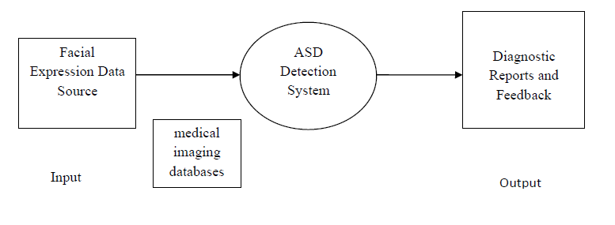

**Fig-1 Context Diagram**

The context diagram illustrates the ASD detection system's interactions with external entities. At the core of the system lies the ASD detection module responsible for processing neuroimaging and facial expression data to generate diagnostic predictions. External entities include sources of neuroimaging and facial expression data, clinicians, and researchers who input data and review diagnostic reports. Training and validation data are used to train and evaluate the ASD detection model, while regulatory and ethical guidelines govern data handling.

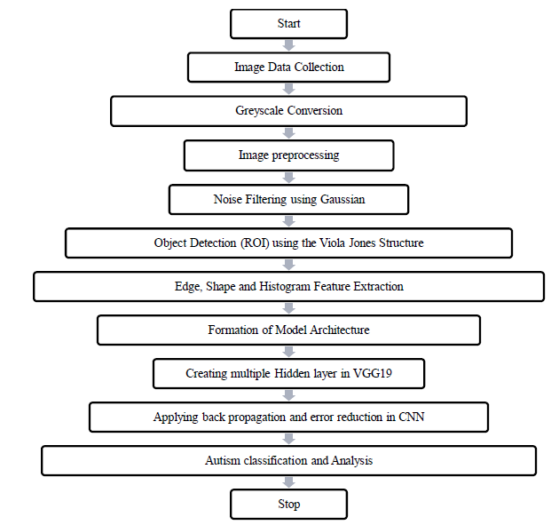

**Fig-2 System flow diagram**

The flow outlines the process for autism detection from image data, starting with image data collection, likely from sources such as MRI scans or facial images. The collected images undergo greyscale conversion for standardized processing. Subsequently, image preprocessing techniques, including noise filtering using Gaussian filters, are applied to enhance image quality and remove Start Image Data Collection Grayscale Conversion Image preprocessing Noise Filtering using Gaussian Object Detection (ROI) using the Viola Jones Structure Edge, Shape and Histogram Feature Extraction Formation of Model Architecture Creating multiple Hidden layer in VGG19 Applying back propagation and error reduction in CNN Autism classification and Analysis Stop unwanted artifacts. Object detection using the Viola-Jones structure is employed to identify regions of interest (ROI) within the images, potentially focusing on facial regions for expression analysis. Feature extraction techniques such as edge detection, shape analysis, and histogram computation are then utilized to capture relevant visual features from the ROIs. The process continues with the formation of the model architecture, possibly involving the creation of multiple hidden layers within the VGG19 model, a deep convolutional neural network (CNN) known for its effectiveness in image classification tasks. Backpropagation and error reduction techniques are applied to optimize the model's parameters and improve its ability to classify images accurately. Finally, the trained model is used for autism classification and analysis, where it predicts whether the input image exhibits signs of autism spectrum disorder based on the extracted features. This flow represents a comprehensive pipeline for leveraging image data and advanced machine learning techniques to aid in autism detection and analysis.

1. **RESULTS AND DISCUSSION**

VGG19 achieved promising results in classifying facial expressions and eye movements. This model also demonstrated robust performance in analyzing diverse datasets comprising facial images of both autistic and non-autistic children. Through iterative training and validation, the VGG19 algorithm effectively extracted and analyzed features that indicate autism in children. Further training could enhance its accuracy for early diagnosis of Autism Spectrum Disorder.

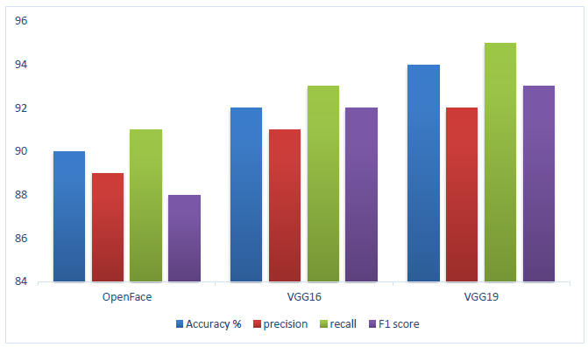

**Fig-3 Comparative Analysis – Performance Measures**

1. **CONCLUSION**

In conclusion, the development and testing of the ASD detection system represent a significant advancement in leveraging AI and facial expression analysis for early diagnosis of autism spectrum disorder. Through meticulous design and implementation, the system offers a comprehensive solution for processing neuroimaging and facial image data, extracting relevant features, and making accurate diagnostic predictions. The integration of advanced machine learning techniques, such as convolutional neural networks (CNNs) and the VGG19 model, ensures robustness and efficiency in analyzing complex image data. Additionally, the system's modular architecture allows for seamless integration of individual components, facilitating flexibility and scalability in adapting to diverse clinical and research environments. Overall, the ASD detection system holds immense promise in revolutionizing early diagnosis and intervention strategies for individuals with autism spectrum disorder, ultimately leading to improved outcomes and quality of life.

1. **REFERENCES**
2. Kumar, A., Umurzoqovich, R. S., Duong, N. D., Kanani, P., Kuppusamy, A., Praneesh, M., & Hieu, M. N. (2022). An intrusion identification and prevention for cloud computing: From the perspective of deep learning. *Optik*, *270*, 170044.
3. Napoleon, D., et al. "Self-organizing map-based color image segmentation with fuzzy C-Means clustering and saliency map." *International Journal of Computer Application* 3.2 (2012): 109-117.
4. Praneesh, M., and R. Jaya Kumar. "Novel approach for color based comic image segmentation for extraction of text using modify fuzzy possibilistic c-means clustering algorithm." *Int J Comput Appl IPRC* 1 (2012): 16-18.
5. Boonsatit, N., Rajendran, S., Lim, C. P., Jirawattanapanit, A., & Mohandas, P. (2022). New adaptive finite-time cluster synchronization of neutral-type complex-valued coupled neural networks with mixed time delays. *Fractal and Fractional*, *6*(9), 515.
6. 14. Napoleon, D., Praneesh, M., Sathya, S., & SivaSubramani, M. (2012). An efficient numerical method for the prediction of clusters using k-means clustering algorithm with bisection method. In *Global Trends in Information Systems and Software Applications: 4th International Conference, ObCom 2011, Vellore, TN, India, December 9-11, 2011. Proceedings, Part II* (pp. 256-266). Springer Berlin Heidelberg.
7. Bours, C.C.A.H., Bakker-Huvenaars, M.J., Tramper, J., Bielczyk, N., Scheepers, F., Nijhof, K.S., Baanders, A.N., Lambregts-Rommelse, N.N.J., Medendorp, P., Glennon, J.C. and Buitelaar, J.K., 2018. Emotional face recognition in male adolescents with autism spectrum disorder or disruptive behavior disorder: an eye-tracking study. European child & adolescent psychiatry, 27, pp.1143-1157.
8. Almourad, M.B. and Bataineh, E., 2020, February. Visual attention toward human face recognizing for autism spectrum disorder and normal developing children: An eye tracking study. In Proceedings of the 2020 the 6th international conference on e-business and applications (pp. 99-104).
9. Kang, J., Han, X., Song, J., Niu, Z. and Li, X., 2020. The identification of children with autism spectrum disorder by SVM approach on EEG and eye-tracking data. Computers in biology and medicine, 120, p.103722.
10. Elbattah, M., Guérin, J.L., Carette, R., Cilia, F. and Dequen, G., 2022, February. Vision-based Approach for Autism Diagnosis using Transfer Learning and Eye-tracking. In HEALTHINF (pp. 256-263).
11. Ahmed, I.A., Senan, E.M., Rassem, T.H., Ali, M.A., Shatnawi, H.S.A., Alwazer, S.M. and Alshahrani, M., 2022. Eye tracking-based diagnosis and early detection of autism spectrum disorder using machine learning and deep learning techniques. Electronics, 11(4), p.530.
12. Kanhirakadavath, M.R. and Chandran, M.S.M., 2022. Investigation of eye-tracking scan path as a biomarker for autism screening using machine learning algorithms. Diagnostics, 12(2), p.518.
13. Black, M.H., Chen, N.T., Iyer, K.K., Lipp, O.V., Bölte, S., Falkmer, M., Tan, T. and Girdler, S., 2017. Mechanisms of facial emotion recognition in autism spectrum disorders: Insights from eye tracking and electroencephalography. Neuroscience & Biobehavioral Reviews, 80, pp.488-515.
14. Yi, L., Fan, Y., Quinn, P.C., Feng, C., Huang, D., Li, J., Mao, G. and Lee, K., 2013. Abnormality in face scanning by children with autism spectrum disorder is limited to the eye region: Evidence from multi-method analyses of eye tracking data. Journal of vision, 13(10), pp.5-5.
15. Zhao, Z., Tang, H., Zhang, X., Qu, X., Hu, X. and Lu, J., 2021. Classification of children with autism and typical development using eye-tracking data from face-to-face conversations: Machine learning model development and performance evaluation. Journal of Medical Internet Research, 23(8), p.e29328.
16. Zhao, Z., Tang, H., Zhang, X., Qu, X., Hu, X. and Lu, J., 2021. Classification of children with autism and typical development using eye-tracking data from face-to-face conversations: Machine learning model development and performance evaluation. Journal of Medical Internet Research, 23(8), p.e29328.