**REVIEW PAPER ON ENHANCING REINFORCED CONCRETE STRUCTURE:**

**PERFORMANCE EVALUATION OF HYBRID FIBER REINFORCED POLYMER**

**REINFORCEMENTS IN ONE-WAY SLABS UNDER STATIC**

**LOADING CONDITIONS**

**AKSHAYDEEP1, ER. NITIN2**

**1** M.Tech Scholar,Matu Ram Institute Of Engineering & Management, Rohtak, India

*Akshayah173*[@gmail.com](mailto:sheelamalik2209@gmail.com)

2Assistant Professor, Matu Ram Institute Of Engineering & Management, Rohtak, India [nralhara884@gmail.com](mailto:nralhara884@gmail.com)

## ABSTRACT

This paper conducts a thorough examination of how the performance of reinforced concrete structures can be improved by incorporating hybrid fibre reinforced polymer (FRP) reinforcements in one-way slabs when subjected to static loading conditions. The objective of the study is to assess the efficacy of hybrid FRP reinforcements in enhancing the structural integrity and load-bearing capability of concrete slabs. The structural behaviour of one-way slabs is investigated by analysing different configurations of hybrid FRP reinforcements using a mix of experimental analysis and numerical simulations.

The study process entails doing meticulous laboratory trials on prototype slabs, accompanied by advanced computational modelling tools. The efficiency of hybrid FRP reinforcements in improving the structural performance of concrete slabs is evaluated by systematically analysing key performance metrics such as load-deflection response, crack development, and ultimate load capacity.

The results of this work make a substantial contribution to our understanding of how hybrid FRP reinforcement behaves in one-way slabs. They also provide useful insights into how this type of reinforcement might be used to enhance the durability and resilience of reinforced concrete structures. The findings have important consequences for the planning and building of environmentally-friendly infrastructure, offering ways to reduce the impact of heavy loads and improve the overall effectiveness of concrete structures in different engineering contexts.

**Key Words**: Reinforced concrete structures.Enhancement techniques,Hybrid fiber reinforced polymer (HFRP) reinforcements,Performance evaluation,One-way slabs,Static loading conditions

# INTRODUCTION

Reinforced concrete structures are widely used in modern civil engineering due to its adaptability, durability, and cost-effectiveness. Nevertheless, conventional reinforced concrete has inherent limits, especially in terms of its ability to withstand tension, resist cracks, and maintain structural integrity when subjected to different types of loads. In order to tackle these difficulties and improve the efficiency of reinforced concrete structures, scientists and engineers have been investigating novel reinforcement materials and methodologies.   
  
An effective approach to enhance the performance of reinforced concrete structures is by incorporating hybrid fibre reinforced polymer (FRP) reinforcements. Hybrid FRP reinforcements leverage the benefits of many fibre types, like carbon, glass, or aramid, to synergistically enhance the mechanical qualities of concrete elements. This integration has the ability to increase the tensile strength, ductility, and crack resistance of concrete structures, hence increasing their overall structural performance.

This thesis aims to assess the performance of hybrid FRP reinforcements in one-way slabs subjected to static loading conditions. One-way slabs are a crucial structural component commonly employed in the construction of buildings and infrastructure projects. This study seeks to contribute to the development of novel and sustainable solutions for reinforced concrete structures by assessing the efficiency of hybrid FRP reinforcements in improving the structural behaviour of one-way slabs.

This research aims to gain valuable insights into the behaviour of hybrid FRP reinforcements in one-way slabs and their potential applications for improving the durability, resilience, and sustainability of reinforced concrete structures. It achieves this through a combination of experimental investigations and numerical simulations. The results of this study have important consequences for the planning, building, and upkeep of infrastructure systems, providing chances to enhance efficiency, decrease maintenance expenses, and improve overall societal resilience.

# LITERATURE REVIEW

**In 1995, Javier Malvar** conducted a study that aimed to examine the tensile properties of fibre reinforced polymer (FRP) bars. The study utilised the ASTM D 3916-84 standard. ASTM D 3916-84 specifies the standardised procedure for assessing the tensile characteristics of polymer matrix composite materials, including the measurement of tensile strength, modulus, and other mechanical parameters.Malvar's research indicated that the tensile properties of FRP bars are affected by the surface characteristics and deformations of the FRP rods. The presence of surface abnormalities, such as roughness or flaws, can have a substantial impact on the adhesive strength between the FRP bars and the surrounding concrete matrix. Furthermore, the tensile behaviour and mechanical properties of FRP rods can be changed by applying surface treatments or changes. Comprehending the correlation between surface distortions of FRP rods and their tensile properties is essential for enhancing the design and effectiveness of reinforced concrete structures. Engineers can enhance the structural integrity, longevity, and overall performance of concrete elements under tensile loading situations by carefully evaluating these parameters and selecting and designing FRP reinforcements.

**Fujisaki and Kobayashi** conducted a study in 1995 to examine the behaviour of fibre reinforced polymer (FRP) bars that were placed in concrete prisms. The experiment entailed inserting FRP bars at both ends of concrete prisms with a distinct length of 5 mm, and subjecting them to compression testing. The researchers conducted a comparative analysis of the compressive strength of concrete prisms reinforced with Aramid FRP (AFRP), Carbon FRP, and Glass FRP bars, in relation to the tensile strength values of the corresponding FRP materials.   
The results showed that the compressive strength of concrete prisms reinforced with FRP bars was significantly inferior than the tensile strength of the FRP materials. The compressive strength of AFRP bars was around 10% of their tensile strength, whereas Carbon FRP and Glass FRP bars had compressive strengths ranging from 30% to 50% and 30% to 40% of their respective tensile strengths. The substantial disparity in strength characteristics between tension and compression emphasises the necessity of meticulous examination of material response and loading circumstances in the design and evaluation of FRP-reinforced concrete structures.

**In 1997, Saadatmanesh and colleagues** conducted a study to examine the impact of salt solutions on the characteristics of fibre reinforced polymer (FRP) bars. The objective of the study was to investigate the effect of exposure to salt solutions, which imitate marine or coastal settings, on the tensile strength of FRP bars. The experimental procedure consisted of submerging FRP bars in salt solutions for a predetermined period of time, followed by exposing them to tensile testing in order to assess their mechanical characteristics. The findings indicated a reduction in the tensile strength by a range of 5% to 7% when comparing FRP bars exposed to salt solutions with those that were not. Multiple variables contribute to the observed decline in tensile strength. The polymer matrix in FRP bars can undergo chemical degradation when exposed to salt solutions, resulting in a decrease in the overall structural integrity. In addition, salt solutions can accelerate the corrosion of metallic components in FRP bars, which can further weaken their mechanical qualities.This study emphasises the significance of taking into account environmental exposure when planning and specifying FRP reinforcements for infrastructure projects, especially in coastal or marine regions. To ensure the long-term performance and longevity of reinforced concrete structures, it may be required to use mitigation techniques such as selecting appropriate materials, applying surface treatments, and using protective coatings. These measures aim to minimise the degradation of FRP bars.

**Chin and colleagues (1997)** observed a decrease in both the tensile and flexural strength of fibre reinforced polymer (FRP) samples when they were placed in a salt solution. The decrease in strength indicates that exposure to salt solution might cause degradation of the mechanical properties of FRP materials. The degradation may occur due to chemical interactions between the salt solution and the FRP components, as well as potential corrosion effects on any metallic elements included in the FRP. Gaining a comprehensive understanding of this phenomenon is essential in order to guarantee the resilience and sustained effectiveness of buildings reinforced with FRP, particularly in areas where there is a high prevalence of salt or salty conditions.

**In 1998, Bank and colleagues** performed a diffusion test on rods made of E-glass/vinylester fibre reinforced polymer (FRP). Their research unveiled that temperature exerts a substantial impact on the moisture content at the immersion point. Furthermore, it was noted that the material experienced degradation over the course of the testing period, leading to an increase in voids and moisture content within the FRP rods. These findings emphasise the significance of taking into account environmental variables, such as temperature, when assessing the effectiveness and longevity of FRP materials. Gaining knowledge about the processes by which materials deteriorate is crucial for creating plans to reduce the negative effects and guarantee the durability of structures reinforced with FRP.

**Hayes and colleagues (1998)** observed a substantial reduction in both tensile strength and Young's modulus of glass/vinylester FRP composites following exposure to wet/dry cycles at 45°C for a duration of 30 days. They specifically noted a decrease of approximately 26% in both the tensile strength and Young's modulus. The decline in mechanical qualities underscores the vulnerability of glass/vinylester FRP materials to environmental factors, specifically fluctuations in temperature and exposure to moisture. Assessing the long-term performance and durability of FRP-reinforced structures in real-world applications requires a thorough understanding of the level of deterioration caused by environmental cycling.

.

**Castro et al. (1998)** created multiple anchors specifically suited for conducting tensile tests on fibre reinforced polymer (FRP) bars. The suggested testing methodology entails the placement of Fibre Reinforced Polymer (FRP) bars inside steel tubes that are filled with high-strength gypsum cement mortar. This novel method offered a secure and dependable anchoring solution for applying tensile forces to FRP bars during experimentation. Castro et al. implemented a standardised testing method to ensure consistent and precise assessment of the mechanical characteristics of FRP bars. This allowed researchers and engineers to make well-informed conclusions about the suitability of these bars for structural applications.

**Pantuso et al. (1998)** investigated the effects of distilled water and an alkaline atmosphere on the long-term strength and durability of glass fiber/polyester pultruded rods. The analyses involved immersing GFRP samples in distilled water at a temperature of 23°C for one day, followed by drying for one day. This treatment was repeated for a total of 60 days. A comparable method has been employed to analyse the effects of an alkaline environment on cement samples by reusing the approach. A reduction in tensile strength has been seen at levels of 1-7% and 6-21% under water and alkali conditions, respectively.

**Tang (1999)** conducted a review and found that although FRP rods have a lower specific gravity than steel rods, they possess a high tensile strength and demonstrate exceptional resilience to weather conditions and chemical attacks. The fibres are often joined together through the use of binding agents like resins and cement, with the assistance of a reinforcing substance. This process leads to a wide diversity of forms and arrangements. Numerous theoretical and experimental studies have been conducted to assess the feasibility of utilising FRP (Fibre Reinforced Polymer) for strengthening concrete structures.

# MATERIAL PROPERTIES

### CONCRETE

Concrete slabs are cast using Normal Strength Concrete (NSC) with grades of 30MPa, 40MPa, and 50MPa. The slabs are cast using Ordinary Portland Cement (OPC) and a coarse aggregate size of 20mm, together with a fine aggregate size reaching up to a 4.75mm screen, under genuine environmental circumstances. The compressive strength of cubes is tested after a curing period of 28 days using a Compression testing equipment. The cubes used for testing have a standard size of 150mm. The parameters of the concrete are listed in Table 1 below.

**Table 1: Properties of Concrete**

|  |  |  |  |
| --- | --- | --- | --- |
| **Material** | **M30 grade of**  **concrete** | **M40 grade of**  **concrete** | **M50 grade of**  **concrete** |
| Cement, kg/m3 | 425.34 | 430 | 450 |
| Fine aggregate, kg/m3 | 615.21 | 664 | 701 |
| Coarse aggregate, kg/m3 | 1181.52 | 1174 | 1163 |
| Water, kg/m3 | 191.58 | 165 | 160 |
| Average compressive  strength, N/mm2 | 38 | 49 | 56 |

### REINFORCEMENT

The properties of reinforcements are already explained in the section 3.3.2 and the values are extracted and shown in Table 2 below.

**Table 2:** Properties of Reinforcements used in the study

|  |  |  |
| --- | --- | --- |
| **Type of Rebar** | **HFRP** | **STEEL** |
| **Properties** |
| Tensile Strength, MPa | 1217.93 | 583.67 |
| Compressive strength, MPa | 746.17 | 435.68 |
| Elastic modulus, GPa | 50 | 200 |
| Transverse Shear strength, MPa | 418.4 | 302.5 |
| Coefficient of linear expansion, /0 C | 9x10-6 | 20 x10-6 |

**TEST SPECIMEN PREPARATION**

The experimental program consists of eighteen one-way slabs of length 2400mm and 600mm width. The various parameters that are involved in the present study and their designations are tabulated in Table 3. The reinforcements of size 8 mm are used as secondary reinforcements in the transverse direction of slab i.e widthwise and 10 mm reinforcements are used as main reinforcements in the span direction of slab i.e. lengthwise at three different spacing viz.186.6 mm c/c, 140 mm c/c and 93 mm c/c. Main and secondary HFRP reinforcements are tied with help of Nylon zip ties. Secondary (8mm steel/HFRP) reinforcements are spaced at 210 mm c/c. Main reinforcements are given a bottom cover of 20mm for all the slabs. Mixing of concrete is done with help of rotary mixers. The slabs are designated with the parameters of m1hρ1D1, m1hρ2D1, m1hρ3D1, m2hρ1D1, m2hρ2D1, m2hρ3D1, m1hρ1D2, m2hρ1D2, m3hρ1D2, m1sρ1D1, m1sρ2D1, m1sρ3D1, m2sρ1D1, m2sρ2D1, m2sρ3D1, m1sρ1D2, m2sq1D2, m3sq1D2 Normal moist curing is done for all slabs; After curing, grid points are marked to locate the loading points and strain measuring positions; Brass pellets are fixed to measure strains using Demouldable mechanical (Demec) strain gauge. In the next section a detailed experimental setup is explained under different loading conditions.

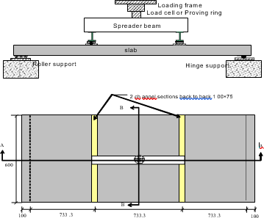**Table 3: Various Parameters involved in the construction of slabs**

|  |  |  |
| --- | --- | --- |
| **Parameters** | **Description** | **Designation** |
| Types of reinforcements | HFRP | *h* |
| Steel | *s* |
| Thickness of slabs | 100 mm | *D*1 |
| 120 mm | *D*2 |
| Grades of concrete | M30 | *m 1* |
| M40 | *m*2 |
| M50 | *m*3 |
| Reinforcement ratios | 0.49% | *hρ1 , sρ1* |
| 0.65% | *hρ2 , sρ2* |
| 0.81% | *hρ3 , sρ3* |

**Fig. 1:** Experimental Test setup

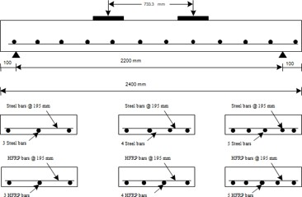

**Fig. 2:** Reinforcements Details for HFRP and Conventional Slabs

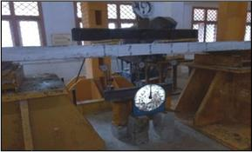

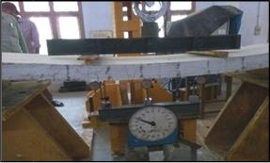**Fig. 3:** Test set up for Static loading

**Fig. 4:** Test set up for Static loading under loading condition

# RESULTS & DISCUSSIONS

**Table 4: Experimental Results**

|  |  |  |  |  |  |  |  |  |  |
| --- | --- | --- | --- | --- | --- | --- | --- | --- | --- |
| **Sl No** | | **Designation of slabs** | | | ***P*u (kN)** | ***Mu,***  **kNm** | | | **Ultimate Deflection**  **(mm)** |
| 1 | | *m1hρ1D1* | | | 40 | 16 | | | 97.63 |
| 2 | | *m1hρ2D1* | | | 42.5 | 17 | | | 89.54 |
| 3 | | *m1hρ3D1* | | | 45 | 18 | | | 80.44 |
| 4 | | *m2hρ1D1* | | | 47.5 | 19 | | | 79.18 |
| 5 | | *m2hρ2D1* | | | 50.25 | 20 | | | 77.72 |
| 6 | | *m2hρ3D1* | | | 55 | 22 | | | 74.56 |
| 7 | | *m1hρ1D2* | | | 57.5 | 23 | | | 70.80 |
| 8 | | *m2hρ1D2* | | | 60 | 24 | | | 69.24 |
| 9 | | *m3hρ1D2* | | | 75 | 30 | | | 58.45 |
| 10 | | *m1sρ1D1* | | | 25 | 10 | | | 42.42 |
| 11 | | *m1sρ2D1* | | | 27.5 | 11 | | | 40.71 |
| 12 | | *m1sρ3D1* | | | 30 | 12 | | | 39.38 |
| 13 | | *m2sρ1D1* | | | 27.5 | 11 | | | 36.75 |
| 14 | | *m2sρ2D1* | | | 30 | 12 | | | 31.28 |
| 15 | | *m2sρ3D1* | 32.5 | | | 13 | 30.12 | | |
| 16 | | *m1sρ1D2* | 35 | | | 14 | 30.6 | | |
| 17 | | *m2sρ1D2* | 30 | | | 12 | 30.55 | | |
| 18 | | *m3sρ1D2* | 27.5 | | | 11 | 35.95 | | |

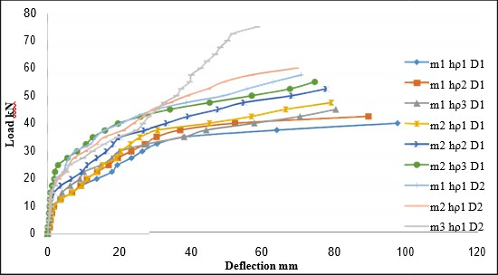

**Chart -1**: Comparison of Load versus Deflection for all HFRP slabs.

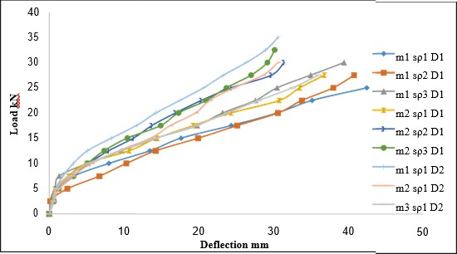

**Chart -2**: Comparison of Load versus Deflection for all conventional slabs

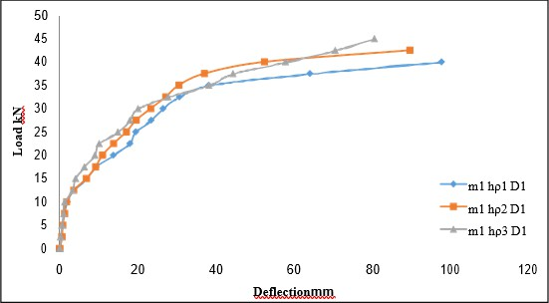

**Chart -3**: Comparison of Load versus Deflection for HFRP slabs with different reinforcement ratio

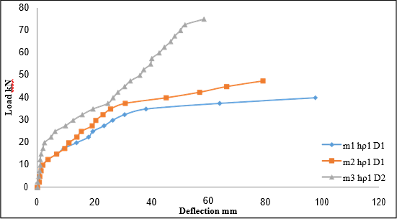

**Chart -4**: Comparison of Load versus Deflection for HFRP and conventional slabs with different grades of concrete

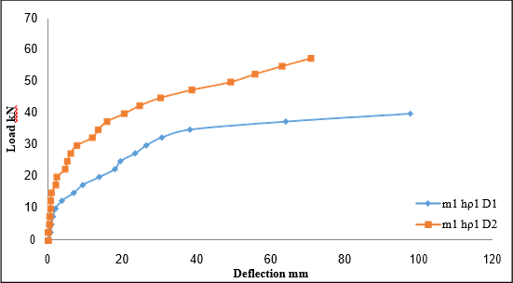

**Chart -5**: Comparison of Load versus Deflection for HFRP slabs with different thickness of slabs

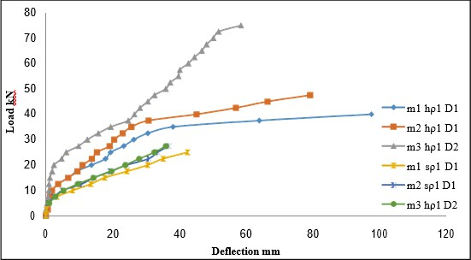

**Chart -6**: Comparison of Load versus Deflection for HFRP and conventional slabs with different grades of concrete

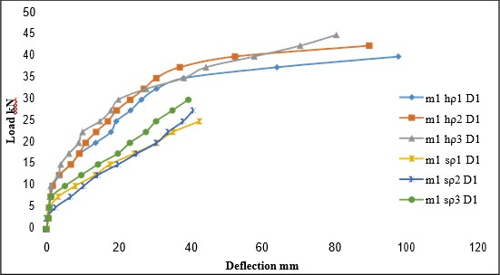

**Chart -7**: Comparison Load versus Deflection for HFRP and conventional slabs with different reinforcement ratios

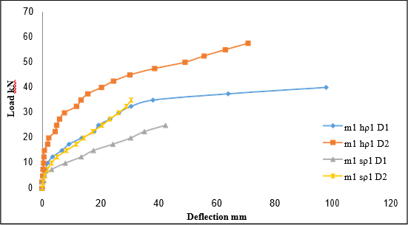

**Chart -8**: Comparison Load versus Deflection for HFRP and conventional slabs with different depths of slabs

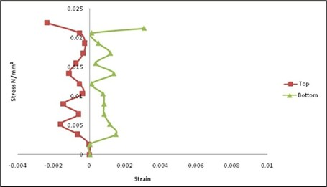

**Chart -9**: Comparison of stress versus strain for HFRP slab for m1hρ1D1 at top and bottom levels

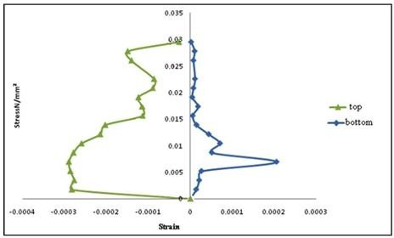

**Chart -10**: Comparison of stress versus strain of Steel for m1sρ1D1 at top and bottom levels

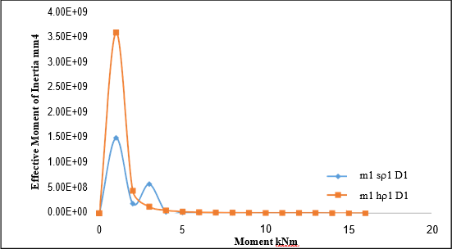

**Chart -11**: Comparison of Experimental Effective Moment of Inertia versus Moment for HFRP and conventional slabs

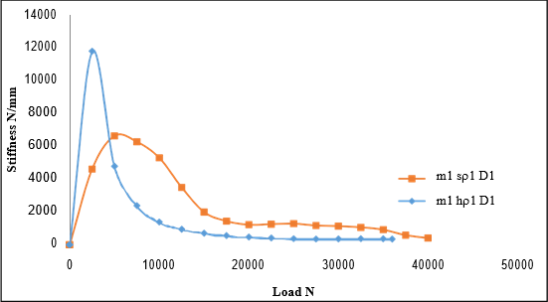

**Chart -12**: Comparison of Experimental Stiffness versus Load for HFRP and conventional slabs

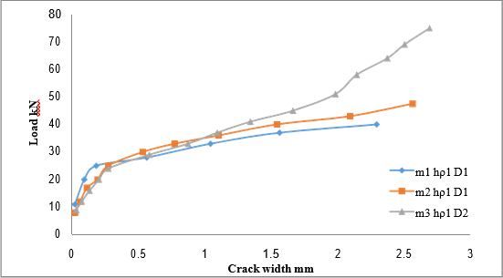

**Chart -13**: Comparison of Load versus crack width for HFRP slabs differing with grade of concrete

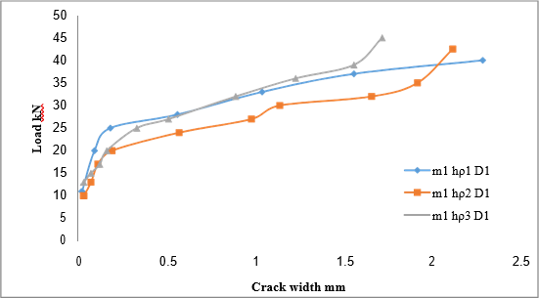

**Chart -14**: Comparison of Load versus crack width for HFRP slabs differing with reinforcement ratio

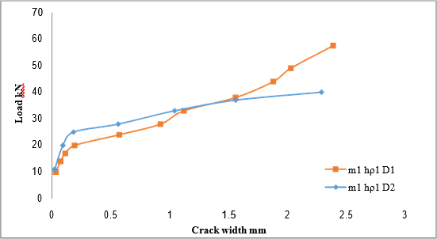

**Chart -15**: Comparison of Load versus crack width for HFRP slabs differing with depth of slabs

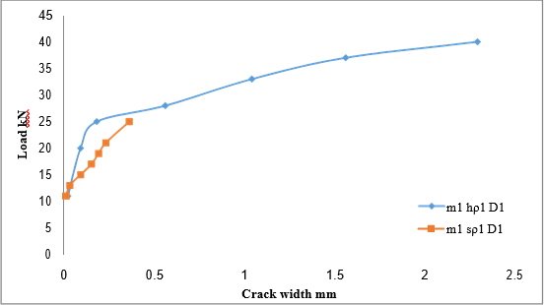

**Chart -16**: Comparison on Load versus crack width between HFRP slabs and conventional slabs

# CONCLUSIONS

The static loading of HFRP reinforced slabs results in a more significant decrease in stiffness compared to conventional slabs, as observed in the load deflection response. In traditional slabs, a greater deflection occurs because the reinforcements yield under pressure. On the other hand, HFRP reinforced slabs do not yield, but still experience a bigger deflection due to increases in stress.

The flexural response of reinforced concrete (RC) members can be categorised into two separate stages. The initial stage pertains to the undamaged section of the structural element, while the subsequent stage pertains to the damaged section of the structural element.

In the second phase, the concrete's ability to withstand tension decreases as cracks form, resulting in the reinforcement bearing the whole tensile load. At this level, the flexural stiffness of a reinforced concrete component is significantly diminished, although the cracked response still remains considerably higher than that of a totally cracked part. This phenomenon is made possible solely by strong adhesion and the transfer mechanism of reinforcing bars, which effectively distribute tension to the surrounding areas, resulting in the contribution of concrete filling the gaps between individual fractures.

Upon increased loading, the tensile stress intensifies, leading to the formation of further cracks. The process continues until the space between cracks decreases to a point where new cracks do not form. The crack pattern described is referred to as the stabilised crack pattern, in which the application of extra load causes existing cracks to grow, while having minimal impact on the flexural stiffness.

The slab m1hρ1D1 has a 6.25% higher load carrying capacity compared to the m1hρ2D1 slab, whereas the deflection is 1.09 times greater in the m1hρ2D1 slab. The slab m1hρ1D1 has a load carrying capacity that is 12.5% higher than the slab m1hρ3D1. However, the deflection of the slab m1hρ2D1 is 1.21 times more than the deflection of the slab.

The load carrying capability of HFRP slab m1hρ1D1 is increased by 6.25% and 12.5% in m1hρ2D1 and m1hρ3D1 slabs, respectively.

Increasing the thickness by 20 mm results in an 8-fold improvement in the weight carrying capability.By raising the grades of concrete, the strength of m2hρ1D1 increases by 18.75% and the strength of m3hρ1D2 increases by 87.5%. Additionally, m2hρ1D1 has 1.8 times less deflection compared to m1hρ1D1 slab. As a result, both the ultimate deflection and the crack width decrease significantly.

The strain distributions across the thickness of High Fibre Reinforced Polymer (HFRP) slabs are depicted in the image above. The HFRP reinforcements on the tension side of the concrete slabs exhibit identical behaviour to the HFRP reinforcements tested under pure tension, as seen in the tensile test specimens. This indicates a strong link between the concrete and HFRP reinforcements. The strain on the concrete surface in slabs reinforced with high fibre reinforced polymer (HFRP) fluctuates between 1.5 to 2 times higher than that of ordinary slabs under similar load conditions. The experimental observations bear a resemblance to the observations provided by the authors Benmokrane (1995), Theriault (1998), and Craig (1998).

The experimental findings regarding crack widths and crack patterns are presented in a comprehensible manner. A fissure initially emerges at the centre of the slab and gradually extends horizontally across its entire width. As additional weights are gradually applied, new cracks form on the slabs. Simultaneously, the preexisting crack has been expanded. The load is sustained up to 75% of its maximum capacity, at which point new cracks begin to form, branching off into smaller fractures around the primary reinforcement bars. Every single slab undergoes flexural collapse. At the point of maximum load, slabs reinforced with high fibre reinforced polymer (HFRP) undergo concrete crushing, while slabs reinforced with steel exhibit flexural failure. Figures 3.41 and 3.42 illustrate the pattern of cracks in slabs under different conditions.

The crack pattern seen in slab m3hρ1D2 indicates the failure of HFRP rebars, accompanied by significant shrinkage. This suggests that the slab is intended as an under-reinforced slab.

Increasing the thickness, grade of concrete, and reinforcing ratio of HFRP reinforced slabs enhances their ultimate load carrying capacity while simultaneously reducing deflections, stresses, and crack width. This can be mostly ascribed to the nearly identical values of the modulus of elasticity for HFRP reinforcements and concrete, as well as the linear elastic behaviour of HFRP reinforcements.

.

# REFERENCES

1. Abdalla, H.A. (2002), Evaluation of deflection in concrete members reinforced with Fibre Reinforced Polymer (FRP) bars, Journal of composite structures, Vol.56(1), April pp.63-71
2. Achillides, Z., and Pilakoutas, K. (2004), Bond Behavior of Fiber Reinforced Polymer Bars under Direct Pullout Conditions, ASCE Journal of Composites for Construction, Vol. 8(2), March pp. 173-181.
3. Aiello,M.A., and Ombres,L. (2000), Load – deflection analysis of FRP reinforced concrete flexural members, Journal of composite construction, Vol.4(4), Nov., pp.164- 17.
4. Al-Harthy, A., and Frangopol, D.M. (1994), Reliability assessment of prestressed concrete beams, Journal of Structural Engineering, Vol.120(1), April pp.180-199.
5. Al-Sunna, R., Pilakoutas, K., Hajirasouliha, I. and Guadagnini M. (2012), Deflection behaviour of FRP reinforced concrete beams and slabs: An experimental investigation. Composites Part B: Engineering, Vol.43(5), March, pp. 2125 - 2134.
6. Al-Salloum, Y., Sayed, S., and Almusallam, T. (1997), Behavior of Concrete Beams Doubly Reinforced by GFRP bars, Non-Metallic (FRP) Reinforcement for Concrete Structures, Proceedings of the Third International Symposium, Vol. 2, Nov., pp 471-478.
7. Al-Salloum, Y., Sayed, S., and Almusallam, T. (1996), Some Design Considerations for Concrete Beams Reinforced by GFRP Bars, First International Conference on Composite Infrastructure (ICCI-96), Jan., pp 318-331.
8. Alkhrdaji, T., Wideman, A., Belarbi, A., and Nanni, A. (2001) Shear strength of GFRP RC beams and slabs, proceedings CCC 2001, Journal of composites in construction, Portugal, Oct., pp. 409-414.
9. Ansys (2010), ANSYS Release 13.0, Finite Element Analysis System, SAS IP, Inc.
10. Arindom, B., Tejaswini, M.L., Kiran, S.M. (2018), Finite Element Analysis of Different Types of FRP on Beam- Column Joint International Journal of Engineering Research & Technology (IJERT) Vol. 7(5), May, pp.416- 422.
11. Arabshahi, A., Gharaei-Moghaddam, N., and Tavakkolizadeh.,M. (2017), ,Reliability analysis of available relations and suggestion of a new formula for effective moment of inertia in concrete beams with FRP bars reinforcement, SMAR-2017 fourth conference on smart monitoring assessment and rehabilitation of structure, At Zurich, Switzerland, 13-15 Sep., pp.1-8. Ashour, AF., Habeeb, MN. (2008), Continuous concrete beams reinforced with CFRP bars, Structural Buildings, Vol.161(6), May, pp.349–357.
12. Ayman S Mosallam, Alemdar Bayraktar, Mohamed Elmikawi, Selim Pul and Suleyman Adanur., (2015), Polymer Composites in Construction: An Overview, SOJ Mater Sci Eng Vol. 2(1), Feb., pp.25.
13. Bakis, C.E., Boothby, T.E., and Jia, J. (2007), Bond Durability of GFRP Bars Embedded in Concrete Beams. Journal of Composites for Construction, Vol.11(3), August, pp. 371-380.
14. Bakis, C.E., Freimanis, J., Gremel,D. and Nanni, A.(1998), Effect of resin material on Bond and tensile properties of unconditioned and conditioned FRP reinforced rods, Proceedings of 1st International conference on durability of fibre reinforced polymer (FRP)composites for construction, Sherbrooke, Aug., pp. 525-535.
15. Bakis, C.E., Boothby, T.E., and Jia, J., (2007), Bond durability of Glass Fibre Reinforced Polymer bars embedded in concrete beams, Journal of composites for construction, Vol.11(3), June, pp.269-277.
16. Bank, C.L., Puterman, M., and Katz, A. (1998), The effect of material degradation on Bond properties of fiber reinforced plastic reinforcing bars in concrete, ACI Materials Journal, Vol. 95(3), Oct, pp.232-243.
17. Barris, C., Torres, Ll., Turon, A., Baena, M. and Catalan., A. (2008), An experimental study of the flexural behaviour of GFRP RC beams and comparison with prediction models. Composites Structures Vol.91(9), Dec., pp. 286- 295.
18. Barris, C., Torres, Ll., Turon, A., Baena, M. Catalan., A. (2008), Experimental study of the flexural Behaviour of GFRP Reinforced Concrete Beams, Fourth International Conference on Composites in Civil Engineering (CICE 2008), Zurich, Switzerland, Dec.,.
19. Benmokrane, B., Tighiouart, B., and Challal, O. (1996), Bond Strength and Load Distribution of Composite GFRP Reinforcing Bars in Concrete, ACI Materials Journal, Vol. 93(3), Jan., pp.254-259.
20. Benmokrane.B., Challal, O., and Masmoudi, R., (2004), Residual Tensile Properties of GFRP reinforcing bars after loading in severe Environments, ASCE Journal of composites for construction, Vol. 10(5),Oct, pp. 370-380.
21. Bischoff, B.H., and Paixao, R. (2004), Tension stiffening and cracking of concrete reinforced with glass fiber reinforced polymer (GFRP) bars, NRC Research press, Canadian Journal of civil Engineering, Vol.31,July, pp. 579- 588.
22. Bischoff, B.H., and Scanlon, A. (2007), Effective Moment of Inertia for Calculating Deflections of Concrete Members Containing Steel Reinforcement and Fiber Reinforced Polymer Reinforcement. ACI Structural Journal, Vol.104(1), Jan., pp. 68 – 75.