Food Consumption estimation Using evolutionary Algorithm for Gestational Diabetes Mellitus

# Mr.D.Ruthwik Reddy1, Lavudya Sreedhar2, Lingireddy Ajay reddy3,

# Sriram Ruchitha4

*1Associate. Professor, CSE Dept, ACE Engineering College, Hyderabad, India*

*ruthwikt@gmail.com*

*2Student, CSE Dept, ACE Engineering College, Hyderabad, India*

*sreedharlavudya@gmail.com*

*3 Student, CSE Dept, ACE Engineering College, Hyderabad, India*

*ajayreddy5118@gmail.com*

*4 Student, CSE Dept, ACE Engineering College, Hyderabad, India*

*Ruchithasriram93@gmail.com*

***Abstract :***

Gestational Diabetes Mellitus (GDM) poses significant health risks for both the mother and the unborn child, necessitating careful management of dietary intake during pregnancy. Accurate estimation of food consumption is crucial for maintaining optimal blood glucose levels in GDM patients. Traditional methods for food consumption estimation often lack precision and may not fully account for individual variations in metabolism and dietary requirements. In this study, we propose a novel approach utilizing evolutionary algorithms to optimize food consumption recommendations tailored specifically for GDM patients.

|  |
| --- |
|  |
|  | C:\Users\RACHAN~1\AppData\Local\Temp\ksohtml2200\wps1.png |

The evolutionary algorithm employs principles inspired by natural selection to iteratively refine dietary plans based on individual patient characteristics, such as age, weight, height, activity level, and glucose tolerance. By incorporating these parameters into the optimization process, the algorithm adapts to the dynamic nature of GDM management, continually adjusting food recommendations to suit changing metabolic needs throughout the pregnancy.

.

# INTRODUCTION

Gestational Diabetes Mellitus (GDM) presents a significant health concern during pregnancy, characterized by elevated blood glucose levels that can lead to complications for both the mother and the fetus. Effective management of GDM involves careful monitoring and regulation of dietary intake to maintain optimal blood glucose levels while ensuring adequate nutrition for maternal and fetal health. However, traditional methods for estimating food consumption and developing dietary plans for GDM patients often lack precision and fail to account for individual variations in metabolism and nutritional requirements.

Gestational Diabetes Mellitus (GDM) poses significant health risks to both pregnant women and their unborn children, necessitating careful management of dietary habits. Accurate estimation of food consumption is pivotal in developing personalized nutritional interventions for individuals with GDM. Existing methods for food consumption estimation often lack precision and fail to consider the unique requirements of pregnant women with GDM. To address this gap, there is a pressing need for an innovative approach that incorporates advanced technologies. This research aims to explore the application of evolutionary algorithms in developing a robust model for accurate food consumption estimation tailored specifically for individuals with Gestational Diabetes Mellitus. Gestational Diabetes Mellitus (GDM) Management: Addressing the complexities of managing GDM during pregnancy.Challenges of Dietary Interventions: Highlighting limitations in existing approaches to dietary management of GDM. Personalized Nutrition: Recognizing the importance of tailoring dietary recommendations to individual patient profiles.Dynamic Nature of Pregnancy: Understanding the physiological changes that influence nutritional needs throughout gestation.Evolutionary Algorithms: Introducing a novel computational approach for optimizing food consumption recommendations.Individual Metabolic Variability: Acknowledging the diverse metabolic responses to dietary interventions among GDM patients.Blood Glucose Regulation: Emphasizing the primary goal of maintaining stable blood glucose levels for maternal and fetal health.Maternal and Fetal Health Outcomes: Focusing on the potential impacts of dietary interventions on both mother and baby.Research Objectives and Methodology: Outlining the study's goals and the proposed methodology for achieving them.

# OBJECTIVES

Diabetes Mellitus is a chronic disease that impairs the body's capacity to regulate blood glucose levels. Diabetes affects 1.2 million people in the Netherlands (1 out of every 14), and researchers project that one in every three persons will develop type 2 diabetes. 1 Diabetes patients must keep their blood sugar levels within a certain range because too much blood sugar (hyperglycemia) can cause serious long-term micro and macrovascular complications such as kidney failure or blindness, and too little blood sugar (hypoglycemia) can cause blackouts, seizures, and even death. Diabetes is a chronic condition characterized by a rapid increase in blood glucose levels in the human body. If the patient does not rule the condition and overcome it, it will result in many malfunctioning organs, which will lead to many additional chronic illnesses. This acute disease is caused by several forms of diabetes.

# 3.PROBLEM STATEMENT

Gestational Diabetes Mellitus (GDM) poses significant health risks to both pregnant women and their unborn children, necessitating careful management of dietary habits. Accurate estimation of food consumption is pivotal in developing personalized nutritional interventions for individuals with GDM. Existing methods for food consumption estimation often lack precision and fail to consider the unique requirements of pregnant women with GDM. To address this gap, there is a pressing need for an innovative approach that incorporates advanced technologies. This research aims to explore the application of evolutionary algorithms in developing a robust model for accurate food consumption estimation tailored specifically for individuals with Gestational Diabetes Mellitus.

# LITERATURE SURVEY

**[1**]T Zilberman Kimhi, E Yefet, A Bejerano, R Iskander... 2023- Microorganisms - www.mdpi.com Diabetes mellitus during pregnancy. There were no restrictions for gestational diabetes mellitus in the initial search... systematic reviews, and literature reviews**. [2]** A comprehensive review and meta-analysis were performed to assess the relationship between gestational diabetes mellitus and infections during pregnancy. We analysed the frequency of infections in women with and without gestational diabetes mellitus using cross-sectional, casecontrol, cohort, and clinical trials. A search was undertaken in the online databases Embase, PubMed, and Web of Science, as well as manually searching references, through March 23, 2022, yielding 16 papers for review, with 111,649 women in the gestational diabetes mellitus group and 1,429,659 in the controls. To examine heterogeneity, Cochrane's Q test of heterogeneity and I2 were utilized. The pooled odds ratio (OR) was computed. The Egger test and funnel plots were employed to assess publication bias. The findings revealed a link between gestational diabetes mellitus and infections (pooled-OR 1.3, 95% CI [1.2-1.5]). Sub-analyses revealed a link between urinary tract infections (pooled-OR 1.2 95% CI [1.1-1.3]), bacterial infections (pooled-OR 1.2 95% CI [1.11.4]), and SARS-CoV-2 (pooled-OR 1.5 95% CI [1.2-2.0]), but not gingivitis or vaginal candidiasis. The findings highlight the importance of recognizing gestational diabetes mellitus as a risk factor for infections. **[3]** S Visentin, R Dogra, M Roverso... -... 2023 Reviews - Wiley Online Library... Gestational diabetes is one of the most common... Gestational diabetes mellitus (GDM) is any degree of glucose intolerance that begins or is first recognized during pregnancy. **[4]** Gestational diabetes (GDM) is one of the most prevalent problems that can occur during pregnancy. The oral glucose tolerance test is used to diagnose, but globally, consistent testing methodologies and criteria are still lacking. Obesity, type 2 diabetes, and an elevated risk of cardiovascular disease are among the short and longterm impacts. The discovery and validation of sensitive, selective, and robust biomarkers for early pregnancy diagnosis in the first trimester. **[5]** Diabetes, Obesity, and..., 2023 - Wiley Online Library.. L Liu, F Yan, H Yan, Z Wang. Gestational diabetes mellitus (GDM) is characterized as glucose intolerance that develops or is exacerbated during pregnancy. During pregnancy, it is regarded as a common medical problem. **[6]** GDM is a frequent pregnancy problem, affecting 14% of pregnancies worldwide, and preventing pathological hyperglycemia during pregnancy is important for global public health. In recent years, there has been a lot of interest in the role of iron supplementation in the advancement of GDM. Iron is an essential micronutrient during pregnancy; however, given the toxic qualities of excess iron, prophylactic iron supplementation is likely to increase the risk of poor pregnancy outcomes, including GDM. It is crucial to understand how iron supplementation affects the risk of GDM. As a result, in this review, we examine the role of iron in pregnancy in depth. The purpose of this review was to examine the need for iron supplementation and the maintenance of iron homeostasis during pregnancy, with a focus on the role and function of iron in beta cells and the mechanisms of excess iron contributing to the pathogenesis of GDM. Furthermore, we hoped to examine the relationship between haemoglobin and ferritin and to suggest priority topics for research. **[7]** Endocrine reviews, 2022 - A Sweeting, J Wong, HR Murphy, GP Ross - academic.oup.com in the United States for gestational diabetes mellitus (GDM) determined from the 100-g 3hour oral glucose tolerance test (OGTT) performed in the second and third trimesters of pregnancy**. [8]** GDM (gestational diabetes mellitus) is a term that refers to impaired glucose tolerance that occurs or is first recognized during pregnancy. GDM has long been linked to obstetric and neonatal problems, most notably increased child birthweight, and is now becoming recognized as a risk factor for future mother and offspring cardiometabolic disease. GDM prevalence continues to rise globally as a result ofepidemiological factors such as rising obesity rates in women of reproductive age, rising maternal age, and the implementation of revised International Association of Diabetes and Pregnancy Study Groups criteria and diagnostic procedures for GDM. **[9]** MM Stefanowicz-Rutkowska, R Modzelewski... - 2022, Journal of Clinical... - www.mdpi.com. JS; Trial Group of the Australian Carbohydrate Intolerance Study in Pregnant Women (ACHOIS). The impact of gestational diabetes mellitus treatment on pregnancy outcomes**. [10]** HT Maindal, MH Rod, K Olesen, E Davidsen... - thelancet.com -..., 2022.GDM (gestational diabetes mellitus) affects an increasing number of pregnant women worldwide.Although studies have highlighted psychosocial consequences of GDM, stigma persists. identifying and mitigating malicious online threats.

# PROPOSED SYSYTEM

GDM (gestational diabetes mellitus) is a condition in which the placenta generates a hormone that prevents the body from using insulin properly. Rather than being absorbed by the cells, glucose accumulates in the circulation. Gestational diabetes, as opposed to type 1 diabetes, is caused by extra hormones released during pregnancy that might impair the efficacy of insulin, a condition known as insulin resistance. When the baby is born, the symptoms of gestational diabetes disappear. Gestational diabetes affects between 3% and 8% of all pregnant women in the United States. Although there is no known cause of GDM, there are various theories as to why it occurs. The placenta not only gives nutrients and water to the developing fetus, but it also produces a variety of hormones that help the pregnancy progress. Among the hormones that can block insulin are estrogen, cortisol, and human placental lactogen.

This is referred to as the contra-insulin effect, and i usually begins between 20 and 24 weeks of pregnancy. As the placenta grows, more of these hormones are produced, raising the risk of insulin resistance. The pancreas can typically create more insulin to overcome insulin resistance, but gestational diabetes develops when the amount of insulin produced is insufficient to counterbalance the influence of placental hormones. Unlike type 1 diabetes, gestational diabetes typically develops too late in pregnancy to cause birth defects. Birth defects are more likely in the first trimester (before the 13th week of pregnancy).

# REQUIREMENTS

* 1. **HARDWARE REQUIREMENTS:**
     + Standard computer with CPU and RAM, internet connectivity, optional GPU for deep learning tasks.

# SOFTWARE REQUIREMENTS:

* + - Evolutionary algorithm framework (e.g., DEAP), DBMS (e.g., MySQL), statistical analysis software (e.g., R), optional GUI tools, machine learning/deep learning libraries (e.g., TensorFlow), text processing tools (e.g., NLTK), documentation/version control tools (e.g., Git).

# PACKAGES USED

**Streamlit**: The primary package for building interactive web applications with Python.**DEAP**: A package for evolutionary algorithms in Python. It provides tools for evolutionary computation such as genetic algorithms, genetic programming, and evolutionary strategies.**Pandas**: For data manipulation and analysis, particularly useful for handling datasets of food items and their nutritional information.**NumPy**: For numerical computing, often used alongside Pandas for efficient data manipulation and mathematical operations.**Matplotlib or Seaborn**: For data visualization, allowing you to create plots and charts to present your findings and analysis visually.**Scikit-learn**: If you're incorporating machine learning algorithms for any part of your application, Scikit-learn provides a wide range of tools for data mining and analysis.**NLTK or spaCy:** For natural language processing tasks, especially if you're dealing with textual data such as food descriptions or nutritional information.**MySQL Connector (or any other DBMS connector):** If you're interfacing with a database to store or retrieve data, you'll need a package to connect to your chosen database management system.

These are the main packages you might use in a Streamlit application for this specific purpose. Depending on your exact requirements and additional functionalities, you may need to include other packages as well.

# ALGORITHM

**Initialization:** Start by initializing a population of candidate solutions, each representing a possible diet plan. These solutions could consist of combinations of food items with varying quantities and nutritional values.**Fitness Evaluation:** Evaluate the fitness of each candidate solution based on its ability to meet the dietary requirements and restrictions for gestational diabetes mellitus. This involves calculating metrics such as total calorie intake, carbohydrate content, glycemic index, and nutrient balance.Selection: Select the most fit individuals from the population to serve as parents for the next generation. This can be done using various selection strategies such as roulette wheel selection, tournament selection, or rank-based selection.**Crossover and Mutation:** Apply genetic operators such as crossover and mutation to create offspring solutions from the selected parents. Crossover involves combining the genetic information of two parents to produce new solutions, while mutation introduces random changes to maintain diversity in the population.**Replacement:** Replace the least fit individuals in the current population with the newly created offspring. This ensures that the population evolves over successive generations towards better solutions.

# SOURCE CODE:

import streamlit as st import pickle import string

import sklearn from sklearn.svm import SVC from

sklearn.metrics import accuracy_score from

sklearn.linear_model import LogisticRegression from

sklearn.tree import DecisionTreeClassifier from

sklearn.ensemble import RandomForestClassifier from

sklearn.svm import SVC from sklearn.neighbors

import KNeighborsClassifier from

sklearn.neural_network import MLPClassifier from

PIL import Image import base64

model = pickle.load(open('model2.pkl','rb'))

#st.image('./spam-filter.png')

st.title("WELCOME TO DIABETES PREDICTION SYSTEM") image

= Image.open('chitti.png')

st.image(image)

Pregnancies_text = st.text_input('Enter number of pregnancies') Glucose_text = st.text_input('Enter your glucose level') BloodPressure_text = st.text_input('Enter your blood pressure') SkinThickness_text = st.text_input('Enter your skin thickness') Insulin_text = st.text_input('Enter the insulin value')

BMI_text = st.text_input('Enter your BMI') DiabetesPedigreeFunction_text = st.text_input('Enter your Diabetes Pedigree Function')

Age_text = st.text_input('Enter your age')

# Convert text inputs to numeric values

Pregnancies = int(Pregnancies_text) if Pregnancies_text else None

Glucose = float(Glucose_text) if Glucose_text else None BloodPressure = float(BloodPressure_text) if BloodPressure_text else None

SkinThickness = float(SkinThickness_text) if SkinThickness_text else None

Insulin = float(Insulin_text) if Insulin_text else None

BMI = float(BMI_text) if BMI_text else None DiabetesPedigreeFunction = float(DiabetesPedigreeFunction_text) if DiabetesPedigreeFunction_text else

None

Age = float(Age_text) if Age_text else None

# Predict button if

st.button('Predict'):

# Perform prediction using the loaded model

features = [[Age, BMI, Pregnancies, Glucose, BloodPressure, SkinThickness, Insulin,

DiabetesPedigreeFunction]] prediction

= model.predict(features)[0] # Display

prediction result if prediction == 1: st.session_state.prediction_result = "diabetes" st.experimental_rerun() else: st.session_state.prediction_result = "no_diabetes" st.experimental_rerun()

# Redirect to another page after prediction

# Check if there's a prediction result in the session state prediction_result = getattr(st.session_state, 'prediction_result', None)

# If redirected due to a diabetes prediction, show a diet chart page

def displayPDF(file):

# Opening file from file path with open(file, "rb") as f: base64_pdf = base64.b64encode(f.read()).decode('utf-8')

# Embedding PDF in HTML pdf_display = F''

# Displaying File st.markdown(pdf_display, unsafe_allow_html=True) if prediction_result == "diabetes": st.write("You are predicted as Positive for Gestational Diabetes.")

st.write("Here is the diet chart you need to follow to ensure being healthy.")

#diet_chart_pdf = "diet_chart.pdf" # Replace with the correct path to your PDF

file if(Age > 20 and Age <= 25): displayPDF("diet_chart_pdf1.pdf") elif(Age > 25 and Age <=30):

displayPDF("diet_chart_pdf2.pdf") elif(Age > 30 and Age <=40):

displayPDF("diet_chart_pdf3.pdf") else: displayPDF("diet_chart.pdf")

# "C:\python3.11\CP3\diet_chart.pdf" # Replace with the correct path to your PDF file if prediction_result == "no_diabetes":

st.write("You are predicted as Negative for Gestational Diabetes.") st.write("No Worriies")

# OUTPUT

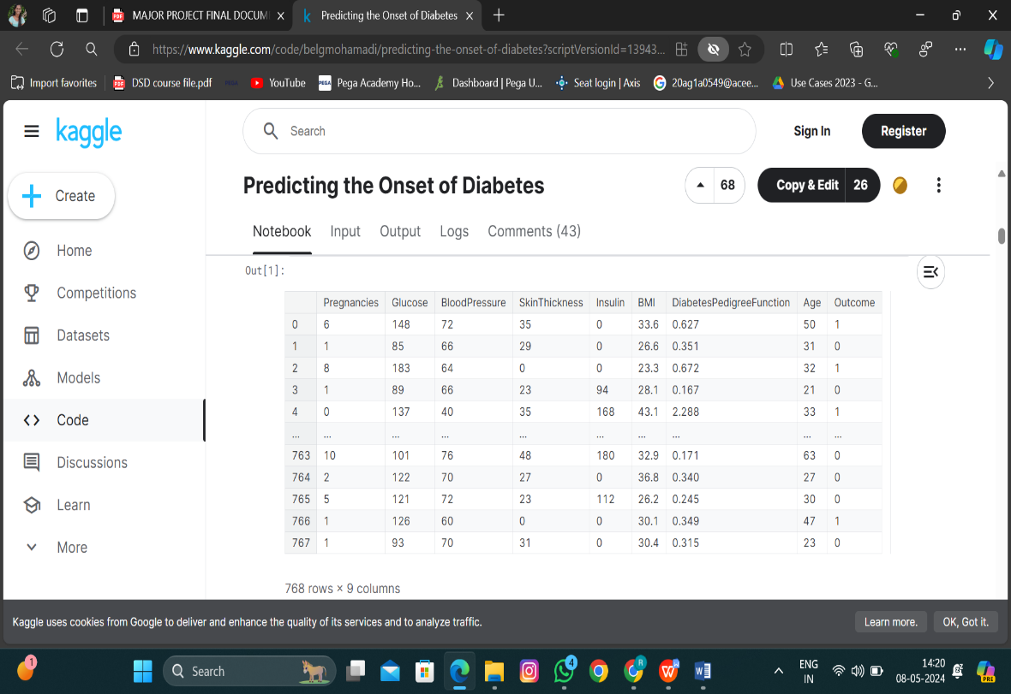

Fig1:Dataset look like above for importing

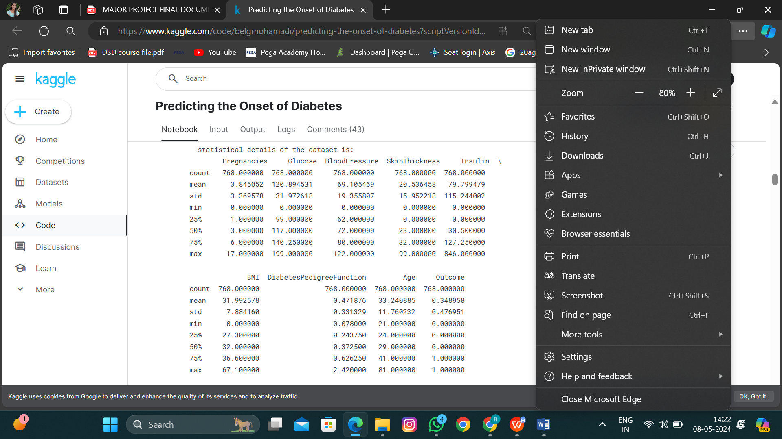

Fig 2:Preprocessing of Data

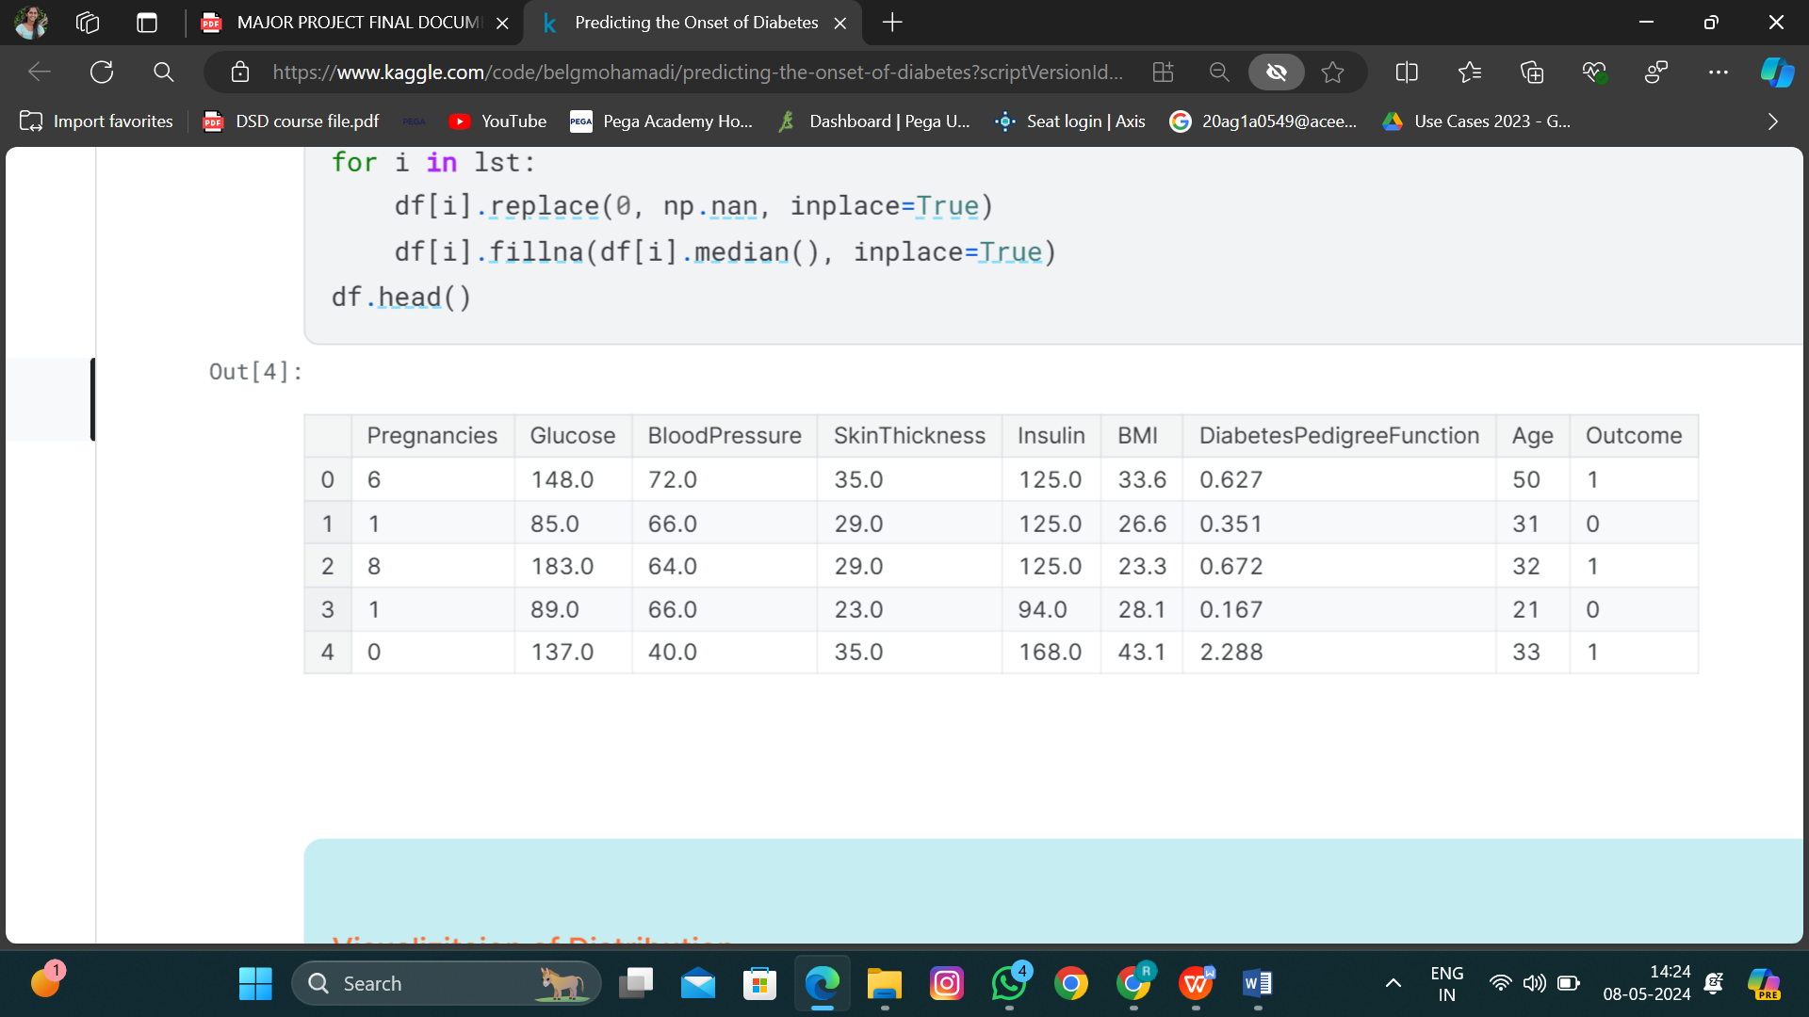

Fig 3:Result For Preprocessing Of Data

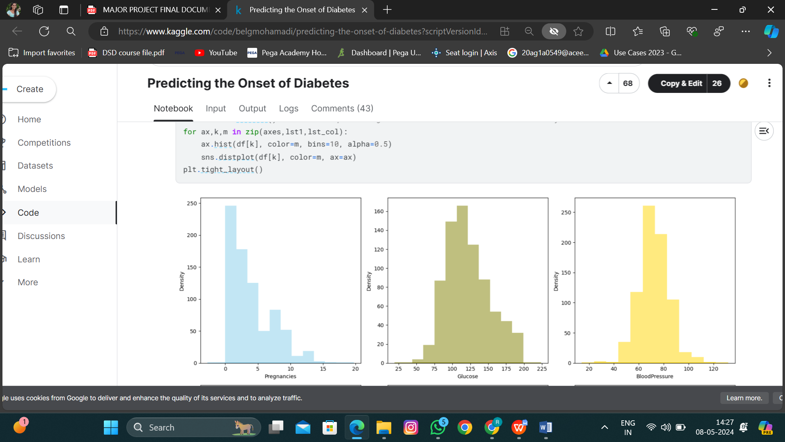

Fig 4:Visualization of Distribution

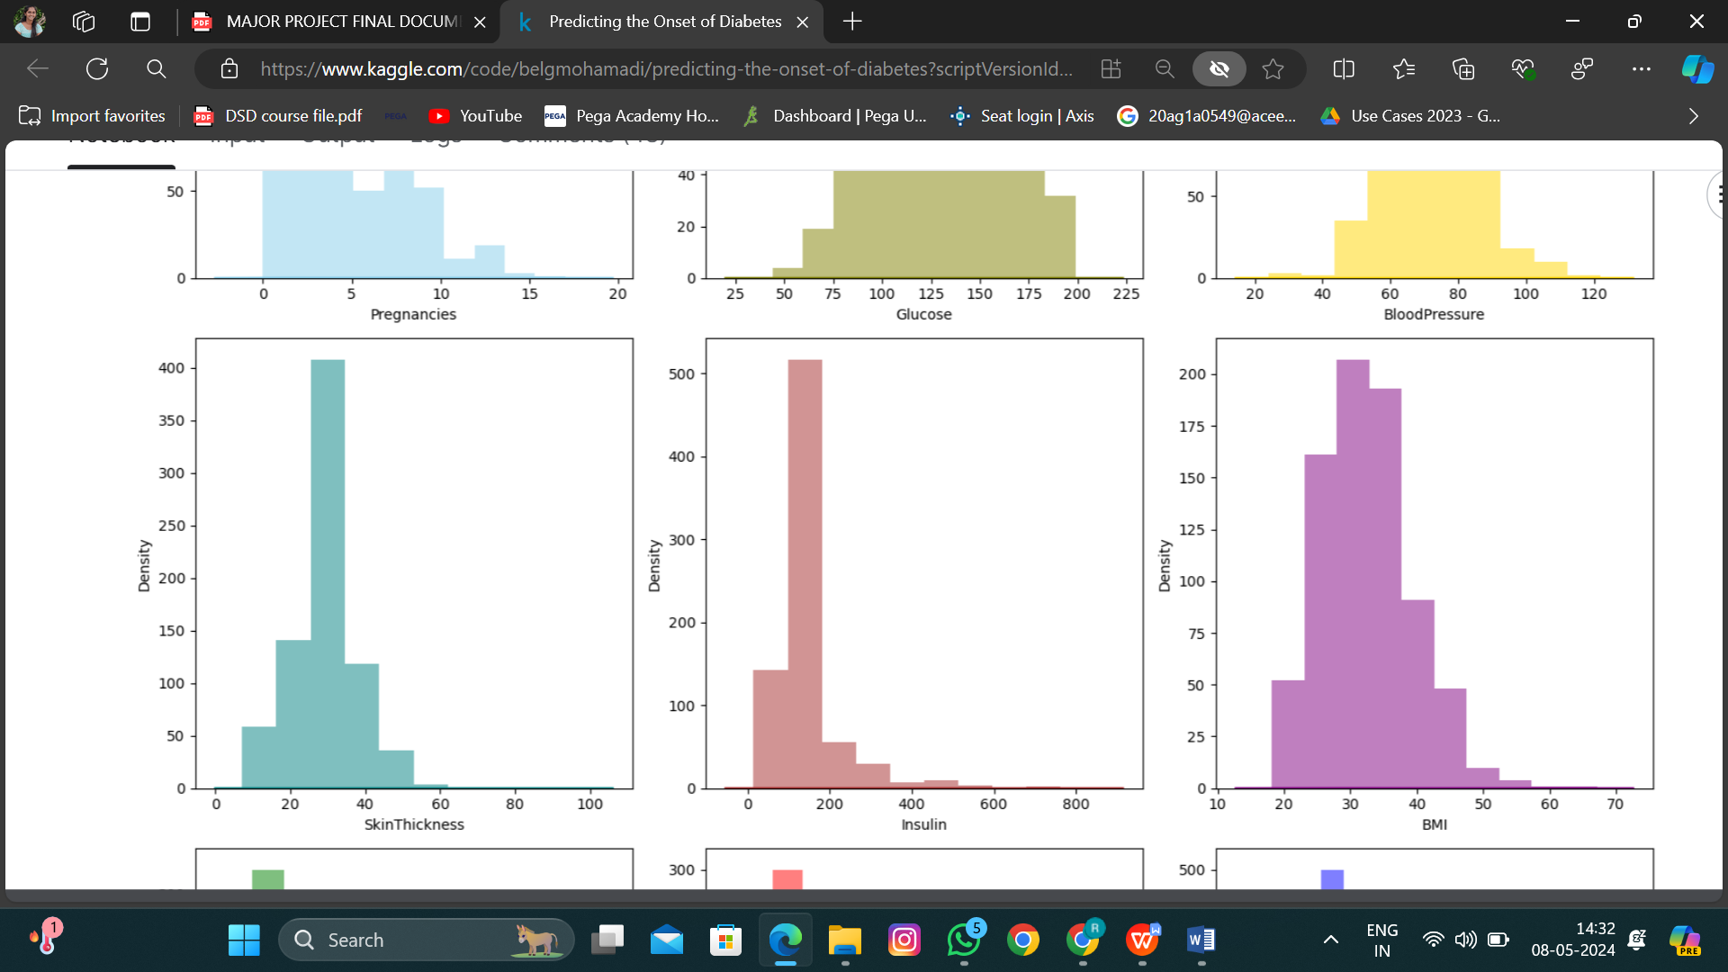

Fig 4.1 Visualization of Distribution



Fig 4.2 Visualization of Distribution



Fig 4.3 Visualization of Distribution

Fig 4.4 Visualization of distribution



Fig 4.5 Visualization of Distribution

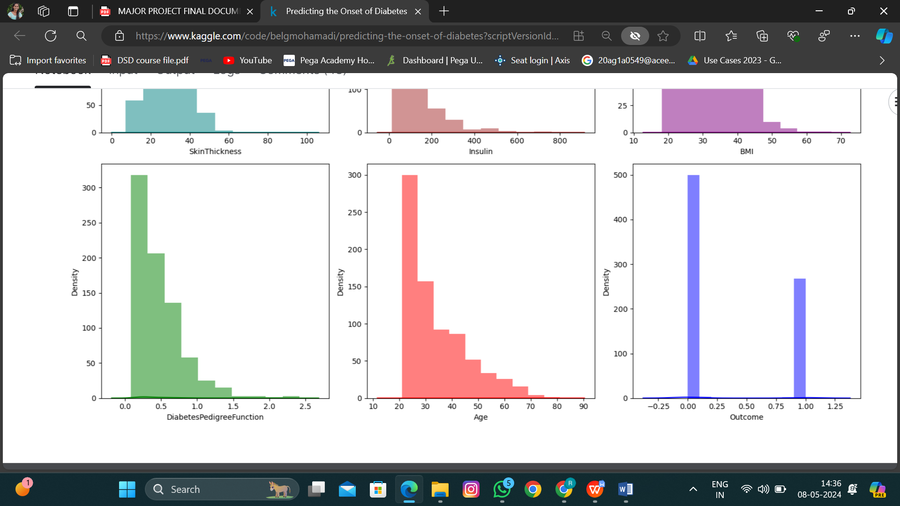

Fig 4.6 Visualization of Distribution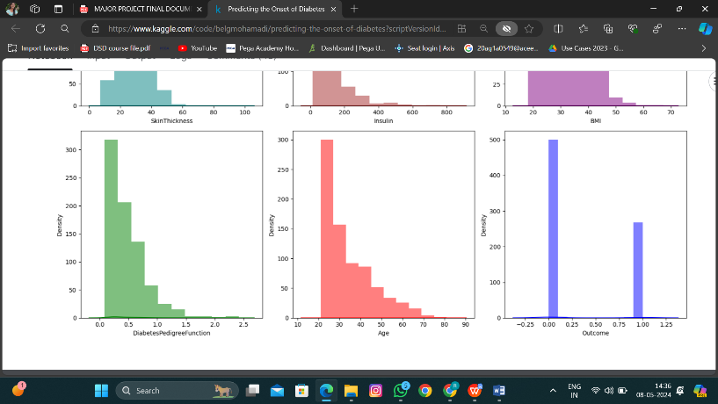

Fig 4.7 Visualization of Distribution



Fig 4.8 Visualization of Distribution

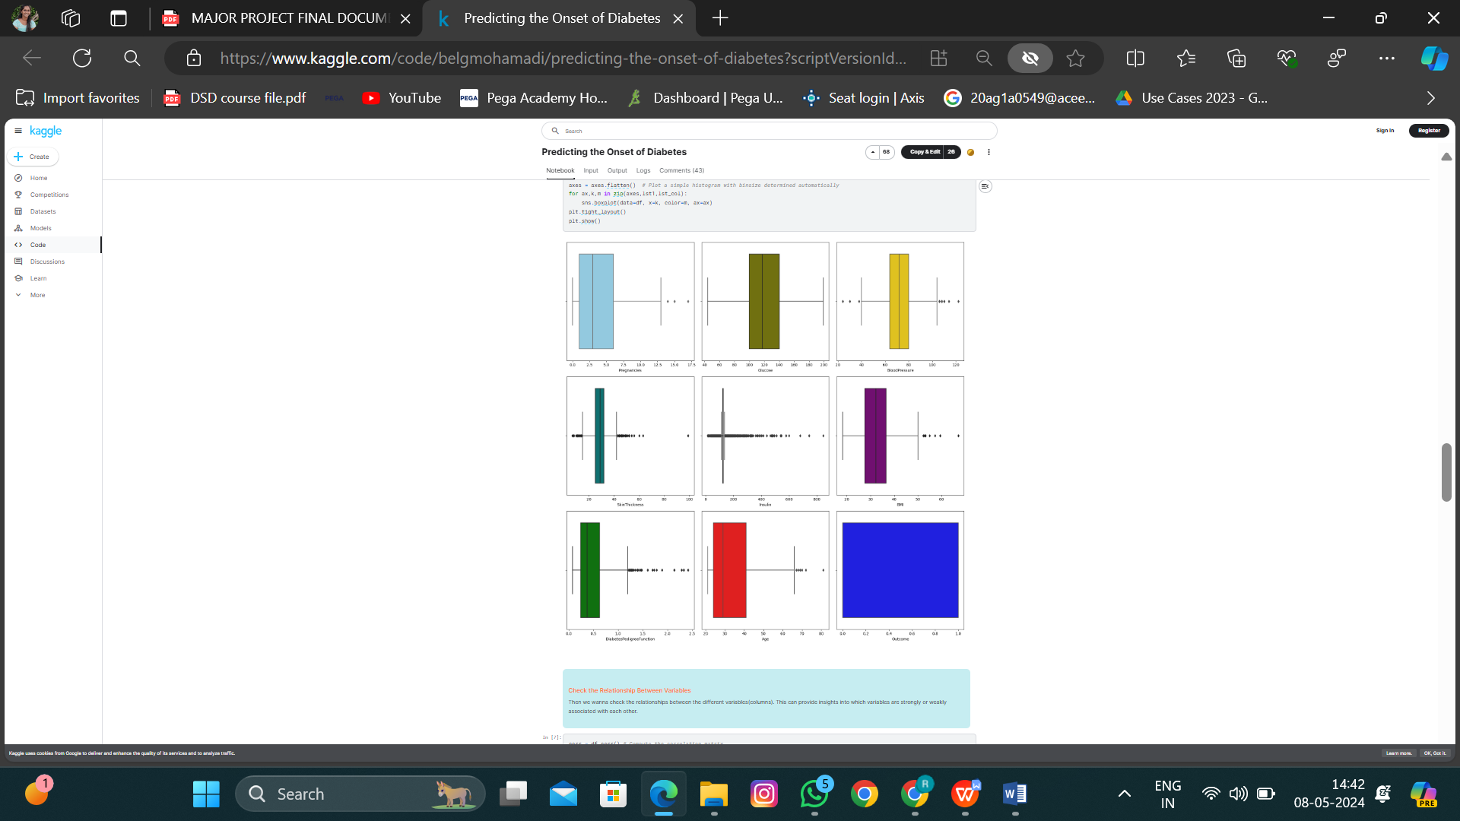

Fig 5:Visualization of Outliers

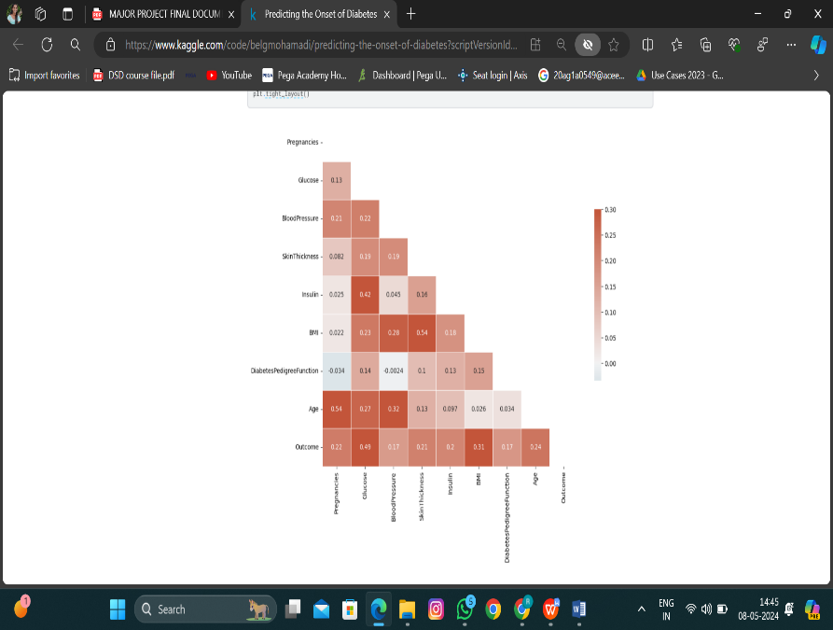

Fig 6:Relationship between variables

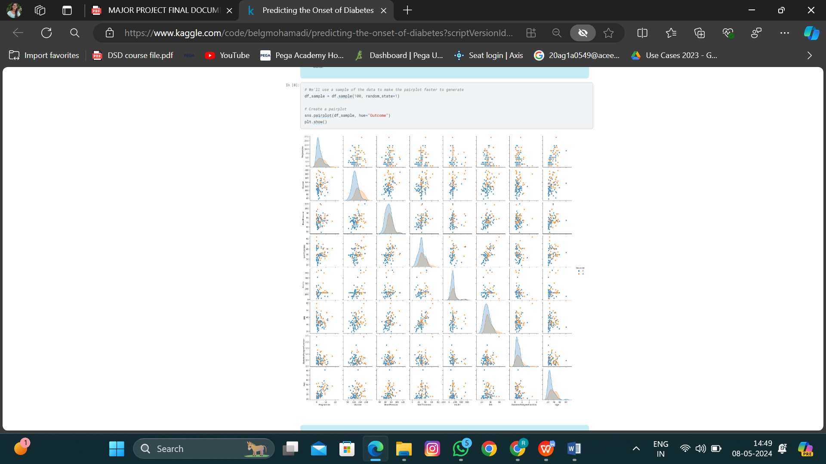

Fig 8 PairPlot For Correlation

# TESTING

In developing a system for managing food consumption in Gestational Diabetes Mellitus (GDM) using an evolutionary algorithm, both training and testing phases are essential. During the training phase, the system learns from data to optimize its performance. This involves feeding the algorithm with a dataset containing information such as dietary guidelines for GDM patients, nutritional requirements, individual preferences, and blood sugar level data. The evolutionary algorithm iteratively refines its recommendations based on this data, aiming to generate meal plans that meet nutritional needs while promoting blood sugar control.

train and test accuracy of LogisticRegression(random_state=42) respectively is: (0.7703583061889251, 0.7532467532467533) train and test accuracy of DecisionTreeClassifier(random_state=42) respectively is: (1.0, 0.7142857142857143)

train and test accuracy of RandomForestClassifier(random_state=42) respectively is: (1.0, 0.7337662337662337)

train and test accuracy of SVC(random_state=42) respectively is: (0.8289902280130294, 0.7467532467532467).

# CONCLUSION

The goal of this research is to develop a novel self-monitoring web interface for GDM patients to track their blood glucose levels based on meal consumption recommendations. Currently, GDM patients record blood glucose levels and maintain track of their food intake using the usual manner. Although there are several selfmanaging applications in healthcare, we have yet to find one that is suitable for GDM monitoring. Furthermore, the majority of the research focused on diabetes selfmanagement apps. The design and development of a website for GDM monitoring utilizing a genetic algorithm to estimate suggested consumption was presented in this work. The genetic algorithm in the engine predicts the most optimal outcomes of advised meals and determines the diversity of the results. The web interface assists GDM sufferers by tracking the calories in their daily meals in order to maintain a healthy blood sugar level. As a result, the website will help individuals forecast their glucose levels based on their regular meals. We're actively working on a GDM monitoring system for patients and healthcare providers. The programme will save data in a centralized database and will be able to sync with other healthcare apps. We believe that this will motivate researchers to investigate using a self-monitoring mobile application to help patients with GDM regulate their blood glucose levels.cross-disciplinary applicability of the system underscores its significance in diverse sectors, including finance, e-commerce, healthcare, and government. Its ability to detect and prevent phishing attacks effectively serves as a critical line of defence against financial fraud, data breaches, and identity theft, thereby safeguarding individuals and organizations worldwide. As the system undergoes continuous refinement and enhancement, fueled by ongoing research and feedback from cybersecurity professionals and end-users alike, it remains poised to redefine the landscape of online security and shape the future of cybersecurity technologies. In essence, the Phishing Website Detection system stands as a testament to the transformative potential of AI and ML in fortifying digital defenses and preserving trust in the interconnected world. Through its implementation

# FUTURE SCOPE

In the realm of gestational diabetes mellitus (GDM) management, the future scope for food consumption estimation using evolutionary algorithms holds promise for significant advancements. Further research will likely concentrate on refining and enhancing these algorithms to tailor them specifically for GDM patients. This refinement could involve incorporating additional variables such as meal timing, portion sizes, and individual metabolic responses, aiming to optimize accuracy and effectiveness. Additionally, there is considerable potential for the development of personalized dietary recommendations based on patient-specific characteristics, preferences, and metabolic profiles. Such personalized approaches could revolutionize GDM management by providing tailored dietary advice that adapts dynamically to changes in pregnancy and individual patient needs throughout gestation.

# REFERENCES

**[1.]** Hazarika, A., Nongkhlaw, B. & Mukhopadhyay, A. Identification of stable reference genes in peripheral blood mononuclear cells from type 2 diabetes mellitus patients. Sci Rep 13, 486 (2023). https://doi.org/10.1038/s41598-023- 27460-3J. Clerk Maxwell, A Treatise on Electricity and Magnetism, 3rd ed., vol. 2. Oxford: Clarendon, 1892, pp.68–73. **[2].** Esteghamati, A., Zamanzadeh, M., Malek, M. et al. Efficacy and Safety of a Biosimilar Liraglutide (Melitide®) Versus the Reference Liraglutide (Victoza®) in People with Type 2 Diabetes Mellitus: A Randomized, Double-Blind, Noninferiority Clinical Trial. Diabetes Ther 14, 1889–1902 (2023). <https://doi.org/10.1007/s13300023-01462-wK>.

**[3].** Ghoreyshi-Hefzabad, SM., Jeyaprakash, P., Vo, H.Q. et al. Subclinical systolic dysfunction detected by 2D speckle tracking echocardiography in adults with diabetes mellitus: systematic review and meta-analysis of 6668 individuals with diabetes mellitus and 7218 controls. Int J Cardiovasc Imaging 39, 977–989 (2023). https://doi.org/10.1007/s10554-023-

02810-4