DETECTION OF BRAIN ABNORMALITIES
USING DEEP LEARNING

Dangeti Srinivasa Rao
Department of IT,
Shri Vishnu Engineering College
for Women,
Bhimavaram, India
dsrinivasaraoit@svecw.edu.in

Balabhadra Devi Anusha
Department of IT,
Shri Vishnu Engineering College
for Women,
Bhimavaram, India
20b01a1207@svecw.edu.in

Appari Varshini
Department of IT,
Shri Vishnu Engineering College
for Women,
Bhimavaram, India
20b01a1204@svecw.edu.in

Budda Ramya Subrahmanya Mani Sri
Department of IT,
Shri Vishnu Engineering College
for Women,
Bhimavaram, India
20b01a1221@svecw.edu.in

Annamdevula Rupa Devi
Department of IT,
Shri Vishnu Engineering College
for Women,
Bhimavaram, India
20b01a1203@svecw.edu.in

Gudivada Pushpa Nagini
Department of IT,
Shri Vishnu Engineering College
for Women,
Bhimavaram, India
21b05a1206@svecw.edu.in

Abstract — Detection and Classification of a brain tumor is an important step to better understanding its mechanism. Magnetic resonance imaging (MRI) is the imaging technique used to diagnosing brain tumor disease. Early diagnosis of brain tumor is an essential task in medical work to find out whether the tumor can potentially become cancerous. Deep learning is a handy and efficient method for image classification. Convolutional Neural Network (CNN) is the deep learning technique to perform image classification. In this study, we propose a novel approach for brain tumor detection utilizing a CNN integrated into a web application. The development of a user-friendly web application enhances the accessibility of this technology for healthcare professionals, allowing for seamless integration into clinical workflows. Our results demonstrate the effectiveness of CNNs in automating the detection process, highlighting the potential for improved patient care outcomes through early diagnosis and intervention. This research underscores the significance of leveraging advanced technologies, such as CNNs and web applications, in the field of medical imaging for enhanced diagnostic capabilities and better patient care.
Keywords — Brain Tumor Detection, Convolutional Neural Networks (CNNs), Medical Imaging, Deep Learning, Magnetic Resonance Imaging (MRI), Tumor Segmentation.

I. INTRODUCTION
Over the last few decades, Brain abnormalities have been increasing rapidly. A brain tumor is one of the deadliest illnesses which occurs due to the sudden and unregulated brain tissue growth inside the skull. This was an important study because accurate and timely detection of brain tumors is critical for patient outcomes. Utilizing Convolutional Neural Networks (CNNs) offers a promising avenue for automating this process, potentially improving diagnostic accuracy and efficiency. Additionally, the development of a web application enhances accessibility to this technology, empowering healthcare professionals with a user-friendly tool for enhanced patient care. This research paper explores a detailed study and practical application of a "Detection of brain abnormalities using deep learning” approach. It utilizes a combination of Flask and CNN in deep learning to achieve this goal effectively.
There are different methods for capturing medical imaging data. Among them MRI which is a non-invasive procedure that provides the radiologist with useful knowledge of medical image data to diagnose brain abnormalities. It is a challenging task in medical research to recognize and define the brain tumors with good accuracy.
In this project, we focused on the segmentation of brain abnormalities in MRI images using deep learning techniques. Within the realm of deep learning models, Convolutional Neural Networks (CNNs) offer a diverse array of convolution layers designed to autonomously extract features from images.
CNNs demonstrate robust performance particularly in scenarios involving extensive datasets, a resource that can be challenging to acquire within the realm of medical imaging. Our approach centered on training a CNN model to automatically detect and classify tumors in brain images with high accuracy. The layers of CNN such as Conv2D, MaxPooling 2D, Flatten, Input, Dropout which extract hierarchical representations of the input images, capturing intricate features, as well as high-level features indicative of tumor structures. The model is trained perfectly to minimize classification errors and optimize its ability to accurately detect tumors. Once trained, the CNN can be deployed to analyse new MRI images, segmenting and classifying tumor regions with high accuracy. This methodology offers a promising approach to early detection of tumors. Integrating Flask which is a python web framework with our deep learning model results in an interactive web application that offers a smooth and easy-to-use interface for users. Overall, our study highlighted the importance of leveraging CNNs for automated brain tumor detection and emphasized comprehensive approach involving data collection, model development, and software engineering.

II. LITERATURE SURVEY

S.No | Title | Author | Year of publication | Methodology | Limitations
1 | A survey of MRI-based medical image analysis for brain tumor studies. | Bauer S., Wiest R., Nolte L.P., Reyes M. | 2013 | Reviewing MRI analysis for brain tumor studies, focusing on segmentation, and modeling techniques. | Artifacts are introduced which had a negative effect on the segmentation.
2 | A 3D convolutional neural network for skull stripping. | Kleesiek J., Urban G., Hubert A., Schwarz D., Maier-Hein K., Bendszus M., Biller | 2016 | Implemented 3D CNN for MRI skull stripping, handling diverse clinical image features. | Significant computational resources are needed, especially for 3D CNNs.
3 | Brain tumor classification using deep CNN features via transfer learning. | Deepak S., Ameer P.M. | 2019 | Utilization of deep transfer learning, employing a pre-trained GoogLeNet to extract features from brain MRI images. | Lack of interpretability, challenging to understand the underlying features.
4 | A deep learning model integrating FCNNs and CRFs for brain tumor segmentation. | Zhao X., Wu Y., Song G., Li Z., Zhang Y., Fan Y | 2017 | Integrating FCNNs and CRFs to achieve segmentation with appearance and spatial consistency | Increase in computational overhead, potentially limiting real-time or resource constrained applications.
5 | Classification of Brain Tumors Using Deep Features Extracted Using CNN. | Basheera S., Ram M.S.S. | 2019 | Pre-trained CNN model was chosen which contained diff layers were used to extract deep features through transfer learning. | Single modality imaging, lack of external validation, limited interpretability of the model.
6 | Tumor Detection in the Brain using Faster R-CNN | R.Ezhilarasi and P.Varalakshmi | 2018 | The project utilizes AlexNet for classification and Faster R-CNN's to accurately detect tumor regions, followed by training for tumor type classification. | The integration of multiple deep learning components may introduce computational overhead.
7 | An overview and application in radiology. Insights Into Imaging. | Yamashita R., Nishio M., Do R.K.G., Togashi K. | 2018 | Preprocessing MRI scans by normalizing and enhancing contrast, followed by data augmentation through flipping to enrich the dataset. | Limited exploration these methods constrain the model's adaptability and robustness across diverse datasets
8 | MRI-Image based Brain Tumor Detection and Classification using CNN-KNN | Shaila Shanjida; Md. Saiful Islam; Mohammad Mohiuddin | 2022 | Classification using a combined CNN-KNN architecture, utilizing Softmax and KNN classifiers for automatic detection and classification of brain tumors. | indicate overfitting to the training dataset, raising concerns about the model's generalizability to unseen data.
9 | Detecting and Classifying Fetal Brain Abnormalities  using Machine Learning Techniques | Omneya Attallah; Heba Gadelkarim; Maha A. Sharkas | 2018 | It employs segmentation, feature extraction, and classification, utilizing ML to detect and classify fetal brain abnormalities across various gestational ages. | Generalization of findings may be hindered by the dataset's limited size and diversity.
10 | Detection of Brain Abnormalities using Machine Learning Algorithm | J. N Bhandavi; Maya V. Karki | 2018 | Utilization of EEG signals for detecting brain abnormalities through statistical features extraction from power spectral density. | Limited by the small dataset of 67 persons and may not fully represent the variability of brain abnormalities.

III. METHODOLOGY

This study demonstrates the utilization of convolutional neural network layers for the detection of brain tumors. The dataset utilized in this research was sourced from Kaggle, comprising image files of brain MRI scans. We collected 3 datasets which represents no tumor, yes tumor and prediction.
The model has to learn invariant features and become more robust to different orientations, positions, and conditions of the input data. Sowe performed data augmentation which involves applying various transformations to the original dataset, such as rotation, scaling, flipping, and cropping, to generate augmented training data. Augmentation is typically performed as part of the data preprocessing pipeline before training the model. Data preparation is done using the Keras library for deep learning. This process prepares the image data and corresponding labels for training a deep learning model, typically a CNN.
Techniques such as Convolutional Neural Networks (CNNs) are selected for their ability to automatically learn relevant features from raw imaging data.

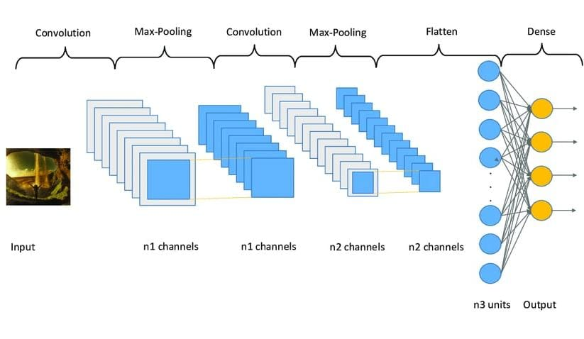
Fig 1: Layers Convolution neural network

The layers of CNN, when combined in a sequential or functional Keras model, form the architecture of a CNN for brain tumor detection. The model is then trained on a labeled dataset of MRI images to learn the features associated with tumor presence, enabling it to make predictions on unseen images.

CONV2D LAYER: This layer performs 2D convolution on input data, which is particularly useful for detecting spatial patterns and features in images. In the context of brain tumor detection, multiple Conv2D layers are typically stacked to extract hierarchical features from MRI images.

MAXPOOLING2D LAYER: After convolutional layers, MaxPooling2D layers are often used to reduce the spatial dimensions of the feature maps while retaining the most important information. Max pooling helps in making the model more robust to variations in the position of features within the input images.

FLATTEN LAYER: Once the feature maps have been extracted and down sampled, the Flatten layer is used to convert the 2D feature maps into a 1D vector. This flattened representation is then fed into fully connected layers for classification.

INPUT LAYER: The Input layer defines the shape of the input data that will be fed into the neural network. For brain tumor detection, this layer specifies the dimensions of the input MRI images (e.g., width, height, number of channels).

DROPOUT LAYER: Dropout layers are commonly inserted after convolutional or fully connected layers to prevent overfitting. By randomly setting a fraction of input units to zero during training, dropout helps to improve the generalization ability of the model.
Two Dense layers are added. The first dense layer consists of 512 neurons with ReLU activation function. This layer learns higher-level features from the flattened input. Dropout regularization is applied to this layer to prevent overfitting. The second dense layer consists of a single neuron with sigmoid activation, producing a binary classification output indicating the presence or absence of a tumor.

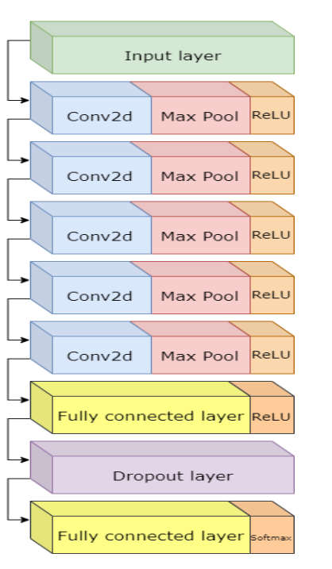

Fig 2: Our Artificial Convolutional Neural Network Architecture
The optimizer chosen here is 'Adam'. Adam is a popular optimization algorithm that adapts the learning rate during training. It combines techniques such as momentum and adaptive learning rates to efficiently minimize the loss function.
The model evaluation typically includes calculating metrics such as accuracy, precision, recall, and F1-score to measure the model's ability to correctly classify tumor and non-tumor cases. The DL model is loaded into memory when the Flask application starts. Endpoints are defined in the Flask app to handle incoming HTTP requests from the frontend. For instance, a route can be set up to accept image uploads from users. When an image is uploaded, Flask preprocesses it, passing it to the DL model for inference. After the DL model makes predictions, Flask sends the results back to the frontend for display to the user.

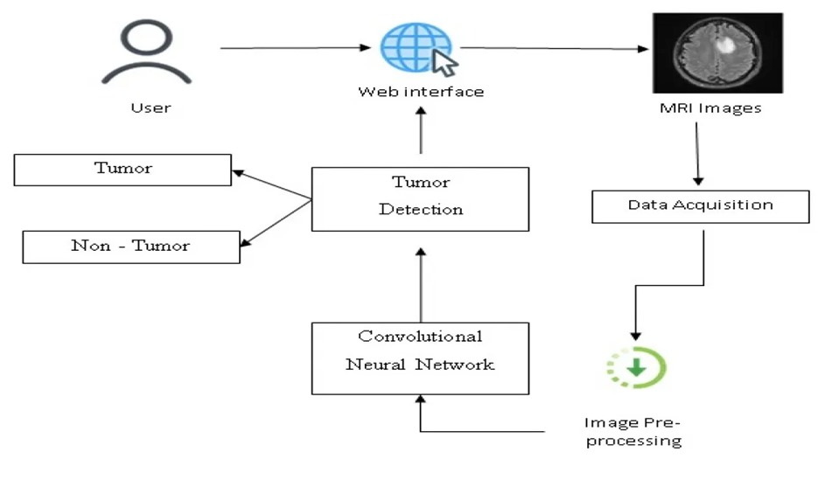
Fig 3: Methodological Framework

IV. RESULTS AND DISCUSSIONS

The model attained a 90% accuracy rate, signifying its proficiency in accurately classifying cases of brain tumors. It comprises several layers, encompassing Conv2D convolutional layers followed by MaxPooling2D max-pooling layers, which aid in extracting crucial features from input images while diminishing spatial dimensions. The layers of the CNN gradually extract hierarchical features from brain tumor images, enabling the model to learn complex patterns and enhance accuracy.

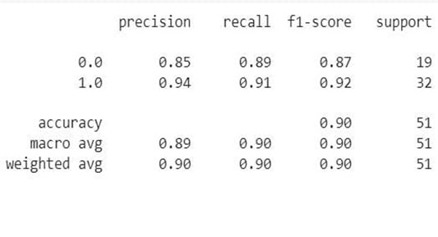
Fig 4: Classification Report

Figure 4 shows the classification report which provides detailed performance metrics for the brain tumor detection model. The overall accuracy of the model is reported to be 0.90. These metrics indicate that the model performs well in both detecting the presence and absence of brain tumors, with high precision, recall, and F1-scores for both classes.
The high precision, recall, and F1-scores for both classes indicate that the model performs well in distinguishing between images with and without brain tumors.

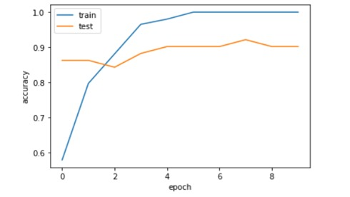
Fig 5: Accuracy of the dataset

The visualization displayed in the figure 5 illustrates the accuracy trends of a dataset across multiple epochs during the training of a machine learning model. By plotting the training and validation accuracy over epochs, this visualization provides valuable insights into the performance and generalization ability of the model. By comparing the training and validation accuracy trends over epochs, analysts and model developers can assess the model's performance.

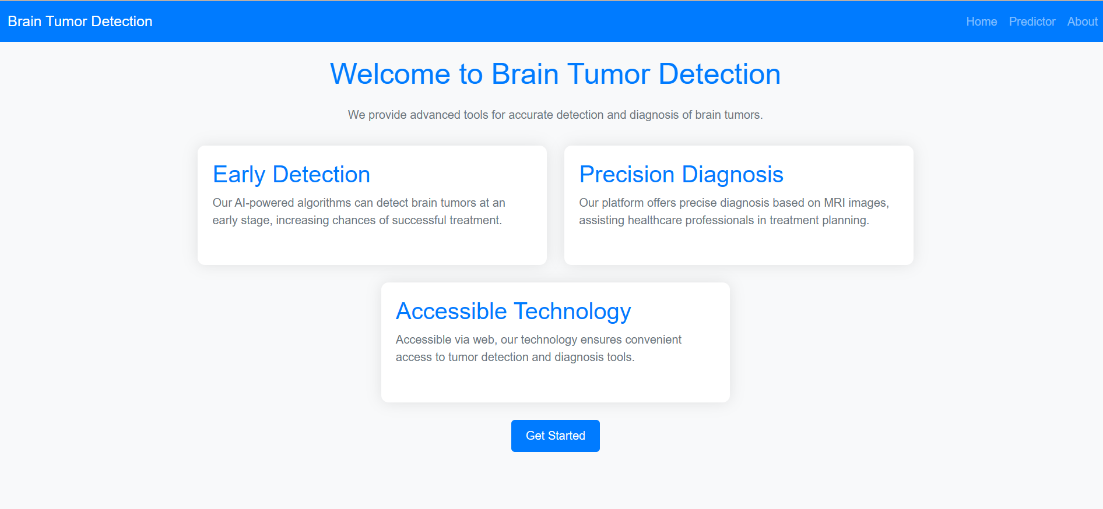

Fig 6: Home Page

There are theree pages in our web app home page, prediction page and about page. The home page serves as the landing page for users when they first visit the web app. It contains information about the purpose of the app and what users can expect. A prominent "Get Started" button is displayed to encourage users to proceed to the prediction page.
The prediction page is where users can upload brain MRI scans for analysis.Once the scan is uploaded, a CNN (Convolutional Neural Network) model is used to predict whether a brain tumor is present or not.The prediction result is displayed to the user, indicating whether a tumor is detected or if the scan is normal. Additionally, the page provides information on the time required to process the prediction using the CNN model. Users can interact with the prediction page to upload multiple scans and receive real-time feedback on tumor detection.

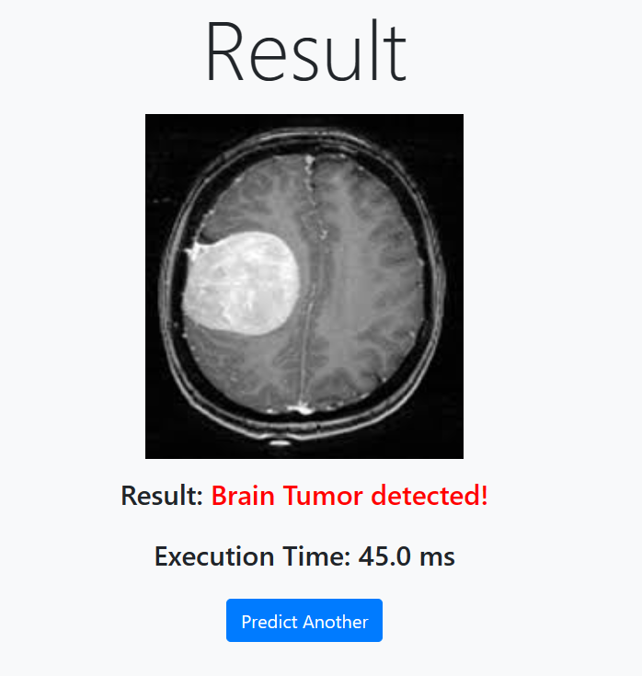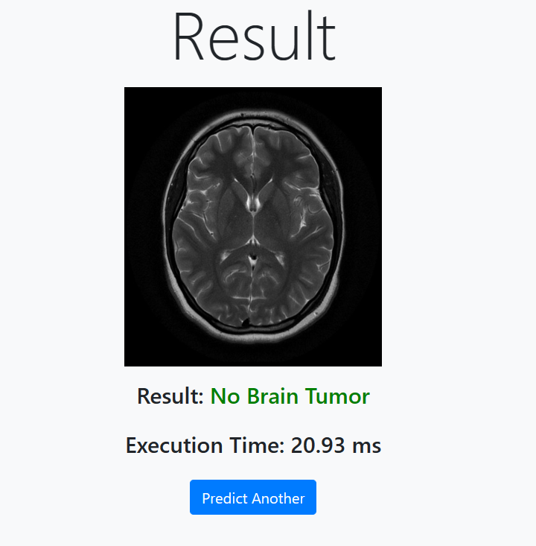
Fig 7: Prediction Page

The about page is designed to provide users with additional information about brain tumors.Overall these three pages work together to provide users with a seamless experience on your web app.

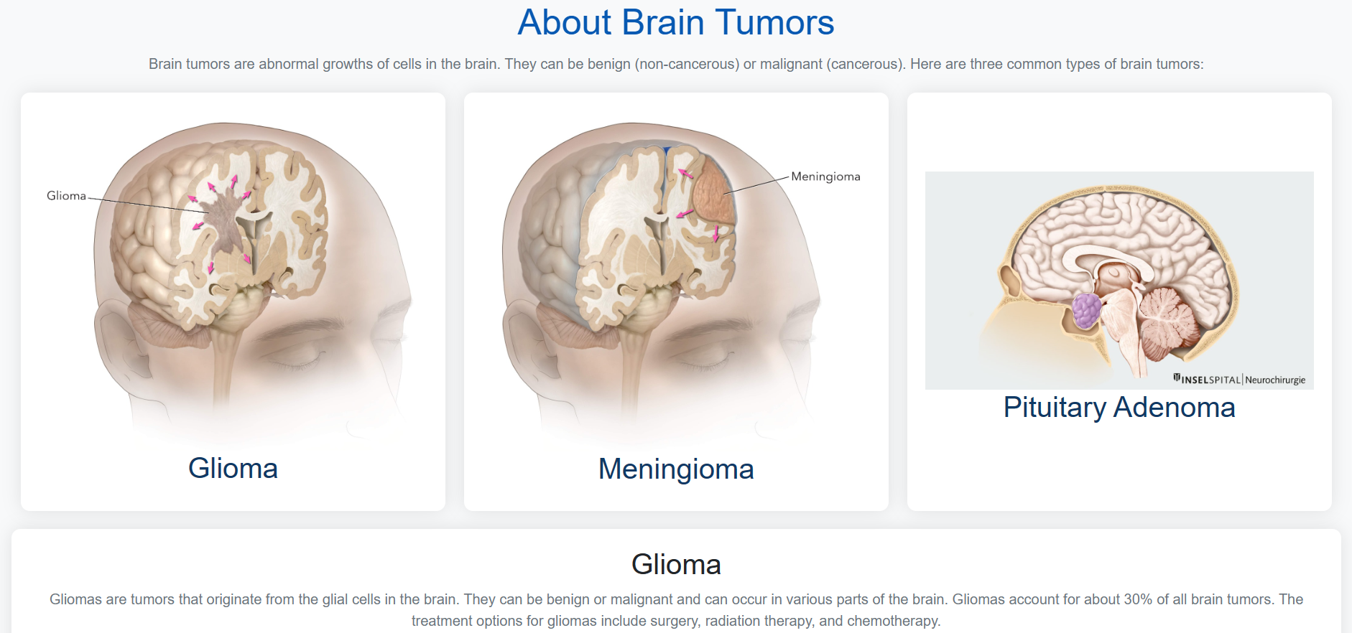
Fig 8: About Page

V. CONCLUSION

In summary, our project addressed the critical need for accurate and efficient detection of brain tumors and successfully demonstrated the efficacy of employing Convolutional Neural Networks (CNNs) for the segmentation and detection of brain tumors in MRI images. The developed CNN model, integrated into a user-friendly web application, offers a promising solution for accurate and timely diagnosis, potentially improving patient outcomes in neurological conditions This research represents a significant advancement by seamlessly blending deep learning techniques with web technology. By doing so, we have illustrated the potential to transform healthcare by providing a rapid, easily accessible, and precise tool for diagnosing brain tumors. Furthermore, our work contributes
to the ongoing progress in medical imaging technology, paving the way for future innovations in the field.

VI. ACKNOWLEDGMENTS

We are deeply thankful to our college administration for furnishing us with the essential resources and infrastructure essential for the completion of this project. Our heartfelt appreciation goes out to Shri Vishnu Engineering College for Women for nurturing an atmosphere that encourages innovation and fosters continuous learning. We wish to place our deep sense of gratitude to Sri. K. V. Vishnu Raju, Chairman of SVECW for his constant support on our each and every progressive work. We are thankful to Dr. G. Srinivasa Rao, Principal of SVECW, for being a source of inspiration and constant encouragement. We wish to express our sincere thanks to Dr. P. Srinivasa Raju, Vice-Principal of SVECW, for being a source of inspiration and constant encouragement. We wish to express our sincere thanks to Dr. D. Venkata Naga Raju, Head of the Department, IT for being a source of inspiration and constant encouragement. We wish to thank our guide Mr. D. Srinivasa Rao for his unflinching devotion and valuable suggestions to complete our main project successfully in time.

VII. REFERENCES

- S. Shanjida, M. S. Islam and M. Mohiuddin, "MRI-Image based Brain Tumor Detection and Classification using CNN-KNN," 2022 IEEE IAS Global Conference on Emerging Technologies (GlobConET), Arad, Romania, 2022, pp. 900-905, doi: 10.1109/GlobConET53749.2022.9872168.

- J. N. Bhandavi and M. V. Karki, "Detection of Brain Abnormalities using Machine Learning Algorithm," 2018 4th International Conference for Convergence in Technology (I2CT), Mangalore, India, 2018, pp. 1-6, doi: 10.1109/I2CT42659.2018.9058200.

- O. Attallah, H. Gadelkarim and M. A. Sharkas, "Detecting and Classifying Fetal Brain Abnormalities Using Machine Learning Techniques," 2018 17th IEEE International Conference on Machine Learning and Applications (ICMLA), Orlando, FL, USA, 2018, pp. 1371-1376, doi: 10.1109/ICMLA.2018.00223.

- Bauer S., Wiest R., Nolte L.P., Reyes M. A survey of MRI-based medical image analysis for brain tumor studies. Phys. Med. Biol. 2013;58:R97–R129. doi: 10.1088/0031-9155/58/13/R97. [PubMed] [CrossRef] [Google Scholar]

- Kleesiek J., Urban G., Hubert A., Schwarz D., Maier-Hein K., Bendszus M., Biller A. Deep MRI brain extraction: A 3D convolutional neural network for skull stripping. NeuroImage. 2016;129:460–469. doi: 10.1016/j.neuroimage.2016.01.024. [PubMed] [CrossRef] [Google Scholar]

- Zhao X., Wu Y., Song G., Li Z., Zhang Y., Fan Y. A deep learning model integrating FCNNs and CRFs for brain tumor segmentation. Med. Image Anal. 2018;43:98–111. doi: 10.1016/j.media.2017.10.002. [PMC free article] [PubMed] [CrossRef] [Google Scholar]

- Basheera S., Ram M.S.S. Classification of Brain Tumors Using Deep Features Extracted Using CNN. J. Phys. Conf. Ser. 2019;1172:012016. doi: 10.1088/1742-6596/1172/1/012016. [CrossRef] [Google Scholar]

- R. Ezhilarasi and P. Varalakshmi, "Tumor Detection in the Brain using Faster R-CNN," 2018 2nd International Conference on I-SMAC (IoT in Social, Mobile, Analytics and Cloud) (I-SMAC)I-SMAC (IoT in Social, Mobile, Analytics and Cloud) (I-SMAC), 2018 2nd International Conference on, Palladam, India, 2018, pp. 388-392, doi: 10.1109/I-SMAC.2018.8653705.

- Yamashita R., Nishio M., Do R.K.G., Togashi K. Convolutional neural networks: An overview and application in radiology. Insights Into Imaging. 2018;9:611–629. doi: 10.1007/s13244-018-0639-9. [PMC free article] [PubMed] [CrossRef] [Google Scholar].

- Deepak S., Ameer P.M. Brain tumor classification using deep CNN features via transfer learning. Comput. Biol. Med. 2019;111:103345. doi: 10.1016/j.compbiomed.2019.103345. [PubMed] [CrossRef] [Google Scholar]

