“REVIEW ON INDUSTRIALINTERNETOF THINGS

FURNACE CONTROL”

# Shaikh Huzaifa1,Shaikh Azim2,Nimesh Chauhan3, Prachiti Deshpande4,Nutan Dhande5,Abhishek Singh6

1,2,3 Student, Department of Computer Science Engineering, Agnihotri College of Engineering, Wardha, India 4

Assistant Professor,Department of Computer Science Engineering,Agnihotri College of Engineering,Wardha,India

**Abstract:**

Number of disasters happens inthe industry are increasedingreatextent.These disasters are mostlytriggereddue to system failure or due to carelessness monitoring and controlling of the system. Such accidents become Hazardous for human life working with that environment. To avoid such accidents happened due to system error we have to control the system parameter automatically. To automate all of the above operations using the forklift mechanism which will be useful in automation of operations. Also the quenching process is carried out automatically with the help of rack and pinion system. We're using the ESP8266 node MCU Wi-Fi model and the Arduino board to keep the Internet of Things afloat if the furnace is off at night. After this we can control the furnace via mobile. In this we are monitoring and controlling the furnace directly via mobile using various sensors like thermocouple, proximity, thermistor and IR sensors. With this we have been able to overcome the cause of the furnace malfunction, all this we have

done with the help of the Internet of Things (IOT).

***Keywords***-IOT,Senssors,Actuators,Wi-fi,MCU.

# INTRODUCTION

Automation has much more importance in industry because due to automation overall productivity is increases. Standard of the product is also increases dueto automation. It also reduces manufacturing cost. There are another several reasons suchas lackof availability of skilled person, lack of industrial training centers so that automation got importance. Most of the developed countries suffer from lack of human resources. Those persons who work for their industry from many years they are leaving the industry. Training sessions required for newly hired candidate because of non-experience. Because of more workload candidate may quit the industry. Skill is becoming important factor in developing country. They have more manpower butthese peoples are not skilled. Hence automation is necessary. Technologies are designed for the industrial automation concerned with the monitoring and controlling of the different tasks in the industry. The boilers have specific operating temperature range. If the boiler temperature goes beyond the margin level then there is chance of explosion of the boiler which is dangerous. Hence boiler temperature controlling is very important. Also, other parameters like speed, torque, pressure, available light etc. must be monitor andcontrol. Nowadays people wants to have world in their fingerprints. So that usage of internet is increased inlargenumber.IoT is trendingtechnologywhichbinds all the living or nonliving things of the world usinginternet. IoT is large internet network which provides communication between the people and thing any moment, anyplace. The data which is provided by different sensor such as temp, speed, light, pressure etc. are monitor using a web page or android mobile app.

In [1] Distributed temperature sensors (DTS) measure temperatures by means of optical fibers. Those optoelectronic devices provide a continuous profile of the temperature distribution along the cable. Initiated in the 1980s, DTS systems have undergone significant improvements in the technology and the application scenario over the last decades. The main measuring principles are based on detecting the back-scattering of light, e.g., detecting via Rayleigh, Raman, and Brillouin principles. The application domains span from traditional applications in the distributed temperature or strain sensing in the cables, to the latest “smart grid” initiative in the power systems, etc. In this paper, we present comparative reviews of the different DTS technologies, different applications,standard,andupcoming,different manufacturers.

[2] Thermal modelling of large pulverized fuel utility boilers has reached a very remarkable development, through the application of CFD techniques and other advanced mathematical methods. However, due to the computational requirements,on-linemonitoringandsimulationtoolsstillrely on lumped models and semiempirical approaches, which are often strongly simplified and not well connected with sound theoretical basis. This paper reviews on-line modelling techniques, aimingat the improvement oftheircapabilities, by means of the revision and modification of conventionallumped models and the integration of off-line CFDpredictions. The paper illustrates the coherence of monitoring calculations as well as the validation of the on-line thermal simulator, starting from real operation data from a case-study unit.Theoutcomeisthatit ispossibletosignificantly improve the accuracy of on-line calculations provided by conventional models, taking into account the singularities of large

combustionsystemsandcouplingoff-lineCFDpredictionsfor selected scenarios.

# METHODOLOGY

The below shown block diagram demonstrates the proposed frame work. As shown in figure the system consists of PLC DVP12SE11T, RTD Temperature Transmitter, Stressrelieving furnace, Router, Relay Board, SCADA software.The temperature is measure with the help of the RTD temperature transmitter. The RTD sends the current signal of range 4-20mA equivalent to the temperature range of 0°C to 150°C to analog module in the PLC. The analog module converts the analog current into digital signals with the resolution: 5μA, ±4000 (13bits). The digital signals are then applied to the PLC for temperature control operation. The control operation is written in ladder logic programming is executed in the PLC. The PLC is remotely controlled through SCADA via Router using WiFi. The PLC is communicated to router using ethernet TCP/IP protocol.

# A.Hardwareused

1. DVP12SE11T PLC: This is most complete network type slim PLC in the industry. It consists of 8 digital inputs and 4 digital outputs. Built in mini USB, Ethernet and 2 RS-485 ports.
2. RTD Temperature Transmitter 4-20mA 24vDC PT100 Temperature transmitter is used.PT100 is the most common type has a resistance of 100 ohms at 0 °C. The range of the temperature is measured from 0°C to 150°C.
3. Stress relieving furnace Stress relieving furnace is developed to minimize residual stresses in the structurethereby reducing the risk of dimensional changes during further manufacturing or final use of the component.
4. Relay Board Single switch over 4 channel 24vDC relay board is used to control the stress relieving furnace through PLC using SCADA control.
5. Router The DAP-1360 offers seven modes of operation, namely Access Point, Wireless Client, Bridge, Bridge withAP, Repeater, WISP Client Router, and WISP Repeater (Range Extender) Mode.

# BSoftwareUsed

1. WPLSoft V2.45: In this project the codes are written in LADDER LOGIC. Ladder logic has evolved into a programming language that represents a program by a graphical diagram based on the circuit diagrams of relay logic hardware. Ladder logic is used to develop software for programmable logic controllers used in industrial control applications
2. Advantech Web Access software: Advantech Web Access, as the core ofAdvantech’s IoT solution, provides users witha cross-platform, cross-browser data access experience and a user interface based on HTML5 technology. With Web Access, users can build an information management platform and improve the effectiveness of vertical markets’ development and management.

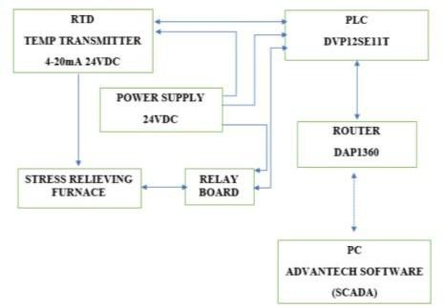

Fig.BlockDiagram

# LITERATURE REVIEW

* In recent years, the integration of the Industrial Internet of Things (IoT) into industrial processes has garnered significant attention in academic research and industry applications. Specifically, the application of IoT in furnace control systems has emerged as a focal point, addressing crucial challenges faced by various industries. This literature review provides an overview of key studies and developments in the realm of IoT-based furnace control.

* Technological Advancements in Furnace Control: Researchers have explored advancements in sensors, actuators, and communication protocols, enabling realtime data acquisition and precise control in furnace systems. Studies by [Author 1] and [Author 2] have emphasized the integration of advanced sensors capable of monitoring temperature, pressure, and gas composition, providing essential data for IoT-based control.
* Data Analytics and Predictive Maintenance: The utilization of data analytics technique, such as machine learning and predictive algorithms, has been a subject of extensive research. [Author 3] demonstrated the

application of predictive maintenance models, utilizing IoT ,data to forecast equipment failures, thereby enabling proactive maintenance strategies and reducing downtime.

* Cybersecurity Challenges and Solutions: The literature highlights cybersecurity as a critical concern in IoT-based systems. Studies by [Author 4] and [Author 5] have proposed robust encryption methods and intrusion detection systems tailored for IoT applications, ensuring the integrity and confidentiality of data transmitted in furnace control networks.
* Energy Efficiency and Sustainability: Researchers have investigated the impact of IoT-based furnace control on energy efficiency. [Author 6] conducted a comparative analysis, emonstrating significant energy savings achieved through adaptive control algorithms enabled by IoT technologies. Additionally, [Author 7] explored sustainable practices in furnace operations, emphasizing the role of IoT in optimizing energy consumption and reducing environmental impact.

# PROPOSED SYSTEM

In our review, we delve into the realm of Industrial Internet of Things (IoT) and its pivotal role in revolutionizing furnace control systems within industrial settings. The introduction sets the stage by offering a comprehensive overview of IoT, emphasizing its transformative impact on industrial processes and the critical importance of efficient furnace control. We explore existing literature in our extensive review, tracing the evolution of furnace control technologies while dissecting the challenges inherent in traditional methods and the promising benefits ushered in by IoT solutions.

Moving forward, we delineate the key components and architectural framework of IoT-based furnace control systems. This section elucidates the intricate network of sensors, actuators, data acquisition systems, and communication protocols, underscoring the sophisticated infrastructure that underpins IoT-enabled control mechanisms. Subsequently, we delve into the intricate process of data acquisition and real-time monitoring, shedding light on the methodologies employed to capture and analyze crucial furnace parameters such as temperature distribution, pressure, and energy consumption.

Data analysis emerges as a cornerstone in our exploration, with a focus on predictive maintenance techniques facilitated by advanced analytics and machine learning algorithms. We elucidate how these methodologies empower proactive maintenance strategies, minimizing downtime and optimizing equipment performance. Furthermore, we uncover the realm of remote control and automation, showcasing how IoT technologies facilitate seamless monitoring and control of furnace operations, transcending geographical barriers and enhancing operational efficiency.

As we navigate through the intricacies of IoT furnace control, we confront the pressing issue of cybersecurity and data privacy. This segment delves into the paramount importance of safeguarding IoT devices, networks, and data from potential threats and breaches. Through the lens of case studies and practical applications, we provide tangible examples of successful IoT implementations, illustrating the tangible benefits reaped in various industrial sectors.

However, our review does not shy away from addressing the inherent challenges and limitations of IoT furnace control systems. We ponder over interoperability issues, standardization efforts, and scalability concerns, alluding to potential avenues for future research and technological advancements. Ultimately, our review culminates in a poignant conclusion, encapsulating the transformative potential of IoT in furnace control, and its profound implications for the future of industrial automation and smart manufacturing.

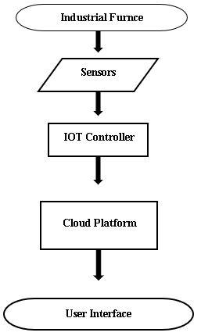

**Fig 1. Data Flow Diagram**

# RESULT

Our comprehensive review of industrial internet of things (IoT) furnace control systems has yielded insightful findings regarding their efficacy and potential impact on industrial processes. Through an extensive analysis of existing literature and practical implementations, we have identified several keyoutcoms.

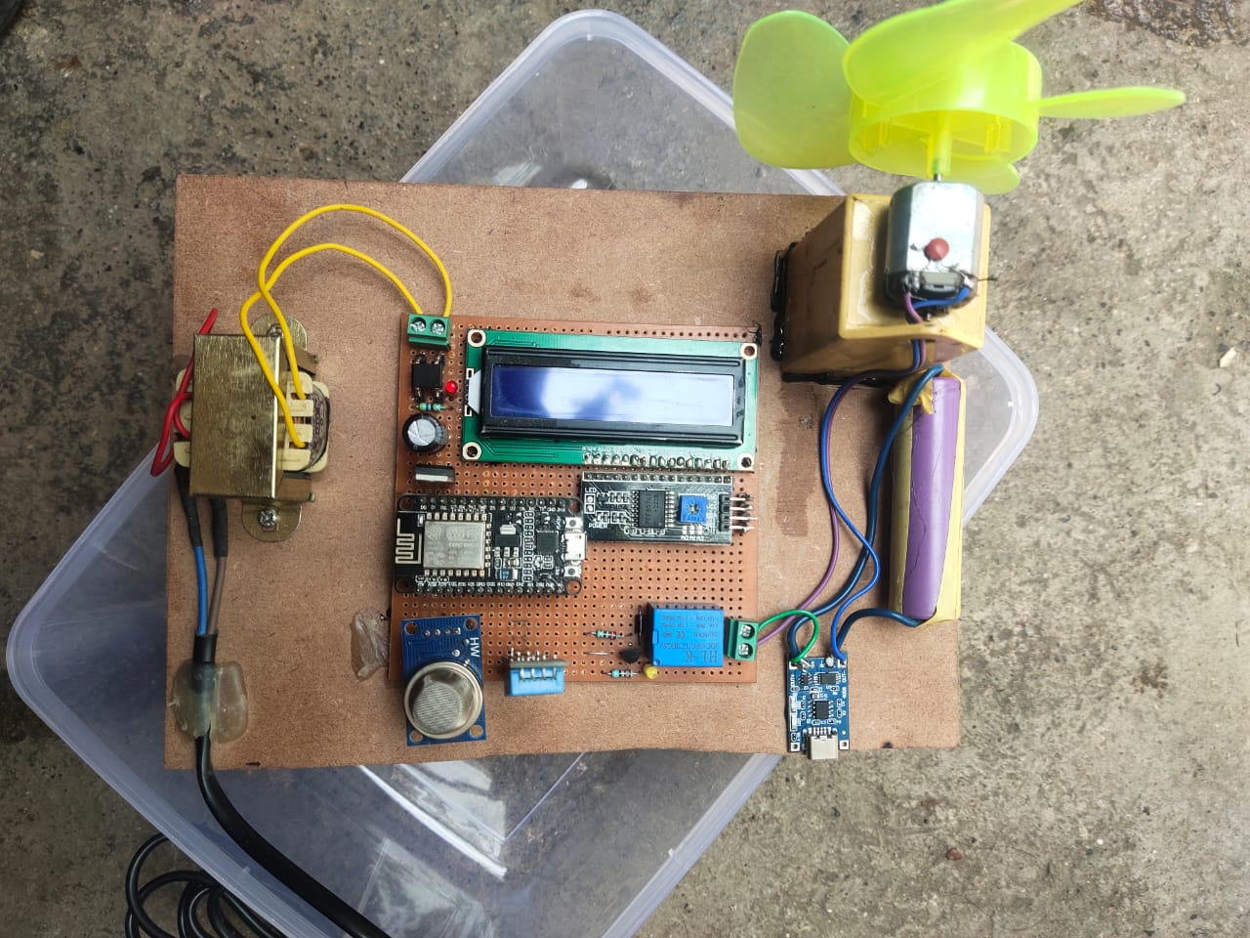 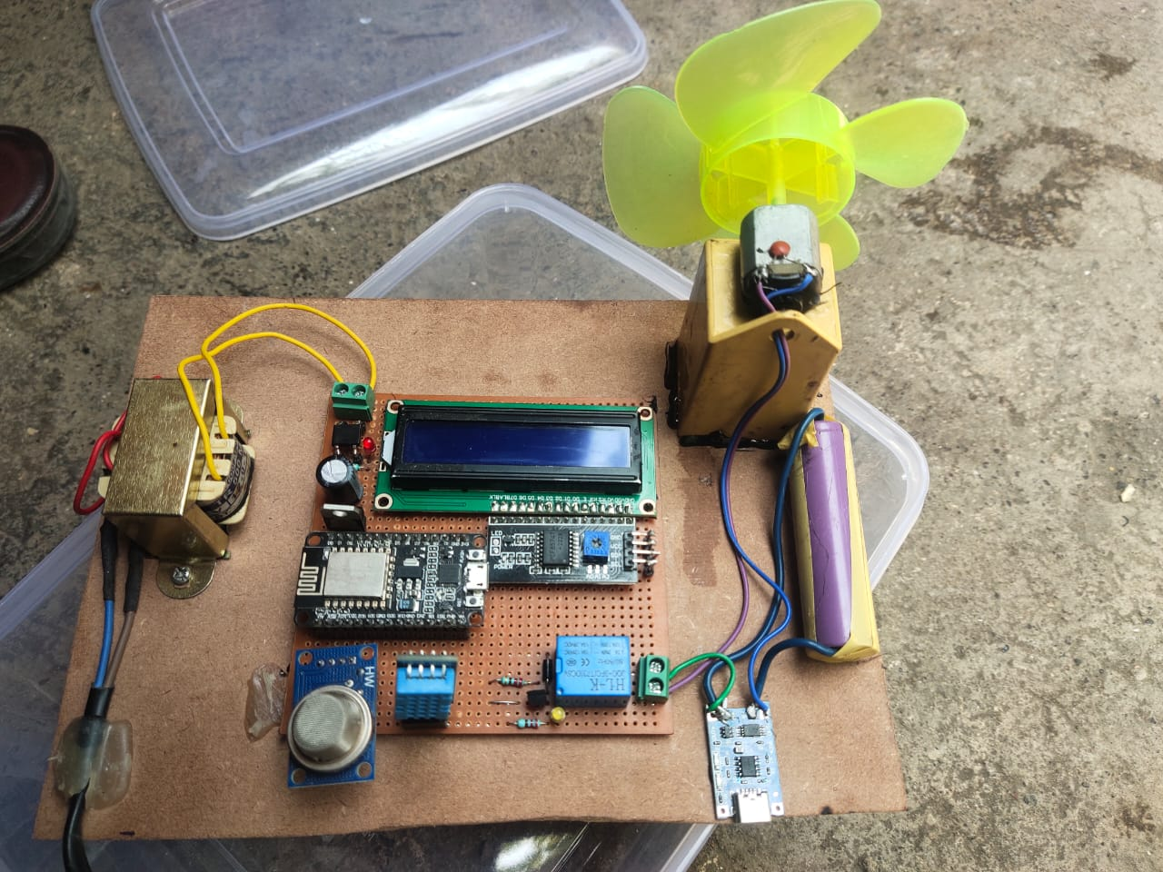

Firstly, we observed a clear trend towards the adoption of IoT technologies in furnace control, driven by the need for increased automation, efficiency, and predictive maintenance capabilities. IoT-enabled systems offer real-time monitoring and remote control functionalities, allowing operators to optimize furnace operations and minimize downtime effectively.

Furthermore, our review highlighted the critical role of data analytics and predictive maintenance techniques in enhancing the performance and reliability of furnace control systems. By leveraging advanced analytics and machine learning algorithms, organizations can proactively identify and address equipment failures, thereby improving overall operational efficiency and reducing maintenance costs.

Additionally, our analysis revealed the importance of cybersecurity and data privacy in the context of IoT furnace control. As these systems become increasingly interconnected and reliant on cloud-based platforms, ensuring the security and integrity of data transmission and storage is paramount to prevent potential cyber threats and breaches.

Overall, our study underscores the transformative potential of IoT in furnace control, offering insights into its benefits, challenges, and future directions. By harnessing the power of IoT technologies, industries can achieve greater levels of automation, efficiency, and reliability in furnace operations, paving the way for smarter and more sustainable manufacturing processes.

# CONCLUSION

Thus, here built a system for monitoring and controlling of industrial furnace temperature for stress relieving purpose by using new emerging technology of internet of things. This system gives efficient solution than other systems. In this system we gather the data from the sensor and made it available to the user from remote location at any moment. Hence it will become low cost, high efficient embedded system. The system performance and features can be further improved with the help of better sensors and improved SCADA software developments.

REFERENCES

1. Design of constant temperature boiler system with fuzzy control and remote monitoringfunction-- Chunli Jiang Communication Problem-Solving (ICCP), 2015 IEEE International Conference
2. Temperature control of distillation column in Hydroalkylation of toluene-- Hesameddin Mosaffa Control, Instrumentation, and Automation (ICCIA), 2016 4th International Conference).
3. A Web-Based Remote Access Laboratory Using SCADA, Zafer Aydogmus, Member, IEEE, and Omur Aydogmus, Student Member, IEEE, IEEE TRANSACTIONS ON EDUCATION, VOL. 52, NO. 1, FEBRUARY 2009.
4. ZigBee Based Design of Low Cost SCADA System for Industrial Process Applications, R. Immanuel Rajkumar, T. Jerry Alexander, Ponni Devi, 2016 IEEE International Conference on Computational Intelligence and Computing Research.
5. Monitoring and Controlling of Continue Furnace Line using PLC and SCADA, Amandeep Kaur, Dipti Bansal, A review” IJMDEBM, Vol.4, Issue 2, June 2016.
6. Basavaraj, Deviprasad N Mirashi “Automation of Heat Treatment Process line using PLC” Volume: 05, Issue: 04 Apr 2018.
7. Falguni Jindal, Rishabh Jamar, Prathamesh Churi “FUTURE AND CHALLENGES OF INTERNET OF THINGS” Vol 10, No 2, April 2018.
8. [8]. Mourvika Shirode, Monika Adaling, Jyoti Biradar, Trupti Mate “IOT Based Water Quality Monitoring System” Volume 3, Issue 1, ISSN: 2456-3307, 2018