**Development of Natural Ventilation System for Crop Storing Structure**

Prof. Puneet Jain

*1Assistant Professor,*

*Department of Civil Engineering,*

*Sandip Institute of Engineering and Management, Nashik –422010, Maharashtra,India.*

*Priyanka Jagdish Bhoi2, Pragati Dhanaji Bhore 3 Swati Nanaji Thakre4, Shruti Mohan Sonawane5*

*Sandip Institute of Engineering and Management, Nashik –422010, Maharashtra,India.*

*Corresponding Author: Prof. Puneet Jain.*

**ABSTRACT**

In regions like Nashik, where agriculture plays a vital role in the economy, effective crop storage is essential to prevent post-harvest losses. Traditional crop storage structures often lack proper ventilation, leading to spoilage and economic losses for farmers. This study aims to develop a natural ventilation system suitable for crop storing structures in Nashik.The proposed ventilation system utilizes principles of natural convection and wind-induced ventilation to create optimal storage conditions for crops. Computational Fluid Dynamics (CFD) simulations are used to design and optimize the ventilation system, taking into account factors such as prevailing wind directions, temperature differentials, and humidity levels.The study involves the design and fabrication of prototype ventilation systems, which are tested in simulated and real-world conditions. Performance parameters such as airflow rate, temperature, and humidity inside the storage structure are monitored and analyzed to evaluate the effectiveness of the ventilation system.Preliminary results indicate that the developed natural ventilation system can significantly improve airflow and reduce temperature and humidity levels within the crop storing structure. Implementation of this system has the potential to reduce post-harvest losses, increase crop shelf-life, and improve the economic viability of farming in Nashik and similar agricultural regions.

**KEYWORDS:** Non-Destructive Testing (NDT), Rebound Hammer, Concrete, Bridge Performance Assessment, Minor Bridge.

---------------------------------------------------------------------------------------------------------------------------------------

Date of Submission: 04-05-2024 Date of acceptance: 06-05-2024

---------------------------------------------------------------------------------------------------------------------------------------

1. **INTRODUCTION**

The essence of storage and preservation is of great importance because not all the harvested leafy vegetables in general will be used immediately after their harvest. Storage refers to the process of keeping agricultural products for future use for sale and to maintain its original state. Despite the achievements in production technology, the post-harvest losses such as sprouting, rotting and physiological loss in weight pose a great problem. There is significant losses in quality and quantity occurs during storage.

To cope with the current and future demand of the increasing population for the food grains, it is emphasized to reduce the loss of stored crops during and after harvest. Crops seeds are stored for varying periods to ensure proper and balanced public distribution through out the year. Post harvest losses in India are estimated to be around 10 per cent, of which the losses during storage alone are estimated to be 6.58 per cent. But, with the advent of improved agricultural technology, the producer can afford to store the seeds for longer period with minimum loss

Lack of adequate and appropriate storage facility is one the major constraint which enforces distress sale on farmers. Keeping in this view, efforts are made to review all possible methods of onion storage or other crops and in this way it could be possible to quest for exact needed facility to reduce the rate of deterioration by making appropriate storage structures both at farm level as well as at market places.

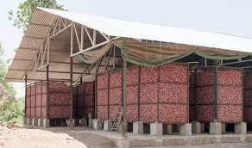.

**Fig 1.1: TRADITIONAL ONION STORAGE STRUCTURE**

**(https://www.google.com/url?sa=i&url=https%3A%2F%2Fblog.bijak.in)**

**II LITERATURE REVIEW**

This literature review provides an overview of existing research and studies related to onion storage ventilation systems. It examines the key findings, methodologies, and advancements in the field, focusing on the impact of ventilation on onion quality, shelf life extension, and the preservation of nutritional attributes. The review also discusses the challenges and future directions for improving onion storage ventilation systems

1. STORAGE OF CROPS IN NATURAL VENTILATION: A REVIEW

Kaur, J., Aslam, R., Afthab Saeed, P.

Environment Conservation Journal,22(SE):95-105, Published on 22 October 2020

India holds the higher position in crop production globally, producing vegetables, fruits, cotton, coffee and spices in large quantities. A large portion of such products is lost owing to bad storage practices. The post-harvest losses associated with fruits and vegetables have been put in the range of 6-18% (Nanda et al., 2012). Appropriate storage environment can improve the quality and marketability of produce. To obtain a suitable atmosphere for the produce, advanced provisions like temperature, air circulation, and relative humidity (RH) control could be made. Also, the composition of air in the storage area could be regulated. Storage spaces can be classified based on the requirement of refrigeration, i.e., those requiring refrigeration and those that do not (El Ramady et al., 2015). Clamps, ventilated structures, cellars, and evaporative cooling chambers are some conventionally used low-cost traditional storage structures. On the other hand, cold or refrigerated storage, modified atmospheric packaging (MAP), controlled atmospheric storage (CAS), hypobaric storage etc. are modern storage techniques used in large industries that provide more effective storage facilities.

|  |
| --- |
| Unorganized retail dwelling upon traditional technology setup and constrained funds is not able to |
| compete with superior technology and infrastructure-based organized retail. It severely affects the |
| social structure and occupational well-being of the unorganized retailers. There lies a dire need to |
| equip them with technology-enriched low-cost design interventions that may empower them to |
| compete with the organized retail. Several researchers have advocated the need of designing and |
| developing context-specific design interventions as a mitigating solution. In the present research, |
| the authors have looked into the problems and challenges faced by street vendors and proposed a |
| low-cost, multipurpose vending cart to empower the street vendors. It will enable them to compete |
| with their counterparts. Its market potential, probable user-acceptance, and enablement aspects |
| have been tested and accumulated using the System Usability Scale and securing Intellectual |
| Property Rights. This paper highlights the developed innovative intervention with its working |
| details. It may act as a ready reckoner and potential literature source for the researchers, |
| entrepreneurs, social scientists to develop similar kinds of innovative solutions to equip the lower |
| strata population for their betterment and occupational well-being. |

**PRECOOLING AND COLD STORAGE METHODS FOR FRUITS AND VEGETABLES IN SUB-SAHARAN AFRICA—A REVIEW Edna Makule 1,\*, Noel Dimoso 1 and Savvas A. Tassou**

**MDPI, Published on 26 August 2022,** Fruits and vegetables, known for their large nutrient potential, are more susceptible to high postharvest loss than other crops. Factors such as perishability, poor post-production handling and storage and processing infrastructures, increase the magnitude of food losses. The postharvest loss of fruits and vegetables in Sub-Saharan Africa ranges from 30% to 50%. One key strategy to overcome such losses is through cold chain integration in value chains. However, most developing countries currently lack the basic infrastructure and management skills needed to support the development of integrated cold chains, particularly in rural areas, where up to 60% of overall food losses occur on the farm and in ‘first-mile’ distribution. Storage of highly perishable produce in a controlled environment with respect to temperature and relative humidity leads to quality and quantity preservation. This contributes to increases in food and nutrition security, household incomes and environmental protection. This review addresses the need for adopting and strengthening measures for the precooling and cold storage of fruits and vegetables to improve their value chains. A range of precooling and cold storage methods, their suitability, energy demands and the constraints on storage and distribution are discussed and recommendations are made on how to improve their accessibility for small-scale farmers in rural communities.

**STUDY ON ZERO ENERGY COOL CHAMBER(ZECC) FOR STORAGE OF VEGETABLES Anand Mishra, Sanjeet Kumar Jha and Pravin Ojha International Journal of Scientific and Research Publcations(IJSRP), Vol.10 Published on 10 january 2020, t**wo-third of the population of Nepal depends on agriculture which shares about 31% of gross domestic product. Although there is huge potential of vegetable cultivation in Nepal, however postharvest losses of vegetable negatively affect the economy of Nepalese agriculture. The vegetables are vulnerable to high temperature. The adoption of newer storage techniques is necessary to prevent waste of fresh vegetables. The zero energy cool chamber (ZECC) is an eco-friendly system with low cost of construction. The present study was conducted to qualify the quality and storability of vegetables(pointed gourd and okra) in different storage conditions such as in ZECC, room, and freeze conditions. We measured the physiological loss of water (PLW) and vitamin C of vegetables under different storage conditions. The study was conducted at Agricultural Engineering Division, Khumaltar, Lalitpur, Nepal. Pointed gourd and okra were purchased from the local market. They were stored in three different storages conditions such as in ZECC room condition, and freeze conditions. The results showed that the highest PLW (%) was recorded on fifth days of storage for the room storage and the lowest was recorded for ZECC condition. The vitamin C significantly increased on the fifth day of storage compared to the first day for all types of storage. On the seventh day of storage, vitamin C was decreased compared to the fifth day in both ZECC and freeze conditions. The PLW was higher in freeze storage condition compared to that of ZECC condition. We concluded that pointed gourd and okra stored in ZECC can be stored until fifth day of storage after considering both quality and PLW. Our result suggested that ZECC can be used as a storage structure for vegetables such as pointed gourd and okra.

STORAGE ANALYSIS OF FRUITS AND VEGETABLES STORED IN LOW COST EARTHEN POT COOLING CHAMBER AND PUSA ZERO ENERGY COOL CHAMBER

Dr. Karuna Kumari, Sanjeev Kumar and Gopal Krishna,

Journal of Pharmacognosy and Phytochemistry, Vol.7, Published on 2018

India ranks second in fruit and vegetable production in the world after China. Despite having such a huge production of eatables, India still fails to fulfill the daily food requirement of an average citizen. Also there is an immense loss in post-production processing, with a huge difference between gross production and net availability. As per an estimate, 30-40% of the produced fruits and vegetables in the country are lost due to wastage and value destruction. Post-harvest losses are very difficult to be curbed, but with the help of better techniques, these losses can be effectively minimized. Earthenware Cool Chamber (ECC) is an eco-friendly, non-toxic, less expensive and biodegradable pot which is made up of readily available materials. In this study, a double vessel ECC is designed to increase the shelf life of stored fruits and vegetables. Working on the principle of evaporation, a Pusa Zero Energy Cool Chamber (PZECC) can be effortlessly constructed anywhere with locally available materials. Evaporative cooling system not only lowers the air temperature surrounding the produce, but also increases the relative humidity of the air. The higher relative humidity retains the water content of post harvested sample. This helps prevent the drying of the products, therefore extending the shelf life of horticultural products. Evaporative cooling system is well suited in areas where temperature is high, humidity is low, and sparse air movement is available. The evaporative chambers are easy and efficient cooling systems that can reduce energy use by 70% and are less expensive to install, operate and maintain. It is economical and can store the fruits and vegetables for 7 to 9 days without

**III METHODOLOGY**

3.1**INTRODUCTION**

Specific storage requirements: Different onion varieties may have slightly different storage requirements, including temperature and humidity preferences. A ventilation system designed for one variety may not be optimal for another, requiring adjustments or separate storage spaces for different onion types.

Climatic variability in the last decade especially erratic rainfall pattern and extreme rises in temperatures led to a drastic reduction in the kharif onion crop yieldi.e., 30 to 40% in Nashik (M.S.). Increases in temperature, rainfall and relative humidity also affected the post-storage quality causing considerable losses in storage (up to 40%). Reduced production creates deficit in the domestic market supply resulting in steep price hike. Onion farming being a major source of income for the farmers of Nashik, reduction in yield increases their vulnerability. Keeping in view the constraints faced by the farmers, the study was undertaken to assess the vulnerability of kharif onion crop to changing climatic conditions in the last ten years. Asurvey of 300 farmers was undertaken from two talukas of Nashik through questionnaire and focused group discussions for the vulnerability assessment.84% farmers revealed germination failure between 40% to 70% due to excessive rainfall and from 40 % to 70% due to drought.

Ventilation systems primarily control airflow within the storage area, but they have limited control over external factors. External conditions, such as outdoor temperature, air quality, and ambient humidity levels, can still impact the storage environment and potentially affect onion quality.

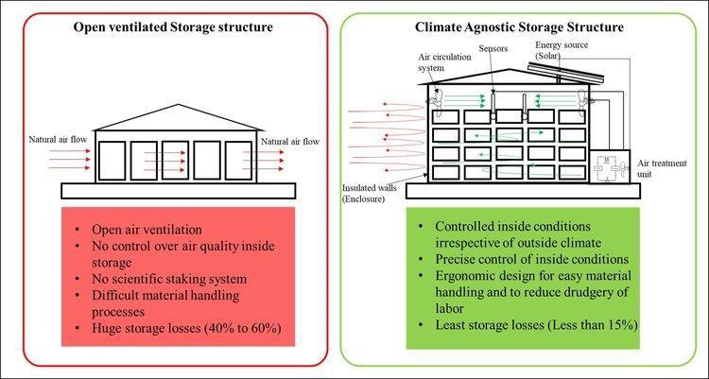

**Fig 3.1 (Ventilated Storage Structure )**

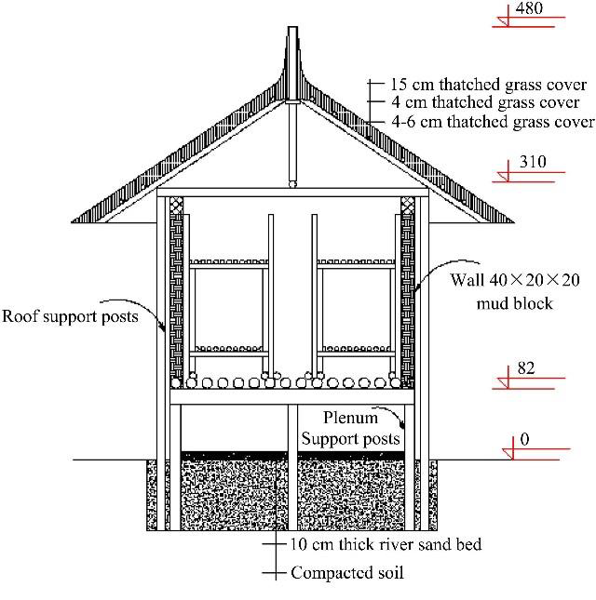

**Fig 3.2 Naturally Ventilated Onion Storage Structure**

(https://www.google.com/imgres?imgurl=https%3A%2F%2Fwww.esru.strath.ac.uk%2FEandE%2

FWeb\_sites%2F02-03%2Fzero\_emission)

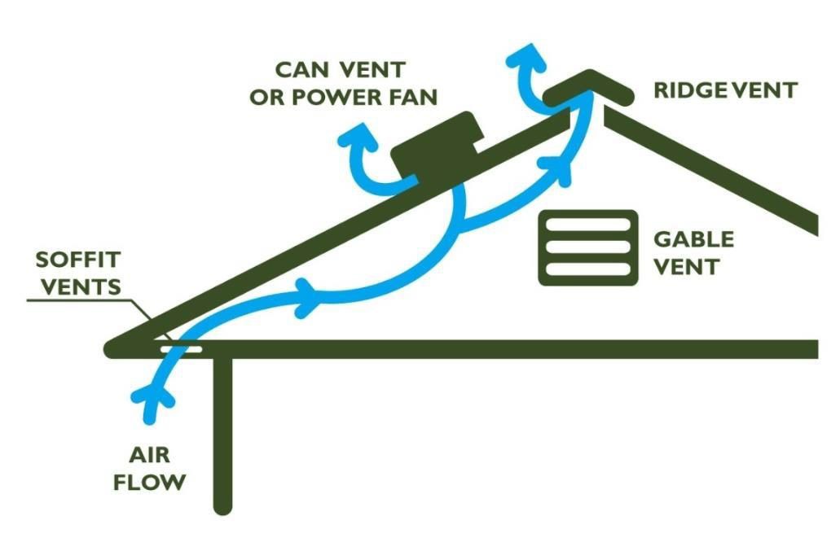

**Fig 3.3 Air Flow**

(https://www.google.com/imgres?)

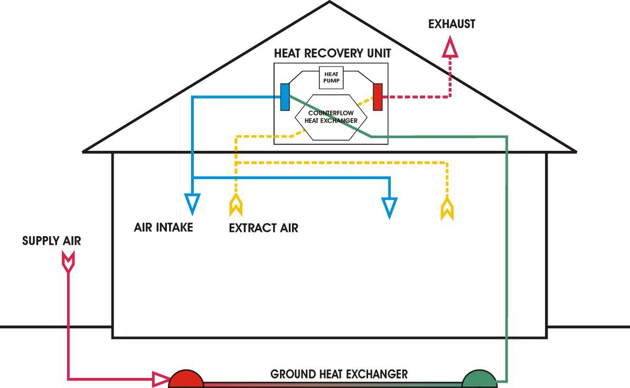

**Fig 3.4 AIR FLOW DESIGN**

(https://www.google.com/imgres?imgurl=https%3A%2F%2Fimages.adsttc.com)

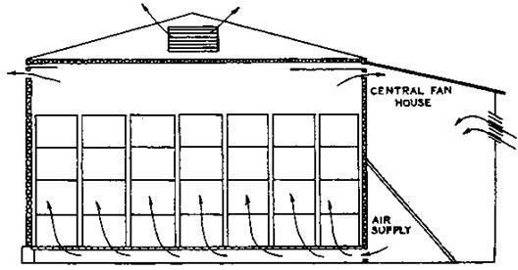

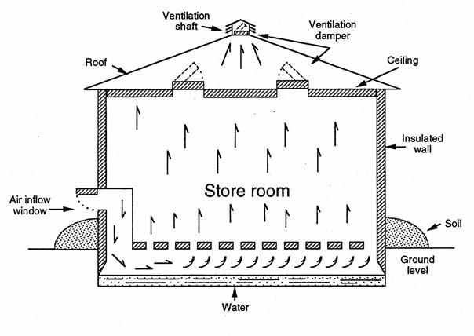

**IV EXPERIMENTAL STUDY**

**4.1 Introduction**

**T**

**BAMBOO**

In bamboo reinforced concrete steel is partially replaced by bamboo as a reinforcement. Bamboos are grass with great height, not trees also bamboo grows abundantly in tropical and sub-tropical regions [18]. The bamboo section is a sort of empty barrel-shaped shell separated by a cross-over diaphragm at nodes. Bamboo columns possess maximum and minimum strength in the direction parallel and perpendicular to the fibers respectively, and these fibers run along the length of bamboo. These fibers are distributed uniformly at the base of the bamboo and then at the middle and end portion of the bamboo. Along the length of bamboo, it is divided by several nodes into segments and each segment act as a short column. With properties such as flexibility and lightweight, bamboo gives high tensile strength [14]. Adhesion is the main drawback of bamboo as the bond strength between concrete and bamboo is weak compared to steel. Improvement can be made to increase bond strength by using a coat of material to enhance the bond. Moisture content is another problem with bamboo however moisture can be reduced by proper treatment of drying and seasoning

Several ways to treat bamboo for storage structure:

1. **Drying bamboo**

Your bamboo needs to be properly dried before you can preserve and conserve it for use in construction. For construction purposes, green bamboo is never a good choice. Bamboo that has just been cut is more enticing to insects and vermin and more prone to fungus and mold.

2**. Air drying**

Bamboo is most often dried outdoors, which is by far the most preferred method. Depending on the temperature and the size of the bamboo, this process typically takes two to three months. The most crucial component for air drying is effective ventilation. Although airflow is important, bamboo also has to be covered and protected from the sun and rain. Keep the bamboo off the ground using a rack, and then simply stack it all together. Additionally, rotating the poles every few weeks will help to prevent bending and curving and maintain even drying.

3. **Heat Treatment**

This is conceivably the best way to treat your bamboo and safeguard it from pests, mold, and the environment. The method employs the bamboo's natural resins to shield the poles. For heat-treating bamboo, all you need is an open flame, some thick gloves, and some rags. Holding the bamboo in the flame until you first notice a tiny bit of shine is the trick. The bamboo's inherent resin was freed, which gave off the shine. When you notice that, carefully remove the bamboo from the flame while using heavy, leather gloves and wipe it down with some old rags.

**Saltwater**

To soak the poles in salt water is a conventional technique that is still popular, particularly in Asia. This is comparable to pickling your bamboo to remove the sugars, preserve it, and reduce its appeal of it to pests. The bamboo is then dried for two to three months in the sun.

5. **Treating bamboo with non-toxic chemicals**

The use of pesticides containing boron as a main ingredient, such as borax, is the most common technique for curing bamboo. These goods are safe for the environment and do not offer any significant risks because they are made of minerals. Both newly harvested bamboo and built and inuse bamboo building items and furnishings can be treated with borax. The best defense against any form of bug infestation is offered by this. It works well and effectively against fungi and mold as well.

**Tensile Strength of Bamboo**

The intact closures of the specimens utilized in static bending tests must be used to create the specimens for the tensile strength test. The test specimens must have a single node in the middle. The general direction of the fibers must be perpendicular to the test specimen's longitudinal axis.

The test specimen must be more or less flat and must have a width of 10 to 20 mm and a length of 60 mm. Depending on the diameter of the culm, the specimen's thickness must be equal to or less than the thickness of the wall. All dimensions must be measured with a 0.1 mm precision. The grips of the testing apparatus must guarantee that the force is applied along the test piece's longitudinal axis and must prevent the test piece from twisting longitudinally. The test specimen should be gripped so that it is compressed radially and perpendicular to the fibers. The testing machine's movable head must move at a steady speed of 0.01 mm/s while the load is applied constantly. It is required to record the maximum load. Bamboo had an ultimate tensile strength of 321 Mpa and the top portion of bamboo has the lowest strength of 167 Mpa [14] [19] . The tensile strength of bamboo varies with the species as well as the portion of bamboo i.e., bottom, middle and Top.

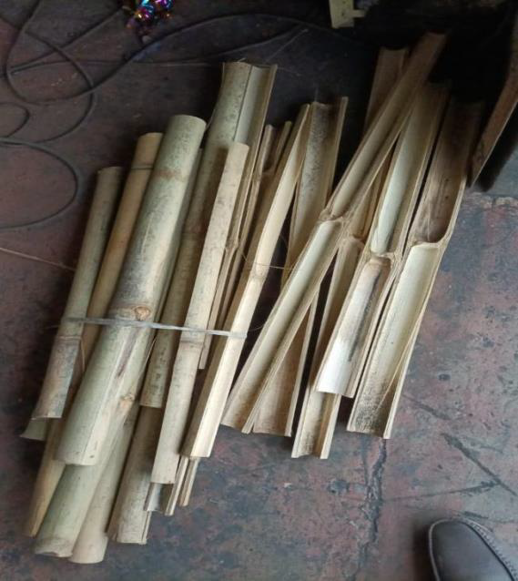

**FIG 4.1 BAMBOO**

**BRICK**

Since, cold storage are being used for the preservation of food, goods, fruits and many more things so that, they can be used for long time without any break in social supply chain. Because there are many things that comes with seasons for them cold storage needed.

Cold storage should be made in such a way that can maintain the proper environment for preserving things that's why, engineers do construct them as per requirements.

The brick that is mostly used in India is HOLLOW BRICK the reason behind using this type because of its performance and flexibility.

They (hollow brick) are great in heat preservation and heat insulation of the building and also make sure the indoor environment of storage is comfortable in every season**.**

**⚫ EXHAUST FAN**

Ventilation fans improve indoor air quality by venting unwanted dirty, humid, and stale air outside quickly, which helps to control mold and mildew growth. For ease of use and automation, modern exhaust fans have built-in timers and humidity sensors.

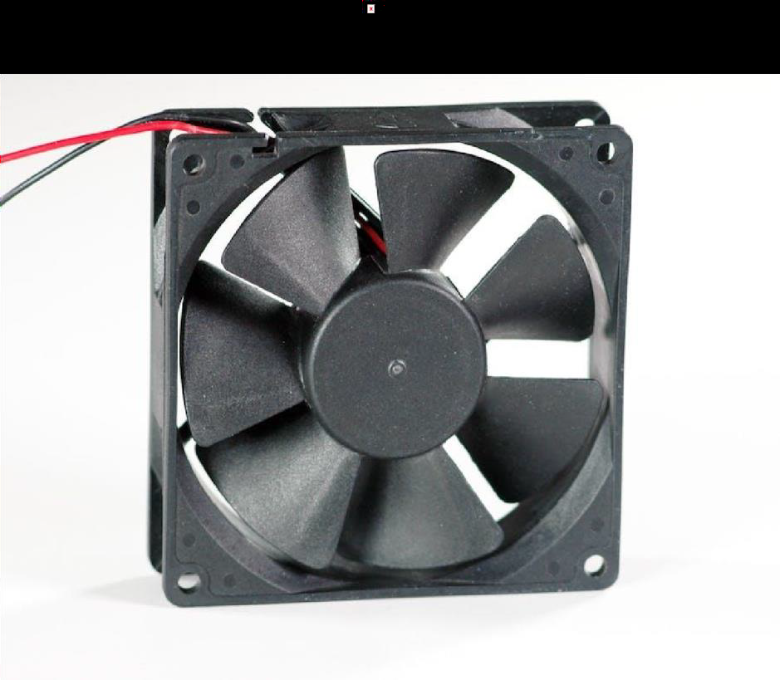

**FIG 4.2 EXHAUST FAN**

Propeller fans have two or more blades, which may be narrow or wide and may have uniform or varied pitch. Normally, the narrow-blade fan (see figure 11) is used to handle large volumes of air against free-delivery or low-static pressure heads. The common range of static pressure used for these is from O to 1 inch (0 to 25 mm) of water pressure equivalent. It's also very important that, when you operate a propeller-type fan against a static head, you use a fan with a fairly large center hub to prevent recirculation of air back through the low-velocity portion of the center axis. For onion storage ventilation systems, you'll need a fan that will operate against a minimum system static pressure head of 1 ¼ inches (32 mm). If you use a refrigeration system, you'll have to use a higher system static pressure, according to the recommendations of the manufacturer of the refrigeration equipment.

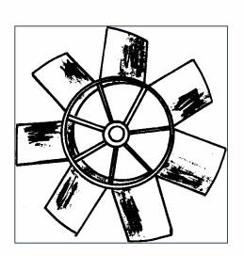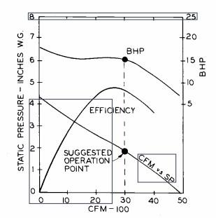

**Summary :**

onion ventilated structures rely on a combination of wood and plastic materials, along with appropriate fittings and sealants, to create a durable, weather-resistant, and well-ventilated environment for onion storage. By selecting and using these materials effectively, onion producers can optimize the storage conditions and maximize the post-harvest quality of their onions

**V CONCLUSION**

**CONCLUSION :**

Storage structure for fruits and vegetables hold huge importance considering in mind the amount of post harvest losses taking place in a developing country like India. In this aspect information regarding low cost storage structures for holding fruits, vegetables and other horticultural produce is even more important. In India where major population of farmers is poor, stay in the remote locations they can only afford construction of low cost storage structures to overcome gluts, limiting price falls and overcome shortage of a particular commodity when prices are high.

FUTURE SCOPE :

The future scope for onion ventilated storage systems lies in the adoption of advanced technologies and sustainable practices to further improve the efficiency and effectiveness of onion storage. Here are some potential areas of development:

Smart monitoring and automation: Incorporating smart sensors and monitoring systems can provide real-time data on temperature, humidity, air quality, and other factors affecting onion storage. This data can be analyzed and used to automate the ventilation system, optimizing conditions for onions and reducing manual intervention.

Energy-efficient solutions: Energy consumption is a significant consideration in onion storage systems. Future advancements may focus on energy-efficient fans, blowers, and cooling systems to reduce electricity usage and minimize environmental impact.

Climate control and precision storage: Climate control systems that can precisely regulate temperature, humidity, and airflow based on the specific requirements of onions can enhance storage conditions. This approach helps to maintain consistent quality and extends the shelf life of onions.

Improved packaging and handling: Innovations in packaging materials can provide better insulation and moisture control, preserving the quality of onions during storage. Additionally, developments in handling and transportation methods can minimize damage and reduce post-harvest losses.

Integration of renewable energy sources: Incorporating renewable energy sources such as solar or wind power into the ventilation system can make onion storage more sustainable and environmentally friendly.

**REFERENCES**

1. P.Arul Paul Sudhahar,V.K.KalaiVani, The Total Edge Monophonic Number of a Graph, International Journal of Applied Mathematics.ISSN 1819-4966 Volume 11,Number 2 (2016) pp.159-166.
2. F.Buckley and F. Harary, *Distance in Graphs*, Addison-Wesley, Redwood City, CA, (1990).
3. F. Buckley, F. Harary, and L. V. *Quintas*, Extremal Results on the Geodetic Number of a Graph, Scientia A2 (1988) 17-26.
4. G. Chartrand, F. Harary, and P. Zhang, On the Geodetic Number of a Graph, *Networks*. 39 (2002) 1-6.
5. F. Harary, *Graph Theory*, Addison- Wesley, 1969.
6. J. John, P. Arul Paul Sudhahar, On the edge monophonic number of a graph, Filomat 26:6 (2012), 1081 - 1089.
7. J.Jhon, P.Arul Paul Sudhahar,The Upper Edge Monophonic Number of a graph, IJMCAR, ISSN 2249-6955, vol 3,(2013) 291-296.
8. J. John, S. Panchali, The Upper Monophonic Number of a Graph, International J. Math, Combin. Vol. 4 (2010), 46-52.
9. A.P. Santhakumaran, P. Titus, K. Ganesamoorthy, On the Monophonic Number of a Graph, *J. Appl. Math. & Informatics* Vol. 32 (2014), No. 1 – 2, pp. 255 – 266.
10. P.Arul Paul Sudhahar,V.K.KalaiVani,International Journal of Computational and Applied Mathematics.ISSN 1819-4966 Volume 11,Number 2 (2016) pp.159-166.
11. F. Harary, *Graph Theory*, Addison- Wesley, 1969.
12. J. John, P. Arul Paul Sudhahar, On the edge monophonic number of a graph, Filomat 26:6 (2012), 1081 - 1089. J.Jhon, P.Arul Paul Sudhahar,
13. The Upper Edge Monophonic Number of a graph, IJMCAR, ISSN 2249-6955, vol 3,(2013) 291-296.
14. J. John, S. Panchali, The Upper Monophonic Number of a Graph, International J. Math, Combin. Vol. 4 (2010), 46-52.
15. A.P. Santhakumaran, P. Titus, K. Ganesamoorthy, On the Monophonic Number of a Graph, *J. Appl. Math. & Informatics* Vol. 32 (2014), No. 1 – 2, pp. 255 – 266.
16. P.Arul Paul Sudhahar,V.K.KalaiVani,International Journal of Computational and Applied Mathematics.ISSN 1819-4966 Volume 11,Number 2 (2016) pp.159-166.
17. F. Harary, *Graph Theory*, Addison- Wesley, 1969.
18. J. John, P. Arul Paul Sudhahar, On the edge monophonic number of a graph, Filomat 26:6 (2012), 1081 - 1089. J.Jhon, P.Arul Paul Sudhahar,
19. The Upper Edge Monophonic Number of a graph, IJMCAR, ISSN 2249-6955, vol 3,(2013) 291-296.
20. J. John, S. Panchali, The Upper Monophonic Number of a Graph, International J. Math, Combin. Vol. 4 (2010), 46-52.
21. A.P. Santhakumaran, P. Titus, K. Ganesamoorthy, On the Monophonic Number of a Graph, *J. Appl. Math. & Informatics* Vol. 32 (2014), No. 1 – 2, pp. 255 – 266.
22. Puneet Jain , Auwal Alhassan Musa , Lasmar Garba, 2020, Application of Nanomaterials in Transportation Engineering, INTERNATIONAL JOURNAL OF ENGINEERING RESEARCH & TECHNOLOGY (IJERT) Volume 09, Issue 02 (February 2020),
23. Assessement of Safety Management for Public Construction Sites in Nigeria. Crossref DOI link: [https://doi.org/10.35940/ijitee.A7105.119119](https://doi.org/10.35940/ijitee.A7105.119119" \t "_blank), Published Online: 2019-11-30 Update policy: [https://doi.org/10.35940/beiesp.crossmarkpolicy](https://doi.org/10.35940/beiesp.crossmarkpolicy" \t "_blank) , Authors Jain\*, Er. Puneet ,Garba, Lasmar.
24. Puneet Jain2, Murala Giridhar Sai1,May –June 2020, Assessment of Fiber Reinforced Concrete (FRC) with Industrial Wastage Material for Rigid Pavements, TEST Management Journal, Article Info Volume 83 Page Number: 13446 -13451Publication Issue: May -June 20.
25. Jain, P. (2017). Partial Replacement of Fine Aggregate with Glass Using DIC Technique with Waste Materials for Investigation of Crack Propagation. International Journal of Engineering Research and Application, 7(11), 5. https://doi.org/DOI: 10.9790/9622-0711056165
26. Jain, P. (2017). Determining Mix Proportion For The Marble Slurry Powder Recovered From Marble Slurry Replacing Fine Aggregate Of Concrete Used In Residential Construction Project In Udaipur, India. IJERA, 7(10), 30–35. https://doi.org/DOI: 10.9790/9622-0710053035
27. Development of eco-friendly low-cost package for shelf-life enhancement of fruits and vegetable, Article, Aug 2022.
28. 3. Indian Horticulture Journal; 6(3): 376-379, July-September (2016) ©Indian Society of Advanced Horticulture ISSN: 2249-6823 DI: 297-16-IHJ-0604-2016-95.
29. Low Cost Storage Structures for Fruits and Vegetables Handling in Indian Conditions .Storage structures for horticultural crops: a review March 2021Environment Conservation Journal 22(SE):95-105.
30. Evaluation of Low-Cost Vegetable Cooling and Storage Technologies in Mali. June 2018.
31. Project: Evaporative Cooling Technologies for Improved Fruit and Vegetable Storage, Authors : Eric Verploegen , Ousmane Sanogo
32. Islam, M. P., & Morimoto, T. (2012). Zero energy cool chamber for extending the shelf-life of tomato and eggplant. Japan Agricultural Research Quarterly:
33. JARQ, 46(3), 257-267.
34. Yadav, R T., Yadav, A N., Ghag, K S., & Gavnang, M. R. (2011). Comparative study of low cost evaporative cooling system for storage of tomato, International Journal of Agricultural Engineering, 3 (2), Oct. 2010.
35. Rayaguru, K., Khan, M. K., & Sahoo, N. R. (2011). Water use optimization in zero energy cool chambers for short term storage of fruits and vegetables in coastal area. Journal of food science and technology, 47(4), 437-441