Study of Different Infill Material on the Seismic Behaviour of Multi-Storey Building

Sourabh Alatekar1, Prasad Babar1, Sanket More1. Avinash Thorat1, Shubham Desai1,Dipak Pawar2

U.G. Student, Department of Civil Engineering, SSIET, Ghogaon, Maharashtra, India1 Assistant Professor , Department of Civil Engineering, SSIET, Ghogaon, Maharashtra, India2

**ABSRTACT:** Display circumstance development of Multistory building is exceptionally tall since of fast urbanization all over the world. Open to begin with story is for the most part given for stopping, gathering anterooms, communication corridors or any reason in multi-storey building. But in case of seismic tremor multi-storey building with delicate story gives destitute execution. There are different variables influences on the conduct of multi-storey building i.e. inconsistency in arrange and rises, uneven dispersion of mass etc. Infill divider in outline building gives solidness and makes strides the conduct of building beneath horizontal loads. Within the show work, think about of distinctive infill materials on the seismic conduct of multi-storey building with delicate stories is carried out. For that, G+12 RCC demonstrate is chosen. Distinctive infill materials like siporex and clay brick are utilized. Diverse area of delicate stories are considered for the investigation. To think about of distinctive infill fabric on the seismic conduct of multistory building, direct energetic examination (Reaction range examination) in ETABs program is carried out. Diverse seismic parameters like time period, story shear, story relocation and story float are checked out.

*KEYWORDS*: Multi-storey building, infill materials, Response spectrum analysis, seismic behaviour, RCC frame.

### Introduction

Cities are growing quickly all over the world, and there is a need for more buildings to be built upwards instead of outwards to save space. This is because more people need places to live and work. In recent times, more tall buildings have been built with an open ground floor for parking. This means the columns on the ground floor don't have walls between them. These kinds of buildings are often called open ground floor buildings or buildings on stilts. The ground floor is more flexible than the upper floors, so it can move more during an earthquake. This is called a soft storey. A soft storey is a floor that is not as strong as the floor above it or the average strength of the three floors above it. So, a building with no walls in the first floor or in between floors is called a soft storey. A soft storey building is a building where one or more floors are not very strong because of how they were built. The soft story might have a lot of open space, big stores, or lots of windows. known as a weak story, refers to a floor in a building that is not as strong or resistant to earthquakes as the floors above it. This can make the building more vulnerable to collapse duringearthquake.

Called a weak floor. A soft storey building is one where one floor is weaker than the others. A soft storey is when one floor of a building has less support than the others, making it weaker. This can be dangerous in a tall building without solid walls on that floor. The walls on the higher floors may absorb the earthquake shakes and become stronger. The ground floor without walls is not as strong as the upper floors. It is important for buildings to be designed to withstand earthquakes in a way that keeps people safe and minimizes damage to the economy and structures. India is split into four areas based on how much earthquakes happen there. According to the IS code IS: 1893-2002, they are in Zone II, III, IV, and V as per the Seismic Zoning Map. Lower floors in tall buildings can easily collapse during an earthquake. These tall buildings with weak levels collapsed because they were not built properly. In tall buildings made of concrete, brick walls are usually built for practical and design reasons. It is known that the material used to fill in the spaces of a framed structure has a big impact on how well the building stands up to earthquakes.

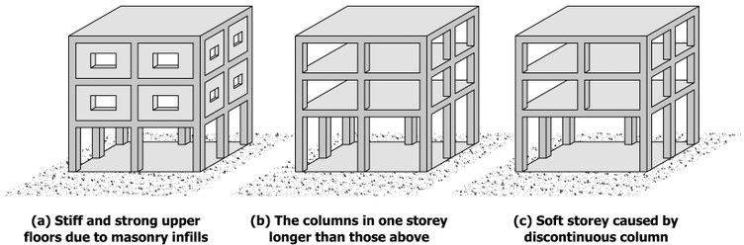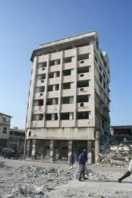

Fig.1.1 Multistory building with soft storey Fig 1.2 Actual view of multistorey building with soft story

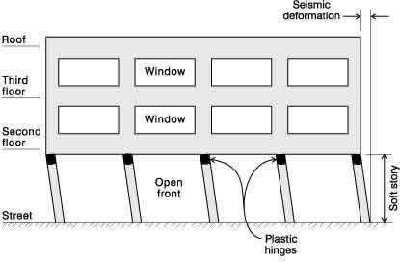[A. Charleson, Seismic Design for Architects, Architectural Press 2008, p.146, Fig. 9.3]

Fig 1.3 Detailing of soft story multistorey building

[A. Charleson, Seismic Design for Architects, Architectural Press 2008, p.146, Fig. 9.3]

### Structural action of infill frames:

Usually, infill frames are made with a concrete frame and different materials used as infill. It's usually seen as something that doesn't affect the structure. Infill walls make buildings strong. Adding a wall inside a building makes it better at withstanding earthquakes. The hole in the brick wall makes the building less strong from the side. Using infill materials makes buildings stronger against sideways forces. So, the infill wall is very important for the structure.

### ANALYTICAL WORK

Response spectrum method is used for seismic analysis of a 13 storied RCC multistory building with soft storey. The different infill materials with different locations of soft storey are used to study the effect of position of soft

storey on behaviour of building. Infill wall provides stiffness and lateral strength to building. The behaviour of multistory building is studied for different parameters like time period, story shear, lateral displacement, story drift, etc[16].

### Infill materials considered for seismic analysis of multistory building:

1. Clay Bricks
2. Siporex Blocks

### Different Models considered for analysis:

Model No. 1: Multistory building with Soft

storey at ground floor.

Model No. 2: Multistory building with Soft

storey at seventh floor.

Following figures shows the Models done in ETABs software

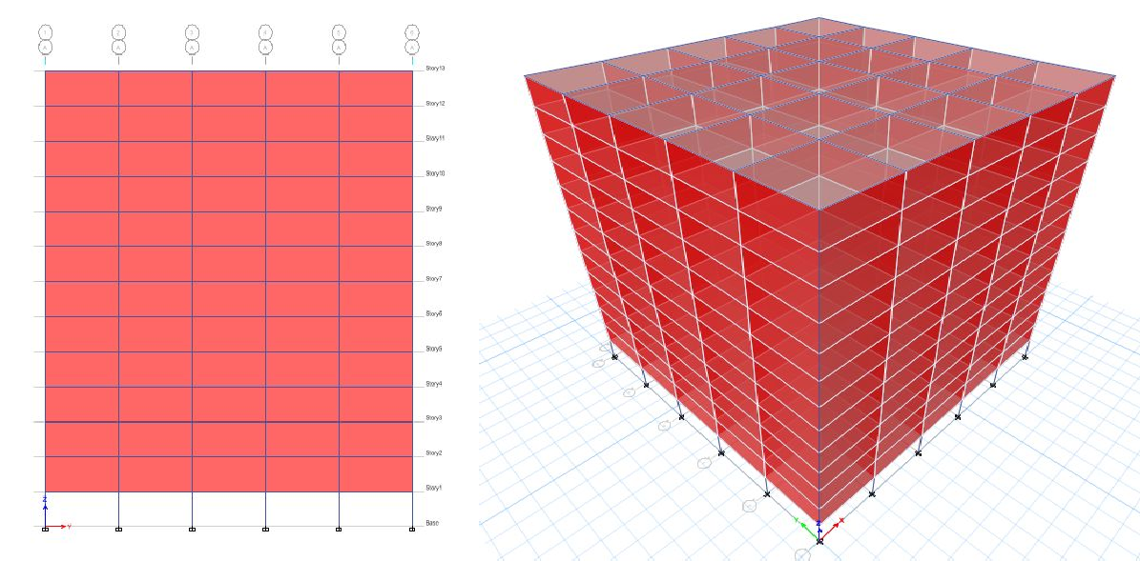

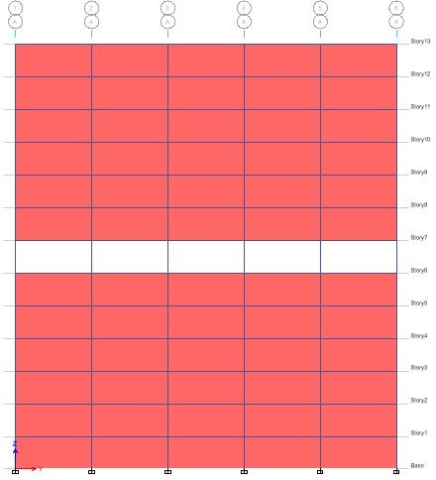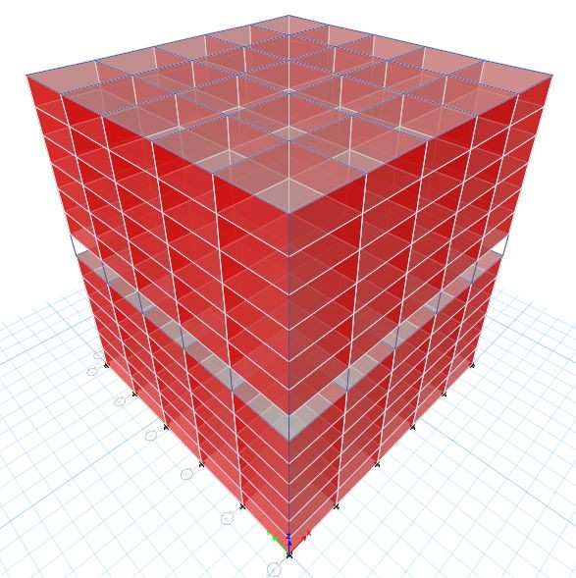

Fig. 2.1 Model No. 1: Multistorey building with Fig. 2.2 Model No. 2: Multistorey building with Soft Soft floor at ground floor storey floor at seventh floor.

### Structural data:

Structural data as shown in table 2.1 given below

### Table 2.1 details of structural data

|  |  |  |
| --- | --- | --- |
| Sr. No. | Parameters | Description |
| 1 | Type of structure | Residential (G+12) |
| 2 | Floor to Floor to height | 3 M |
| 3 | Size of Beam | 300mmX500mm |
| 4 | Size of column | 500mmX500mm |
| 5 | Slab thickness | 130mm |
| 6 | Wall thickness | 150 mm |
| 7 | Live Load | 2KN/m2 |
| 8 | Floor Finish Load | 1KN/m2 |
| 9 | Type of structure | RCC |
| 10 | Seismic zone | V |
| 11 | Importance factor (I) | 1 |
| 12 | Response reduction  factor (R) | 3 |
| 13 | Damping of structure | 5% |
| 14 | Zone factor (Z) | 0.36 |
| 15 | Infill materials | 1. Clay Brick 2. Siporex Block |

Fig. 2.3 Typical plan of considered model for study

### RESULT ANALYSIS AND DISCUSSION

Results obtained from ETABs software for different condition given as follows:

### Clay Brick as an infill material

* + 1. **Time period Time**

**2.4** The plan layout of the multistory RCC frame building with G+12 Storey is shown in fig. 2.3

Time period in sec. is given below in table 3.1.

### Table 3.1 Time period for Clay Brick (Sec.)

|  |  |  |
| --- | --- | --- |
| Infill material | Model 1 | Model 2 |
| Clay Brick | 0.796 | 0.723 |

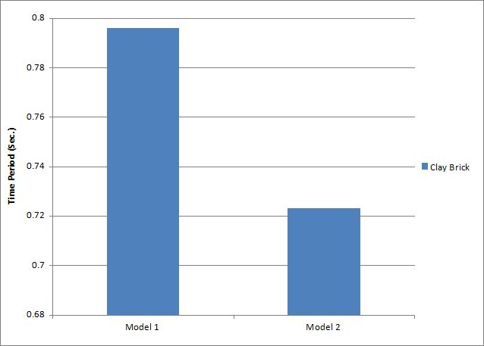From graph 3.1 it is observed that the time period is obtained 9.171% less for Model 2 as compare to Model

1 in case of Clay Brick as an infill material in multistorey building with soft story. It indicates that soft storey at seventh floor is most suitable than soft storey at ground floor in multistorey building. Time period is depends on position of soft storey in building.

Graph 3.1 Time period

.

### Storey shear:

Storey shear is the sum of design lateral forces at all levels above the storey under consideration. Base shear is an estimate of the maximum expected lateral forces that will occur due to seismic ground motion at the base of structure.

Base shear is calculated as shown in table 3.2.

### Table 3.2 Storey shear for Clay Brick (KN)

|  |  |  |  |
| --- | --- | --- | --- |
| Storey | Elevation | Model 1 | Model 2 |
| X and Y- Dir. | X and Y- Dir. |
| Story 13 | 39 | 1744.281 | 2217.649 |
| Story 12 | 36 | 3796.79 | 4807.99 |
| Story 11 | 33 | 5759.214 | 7254.133 |
| Story 10 | 30 | 7621.125 | 9540.774 |
| Story 9 | 27 | 9378.643 | 11667.39 |
| Story 8 | 24 | 11032.12 | 13655.32 |
| Story 7 | 21 | 12583.79 | 15199.33 |
| Story 6 | 18 | 14036.25 | 15816.52 |
| Story 5 | 15 | 15391.86 | 16633.4 |
| Story 4 | 12 | 16652.74 | 17533.18 |
| Story 3 | 9 | 17817.92 | 18377.01 |
| Story 2 | 6 | 18892.33 | 19024.36 |
| Story 1 | 3 | 19537.53 | 19303.8 |

Graph 3.2 Variation of Storey shears along X & Y- Direction for Clay Brick

From graph 3.2 it is observed that for Model 1 Storey shears is found more in comparison to Model 2. And Base shear is 1.17% greater for Model 1 as compare to

Model 2. As shown in results the position of soft storey not significantly effective. Base shear is also depends on position of soft storey in building. pounding and

estimating maximum storey drift to avoid destruction of non-structural elements.

### Storey displacement:

For seismic design it is important to estimate, maximum lateral displacement of the structures due to

sever earthquake for several reasons. Such as estimating minimum separation joint width to avoid

Story displacement is calculated as shown in table 3.3 for multistorey building.

### Table 3.3 Storey displacement for Clay Brick (mm)

|  |  |  |  |
| --- | --- | --- | --- |
| Storey | Elevation | Model 1 | Model 2 |
| X and Y- Dir. | X and Y- Dir. |
| Story 13 | 39 | 28 | 28.8 |
| Story 12 | 36 | 27.3 | 28.2 |
| Story 11 | 33 | 26.6 | 27.3 |
| Story 10 | 30 | 25.7 | 26.2 |
| Story 9 | 27 | 24.7 | 25 |
| Story 8 | 24 | 23.5 | 23.7 |
| Story 7 | 21 | 22.2 | 21.8 |
| Story 6 | 18 | 20.8 | 10 |
| Story 5 | 15 | 19.3 | 8 |
| Story 4 | 12 | 17.8 | 6.4 |
| Story 3 | 9 | 16.2 | 4.8 |
| Story 2 | 6 | 14.6 | 3.1 |
| Story 1 | 3 | 12.6 | 1.5 |

Graph 3.3 Variation of Storey displacements along X & Y- Direction for Clay Brick

From above graph 3.3 it is observed that the storey displacement at initial stage i.e. First storey is less for Model 2 as compare to Model 1. As shown in graph in Model 2 displacement is suddenly increases because of

soft story is provided at middle of multistory building. From reference of above graph more displacement obtains at rising level of soft storey. Therefore it is observed that soft storey provides at perticular floor the story

displacement raises suddenly for that particular floor where soft story is provided. Storey displacement is obtained 2.857% less for Model 1 as compare to Model 2.

### Storey drift:

It is the displacement of one level relative to the other level above or below. Drift is the maximum lateral displacements of the structure with respect to total height

or relative inter storey displacement. Drift have three primary effects on a structure; the movement can affect the structural elements, non- structural elements and adjacent structures, without proper consideration large deflection and drifts have adverse effects on structural elements, non-structural elements and adjacent structures. Story drift is calculated as shown in table 3.4.

### Table 3.4 Storey drift for Clay Brick

|  |  |  |  |
| --- | --- | --- | --- |
| Storey | Elevation | Model 1 | Model 2 |
| X and Y- Dir. | X and Y- Dir. |
| Story 13 | 39 | 0.000211 | 0.000238 |
| Story 12 | 36 | 0.000257 | 0.000296 |
| Story 11 | 33 | 0.000307 | 0.000359 |
| Story 10 | 30 | 0.000354 | 0.000423 |
| Story 9 | 27 | 0.000397 | 0.000449 |
| Story 8 | 24 | 0.000436 | 0.000674 |
| Story 7 | 21 | 0.000469 | 0.004096 |
| Story 6 | 18 | 0.000498 | 0.000704 |
| Story 5 | 15 | 0.000519 | 0.000529 |
| Story 4 | 12 | 0.000545 | 0.000558 |
| Story 3 | 9 | 0.000523 | 0.000549 |
| Story 2 | 6 | 0.00074 | 0.00055 |
| Story 1 | 3 | 0.004192 | 0.000489 |

Graph 3.4 Variation of Storey drift along X & Y- Direction for Clay Brick

As per IS 1893:2002 maximum storey drift should not be more than 0.004 times to storey height of the structure. Here value of limiting storey drift is 0.012 where height of storey is 3m. From the graph 3.4 it is observed that the

values of the storey drift for all the stories are found to be within the limits.

Time period in sec. is given below in table 3.5.

### Table 3.5 Time period for Siporex Block (Sec.)

|  |  |  |
| --- | --- | --- |
| Infill material | Model 1 | Model 2 |
| Siporex blocks | 0.749 | 0.685 |

From graph 3.5 it is observed that the time period is obtained 5.1314% less for Model 2 as compare to Model

1 in case of Siporex Block as an infill material in multistorey building with soft story. It indicates that soft storey at seventh floor is most suitable than soft storey at ground floor in multistorey building. Time period is depends on position of soft storey in building.

Graph 3.5 Time period for Siporex Block

### Storey shear:

Storey shear is calculated as shown in table 3.6.

### Table 3.6 Storey shear for Siporex Block (KN)

|  |  |  |  |
| --- | --- | --- | --- |
| Storey | Elevation | Model 1 | Model 2 |
| X and Y- Dir. | X and Y- Dir. |
| Story 13 | 39 | 1595.481 | 2033.018 |
| Story 12 | 36 | 3366.177 | 4273.093 |
| Story 11 | 33 | 5061.898 | 6393.157 |
| Story 10 | 30 | 6673.493 | 8379.841 |
| Story 9 | 27 | 8196.903 | 10231.32 |
| Story 8 | 24 | 9631.334 | 11963.38 |
| Story 7 | 21 | 10977.45 | 13396.22 |
| Story 6 | 18 | 12236.28 | 13994.86 |
| Story 5 | 15 | 13408.75 | 14701.18 |
| Story 4 | 12 | 14495.77 | 15445.92 |
| Story 3 | 9 | 15495.92 | 16127.25 |
| Story 2 | 6 | 16413.12 | 16642.77 |
| Story 1 | 3 | 16983.36 | 16856.46 |

Graph 3.6 Variation of Storey shears along X & Y- Direction for Siporex Block

greater for Model 2 as compare to Model 1. As shown in results the position of soft storey not significantly

effective. Base shear is also depends on direction and position of soft storey in building.

### Storey displacement:

Story displacement is calculated as shown in table 3.7.

### Table 3.7 Storey displacement for Siporex Block (mm)

|  |  |  |  |
| --- | --- | --- | --- |
| Storey | Elevation | Model 1 | Model 2 |
| X and Y- Dir. | X and Y- Dir. |
| Story 13 | 39 | 24.9 | 26.1 |
| Story 12 | 36 | 24.3 | 25.4 |
| Story 11 | 33 | 23.7 | 24.6 |
| Story 10 | 30 | 22.8 | 23.7 |
| Story 9 | 27 | 21.9 | 22.6 |
| Story 8 | 24 | 20.9 | 21.4 |
| Story 7 | 21 | 19.7 | 19.7 |
| Story 6 | 18 | 18.4 | 9.1 |
| Story 5 | 15 | 17.1 | 7.3 |
| Story 4 | 12 | 15.7 | 5.9 |
| Story 3 | 9 | 14.2 | 4.3 |
| Story 2 | 6 | 12.8 | 2.8 |
| Story 1 | 3 | 11 | 1.3 |

Story drift is calculated as shown in table 3.8.

### Table 3.8 Storey drift for Siporex Block

|  |  |  |  |
| --- | --- | --- | --- |
| Storey | Elevation | Model 1 | Model 2 |
| X and Y- Dir. | X and Y- Dir. |
| Story 13 | 39 | 0.000188 | 0.000215 |
| Story 12 | 36 | 0.00023 | 0.000268 |
| Story 11 | 33 | 0.000276 | 0.000325 |
| Story 10 | 30 | 0.000319 | 0.000383 |
| Story 9 | 27 | 0.000358 | 0.000407 |
| Story 8 | 24 | 0.000393 | 0.000613 |
| Story 7 | 21 | 0.000423 | 0.003628 |
| Story 6 | 18 | 0.00045 | 0.000645 |
| Story 5 | 15 | 0.00047 | 0.000486 |
| Story 4 | 12 | 0.000493 | 0.000512 |
| Story 3 | 9 | 0.000475 | 0.000503 |
| Story 2 | 6 | 0.000671 | 0.000503 |
| Story 1 | 3 | 0.003654 | 0.000445 |

Graph 3.8 Variation of Storey drift along X & Y- Direction for Siporex Block

As per IS 1893:2002 maximum storey drift should not be more than 0.004 times to storey height of the structure. Here value of limiting storey drift is 0.012 where height of storey is 3m. From the graph 3.8 it is observed that the values of the storey drift for all the stories are found to be within the limits.

### Comparison of Clay Brick and Siporex Block as an infill material:

* + 1. **Time period:**

Time period in sec. is given in table 3.9.

### Table 3.9 Time period for comparison of Clay Brick and Siporex Block for comparison of Clay Brick and Siporex Block (Sec.)

|  |  |  |
| --- | --- | --- |
| Infill material | Model 1 | Model 2 |
| Clay Bricks | 0.796 | 0.723 |
| Siporex Blocks | 0.749 | 0.685 |

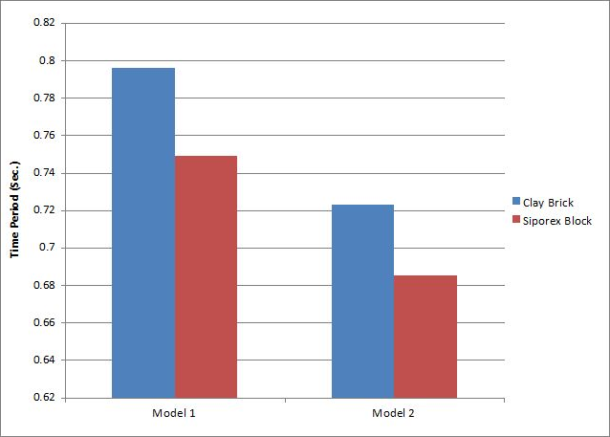

Graph 3.9 Time period for comparision of different infill materials

From graph 3.9 it is observed that Model 2 Siporex Block obtains minimum time period. For different infill materials i.e. Clay Brick and Siporex Block, Time Period is minimum when Siporex Block is used as infill material. It is 5.90% and 5.25% minimum than Clay Brick for Model 1 i.e. soft storey at ground floor and Model 2 i.e. soft storey at seventh floor respectively. As per reference of above graph with comparison other models, Model 2 give less time period.

### Storey shear:

Storey shear is calculated as shown in table 3.10.

### Table 3.10 Storey shear for for comparison of Clay Brick and Siporex Block (KN)

|  |  |  |  |  |  |
| --- | --- | --- | --- | --- | --- |
| Storey | Elevation | Model 1  Clay Brick | Model 2  Clay Brick | Model 1  Siporex Block | Model 2  Siporex Block |
| X and Y- Dir. | X and Y- Dir. | X and Y- Dir. | X and Y- Dir. |
| Story 13 | 39 | 1744.282 | 4807.99 | 1595.481 | 2033.018 |
| Story 12 | 36 | 3796.791 | 7254.133 | 3366.177 | 4273.093 |
| Story 11 | 33 | 5759.214 | 9540.774 | 5061.898 | 6393.157 |
| Story 10 | 30 | 7621.126 | 11667.39 | 6673.493 | 8379.841 |
| Story 9 | 27 | 9378.643 | 13655.32 | 8196.903 | 10231.32 |
| Story 8 | 24 | 11032.12 | 15199.33 | 9631.334 | 11963.38 |
| Story 7 | 21 | 12583.79 | 15816.52 | 10977.45 | 13396.22 |
| Story 6 | 18 | 14036.25 | 16633.4 | 12236.28 | 13994.86 |
| Story 5 | 15 | 15391.86 | 17533.18 | 13408.75 | 14701.18 |
| Story 4 | 12 | 16652.74 | 18377.01 | 14495.77 | 15445.92 |
| Story 3 | 9 | 17817.92 | 19024.36 | 15495.92 | 16127.25 |
| Story 2 | 6 | 18892.33 | 19303.8 | 16413.12 | 16642.77 |
| Story 1 | 3 | 19537.53 | 19303.8 | 16983.36 | 16856.46 |

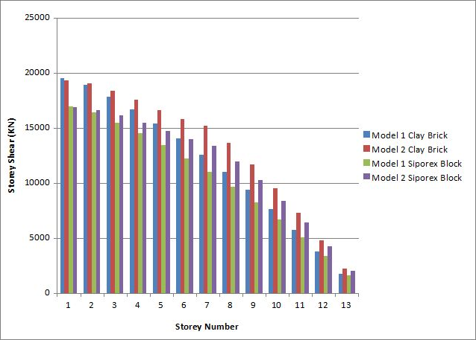

Graph 3.10 Variation of Storey shears along X & Y- Direction for comparision of different infill materials

As shown in graph 3.10 it is observed that Base shear is greater for Model 1 i.e. soft storey at ground floor for both infill materials. Base shear is 13.07% and 12.678% maximum for Clay Brick as compare to Siporex Block for Model 1 i.e. soft storey at ground floor and Model 2 i.e.

soft storey at seventh floor respectively. It shows that the Base shear is depends on weight of structures. It represents that position of soft storey is not significantly affect on the value of Base Shear.

### Storey displacement:

Story displacement is calculated as shown in table 3.11.

### Table 3.11 Storey displacement for comparison of Clay Brick and Siporex Block (mm)

|  |  |  |  |  |  |
| --- | --- | --- | --- | --- | --- |
| Storey | Elevation | Model 1  Clay Brick | Model 2  Clay Brick | Model 1  Siporex Block | Model 2  Siporex Block |
| X and Y- Dir. | X and Y- Dir. | X and Y- Dir. | X and Y- Dir. |
| Story 13 | 39 | 28 | 28.8 | 24.9 | 26.1 |
| Story 12 | 36 | 27.3 | 28.2 | 24.3 | 25.4 |
| Story 11 | 33 | 26.6 | 27.3 | 23.7 | 24.6 |
| Story 10 | 30 | 25.7 | 26.2 | 22.8 | 23.7 |
| Story 9 | 27 | 24.7 | 25 | 21.9 | 22.6 |
| Story 8 | 24 | 23.5 | 23.7 | 20.9 | 21.4 |
| Story 7 | 21 | 22.2 | 21.8 | 19.7 | 19.7 |
| Story 6 | 18 | 20.8 | 10 | 18.4 | 9.1 |
| Story 5 | 15 | 19.3 | 8 | 17.1 | 7.3 |
| Story 4 | 12 | 17.8 | 6.4 | 15.7 | 5.9 |
| Story 3 | 9 | 16.2 | 4.8 | 14.2 | 4.3 |
| Story 2 | 6 | 14.6 | 3.1 | 12.8 | 2.8 |
| Story 1 | 3 | 12.6 | 1.5 | 11 | 1.3 |

From above graph 3.11 it is observed that at initial level Model 2 Clay Brick i.e. soft storey at seventh floor gives least storey displacement but later it achieves great at top floor. For different infill material storey displacement suddenly rises where soft storey is provided and it goes on increasing uniformly along height of structure. Storey

displacement is maximum for Clay Brick as an infill material in multistorey building. And it is 11.071% and 9.37% maximum than Siporex Block for Model 1 i.e. soft storey at ground floor and Model 2 i.e. soft storey at seventh floor respectively.

### Storey drift:

Story drift is calculated as shown in table 3.12.

### Table 3.12 Storey drift for comparison of Clay Brick and Siporex Block

|  |  |  |  |  |  |
| --- | --- | --- | --- | --- | --- |
| Storey | Elevation | Model 1  Clay Brick | Model 2  Clay Brick | Model 1  Siporex Block | Model 2  Siporex Block |
| X and Y- Dir. | X and Y- Dir. | X and Y- Dir. | X and Y- Dir. |
| Story 13 | 39 | 0.000211 | 0.000238 | 0.000188 | 0.000215 |
| Story 12 | 36 | 0.000257 | 0.000296 | 0.00023 | 0.000268 |
| Story 11 | 33 | 0.000307 | 0.000359 | 0.000276 | 0.000325 |
| Story 10 | 30 | 0.000354 | 0.000423 | 0.000319 | 0.000383 |
| Story 9 | 27 | 0.000397 | 0.000449 | 0.000358 | 0.000407 |
| Story 8 | 24 | 0.000436 | 0.000674 | 0.000393 | 0.000613 |
| Story 7 | 21 | 0.000469 | 0.004096 | 0.000423 | 0.003628 |
| Story 6 | 18 | 0.000498 | 0.000704 | 0.00045 | 0.000645 |
| Story 5 | 15 | 0.000519 | 0.000529 | 0.00047 | 0.000486 |
| Story 4 | 12 | 0.000545 | 0.000558 | 0.000493 | 0.000512 |
| Story 3 | 9 | 0.000523 | 0.000549 | 0.000475 | 0.000503 |
| Story 2 | 6 | 0.00074 | 0.00055 | 0.000671 | 0.000503 |
| Story 1 | 3 | 0.004192 | 0.000489 | 0.003654 | 0.000445 |

Graph 3.12 Variation of Storey drift along X & Y- Direction for comparision of different infill materials

As per IS 1893:2002 maximum storey drift should not be more than 0.004 times to storey height of the structure. Here value of limiting storey drift is 0.012 where height of storey is 3m. From the graph 3.12 it is observed that the values of the storey drift for all the stories are found to

be within the limits. Storey drift values are obtained greater where soft storey is provided for Model 1 i.e. soft storey at ground floor and Model 2 i.e. soft storey at seventh floor. In which Siporex Block provide minimum Storey Drift comparison of Clay Brick.

### CONCLUSIONS

By analyzing seismic behavior of G+12 multistory building for Clay Brick and Siporex Block as an infill material using ETABS following conclusion can be drawn:

For different infill materials i.e. Clay Brick and Siporex Block Time Period is minimum when Siporex Block is used as infill material. It is 5.90% and 5.25% minimum than Clay Brick for Model 1 and Model 2 respectively. Base shear is greater for Model 1 and it is 13.07% and 12.678% maximum for Clay Brick as compare to Siporex Block for Model 1 and Model 2 respectively. It represents that position of soft storey is not significantly affect on the value of Base Shear. Storey displacement is maximum for Clay Brick as an infill material in multistory building. It is 11.071% and 9.37% maximum than Siporex Block for Model 1 i.e. soft storey at ground floor and Model 2 i.e. soft storey at seventh floor respectively.

The value of storey drift for all stories for all cases are found to be within permissible limit i.e. As per IS 1893:2002 they should not be more than 0.004 times to storey height of the structure. Storey drift found minimum where Siporex Block used as an infill material. From above it shows that the light weight infill material i.e. Siporex Block provides less Time Period, Base Shear, Storey Displacement And Storey Drift etc.

Considering all cases i.e. seismic behavior, weight, time of building construction etc. Siporex Block is more efficient material as an infill material for multistory building soft storey.

### References

1. Dande P. S., Kodag P. B. “Influence of Provision of Soft Storey in RC Frame Building for Earthquake Resistance Design”, International Journal of Engineering Research and Applications, Vol. 3, Issue 2, March -April 2013, pp.461-468.
2. Ankita Pramod Shelke, Dr. Rajashekhar S. Talikoti., “Survey Paper on Seismic Analysis of Low-rise Soft Storey Frame Building”, International Journal of Emerging Technology and Advanced Engineering, Volume 5, Issue 6, June 2015, ISSN

2250-2459.

1. IS 1893 (Part 1):2002 Indian Standard Criteria for Earthquake Resistant Design of Structures (part-1), BIS New Delhi.
2. M.P. Mishra, Dr. S. K. Dubey, “Seismic Drift control in soft storied RCC buildings: A Critical Review” International Journal of Engineering and Technical Research (IJETR), Volume-3, Issue-8, August 2015 ISSN: 2321-0869 (O) 2454-

4698 (P).

1. Pramod M Gajbe, Prof. R. V. R. K. Prasad “Analysis of soft story multistoried steel structure building”, International Journal of Engineering Sciences & Research Technology, Gajbe et al., 5(7): July, 2016.
2. P. B. Lamb And Dr. R. S. Londhe “Seismic Behavior of Soft First Storey”, IOSR Journal of Mechanical and Civil Engineering, (IOSR-JMCE) ISSN: 2278-1684 Volume 4,

Issue 5 (Nov. - Dec. 2012), PP 28-33.

1. Hiten L. Kheni, Anuj K. Chandiwala, “Seismic Response of RC Building with Soft Stories” International Journal of Engineering Trends and Technology (IJETT), – Volume 10 Number 12 - Apr 2014 ISSN:2231-5381.
2. Suchita Hirde and Ganga Tepugade “Seismic Performance of Multistory Building with Soft Storey at Different Level with RC Shear Wall”, International Journal of Current Engineering and Technology, 01 June 2014, Vol.4, No.3 (June 2014) E- ISSN 2277 – 4106, P-ISSN 2347 – 5161.
3. Nikhil Agrawal, Prof.P.B Kulkarni, Pooja Raut, “Analysis of Masonry Infilled R.C.Frame with&without Opening Including Soft Storey by using “Equivalent Diagonal Strut Method”, International Journal of Scientific and Research Publications, Volume 3, Issue 9, September 2013 ISSN 2250-3153.
4. S. Arunkumar, Dr. G. Nandini Devi, “seismic demand study of soft storey building and it’s strengthening for seismic resistance from International Journal of Emerging Trends & Technology in Computer Science (IJETTCS), Volume 5, Issue 2, March - April 2016 ISSN 2278-6856.
5. Dr. C. P. Pise, S. S. Kadam, Y. P. Pawar, D. D. Mohite, C. M. Deshmukh, G. D. Lakade, “Performance-Based Seismic Design of Structures”, International Journal Of Scientific Research, vol. 04, pp 475-478, 2015.
6. G. D. Lakade, Dr. C. P. Pise, S. S. Kadam, Y. P. Pawar, D. D. Mohite, C. M. Deshmukh, “Performance Of Rc Building Under Dynamic Forces And Suitability Of Strengthening By FRP Jacketing”, International Journal of Civil Engineering and Technology, vol. 06, Issue 9, pp 147-159, 2015.
7. R. V. Surve, Y. P. Pawar, C. P. Pise, S. S. Kadam, D. S. Jagtap, D. D. Mohite, C. M. Deshmukh, “Use of RC shear walls in strengthening of multistoried building with soft storey at different level”, International Journal of Civil, Structural, Environmental and Infrastructure Engineering Research and Development, vol.05 pp 79-86, 2015.
8. Ms. Rajashri A. Deshmukh, Dr. P. S. Pajgade “Study of effect of infill material on seismic performance of rc buildings”, International Journal of Engineering Sciences & Research Technology, January, 2015 ISSN: 2277-9655.
9. Dattatraya L. Bhusnar, Dr. C. P. Pise, D. D. Mohite, Y. P. Pawar, S. S. Kadam, C. M. Deshmukh, “Seismic behavior of Multi-storey building with soft storey considering different infill materials: A Review”, International Journal of Engineering Research and Applications, Volume 6, Issue 10, (Part-4) Occtober 2016, pp.23-26, ISSN:2248-9622.
10. Dhanaji R. Chavan, Mohite D. D., Dr. C. P. Pise, Pawar Y. P., Kadam S. S., Deshmukh C. M., “Analysis of flat slab building with and without shear wall”, International Journal Of Engineering Research And Application, ISSN:2248-9622, Volume 06, Issue 10, (Part-4), pp 35-43,October 2016