Design of **Compact ACS Feed Microstrip Antenna for UWB Applications**

Mr. Jairaj N. Hire

Department of Mechatronics Engineering

Amrutvahini Polytechnic, Sangamner, Dist.- Ahmednagar. (M.S), India.

[jairajhire@gmail.com](mailto:jairajhire@gmail.com)

**ABSTRACT*: In This article, a compact Asymmetric Coplanar Strip (ACS) Feed Microstrip antenna has been summarized and reported. Designed antenna has very compact size of 12m x 24 mm and has been simulated over the CADFEKO EM Simulation tool. Proposed ACS antenna has been simulated against the Ultra-Wideband (UWB) operating region with frequency of 3.10 GHz to 10.60 GHz. Simulated antenna shows <-10 dB reflection coefficient bandwidth all over the UWB region and poses 90% of operating efficiency. Proposed antenna has been modelled with semicircular patch. Beveling structure have been adopted for proper UWB operation and gain enhancement. Antenna has been simulated with FR-4 dielectric substrate with effective dielectric constant of 4.4 and loss tangent of 0.02.***

**KEYWORDS *-Asymmetric Coplanar Strip, Compact antenna, CADFEKO, Microstrip antenna, Ultra-Wideband.***

# **I. INTRODUCTION**

Now a day, wideband communication applications are trending to fulfill the requirements of high data rates and hence higher bandwidths. High data transmission and receptions is a key feature of today’s modern communication applications. To enhance the data rates and throughput of a communication channel, various digital modulation schemes has been proposed and evaluated [1]-[2]. This all system has prime requirement of an efficient and suitable transmitting sections to achieve the expected data rates and related transmission characteristics. Ultra-Wideband (UWB) system was proposed in 1866 to fulfill the high data rates, throughputs, and bandwidth requirements of existing communication systems [3]. UWB system offers challenging features in faded wireless media with various benefits and improvements related to high data transmission capabilities.

UWB system ranges from 3.10 GHz to 10.60 GHz of wireless spectrum of microwave applications and channels. It supports enhanced 7.176 GHz of active bandwidths supporting advanced high data rates of communication protocols and realizations.

Microstrip antenna system offers good remedy for UWB feasibility in the current application scenario of wideband communication systems. Microstrip antenna configuration supports low weight, moderate gain, high bandwidth and conformal distinct features and hence the high frequency modeling of microwave system can be easy to exhibit.

Proposed antenna has been simulated at UWB band of application and has been carried out with ACS technologies. Size deduction of total geometry has been proposed and simulated results have been described in the next sections.

# **II. Antenna Design and Considerations**

Proposed ACS feed antenna has been designed by using cavity model formulae for antenna design [3], [5]-[10]. Designed antenna has been simulated by using FR-4 substrate having dielectric constant of 4.4, loss tangent 0.02 and effective dielectric constant of 3.88 with substrate thickness of 1.6 mm. Antenna parameters for ACS-UWB operation has been summarized in table I. Designed antenna geometrical specifications are shown in figure 1.

Operating Wavelength ($ƛ$) = $\frac{C0}{F*√∈r}$ (1)

Patch Width $(w)=\frac{ƛ}{4}$ (2)

Patch Length $\left(l\right)=\frac{C}{4f}*√\frac{2}{∈r+1}$ (3)

Radius of Patch can be calculated by,

a = $\frac{\text{F}}{ {\left\{1+\frac{2h}{πε_{r}F} \left[ln\left(\frac{πF}{2h}\right)+1.7726\right]\right\}}^{0.5}}$ (4)

Effective radius of the patch,

${ a}_{e}=a{\left\{1+\frac{2h}{πε_{r}a}\left[ln\left(\frac{πa}{2h}\right)+1.7726\right]\right\}}^{\frac{1}{2}}$ (5)

Resonant frequency of antenna

$f_{r}=\frac{1.8412 c}{2πa_{e }\sqrt{ε_{r}}}$ (6)

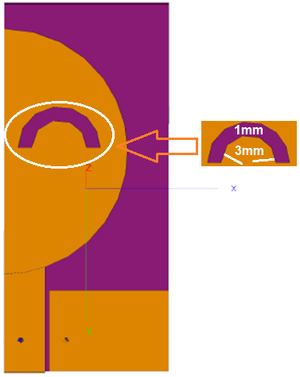

Figure 1.Proposed antenna geometrical details.

Table I. Antenna design parameters.

|  |  |
| --- | --- |
| **Parameters** | **Calculated values** |
| Resonance frequency (Fr) | 3.1GHz to 10.6 GHz |
| Lower Edge frequency (f) | 3.1GHz |
| Relative permittivity of substrate (εr) | 4.4 |
| Loss tangent ( tanδ) | 0.02 |
| Substrate height (h) | 1.6mm |
| Effective dielectric constant (εreff) | 3.88 |
| Substrate length (Ls) and width (Ws) | 24mm x 12mm |
| Patch radius (Rp) in Z direction | 7.2mm |
| Patch radius (Rp) in X direction | 10mm |
| Feed line length (Lf) | 8.2mm |
| Feed line width (Wf) | 3mm |
| Ground plane length (Lg) | 6mm |
| Ground plane width (Wg) | 8.7mm |

Simulated antenna geometry shown in figure 1 and has been evaluated and developed in method of moment (MOM) based cadfeko antenna simulation tool [4].Proposed antenna has Microstrip feed of 3 mm x 8.2 mm giving the conformal geometry for MMIC applications of proposed antenna. As ground plane and antenna patch is over the same plane, 50% of size saving has been succeeded and hence compact geometry has been advised. Elliptical slot over the patch has been placed as per current distributions to achieve the proper UWB portioning over the band of 3.10 GHz to 10.60 GHz operating band.

# **III. Antenna Performance Evaluation and Results**

Proposed antenna has been simulates against the UWB band of 3.10 GHZ to 10.60 GHz and analyzed against various parameters including reflection coefficient, Voltage Standing Wave Ratio, Impedance magnitude, Co and Cross polarizations, Gain, efficiency and so on.

Simulated antenna reflection coefficient magnitude in dB is shown in figure 2. Proposed antenna offers <-10 dB reflection coefficient at simulating UWB (3.1 GHz to 10.6 GHz) frequencies. Proposes ACS-UWB antenna provides 7.176 GHz of wide bandwidths at UWB band.

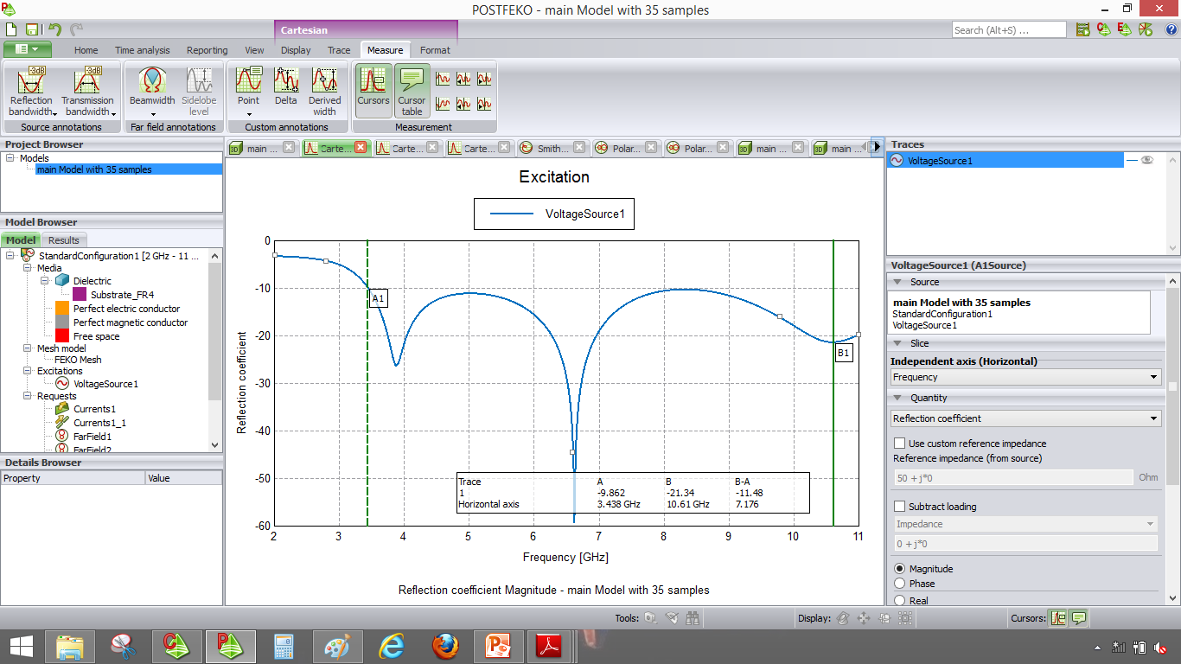

Figure 2.Reflection coefficient magnitude of proposed antenna.

VSWR magnitude of proposed ACS-UWB antenna is shown in figure 3. VSWR parameter measures a standing wave ratio when antenna is mismatched to its load. Simulated antenna achieves good matching behavior and provides 5.11 GHz of VSWR bandwidths at simulating frequencies.

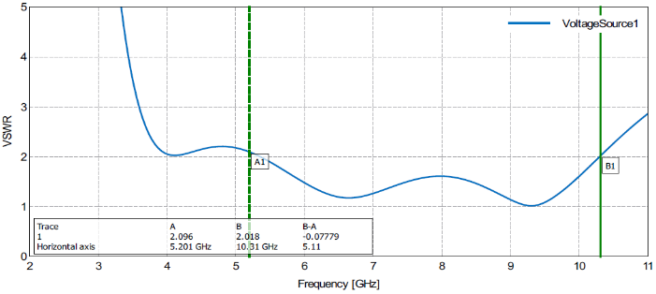

Figure 3.VSWR magnitude of proposed antenna.

Figure 4. Impedance matching characteristics of proposed antenna is shown in figure 4. Simulating antenna offers best impedance matching capabilities a UWB operating bands and poses zero mismatch. Simulated antenna shows almost and exactly 50 ohms impedance at simulating bands providing efficient operating behavior at other MMIC microwave circuitry.

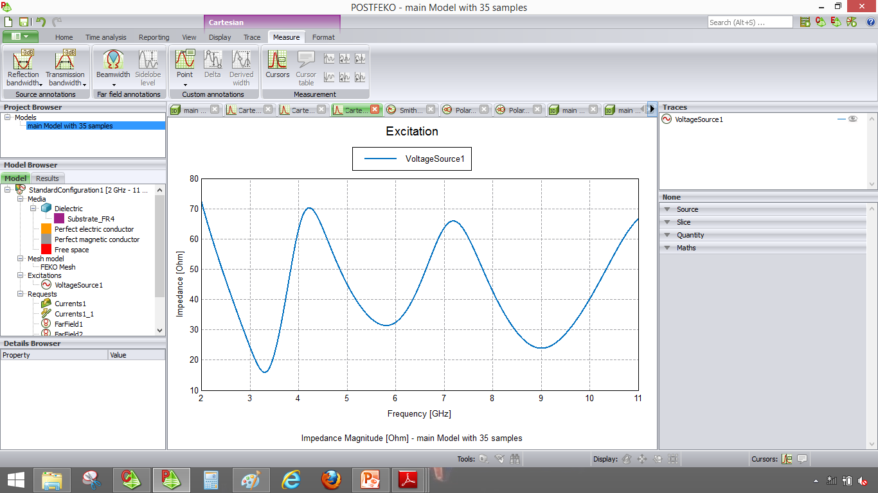

Figure 4.Impedance magnitude of proposed antenna.

Simulated antenna effectiveness in terms of efficiency is shown in figure 5. Simulated antenna has approximately 90% of effectiveness at simulating UWB frequencies.

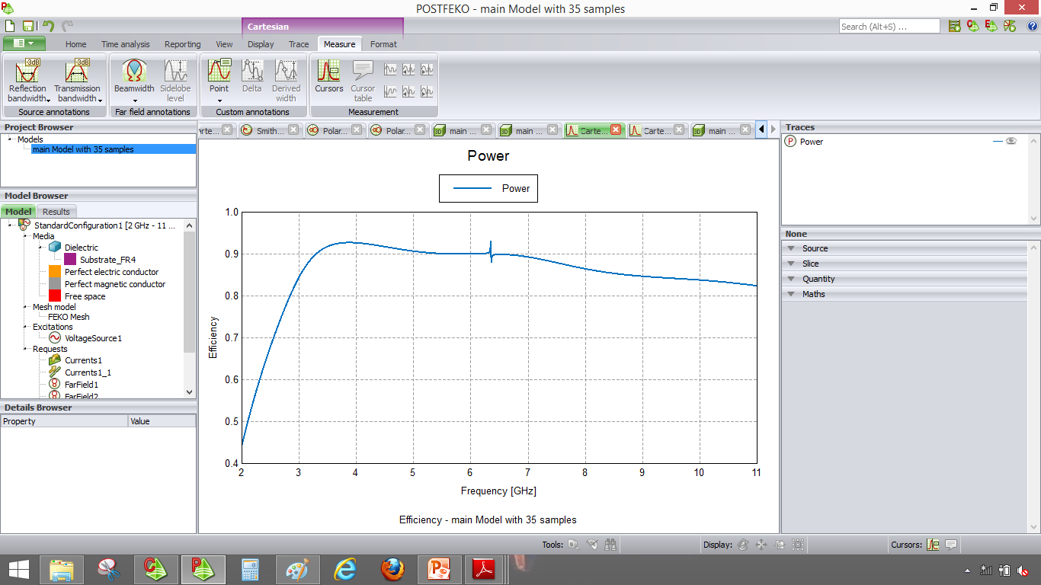

Figure 5.Simulated efficiency of proposed antenna.

Radiation patterns of simulated antenna have been shown in figure 6. Simulated antenna challenges > 20 dB co-polarized operation and < 15 dB cross polar operations at faded wireless channel. Simulated antenna shows omnidirectional radiation pattern at E-plane and directional radiation pattern at H-plane of propagation.

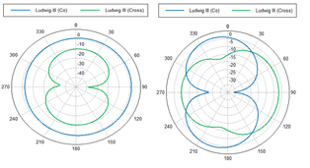

Figure 6. Radiation Patterns of proposed antenna.

Simulated gain of proposed antenna with 2D polar and 3D plot is shown in figure 7 and 8 respectively. Polar gain of 3.7 dB has successfully achieved as shown in figure 7. Simulated isotropic gain of 3.0dB has been obtained by proposed ACS-UWB antenna as shown in figure 8.

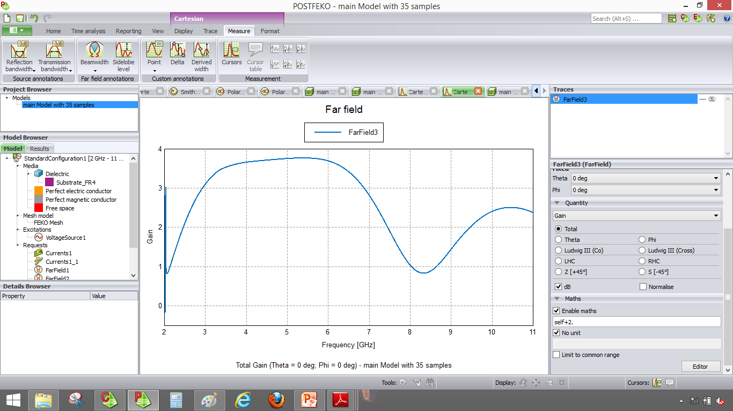

Figure 7. Gain of proposed antenna.

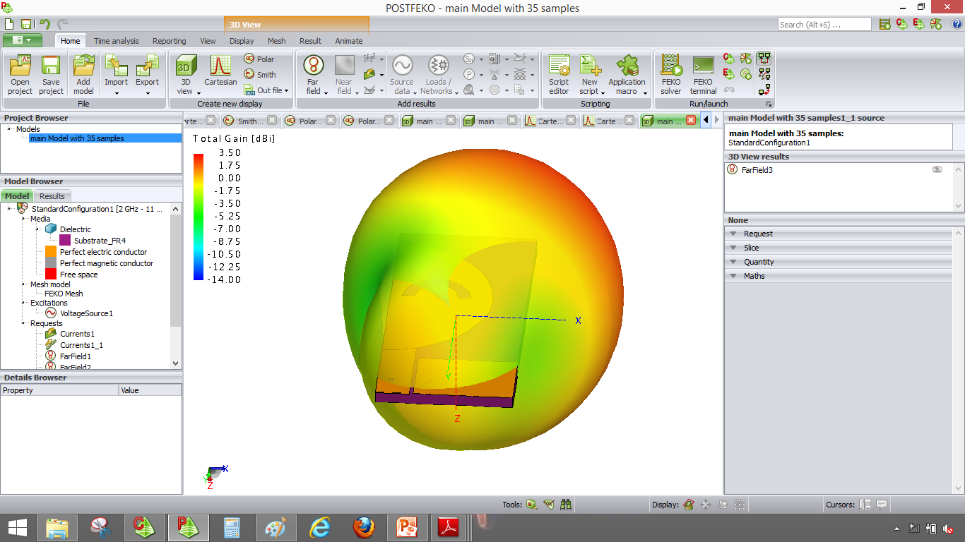

Figure 8. 3D gain of proposed antenna.

Performance parameters of proposed ACS-UWB antenna has been demonstrated in table II.

Table II. Proposed ACS-UWB antenna performance summary.

|  |  |  |
| --- | --- | --- |
| **Sr. No** | **Performance Parameters** | **Depictions** |
| 1 | Reflection coefficient bandwidth | 7.176 GHz |
| 2 | VSWR bandwidth | 5.11 GHZ |
| 3 | Impedance at 5.9 GHz | 50 ohm |
| 4 | Polarization behavior | Co-polar plane > 20 dB |
| Cross-polar plane < 15 dB |
| 5 | Efficiency | 90% |
| 6 | Gain | Polar gain= 3.7 dB |
| 3D Gain= 3.0dBi |

# **IV. Conclusion**

A compact ACS feed antenna for Ultra-wideband (UWB) applications has been presented. Proposed antenna has been simulated for low-profile FR-4 material.

Proposed antenna has very compact structure and can be suitable for advanced high-data rate wireless applications as well as for radar and safety applications. Simulated antenna exhibits 7.176 GHz of working Reflection coefficient bandwidth having < -10 dB return loss.

Proposed antenna offers 3.7 dB gain and has good impedance matching capabilities with almost 50 ohm of impedances. Simulated antenna offers approximately directional pattern in E-plane and omnidirectional radiation pattern in H-plane of propagation.

# **References**

[1] Batra, Multiband OFDM Physical layer proposal for IEEE 802.15 task group 3a, 2003.

[2] "FCC Ultra-Wideband Operation FCC Reportand Order", Tech.Rep, 2002.

[3] Girish. Kumar, K. P. Ray, "Braodband Microstrip Antennas", Artech House Boston.

[4] CAD-FEKO Simulation software Version 6.3 User Manual.

[5] AvinashTambe, RekhaLabade, Shankar B. Deosarkar, and Rahul Parbat.ACS Feed Compact Multiband Antenna for Personal Wireless Communication Applications. Progress In Electromagnetics Research Letters, Vol. 57, 31–38, 2015.

[6] Valderas, D., J. I. Sancho, D. Puente. Ultra wideband Antennas, Design and Application, Imperial College Press, 2010.

[7] Ashkarli, P., S. Sreenath, R. Sujith, R. Dinesh, D. D. Krishna, and C. K. Aanandan. A compact asymmetric coplanar strip fed dual band antenna for DCS/WLAN applications. Microwave Technology Letters, Vol. 54, No. 4, 1087–1089, 2012.

[8] Papantonis, S. and E. Episkopou. Compact dual band printed 2.5-shaped monopole antenna for WLAN applications. Progress In Electromagnetics Research C, Vol. 24, 57–68, 2011.

[9] R. Kohno, M. McLaughlin, M. Welborn, DS-UWB physical layer submission to 802.15 task group 3a, 2005.

[10] C.A. Balanis, Antenna Theory and design, NewYork:John Wiley and Sons, 1997.