IOT Based Pet Daycare Robot

# Ms. Shubhangi Mahule1, Pathuri Jaya Meghana2, Alimineti Sravani3, Thalari Abhinaya4, Sonti Varun5

*1Associate Professor, CSE Dept, ACE Engineering College, Hyderabad, India*

[June.pnancy@gmail.com](mailto:June.pnancy@gmail.com)

*2Student, CSE Dept, ACE Engineering College, Hyderabad, India*

[jayameghanapathuri@gmail.com](mailto:jayameghanapathuri@gmail.com)

*3 Student, CSE Dept, ACE Engineering College, Hyderabad, India* [*sravanialimineti60@gmail.com*](mailto:sravanialimineti60@gmail.com)

*4 Student, CSE Dept, ACE Engineering College, Hyderabad, India* [*thalariabhinaya@gmail.com*](mailto:thalariabhinaya@gmail.com)

*5 Student, CSE Dept, ACE Engineering College, Hyderabad, India* [*Sontivarun5@gmail.com*](mailto:Sontivarun5@gmail.com)

**Abstract:**

**The IoT-based Pet Daycare Robot represents a groundbreaking approach to pet care, combining automation with advanced monitoring and control features. By leveraging IoT technologies and machine learning, this system ensures pets receive optimal care and attention, even in the absence of their owners. Operated by an ESP32 microcontroller, the Pet Daycare Robot orchestrates the operation of servo motors, buzzers, and optional sensors. These components work harmoniously to perform tasks such as dispensing food, opening/closing doors, and providing auditory alerts, enhancing the overall well-being of pets. A user-friendly mobile/web application interface serves as the primary means for pet owners to remotely interact with the robot. The Pet Daycare Robot offers pet owners a seamless web application experience with convenient start and stop buttons for controlling the dispenser. Safety is paramount in the design of the Pet Daycare Robot, with robust features in place to prevent accidents and ensure data security. With its seamless integration of hardware and software components, this innovative solution sets a new standard in pet care, offering convenience, reliability, and peace of mind to pet owners worldwide**

# INTRODUCTION

The contemporary lifestyle often challenges pet owners to provide adequate care for their beloved companions, particularly when faced with time constraints and busy schedules. As pets are increasingly regarded as integral members of the family, ensuring their well-being becomes paramount. To address this need, innovative solutions are emerging, among which stands the IoT- based Dog Care Robot. This introduction sets the stage by acknowledging the evolving relationship between humans and their pets, emphasizing the emotional bond and responsibility associated with pet ownership. It then introduces the concept of the IoT-based Dog Care Robot as a solution to the challenges posed by modern lifestyles. In this introduction, there's an opportunity to elaborate on the key features and functionalities of the IoT-based Dog Care Robot, such as its ability to dispense food, monitor the pet's activity, and provide interactive features for both the pet and the owner. Additionally, mentioning the underlying technology, such as IoT connectivity, sensors, and

actuators, can provide insights into the sophistication and capabilities of the robot.

# OBJECTIVES

In our project there are 4 objectives. They can be listed as:

* + Create User-Friendly Interface
  + Add Automation Features
  + Integrate IoT Technologies
  + Ensure Security and Reliability
  + Test and Validate

# METHODOLOGY

In the development of our IoT-based pet daycare robot, we start by gathering data from various sources to understand pet behaviors and user preferences, then clean and organize it for accuracy. We design features to capture key aspects of pet care and create a tailored architecture for our pet daycare robot. Through training and optimization using historical data, we fine- tune the system for real-world use. We assess its performance and make improvements before deploying it. Continuous monitoring and adaptation ensure it remains effective over time, meeting evolving pet care needs.

# LITERATURE SURVEY

**Title:** Pet food auto feeder by using Arduino.

**Authors:** M. Ibrahim et al, H Zakaria, EE Wei Xian – [2019] This innovative pet feeding robot offers remote control capabilities from anywhere globally. It features advanced functionalities such as a differential drive mechanism, collision- free distance sensing, wireless control, User-End GUI, and Camera Vision. The hardware includes an Arduino Microcontroller, Raspberry Pi 3, 6-DOF Robotic Arm, RF-SPI, HD Camera, Sabertooth Motor Driver, and 4S Lipo Battery.

**Title:** Internet of Things based Pet Feeder automation Using Raspberry Pi.

**Authors:** Adetokunbo A. Adenowo, Jonathan C. Anyi, James A. Akobada – [2020]

Household pets require attentive care, including timely provision of food, water, and medication, but with owners often busy and managing multiple tasks, manual pet management can be challenging. Transitioning to technology-based solutions becomes crucial, and an Internet of Things (IoT) based automatic feeder system offers a convenient option. This system allows pet owners to remotely manage their pets' needs while attending to other tasks. In existing literature, efforts to automate various human activities, such as home automation systems developed by Asadullah et al. [1] and methods proposed by Ricci [2], demonstrate the potential of technology to enhance household management and pet care.

**Title:** Design of Home Service Robot for Pet Caring.

**Authors:** Weilun Deng, Yongtao Shi, Chuanqing Li, Tian Zou and Chunlai Tian – [2020]

Pets have become integral members of many families, offering companionship and joy. Owners prioritize their pets' well-being, especially when unable to attend to them due to work or other obligations. However, existing pet products often lack versatility, leaving gaps in meeting users' needs. To address this, there's a growing demand for service robots tailored to pet care, offering functions such as feeding, monitoring, and companionship. These smart robots fulfill the evolving needs of pet owners, ensuring the health and happiness of their beloved companions.

**Title:** IOT based Pet Feeder.

**Authors:** Raed Abdulla, Ahmed Abdlekader Eldebani, Sathish Kumar Selvaperumal, Maythem K. Abbas – [2020]

In an increasingly interconnected world, the Internet of Things (IoT) facilitates automation and monitoring, enhancing efficiency and convenience. This research introduces a smart pet feeder system aimed at providing personalized care for pets. Divided into measurement and control units, the system periodically assesses the pet's weight and food levels, allowing for tailored feeding schedules based on energy requirements and pet type.

**Title:** Implementation of an IoT based Pet Care System.

**Authors:** Yixing Chen, Maher Elshakankir – [2020]

The Internet of Things (IoT) technology has revolutionized daily life by connecting a wide range of objects, making them smarter and enabling control through a network. This research focuses on an IoT-based pet care system, comprising food dispensers, water dispensers, and a litter box. The system aims to streamline pet care by allowing owners to control these devices through a smartphone app and monitor their pet's behavior. By collecting data on feeding, drinking, and defecation, the system can detect any abnormalities that may indicate illness, assisting both pet owners and veterinarians in health analysis.

# PROPOSED SYSYTEM

The proposed solution is a Pet DayCare Robot, a cutting-edge system leveraging IoT technology to revolutionize pet care. This innovative robot empowers pet owners by enabling them to tend to their pets' needs even when they are away. Through a user- friendly mobile/web application interface, owners can effortlessly control the robot's functions, such as feeding and door control, ensuring their pets are cared for with ease. Importantly, safety features are seamlessly integrated into the system to prevent accidents and protect sensitive data, offering pet owners peace of mind knowing that their beloved companions are in good hands.

# HARDWARE AND SOFTWARE REQUIREMENTS

* 1. **HARDWARE REQUIREMENTS:**
     + ESP32
     + Servo motor
     + Buzzer
     + Female to Female Jumper Wires

# SOFTWARE REQUIREMENTS:

* + - Operating System - Arduino IDE
    - Coding language - C++
    - Designing - HTML, CSS
    - Back-end - JavaScript

# PACKAGES USED

## WiFi.h:

WiFi.h is a library for Arduino that enables the ESP32 microcontroller to establish and manage Wi-Fi connections. It provides functions and classes to configure network settings, connect to Wi-Fi networks, and perform network-related tasks such as scanning for available networks and obtaining IP addresses. With WiFi.h, the pet daycare robot can seamlessly connect to a local Wi-Fi network, enabling remote communication and control through a mobile/web application interface.

## WiFiClient.h:

WiFiClient.h is a library that works in conjunction with WiFi.h to create client connections over Wi-Fi networks. It allows the ESP32 microcontroller to establish connections to other devices or servers on the internet using TCP/IP protocol. This library enables the pet daycare robot to communicate with external servers or devices, facilitating tasks such as sending sensor data, receiving commands, or fetching updates from remote sources. By leveraging WiFiClient.h, the robot can interact with external systems to enhance its functionality and responsiveness.

## ESP32Servo.h:

ESP32Servo.h is a specialized library designed for controlling servo motors using the ESP32 microcontroller. Servo motors are commonly used in robotics to achieve precise angular positioning, making them ideal for tasks like dispensing food or opening/closing doors in the pet daycare robot. This library provides functions and classes to interface with servo motors, allowing the robot to control their position, speed, and direction of rotation. With ESP32Servo.h, the pet daycare robot can execute tasks accurately and reliably, ensuring the smooth operation of its physical components.

# TECHNOLOGY DESCRIPTION

ESP32 is a versatile microcontroller widely used in IoT applications due to its integrated Wi-Fi and Bluetooth capabilities. It features a dual-core processor, making it capable of handling complex tasks efficiently. With its extensive range of built-in peripherals and support for various communication protocols, including SPI, I2C, and UART, the ESP32 is well- suited for interfacing with sensors, actuators, and other hardware components. Its ease of programming and compatibility with the Arduino IDE make it accessible to both hobbyists and professionals, enabling the development of diverse IoT projects, including the pet daycare robot.

# SOURCE CODE:

#include <WiFi.h> #include <WiFiClient.h> #include <ESP32Servo.h>

#define LED_BUILTIN 2

#define SERVO_PIN 14

#define buzzer 15 Servo myServo;

const char *ssid = "DOG CARE BOT"; const char *password = "yourPassword";

WiFiServer server (80); void setup () {

pinMode(LED_BUILTIN, OUTPUT);

pinMode(buzzer, OUTPUT); myServo.attach(SERVO_PIN);

Serial.begin(115200); Serial.println();

Serial.println("Configuring access point...");

WiFi.softAP(ssid, password); IPAddress myIP = WiFi.softAPIP();

Serial.print("AP IP address: "); Serial.println(myIP); server.begin(); Serial.println("Server started")

}

void loop () {

WiFiClient client = server.available(); if (client) {

Serial.println("New Client."); String currentLine = ""; while (client.connected()) {

if (client.available()) { char c = client.read(); Serial.write(c);

if (c == '\n') {

if (currentLine.length() == 0) { client.println("HTTP/1.1 200 OK"); client.println("Content-type:text/html") client.println();

// HTML code with buttons for LED and servo control client.println("<!DOCTYPE html><html><head><title>DOG

CARE ROBOT</title>");

client.println("<meta name=\"viewport\"content=\" width=device-width, initial-scale=1\">");

client.println("<style>");

client.println("body { font-family: Arial, sans-serif; margin: 0; padding: 0; text-align: center; background-color: #f0f0f0; }");

client.println("h1 { margin-top: 20px; }");

client.println("button { margin: 10px; padding: 10px 20px; font- size: 18px; background-color: #4CAF50; color: white; border: none; border-radius: 8px; cursor: pointer; }");

client.println("button:hover { background-color: #45a049; }"); client.println("</style>");

client.println("</head><body>");

client.println("<h1>DOG CARE ROBOT</h1>"); client.println("<h2>Controller</h2>"); client.println("<p>Take care of your furry friend with our Dog

Care Robot! Control the feeding schedule and monitor your dog's activities remotely. </p>");

client.println("<h2>Controller</h2>"); client.println("<button

onclick=\"startTimer()\">Start</button>"); client.println("<button onclick=\"stopTimer()\">

Stop</button>");

client.println("<p id=\"timer\"></p>"); client.println("<script>");

client.println("function startTimer() { startTime = new Date().getTime();

timerRunning = true; sendPosition('/H'); }");

client.println("function stopTimer() { timerRunning = false; sendPosition('/L'); }");

client.println("function sendPosition(pos) { var xhr = new XMLHttpRequest(); xhr.open('GET', pos, true); xhr.send();

}");

client.println("setInterval(updateTimer, 1000);"); // Update timer every second client.println("function updateTimer() { if (timerRunning) { var currentTime = new

Date().getTime(); var elapsedTime = Math.floor((currentTime

–startTime) / 1000); document.getElementById ('timer').innerHTML = 'Time: ' + elapsedTime + 's'; } }");

client.println("</script>"); client.println("</body></html>"); client.println();

break;

}

else { currentLine = "";

}

}

else if (c != '\r') { currentLine += c;

}

if (currentLine.endsWith("GET /H")) { digitalWrite(LED_BUILTIN, HIGH); digitalWrite(buzzer, HIGH);

delay (1000); digitalWrite(buzzer, LOW);

Serial.print("Servo Target Position: "); Serial.println("0");

myServo.write(0);

Serial.println("Servo moved to target position.");

}

if (currentLine.endsWith("GET /L")) { digitalWrite(LED_BUILTIN, LOW); Serial.print("Servo Target Position: "); Serial.println("90"); myServo.write(90);

Serial.println("Servo moved to target position.");

}

}

}

client.stop();

Serial.println("Client Disconnected.");

}

}

# OUTPUT

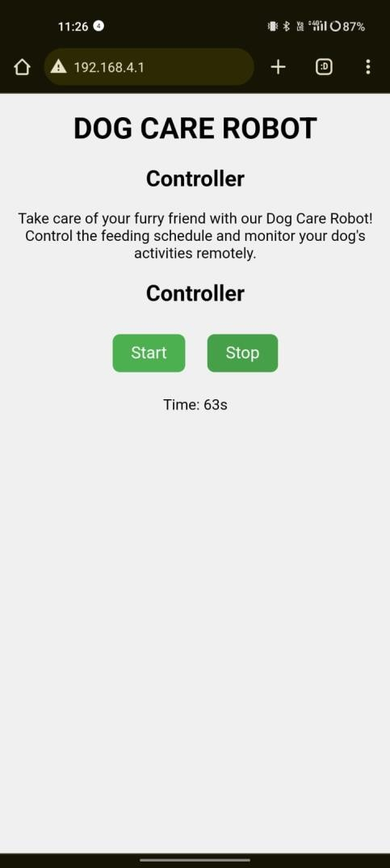

Fig 10.1 Web Application Screen

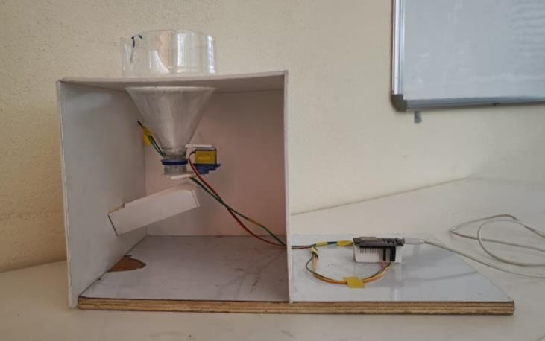

Fig 10.2 IOT Based Pet Daycare Robot

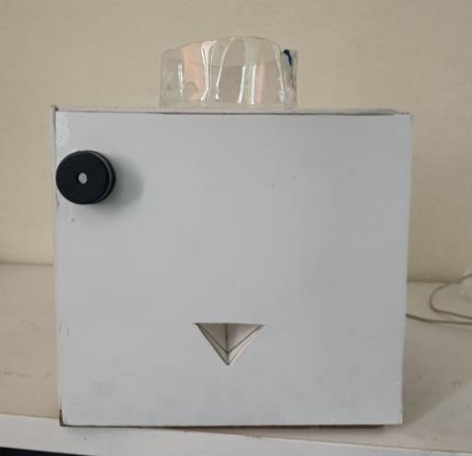

Fig 10.3 Buzzer and Food Serving Hole

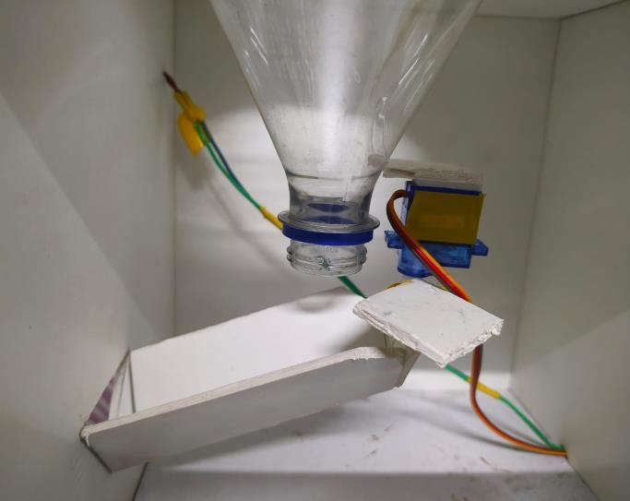

Figure 10.4 Food Dispenser Opened

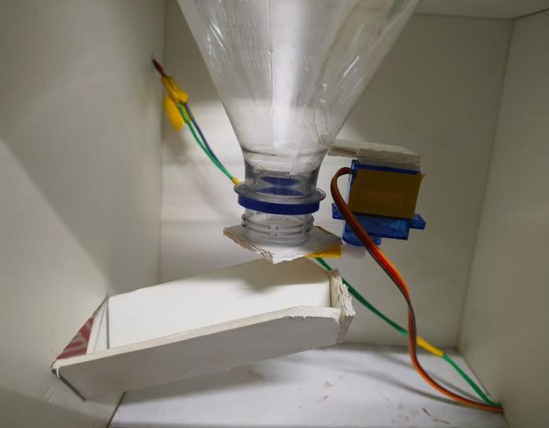

Figure 10.5 Food Dispenser Closed

# CONCLUSION

In conclusion, IoT-based dog care robots stand as a beacon of promise in the realm of technological solutions tailored to meet the needs of pet owners striving to optimize the well-being and care of their cherished canine companions. These innovative robots embody a plethora of advanced features and functionalities meticulously crafted to streamline various facets of pet care, all while furnishing pet owners with unprecedented levels of remote monitoring and control capabilities. Through the seamless integration of IoT technology, cutting-edge sensors, sophisticated cameras, and interactive interfaces, these robots epitomize a transformative paradigm shift in the landscape of pet care. By harnessing the power of IoT, these robots transcend mere automation, becoming stalwart companions in the journey of pet ownership. They seamlessly ensure that every aspect of a dog's daily routine, from nutrition to hydration, exercise to safety, is meticulously attended to with unparalleled precision and care, even in the absence of their human guardians. With the ability to dispense nourishment at prescribed intervals, keep vigilant watch over hydration levels, facilitate engaging exercise sessions, and diligently monitor for signs of health and safety concerns, these robots serve as steadfast guardians, offering peace of mind and reassurance to both dogs and their devoted owners alike.

# FUTURE SCOPE

* Artificial Intelligence Integration

Integrating AI algorithms into dog care robots can enable more intelligent and adaptive behavior, allowing the robot to learn and respond to the individual needs and preferences of each dog.

* Health Diagnosis and Monitoring

Future robots may incorporate advanced medical sensors and diagnostic tools to monitor the dog's health in real-time, detect early signs of illness or injury, and provide proactive healthcare recommendations.

* Emotional Support and Interaction

Advancements in robotics and AI could enable robots to provide emotional support and companionship to dogs, helping to alleviate loneliness and anxiety, especially for pets left alone for extended periods.

* Environmental Sensing and Control

Robots equipped with environmental sensors can monitor factors such as temperature, humidity, and air quality in the dog's environment, ensuring optimal comfort and safety.

* Integration with Smart Home Ecosystems

Future dog care robots may seamlessly integrate with other smart home devices and ecosystems, allowing for enhanced automation, coordination, and communication between various IoT devices.

# REFERENCES

1. M. Ibrahim et al, H Zakaria, EE Wei Xian, Pet food auto feeder by using Arduino, IOP Conference Series Materials Science and Engineering, 2019 [https://www.researchgate.net/publication/337691445_Pet_f](https://www.researchgate.net/publication/337691445_Pet_food_autofeeder_by_using_Arduino) [ood_autofeeder_by_using_Arduino](https://www.researchgate.net/publication/337691445_Pet_food_autofeeder_by_using_Arduino)
2. Adetokunbo A. Adenowo , Jonathan C. Anyi, James A. Akobada, Internet of Things based Pet Feeder Automation using Raspberry Pi, International Journal of Scientific & Engineering, 2020 [https://www.ijser.org/researchpaper/Internet-of-Things-](https://www.ijser.org/researchpaper/Internet-of-Things-based-Pet-Feeder-Automation-using-Raspberry-Pi.pdf) [based-Pet-Feeder-Automation-using-Raspberry-Pi.pdf](https://www.ijser.org/researchpaper/Internet-of-Things-based-Pet-Feeder-Automation-using-Raspberry-Pi.pdf)
3. Weilun Deng, Yongtao Shi, Chuanqing Li, Tian Zou and Chunlai Tian , Design of Home Service Robot for Pet Caring, Journal of Physics: Conference, 2020 [https://iopscience.iop.org/article/10.1088/1742-](https://iopscience.iop.org/article/10.1088/1742-6596/1550/2/022026/pdf) [6596/1550/2/022026/pdf](https://iopscience.iop.org/article/10.1088/1742-6596/1550/2/022026/pdf)
4. Raed Abdulla, Ahmed Abdlekader Eldebani, Sathish Kumar Selvaperumal, Maythem K. Abbas, IOT based Pet Feeder, TEST ENGINEERING AND MANAGEMENT, 2020 [https://www.researchgate.net/publication/340261266_IOT_](https://www.researchgate.net/publication/340261266_IOT_based_Pet_Feeder) [based_Pet_Feeder](https://www.researchgate.net/publication/340261266_IOT_based_Pet_Feeder)
5. Yixing Chen, Maher Elshakankir, Implementation of an IoT based Pet Care System, Fifth International Conference on Fog and Mobile Edge Computing, 2020

[https://www.researchgate.net/publication/343114482_Im](https://www.researchgate.net/publication/343114482_Implementation_of_an_IoT_based_Pet_Care_System) [plementation_of_an_IoT_based_Pet_Care_System](https://www.researchgate.net/publication/343114482_Implementation_of_an_IoT_based_Pet_Care_System)