"Deadline and Energy Aware Application Module Placement in Fog-cloud system"

**Attar Mohammad Younus** [ay2229@srmist.edu.in](mailto:ay2229@srmist.edu.in) **Avijoy Das Adhikari** [ad3361@srmist.edu.in](mailto:ad3361@srmist.edu.in) **Jagannath Rath** [ju8516@srmist.edu.in](mailto:ju8516@srmist.edu.in)

**Dr. Sujatha K., M.E., Ph.D.,**

[sujathak@srmist.edu.in](mailto:sujathak@srmist.edu.in)

**Abstract: Fog computing, situated at the edge of the network, offers potential as an extension of cloud computing, especially for a wide array of Internet of Things (IoT) applications. Despite its promise to reduce application response times, its widespread implementation relies heavily on the availability and capabilities of resources within the fog infrastructure.**

**Consequently, efficiently utilizing fog systems to execute various IoT type applications seeing their quality of service (QoS) requirements becomes imperative. This task is surely challenging when applications are broken down into multiple modules with varying latency sensitivities. Moreover, scattering application modules across distributed fog nodes exacerbates the issue by elevating the overall energy consumption of the fog environment. Study introduces a policy for modular application placement in fog computing environments that is deadline and energy-conscious. This policy prioritizes placing critical applications in the fog infrastructure while also consolidating active fog nodes for energy management. The performance of this policy was assessed and compared with various contemporary solutions. Analysis indicate that it can be checked through several prediction models from time series data of collected ip addresses**

|  |  |
| --- | --- |
| * 1.**Introduction**   Emerging technologies such as the Internet of Things  (IoT) necessitate rapid computation services, particularly for managing real-time applications. In IoT, devices like sensors and mobile devices generate substantial data, ideally processed in cloud systems due to their cost- effectiveness and scalability. However, for certain IoT applications requiring swift responses and minimal latency, cloud systems may not suffice. Addressing this concern, Cisco introduced fog computing in 2012, akin to cloud services but situated closer to users and devices, thereby enhancing service quality and reducing computing and communication costs.  Fog nodes, strategically positioned near data sources, mitigate communication delays, serving as an intermediary layer between IoT and cloud computing, ideal for latency-sensitive applications. Nonetheless, fog nodes are geographically dispersed and possess fewer resources compared to cloud servers, rendering them incapable of handling all applications. Consequently, determining the optimal placement of applications in fog/cloud systems poses a challenge, exacerbated by microservices applications characterized by interdependent modules spanning various computing nodes. Each module necessitates specific resources to function within designated deadlines.  . | In our research, we introduce a fresh method for positioning applications within fog-cloud systems. We segment applications into modules and prioritize them according to deadlines. This facilitates parallel processing of modules and their efficient distribution across fog/cloud servers, thereby decreasing latency through local or parallel processing on servers and conserving energy.  Our contributions are:   * Introduction of two placement strategies aimed at enhancing service quality and diminishing power usage. * Accounting for the dynamic arrival of time- sensitive applications, represented as a Distributed Data Flow model. * Assessment of our methodologies within the simulated fog environment, iFogSim, demonstrating superior performance compared to alternative approaches.   . |
|  | 1 |

Once requirements are met, module mapping occurs. However, this endeavor solely considers computing resources like CPU and RAM for node selection. Negligible attention is given to other crucial IoT ecosystem factors such as latency and resource availability. In , researchers devised an algorithm for optimal resource allocation in fog computing, framing the allocation issue as a bin-packing penalty aware problem. Each fog device is assessed based on idle energy, maximum frequency, and maximum energy parameters. Penalty and reward mechanisms minimize energy consumption, preventing exponential increases..

The goal of the system is to efficiently allocate computing resources to different modules of an application. This aims to ensure that:

|  |  |  |
| --- | --- | --- |
|  | **1. Deadlines are ad** | **hered to**: Every module in an |
| application must be processed within a designated timeframe. Through strategic module placement, the system guarantees timely processing of all modules, thereby meeting application deadlines collectively.  **2. Energy usage is reduced**: Through strategic distribution of modules across fog and cloud servers, the system strives to minimize energy consumption. This includes situating modules near data sources when feasible, employing local processing to cut down on data transmission, and optimizing resource allocation to prevent needless  energy expenditure. | | |

Introduced the (FSPP) to efficiently distribute resources among IoT services on fog nodes, considering latency and deadline requirements. Proposed a policy for application module management, aiming to optimize working node count to reduce power consumption without violating QoS constraints. Evaluated using it excelled in satisfying latency for applications with strict deadlines. Developed a application placement policy prioritizing requests according to user expectations, considering fog instance capabilities. Similarly, examined QoE. Proposed an optimized placement approach for fog computing applications using genetic algorithms (GA), minimizing computational and communication costs while ensuring resource efficiency.

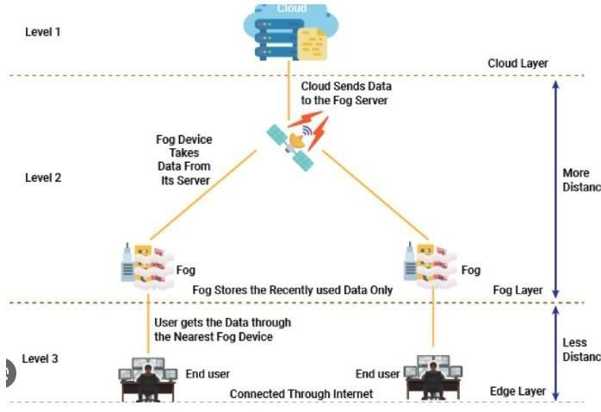

By achieving these goals, the system can enhance the overall performance and efficiency of fog-cloud systems, providing better quality of service while reducing operational costs and environmental impact.

Likewise, used GA for cost-effective task scheduling in cloud architecture, enhancing cost efficiency for time- sensitive applications. It is a real-time task schedule type system considering deadline type constraints to enhance task mapping, processing.

**Figure 1: IoT with Fog-cloud Environment.**.

1. **Related Works**

Task distribution and resource handling in fog computing represent emerging subjects that amalgamate various elements of cloud computing, mobile computing, and sensor networks . Within data from sensors, actuators, and similar devices necessitates processing through fog nodes and/or clouds. The authors in introduced a blueprint for distributing workloads in a fog-cloud system, balancing power consumption against latency concerns. The workload allocation issue is subdivided into primary and secondary problems. the framework tackled this challenge, illustrating the complementary nature of fog and cloud ip systems. The interplay architecture of workloads and resources received limited scrutiny . The investigation by introduced a

module-mapping strategy for situating IoT applications within a fog-cloud environment, aiming to optimize utilization of the various resources. This policy addresses network challenges by prioritizing both network nodes and application modules based on available capacity.

Once requirements are met, module mapping occurs. However, this endeavor solely considers computing resources like CPU and RAM for node selection. Negligible attention is given to other crucial IoT ecosystem factors such as latency and resource availability. In researchers devised an algorithm for optimal resource allocation in framing the allocation issue as a penalty aware problem. Each device is assessed based on energy, maximal frequency, and energy parameters. Penalty and reward mechanisms minimize energy consumption, preventing exponential increases. Explored how it influences application performance by analyzing scheduling problems in fog computing. They examined three scheduling policies— concurrent, first come first serve and delay priorities—to enhance execution time based on application characteristics. Introduced the IP Service Placement Problem to efficiently distribute resources on fog nodes, considering latency and deadline requirements. Proposed a policy for application module management, aiming to optimize working node count to reduce power consumption without violating QoS constraints., it excelled in satisfying latency for applications with strict deadlines. . Similarly, examined QoE. Proposed an optimized placement approach for fog computing applications using genetic algorithms (GA), minimizing computational and communication costs while ensuring resource efficiency. Likewise, used GA for cost-aware task scheduling in fog-cloud infrastructure, enhancing cost efficiency for time-sensitive applications. Presented a real- time task scheduler considering deadline and frequency constraints to enhance task mapping and processing.

The service function chain concept aims to enhance speed, resource use, and efficiency in fog computing through a flexible planning model. It improved resource use by introducing an SFC queue network. introduced the HR-Alloc algorithm for big data applications, focusing on cost and load balancing while maintaining performance. . created Fog-Care, a healthcare software prototype, to decrease latency and increase throughput in distributed locations. proposed a method using FedAvg-BE to handle non-iid data in Federated Learning, selecting quality data with border entropy evaluation. Table 1 compares these works with the current study.

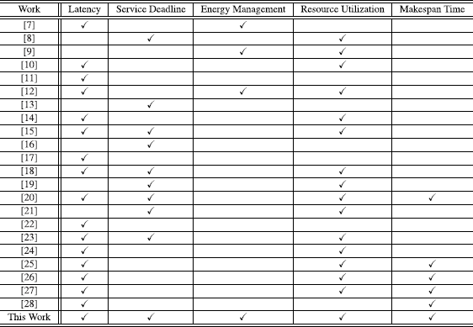

**Table1: Summary on related work**

1. **Proposed Work**

In this section, a novel approach is presented for positioning application modules within fog-cloud systems, prioritizing performance and power efficiency. The objective is to decrease the make span time (MST) of application modules by strategically situating them on fog nodes. Furthermore, the aim is to minimize the quantity of active fog nodes by consolidating more modules onto fewer nodes, thereby enhancing resource utilization and subsequently decreasing power consumption by fog nodes.

Additionally, we consider the possibility of running certain applications on cloud nodes without missing deadlines. In such instances, we choose to deploy those applications on cloud nodes. This not only enhances performance but also diminishes the necessity for fog nodes in the system..

1. **MECHANISM FOR PERFORMANCE- AWARE PLACEMENT SYSTEM**

Algorithm 1 outlines the Performance-Aware Placement Mechanism (PEAPM). It initiates by arranging application modules based on their deadlines and then proceeds to select modules for each application in accordance with their dependency constraints, prioritizing modules with no dependencies within the application.

Applications are sequenced by their deadlines, and within each application, modules are sorted by the type of their dependencies. Modules with dependencies are assessed based on their data dependency delay type of system , favoring nodes with minimal delay. Nodes in closer proximity are preferred to reduce data dependency delay, considering node processing speed. The node with the shortest MST is chosen to accommodate the module, provided it possesses sufficient CPU and RAM resources. The placement ensures compliance with the application's delay requirement.

The algorithm predicts the completion time for each task before placing the module on the designated node. If no fog node can accommodate the module, the algorithm yields false results, and the module may be redirected to cloud computing based on resource and delay requirements.

.

**Algorithm1:**

.

Define the placement algorithm with parameters \( m \), \

( l_{\text{max}} \), \( \text{modules} \), and \( \text{nodeList} \):

1. Sort modules by deadline:

- \( Q = \text{sorted(modules, key=lambda x: x.deadline)} \)

1. Initialize \( \text{MSTmin} \) to positive infinity:

- \( \text{MSTmin} = \text{float('inf')} \)

1. Initialize index to -1:

- \( \text{index} = -1 \)

1. Iterate while the queue is not empty:

- \( \text{while Q:} \)

- Iterate over nodes:

- \( \text{for n in nodeList:} \)

- Check resource availability and delay constraint:

- \( \text{if Req}(m) \leq \text{Cap}(n) \) and

\( n.\text{delay} \leq l_{\text{max}} \):

- Calculate temporary MST:

- \( \text{MSTtmp} = \text{MST}(m, n) \)

index = nodeList.getIndex(n)

# Remove processed module from the queue Q.pop(0)

# Check if a suitable node was found if index == -1:

return False else:

# Update node capacity and return true

1. **MECHANISM FOR POWER-AWARE PLACEMENT** Efficiency in power consumption holds significant importance in both cloud and fog computing environments, directly influencing operational expenses for providers and users. The key to achieving power savings lies in maximizing resource utilization, thereby diminishing the necessity for multiple active computing nodes in fog or cloud configurations. Studies have indicated that. Building upon this insight, this section presents an innovative approach to reducing power usage in fog environments by minimizing the number of active fog nodes, while transitioning inactive nodes to a power-saving mode.

The level of utilization of a fog node, denoted as directs the objective of this mechanism to decrease the count of fog devices hosting application modules. Accordingly, we introduce a power-conscious placement strategy termed Power-Aware Placement Mechanism (POAPM), elucidated in Algorithm 2. The algorithm commences by evaluating the utility level of each fog node, initiating a migration process for application modules if the utility falls below a specified threshold.

The utility threshold, a parameter of the algorithm, plays a crucial role in determining the optimal threshold for achieving maximal power savings. Lower thresholds, like 10%, result in minor migrations, offering limited power benefits. Conversely, higher thresholds may induce excessive migrations.

Discovering the optimal threshold necessitates an iterative approach, experimenting with different values to identify the most suitable one.

In line 4, the algorithm organizes fog layer nodes in ascending order based on their current utilization levels, with the most utilized node selected first. The strategy aims to consolidate application modules on fewer nodes to bolster utilization and, consequently, enhance power savings. The migration of application modules from underutilized nodes (n) to candidate

* Update \( \text{MSTmin} \) if temporary MST is smaller:nodes (nc) is facilitated by the update Cap and remove
  + \( \text{if MSTtmp} \leq \text{MSTmin}: \)
    - \( \text{MSTmin} = \text{MSTtmp} \)
    - \( \text{index} = \text{nodeList.getIndex}(n) \)
* Remove processed module from the queue:

- \( \text{Q.pop(0)} \)

* Check if a suitable node was found:

- \( \text{if index == -1:} \)

* + \( \text{return False} \)

- \( \text{else:} \)

- Update node capacity and return true:

- \( \text{updateCap}(n, m)

methods. Ensuring compliance with fog environment performance, line 8 verifies if the latency of the candidate node aligns with latency requirements; otherwise, the module is placed elsewhere. Modules are allocated to nodes to optimize compactness, reducing the need for multiple fog nodes and resulting in lower energy consumption.

**Algorithm2:**

This study introduced a new approach for placing application modules within a fog-cloud system. The focus was on reducing processing time while ensuring acceptable delay levels. We created two strategies, PEAPM and POAPM, and tested them through simulations under different conditions. Based on our findings, our methods outperformed others regarding metrics like TGR, make span, power usage, and violation cost. Performance varied depending on

However, identifying the optimal number of servers for each layer is essential for system improvement, a point to explore in future research.

Additionally, leveraging different meta-heuristic optimization frameworks could further enhance system performance, offering promising directions for future investigation in this field.

def minimizePowerUsage(threshold, nodeList): sortedNodes = sorted(nodeList, key=lambda node:

node.utilization, reverse=True) for node in nodeList:

if node.utilization < threshold: index = 0

for module in node.modules: candidateNode = sortedNodes[index] if requiredResources(module) <=

candidateNode.capacity and candidateNode.delay <= module.max_latency:

updateCapacity(candidateNode, module) remove(node, module)

else:

index += 1

* 1. **Results and Discussions**

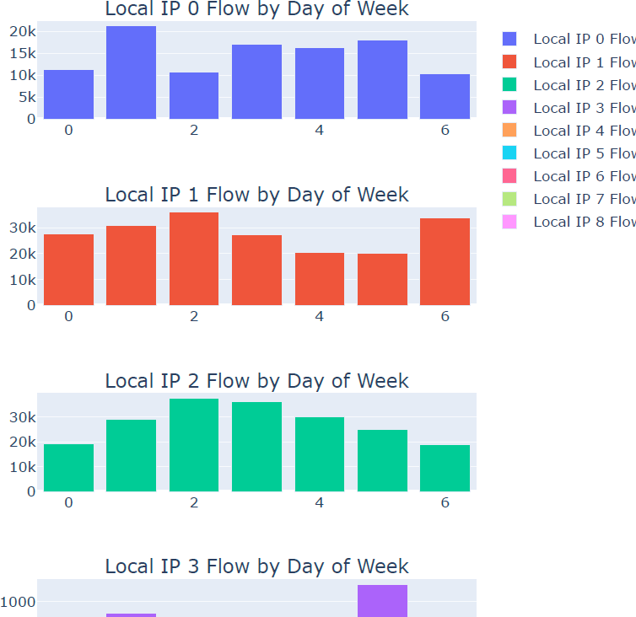

Exploratory Data Analysis (EDA) is an approach/philosophy for data analysis that employs a variety of techniques (mostly graphical) to maximize insight into a data set. uncover underlying structure. extract important variables. detect outliers and anomalies. test underlying assumptions. develop parsimonious models; and determine optimal factor settings. EDA is not identical to statistical graphics although the two terms are used almost interchangeably. Statistical graphics is a collection of techniques--all graphically based and all focusing on one data characterization aspect. EDA encompasses a larger venue; EDA is an approach to data analysis that postpones the usual assumptions about what kind of model the data follow with the more direct approach of allowing the data itself to reveal its underlying structure and model. EDA is not a mere collection of techniques; EDA is a philosophy as to how we dissect a data set; what we look for; how we look; and how we interpret..

* 1. **Conclusion**
  2. . **References**

1. F. Bonomi, R. Milito, J. Zhu, and S. Addepalli, ‘‘Fog computing and its role

in the Internet of Things,’’ in *Proc. 1st, Ed., MCC Workshop Mobile Cloud*

*Comput. (MCC)*, vol. 131. New York, NY, USA: ACM Press, Aug. 2012,

p. 13.

1. R. Deng, R. Lu, C. Lai, and T. H. Luan, ‘‘Towards power consumption-delay tradeoff by workload allocation in cloud- fog

computing,’’ in *Proc. IEEE Int. Conf. Commun. (ICC)*, Jun. 2015,

pp. 3909–3914.

1. M. A. Al Faruque and K. Vatanparvar, ‘‘Energy management-as-a-service

over fog computing platform,’’ *IEEE Internet Things J.*, vol. 3, no. 2,

pp. 161–169, Apr. 2016.

1. S. P. Singh, A. Nayyar, R. Kumar, and A. Sharma, ‘‘Fog computing: From

architecture to edge computing and big data processing,’’ *J. Supercomput.*,

vol. 75, no. 4, pp. 2070–2105, Apr. 2019.

1. P. Bellavista, J. Berrocal, A. Corradi, S. K. Das, L. Foschini, and A. Zanni,

‘‘A survey on fog computing for the Internet of Things,’’

*Pervasive Mobile*

*Comput.*, vol. 52, pp. 71–99, Jan. 2019.

1. S. Jošilo and G. Dán, ‘‘Decentralized algorithm for randomized task

allocation in fog computing systems,’’ *IEEE/ACM Trans. Netw.*, vol. 27,

no. 1, pp. 85–97, Feb. 2019.

1. R. Deng, R. Lu, C. Lai, T. H. Luan, and H. Liang, ‘‘Optimal workload

allocation in fog-cloud computing toward balanced delay and power consumption,’’ *IEEE Internet Things J.*, vol. 3, no. 6, pp. 1171– 1181,

Dec. 2016.

1. M. Taneja and A. Davy, ‘‘Resource aware placement of IoT application

modules in fog-cloud computing paradigm,’’ in *Proc. IFIP/IEEE Symp.*

*Integr. Netw. Service Manage. (IM)*, May 2017, pp. 1222–1228.

1. Z. Pooranian, M. Shojafar, P. G. V. Naranjo,

L. Chiaraviglio, and M. Conti,

‘‘A novel distributed fog-based networked architecture to preserve energy

in fog data centers,’’ in *Proc. IEEE 14th Int. Conf. Mobile Ad Hoc Sensor*

*Syst. (MASS)*, Oct. 2017, pp. 604–609.

1. L. F. Bittencourt, J. Diaz-Montes, R. Buyya, O. F. Rana, and M. Parashar,

‘‘Mobility-aware application scheduling in fog computing,’’

*IEEE Cloud*

*Comput.*, vol. 4, no. 2, pp. 26–35, Mar. 2017.

1. O. Skarlat, M. Nardelli, S. Schulte, and S. Dustdar, ‘‘Towards QoS-aware

fog service placement,’’ in *Proc. IEEE 1st Int. Conf. Fog Edge Comput.*

*(ICFEC)*, May 2017, pp. 89–96.

1. R. Mahmud, K. Ramamohanarao, and R. Buyya, ‘‘Latency-aware application

module management for fog computing environments,’’ *ACM Trans.*

*Internet Technol.*, vol. 19, no. 1, pp. 1–21, Feb. 2019.

1. R. Mahmud, S. N. Srirama, K. Ramamohanarao, and R.

Buyya, ‘‘Quality

of experience (QoE)-aware placement of applications in fog computing

environments,’’ *J. Parallel Distrib. Comput.*, vol. 132, pp. 190– 203,

Oct. 2019.

1. A. Brogi, S. Forti, C. Guerrero, and I. Lera, ‘‘Meet genetic algorithms

in Monte Carlo: Optimised placement of multi-service applications in

the fog,’’ in *Proc. IEEE Int. Conf. Edge Comput. (EDGE)*, Jul. 2019,

pp. 13–17.

1. T. S. Nikoui, A. Balador, A. M. Rahmani, and Z. Bakhshi, ‘‘Cost-aware

task scheduling in fog-cloud environment,’’ in *Proc. CSI/CPSSI Int. Symp.*

*Real-Time Embedded Syst. Technol. (RTEST)*, Jun. 2020, pp. 1– 8.

1. M. Louail, M. Esseghir, and L. Merghem-Boulahia, ‘‘Dynamic task

scheduling for fog nodes based on deadline constraints and task frequency

for smart factories,’’ in *Proc. 11th Int. Conf. Netw. Future (NoF)*, Oct. 2020,

pp. 16–22.

1. F. Faticanti, F. De Pellegrini, D. Siracusa, D. Santoro, and

S. Cretti,

‘‘Throughput-aware partitioning and placement of applications in fog

computing,’’ *IEEE Trans. Netw. Service Manage.*, vol. 17, no. 4,

pp. 2436–2450, Dec. 2020.

‘‘Context-aware placement of Industry 4.0 applications in fog computing

environments,’’ *IEEE Trans. Ind. Informat.*, vol. 16, no. 11, pp. 7004–7013,

Nov. 2020.

1. A.-V. Postoaca, C. Negru, and F. Pop, ‘‘Deadline-aware scheduling in

cloud-fog-edge systems,’’ in *Proc. 20th IEEE/ACM Int. Symp. Cluster,*

*Cloud Internet Comput. (CCGRID)*, May 2020, pp. 691–698.

1. M. Salimian, M. Ghobaei-Arani, and A. Shahidinejad, ‘‘Toward an

autonomic approach for Internet of Things service placement using gray

wolf optimization in the fog computing environment,’’ *Softw., Pract. Exp.*,

vol. 51, no. 8, pp. 1745–1772, Aug. 2021

1. T. Lähderanta, T. Leppänen, L. Ruha, L. Lovén, E. Harjula, M. Ylianttila,

J. Riekki, and M. J. Sillanpää, ‘‘Edge computing server placement with

capacitated location allocation,’’ *J. Parallel Distrib. Comput.*, vol. 153,

pp. 130–149, Jul. 2021.

1. E. Batista, G. Figueiredo, and C. Prazeres, ‘‘Load balancing between

fog and cloud in fog of things based platforms through software-defined

networking,’’ *J. King Saud Univ. Comput. Inf. Sci.*, vol. 34, no. 9,

pp. 7111–7125, Oct. 2022.

1. N. Godinho, H. Silva, M. Curado, and L. Paquete, ‘‘A reconfigurable

resource management framework for fog environments,’’

*Future Gener.*

*Comput. Syst.*, vol. 133, pp. 124–140, Aug. 2022.

1. X. Gao, R. Liu, and A. Kaushik, ‘‘Virtual network function placement in

satellite edge computing with a potential game approach,’’

*IEEE Trans.*

*Netw. Service Manage.*, vol. 19, no. 2, pp. 1243–1259, Jun. 2022.

1. J. C. S. D. Anjos, K. J. Matteussi, P. R. R. De Souza, G. J.

A. Grabher,

G. A. Borges, J. L. V. Barbosa, G. V. González, V. R. Q. Leithardt, and

C. F. R. Geyer, ‘‘Data processing model to perform big data analytics in

hybrid infrastructures,’’ *IEEE Access*, vol. 8, pp. 170281– 170294, 2020.

1. P. R. R. De Souza, K. J. Matteussi, A. D. S. Veith, B. F. Zanchetta,

V. R. Q. Leithardt, Á. L. Murciego, E. P. De Freitas, J. C. S. D. Anjos, and

C. F. R. Geyer, ‘‘Boosting big data streaming applications in clouds with

BurstFlow,’’ *IEEE Access*, vol. 8, pp. 219124–219136, 2020.

1. H. J. D. M. Costa, C. A. D. Costa, R. D. R. Righi, R. S. Antunes,

J. F. D. P. Santana, and V. R. Q. Leithardt, ‘‘A fog and blockchain software

architecture for a global scale vaccination strategy,’’ *IEEE*

pp. 44290–44304, 2022.

1. F. C. Orlandi, J. C. S. D. Anjos, V. R. Q. Leithardt, J. F. .

D. P. Santana, and

C. F. R. Geyer, ‘‘Entropy to mitigate non-IID data problem on federated

learning for the edge intelligence environment,’’ *IEEE Access*, vol. 11,

pp. 78845–78857, 2023.