**Research Paper on Internet of Things (IoT) and its Applications**

Mr. Sarthak Bhola1, Mr Ansh Shokeen2, Dr. Sonam Kaushik3

1Student, BCA, MSI, New Delhi, India

2Student, BCA, MSI, New Delhi, India

3Assistant Professor, BCA, MSI, New Delhi, India

-----------------------------------------------------------***-----------------------------------------------------------

**Abstract -** The Internet is an innovation that is always evolving into new types of hardware and software that no one can stop. The type of communication we see today is person-to-person or person-to-device, but the Internet of Things (IoT) promises a great future for networks where the communication type is machine-to-machine (M2M). Internet of Things (IoT) is defined as a concept in which objects equipped with sensors, actuators and processors communicate with each other to serve a common purpose. In this article, we talk about the Internet of Things and its architecture. We also explained the different uses of IoT, advantages and disadvantages of IoT.

***Key Words: IoT, Edge Computing, Field Protocol, Cloud Protocol, Smart City, Smart Grid, Smart Health, Smart Farming***

**1. INTRODUCTION**

The evolution and development of the Internet began with computer connections. Later, many computers were connected to each other to create the World Wide Web. Mobile internet emerges because mobile devices are connected to the internet. People started to use the internet through social media. This eventually led to the idea of ​​connecting everyday devices to the internet, leading to IoT technology [1].

Kevin Ashton executive director of the Auto-ID Center coins the Internet of Things term. The concept of IoT was first popularized in 2003 by the Auto-ID Center and business analysis and reporting [2]. When this concept of communication was born, different companies tried to understand its importance by listening to it and started analyzing its role and impact in the future, and then these companies started investing in IoT at various times, although not regularly [3] .

**1.1 Definition of IoT**

If we want to define IOT then we cannot define it precisely and concisely but Vermesan et al. Defining the Internet of Things is the interaction between the physical and digital worlds. The digital world uses many sensors and actuators to interact with the physical world [4].

IoT can also be defined as “An open-comprehensive network of intelligent objects that have the capacity to organize, share information, data and resources, reacting and acting in face of situations automatically and changes in the environment accordingly”[5].

Current research on Internet of Things (IoT) mainly focuses on how to enable general objects to see, hear, and smell the physical world for themselves, and make them connected to share the observations. In that sense, monitoring and decision making can be moved from the humans to the machines very easily.

So in general we can say IoT allows people and things to be connected Anytime, Anyplace, with anything and anyone using any network and any service as shown in Fig-1.

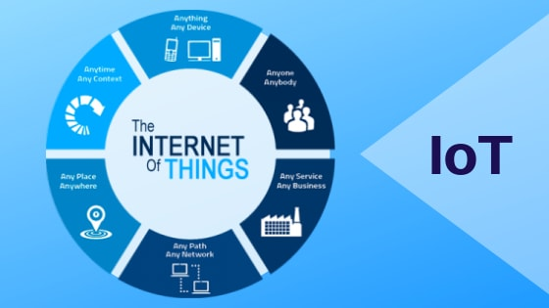

**Fig - 1:** Definition of IoT

**2. THE IOT ARCHITECTURE**

Fig-2 Shows main components of this architecture i.e. edge side and cloud side.



**Fig - 2 :** Architecture of IoT

**2.1 The Edge Things**

At the end these components; It can be sensors, actuators, devices and a key element called a gateway. The main function of this gateway is to communicate between cloud products and services and manage the functioning of everything. The word “edge” comes from [6]edge computing, where information is processed as close as possible to the original information at the center of the network. The endpoint could be a smart city, a smart building, a factory, a power grid, an oil mill, a wind farm, a farm, a plane, a train or a car. The main thing that makes working at the edge important is to keep the data as close as possible and work in real-time.

**2.2 Field Protocols**

Sensors, actuators, and devices are at the edge, so they need to communicate with each other and with smart gateways. This type of communication is based on field rules, the most popular methods are:

Bluetooth: It is a significant protocol for IoT applications. It has been designed to offer significantly reduced power consumption. Standard: Bluetooth 4.2 core specification, Frequency: 2.4GHz (ISM), Range: 50-150m (Smart/BLE), Data Rates: 1Mbps (Smart/BLE)[7].

Zigbee: Similar to Bluetooth, it has a large installed base of operation, although perhaps traditionally more in industrial settings. ZigBee PRO and ZigBee Remote Control (RF4CE), among other available ZigBee profiles, are based on the IEEE802.15.4 protocol, which is an industry-standard wireless networking technology operating at 2.4GHz targeting applications that need comparatively unusual information exchanges at low data-rates over a restricted area and within a 100m range such as in a home or building[7].

Wi-fi: This type is often a distinct choice for many developers, especially given the ubiquitous of Wi-Fi within the home environment within LANs. It offers fast data transfer and the ability to handle high quantities of data[7].

NFC: Near Field Communication (NFC) is a technology that enables simple and safe two-way communication between electronic devices, and especially applicable for smartphones, allowing consumers to perform contactless payment transactions, access digital content and connect electronic devices. Essentially it extends the capability of contactless card technology and enables devices to share information at a distance that is less than 4cm[7].

**2.3 IoT Smart Gateway**

The main role of the IoT gateway is to facilitate edge-to-cloud communication. This means it needs to understand the site's process and translate it into the cloud protocol. The smart gateway has functions such as traffic, data flow, data management, data monitoring and storage of data[8].

**2.4 Cloud Protocols**

The most of IoT solutions, even those that live almost entirely on the edge needs to integrate with cloud services or other IoT solutions based on the cloud. These are some methods to communicate using a cloud protocol as listed below:

MQTT: Message Queue Telemetry Transport (MQTT) was introduced by IBM in 1999 and standardized by OASIS in 2013. MQTT is frequently used and supported by embedded devices, and is also common in machine-to-machine interactions. It is designed to provide embedded connectivity between applications and middle wares on one side and networks and communications on the other side[9].

AMQP: The Advanced Message Queuing Protocol (AMQP) is a protocol that was designed for financial industry. It runs over TCP and provides a publish/ subscribe architecture which is similar to that of MQTT. The difference is that the broker is divided into two main components: exchange and queues. The exchange is responsible for receiving publisher messages and distributing them to queues based on pre-defined roles and conditions. Queues basically represent the topics and subscribed by subscribers which will get the sensory data whenever they are available in the queue[9].

CoAP: The Constrained Application Protocol (CoAP) is another session layer protocol designed by IETF Constrained Resurce Environment working group to provide lightweight RESTful (HTTP) interface. Representational State Transfer (REST) is the standard interface between HTTP client and servers. However, for lightweight applications such as IoT, REST could result in significant overhead and power consumption. CoAP is a document transfer protocol. CoAP is designed to enable low-power sensors to use RESTful services while meeting their power constraints. It is built over UDP, instead of TCP commonly used in HTTP and has a light mechanism to provide reliability. CoAP architecture is divided into two main sublayers: messaging and request/response. The messaging sublayer is responsible for reliability and duplication of messages while the request/response sublayer is responsible for communication. As in HTTP, CoAP uses GET, PUT, PUSH, DELETE messages requests to retrieve, create, update, and delete, respectively[9].

HTTP: HTTP is a "connectionless" protocol. With the HTTP bridge, devices do not maintain a connection to Cloud IoT Core. Instead, they send requests and receive responses. This is the standard protocol for web services and still will be using in IoT solutions. The overhead of this protocol is well known but we will continue use of this protocol in some case when latency and bandwidth are not issues[9].

**3. USE OF IoT IN VARIOUS APPLICATIONS**

Most applications in daily life are already smart, but they cannot communicate with each other, and enabling them to communicate with each other and share valuable information will create more new applications [10]. These emerging apps with some autonomy will make our lives better, all due to the concept of IoT. In this section, we present few of IoT applications as shown in Fig-3.

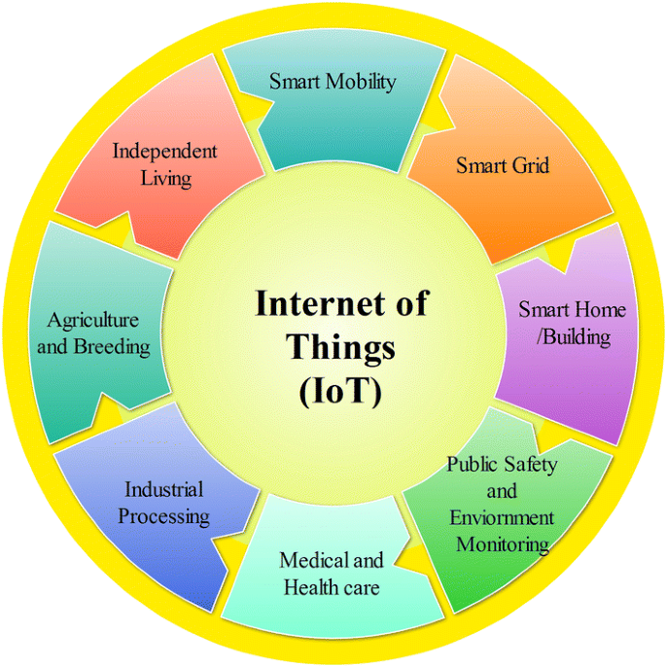

**Fig - 3 :** Applications of IoT

**3.1 IoT For Smart Home/Building**

Nowadays, smart homes have become an urgent need for life. Smart homes allow multiple homes to communicate via an Internet connection. In a smart home, many home appliances such as air conditioners, doors, windows, lighting, washing machines and refrigerators can be controlled manually, as seen in Figure 4. The combination of IoT and wireless sensor networks can provide smart solutions for energy management. With the help of laptop or smartphones, anyone can access the energy information and control system of one or more buildings[11].

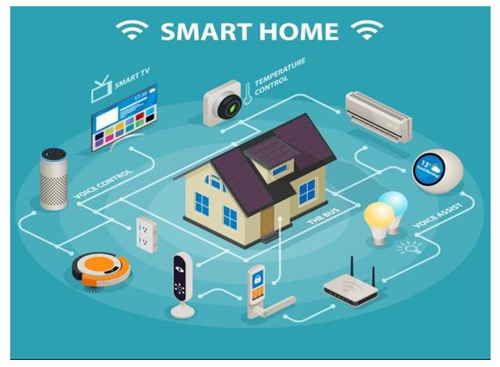

**Fig - 4 :** Smart Home

**3.2 IoT for Smart Farming**

IoT-based smart farming systems can help monitor, for instance, light, temperature, humidity, rain prediction and soil moisture of crop fields using connected sensors as shown in Fig-5. IoT also plays an important role in improving water resources. Benefits of smart agriculture; to improve economy, increase product quality and yield, and improve management, weather monitoring and crop management through standard automation. It also allows better control of internal processes and reduces production risks..

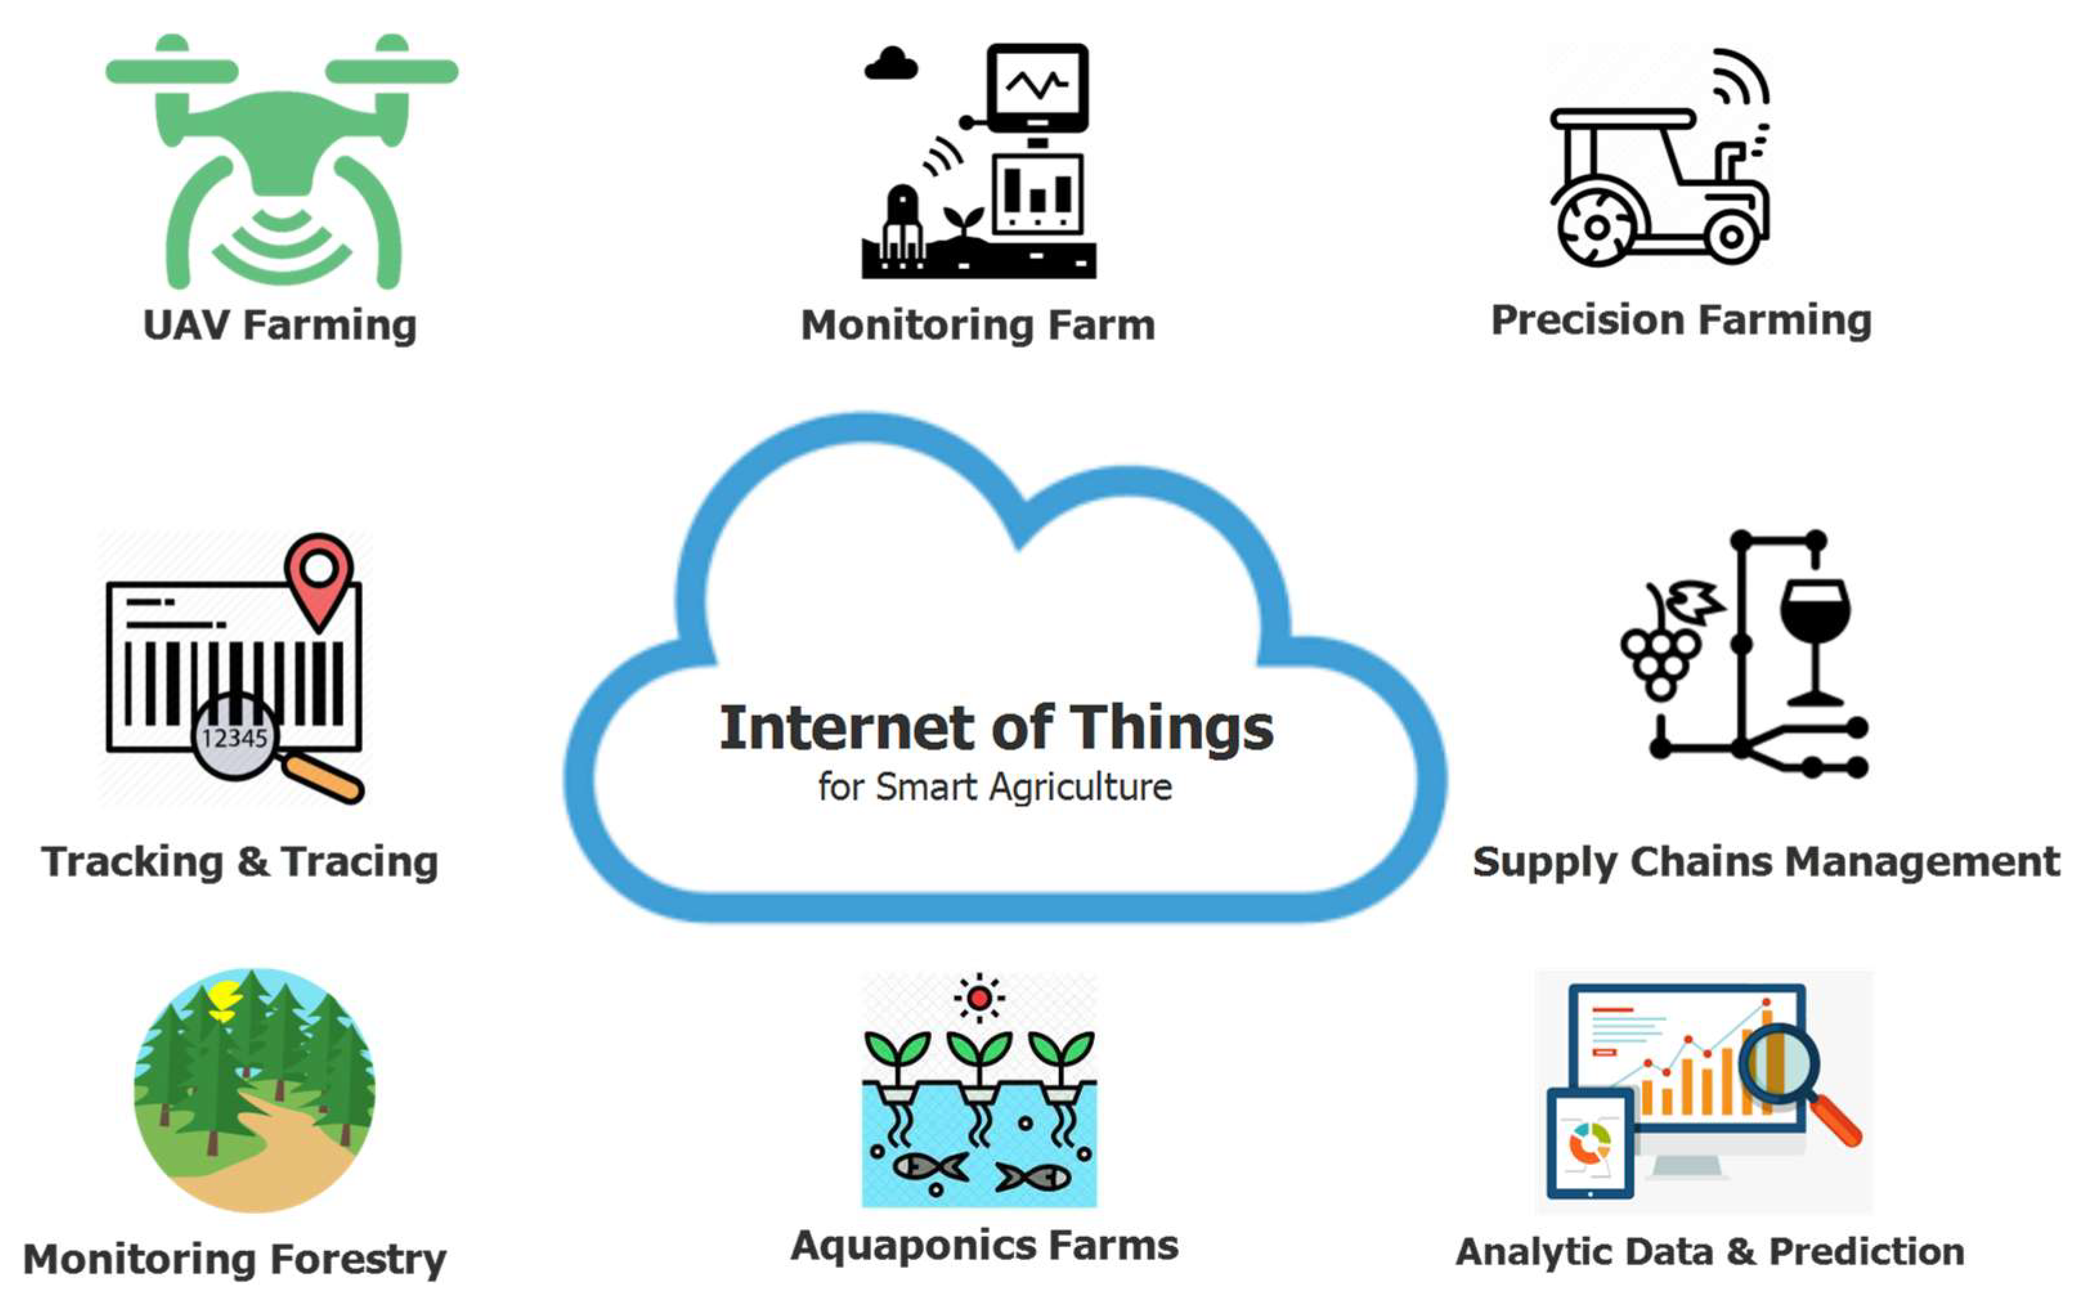

**Fig - 5 :** Smart Farming

**3.3 IoT For Smart Health**

Patients in the hospital need constant care and their physical condition needs to be constantly monitored, and this can be done continuously using IoT monitoring technology. Smart health meters are used to collect physical data and use the gateway and cloud to analyze and store the data, and then wirelessly send the analyzed data to the tracker for further review and analysis [12]. Instead of having to periodically visit a doctor to check a patient's vital signs, it provides doctors with a continuous, automatic flow of data.In this way, the simultaneously improvement of the quality of care through continuous attention and lowers the cost of care in addition to data collection and analysis as shown in Fig-6.

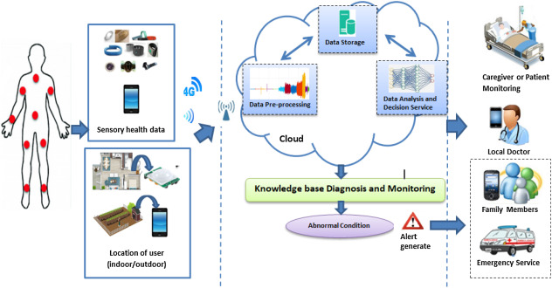

**Fig - 6 :** Smart Healthcare

**3.4 IoT for Smart City**

Every step of the smart city should be carefully planned, and IoT technology should be used in every aspect with the support of the state and the public. Using IoT, cities in India can be improved in many ways, by improving infrastructure, enhancing public transportation by reducing traffic congestion, and keeping citizens safe and sound in the city and healthy[13].Smart city layout is shown in Fig-7.

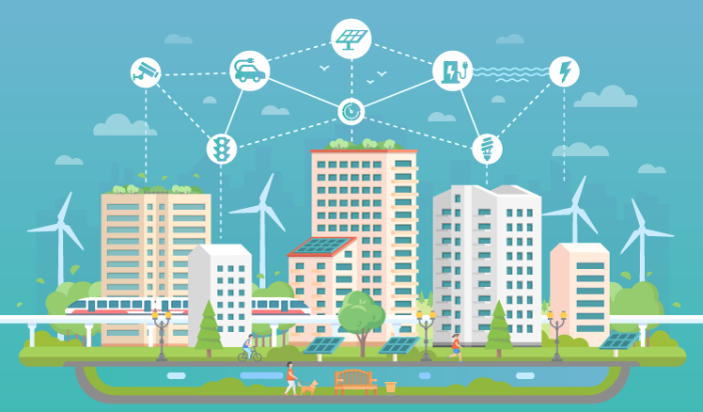

**Fig - 7 :** Smart City

**3.5 IoT for Smart Energy and The Smart Grid**

Combining information and communications technology (ICT) with the power of connectivity, smart grids will enable instant two-way communication between suppliers and users. It creates greater interaction between energy flows, which helps deliver more and more stable electricity efficiently and sustainably [14]. The essence of information and communication technology will include the technology of understanding and monitoring electronic digital communication to send information through the electronic meter at home to collect and complete different electricity usage and integration, management and electronic usage. Messages create an interactive and responsive force to create a highly interactive, responsive electricity [15]. IoT for smart grids leads to many applications such as business, solar energy, nuclear energy, automobile, hospital and city power management.. Fig-8 shows the most important application may be enabled by the internet of things as in smart grid aspect.

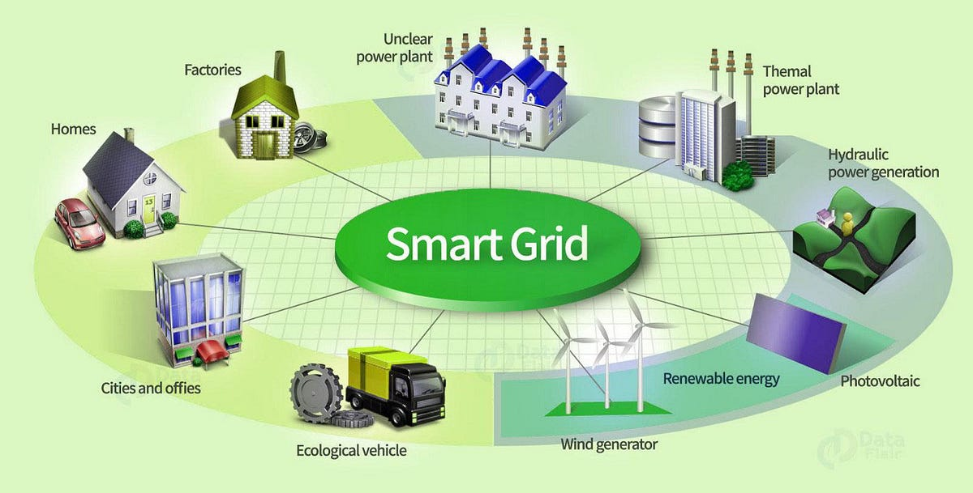

**Fig 8 :** Smart Grid

**4. ADVANTAGES AND DISADVANTAGES OF IoT**

This section contains the advantages and disadvantages of IoT Applications.

**4.1 Advantages of IoT Applications:**

* Security: You can monitor your home using your mobile phones, with the ability to control it. It can provide personal safety.
* Stay connected: You and your family members can always be in the network. You can virtually stay connected.
* Efficient use of electricity and energy: If your home appliances are communicating with you about the work done, their maintenance and repair will be easy. If appliances can operate by themselves then electricity utilization will be possible by an efficient way.
* Best Health Care and Management: The patient monitoring is possible on a real time basis without doctor's visit and enables them to make decisions as well as offer treatment when emergency is there.
* Cost- Effective Business Operations: A large number of business operations like shipping and location, security, asset tracking and inventory control, individual order tracking, customer management, personalized marketing & sales operations etc. can be done efficiently with a proper tracking system using IoT.

**4.2 Disadvantages of IoT Applications**

* Privacy issues: Hackers can break into the system and possibility of stealing the data.
* Becoming Indolent: People are more habituated to have a click-based work making them lazy to any sort of physical activity, applied science in their daily routine.
* Unemployment: Lower level people like unskilled labour may have high risks of losing their jobs.

**5. CONCLUSION**

The Internet of Things has gradually brought great changes to our daily lives, making our lives easier and more convenient with various technologies and applications. IoT has many applications across all industries, including healthcare, manufacturing, business, transportation, education, management, mining, housing, and more. Uses of IoT in various applications have been described in this paper. In present and in future also, IoT is on the way of making the human life as one ‘connected’ and ‘smart’ life.

**6. CONCLUSION**

Research gate:

<https://www.researchgate.net/>

SpringerOpen: <https://journalofbigdata.springeropen.com/articles/10.1186/s40537-019-0268-2>