**Experimental Investigation of Composite Materials Made up of Human Hair**

**Bansode V. D. 1, Patale S. D.2 , Sarvade D. R. 3 Bondre K. S. 4 Prof. Deshmukh R. N. 5**

1Assistant Professor, Department of Mechanical Engineering, SMSMPITR, Akluj, Maharashtra, India

2-4UG Student, Department of Mechanical Engineering, SMSMPITR, Akluj, Maharashtra, India

**ABSTRACT**

In modern technology, the composites materials play a major role to meet various requirements in all the industrial manufacturing needs. Such as, it increases physical properties, chemical, and structural properties. In this study, Human Hair fibers to make composites using epoxy resin.The tensile, flexural and impact tests of this composite were carried out experimentally according to ASTM standards. The human hair fiber is treated with NaOH (5%,7.5%&10%). To evaluate the mechanical properties of fiber such that tensile, impact test, flexural test among these treated 5 % gives more strength.

**Keywords:** Composites, Human Hair Fiber, Epoxy resin

1. **INTRODUCTION**

Modern composite materials constitute a significant proportion of the engineered materials market ranging from everyday products to sophisticated niche applications. Research on plastics and cement reinforced with natural fibers such as jute, sisal, coir, pineapple leaf, banana, sun hemp, straw, broom, and wood fibers are done. Although natural fibers reinforced in thepolymer matrix are environment- friendly, they suffer from lower modulus, lower strength, and relatively low moisture resistance compared to synthetic fiber reinforced composites such as glass fiber reinforced composites. Hybridization of natural fiber with stronger and more corrosion resistant synthetic fibers such as glass fibers and carbon fibers improves stiffness, strength as well as themoisture resistant behavior of the composite While composites have already proven their worth as weight-saving materials, the current challenge is to make them cost effective. The efforts to produce economically attractive composite components have resulted in several innovative manufacturing techniques currently being used in the composites industry. It is obvious, especially for composites, that the improvement in manufacturing technology alone is not enough to overcome the cost hurdle. It is essential that there be an integrated effort in materials process. Tooling, quality assurance, manufacturing, and even program management for composites to become competitive with metals. Composite materials are engineered materials made from two or more constituent materials with significantly different physical or chemical properties which remain separate and distinct on a macroscopic level within the finished structure. In practice, most composites consist of a bulk material (the 'matrix'), and a reinforcement of some kind, added primarily to increase the strength and stiffness of the matrix. Many materials when they are in a fibrous form exhibit very good strength property but to achieve these properties a suitable matrix should bond the fibers. The matrix isolates the fibers from one another to prevent abrasion and formation of new surface flaws and acts as a bridge to hold the fibers in place. A good matrix should possess the ability to deform easily under applied load, transfer the load onto the fibers and evenly distributive stress concentration.

The role of the reinforcement in a composite material is fundamentally one of increasing the mechanical properties of the neat resin system. All of the different fibers used in composites have different properties and so affect the properties of the composite in different ways. For most of the applications, the fibers need to arrange into some form of a sheet, known asa fabric, to make handling possible. Different ways for assembling fibers into sheets and the variety of fiber orientations are possible to achieve different characteristics.

1. **Material and Methodology**
   1. **Raw Material**

As an Innovation to the field of Fibre Reinforced composites, usage of Human Hair as a Fibre gained its importance. Chemically, about 80% of human hair is formed by a protein known as keratin, with a high grade of sulfur – coming from the amino acid cysteine – which is the characteristic to distinguish it from other proteins. Keratin is a laminated complex formed by different structures, which gives the hair strength, flexibility, durability, and functionality. The hair thread has a cylindrical structure, highly organized, formed by inert cells, most of them keratinized and distributed following a very precise and pre-defined design. Hair forms a very rigid structure at the molecular level, which can offer the thread both flexibility and mechanical resistance. Human hair has about 65-95% of its weight in proteins, 32% of water, lipid pigments and other components. Human Hair fiber is composed of three main structures: cuticle, cortex, and medulla. Proteins with α- helix structure which is winded in the hair have long filaments of unknown microfibers which link to each other to form bigger structures, to produce cortex cells. This enchained structure offers the capillary fiber more strength and elasticity. The main factor to be considered in the human hair is the high amount of the amino acid cysteine, which may be degraded and afterward, may be re-oxidated under a disulphide bonding form. Hair is surprisingly strong. Cortex Keratin is responsible for this propriety, and its long chains are compressed to form a regular structure which, besides being strong, is flexible. The physical proprieties of hair involve resistance to stretching, elasticity and hydrophilic power.

* 1. **Methodology**
     1. **Preparation of Matrix**

Matrix is prepared by mixing resin (Epoxy Resin), Curing agent (Phenalkamime PPA-7040) in the ratio 10:1. The matrix must be used immediately after its preparation since it gets hardened if it is kept for too long

* + 1. **Fabrication of Composite Specimen**

The composite specimen consists of the random orientation of human hair fiber until we obtain required thickness. A mat with large surface area is placed on a floor, and OHP sheet is placed on its surface to avoid the adherence of laminate to the mat. The fiber and resin were mixed in 1:4 ratios. Then the mixture was poured in the die. The ASTM standard size of the specimen is 180mm length, 110mm Wide, 5mm thicknesses shown in figure1.The composite mixture is settled in the die using Hand lay-up method. The hand lay-up method, sometimes called contact molding, is simple and versatile and the most widely used FRP process.

1. **Experimentation**
   1. **Specimen Dimensions**

Specimen prepared by hand lay-up process is cut into required dimensions. And Tensile, Flexural and Impact test specimens are obtained according to ASTM standards. Tensile Test Specimen is prepared into Dog Bone shape of dimensions 165x19x5 mm3 according to ASTM D638 standard. Flexural Test Specimen is prepared into the Flat shape of dimensions 80x15x5 mm3 according to ASTM D790 standard. Impact Test Specimen is prepared according to ASTM A370 standard of dimensions 65x12x5 mm3.

* 1. **Mechanical Testing**
     1. Tensile Test

The tensile strength of material is the maximum amount of longitudinal stress that it can take before failure. The testing process involves placing the test specimen in the testing machine and applying tension to it until it fractures. The tensile force is recorded as a function of the increase in gauge length. During the application of tension, the elongation of the gauge section is recorded against the applied force. The tensile test is performed in BISS UTM of capacity 50KN. Figure shows tensile test specimens.

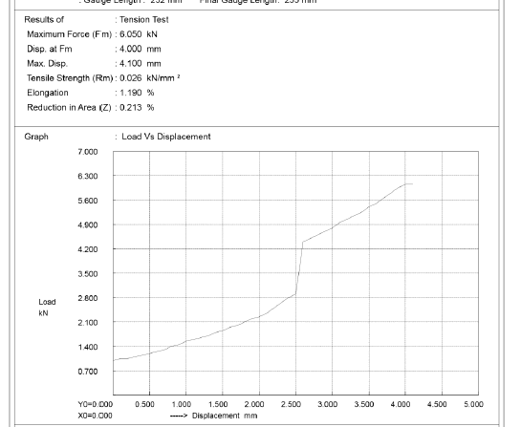

Figure 1: Test Results for Tensile Test

* + 1. Impact Test

During the Izod impact testing process, the specimen must be loaded in the testing machine and allows the pendulum until it fractures or breaks. Using the impact test, the energy needed to break the material can be measured easily and can be used to measure the toughness of the material and the yield strength. Figure shows impact test specimens.

* + 1. Flexural Test

In composite materials, specimen deflection is measured by the crosshead position. Test results include flexural strength and displacement. The testing process involves placing the test specimen in the universal testing machine and applying force to it until it fractures and breaks. The specimens used for conducting the flexural test are presented in Figure 4. The flexural test is performed on the Computerized UTM.

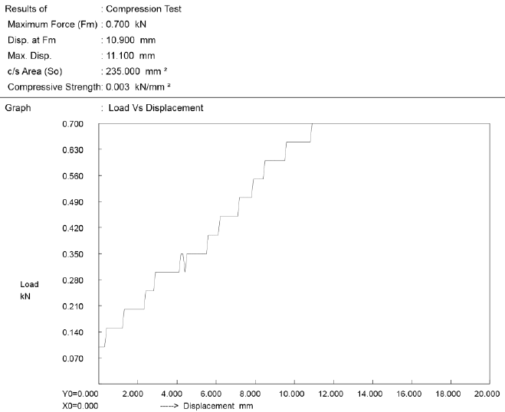

Figure 2: Test Result for Flexural Test

1. **RESULTS AND DISCUSSION**

The use of composite materials in the different fields is increasing day by day due to their improved properties. Engineers and Scientists are working together for some years for finding the alternative solution for the high solution materials. In the present study, human hair fiber reinforced the composite material, and their effect on mechanical properties is evaluated, and their properties are compared. The test results for the Tensile, Flexural, and Impact tests of the composite samples are presented.

* 1. **Tensile Test Results**

The different composite specimen samples are tested in the universal testing machine (UTM) and the samples are left to break till the ultimate tensile strength occurs. Stress–strain bar chart is plotted for the determination of ultimate tensile strength and elastic modulus as shown. After the consideration of all the result data, the 5% treated fiber specimen had the highest tensile strength and Young’s modulus.

|  |  |  |  |  |  |  |  |  |  |
| --- | --- | --- | --- | --- | --- | --- | --- | --- | --- |
| 2000  1500  1000  500  0 | PEAK load, N | | | | | | | | |
|  | | | | | | | | |
|  | | |  |  | | | | |
|  |  |  |  |  |  | | |
|  |  |  |  |  |  |
|  |  |  |  |  |
| untreated treated fibre treated fibre treated fibre fibre 5% 7.5% 10%  Peak load, N | | | | | | | | |

* 1. **Flexural Test Result**

Three-point bend test was carried out in a UTM machine by ASTM standard to measure the flexural strength of the composites. All the specimens were of rectangular shape having dimension of 90x10x3 mm3. The span length was 75mm. The load vs. displacement figures are plotted from Figures 8 to 10.

Formula to calculate flexural strength, Flexural Strength = (3PL)/(2wt2)

Where, P = Peak Load in KN, L = Gauge Length

in mm, w = Width of the Specimen in mm and t = Thickness of the Specimen in mm

* 1. **Compression Test Result**

The following graph shows the behavior of Test Specimen under compressive loading. The maximum load carried by the specimen has been specified in the same.

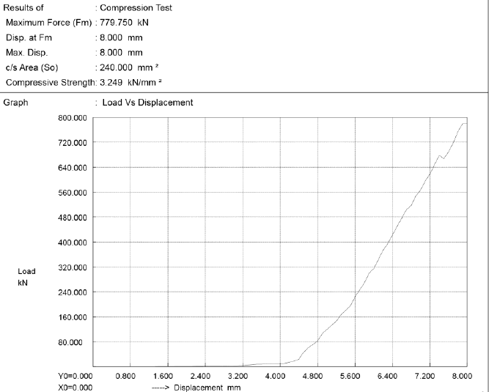

Figure 3: Compression Test Results

1. **CONCLUSION**

This experimental investigation on mechanical characteristic of Human Hair Fiber Reinforced Epoxy Composites leads to the following conclusions:

It has been noticed that the mechanical properties of the composites such as tensile strength, flexural strength, impact strength are greatly influenced by the 5% treated fiber. From the tensile test, it is found that the maximum tensile strength was 36.994 N/mm2 for 5% treated fiber and minimum were 14.392 N/mm2 for 10% treated fiber. The flexural test result shows that5% treated fiber has the highest flexural strength (28.048 Mpa) and Non- treated fiber has the lowest flexural strength (11.185 Mpa).It is found from the impact test that, the impact strength of 5% treated fiber is the highest (0.7 J) and impact strength of the untreated fiber is the lowest (0.55 J).

1. **REFERENCES**
2. Andressa Cecilia Milanese, Maria Odila Hilario Cioffi, and Herman Jacobus Cornelis Voorwald, 2011 "Mechanical behavior of natural fiber composites' procedia Engineering 107, 2022- 2027..
3. Aninmemon, Asami Nakai, 2013 "Fabrication and Mechanical Properties of Jute Jpun yarn/PLA Unidirectional Composites by Compression Molding" Energy procedia 34,830-38.
4. R. MeN. Arib, s.M. Sapuana„ M.M.H.M Ahmad, M.T. Paridah,
5. H.M.D. Khairul Zaman, 2006 "Mechanical properties of pineapple leaf fiber reinforced polypropylene composites," Materials and Design 27,391-396.
6. R.Badrinath, T.Senthilvelan, 2014 "Comparative Investigation on Mechanical Sisal Reinforced Polymer Based and of Banana Properties composites,"Prodedia Materials Science 5, 2263- 2272.
7. Wang, X., et al. (2019). Thermal Conductivity of Human Hair-Based Composite Films with Different Morphologies. Materials Letters, 254, 1-4.
8. Wang, Y., et al. (2020). Development of Recyclable Human Hair Reinforced Poly(lactic acid) Composites. Polymer Degradation and Stability, 174, 109095.
9. Zhang, M., et al. (2020). Flame Retardant Properties of Human Hair Reinforced Intumescent Flame Retardant Polypropylene Composites. Polymer Testing, 89, 106646.
10. Li, C., and Wu, Q. (2019). "Preparation and Properties of Human Hair Fiber-Reinforced Epoxy Composites." Polymers, 11(3), 513.
11. Gassan, J., and Bledzki, A. K. (2001). "Possibilities for improving the mechanical properties of jute/epoxy composites by alkali treatment of fibers." Composites Science and Technology, 61(9), 1303-1309.
12. Kim, Y. H., et al. (2017). "Thermal properties of hemp-epoxy composites: Influence of chemical treatment and fiber/matrix modifications." Composites Part B: Engineering, 127, 60-68.
13. Chen, Y., Zhang, W., Zhang, H., & Zhu, S. (2017). Reinforcement of hydroxyapatite on human hair keratin/polyvinyl alcohol composite nanofibers for bone tissue engineering. Journal of Biomedical Materials Research Part A, 105(8), 2341-2349.
14. Gupta, V., Sharma, S., & Chauhan, A. (2019). Mechanical properties of human hair: A Review. International Journal of Engineering Research and Applications, 9(1), 100-105.
15. Karana, E., Blauwhoff, D., & Hultink, E. J. (2016). Human hair as wearable material: Exploring the potential of hair fibres in fashion textiles. Journal of Fashion Marketing and Management, 20(3), 270-285.
16. Kim, J. Y., Kang, T. J., & Park, H. J. (2018). Comparative Study on Mechanical Properties and Fracture Behavior of Carbon Fiber, Carbon Nanotube, and Kevlar-Reinforced Composites. Polymers, 10(8), 835.
17. Peng, Z., Han, G., Sun, X., Zhang, X., Sun, S., & Wang, Z. (2021). Study on Mechanical Properties and Microstructure of Polypropylene Composites Filled with Hydroxyapatite from Human Hair. Materials, 14(1), 63.
18. Tang, H., Pan, X., Zhou, W., & Xu, Z. (2019). Mechanical and thermal properties of a biocomposite based on soy protein and hydroxyapatite from human hair. International Journal of Biological Macromolecules, 133, 218-225.
19. Yousefi, H., Yeganeh, H., Farnoush, H., Shokrieh, M. M., & Zaarei, D. (2020). Effect of keratin filler on mechanical and thermal properties of unsaturated polyester composites. Composites Part B: Engineering, 197, 108130.
20. Jawaid, M., Khalil, H. P. S. A., Abu Bakar, A., & Woven, P. (2019). Mechanical performance of natural fibre reinforced polymer composites. Woodhead Publishing.
21. Guo, Z., Li, Y., & Li, X. (2018). Thermal analysis and fire resistance of composites. In J. Lin (Ed.), Fire resistance of composites (pp. 29–56). Woodhead Publishing.