**SOLAR BASED DYNAMIC WIRELESS CHARGING STATION**

**Prof Sameer Raut , Tejas Kolhe, Hitesh Kamble, Shubham Dhoke, Deepak Chatpalliwar**

*Department of Electrical Engineering*

*Shri Sai College of Engineering and Technology,Bhadrawati(MS), India*

**Abstract**: As the new era of the automobile, the industry is rapidly transforming from an IC engine vehicle to an electric vehicle. The demand for an electric vehicle is increasing, these lead to an increase in charging station as well. In this project, a wireless charging system is used to charge the vehicle wirelessly via inductive coupling. we just simply need to park the car on the charging spot. The transmission of electrical energy from source to load from a distance without any conducting wire or cables is called Wireless Power Transmission. The concept of wireless power transfer was the greatest invention by Nikola Tesla. This system doesn’t require any human interaction. Wireless power transmission might be one of the technologies that are one step towards the future. This project can open up new possibilities of wireless charging that can use in our daily lives.

**Keywords: Atmega 328p microcontroller, Battery Management System (BMS), 18560 Rechargeable Battery, Solar Panel**

**Objectives**:

* The objective of this project is to develop a wireless charging system for electric vehicles that can charge them wirelessly while driving on a road with multiple copper coils.
* The system will utilize inductive or resonant coupling technology to transmit power from the coils to the EV's battery.
* The goal is to design a system that is safe, efficient, and practical for use on public roads.

**Introduction:**

We live in a world of technological advancement. New technologies emerge each and every day to make our life simpler. Despite all these, we still rely on the classical and conventional wire system to charge our everyday electronic gadgets. The conventional wire system creates a mess when it comes to charging several electric vehicles simultaneously. It also takes up a lot of electric sockets at the charging port. At this point, a question might arise. ―What if a single technology can be used to charge these electric vehicles simultaneously without the use of wires and not creating a mess in the process? We gave it a thought and came up with an idea. The solution to this problem is inductive coupling, a simple and effective way of transferring power wirelessly.

Road transportation is the majorly used transportation in the entire world. Usage of the car has drastically increased and the need for petrol and diesel has increased. So recently, Electric vehicles (EVs) are becoming popular, as they decrease reliance on fossil fuels and reduce greenhouse emissions. The problem of the Electric Vehicle is nothing else but the electricity storage technology, which is the major drawback today due to its unsatisfactory energy density, limited lifetime, and high cost. So, our project proposes a novel idea to charge the Electric vehicle wirelessly through the inductive power transfer principle using the transmitting and receiving coil while simultaneously decreasing the battery size and improving the convenience and without the requirement of the cable. The electric vehicle can be charged both by the static wireless power transmission (SWPT) and dynamic wireless power transmission (DWPT) method for cost savings.

Wireless Power Transmission (WPT) is the efficient transmission of electric power from one point to another point through a vacuum or an atmosphere without the use of wire or any other substance. This can be used for applications where either an instantaneous amount or a continuous delivery of energy is needed, but where conventional wires are unaffordable, inconvenient, expensive, hazardous, unwanted, or impossible. The power can be transmitted using Inductive coupling for short-range, Resonant Induction for mid-range and Electromagnetic wave power transfer for high range. WPT is a technology that can transport power to locations, which are otherwise not possible or impractical to reach. Charging the battery of electric vehicles by means of inductive coupling could be the next big thing.

The main objective of the project work area, the installation of the wireless charging path (WCP) in the Electric Vehicle Service Road (EVSR) since service roads will be easy for charging the electric vehicles wirelessly while traveling. To provide the non-cable system. To reduce the complexity of the charging process of electric vehicles. The power required to charge an electric vehicle is generated from the solar panel.

**Circuit Diagram**

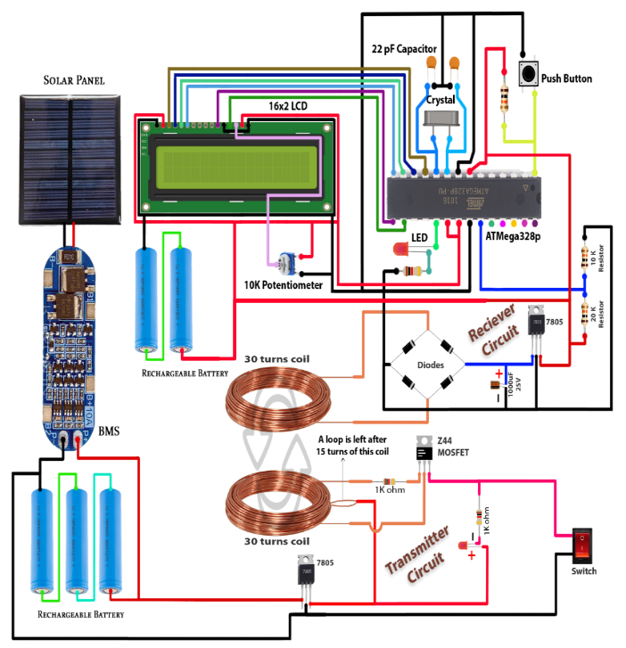

**Methodology**

In this project, we are going to develop a system using IoT based technology and renewable energy source i.e.solar energy. Whole system will be operated on 12 V supply using battery. Battery will be charged by solar panel. This controller converts Analog signal into digital form and provides it to LCD. Percentage of battery will be displayed on LCD 16X2. For wireless power transfer, we are using transmitter and receiver coil. The distance between these two coils is less than 5 mm so we get the voltage 5 volt. The transmitter coil requires 9 volt DC supply and at the end of receiver coil, we get the 5 volt supply. We can have customized control from Android App to ON and OFF the relay for charging the battery with time. If the Relay is OFF then it will turn OFF the transmitter coil supply 9 Volt. If the relay is ON then it will turn ON the wireless transmitter coil supply 9 Volt.

**Advantages:**

• It uses a clean, renewable source of energy, the sun.

• Cost-efficient.

• A readily available alternative source of energy in case electricity is unavailable.

• Portability.

• Durability.

• Convenience

**Disadvantages:**

They are environmentally friendly and can be useful in outdoor activities. However, their charging capacity may be limited. Disadvantages include longer charging times compared to traditional chargers and reliance on weather conditions.

**Result:**

Wireless power transfer for electric car using ATmega328 microcontroller can be done by different methods such as inductive coupling or resonance coupling using ic555 circuit, and power MOSFET circuit with primary and secondary coil works well. The results of this project will depend on characteristics such as efficiency, range and power transfer capacity, as well as specific usage and design options. It is important to consider the safety, EMI, and overall performance of the system. The result will depend on the success of hardware integration, firmware programming, energy storage for the EV battery on both sides where the coils are energized, and this car is solar powered, both wireless and solar energy is stored in the

battery. Another explanation of the project is how long the battery lasts.

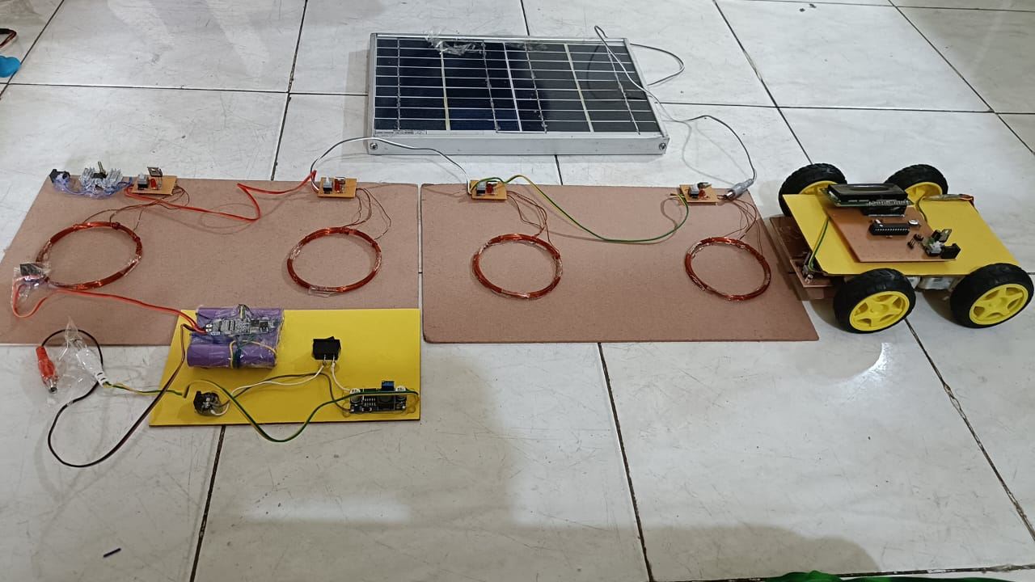

**Conclusion:**

In this system, we are presenting the Wireless Power Transmission. As the electric vehicle in the market is increasing. We can use the wireless charging system to charge our vehicles. This system shows the efficiency and implementation of the charging station in future technology. Overall, this paper compares various smart parking, charging and combined charging-parking system, which can help to solve various issues related with it. The conclusion of building a wireless charging prototype for electric vehicles using multiple copper coils and an Arduino Nano-based control system is that the technology has the potential to offer a practical and efficient alternative to traditional charging methods for EVs.

**Future Scope:**

* Increasing the efficiency of the wireless charging system: While wireless charging technology has come a long way, there is still room for improvement in terms of efficiency. By optimizing the design of the coils, improving the electronics, or using different materials, it may be possible to increase the efficiency of the charging system.
* Scaling up the charging system for commercial use: The prototype you are building is just the beginning. To make this technology practical for widespread use, you may need to scale up the system to cover longer distances or support more vehicles charging at the same time. This will likely require additional engineering and testing to ensure safety and efficiency.
* Exploring alternative power sources: While using copper coils to charge electric vehicles wirelessly is a promising technology, it still relies on an external power source. In the future, it may be possible to integrate solar panels or other renewable energy sources into the road to power the charging system.
* Integrating with autonomous vehicle technology: As autonomous vehicle technology advances, it may become possible to integrate wireless charging capabilities directly into the vehicles themselves. This could eliminate the need for external charging stations or coils along the road and make charging even more convenient for EV owners.
* Improving the user interface: While the LCD display you are planning to use is a good start, there may be opportunities to improve the user interface for EV drivers. For example, you could develop a mobile app that allows drivers to monitor their battery level and track their charging history. This could also help drivers find wireless charging stations along their route.

**References:**

1. Supriyadi, Edi Rakhman, Suyanto, Arif Rahman and Noor Cholis Basjaruddin, “Development of a Wireless Power Transfer Circuit Based on Inductive Coupling, “TELKOMNIKA, Vol.16, No.3, June 2018, pp. 1013~1018
2. N. uthaya Banu, U. Arun Kumar, A. Gokula Kannan, M.K. Hari Prasad and A.B. Shathish Sharma, “Wireless Power Transfer in Electric Vehicle by Using Solar Energy, “ Asian Journal of Electrical Sciences, Volume 7, Issue 1, January-June 2018
3. Govind Yatnalkar and Husnu Narman, “Survey on Wireless Charging and Placement of Stations for Electric Vehicles, “Conference: 2018 IEEE International Symposium on Signal Processing and Information Technology (ISSPIT), December 2018
4. Md M. RANA, WEI XIANG, Internet of Things Infrastructure for Wireless Power Transfer Systems, IEEE Access, volume 6, pp.19295-19303, 24 Jan 2018.IEEE
5. Sahil Rupani, Nishant Doshi, A review on smart parking using internet on things (IOT), The 3rd International Workshop on Recent advances on Internet of Things: Technology and Application Approches (IoT-T&A 2019) Nov 2019, Coimbra, Portugal.
6. Julian Timpner, Lars Wolf, A Back-end System for an Autonomous Parking and Charging System for Electrical Vehicles, International Electrical Vehicle Conference Greenville, SC, USA IEEE 2012
7. Mehmet Sukru Kuran, Aline Carnerio Viana, Luigi Iannone, Daniel Kofman, Gregory Mermound, Jean P. Vasseur, A Smart Parking
8. Adilet Sultanbek, Auyez Khassenov, Yerassyl Kanapyanov, Madina Kenzhegaliyeva, Mehdi Nagheri, Intelligent Wireless Charging Station for Electrical Vehicles, International Siberian Conference on Control and Communication, 2017, IEEE
9. Zhe Wei, Yue Li, Yongmin Zhang, Lin Cal, Intelligent Parking Garage EV Charging Scheduling Considering Battery Charging Characteristic, IEEE Transaction on Industrial Electronics, Vol 65, 3 March 2018