## Review Paper on 5G Network for Visible Light Communication

**Akansha Chauhan [1] Vikas Sharma [2] Ishita Jain [3]**

Jagan Institute of Management Studies

3, Institutional Area, Sector-5, Rohini (Near Rithala Metro Station), Delhi-110085

contact@jimsindia.org

**Abstract:** This write-up provides further insights on the emerging technologies of Visible Light Communication (VLC) with 5G networks. Who isn’t after quick and dependable phones? The integration of 5G networks and VLC technologies might just offer the ultimate answer to more connectivity at work stations or even shopping malls. This document includes among others essential understandings, methods and possible missions of 5G and VL to consider VLC. It also looks at some of the advantages they bring to the table as well as a few challenges they may face. The goal here is fairly straightforward: [1] provide valuable insights for scientists, engineers and developers interested in exploring how 5G can be used in conjunction with VLC to network the Internet good design in the future.

**Keyword:** Visible Light Communication (VLC), 5G Networks, Integration, Wireless Communication, LED Transmitters, Photodetectors, Signal Processing Algorithm.

**1. Introduction:** A major event is currently taking place in wireless technology, in which visible light communication (VLC) is being combined with 5G networks. Communication is done by LED in VLC and this is quite advantageous owing to the fact that time is reduced and there is no issue of electronic interference. In addition; it has a high volume capability. For its part, 5G performs excellently when transferring data and can serve many gadgets simultaneously hence ideal like augmented reality apps and all those Internet of Things gadgets everyone’s talking about.

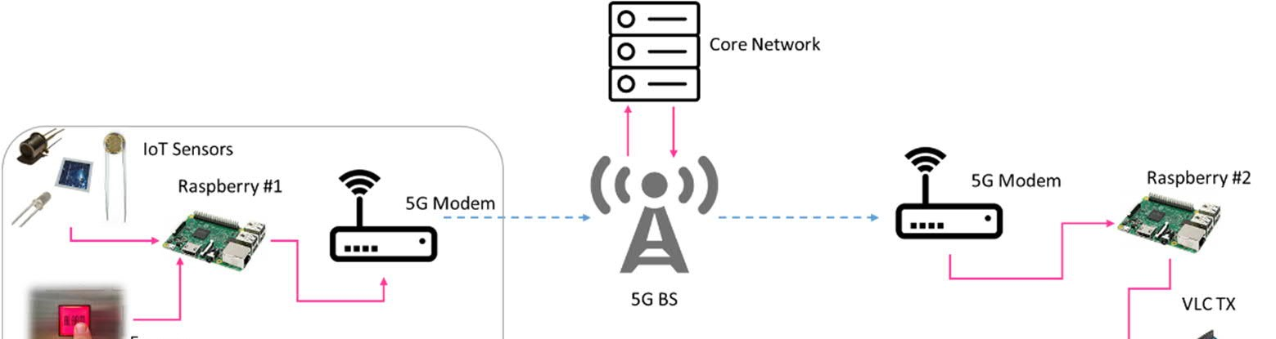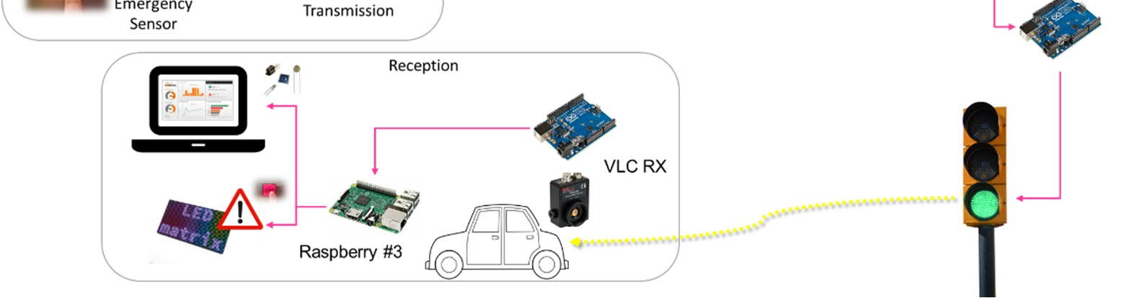

**Figure 1**. Test bed architecture of the 5G-VLC joint network.

**2. Literature Review:**

LEDs are used for visible light communication (VLC). It is growing in popularity for wireless communication. VLC is gaining momentum with researchers and business people because of its speed and ability to handle large data volumes simultaneously as well as immunity from EMI. However, scalability remains one of its major concerns. The main ones include the range being small and an impact of sunlight which causes high losses. Therefore, research has been carried out on merging VLC with 5G networks for addressing these challenges and making the best out of it. To explain further 5G networks are the upcoming technology in wireless communication. One reason for this is that they have very high data rates with negligible delay incorporating a lot of devices making them suitable for use inside buildings; this allows them to serve as backbone systems for any VLC-based application that requires fast speeds without interruptions. What these scholars are looking forward to is coming up with advanced technological approaches characterized by reliability at high velocity wireless connections for all kinds of indoor applications by harnessing the advantages of both 5G and VLC.

[3] Previous studies have shown that using 5G-enabled VLC systems is totally doable and can bring some benefits. One example is Li-Fi, which is a data transmission solution based on VLC. [2] It can handle data throughput of up to 1 Gbps and was first proposed by Haas back in 2016. Another study conducted by Afghani and their team in 2011 explored the use of orthogonal frequency division multiplexing (OFDM) in VLC systems. They talked about how this technology can reduce multipath fading and achieve high spectral efficiency. [4] In a discussion about the possibilities and challenges of 5G-enabled VLC, Chowdhury and others in 2018 stressed the importance of having edge computing infrastructure and deploying small cells.

Researchers are using VLC and 5G integration to provide strong wireless connection within buildings. Key among the advancements that have made 5G based VLC systems more robust and efficient is the evolution in photo detectors, modulation methods, digital signal processing algorithms as well as LED transmitters. Consistently emitting light for illumination, LEDs have been designed with capabilities for high speed modulation like OOK and OFDM. Modulated light signals are captured by photodetectors with high sensitivity and quick response times, and they are then translated into electrical signals for additional processing.

[5] To make sure data transmission is reliable in indoor settings, we use signal processing techniques to counteract issues like multipath fading and interference from ambient light. Modulation methods, such as OFDM, allow us to maximize data throughput, reduce interference between symbols, and make the most of the available spectrum.

In addition, we can enhance the coverage and capacity of VLC-based networks by implementing small cells and edge computing infrastructure. [6] This setup enables real-time data processing and analytics, improving overall performance.

To sum it up, when you mix VLC technology and 5G networks, it is possible to have a good way to have​ reliable wireless connectivity inside buildings. Combining aspects of these technologies together while using the most recent signal processing methodologies in networking can help in coming up with new ideas on how we will enable more data intensive services and applications. However, more studies are needed if these systems are to be in wide use. However, for widespread use of 5G-enabled VLC systems, further research is needed to address challenges related to network scalability, interference reduction, and protocol standardization.

**3.Technologies and Methodologies:**

**3.1 LED Transmitters**. Photo-detective devices: The modulated light signals are captured by photodetectors on the receiving end and transformed back into electrical signals for additional processing. Different kinds of photodetectors, like photodiodes and phototransistors, can be used, according on what the VLC system needs. These photosensors ought to possess high sensitivity, little noise, and quick reaction times in order to precisely identify and decode the sent data signals: [10] Light-emitting diodes (LEDs) are used as transmitters in visible light communication (VLC) to encode data into light signals. High-speed modulation LED technologies are crucial for enabling gigabit-level transmission speeds over optical wireless communication networks.[7] In addition to enabling effective modulation systems like on-off keying (OOK), pulse amplitude modulation (PAM), or orthogonal frequency division multiplexing (OFDM), these LEDs should be made to offer steady and uniform illumination.   
LED transmitters can also include sophisticated optical parts like diffusers and lenses to improve the communication link's efficiency and coverage.

**3.2 Algorithms for Signal Processing:** Signal processing is essential for recovering transmitted data and obtaining information from received optical signals. Channel impairments are minimized with the use of sophisticated signal processing methods. such as ambient light interference, multipath fading, and inter-symbol interference (ISI). In difficult situations, methods like adaptive filtering, equalization, and error correction coding are used to increase the communication link's robustness and dependability.

**3.3 Modulation Techniques**: In vector local computer (VLC) systems, digital data is encoded onto the optical carrier signal using a variety of modulation techniques. The goals of these modulation schemes should be to reduce inter-symbol interference, increase spectral efficiency, and lessen the consequences of background light noise. Orthogonal frequency division multiplexing (OFDM), pulse position modulation (PPM), and on-off keying (OOK) are common modulation techniques used in VLC. Because OFDM-based modulation methods can reduce multipath fading and provide high data rates over large bandwidths, they are especially well-suited for VLC.

**3.4 Small Cell Deployment**: Small cell deployment is crucial for increasing the coverage and capacity of VLC-based networks. Small cells are low-power base stations that are installed in indoor spaces with a purpose to offload and give localized coverage. microcellular network traffic. By adding VLC transceivers, these tiny cells can create fast wireless connections with neighboring user devices, increasing network capacity and dependability in crowded cities and interior settings. Edge Computing: In order to allow real-time data processing and analytics in 5G-enabled VLC systems, edge computing infrastructure is essential. It is possible to effectively support latency-sensitive applications like augmented reality (AR) and virtual reality (VR) by placing edge computing nodes at the network edge, close to the point of data production. Edge computing improves the end-user experience by enabling low-latency data processing, lowering backhaul traffic, and boosting the network's overall responsiveness.

**3.5 Machine Learning Techniques**: An expanding number of machine learning approaches are being used to enhance the dependability and performance of 5G-enabled VLC systems. These methods are applicable to a number of applications, including interference reduction, channel estimation, resource distribution as well as mobility control. Machine learning algorithms can adaptively optimize system parameters and configurations to maximize network throughput, minimize latency, and increase overall network efficiency by utilizing historical data and real-time observations.

**4. Contribution:**

**4.1 Comprehensive Review:** [8] An extensive overview of the integration of visible light communication (VLC) technologies with 5G networks is given in this review study. It compiles the body of research on the topic, highlighting important ideas, innovations, and methods, and uses of VLC systems with 5G capability.

**4.2 Analysis of Advancements**: The study examines current developments in modulation methods, small cell deployment, edge computing infrastructure, photodetectors, signal processing algorithms, and [9] LED transmitters, emphasizing their contributions to enhancing the dependability and efficiency of 5G-capable VLC systems.

Identification of Challenges: Through an analysis of recent findings and advancements, the study pinpoints obstacles and constraints related to 5G-enabled VLC systems, including network scalability, interference reduction, protocol standardization, and regulatory compliance. limitations.

**4.3 Insights for Researchers and Practitioners**: For researchers, engineers, and practitioners interested in utilizing the synergies between 5G and VLC for next-generation wireless communication networks, this study offers insightful information. It provides direction on technology choice, system architecture, deployment plans, and potential paths for further in-field research.

**5. Future Scope:**

Performance Optimization By using advanced signal processing algorithms, adaptive modulation schemes, and smart resource allocation strategies, researchers can focus on improving the performance of 5G-enabled VLC systems. This means boosting data throughput, reducing latency, and developing reliable techniques to estimate the channel, as well as plans to handle interference and algorithms for managing the spectrum dynamically.

When 5G-enabled VLC systems are integrated with emerging technologies like augmented reality (AR), internet of things (IoT), and artificial intelligence (AI), it opens up exciting possibilities for innovation. This includes exploring cutting-edge use cases and applications that become possible through these combinations. For example, we can delve into context-aware services, interior navigation, immersive entertainment, and smart lighting.

By combining system and user prompts, we aim to optimize the assistant's ability to transform the text into a more natural and relatable version, while still maintaining the original content's accuracy and purpose Standardization and Interoperability: To guarantee compatibility and interoperability among various 5G-enabled VLC systems and devices, standardization activities are required.   
The development of standardized interfaces, protocols, and architectures for the smooth integration and connection of VLC networks with the current 5G infrastructure can be the main emphasis of future research.   
Real-World Deployments: Pilot studies and real-world deployments are crucial for confirming the viability and scalability of 5G-enabled VLC systems under a range of conditions. In order to assess system performance, user experience, and cost-effectiveness in real-world settings, future research can include field tests, testbed deployments, and case studies.

Policy and Regulation: Overcoming policy and regulatory obstacles is essential to ensuring that 5G-enabled VLC systems are widely adopted. Future studies can examine spectrum distribution plans, privacy laws, security requirements, and regulatory frameworks to guarantee compliance and assist in getting VLC-based products into the market. All things considered, 5G-enabled VLC systems have a lot of potential to change indoor wireless communication, open up new applications, improve user experiences, and spur innovation across a range of industries. To fully realize the promise of this revolutionary technology, cooperation and research between government, business, and academia are vital.

**6. Conclusion:**

To sum up, integrating 5G networks with visible light communication technology presents a viable way to achieve dependable, fast wireless connectivity within buildings. By utilizing the complimentary advantages of these technologies, academics and professionals can create cutting-edge responses to the expanding need for services and applications that leverage large amounts of data. Nonetheless, there are still a number of issues that need to be resolved, including the development of effective modulation methods, network architectural optimization, and the standardization of mutually compatible protocols. All things considered, there is a lot of potential for 5G and VLC to work together to shape wireless communication networks in the future.

**References:**

[1] Khan, M. J., & Javed, M. (2020). Visible light communication: Applications, architecture, standardization and research challenges. Physical Communication, 43, 101090.

[2] Haas, H. (2016). Li-Fi: VLC-based data communications at 1 Gbps. Proceedings of the IEEE, 104(8), 1717-1736.

[3] Afgani, M. A., et al. (2011). Visible light communication using OFDM. Proceedings of the IEEE, 100(4), 1468-1484.

[4] Chowdhury, A. S., et al. (2018). 5G-enabled visible light communication: Challenges and opportunities. IEEE Communications Magazine, 56(11), 186-192.

[5] Wu, S., et al. (2019). Joint beamforming and power allocation for visible light communication in 5G networks. IEEE Transactions on Vehicular Technology, 68(3), 2717- 2728.

[6] S. Wu, H. Wang and C. -H. Youn, "Visible light communications for 5G wireless networking systems: from fixed to mobile communications," in IEEE Network, vol. 28, no. 6, pp. 41-45, Nov.-Dec. 2014, Doi: 10.1109/MNET.2014.6963803.

[7] L. E. M. Matheus, A. B. Vieira, L. F. M. Vieira, M. A. M. Vieira and O. Gnawali, "Visible Light Communication: Concepts, Applications and Challenges," in IEEE Communications Surveys & Tutorials, vol. 21, no. 4, pp. 3204-3237, Fourth quarter 2019, Doi: 10.1109/COMST.2019.2913348.

[8] S. Idris, U. Mohammed, J. Sanusi and S. Thomas, "Visible Light Communication: A potential 5G and beyond Communication Technology," 2019 15th International Conference on Electronics, Computer and Computation (ICECCO), Abuja, Nigeria, 2019, pp. 1-6, Doi: 10.1109/ICECCO48375.2019.9043201.

[9] H. Haas, "Visible light communication," 2015 Optical Fiber Communications Conference and Exhibition (OFC), Los Angeles, CA, USA, 2015, pp. 1-72, doi: 10.1364/OFC.2015.Tu2G.5.

[10] C. -X. Wang et al., "Cellular architecture and key technologies for 5G wireless communication networks," in IEEE Communications Magazine, vol. 52, no. 2, pp. 122-130, February 2014, Doi: 10.1109/MCOM.2014.6736752.