**INVESTIGATING THE INFLUENCE AND PERFORMANCE OF**

**LIGHTWEIGHT COARSE AGGREGATES WITH FLY ASH IN**

**CONCRETE**

**KARTIKA1, Mr. ABHISHEK ARYA2**

**1** M.Tech Scholar,Matu Ram Institute Of Engineering & Management, Rohtak, India

[rksiwach96@gmail.com](mailto:rksiwach96@gmail.com)

2 Assistant Professor, Matu Ram Institute Of Engineering & Management, Rohtak, India

[abhi007arya@gmail.com](mailto:abhi007arya@gmail.com)

## **ABSTRACT**

This paper conducts a thorough examination of the impact and effectiveness of lightweight coarse aggregates (LWCAs) in concrete when used in conjunction with fly ash. The objective is to address the urgent requirement for sustainable construction materials that provide improved Features and minimised environmental effects. Lightweight aggregates, made from substances like expanded clay, shale, or slate, have inherent qualities that help decrease the density of concrete and the total weight of structures. Nevertheless, including them into concrete mixes often poses difficulties associated with diminished compressive strength and heightened vulnerability to cracking. This study investigates the potential advantages of using fly ash, a byproduct of coal combustion, as an extra cementitious material to minimise the disadvantages and maximise the benefits of lightweight aggregates.

The experimental approach involves conducting laboratory testing on concrete samples made with different quantities of lightweight coarse aggregates and fly ash, which substitute some of the traditional aggregates and Portland cement, respectively. The research assesses fundamental attributes of the resultant concrete mixes, including compressive strength, density, workability, durability, and microstructural traits. The focus is on studying the interactions of lightweight particles, fly ash, and the cementitious matrix to understand how they together affect concrete performance.

The thesis aims to investigate the intricate correlation between lightweight aggregates and fly ash in concrete by conducting a thorough analysis and comparing them with control samples. This research will provide insights into the combined impact of these materials on mechanical Features, such as compressive strength and flexural strength, as well as on durability aspects, including resistance to freeze-thaw cycles and chloride ingress. Moreover, the study examines how lightweight particles and fly ash affect the speed at which concrete hardens and the arrangement of its tiny openings, shedding information on the underlying processes that cause changes in the material's Features.

**Key Words: ,**Lightweight, Coarse Aggregates, Fly Ash, Concrete, Investigation

# INTRODUCTION

Concrete is widely employed as a construction material on a global scale owing to its adaptability, long-lasting nature, and economical value. However, traditional techniques for manufacturing concrete are associated with significant environmental impacts, including high energy use and the generation of CO2. To address these difficulties, there has been an increasing focus on developing concrete mix designs that incorporate alternative materials and technologies in order to achieve sustainability. The objective is to decrease the ecological footprint while maintaining or enhancing performance Features. One promising area of study involves the utilisation of lightweight coarse aggregates (LWCAs) in combination with other cementitious materials such as fly ash.

Lightweight aggregates, derived from either natural or synthetic sources, offer distinct advantages over typical aggregates due to their lower density and higher specific surface area. These attributes lead to a reduction in the density of concrete, which brings benefits such as enhanced thermal insulation, reduced structural weight, and improved ease of handling during placement. However, using lightweight aggregates into concrete mixtures can occasionally lead to challenges related to decreased mechanical strength and increased susceptibility to cracking. This can potentially compromise the structural stability and durability of the final concrete.

To address these challenges and capitalise on the potential benefits of lightweight aggregates, researchers have explored alternative methods, including as incorporating supplementary cementitious materials (SCMs) such fly ash. Fly ash, a byproduct produced from the burning of coal in power plants, is easily obtainable and possesses pozzolanic Features that improve the hydration and compaction of cementitious structures in concrete.

The researchers want to develop concrete mixtures that exhibit superior mechanical Features, enhanced durability, and reduced environmental impact in comparison to conventional concrete. This will be achieved by utilising a blend of lightweight particles and fly ash.

**Types of Concrete**

**Lightweight Aggregate Concrete (LWAC)** is created by adding lightweight coarse aggregates, such as expanded clay, shale, or slate, to the concrete mixture. These low-density aggregates decrease the overall weight of concrete, making it appropriate for use in situations where weight reduction is preferred, such as in precast panels, lightweight structural components, and insulating concrete.

**High-Strength Concrete (HSC)** High-strength concrete, often known as HSC, is distinguished by its exceptional compressive strength, which typically surpasses 40 MPa. The project aims to assess the possibilities of combining LWCAs and fly ash to enhance the strength qualities of concrete, while also achieving a lower density. HSC, or High-Strength Concrete, is frequently employed in the construction of tall buildings, bridges, and other structures that necessitate a significant capacity to sustain heavy loads.

**Self-Compacting Concrete (SCC)** is a type of concrete that has a high level of fluidity and does not separate into different components. It is capable of filling complex shapes and densely packed reinforcement without requiring vibration. Examining the impact of Lightweight Concrete Admixtures (LWCAs) and fly ash on the self-compacting Features of concrete might offer valuable information on the practicality of creating lightweight self-compacting mixtures for many uses, including architectural concrete, precast components, and intricate structures.

**Fiber-Reinforced Concrete (FRC)** is a type of concrete that has discrete fibres evenly spread throughout the material to improve its tensile strength, hardness, and resistance to cracking. Exploring the integration of LWCAs, fly ash, and other fibres (such as steel, polypropylene, or glass fibres) can result in the creation of concrete that is both lightweight and long-lasting, with enhanced resistance to cracking. This type of concrete might be utilized in several uses, encompassing pavements, overlays, and industrial floors.

**Natural Aggregates**

**Gravel**

Gravel is a prevalent natural aggregate composed of rock fragments that can be either spherical or angular in shape. Its widespread utilisation in concrete production is attributed to its abundant availability, economical price, and commendable mechanical Features. The performance of concrete with fly ash can be evaluated by comparing combinations comprising gravel with those having lightweight aggregates, in order to determine the impact of aggregate type.

**Sand**

Sand is a crucial natural aggregate that is mostly used as a fine aggregate in the making of concrete. It enhances the workability, strength, and durability of concrete mixes. Studying the relationship between sand, lightweight particles, and fly ash can offer valuable information on the overall effectiveness of concrete mixtures and their appropriateness for various uses.

**Crushed Stone**

Crushed stone, usually referred to as angular rock, is frequently utilised as a coarse aggregate in the making of concrete. It possesses favourable mechanical Features and is frequently favoured for the formulation of high-strength concrete mixtures. By incorporating crushed stone into the study, researchers can assess the impact of aggregate gradation and shape on the Features of lightweight aggregate concrete containing fly ash.

**Lime Stone**

Limestone aggregates are obtained from sedimentary rock mostly consisting of calcium carbonate. They are utilised in the manufacturing of concrete due to their accessibility, cost-efficiency, and commendable performance in specific applications. An analysis of the behaviour of concrete mixtures that include limestone aggregates, lightweight aggregates, and fly ash can offer useful insights into the potential benefits and drawbacks of using different types of aggregates.

**Artifical Aggregates**

**Expanded Clay Aggregates**

Expanded Clay Aggregates (ECAs) are lightweight aggregates created by subjecting natural clay to high temperatures in a rotating kiln. This method induces the expansion of the clay, resulting in the formation of porous and lightweight particles that possess exceptional strength and durability. ECAs are frequently employed in lightweight concrete applications because of their low density, thermal insulating Features, and ability to withstand freeze-thaw cycles. Studying the relationship between ECAs (Expanded Clay Aggregates), fly ash, and the cementitious matrix might offer valuable understanding of how lightweight aggregate concrete performs under different environmental circumstances.

**Expanded Shale Aggregates**

Expanded Shale Aggregates (ESAs) are created through the process of heating shale clay to high temperatures, resulting in the production of lightweight and porous particles. ESAs has comparable Features to ECAs, such as low density, high strength, and resistance to moisture absorption. They are frequently utilised in lightweight concrete blends for both structural and non-structural purposes. An analysis of the behaviour of concrete mixtures comprising ESAs and fly ash can provide insights into their compatibility and potential synergistic effects on improving concrete performance.

**Expanded Glass Aggregates**

Expanded Glass Aggregates (EGAs) are produced by crushing and heating recycled glass resources to form lightweight and porous particles. EGAs possess benefits such as low density, high compressive strength, and resistance to chemical assault, which make them appropriate for incorporation into concrete mixtures. Studying the impact of EGAs on the Features of lightweight aggregate concrete using fly ash can offer valuable information on the environmental friendliness and effectiveness of utilising recycled resources in construction.

**Synthetic Lightweight Aggregates**

Synthetic lightweight aggregates, such as expanded perlite or vermiculite, are created by expanding mineral ores or industrial wastes. These aggregates provide lightweight Features, provide thermal insulation, and exhibit resistance to moisture absorption. Examining the efficacy of concrete mixtures incorporating synthetic lightweight aggregates and fly ash can offer valuable insights into their appropriateness for particular construction purposes and environmental circumstances.

**Industrial By Products**

When studying the impact and effectiveness of lightweight coarse aggregates (LWCAs) combined with fly ash in concrete, using industrial by-products as alternative aggregate materials can provide notable benefits in terms of sustainability, cost-efficiency, and resource preservation. Below are many instances of industrial by-products that could be included in the investigation:

**Blast Furnace Slag (BFS)** is a by-product of iron manufacturing processes and is frequently utilised as a supplemental cementitious ingredient in the construction of concrete. Besides its pozzolanic Features, BFS can also be transformed into lightweight aggregates via pelletization or foaming methods. Examining the integration of lightweight BFS aggregates with fly ash in concrete might yield valuable information on their collective impact on concrete Features, such as compressive strength, durability, and sustainability.

**Coal Combustion Products** (CCPs): CCPs, including bottom ash and boiler slag, are byproducts of coal-fired power stations and are commonly disposed of in landfills. Nevertheless, these materials have the potential to be recycled and repurposed as lightweight aggregates in the creation of concrete. Researchers can evaluate the potential of using CCPs as lightweight aggregates in concrete mixtures, along with fly ash, to enhance the presentation and environmental sustainability of concrete structures.

**Fly ash** a by-product of coal burning, can be used as a lightweight aggregate in the making of concrete. Lightweight aggregates with desired Features can be created by pelletizing or sintering fly ash particles. Examining the utilisation of fly ash-based lightweight aggregates along with extra fly ash as a supplemental cementitious material might provide valuable understanding of the combined effects of these materials on the performance of concrete.

# OBJECTIVES

The objectives of this research are:-

* Assess the mechanical Features of concrete mixtures that use lightweight coarse particles and fly ash, specifically examining compressive strength, flexural strength, and modulus of elasticity.
* Examine the durability Features of lightweight concrete containing fly ash, including its capacity to withstand freeze-thaw cycles, resist chloride penetration, and prevent alkali-silica reaction, in order to assure its long-term performance.
* Evaluate the feasibility and flow Features of concrete mixtures containing lightweight coarse aggregates and fly ash in order to enhance the efficiency of placement and compaction procedures.
* Evaluate the environmental sustainability of lightweight concrete mixtures using fly ash by measuring carbon emissions, energy usage, and total environmental impact in comparison to traditional concrete.
* Create efficient concrete mix designs by modifying the ratios of lightweight coarse aggregates, fly ash, cement, water, and superplasticizers to meet specific performance goals while reducing material consumption and environmental effect.
* Investigate the microstructural Features of lightweight concrete containing fly ash, such as pore structure, hydration products, and interfacial transition zones, in order to comprehend the underlying mechanisms that determine its performance.

# LITERATURE REVIEW

The literature review section of "Investigating the Influence and Performance of Lightweight Coarse Aggregates with Fly Ash in Concrete" presents a thorough summary of previous research and academic publications concerning high-performance concrete, OPC, fly ash, bottom ash, and lightweight aggregates. The specific emphasis is on light expanded clay aggregate. The course also delves into mathematical modelling approaches, including optimisation methods, that are applicable to concrete mix design and performance prediction. This part aims to present the existing knowledge in the topic, highlight any gaps or shortcomings in previous research, and give a theoretical basis for the experimental investigations and optimisation analyses carried out in the study.

Rashad (2015) examines the mechanical Features of large-volume fly ash concrete, which is known for its great workability. Rashad provides valuable insights into the various applications of this concrete variant in building through conducting thorough investigations. High-volume fly ash concrete is a type of concrete in which a substantial amount of the cement is replaced with fly ash, which is a residue produced by burning coal. By substituting materials, the environmental impact of concrete manufacturing is not only reduced, but some attributes such as workability are also improved. Rashad's research illuminates the performance of concrete mixes, with a specific emphasis on their mechanical strength, durability, and other pertinent features. Construction professionals can make informed decisions about using high-volume fly ash concrete with high workability in different structural and non-structural applications by understanding its behaviour. This ultimately helps promote sustainable and cost-effective construction practices.

Gholampour and Nikbin (2017) conduct a comprehensive examination of the impact of fly ash on the strength in compression of concrete in their study. Through conducting extensive tests and analysis, they investigate the impact of different levels of fly ash content on the strength in compression Features of concrete mixtures. Gholampour and Nikbin's research provides useful insights on optimising the fly ash content in concrete mixtures. This optimisation procedure entails identifying the ideal ratio of fly ash that may be added to concrete mixtures without affecting their compressive strength. Construction professionals may optimise concrete mix designs and enhance performance outcomes by comprehending the influence of fly ash content on compressive strength. This allows for the efficient utilisation of fly ash as a supplementary cementitious material. Gholampour and Nikbin's research enhances the progress of sustainable concrete production methods by advocating for the effective utilisation of fly ash in concrete mixtures.

Li and Li (2018) “examine the impact of lightweight aggregates on the mechanical Features of lightweight concrete in their research. By conducting thorough experiments and analysis, they investigate the impact of integrating lightweight aggregates on different mechanical parameters, including compressive strength, flexural strength, and modulus of elasticity. Their research emphasises the crucial function of light weight aggregates in improving the strength Features of light weight concrete while simultaneously decreasing its density. Li & Li's investigation into the influence of various types and quantities of lightweight aggregates on concrete Features offers useful insights for optimising lightweight concrete mix designs. Comprehending the correlation between lightweight aggregates and mechanical qualities empowers construction experts to create customised lightweight concrete formulations that meet individual project needs, effectively combining structural performance and lightweight attributes.

Mangulkar (2023) provides a thorough examination of fly ash based geopolymer concrete as a substitute for Ordinary Portland Cement (OPC)-based concrete in his research. He conducts a thorough examination of the composition, Features, and uses of geopolymer concrete, which makes use of fly ash as a crucial binding element. Mangulkar investigates the chemical reactions associated with geopolymerization, examining its potential to provide enhanced mechanical qualities, durability, and sustainability in comparison to concrete based on ordinary Portland cement (OPC). In addition, he emphasises the wide range of uses for fly ash-based geopolymer concrete in different construction projects, with a particular focus on its ability to decrease carbon emissions and preserve natural resources. Mangulkar's review enhances our understanding of the composition, Features, and uses of geopolymer concrete, hence promoting the progress of eco-friendly construction methods and the utilisation of alternative binding materials in the building sector.

Razak and Abidin (2023) “investigate the impact of fly ash and silica fume on the strength in compression of foamed concrete in their study. They conduct extensive experimentation and research to investigate the impact of different ratios of fly ash and silica fume on the strength in compression parameters of foamed concrete mixtures. Their research provides vital insights into optimising mix designs for the manufacturing of lightweight concrete, as foamed concrete is renowned for its low density and excellent workability. Razak and Abidin offer valuable information to engineers and construction experts by examining the influence of fly ash and silica fume on compressive strength. Their research aids in the development of customised foamed concrete compositions that meet specific project needs. Their discoveries contribute to the progress of lightweight concrete technology, providing possibilities for the effective utilisation of auxiliary cementitious ingredients in the manufacturing of foamed concrete.”

Taha and Nounu (2014) conduct a comparative investigation to examine the impact of micro- and nano-sized fly ash particles on the Features of concrete. By conducting careful experiments and analysis, they examine the impact of fly ash particle size on several elements of concrete performance. The researchers intend to clarify the possible advantages of using nano-sized particles to improve concrete Features by comparing the effects of micro- and nano-sized fly ash. Nanoparticles have distinct Features, including enhanced surface area and reactivity, that can enhance the mechanical strength, durability, and microstructural refinement of concrete. Taha and Nounu's study illuminates the capacity of nano-scale fly ash particles to improve the efficiency of concrete, providing valuable knowledge on novel methods for optimising concrete mixture compositions. Through comprehending the influence of particle size on the Features of concrete, engineers and construction experts can make well-informed choices regarding the integration of nano-sized fly ash in the production of concrete. This will ultimately result in the creation of concrete structures that are more long-lasting and environmentally friendly.

# METHODOLOGY

In this chapter the explanation is provided regarding the specific materials and methods used to evaluate the effectiveness of lightweight concrete. The experimental study involves creating lightweight concrete by combining fly ash, bottom ash, LECA and Lytag lightweight aggregate. Concrete cubes, cylinders, and beams are used as samples to assess the mechanical Features of the concrete. The chapter seeks to offer a thorough understanding of the impact and effectiveness of lightweight coarse aggregates mixed with fly ash in concrete mixtures. This will be achieved through rigorous testing, including compressive strength tests on cubes and cylinders, as well as flexural strength tests on beams. This experimental methodology allows for the evaluation of several Features, including as strength, durability, and workability, which in turn enhances our comprehension of lightweight concrete compositions and their appropriateness for a wide range of building uses.

**MATERIALS**

* OPC
* Fly Ash
* Bottom Ash
* Fine Aggregates
* Coarse Aggregates
* Light Expanded Clay Aggregates
* Lytag Light Weight Aggregates
* Conplast SP 430 G

**Ordinary Portland Cement**

The study employed Ordinary Portland Cement (OPC) of 43-grade, as indicated in Figure 3.1, with a specific gravity of 3.15. The cement exhibited an initial setting time of 50 minutes and a final setting time of 450 minutes.

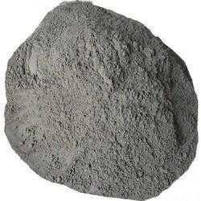 **figure 4.1 OPC**

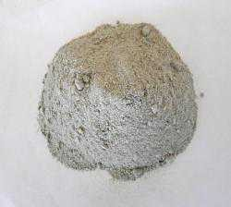

**Figure 4.2 Fly Ash**

“

**Chemical Composition**

Table 4.1 presents the chemical composition of cement and fly ash. The reactive constituents of fly ash, which consist of alumino silicates and calcium alumino silicates, are regularly denoted by their oxide names, such as silicon dioxide, aluminium oxide, and calcium oxide. Periodic assessments of the chemical composition's variability are carried out as a quality assurance procedure. The alumino silicate components have a crucial function in reacting with calcium hydroxide to produce cementitious materials, which significantly enhance the overall performance of the concrete mixture.

**Table 4.1 “Chemical Composition (%) of cement and fly ash”**

|  |  |  |  |  |  |  |  |  |
| --- | --- | --- | --- | --- | --- | --- | --- | --- |
| **Consitituent** | SiO2 | Al2O3 | Fe2O3 | CaO | MgO | Na2O | K2O | SO3 |
| **Cement** | 18.4 | 6.2 | 4.4 | 66.7 | 0.8 | 0.02 | 0.9 | 3.2 |
| **Fly ash** | 43.2 | 18.5 | 3.5 | 30 | 1.9 | 0.01 | 1.2 | 2.5 |

**Bottom Ash**

Coal-derived bottom ash (as depicted in Figure 4.3) was sourced from the gurgaon Thermal Power Plant. Table 4.2 provides details on the fineness modulus, while Figure 4.4 Illustrates the grain size distribution graph specifically for the bottom ash sample.

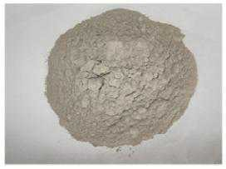

**Figure 4.3 bottom Ash**

**Table 4.2 FM of bottom ash**

|  |  |  |  |  |
| --- | --- | --- | --- | --- |
| **Sieve size** | **weight retained on sieve (grams)** | **%age of wt. retained (%)** | **%age of wt. passing (%)** | **Cumulative %age of passing (%)** |
| 4.75 mm | 0 | 0 | 100 | 100 |
| 2.36 mm | 0 | 0 | 100 | 200 |
| 1.18 mm | 142 | 14.2 | 85.8 | 285.8 |
| 600 µ | 296 | 29.6 | 70.4 | 356.2 |
| 300 µ | 561 | 56.1 | 43.9 | 400.1 |
| 150 µ | 775 | 77.5 | 22.5 | 422.6 |
| pan | 1000 | 100 | 0 | 422.6 |

Fineness Fineness Modulus of the bottom ash can be calculated as:

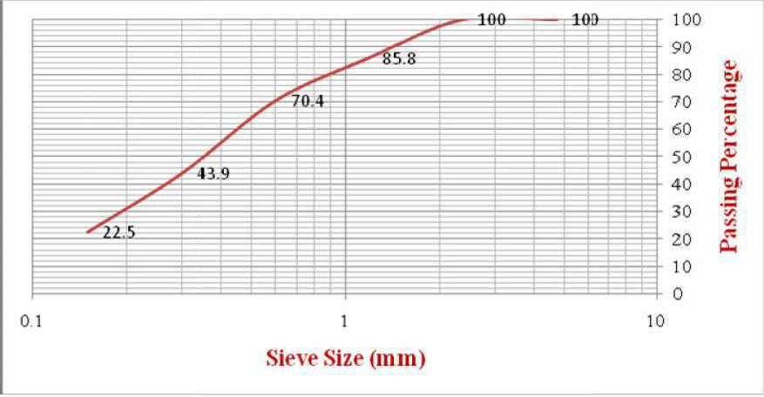=177/100 =1.77

**Figure 3.4 grain size distribution graph for bottom ash**

**Fine Aggregates**

The fine aggregate, shown in Figure 4.5, had a specific gravity of 2.67 and a fineness modulus of 2.3. Table 4.3 presents further information regarding the fineness modulus, whilst Figure 4.6 illustrates the unique grain size distribution graph for the fine aggregate sample.

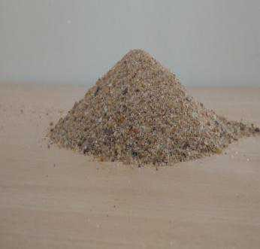

**Figure 4.5 fine aggregate**

**Table 3.3 fineness modulus of the aggregates**

|  |  |  |  |  |
| --- | --- | --- | --- | --- |
| **Sieve size** | **weight retained on sieve**  **(grams)** | **Percentage of weight retained (%)** | **Percentage of weight passing (%)** | **Cumulative percentage of passing (%)** |
| 4.75 mm | 18 | 1.8 | 98.2 | 98.2 |
| 2.36 mm | 18 | 1.8 | 98.2 | 196.4 |
| 1.18 mm | 158 | 15.8 | 84.2 | 280.6 |
| 600 µ | 300 | 30 | 70 | 350.6 |
| 300 µ | 853 | 85.3 | 14.7 | 365.3 |
| 150 µ | 990 | 99 | 1 | 366.3 |
| pan | 1000 | 100 | 0 | 366.3 |

Fineness modulus of fine aggregate = cumulative percentage of weight retained /100

= 233/100

= 2.33

**Coarse Aggregates**

The coarse aggregate has a specific gravity of 2.60. Coarse aggregate generally refers to particles that are larger than 4.75 mm, and fine aggregate refers to particles that are less than 4.75 mm. To obtain comprehensive information on the Features of the aggregate, please consult Table 4.4.

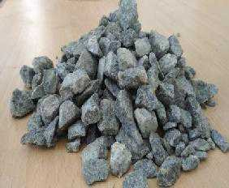  
  
**figure 4.6 coarse aggregate**  
  
**Table 4.4 Features of aggregates**

|  |  |  |  |  |
| --- | --- | --- | --- | --- |
| **S.No** | **Property** | **“Fine aggregate”** | **Bottom ash** | **“Coarse aggregate”** |
| 1 | Specific gravity | 2.67 | 2.32 | 2.60 |
| 2 | FM | 2.48 | 1.77 | - |
| 3 | Absorption of Water (%) | 1.85 | 1.80 | 0.63 |
| 4 | Crushing value (%) | - | - | 24.94 |
| 5 | Impact value (%) | - | - | 23.86 |

**Light Expanded Clay Aggregates**

LECA, depicted in Figure 4.8, has a particle size of 10 mm and a maximum density of 480 kg/m³, which is considered praiseworthy. To gain a thorough comprehension of this material, one can consult Table 4.5, which provides detailed information on its qualities, including porosity, absorption of water, strength in compression, and thermal conductivity. Table 4.6 provides a detailed explanation of the chemical makeup of LECA, specifically highlighting the presence of silica, alumina, iron oxide, and several trace elements. These insights are crucial reference points for assessing the appropriateness of LECA in many applications, including building, insulation, and horticulture.

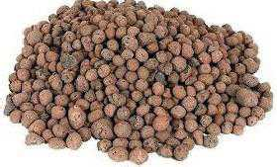

**Figure 4.7 Light expanded clay aggregate**

**Table 4.5 Features of LECA**

|  |  |  |
| --- | --- | --- |
| **S. No** | **Property** | **LECA** |
| 1 | Specific gravity | 1.54 |
| 2 | Water absorption (%) | 21.25 |

**Table 4.6 chemical composition (%) LECA**

|  |  |  |  |  |  |  |  |
| --- | --- | --- | --- | --- | --- | --- | --- |
| **Consitituent** | SiO2 | Al2O3 | Fe2O3 | CaO | MgO | Na2O | K2O |
| **LECA** | 52.13 | 23.78 | 9.75 | 2.10 | 1.63 | 1.14 | 3.83 |

**Lytag Light Weight Aggregates**

The Lytag lightweight aggregate has a diameter of 10mm, and its density normally ranges from 700 to 800 kg/m³. Tables 4.7 and 4.8 provide a comprehensive overview of the Features and chemical makeup of Lytag, respectively.

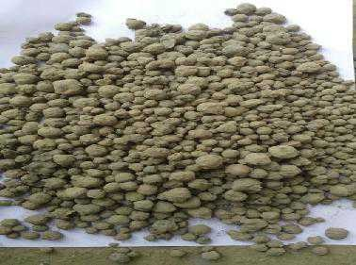

**Figure 4.8 Lytag light weight aggregate**

**Table 4.7 Features of Lytag**

|  |  |  |
| --- | --- | --- |
| **Sl. No** | **Property** | **Lytag** |
| 1 | Specific gravity | 1.50 |
| 2 | Water absorption(%) | 14.23 |

**Table 4.8 chemical composition (%) of Lytag**

|  |  |  |  |  |  |  |  |
| --- | --- | --- | --- | --- | --- | --- | --- |
| **Consitituent** | SiO2 | Al2O3 | Fe2O3 | CaO | MgO | Na2O | K2O |
| **Lytag** | 53.24 | 25.85 | 10.33 | 1.97 | 1.48 | 1.04 | 3.91 |

**Admixture**

Conplast SP430 (G) is a specifically engineered additive created to achieve significant reductions in water content, up to 25%, while maintaining the concrete's capacity to be easily worked with. This results in the manufacture of superior quality concrete that has enhanced permeability. It improves cohesiveness by distributing cement particles, reducing segregation, and boosting surface smoothness. The recommended dosage range is between 0.6 and 1.5 litres per 100 kg of cement. Conducting on-site testing is advised in order to ascertain the optimal dosage for achieving the intended effects on strength, hardness, workability, and permeability. Conplast SP430 (G) is well-suited for applications that demand excellent workability, enabling the creation of easily controllable, top-notch concrete.

# Results and Conclusions

This chapter offers a thorough examination of the results of experiments. Furthermore, the experimental result data are utilised to construct the mathematical model. This inquiry utilises concrete cubes and cylinders to assess their strength in compression, STS, and flexural strength of beams at 7, 28, and 56 days. Following this assessment process, the main objective of the suggested technique is to construct a mathematical model using optimisation techniques. Mathematical modelling is used to forecast the strength in compression STS for 7, 28, and 56 days, as well as the deflection (D). Regarding the concrete. The following text: Various optimisation algorithms such as  Artificial fish Swarm Optimisation (AFSO), Particle Swarm Optimisation (PSO), and Harmony Search (HS) are employed to illustrate that the discrepancy between the experimental and anticipated values is effectively reduced to zero in the desired representation. The complete process is executed utilising the MATLAB 2014 programme.

**EXPERIMENTAL AND SOFT COMPUTING TECHNIQUE**

The project entailed performing experiments and constructing computational models to ascertain the optimal composition of M20 grade concrete. This was accomplished by substituting cement with fly ash, fine aggregate with bottom ash, and coarse aggregate with LECA at different proportions ranging from 5% to 35%. In addition, an additional empirical analysis is performed on concrete mix M20 by replacing cement with fly ash, while keeping the fine aggregate constant, and substituting the coarse aggregate with Lytag lightweight aggregate at different levels.

proportions of 5%, 10%, 15%, 20%, and 25%. An analysis is conducted on the variables CS, STS, FS, and D. In the process of mathematical modelling, many methods for optimisation such as AFSO, PSO, and HS are used to optimise the weights that are used.

**EXPERIMENTAL RESULT ANALYSIS OF COMPRESSIVE STRENGTH AND SPLIT TENSILE STRENGTH OF CONCRETE**

The compressive strength and split tensile strength of concrete are assessed by varying the amount of substitutes in concrete mixtures and observing the effects of various curing durations.

**Table 5.1: compressive strength of concrete made with LECA**

|  |  |  |  |  |  |
| --- | --- | --- | --- | --- | --- |
| **S.No** | **Percentage of replacement (%)** | **Dry wt. of sample (Cube)in**  **kg** | **Average Compressive Strength (N/mm2)** | | |
| **7 Days** | **28 Days** | **56 Days** |
| 1 | 0 | 8.45 | 17.96 | 26.93 | 26.95 |
| 2 | 5 | 8.18 | 17.94 | 26.89 | 26.97 |
| 3 | 10 | 7.89 | 17.17 | 25.73 | 25.76 |
| 4 | 15 | 7.54 | 16.06 | 24.09 | 24.11 |
| 5 | 20 | 7.41 | 13.41 | 20.10 | 20.13 |
| 6 | 25 | 7.31 | 11.32 | 16.96 | 16.97 |
| 7 | 30 | 7.24 | 10.19 | 15.26 | 15.23 |
| 8 | 35 | 7.13 | 9.73 | 14.57 | 14.58 |

**Table 5.2 : Split tensile strength of concrete made with LECA**

|  |  |  |  |  |  |
| --- | --- | --- | --- | --- | --- |
| **Sl.No** | **Percentage of replacement (%)** | **Dry wt. of sample (Cube) in**  **Kg** | **Average Split Tensile Strength (N/mm2)** | | |
| **7 Days** | **28 Days** | **56 Days** |
| 1 | 0 | 13.35 | 1.60 | 2.54 | 2.57 |
| 2 | 5 | 13.20 | 1.53 | 2.52 | 2.59 |
| 3 | 10 | 12.85 | 1.5 | 2.32 | 2.33 |
| 4 | 15 | 12.60 | 1.44 | 2.17 | 2.18 |
| 5 | 20 | 12.40 | 1.4 | 2.11 | 2.12 |
| 6 | 25 | 12.15 | 1.35 | 2.05 | 2.06 |
| 7 | 30 | 11.72 | 1.31 | 1.96 | 1.98 |
| 8 | 35 | 11.34 | 1.26 | 1.90 | 1.92 |

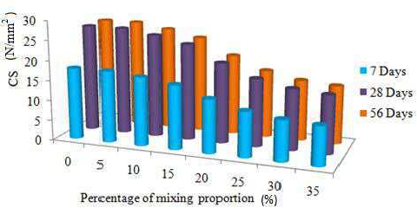

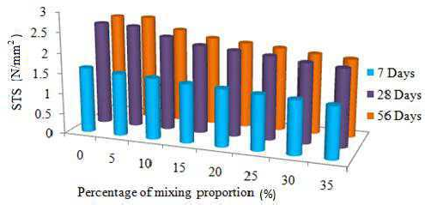

**Fig 5.1: (a) “compressive strength of concrete made with LECA. (b) split tensile strength of concrete made with LECA”**

**Table 5.3: compressive strength of concrete made with Lytag**

|  |  |  |  |  |  |
| --- | --- | --- | --- | --- | --- |
| **Sl.No** | **Percentage of replacement (%)** | **Dry wt. of sample (Cube) in**  **Kg** | **Average Compressive Strength (N/mm2)** | | |
| **7 Days** | **28 Days** | **56 Days** |
| 1 | 0 | 8.49 | 17.94 | 26.95 | 27.1 |
| 2 | 5 | 8.23 | 17.98 | 26.97 | 26.98 |
| 3 | 10 | 7.94 | 18.05 | 27.1 | 27.12 |
| 4 | 15 | 7.59 | 17.43 | 25.92 | 25.94 |
| 5 | 20 | 7.46 | 16.89 | 25.12 | 25.19 |
| 6 | 25 | 7.36 | 14.21 | 23.95 | 23.97 |

**Table 5.4: split tensile strength of concrete made with Lytag**

|  |  |  |  |  |  |
| --- | --- | --- | --- | --- | --- |
| **Sl. No** | **Percentage of replacement (%)** | **Dry wt. of sample (Cube) in**  **Kg** | **Average Split Tensile Strength (N/mm2)** | | |
| **7 Days** | **28 Days** | **56 Days** |
| 1 | 0 | 13.32 | 1.63 | 2.55 | 2.58 |
| 2 | 5 | 13.27 | 1.61 | 2.54 | 2.56 |
| 3 | 10 | 12.92 | 1.6 | 2.57 | 2.59 |
| 4 | 15 | 12.67 | 1.42 | 2.34 | 2.37 |
| 5 | 20 | 12.47 | 1.38 | 2.16 | 2.19 |
| 6 | 25 | 12.22 | 1.33 | 2.1 | 2.12 |

“The results indicate that there is an increase in the fluctuation of the replacement quantity, while the weight of the sample has reduced. However, when it comes to the element of strength, an increase in the replacement percentage will undoubtedly decrease the strength, specifically the compressive and split tensile strength. The strength analysis is explicitly presented in Table 5.1, 5.2, 5.3, and 5.4.The compressive strength of control concrete after 56 days. Similarly, by referring to table 5.3 and table 5.4, it can be observed that there is no replacement (0% replacement) of the mentioned item. The composition consists of cement blended with fly ash and fine aggregate. Coarse aggregate refers to the granular material used in construction, often larger than 4.75 mm in size.Lytag lightweight aggregate exhibits comparable compressive strength to that of conventional concrete.”

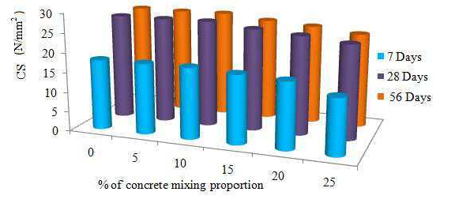

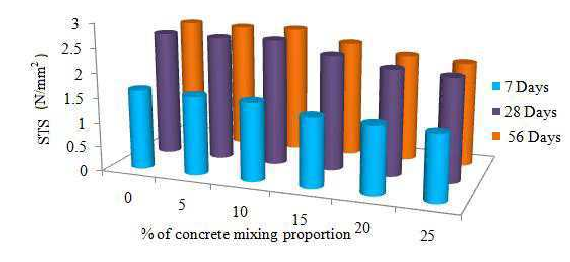 **(a)  
 (b)**

**Fig:5.2 (a) compressive strength of concrete made with Lytag. (b) split tensile strength of concrete made with Lytag**

**ACCURACY ANALYSIS USING MATHEMATICAL MODELING**

Figures 5.3 and 5.4 display the examination of correctness in mathematical modelling using optimisation approaches for time periods of 7, 28, and 56 days. The analysis focuses on CS (confidence score) and STS (statistical test score). The Mean Square Error (MSE) is calculated using the test data values and the predicted values. The Mean Squared Error (MSE) graph demonstrates that the Adaptive Firefly Swarm Optimisation (AFSO) algorithm effectively reduces the error value within the given context. Compressive strength, also known as CS-7 and CS-28, refers to the ability of a material to withstand a compressive force without breaking or deforming. The terms "CS-56" and "split" refer to two different concepts. The tensile strength of the materials was measured in three different experiments: STS-7, STS-28, and STS-56.

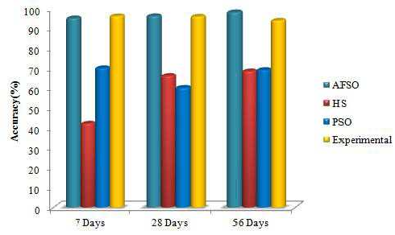

**Fig. 5.3 Accuracy analysis for CS**

In Figure 5.3, the compressive strength of the material for a minimum duration of 7 days is depicted. The AFSO algorithm has an error of 0.240, which is contrasted to the error value of another algorithm, resulting in a variance of 73.86%. During the 28-day test procedure, the smallest level of error has been contrasted with the Particle Swarm Optimisation (PSO) method, which has risen by 40.25%. Additionally, the Harmony Search (HS) method has increased by 47.86%. similarly, when contrasted to the other technique, the rate of error is raised by 49.23% for a duration of 56 days. The compressible strength of AFSO is reduced by 75.69% compared with HS and PSO in the testing method after 7, 28, and 56 days.

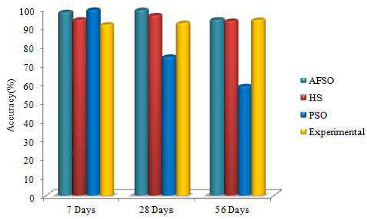

**Fig. 5.4 Accuracy analysis for STS**

The split tensile strength of the AFSO method was measured in a 7-day testing period. Figure 5.4 displays the smallest error value, which is 0.52. When contrasted to the HS and PSO processes, the AFSO method showed a 47.87% difference. During the 28-day procedure, the smallest error is 0.35. This is an elevation of 56.23% compared to the other algorithm. When comparing the HS and PSO procedures, the AFSO method reduces the minimum error of the 56-day tensile strength process by 65.39%. The entirety of the age Checking the suggested 56.23%.

# CONCLUSIONS

The "Conclusions" section represents an important milestone in our understanding of concrete technology, since it concludes our investigation into the impact and effectiveness of using lightweight coarse particles with fly ash in concrete. During the course of this thesis, titled "Examining the Impact and Effectiveness of Lightweight Coarse Aggregates with Fly Ash in Concrete," we have extensively explored the complex interactions of these elements in concrete mixtures. This introduction establishes the context for a thorough integration of our research discoveries, utilising factual data and conceptual frameworks to illuminate significant understandings. Through careful examination of the data gathered and thorough interpretation of the results, our goal is to offer a definitive analysis of the findings from our study. Moreover, this section will examine the wider consequences of our discoveries in the field of construction materials science and suggest potential areas for future research endeavours. Our ultimate goal is to contribute to the continuous development and enhancement of concrete technology by making well-informed findings based on thorough inquiry.

By adding lightweight coarse particles and fly ash to concrete, its compressive strength, durability, and workability are enhanced compared to typical concrete mixes.

Utilising fly ash as a supplemental material effectively mitigates environmental impact by reducing the need for natural resources and diverting waste from landfills.

The use of lightweight aggregates and fly ash in concrete production reduces the release of greenhouse gases that are typically emitted during conventional concrete manufacturing procedures.

Cost-effectiveness: The utilisation of these materials provides economic advantages by potentially reducing costs in the acquisition of resources and construction methods.

Local Material Utilisation: The use of lightweight coarse aggregates and fly ash encourages the utilisation of resources that are readily available in the local area, hence decreasing transportation expenses and minimising the impact on the environment.

Enhanced construction efficiency: Concrete mixes that include these components demonstrate improved workability, making it easier to lay and finish during construction.

Incorporating lightweight coarse particles and fly ash into the concrete improves its ability to resist cracking, resulting in greater durability and longer lifespan of structures.

These materials can be customised to meet unique project needs, providing adaptability in concrete mixture compositions for a wide range of construction applications.

Regulatory compliance is achieved when concrete mixes that include fly ash consistently meet or surpass the standards set for strength, durability, and environmental sustainability.

This work highlights potential areas for further research, such as the need for ongoing monitoring of performance over an extended period, assessing the environmental impact, and refining the composition of mix designs for optimal results.

The research findings have consequences for the building sector, specifically for engineers and practitioners who want to embrace sustainable and high-performance concrete practices.

# REFERENCES

1. ACI Committee 209, (1993). Prediction of creep, shrinkage, and temperature effects in concrete structures (ACI 209R-92). ACI Manual of Concrete Practice, American Concrete Institute, Detroit, MI, Part 1, pp.47.
2. ACI Committee 363, (1992). State of theF art report on high-strength concrete (ACI 363R-92), American Concrete Institute, Farmington Hills, Mich, Vol. 55.
3. Aggarwal, P., Aggarwal, Y., and Gupta, S.M. (2007). Effect of bottom ash as replacement of fine aggregates in concrete, Asian J. Civil Eng. (Building and Housing), Vol. 8, No. 1, pp. 49-62.
4. Aggarwal, Y., and Siddique, R. (2014). Microstructure and properties of concrete using bottom ash and waste foundry sand as partial replacement of fine aggregates, Const. Build Mater., Vol.54, pp.210-223.
5. Al-Khaiat, H., and Haque, M.N. (1998). Effect of initial curing on early strength and physical properties of lightweight Concrete, Cem. Concr. Res., Vol. 28, No. 6, pp. 859–866.
6. ACI Education Bulletin E1-07, ‘ ggregates for concrete’, Developed by Committee E-701, Materials for concrete construction.
7. CI 2 , ‘Standard practice for selecting proportions for structural LWC- Part 1, ACI manual of concrete practice, American Concrete Institute.
8. Gettu.R, Gomes, P.C.C, Agullo.L. andJosa.A(1995), “ High –Strength Self –Compacting Concrete with Fly ash: Developments and Utilisation ”, Seventh CANMET/ACI International Conference on Fly ash, Silica fume, Slag and Natural Pozzolans in Saskatchewan, Canada.
9. Indian standard methods of tests for strength of concrete IS 516: 1959 (Reaffirmed 1999), Bureau of Indian Standards, New Delhi.
10. Indian standard method of tests for splitting tensile strength of concrete IS: 5816 (1999), Bureau of Indian Standards, New Delhi.
11. ndian standard specification for pulverised fuel ash, Part 1; for use as pozzolana in cement, cement mortar and concrete, IS: 3812 (part 1), 2003, Bureau of Indian Standards, New Delhi
12. Indian standard specification for pulverised fuel ash , Part 2; For use as admixture in cement mortar and concrete,IS :3812( part 2),2003, Bureau of Indian Standards , New Delhi
13. VaishaliG.Gorphade, H.SudarsanaRao, M.Beulah,(2013)“Development of Genetic Algorithm Based Neural Network Model for Predicting Strength of High Performance Concrete”, International Journal of Engineering Research and Applications, vol. 3, Issue 2, pp.1687-1694.
14. Vengata G. K.B., 2009, „High volume fly ash concrete for pavements‟, M.E. Dissertation, Department of Civil Engineering, Anna University, Chennai, India.
15. Zong, W.J., Guang, N.H. and Yun, H.J (1999),” The application of acquisition of knowledge to mix design of concrete", Cement and Concrete Research, vol. 29(12), pp.1875- 1880.
16. Gunasekaran, K, nnadurai, R & Kumar, PS 20 b, ‘Study on reinforced lightweight coconut shell concrete beam behavior under flexure’, aterials and Design, vol. , pp. 7–167.