Motor Speed Control using Arduino and PID

Saravana Kumar K P
Instrumentation and Control Engineering
Saranathan College of Engineering
Tiruchirappalli, India
saravananpoyyamozhi@gmail.com
Irshath Ahmed M S
Instrumentation and Control Engineering
Saranathan College of Engineering
Tiruchirappalli, India.
msirshathahmed@gmail.com

Mr. S Prassanna Perumal, M.E.,
Asssitant Professor
Instrumentation and Control Engineering
Saranathan College of Engineering
Tiruchirappalli, India
prassanna-ice @saranathan.ac.in
Joe Jasper Raja B
Instrumentation and Control Engineering
Saranathan College of Engineering
Tiruchirappalli, India.
joejaasper@gmail.com

Abstract—In many applications, direct current (DC) motor speed regulation is essential and requires accurate and effective functioning. The creation of a DC motor speed control system with an Arduino Uno microcontroller is presented in this paper. The motor's average voltage is regulated by the system using Pulse Width Modulation (PWM), which also controls the motor's speed. This project shows how simple and efficient it is to use Arduino to control the speeds of DC motors in a variety of applications.
Keywords—DC Motor,Arduino , Microcontroller,PWM

Introduction
The modern world is becoming more and more dependent on motors with high efficiency, high torque, wide and variable speed ranges, and relatively cheap maintenance costs.
Nevertheless, these needs have not been satisfied because DC and induction motors are now the only types of motors that are produced on a global scale. The motor drive in DC motors employs the rotor's DC voltage.
Conversely, DC motors necessitate high maintenance expenses. The fact that brushes are used in DC motors for commutation results in high maintenance expenses. The brush will soon become destroyed because of the commutation process, which causes the brush to arch when the motor switches back on. Compared to DC motors, induction motors are faster and require less maintenance

Design of PID Controller

PID CONTROLLER :
The PID controller calculates a control signal (output) based on the difference (error) between the desired speed (setpoint) and the actual motor speed (feedback). The control signal is then sent to the motor driver, regulating the power delivered to the motor and influencing its speed.
PID Controller Tuning :
PID control is a popular and adaptable feedback control method utilised in many different automation systems, such as motor speed control. The difference (error) between a planned setpoint and the actual system measurement (feedback) is used to calculate a control signal, or output. After that, the system's behaviour is modified with the help of this control signal to get it closer to the intended state.

Kp | WHICH | KD | Rise Time  (Tr) | Overshot (Mp) | Peak Time | Settling  Time | Error
1.5 | 0.87 | 0.27 | 0.9925 | 1.3333 | 3 | 2.7368 | 0
2.2 | 0.85 | 0.85 | 0.8824 | 1.3333 | 16 | 4.5000 | 0
2.0 | 1.0 | 0.7 | 1.0301 | 3.3333 | 3.3333 | 7.4000 | 0
1.0 | 0.91 | 0.21 | 0.9925 | 1.3333 | 3 | 2.7368 | 0

Fig 1 . The Table of PID Values
PID control results in addition to the rotation results on the DC motor, this study also displays the PID control results through a graph displayed by the serial monitor, data from the serial monitor will later be processed to in the application MATLAB will be used to calculate the results of the PID controller so that the values of the PID control parameters are obtained, such as the calculation of risetime, settling time, overshoot, undershoot and its peak value.

SYSTEM DESIGN

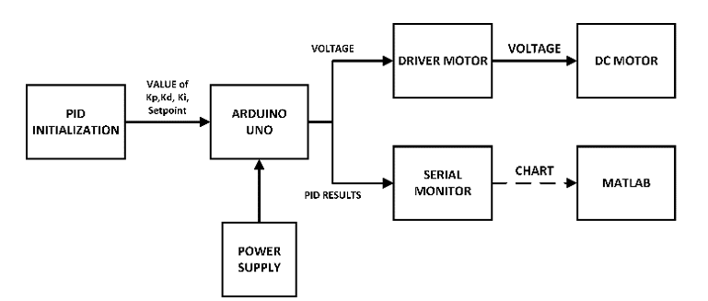

Fig 2.Block Diagram of Simulation Model

PID Controller :
The proportional, integral, and derivative control actions are combined by the PID controller to produce the intended system response. Based on the current error, the proportional term makes a quick correction; over time, the integral term reduces steady-state error; and the derivative term predicts future error patterns, improving stability and responsiveness.
Motor Driver :
In order to efficiently drive motors, control systems require a motor driver, which converts control inputs into power outputs. In order to precisely control motor speed and torque, it is essential for controlling voltage, current, and direction. H-bridge and brushed or brushless DC motor drivers are two examples of the several types of motor drivers available; each is made for a particular kind of motor and its control requirements.
Arduino UNO :
Arduino is an open-source electronics platform that empowers users to create interactive projects. It consists of easy-to-use microcontrollers (mini computers) and a beginner-friendly software environment for writing code (sketches) that controls how these boards interact with electronic components like sensors, motors, and LEDs. Arduino's open-source nature fosters a large community that shares project ideas and makes it a great platform for learning electronics and programming, particularly for beginners.
DC Motor :
DC motors, known for their simplicity and controllability, are workhorses in many applications. They convert electrical energy into mechanical energy through the interaction of magnetic fields in a stationary part (stator) and current-carrying coils in a rotating part (armature). A commutator and brushes ensure continuous current flow and unidirectional rotation. By varying the voltage or using pulse width modulation (PWM), DC motors offer precise speed control, making them suitable for power tools, robotics, consumer electronics, and even some electric vehicles
MatLab :
MATLAB is a software powerhouse for technical computing. It tackles complex math with ease, analyzes and visualizes data to reveal patterns, empowers you to design and implement algorithms to solve problems, and lets you build models to simulate real-world systems - all in a user-friendly environment geared towards engineers, scientists, and mathematician.

METHODOLOGY
Simulation of controller model in Matlab:
- Develop the controller model using Simulink, Integrate it with the system being controlled.
- Configure simulation settings and scenarios, Analyze results to evaluate controller performance.
Process parameters analyzing:
- Through the utilization of MATLAB, we acquire and analyze the process parameters of our simulation model.
- Through this process, we can calculate the performance of the controller and identify areas for improvement to achieve a more stable controller model.
- Monitoring and Maintenance: Monitor the performance of your deployed system and address any issues or anomalies that arise. Periodically update your models and algorithms with new data and improvements to maintain their effectiveness over time.Continuously gather feedback from users and stakeholders to refine and enhance the system's functionality and usability.
Hardware Design :
The Arduino Uno controller, which manages all sensors and actuators, is the foundation of this DC motor's angular velocity control system's hardware architecture.
- The design of this DC motor angular velocity control system uses an Arduino UNO microcontroller to regulate a DC motor that has an encoder in it
- Arduino will send a voltage signal to the driver motor to be subsequently discharged to the DC motor according to the voltage calculation results of the PID controller.
- The voltage value in the DC motor is influenced by the PID controller, depending on the setpoint value.
Tinker Cad :
- Tinkercad is a web-based platform that simplifies 3D design, electronics simulation, and coding for beginners.
- a user-friendly online tool where you can drag-and-drop geometric shapes to create 3D models, virtually connect electronic components to design circuits, and write code using graphical blocks or text for various applications.
- Tinkercad is a free resource, perfect for students, educators, hobbyists, and anyone interested in exploring these creative and technical fields without needing complex software

RESULTS
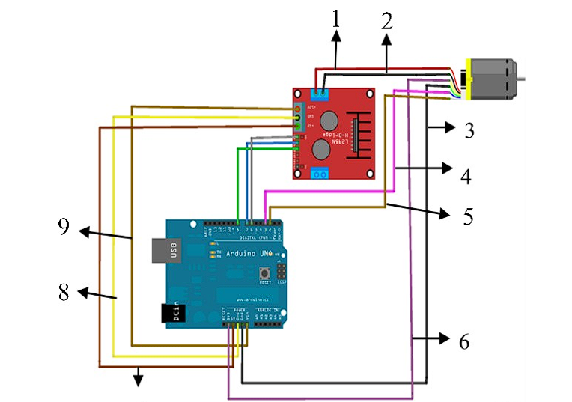
7
Fig 3. Simulation Model of Arduino Wiring Program

No. | Pi | Information
1 | + Driver | + Driver to motor Encoder +
2 | - Driver | - Driver to Motor Encoder -
3 | GND | GND Arduino to GND Encoder
4 | D3 | Battery D3 to Battery Encoder Chanel B motor DC
5 | D2 | Pin D3 to pin Encoder Chanel A motor DC
6 | 3,3 | VCC 3,3 Volt Encoder
7 | 5 | VCC Motor Driver 5 Volt
8 | GND | Ground Motor Driver & Ground Encoder
9 | Wire | VCC 12 Volt Motor Driver

Fig 4 . Input And Output of Arduino Pins

CONCLUSION
- Based on the discussion and test results of the research controller of the angular velocity of the DC motor using the Arduino UNO-based PID method, conclusions were obtained.
- For the work of the DC motor control tool system that has been designed and can be controlled so that it reaches the rotation that is in line with the reference value that has been given.
- From the parameters that have been tested, the system response is obtained from the values of the 𝐾𝑝, 𝐾𝑖,
𝐾𝑑 parameters that correspond to software testing where the value of Rise Time = 0.9925, settling time = 2.7368, overshoot = 1.3333 and steady state error = 0

VII .REFERENCES

- D. Saputra, A. Ma'arif, A. Maghfiroh, H. Chotikunnan, P. Rahmadhia, and S. N., "Design and Application of PLC-based Speed Control for DC Motor Using PID ” with Identification System and MATLAB Tuner
- D. O. Machado, A. J. Sánchez, A. J. Gallego, G. A. de Andrade, J. E. Normey-Rico, and C. Bordons, "Split-range control for improved operation of solar absorption cooling plants .
- S. J. Hammoodi, K. S. Flayyih, and A. R. Hamad, "Design and implementation of a speed control system for DC motor based on PID control and MATLAB Simulink.
- Reyes-Lúa, A.Skogestad S."Multi-input single-output control for extending the operating range: Generalized split range control using the baton strategy.
- M. A. Hassanin, F. E. Abdel-Kader, S. I. Amer, and A. E. Abu-Moubarka, “Operation of Brushless DC Motor to Drive the Electric Vehicle,” in 2018 20th International Middle East Power Systems Conference, MEPCON 2018 - Proceedings, 2019, pp. 500–503.
- P. Vishnu Sidharthan and Y. Kashyap, “Brushless DC hub motor drive control for electric vehicle applications,” in 2020 1st International Conference on Power, Control and Computing Technologies, ICPC2T 2020, 2020, pp. 448–453.
- J. Meng, A. Liu, Y. Yang, Z. Wu, and Q. Xu, “Two-Wheeled Robot Platform Based on PID Control,” in Proceedings - 2018 5th International Conference on Information Science and Control Engineering, ICISCE 2018, 2019, pp. 1011–1014.
- K. Sharma and D. K. Palwalia, “A modified PID control with adaptive fuzzy controller applied to DC motor,” in IEEE International Conference on Information, Communication, Instrumentation and Control, ICICIC 2017, 2018, vol. 2018-Janua, pp. 1–6.
- R. R. Carmona, H. G. Sung, Y. S. Kim, and H. A. Vazquez, “Stable PID Control for Mobile Robots,” in 2018 15th International Conference on Control, Automation, Robotics and Vision, ICARCV 2018, 2018, pp. 1891–1896.
- M. Ahmed, N. M. Tahir, A. Y. Zimit, M. Idi, K. A. Abubakar, and S. A. Jalo, “Improved PID Controller for DC Motor Control,” IOP Conference Series: Materials Science and Engineering, vol. 1052, no. 1, p. 012058, Jan. 2021

