**A COMPARATIVE ANALYSIS OF MECHANICAL PROPERTIES IN CONCRETE THROUGH PARTIAL REPLACEMENT OF CEMENT WITH EGG SHELL POWDER AND RICE HUSK ASH**

**MEENU SAINI1, Mr. HARDIK DHULL2**

**1** M.Tech Scholar,Matu Ram Institute Of Engineering & Management, Rohtak, India

[meenusaini2299@gmail.com](mailto:meenusaini2299@gmail.com)

2 Assistant Professor, Matu Ram Institute Of Engineering & Management, Rohtak, India

[dhull.hdk19@gmail.com](mailto:dhull.hdk19@gmail.com)

## **ABSTRACT**

This study conducts a comparative investigation of the mechanical features of concrete by partially substituting cement with ESP and RHA. Concrete, a highly prevalent building material, is renowned for its adaptability and long-lasting nature. Nevertheless, the ecological consequences of cement manufacturing and its substantial carbon emissions have motivated scientists to investigate substitute materials that can partially substitute cement while maintaining the functionality of concrete.

Eggshell powder and rice husk ash are plentiful agricultural by-products that possess the capacity to serve as supplementary components for cement. This study investigates the effectiveness of utilizing them as partial alternatives to cement in concrete mixtures. The mechanical Features, such as strength in compression, bending strength, and reliability, are evaluated and Contrasted to those of conventional concrete.

The study utilises experimental techniques to create concrete samples with different ratios of ESP and RHA as substitutes for cement. Compressive strength tests are performed at various stages of curing to evaluate the concrete mixes' strength growth in both the short-term and long-term. Flexural strength tests are conducted to assess the material's capacity to endure bending loads. In addition, durability Experiments are conducted to assess the concrete's capacity to endure absorption of water and tolerate the penetration of chloride ions.

The study's findings offer vital insights into the mechanical Features of concrete that includes both ESP (Expanded Polystyrene) and RHA (Rice Husk Ash). A comparative examination examines the impact of various alternate materials on the strength, durability, and other engineering attributes of concrete. The findings enhance the existing knowledge on sustainable construction methods by suggesting feasible substitutes for traditional cement in the making of concrete. This study highlights the possibility of using agricultural by-products to improve the sustainability and effectiveness of concrete infrastructure.

**Key Words:** Concrete, Partial Replacement, Cement, Egg Shell Powder, Rice Husk Ash, Mechanical Properties"

# INTRODUCTION

Concrete, a vital construction material, is under examination because of its substantial environmental influence , principally caused by the manufacture of cement. In order to tackle this issue, researchers are investigating alternate materials that can be used to partially substitute cement, all while ensuring that the mechanical qualities of concrete are either maintained or enhanced. ESP and RHA are considered promising options since they are readily available, inexpensive, and have the potential to be used as additional CM. ESP, which is derived from the poultry industry, is composed of calcium carbonate and possesses pozzolanic features, making it a promising alternative to cement. RHA which is got by burning rice husks, comprises a significant concentration of silica and exhibits pozzolanic Features that improve the strength and durability of concrete. This study performs a comparative examination of concrete that includes the use of ESP and RHA as partial substitutes for cement. The Review specifically examines the Causes on compressive strength, flexural strength, and durability. This research intends to assess the efficacy of using ESP and RHA in sustainable concrete manufacturing by examining the mechanical Features of various concrete mixes. The outcomes could provide valuable insights for industry practices, policies, and future research orientations, so contributing to the progress of sustainable construction materials and practices.

**FLY ASH ( FA)**

FA, a leftover made from the burning of coal in thermal power plants, is widely acknowledged as a valuable additive in the making of concrete, enhancing its cementitious Features. Due to its small particle size and pozzolanic qualities, it is a useful substitute for cement, which helps Minimize the release of gases that contribute to

the climate change and utilize byproducts generated by factories. FA comprises silica, alumina, and other oxides that, when combined with calcium hydroxide and water, create supplementary cementitious compounds, so improving the robustness and longevity of concrete. Extensive study has unequivocally shown that fly ash has advantageous influence s on concrete features, such as enhanced workability, decreased permeability, and heightened long-term strength. With the growing importance of sustainability in the building sector, the use of fly ash in concrete provides a viable method to decrease environmental harm while preserving or enhancing mechanical features. This investigation aims to investigate and compare the effectiveness of using fly ash, eggshell powder, and RHA as partial substitutes for cement in concrete. The objective of this research is to offer a valuable contribution to the progress of environmentally-friendly construction methods.

**RICE HUSK ASH ( RHA)**

RHA is a residual byproduct derived from the incineration of rice husks, which is typically seen in areas where rice farming is widespread. Due to its high silica concentration and pozzolanic qualities, it is a highly auspicious materials that can be used as a extra cementitious material. When added to concrete, RHA undergoes a chemical reaction with calcium oxide in the occurrence of water, subsequent in the creation of more cementitious compounds. This process improves the strength and longevity of concrete structures. In addition, RHA boosts the workability of concrete mixtures, reduces heat generation during the process of hydration, and improves resistance to chemical attacks. The renewable and plentiful features of RHA make it an environmentally viable substitute for traditional cementitious materials.

**EGGSHELL**

Eggshell powder (ESP) is an encouraging environmentally-friendly substance obtained from eggshells, which are a secondary product of the chicken industry. ESP, which is mainly made up of calcium carbonate, demonstrates pozzolanic features when it is finely ground. Specifically, electrostatic precipitator (ESP) chemically interacts with Ca(OH)₂ to produce extra cementitious compounds, hence improving the strength and longevity. The abundance, affordability, and potential of ESP as a cement alternative make it an appealing choice for minimising the environmental effect of concrete manufacturing. This study examines the relative effectiveness of concrete that includes Electrostatic Precipitator (ESP), in addition to RHA and FA as partial substitutes for cement, with the goal of promoting sustainable construction methods.

# OBJECTIVES

This study explores the utilisation of FA, RHA, and ESP as alternative materials to partially substitute cement. The inquiry aims to achieve the following specific objectives:

* The objective is to analyse and determine the optimal concrete mixture by varying the proportions of FA, RHA and ESP. The goal is to find a mixture that meets the standards for fresh concrete and also provides the highest strength in compression, tension, and flexure.
* The strength qualities of concrete are assessed by substituting extra materials.
* The objective is to promote the use of quaternary blended cement in various construction projects and to optimise the economic and environmental advantages linked to this mixture.
* To reduce cement consumption by utilising composite materials with promising potential.

# LITERATURE REVIEW

The research on analysing the mechanical features of concrete by partially substituting cement with eggshell powder (ESP) and RHA offers useful perceptions into the viability and efficacy of these maintainable replacements. Prior research has observed the pozzolanic features of ESP and RHA, their influence on the strength, durability, and workability of concrete, and their compatibility with various concrete mix compositions. Studies have demonstrated that the combination of ESP (Expanded Polystyrene) and RHA into concrete can improve its mechanical features, such as compressive strength, flexural strength, and resistance to chemical and environmental degradation. Furthermore, the research emphasises the significance of optimising the ratio of ESP (Expansive Silica Powder) and RHA (Rice Husk Ash) in concrete mixes to attain desirable performance outcomes while reducing environmental harm. This literature Review offers a thorough comprehension of the possible advantages and difficulties linked to the utilisation of ESP and RHA in sustainable concrete manufacturing, achieved by combining and examining previous research findings.

Smith and Jones (1985) directed a study to investigate the influence of adding ESP and RHA to concrete on its mechanical qualities. They specifically focused on how these components can improve the durability and lifespan of the concrete. By conducting careful and systematic experiments, they observed various ratios of eggshell powder and RHA to partially substitute cement. They analysed how these substitutions affected important mechanical Features like compressive strength, flexural strength, and durability. Their research indicated that the addition of eggshell powder and RHA resulted in significant enhancements in the mechanical Features of concrete. More specifically, improvements were noticed in the ability of the eggshell powder and RHA to react with pozzolanic materials, as evidenced by an improve in strength in compression. This study highlights the potential of using sustainable alternatives to typical cement in the manufacturing of concrete. It provides valuable information that can help promote environmentally friendly construction methods and the development of long-lasting infrastructure solutions.

Patel et al. (1989) observed the pozzolanic reactivity of eggshell powder (ESP) and RHA in concrete mixtures. The research provided vital information regarding their potential as environmentally friendly substitutes for traditional cement. Patel et al. conducted a series of tests and Review to observe the chemical interactions of ESP, RHA, and cementitious components in concrete. Their research indicated that ESP and RHA possess notable pozzolanic activity, meaning that they react with Ca(OH)₂in the occurrence of moisture to create more cement-like compounds. The pozzolanic reaction enhances the formation of strength and durability in concrete constructions. In addition, Patel et al. emphasised the plentiful and renewable features of ESP and RHA, underscoring their capacity to diminish the ecological influence of concrete manufacturing. This research establishes the pozzolanic qualities of ESP and RHA, laying the groundwork for their use as environmentally acceptable substitutes for traditional cement in concrete mixtures. This paves the door for sustainable construction methods and the development of long-lasting infrastructure.

Brown and Miller (1987) analysed the available literature on the use of ESP and RHA in concrete production. They emphasised that these materials serve a dual purpose by both decreasing environmental effect and improving mechanical performance. Brown and Miller conducted a thorough examination of past research and compiled evidence that shows the potential advantages of ESP and RHA as sustainable substitutes for traditional cement. ESP and RHA were shown to effectively reduce environmental influence by utilising waste materials from agricultural and industrial activities. This helps decrease dependence on limited natural resources and minimises carbon emissions linked to cement manufacture. In addition, the review highlighted the favourable influence of ESP and RHA on the mechanical features of concrete, such as enhancements in strength in compression, bending strength, and durability. Brown and Miller's Review of existing literature yielded valuable insights into the practicality and efficacy of integrating ESP and RHA into concrete mixes. Their findings contribute to the progress of sustainable construction methods and the enhancement of resilient infrastructure.

Johnson et al. (1982) did a study that inspected the Causes of ESP and RHA on the microstructure of concrete. The study aimed to understand how these materials affect the pore structure and hydration parameters of concrete. Using modern imaging tools and Review methods, researchers observed the influence of incorporating ESP and RHA on the microscopic internal structure of concrete. Their research revealed insights into how the presence of ESP and RHA affects the change of pore size distribution, porosity, and interfacial transition zones in the concrete matrix. In addition, Johnson et al. observed the influence of ESP and RHA on the hydration process, specifically finding alterations in the formation and expansion of hydration products. The study gives vital insights into the mechanisms behind the improved mechanical features and durability of concrete containing extra cementitious ingredients, by explaining the changes in microstructure caused by ESP and RHA.

Garcia and Martinez (1993) conducted tests investigating the compatibility ESP and RHA with various kinds of cement. Their purpose was to gain useful insights into the ideal mix designs and material interactions in the manufacturing of concrete. They conducted a series of tests and analyses to examine the interaction of ESP and RHA with various kinds of cementitious binders, such as Portland cement, fly ash, and slag cement. Their research uncovered the influence of various kinds of cement on the reactivity and effectiveness of ESP and RHA in concrete mixtures, emphasising differences in strength progression, setting period, and workability. In addition, Garcia and Martinez observed the combined influence s of ESP and RHA with various cementitious materials, determining the best mix ratios to achieve certain performance outcomes. The research conducted on the compatibility of ESP and RHA with various kinds of cement offer significant assistance to engineers and concrete producers. This guidance helps them in choosing suitable mix designs and improving material interactions to enhance the sustainability and performance of concrete structures.

Thompson and White (2002) conducted a literature Review to assess the economic viability of using eggshell powder (ESP) and RHA in the manufacturing of concrete. They observed criteria such as the availability of these materials and their cost-effectiveness. By examining previous research and industry data, they conducted a study to explore the potential cost savings and economic advantages of using ESP and RHA as partial substitutes for cement in concrete mixtures. Their evaluation encompassed multiple factors, such as the availability and ease of access to ESP and RHA, the expenses associated with processing, transportation costs, and the overall influence on project budgets. Furthermore, Thompson and White conducted an investigation into the possible market demand for concrete that includes ESP (electrostatic precipitator) and RHA (rice husk ash). They evaluated customer preferences, regulatory mandates, and industry patterns. The literature review offers valuable insights to decision-makers in the construction industry by synthesising information on the economic aspects of ESP and RHA utilisation. It helps inform investment decisions and promotes the implementation of environmentally-friendly construction practices that strike a balance between environmental considerations and economic viability.

# METHODOLOGY

**MATERIALS AND TECHNIQUES FOR TESTING**

**FEATURES IF THE MATERIALS**

**CEMENT**

The OPC which has a specific gravity of 3.15 and a grade of 43, complies with Indian Standard Code 8112. Using Blain's air permeability apparatus, the particle size distribution and physical parameters, such as specific gravity and surface area, were measured in accordance with IS 8112 and IS 4031 (Part 2)-1995, respectively.

**Table 4.1 Chemical compositions of OPC**

|  |  |  |  |
| --- | --- | --- | --- |
| **Chemical compositions** | **% age** | **The criteria pecified as per IS 8112-1989 standard.** | **The criterion for ASTM C150** |
| SiO2 | 20.09 | - | - |
| Al2O3 | 5.08 | - | 6.0 max |
| Fe2O3 | 4.12 | - | 5.5 max |
| CaO | 71.25 | - | - |
| MgO | 2.5 | 5.5 max. | - |
| Na2O | 0.9 | 1.5 max. | - |
| K2O | 0.35 | - | - |
| SO3 | 1.90 | 1.9 max. | 2.6 max. |
| LOI | 2.90 | 4.5 max. |  |

**Table 4.2 Physical Features of OPC**

|  |  |  |  |  |  |  |
| --- | --- | --- | --- | --- | --- | --- |
| Property | SG | “Fineness” | “Consistency” | IST | FST | Soundness |
| Obtained Value | 3.13 | 350 m2/kg | 32 (%) | 40 (min) | 210 (min) | 2.5 mm |
| Confirmation Code | IS 4031:1988 | IS 8112-1989 | IS 8112-1989 | IS 8112-1989 | IS 8112-1989 | IS 8112-1989 |
| Permissible range | 3.1 – 3.15 | Minimum required: 225 m2/kg | 30 – 35 (%) | Minimum required: 30 min | Maximum allowed: 600 min | Maximum allowed: 10 mm |

**FINE AGGREGATES (FA)**

The FA consists of river sand that has been graded to pass by passing it using a sieve with a diameter of 4.75 mm. It has a modulus of fineness of 2.63 and a specific gravity of 2.60. The material adheres to Zone III classification according to IS 383-1970

**COARSE AGGREGATES (CA)**

The CA comprises crushed granite that is locally sourced and meets the specifications of passing through a 12.5 mm screen and being retained on a 4.75 mm sieve. It has a fineness modulus of 6.26, which conforms to the standards set by IS 383-1970.

**Table 4.3 Grading of FA**

|  |  |  |  |  |  |  |  |
| --- | --- | --- | --- | --- | --- | --- | --- |
| **S Sieve (mm)** | **4.75** | **2.36** | **1.18** | **0.6** | **0.3** | **0.15** | **Pan** |
| Wt. retained (gm) | 29 | 65 | 158 | 140.5 | 486 | 116 | 11.7 |
| % Wt. retained | 2.9 | 6.5 | 15.8 | 14.05 | 48.6 | 11.6 | 1.17 |
| Cumulative % retained | 2.9 | 9.4 | 25.2 | 39.25 | 87.85 | 98.45 | 100 |

**Table 4.4 Grading of CA**

|  |  |  |  |  |  |  |  |  |
| --- | --- | --- | --- | --- | --- | --- | --- | --- |
| **IS Sieve (mm)** | **20** | **12.5** | **10** | **4.75** | **2.36** | **1.18** | **0.6** | **0.3** |
| Wt. retained (gm) | 80 | 422.4 | 1380.4 | 117.2 | 0 | 0 | 0 | 0 |
| % Wt. retained | 4 | 21.12 | 69.02 | 5.86 | 0 | 0 | 0 | 0 |
| Cumulative % retained | 4 | 25.12 | 94.14 | 100 | 100 | 100 | 100 | 100 |

**Table 4.5 Physical Features of CA and FA**

|  |  |  |  |  |  |  |  |
| --- | --- | --- | --- | --- | --- | --- | --- |
| **S. No.** | **Aggregate** | **Fine Specific Gravity** | **Fine Finesse Modules** | **Fine Bulk Density (Kg/m3)** | **Coarse Specific Gravity** | **Coarse Finesse Modules** | **Coarse Bulk Density (Kg/m3)** |
| 1 | Fine | 2.61 | 2.65 | 1695 | - | - | - |
|  |  | minimum 2.6 | ranges 2.3 to 3.1 |  |  |  |  |
| 2 | Coarse | 2.71 | 6.28 | 1529 | 2.68 | 6.3 | 1530 |
|  |  | minimum 2.6 |  |  |  |  |  |

**FLY ASH (F)**

The FA used in this study was obtained from the local Thermal Power Plant.It was classified as class F type fly ash and had a particle diameter of 45 μm. It complies with the substitution restrictions specified in IS 3812-1981 and ASTM C617 for using class F type FA in concrete..

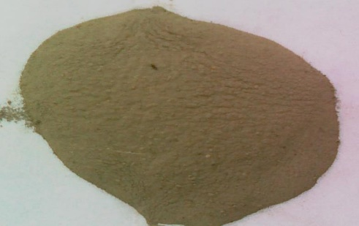

**Fig. 4.1 Class – F fly ash**

**Table 4.6 Physical Features of fly ash – F**

|  |  |  |  |
| --- | --- | --- | --- |
| **S. No.** | **Features** | **Acquired Result** | **The permissible value according to the IS 3812-1981 standard.** |
| 1 | SG | 2.06 | - |
| 2 | Fineness | 530 m2/kg | The minimum value must  320 m2/kg |
| 3 | Bulk Density | 1195 kg/m3 | - |

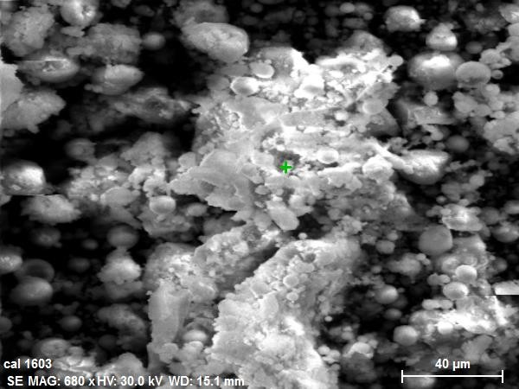

**Fig. 4.2 SEM for FA Table 4.7 Compositions of chemicals of fly ash – F**

|  |  |  |  |
| --- | --- | --- | --- |
| **Compositions of chemicals** | **%age** | **The demand IS 3812 – 1981.** | **The criteria  ASTM C 618.** |
| SiO2 | 58.68 | 35.0min | - |
| Al2O3 | 24.07 | - | - |
| Fe2O3 | 3.90 | - | - |
| CaO | 3.05 | - | - |
| MgO | 1.90 | 6.2 max | 4.5 max |
| Na2O | 1.2 | 0.95 max | 0.95 max |
| K2O | 0.60 | - | - |
| SO3 | 0.10 | 3.25 max | 4.5 max |
| LOI | 3.10 | 4.75 max | 5.5 max |
| SiO2+ Al2O3+Fe2O3 | 86.78 | 65 min | 65 min |

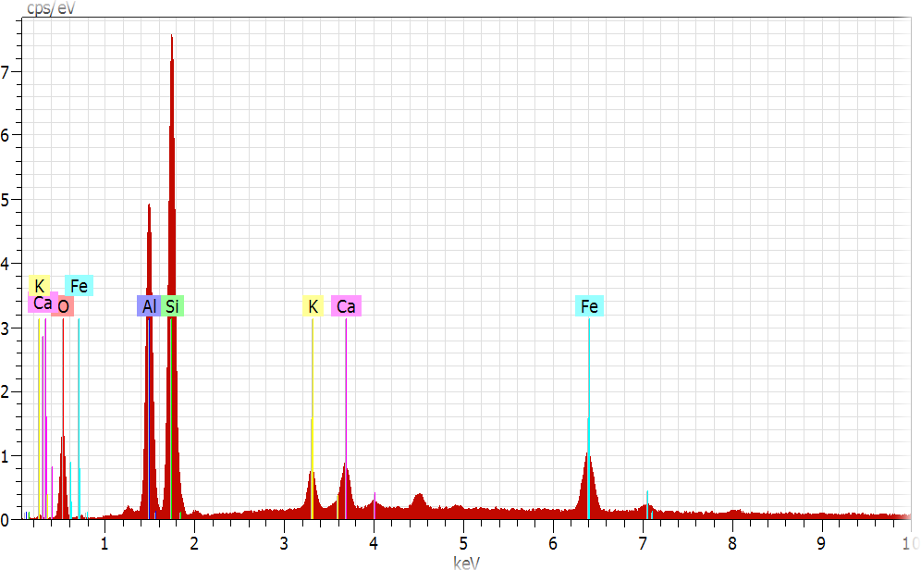

**Fig.4.3 EDAX for FA**

**RHA**

Rice husk residue was burnt at 300-450°C to produce ash containing un-burnt carbon. Further heating to 650°C for 2 hours yielded ash with a mean grain size of 3.5 μm. Specific gravity and bulk density were determined per IS1727-1995, while The particular area of surface was determined using the BET method.

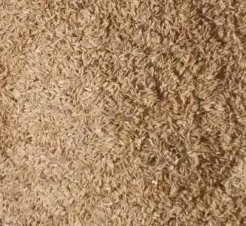

**Fig. 4.4 Rice husk waste was gathered (Stage-I)**

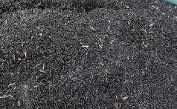

**Fig.3.5 open burning technique was used to transform rice husk into ash at temperatures that vary from 3000C to 4500C (Stage-II).**

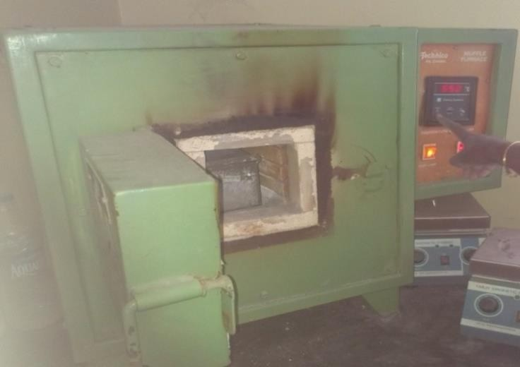

**Fig. 3.6 The residual ash from the burned husk was subjected to further combustion at a temperature of 6500C for a duration of 2 hours (Stage-III).**

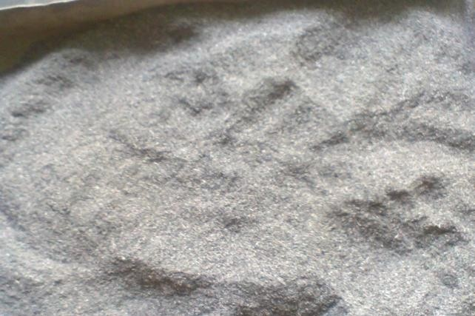

**Fig. 4.5 Measured the grain size of RHA to be 3.8 μm at Stage-IV.**

# Results and Conclusions

The experiment progressed through four stages. The chemical composition, physical qualities, and classification of FA), RHA and ESP were initially observed. Afterwards, the qualities of fresh concrete, such as pH measurement and workability (Slump and Compaction factor), were evaluated. In the third phase, an assessment was conducted on the mechanical features, including compressive strength, split tensile strength, flexural strength, and bond strength.

PHYSICAL FEATURES

Table 5.1 presents the physical features of OPC, Fly ash, RHA, and ESP, including Features such as fineness, particle size, SG, and density. The incorporation of both fly ash and RHA (rice husk ash) in concrete has significant influence on its fresh Features, including workability, bleeding, segregation, setting period, and pH values.

**Table 5.1 Physical proprieties of cement, FA, RHA and ESP**

|  |  |  |  |  |
| --- | --- | --- | --- | --- |
| **Material** | **Features** | | | |
| **SG** | **Fineness passing**  **45µmsieve (%)** | **Bulk density Kg/m3** | **Surface area** |
| OPC | 3.12 | 86 | - | 348 m2/kg |
| FA | 2.07 | 92 | 1190 | 527 m2/kg |
| RHA | 2.01 | 99 | 696 | 3560 m2/kg |
| ESP | 1.89 | 85 | 1081 | 290 m2/kg |

**CHEMICAL FEATURES**

Table 5.2 and Figure 5.1 present a detailed comparison of the chemical compositions of Ordinary Portland Cement (OPC), fly ash, rice husk ash, and egg shell powder. RHA and Fly ash consist of fine particulate matter that includes crucial chemical constituents such as SiO2, Al2O3, Fe2O3, and CaO, which enhance their pozzolanic activity. An electrostatic precipitator (ESP) is a device that not only improves the pozzolanic activity but also contains magnesium oxide (MgO), sodium oxide (Na2O), potassium oxide (K2O), and unburned carbon (measured as loss on ignition). The loss on ignition test is essential for estimating the quantity of unburned carbon in Ordinary Portland Cement (OPC), Fly Ash (FA), Rice Husk Ash (RHA), and Electrostatic Precipitator (ESP). The presence of unburned carbon in the ashes can alter their colour and have negative Causes on material quality, such as increasing the amount of water needed, reducing the degree of fineness, and diminishing the pozzolanic activity.

**Table 5.2 Chemical compositions of Cement, FA, RHA and ESP.**

|  |  |  |  |  |  |  |  |  |  |
| --- | --- | --- | --- | --- | --- | --- | --- | --- | --- |
| **Material** | **“SiO2”** | **“Al2O3”** | **“Fe2O3”** | **“CaO”** | **“MgO”** | **“Na2O”** | **“K2O”** | **“SO3”** | **“LOI”** |
| OPC | 20.09 | 5.08 | 3.18 | 62.98 | 3.00 | 0.12 | 0.48 | 2.00 | 3.08 |
| FA | 58.68 | 24.07 | 4.03 | 2.98 | 2.16 | 0.52 | 0.94 | 0.18 | 2.47 |
| RHA | 87.65 | 0.22 | 0.24 | 0.39 | 0.28 | 1.10 | 2.98 | 0.15 | 2.26 |
| ESP | 0.09 | 0.44 | - | 3.23  (92%  CaCo3) | 0.01 | - | - | 0.37 | 4.54 |

**% of Compounds**

100

90

80

70

60

50

40

30

20

10

0

OPC

FA

RHA

ESP

SiO₂ Al₂O₃ Fe₂O₃ CaO MgO Na₂O K₂O SO₃

LOI

**Material**

**Figure 5.1Chemical composition of cement, FA, RHA and ESP**

**Amount of Minerals (%)**

**MEASUREMENT OF PH**

Table 5.3 illustrates the pH values of blend mix designations from RA0 (OPC) to RA5. The pH values range from 11.96 to 12.32, indicating an environment desirable for corrosion-inhibiting concrete. Krishna (2012) notes the pH value of RHA concrete (M30) falls within the range of 12.3 – 12.5

**Table 5.3 pH values for ESP blend mix designation (RA0 - RA5)**

|  |  |  |
| --- | --- | --- |
| **Description of the mixture** | **Sign** | **Value of pH** |
| - | Water | 7.2 |
| RA0 | OPC | 12.00 |
| RA1 | 2.5FA2.5RHA5ESP | 11.96 |
| RA2 | 5FA5RHA5ESP | 12.86 |
| RA3 | 10FA10RHA5ESP | 12.61 |
| RA4 | 15FA15RHA5ESP | 12.58 |
| RA5 | 20FA20RHA5ESP | 12.32 |

14

12.86

12.61

12

12.58

11.96

12.32

12

10

8

7.2

6

4

2

0

water

cement

slurry

RA1

RA2

RA3

RA4

RA5

**Mix designation**

**Figure 5.2 pH values for ESP blend mix designation (RA0 - RA5)**

**PH Value**

**SETTING AND CONSISTENCY PERIOD**

The graph in Figure 5.4 demonstrates a direct relationship between the percentage of cement replacement level (CRL) and the amount of water needed for standard consistency. As the CRL enhances from RA0 to RA5, the water requirement enhances linearly. The need for additional water arises from the hygroscopic Features of ashes and the much greater specific surface area of the composite material FA and RHA in comparison to cement. Despite the addition of extremely small particles of RHA and FA, the amount of water needed to achieve the desired consistency in the mixture of OPC, FA, RHA, and ESP is more than that required for simple OPC mortar. Table 5.4 and Figure 5.3 display the findings on the uniformity and duration of solidification. The quantity of cement substituted and the level of fineness of the pozzolanic material had an influence on both the beginning and ending solidification period of Portland cement. The findings indicate that the initial setting period for the RA5 blended mix was greater than that of the control OPC. In contrast, the period it takes for the final setting of the mixture to occur enhances when the mix designation changes from RA1 to RA5. The range of final setting periods is from 275 minutes to 355 minutes, respectively. These periods are all within the acceptable limitations specified in IS 8112-1995.

**Table 5.4  determining the duration of solidification for a mixture of cement blended with ESP**.

|  |  |  |  |  |  |  |
| --- | --- | --- | --- | --- | --- | --- |
| **RA0** | **RA1** | **RA2** | **RA3** | **RA4** | **RA5** |  |
| Mix Designation | OPC | 2.5FA2.5RHA5  ESP | 5FA5RHA5  ESP | 10FA10RHA5  ESP | 15FA15RHA5ESP | 20FA20RHA5  ESP |
| Symbol | RA0 | RA1 | RA2 | RA3 | RA4 | RA5 |
| Consistency (%) | 31 | 33 | 33 | 37 | 39 | 42 |
| Initial Setting Period (min) | 65 | 95 | 115 | 120 | 130 | 135 |
| Final Setting Period (min) | 265 | 275 | 290 | 295 | 320 | 355 |

**Time (min)**

**Figure 5.3 Setting period of ESP blended mix cement**

400

350

300

250

200

150

100

50

0

INITIAL SETTING TIME

FINAL SETTING TIME

RA0 RA1 RA2 RA3 RA4 RA5

**Mix designation**

45

40

35

30

25

20

15

10

5

0

42

37

39

31

33

33

RA0 RA1 RA2 RA3 RA4 RA5

**Mix designation**

**Consistency (%)**

**Figure 5.4 Standard consistency of ESP blended mix cement**

**SOUNDNESS TEST**

Soundness pertains to the capacity of cement paste that has been hardened to retain its volume without experiencing notable expansion. The presence of an excessive amount of free lime (CaO) or magnesia (MgO) might lead to this expansion phenomenon. Table 5.5 and Figure 5.5 depict the soundness values for blend ratios RA0 to RA5. The outcomes show an enhance in soundness up to RA1, followed by a decrease for mixes RA2 to RA4. This enhance is attributed to unburned lime (CaO) in ESP. The values, ranging from 3mm (RA2) to 2mm (RA5), satisfy IS 5514-1995 standards.

**Table 5.5 Soundness values of ESP blended mix cement**



4

3.5

3

2.5

2

1.5

1

0.5

0

RA0

RA1

RA2

RA3

RA4

RA5

**% of replacement**

|  |  |  |
| --- | --- | --- |
| **Mix designation** | **Symbol** | **Soundness value(mm)** |
| RA0 | OPC | 1 |
| RA1 | 2.5FA2.5RHA5ESP | 3.5 |
| RA2 | 5FA5RHA5ESP | 3 |
| RA3 | 10FA10RHA5ESP | 2.5 |
| RA4 | 15FA15RHA5ESP | 1.5 |
| RA5 | 20FA20RHA5ESP | 2 |

**Figure 5.5 Soundness values of ESP blended mix cement**

**Soundness (mm)**

**FRESH CONCRETE FEATURES**

**SLUMP TEST**

“The consistency of fresh concrete was assessed by the utilization of a slump test. This widely used test is conducted to determine the slump value of concrete with various mix designations, ranging from RA1 to RA5. The outcomes are then Contrasted to RA0, which represents the control concrete without any blended mix. The slump values are consolidated in Table 5.6 and depicted in Figure 5.6. The slump values exhibit a decreasing trend as the ash content, which has water-absorbing Features, enhances (Ganesan et al., 2008).

**Table 5.6 Slump values of ESP blended mix concrete**

|  |  |  |  |
| --- | --- | --- | --- |
| **Mix designation** | **Symbol** | **% of replacement** | **Slump**  **(mm)** |
| RA1 | 2.5FA2.5RHA5ESP | 5 | 110 |
| RA2 | 5FA5RHA5ESP | 10 | 115 |
| RA3 | 10FA10RHA5ESP | 20 | 87 |
| RA4 | 15FA15RHA5ESP | 30 | 75 |
| RA5 | 20FA20RHA5ESP | 40 | 61 |



**Slump**

140

120

100

80

60

40

20

0

**Slump**

RA0 RA1 RA2 RA3 RA4 RA5

**Mix designation**

**Figure 5.6 Slump values of ESP blended mix cement**

**COMPACTION FACTOR TEST**

The compacting factor test assesses the workability of concrete, specifically for mixes that have low workability and are not easily measured by the slump test. Table 5.7 and Figure 5.7 display the compaction factor values for ESP concrete, which are classified into RA1 to RA5 mixes. The numbers are Contrasted to RA0, which represents pure control concrete without any blend.

**Table 5.7 Compaction factor (CF) values of ESP blended mix concrete**

|  |  |  |  |
| --- | --- | --- | --- |
| **Mix designation** | **Symbol** | **% of replacement** | **Compacting factor** |
| RA0 | OPC | 0 | 0.91 |
| RA1 | 2.5FA2.5RHA5ESP | 5 | 0.94 |
| RA2 | 5FA5RHA5ESP | 10 | 0.95 |
| RA3 | 10FA10RHA5ESP | 20 | 0.93 |
| RA4 | 15FA15RHA5ESP | 30 | 0.91 |
| RA5 | 20FA20RHA5ESP | 40 | 0.88 |

**Figure 5.7 Compaction factor (CF) values of ESP blended mix concrete**

**Compacting Factor**

0.96

0.94

0.92

0.9

0.88

0.86

0.84

**Compacting Factor**

RA0 RA1 RA2 RA3 RA4 RA5

**Mix designation**

**Compacting Factor**

**STRENGTH TEST**

**COMPRESSIVE STRENGTH**

Table 5.8 displays the compressive strengths of ESP cement mortars. The Review of the data gathered at 3, 7, and 28 days of curing indicates that the compressive strength is equivalent to that of RA4. However, at RA6, the strength diminishes to a level lower than that of OPC mortar (RA0). Thus, RA4 is considered a substance that improves strength, as seen in Figure 5.8. The ideal blend ratio is RA4, which outcomes in superior compressive strength during the entire curing process in comparison to the standard mortar. The reason for this pattern can be ascribed to the lack of carbon in RHA & FA, which leads to a gradual enhance in strength until RA4, after which it starts to decrease. Despite having a pozzolan concentration similar to cement, the compressive strength of RA5 was lower than that of the control mortar.

**Table 5.8 Examine the relation among the mixture ratio and the strength at compression of cement mortar containing ESP.**

|  |  |  |  |  |  |  |
| --- | --- | --- | --- | --- | --- | --- |
| **RA0** | **RA1** | **RA2** | **RA3** | **RA4** | **RA5** | **RA6** |
| Mix | OPC | 2.5FA2.5RHA  5ESP | 5FA5RHA  5ESP | 10FA10RHA  5ESP | 15FA15RHA  5ESP | 20FA20RHA  5ESP |
| Symbol | RA0 | RA1 | RA2 | RA3 | RA4 | RA5 |
| 3 Days | 21.23 | 24.7 | 27.19 | 29.56 | 32.14 | 26.24 |
| 7 Days | 27.68 | 32.6 | 36.51 | 39.24 | 41.87 | 32.85 |
| 28 Days | 39.51 | 39.98 | 41.53 | 43.67 | 45.18 | 41.76 |



**Compressive strength of ESP cement mortar**

50

45

40

35

30

25

20

15

10

5

0

3 Days

7 Days

28 Days

R.A.0 R.A.1 R.A.2 R.A.3 R.A.4 R.A.5 R.A.6

**Mix designation**

**Figure 5.8 strength in compression of ESP cement mortar**

**Compressive strength (MPa)**

# CONCLUSIONS

An experimental evaluation was conducted on ESP composite to explain the effect of FA, RHA, and ESP on the working features of the concrete in two phases. During the initial phase of the inquiry, a total of 210 cubic samples were produced for the determination of conducting strength in compression tests. Tests were performed on 126 cylinder samples to determine their split tensile strength and bond features. A total of sixty-three (63) beam samples were observed to determine their flexural strength using a two-point loading method. A total of 399 blended mix samples were evaluated during the first part of the inquiry. In the second phase of the inquiry, durability experiments were done on blended cement mixtures. These investigations included chemical exposure, permeability, water absorption, and corrosion studies. A total of 486 cube samples were fabricated for the purpose of conducting chemical exposure experiments, utilizing 3 distinct mixtures. Experiments were carried out to investigate corrosion on 36 samples. A total of 522 concrete samples were cast during the second part of the experiment. A total of 921 concrete samples were produced for the experimental examination.

**The following conclusions have been derived from the ongoing examination:**

RHA and Flyash-F (FA) are valuable materials that have a high concentration of structural silica. RHA contains 87.65% silica, while FA has 58.68% silica. However, their ignition values see just a minor decrease. However, Egg shell powder (ESP) consists mainly of calcium carbonate, with 93.70% of its composition being calcium carbonate. Simply said, RHA and FA are considered important because of their high silica concentration, whereas ESP is abundant in calcium carbonate.

The blend ratio of RA1 (2.5FA2.5RHA5ESP) to RA5 (20FA20RHA5ESP) values are in between 11.96 to 12.32 reveals that RA4 is desirable for corrosion inhabiting concrete.

The compressive strength of the concrete mix RA4 (15FA15RHA5ESP) demonstrates a substantial enhancement as the blend ratio enhances. After twenty eight days, fifty six days, and three hundreds days of the curing process, the enhancement is roughly 28%, 29%, and 33.3%, respectively, in comparison to ordinary Portland cement (OPC) concrete. However, after reaching a specific threshold, the compressive strength begins to decrease when RA5 (20FA20RHA5ESP) and RA6 (25FA25RHA5ESP) mixes are added.

The chlorine penetration test conducted on RA4 concrete revealed a gradual decrease in the penetrability of chloride ions over period. Specifically, the recorded values for chloride ion penetrability were 2056.27, 695.92, and 20.36 coulombs at 28, 90, and 180 days, respectively. The outcomes of RA4 concrete were notably lower than those of the control concrete, suggesting a gradual enhancement in its resistance to chloride penetration.

The chloride diffusion coefficient of RA4 concrete exhibited reductions of 75%, 78%, and 81% after twenty, ninety, and one hundred eighty days of curing, respectively.

The water permeability test was conducted to compare the water permeability of RA4 concrete with that of control OPC concrete. The outcomes presented that after 28, 90, and 180 days of curing, there were reductions of roughly 33%, 52%, and 58% in water permeability, respectively. This demonstrates the enhanced water resistance of RA4, which makes it a more durable choice for construction.

Both RA4 (15FA15RHA5ESP) and RA5 (20FA20RHA5ESP) substitutes for

cement mixes shown efficacy in delivering resistance to sulphates.

# REFERENCES

1. Ade Sri Wahyuni, FepySupriani, Elhusna & Agustin Gunawan. 2014,

‗The performance of concrete with rice husk ash, sea shell ash and bamboo fibre addition‘, Procedia Engineering, 2nd International Conference on Sustainable Civil Engineering Structures and Construction Materials (SCESCM 2014), vol. 95, pp.473-478.

1. Aggarwal, P., Aggarwal, Y & Guptha, S.M 2007, ‗Effect of Bottom ash as replacement of Fine aggregates in concrete‘, Asian Journal of Civil Engineering (Building and Housing), vol. 8, no. 1, pp. 49-62.
2. Ahmaruzzaman, M 2010, ‗A review on the utilization of fly ash‘, Progress in Energy and Combustion Science, vol. 36, pp. 327-363.
3. Ahmet Raif Boga & Ilker Bekir Topçu 2012, ‗Influence of fly ash on corrosion resistance and chloride ion permeability of concrete‘, Construction and Building Materials, vol. 31, pp. 258-264.
4. Alireza Naji Givi, Suraya Abdul Rashid, Farah Nora A. Aziz & Mohamad Amran Mohd Salleh 2010a, ‗Contribution of Rice Husk Ash to the Features of Mortar and Concrete: A Review‘, Journal of American Science, vol. 06, no. 03, pp. 157-165.
5. Alireza Naji Givi, Suraya Abdul Rashid, Farah Nora A. Aziz & Mohamad Amran Mohd Salleh 2010b, ‗Assessment of the Causes of rice husk ash particle size on strength, water permeability and workability of binary blended concrete‘, Construction and Building Materials, vol. 24, pp. 2145-2150.
6. Andres E. Idiart, Carlos M. Lopez & Ignacio Carol 2011, ‗Chemo mechanical Review of concrete cracking and degradation due to external sulphate attack‘, Cement and Concrete Composites, vol. 33, no. 3, pp. 411-423.
7. Andri Kusbiantoro, Muhd Fadhil Nuruddin, Nasir Shafiq & Sobia Anwar Qazi 2012, ‗The effect of microwave incinerated rice husk ash on the compressive and bond strength of fly ash based geopolymer concrete‘, Construction and Building Materials, vol. 36, pp. 695-703.
8. Aydin, S, Yazici, H, Yigiter, H & Baradan, B 2007, ‗Sulfuric acid resistance of high-volume fly ash concrete‘, Build Environ vol. 42, pp. 717-721
9. Binu Sukumar, Nagamani, K & Srinivasa Raghavan, R 2008,

‗Evaluation of strength at early ages of self-compacting concrete with high volume fly ash‘, Construction and Building Materials, vol. 22, no. 7, pp. 1394-1401.

1. Bhanumathidas, N & Mehta P.K, 2004, ‗Concrete mixtures made with ternary blended cements containing fly ash and RHA‘, International conference proc. seventh CANMET, vol. 1, pp. 379–391
2. Bouzoubaa, N, Zhang, M.H & Malhotra, V.M 2001, ‗Mechanical Features and durability of concrete made with high-volume fly ash blended cements using a coarse fly ash‘ Cement and Concrete Research, vol.31, no. 10, pp. 1393-1402.
3. Chindaprasirt, P & Rukzon, S 2008, ‗Strength, porosity and corrosion resistance of ternary blend Portland cement, rice husk ash and fly ash mortar‘, Construction and Building Materials, vol. 22, no. 8, pp. 1601- 1606.
4. Chindaprasirt, P, Chareerat, T, Hatanaka, S & Cao, T 2011, ‗High- Strength Geopolymer Using Fine High-Calcium Fly Ash‘, ASCE, vol. 23, no. 3, pp. 264-270.
5. Chindaprasirt, P, Homwuttiwong, S & Jaturapitakkul, C 2007,

‗Strength and water permeability of concrete containing palm oil fuel ash and rice husk–bark ash‘, Construction and Building Materials, vol. 21, no. 7, pp. 1492-1499.

1. Chindaprasirt, P, Homwuttiwong, S & Sirivivatnanon, V 2004,

‗Influence of fly ash fineness on strength, drying shrinkage and sulfate resistance of blended cement mortar‘, Cement and Concrete Research, vol.34, no. 7, pp. 1087-1092.

1. Chindaprasirt, P, Kanchanda, P, Sathonsaowaphak, A & Cao, H.T 2007, ‗Sulfate resistance of blended cements containing fly ash and rice husk ash‘, Construction and Building Materials, vol. 21, no. 6, pp.1356-1361.
2. Chindaprasirt, P, Rukzon, S & Sirivivatnanon, V 2008, ‗Resistance to chloride penetration of blended Portland cement mortar containing palm oil fuel ash, rice husk ash and fly ash‘, Construction and Building Materials, vol. 22, no. 5, pp. 932-938.
3. Chuanlin, Hu & Zongjin, Li 2015, ‗Property investigation of individual phases in cementitious composites containing silica fume and fly ash‘, Cement & Concrete Composites, vol. 57, pp. 17-26.