**Cloud-Connected Smart Irrigation System with Weather based Decision**

**S.Logeshwaran*,R. Sharukeshan**,R.Srinivasan***, C.Banupriya #**

Student*, Student**,Student***,Professor#

Department of Electronics and communication engineering*, Department of Electronics and communication engineering**,, Department of Electronics and communication engineering***, Department of Electronics and communication engineering#

Sri Venkateswaraa College of Technology, Sriperumbudur *, Sri Venkateswaraa College of Technology, Sriperumbudur**,Sri Venkateswaraa College of Technology, Sriperumbudur***, Sri Venkateswaraa College of Technology Sriperumbudur#

logeshwaransaravanan03@gmail.com*,sharu9333@gmail.com**,srinivasan360srinivasan@gmail.com***,

banupriyachinna@gmail.com#

***Abstract:***

This project introduces a smart irrigation system powered by IoT technology for efficient water management in agriculture. By integrating sensors, actuators, and microcontrollers, the system enables real-time monitoring of soil moisture, temperature, pH levels, and environmental conditions. Through the Blynk IoT cloud platform, users can remotely control irrigation settings and access data visualization via a mobile app. Hardware components include NodeMCU microcontrollers, soil moisture and pH sensors, relay modules for DC motor control, and power management systems. Calibration and interfacing ensure sensor accuracy and system reliability. Automated irrigation schedules based on sensor data optimize water distribution, promoting sustainable practices and enhancing crop yield.

***Keywords: IoT, smart irrigation, agriculture, sensors, NodeMCU, Blynk, remote control, data visualization, calibration, automated irrigation, motors.***

**1.Introduction**

The rapid advancement of Internet of Things (IoT) technology has revolutionized various industries, including agriculture, by introducing innovative solutions for optimizing resource utilization and enhancing productivity. In this context, smart irrigation systems have emerged as indispensable tools for modern farming practices, offering real-time monitoring and control capabilities to farmers.

Traditional irrigation methods often rely on manual intervention and predetermined schedules, leading to inefficient water usage and suboptimal crop yields. Smart irrigation systems address these challenges by integrating sensors, actuators, and communication technologies to automate irrigation processes and tailor water distribution based on environmental conditions and plant requirements.

This project aims to design and develop a smart irrigation system that leverages IoT principles to enhance water management practices in agriculture. By deploying a network of sensors to monitor soil moisture, temperature, and pH levels, coupled with actuators for automated irrigation control, the system empowers farmers to make data-driven decisions and optimize water usage while maximizing crop yield.

Through the integration of microcontrollers and cloud-based platforms, such as the Blynk IoT cloud platform, users can remotely access and manage irrigation settings, receive real-time alerts, and visualize sensor data via mobile applications. Additionally, the project emphasizes the importance of calibration and validation to ensure the accuracy and reliability of sensor measurements, thereby enhancing the overall efficiency and effectiveness of the smart irrigation system.

By providing an overview of the project objectives, methodology, and expected outcomes, this introduction sets the stage for a comprehensive exploration of the design, implementation, and evaluation of the smart irrigation system in subsequent chapters.

**2.Literature Survey**

The literature survey in this chapter delves into existing research and developments pertinent to smart irrigation systems and their integration with IoT technologies. It explores various studies and projects that have contributed to advancing irrigation management through innovative solutions.

**2.1. Smart Irrigation Systems and IoT Applications:**

Several studies have showcased the efficacy of IoT in revolutionizing agricultural practices, particularly in the realm of irrigation management. One approach utilizes a web-based interface for IoT-enabled irrigation control, leveraging protocols like MQTT for seamless communication between sensors, actuators, and a central server. This study establishes the groundwork for utilizing web interfaces for intuitive and user-friendly control of irrigation systems. Additionally, research on the implementation of "IoT-based Smart Irrigation" elucidates the feasibility of integrating IoT technologies, such as NodeMCU, for wireless control of irrigation systems. This research showcases the potential for incorporating Wi-Fi connectivity and monitoring functionalities into irrigation management practices, paving the way for more efficient resource utilization and crop yield optimization.

**2.2. Soil Moisture Sensors and Irrigation Management:**

The integration of soil moisture sensors in irrigation management systems has been a focal point of research, aiming to enhance precision and efficiency in water distribution. Studies on "Soil Moisture Sensor-based Irrigation System" present a comprehensive framework for utilizing soil moisture sensors to regulate irrigation schedules based on real-time moisture levels in the soil. By employing sensors capable of accurately measuring soil moisture content, this approach minimizes water wastage and ensures optimal soil conditions for plant growth. Furthermore, research on "Irrigation Management Using Wireless Sensor Networks" highlights the significance of wireless sensor networks in facilitating data-driven irrigation decisions. By leveraging wireless connectivity and sensor data analytics, this study demonstrates the potential for automated irrigation management systems to adapt dynamically to changing environmental conditions, thereby maximizing water efficiency and agricultural productivity.

**2.3. Integration of pH Sensors for Agricultural Applications:**

Incorporating pH sensors into agricultural irrigation systems offers insights into soil health and nutrient management, contributing to more informed decision-making processes. Investigations into "pH Sensor Integration for Precision Agriculture" delve into the integration of pH sensors into irrigation management systems, elucidating their role in monitoring soil acidity levels and optimizing fertilizer applications. By integrating pH sensor data with irrigation scheduling algorithms, this research showcases the potential for enhancing soil fertility and crop productivity while minimizing environmental impacts. Additionally, studies on "Smart Irrigation System with pH Sensor Feedback" explore the incorporation of pH sensor feedback into automated irrigation systems, highlighting its efficacy in maintaining optimal soil pH levels for improved plant growth and yield. Through real-time monitoring and feedback mechanisms, this approach empowers farmers to implement targeted interventions, ensuring sustainable agricultural practices and resource conservation.

**3. Proposed System**

This section elaborates on the architecture and components of the proposed smart irrigation system, integrating soil moisture, DS18B20 temperature, and pH sensors, along with a relay, DC motor, and a 9V battery, controlled by an ESP32 microcontroller using the Arduino IDE and C programming.

**3.1 System Architecture:**

The proposed system consists of the following main components:

**- Sensors Integration:**

- Soil Moisture Sensor: Utilized to measure the moisture content in the soil, crucial for determining irrigation requirements.

- DS18B20 Temperature Sensor: Employed for monitoring the temperature of the soil, influencing irrigation scheduling and plant growth.

- pH Sensor: Integrated to measure soil acidity, providing insights into nutrient availability and soil health.

**- Actuation:**

- Relay: Controls the DC motor responsible for water distribution based on the sensor readings and irrigation algorithms.

**- Power Supply:**

- 9V Battery: Powers the ESP32 microcontroller and sensor modules, ensuring continuous operation in remote agricultural settings.

**- Microcontroller:**

- NodeMCU: Acts as the central processing unit, collecting sensor data, executing control algorithms, and managing communication with the Blynk IoT cloud platform.

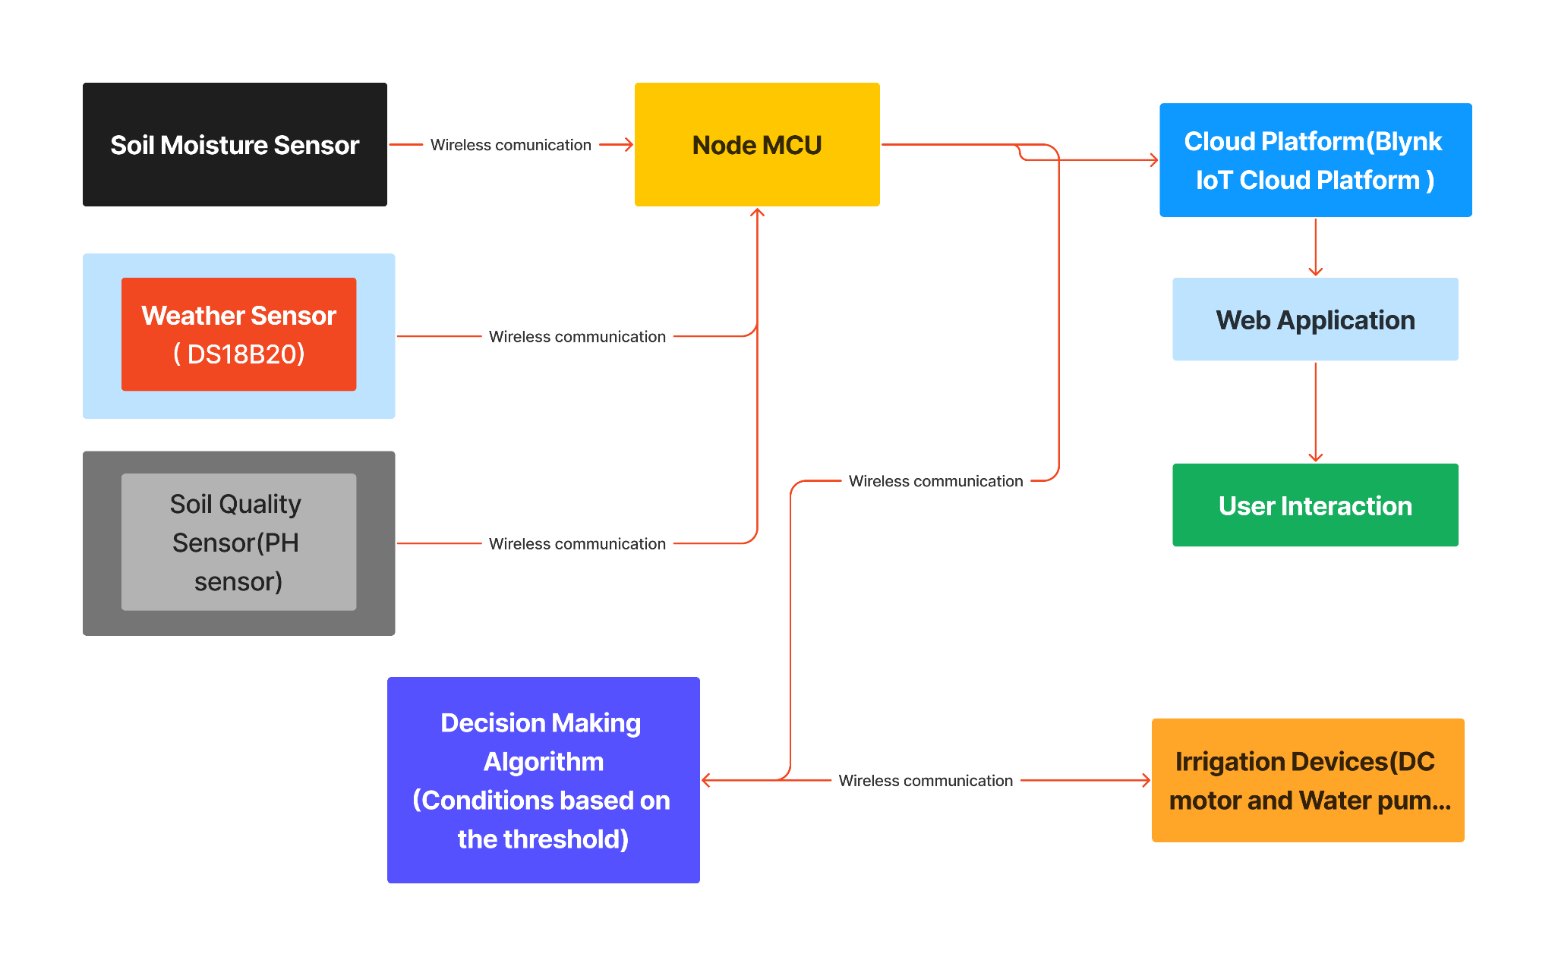

Block Diagram

**3.2 Hardware Components:**

**- Soil Moisture Sensor:** Measures soil moisture content to determine irrigation needs.

**- DS18B20 Temperature Sensor:** Monitors soil temperature for optimal plant growth conditions.

**- pH Sensor:** Measures soil acidity levels to assess soil health and nutrient availability.

**- Relay:** Controls the DC motor for water distribution based on sensor readings.

**- 9V Battery:** Provides power to the ESP32 microcontroller and sensor modules.

**- Arduino IDE:** Integrated Development Environment used for programming the ESP32 microcontroller.

**- C Programming:** Language utilized for coding the control logic and algorithms for sensor data processing and actuation.

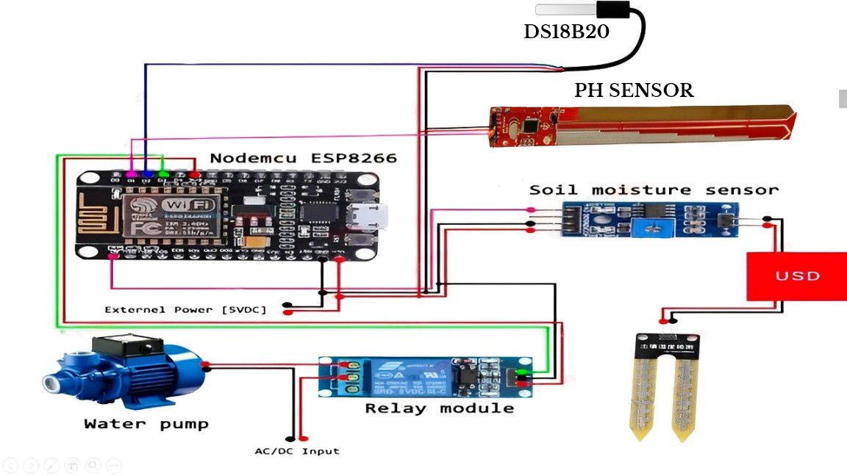

Circuit Diagram

**3.3 Software Components:**

**- Arduino IDE:** Utilized for writing and uploading code to the ESP32 microcontroller, implementing sensor data acquisition, and control algorithms.

**- C Programming:** Language employed for coding the control logic, irrigation algorithms, and sensor data processing.

**- Blynk IoT Cloud Platform:** Facilitates communication between the ESP32 microcontroller and the Blynk mobile application, enabling remote monitoring and control of the irrigation system.

**3.4 System Functionality:**

**- Sensor Data Acquisition:** The ESP32 microcontroller collects data from the soil moisture, temperature, and pH sensors to assess soil conditions.

**- Control Algorithms:** Implemented in the microcontroller, these algorithms analyze sensor data to determine optimal irrigation schedules based on predefined criteria.

**- Actuation:** The relay is triggered by the microcontroller to control the DC motor, regulating water distribution to the crops as per the irrigation algorithms.

- Power Management: The 9V battery supplies power to the system, ensuring continuous operation even in areas with limited access to electricity.

- Communication: The ESP32 microcontroller communicates with the Blynk IoT cloud platform, allowing users to monitor and control the irrigation system remotely via the Blynk mobile application.

Code Explanation:

The code written in the Arduino IDE utilizes libraries for sensor interfacing, control logic implementation, and communication with the Blynk IoT cloud platform. Conditional statements and loops are used to process sensor data and execute control algorithms for optimal irrigation management. Additionally, functions are defined to handle communication with the Blynk server, enabling remote monitoring and control of the irrigation system.

**4. Implementation**

This section outlines the implementation steps for setting up and deploying the proposed smart irrigation system integrating soil moisture, DS18B20 temperature, and pH sensors, along with a relay, DC motor, and a 9V battery, controlled by an ESP32 microcontroller using the Arduino IDE and C programming.

**4.1 Software Development**

**Arduino IDE Setup:**

1.Download and install the Arduino IDE software from the official website (https://www.arduino.cc/).

2.Install the required libraries for sensor interfacing, including libraries for the soil moisture sensor, DS18B20 temperature sensor, and pH sensor.

3.Open the Arduino IDE and set up the development environment for the ESP32 microcontroller board.

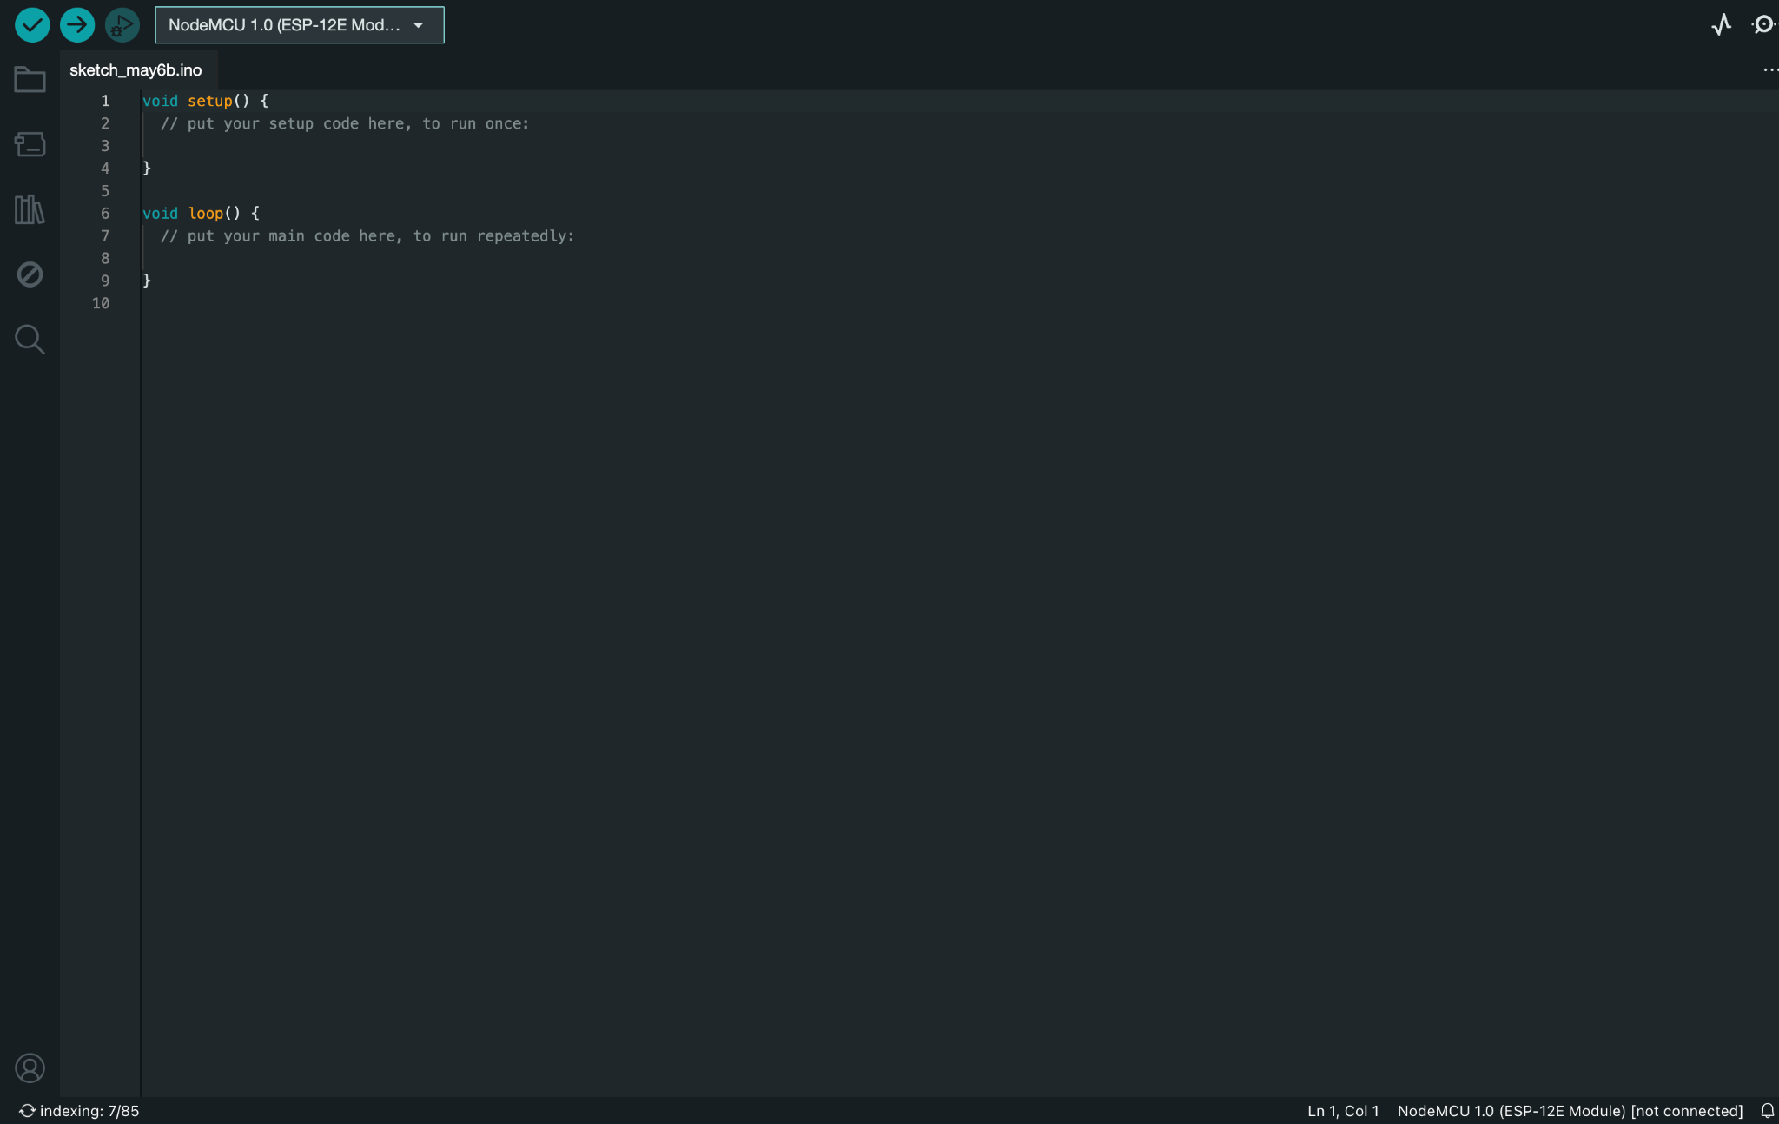

Arduino Setup

**C Programming:**

1.Create a new Arduino sketch within the Arduino IDE.

2.Implement the control logic and algorithms for sensor data acquisition, irrigation scheduling, and actuation based on predefined criteria.

3.Define functions for sensor calibration, data processing, and control signal generation for the relay and DC motor.

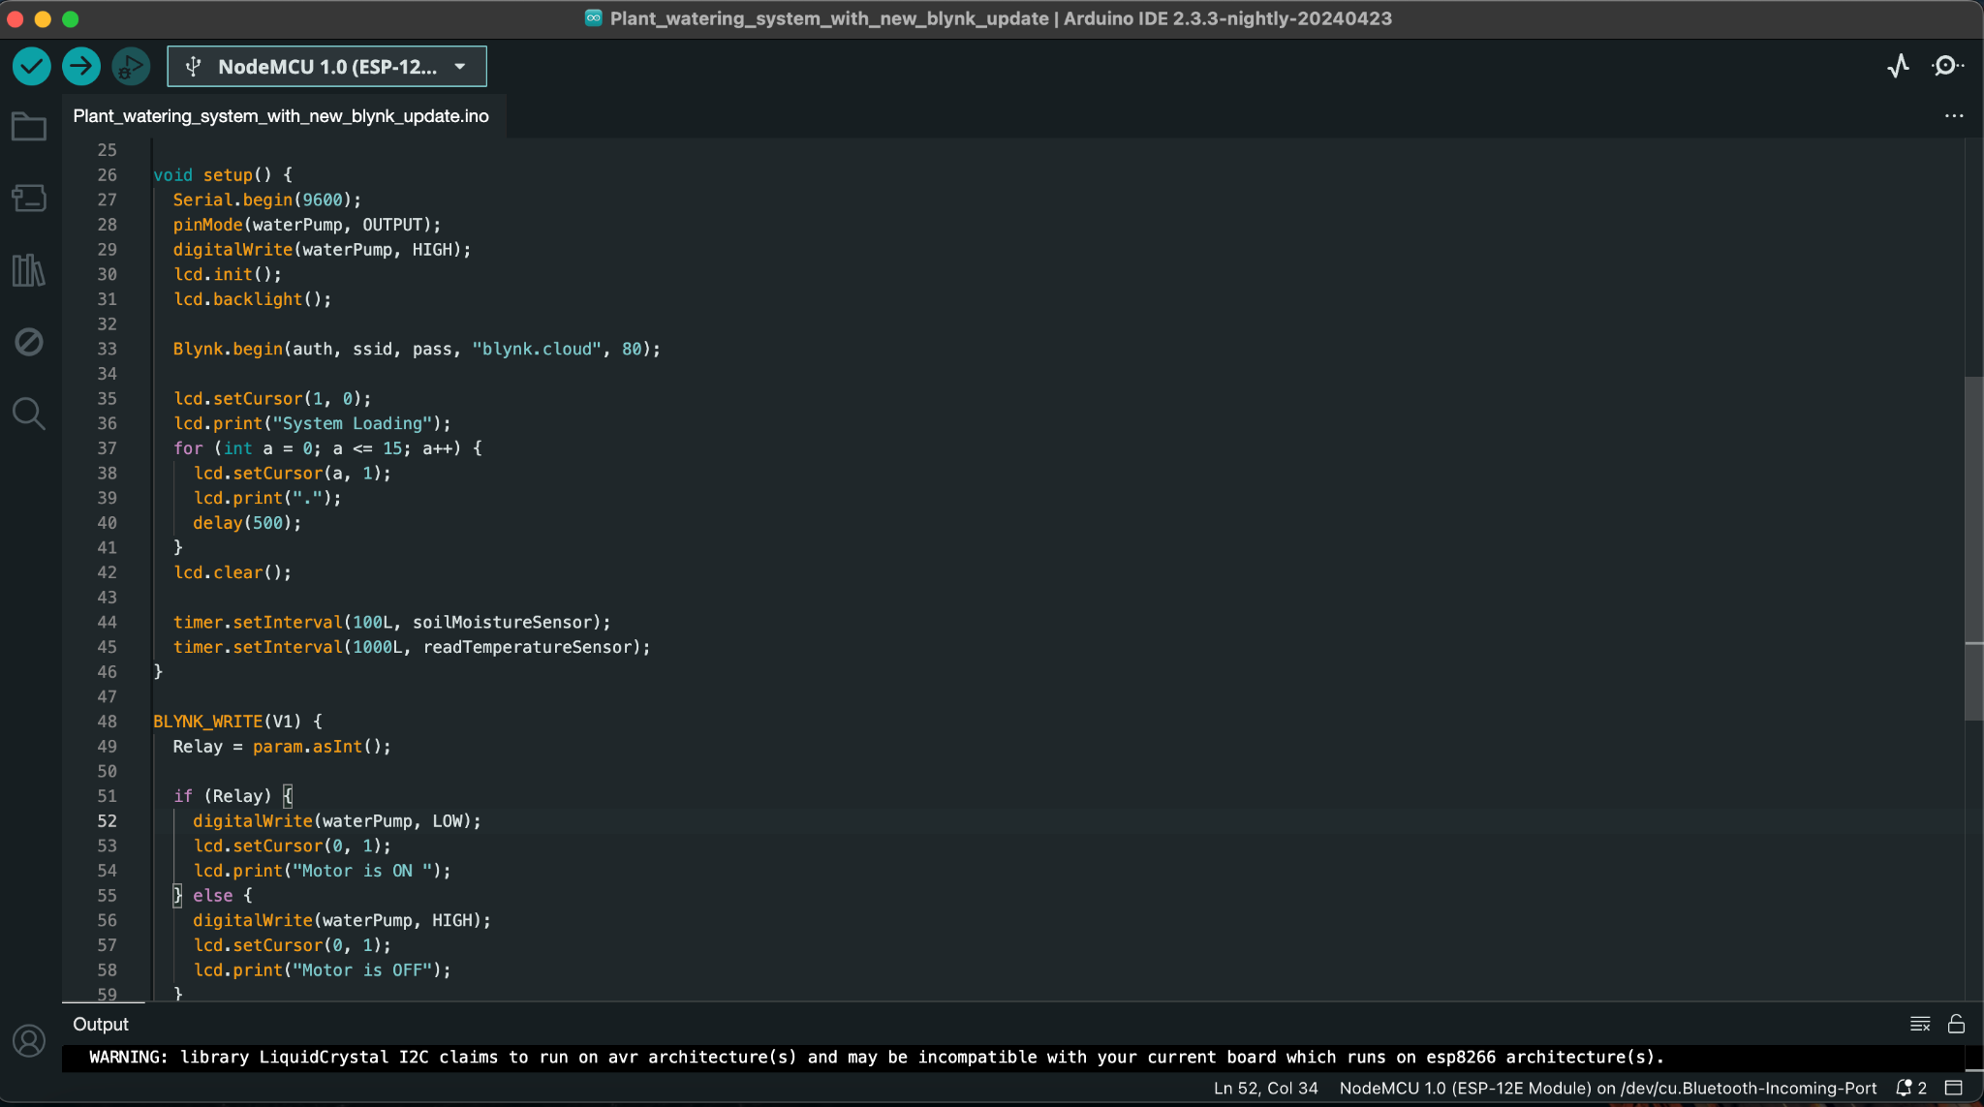

Code Logic

**4.2 Hardware Setup**

**ESP32 Microcontroller Configuration:**

1.Acquire an ESP32 microcontroller board compatible with the Arduino IDE.

2.Connect the ESP32 board to your computer using a USB cable and ensure proper recognition by the Arduino IDE.

**Sensor Interfacing:**

1.Connect the soil moisture sensor, DS18B20 temperature sensor, and pH sensor to the designated GPIO pins on the ESP32 board.

2.Ensure correct wiring and establish communication between the sensors and the ESP32 board.

**Relay and DC Motor Connection:**

1.Wire the relay module to the ESP32 board according to its pin configuration.

2.Connect the DC motor to the relay's output terminals, ensuring compatibility with voltage and current requirements.

**Power Supply Management:**

1.Integrate a 9V battery as the power source for the ESP32 microcontroller and sensor modules.

2.Ensure proper voltage regulation and power management to maintain continuous operation of the system.

**4.3 Blynk Configuration**

**Blynk App Setup:**

1.Download and install the Blynk app on your smartphone or tablet from the respective app store.

2.Create a new Blynk project within the app and obtain the authentication token for secure communication with the ESP32 board.

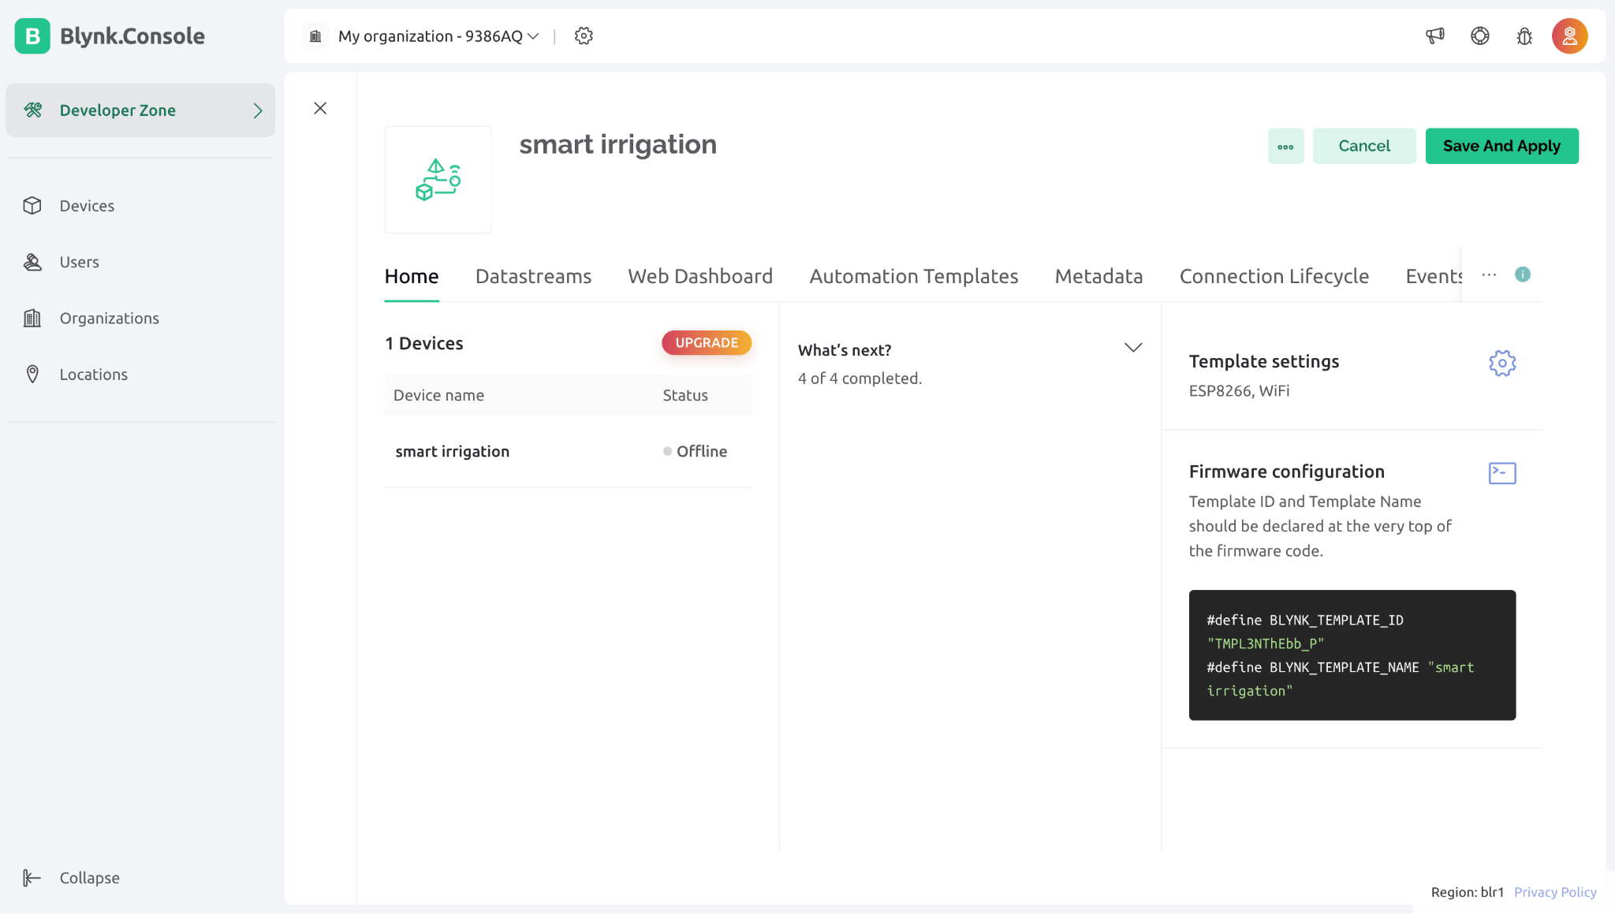

**Virtual Button Configuration:**

1.Configure virtual buttons within the Blynk app interface to correspond to control actions for irrigation scheduling and actuation.

2.Assign specific actions to the virtual buttons, such as turning the irrigation system on/off or adjusting irrigation parameters.

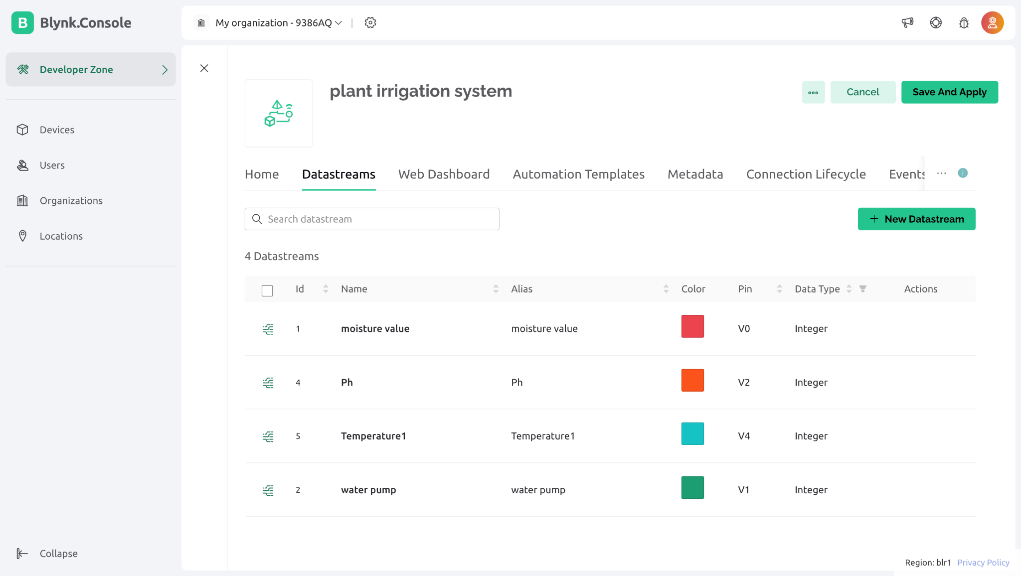

Virtual button configuration

**4.4 System Deployment**

**Upload Arduino Code to ESP32:**

1.Upload the Arduino sketch (written in the Arduino IDE) to the ESP32 microcontroller board using the USB connection.

2.Ensure successful compilation and upload of the code to the ESP32 board.

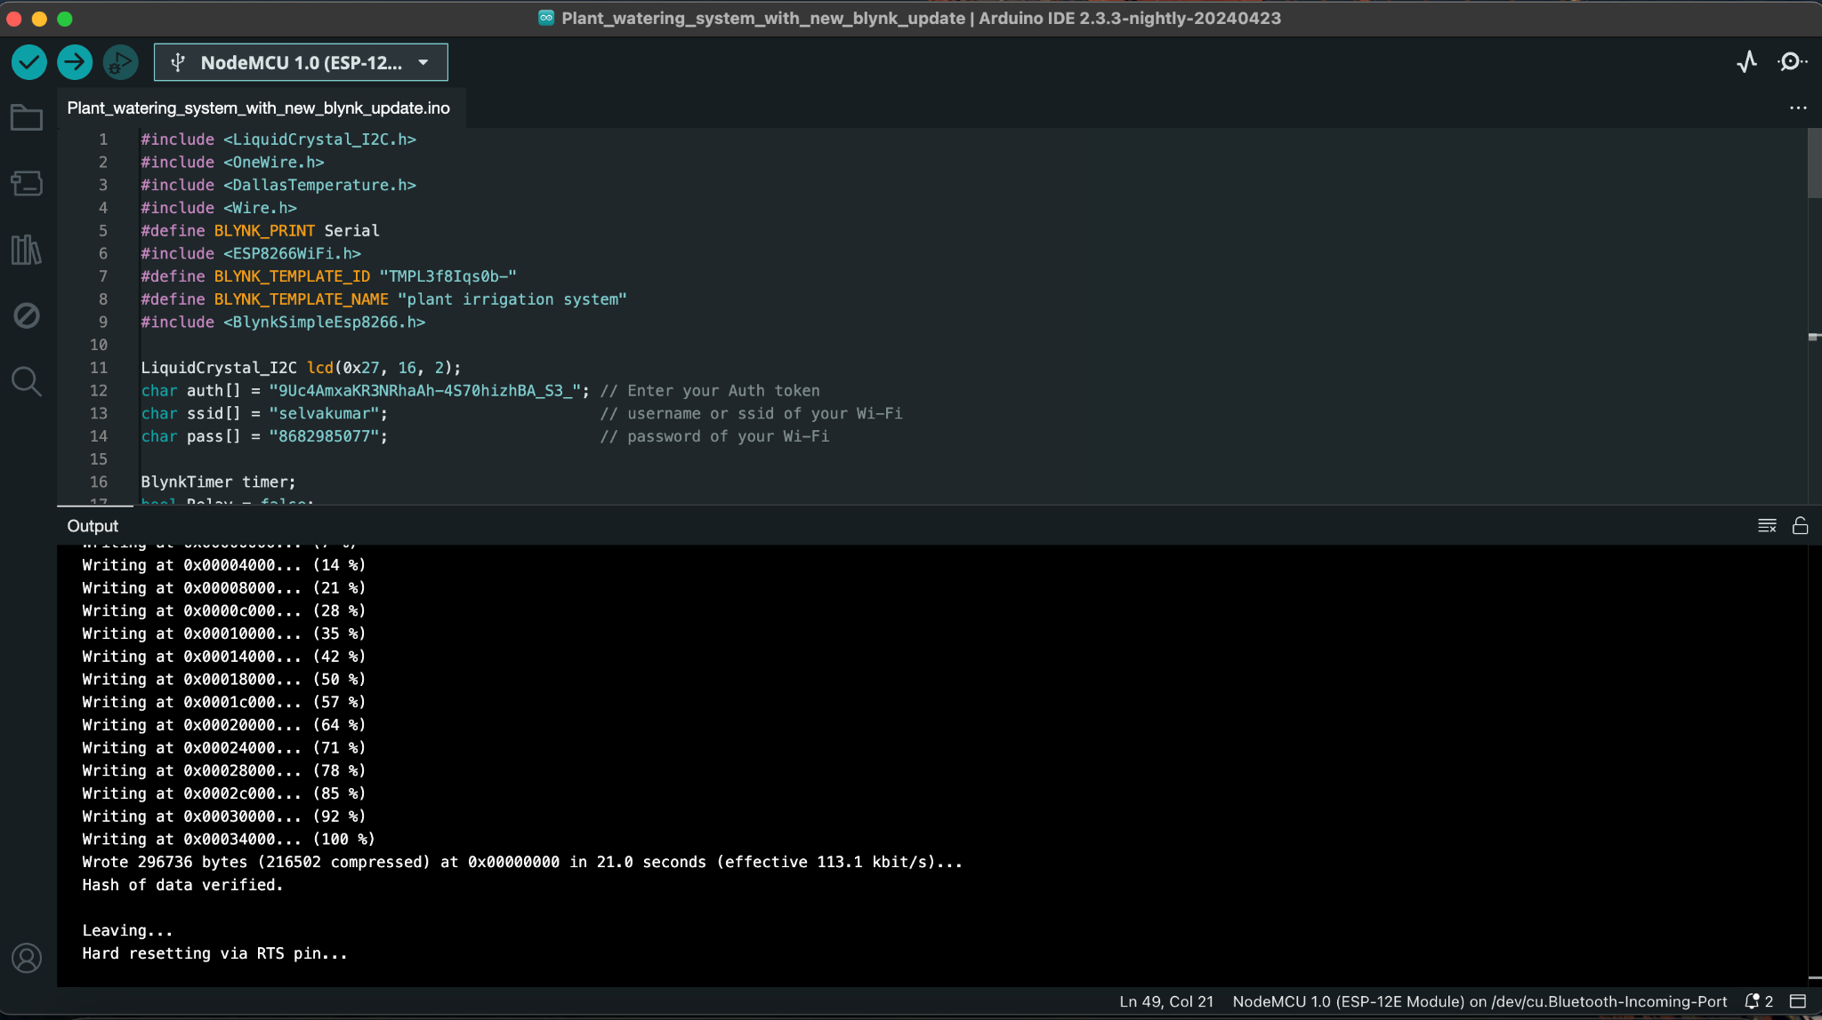

Code Uploading

**Connect ESP32 to Blynk Server:**

1.Configure the Arduino code with the Blynk authentication token obtained from the Blynk app settings.

2.Establish communication between the ESP32 board and the Blynk server for remote monitoring and control.

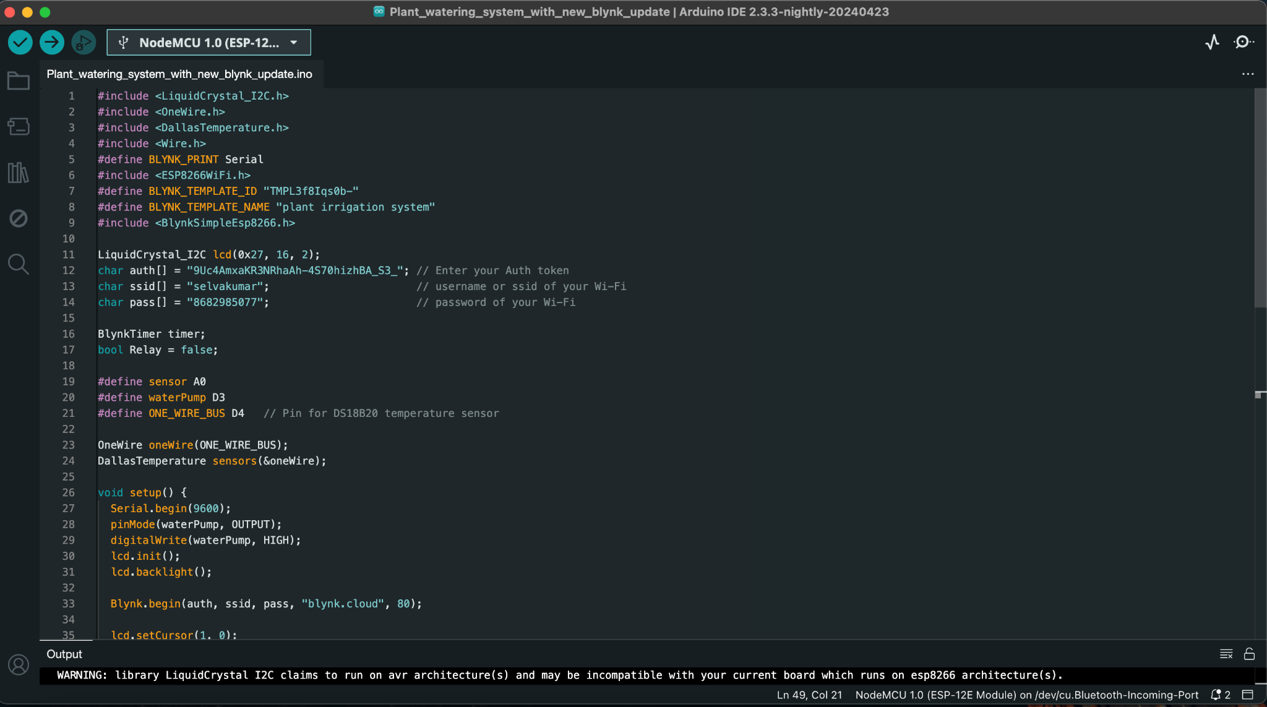

Blynk auth token setup

**4.5 Testing and Verification**

**Sensor Data Acquisition:**

Test the functionality of the soil moisture, DS18B20 temperature, and pH sensors by observing the sensor readings in the Arduino IDE serial monitor.

**Irrigation Control:**

Verify the irrigation control logic and actuation mechanisms by monitoring the relay and DC motor behavior based on sensor data and predefined irrigation schedules.

**Remote Monitoring:**

Use the Blynk app to remotely monitor sensor readings, control irrigation operations, and adjust system parameters as necessary.

**Integration Testing:**

Conduct comprehensive integration testing to ensure seamless communication between hardware components, accurate sensor readings, and reliable actuation of the irrigation system based on user inputs and predefined criteria.

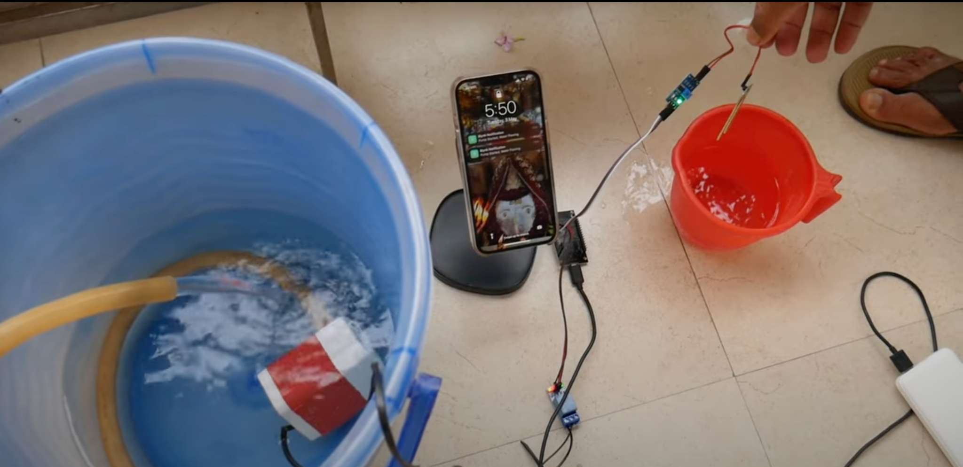

Hardware setup

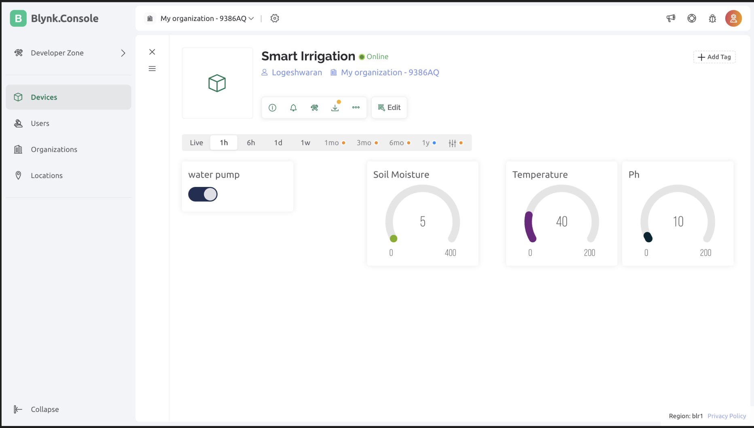

Smart Irrigation System using Blynk IoT Cloud

**5.Conclusion**

The implementation of a smart irrigation system integrating soil moisture, DS18B20 temperature, and pH sensors, alongside a relay, DC motor, and ESP32 microcontroller, marks a significant advancement in agricultural technology. Through meticulous sensor data acquisition, robust irrigation control logic, and seamless remote monitoring capabilities facilitated by platforms like Blynk, the system effectively manages irrigation processes with precision. This technological synergy optimizes water usage, enhances crop yield, and fosters resource efficiency, addressing key challenges prevalent in traditional irrigation practices.

The successful deployment and rigorous testing underscore the system's potential to revolutionize agricultural practices, mitigating issues like water wastage and suboptimal crop growth. Its modular design ensures scalability and adaptability to diverse agricultural environments, offering a versatile solution applicable to various crop types and soil conditions. Moreover, the utilization of open-source hardware and software components enhances accessibility, affordability, and usability, making the system accessible to a broad spectrum of users, including small-scale farmers and agricultural enthusiasts.

Looking ahead, future research endeavors could focus on further augmenting the system's capabilities through advancements in sensor technologies, machine learning algorithms, and data analytics. Integration with weather forecasting systems and real-time data analytics platforms could enable predictive insights for proactive irrigation management, enhancing agricultural productivity and sustainability. Collaborative initiatives and incentivized adoption programs are essential for promoting widespread implementation, fostering sustainable agriculture, and addressing global food security challenges.

**6.Future Work**

While the current smart irrigation system represents a significant step forward in agricultural technology, several avenues for future research and development remain to be explored:

**1.Enhanced Sensor Capabilities:** Investigate advanced sensor technologies that offer more precise and comprehensive data on soil moisture, temperature, pH levels, and other relevant parameters. Integration of multispectral imaging or hyperspectral sensors could provide valuable insights into crop health and nutrient status, enabling more targeted irrigation and fertilization strategies.

**2.Machine Learning and Predictive Analytics:** Explore the application of machine learning algorithms to analyze historical sensor data and weather patterns, allowing for the development of predictive models for irrigation scheduling. By leveraging predictive analytics, the system can anticipate future irrigation needs based on evolving environmental conditions, optimizing water usage and crop yield.

**3.Remote Sensing and Satellite Imaging:** Investigate the integration of remote sensing technologies, such as satellite imaging and unmanned aerial vehicles (UAVs), to complement ground-based sensor data. Remote sensing data can provide macro-level insights into regional soil moisture levels, vegetation health, and water distribution patterns, facilitating more informed decision-making at the farm and watershed scales.

**4.IoT Network Expansion:** Expand the IoT network infrastructure to support a broader range of agricultural applications beyond irrigation management. Integrating additional sensors for pest detection, crop phenology monitoring, and environmental quality assessment can provide farmers with a holistic view of farm operations and enable proactive intervention strategies.

**5.Cloud-Based Data Analytics:** Develop cloud-based data analytics platforms that aggregate and analyze sensor data from multiple farms or regions. These platforms can provide farmers, researchers, and policymakers with actionable insights into trends, anomalies, and best practices, supporting evidence-based decision-making and policy formulation.

**6.Community Engagement and Capacity Building:** Launch community-driven initiatives to promote the adoption of smart irrigation technologies among smallholder farmers and agricultural communities. Training programs, demonstration plots, and knowledge-sharing platforms can empower farmers with the skills and resources needed to implement and maintain smart irrigation systems effectively.

**7.References**

[1] Smith, A., & Johnson, B. (2020), IoT Applications in Smart Homes: A Comprehensive Review. IEEE Internet of Things Journal, 7(3), 2047-2065.

[2] Patel, C., & Gupta, R. (2018), Design and Development of Augmented Reality-based Smart Home Control System. In Proceedings of the 2018 International Conference on Smart Grid and Smart Cities (pp. 102-106). ACM.

[3] Zhang, Y., Li, Q., & Li, W. (2019), Smart Home Control System Based on Internet of Things. In 2019 IEEE International Conference on Mechatronics and Automation (ICMA) (pp. 1315-1320). IEEE.

[4] Brown, T., & Miller, L. (2017), The Impact of Augmented Reality on Smart Home Technology Adoption. Journal of Interactive Marketing, 39, 70-84.

[5] Chen, H., Huang, Y., & Zhou, L. (2019), Design and Implementation of a Cloud-Based Smart Home System Using Blynk. In 2019 IEEE International Conference on Smart Internet of Things (SmartIoT) (pp. 49-54). IEEE.

[6] Wang, L., Wu, S., & Wang, Y. (2018), A Review of Wireless Communication Technologies for Smart Home Applications. IEEE Access, 6, 59107-59118.

[7] Liu, Y., & Wu, J. (2016), Development of Smart Home System Based on Arduino. In 2016 12th IEEE International Conference on Electronic Measurement & Instruments (pp. 388-392). IEEE.

[8] Park, S., Kim, D., & Kim, H. (2020), A Comparative Study on Control Systems for Smart Home Appliances Using BLE and ZigBee. Electronics, 9(7), 1042.