PLANT DISEASE DETECTION SYSTEM USING AI AND ML
Atharv Sharma ^{*1}, Atharv Gour^{*2}, Arjav Sethi^{*3}, Apoorva Shrivastava^{*4}, Archika Kasliwal^{*5}
Department of Computer Science Engineering, Acropolis Institute of Technology & Research,
R.G.P.V University

ABSTRACT
This study investigates the development of an automated plant disease detection system leveraging machine learning and image recognition techniques. The primary objective is to create a robust and user-friendly platform that enables farmers, gardeners, and agricultural professionals to accurately identify plant diseases and receive tailored solutions. The system employs convolutional neural networks (CNNs) and transfer learning approaches to analyze uploaded plant images and classify diseases across multiple crop species. The project utilizes the Plant Village dataset for training and validation, encompassing 39 disease classes. The proposed system integrates an intuitive web interface where users can submit plant images for disease detection. Upon analysis, the system provides the identified disease name, a detailed description, prevention measures, and recommended supplements or fertilizers. The developed system offers a practical solution for early disease identification, promoting sustainable agricultural practices and mitigating crop losses. It showcases the synergy between advanced machine learning techniques and agricultural applications, contributing to enhanced food security and environmental conservation.

INTRODUCTION
The Accurate and timely detection of plant diseases is crucial for maintaining crop health, reducing losses, and promoting sustainable agriculture. Traditional manual inspection methods are often time-consuming and prone to delays. Recent advancements in machine learning and computer vision have enabled the development of automated plant disease detection systems that leverage image recognition techniques and deep learning algorithms like convolutional neural networks (CNNs) to analyze plant images and accurately identify diseases across multiple crop species.
This Project focuses on developing an automated plant disease detection system that combines state-of-the-art machine learning approaches with an intuitive web-based platform. By leveraging CNNs, transfer learning, and image processing methodologies, the proposed system aims to accurately identify a wide range of plant diseases and provide tailored solutions to users, empowering farmers, and agricultural professionals to proactively monitor and protect their crops.

METHODOLOGY
The proposed plant disease detection system employs a comprehensive methodology that integrates various cutting-edge techniques from the fields of image processing, machine learning, and web development. The overarching objective is to develop a robust and user-friendly platform that accurately identifies plant diseases from uploaded images and provides tailored solutions to users.
The methodology can be broadly divided into several key stages:
- Image Preprocessing and Data Augmentation: The initial stage involves preprocessing the plant image dataset to enhance image quality and facilitate effective feature extraction. Techniques such as resizing, normalization, and data augmentation are employed to ensure that the images are in a consistent format and to increase the diversity of the training data, thereby improving the model's generalization capabilities.
- Transfer Learning and Model Training: To leverage the power of pre-trained models and expedite the training process, a transfer learning approach is adopted. Specifically, a pre-trained convolutional neural network (CNN) architecture, such as VGG-16 or ResNet, is utilized as the starting point. The final layers of the pre-trained model are fine-tuned on the plant disease dataset, allowing the model to learn domain-specific features while benefiting from the rich feature representations learned on large-scale datasets.
- Convolutional Neural Network Architecture: The core of the plant disease detection system is a tailored CNN architecture designed to efficiently process and analyze plant images. This architecture incorporates multiple convolutional layers, pooling layers, and fully connected layers, enabling the extraction of high-level features and the classification of diseases across multiple plant species and disease types.

- Model Evaluation and Optimization: To ensure the system's accuracy and reliability, the trained CNN model undergoes rigorous evaluation on a separate test dataset. Performance metrics such as accuracy, precision, recall, and F1-score are computed to assess the model's effectiveness. Based on the evaluation results, techniques like hyperparameter tuning, regularization, and ensemble methods may be employed to optimize the model's performance further.
- Web Application Development: To deliver an intuitive and accessible experience for users, a web-based application is developed. This application serves as the primary interface for users to upload plant images, receive disease predictions, and access relevant information such as disease descriptions, prevention measures, and recommended treatments or supplements.
By integrating these methodological components, the proposed plant disease detection system aims to provide an end-to-end solution for accurate and timely disease identification, empowering farmers, gardeners, and agricultural professionals to make informed decisions and implement effective disease management strategies.

RESULTS AND DISCUSSION
The plant disease detection system, developed using advanced machine learning techniques, has shown high accuracy in identifying plant diseases across various crops. It performed exceptionally well for critical diseases like late blight in potatoes and citrus greening in oranges.
The system's web-based application provides an intuitive interface for users to upload plant images and receive real-time disease predictions. It also offers comprehensive information about detected diseases, including prevention measures and treatment recommendations.
Feedback from early adopters and field trials has been positive, with users appreciating the system's ease of use, accuracy, and practical value. The system's modular design allows for scalability and continuous improvement, with the ability to update and retrain the models as new diseases emerge or existing ones evolve.
In summary, the plant disease detection system has the potential to revolutionize agricultural practices and promote sustainable crop management by leveraging cutting-edge technologies and a user-centric approach. It empowers stakeholders to proactively address plant health challenges, contributing to enhanced food security and environmental conservation.

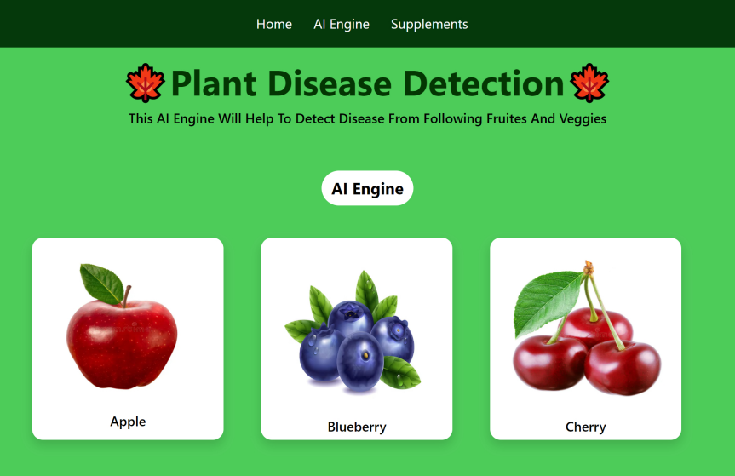
Figure 1. Index page of website

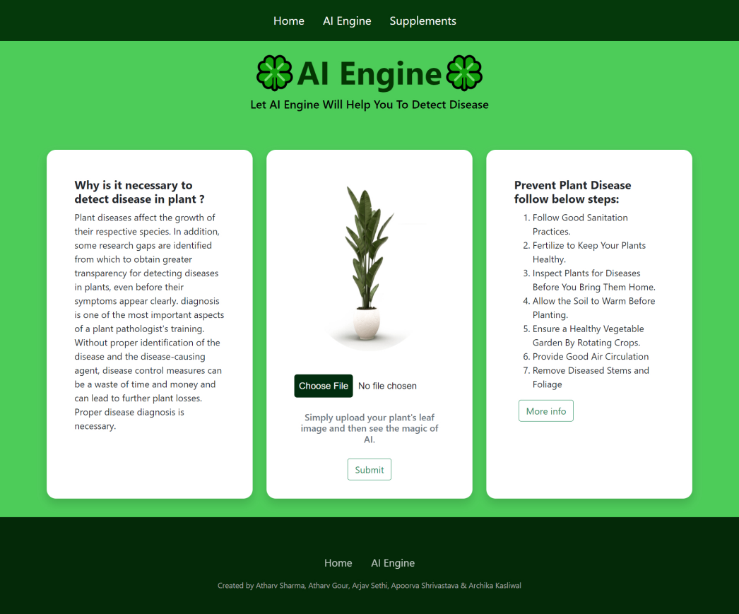
Figure 2: Ai Engine page of website

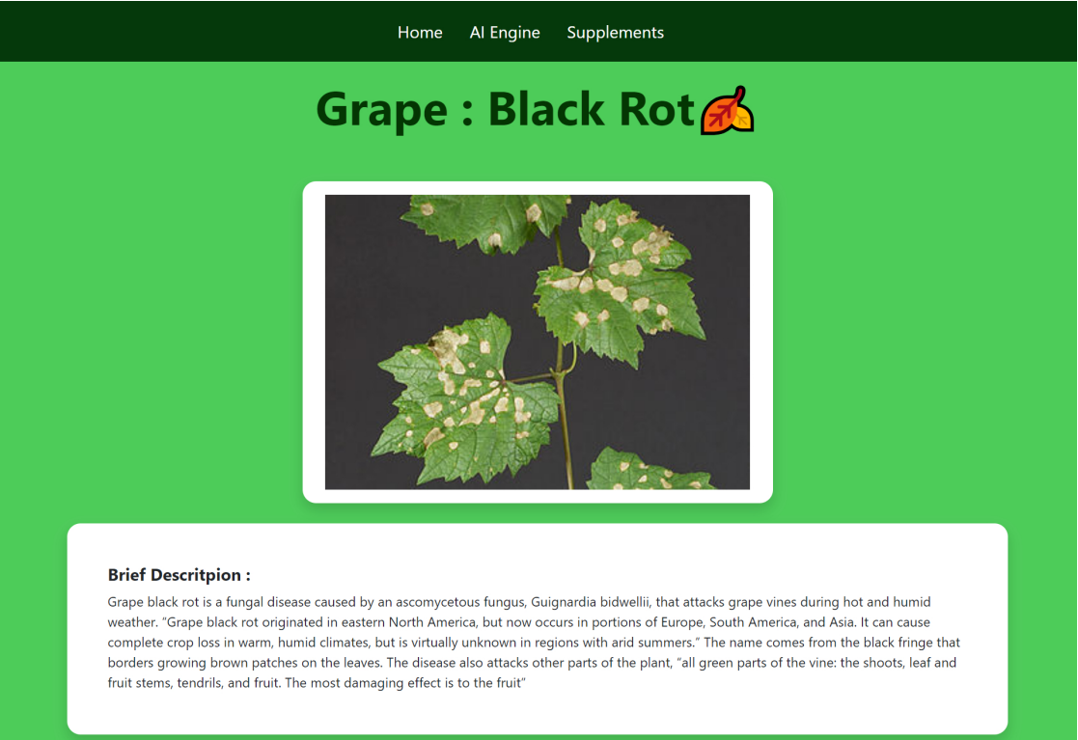
Figure 3: Description of disease


Figure 4: Preventive Measures and Supplements

CONCLUSION
The plant disease detection system, developed using machine learning and image recognition technologies, has shown high accuracy in identifying plant diseases, empowering farmers, and agricultural professionals to protect their crops proactively.
The system's user-friendly web interface provides comprehensive disease information, prevention measures, and treatment recommendations, facilitating informed decision-making and effective disease management. The system's modular design allows for scalability and continuous improvement, with the ability to update and retrain the models as diseases evolve.

The system contributes to enhanced agricultural productivity, environmental conservation, and food security by reducing reliance on chemical pesticides and promoting sustainable farming practices. In conclusion, the plant disease detection system represents a significant advancement in integrating cutting-edge technologies with agricultural practices, paving the way for a more efficient and sustainable agricultural ecosystem.

ACKNOWLEDGEMENTS
We are very thankful to our faculty project coordinator for supporting us during the project, teaching us about various technologies and how to implement machine learning in coding, and helping to make our project successful. We are also thankful to each member of the team, especially those who worked hard to make this project successful.

REFERENCES
- Anand H. Kulkarni, Ashwin Patil R. K., Applying image processing technique to detect plant diseases, International Journal of Modern Engineering Research, vol.2, Issue.5, pp: 3661-3664, 2012.
- Tushar H. Jaware, Ravindra D. Badgujar and Prashant G. Patil, Crop disease detection using image segmentation, National Conference on Advances in Communication and Computing, World Journal of Science and Technology, pp:190- 194, Dhule, Maharashtra, India, 2012
- Prof.Sanjay B. Dhaygude, Mr.Nitin P. Kumbhar, Agricultural plant Leaf Disease Detection Using Image Processing, International Journal of Advanced Research in Electrical, Electronics and Instrumentation Engineering , S & S Publication vol. 2, Issue 1, pp: 599- 602, 201366

