**IOT BASED MULTI PARAMETER MONITORING OF MOTOR**

**Prof Divya Bawane , Jai Sharma, Sheikh Taufik, Aditya Rawate, Aniket Khade**

*Department of Electrical Engineering*

*Shri Sai College of Engineering and Technology,Bhadrawati(MS), India*

**Abstract**: In Today’s generation IoT plays an essential role in our day to day life. Technology has advanced significantly in recent years, making our lives easier, faster, and more enjoyable. This paper we use Internet of Things to control and monitor induction motors (IoT). Monitoring and controlling of induction motor parameter is very essential in many application and also for the reliable operation there are several techniques available for the same. This system deals with the monitoring of various parameters & control of three phase induction motor remotely based on Internet Of Things [IOT].The system has been designed to combine various parameter measurements in real-time, improving the delectability of different faults. The monitoring of the motor system presents the measurement of different parameters namely vibrations, temperature, voltage and current consumption.

**Keywords: Induction Motor, Internet of Things, Arduino Uno, Parameter Monitoring, Parameter Controlling.**

**Objectives**:

The main aim of the paper is the use of IoT for online monitoring of motor parameters like current, temperature, vibration, and humidity and observing its online trending using a web server. The future of this project is the real-time monitoring of the motor from any remote area and in case of any abnormality operating personnel can take necessary steps for preventing complete breakdown.

**Introduction:**

Today's manufacturing industries, mechanical and electromechanical systems are mostly driven by electric motors. Before the invention of AC induction motors dc motors were widely used for industrial requirements. Currently, we have been using two types of motors with respect to their supply voltages: the DC motors, which operate on DC (direct current) voltages, and the AC motors, or induction motors, which operate on AC (alternating current) voltages. But here we will only talk about three-phase induction motors, which are quite popular in domestic and industrial-level applications. These motors are highly efficient, low-cost, and small in size. It consists of two magnetic circuits that are interlinked with each other. With the invention of AC induction motors due to their higher performance attributes over DC motor, industrial automation is being frequently done with it. The primary advantages of the induction motor are its straightforward rotor construction leading to low cost, ruggedness, and low-maintenance requirements. From the study of construction and operation of an induction motor, Generally, industries use two types of induction motors, such as wound rotors and squirrel cage rotors, but their faults are almost the same it reveals that main Faults in induction motors can be categorized as follows:

1. Electrical Faults
2. Mechanical Faults
3. Environmental Faults

### Electrical faults

These faults further subdivide into seven types, such as:

#### Single Phasing Fault

This occurs when any one phase of the supply voltage is lost. This is because the requirement for normal operation of a three-phase induction motor is a three-phase voltage supply. Due to this fault, the motor could burn or heat up.

#### Reverse Phase Sequencing Fault

A reverse phase sequencing fault occurs when any one phase of the three-phase voltage supply is reversed, meaning the phase order of the supply voltages is swapped. Due to this fault, the direction of rotation of the motor changes.

#### Under and Over Supply Voltage Fault

This fault occurs when supply voltages are under or over a specific limit. The limit of three-phase AC supply voltages is 380 to 440 volts, so when supply voltages cross this limit, the motor could burn or heat up.

#### Overload fault

Overload occurs when a higher load connects at the output of the motor, and due to this load, the motor could heat up or experience excessive vibration.

#### Earth Fault

This fault occurs when any one phase of the supply voltage connects to the housing of the motor. Hence, this results in a complete short circuit of the motor. In this condition, if anyone touches this motor, he will feel a heavy shock. Besides this, the motor will take over current, which could be dangerous for an induction motor.

#### Inter Turn Short Circuit Fault

This type of fault occurs when two turns of the same phase or different phases short circuit each other. During this fault, the motor can suffer total damage or damage to the coils of a specific phase.

#### Crawling Fault

This is basically an electromechanical fault in a three-phase induction motor. This fault occurs when the motor is fully loaded with supply voltage. It does accelerate, but it runs at nearly one-seventh of its synchronous speed. This specific phenomenon of induction motors is crawling.

### Mechanical Faults in Three Phase Induction Motor

Mechanical faults are such types of faults that generally occur in the internal housing of a three-phase induction motor. These faults further subdivide into three types, such as:

#### Broken Rotor Fault

The squirrel cage induction motor consists of rotor bars and a shorted end ring. If these bars suffer damage or a partial crack, then this type of fault is a rotor-broken-bar fault. There are so many reasons for this fault occurring, but mainly, it occurs due to a manufacturer defect. Because during the brazing process, non-uniform metallurgical stress may occur in rotor bars, which may lead to the rotor bars failure during the rotation of the rotor. We can see the broken rotor bar fault in the following figure:

[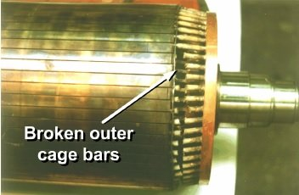](http://microcontrollerslab.com/wp-content/uploads/2018/12/2-types-of-faults-in-induction-motor.jpg)

Figure 1 Broken Rotor Bar Fault

#### Rotor Mass Unbalance Fault

If we concentrate on the construction of an induction motor, then we can easily know that the placement of the rotor of an induction motor is inside the stator bore and rotates coaxially with the stator. In heavy motors, it aligns at the center with the stator, and its axis of rotation is also the same as the geometrical axis of the stator. So the air gap between the inner stator and the outer rotor is the same. Similarly, if this air gap is not the same, then the situation of eccentricity will occur. In this eccentricity situation, the fault occurs due to the unbalancing of the rotor. For reference, we can see this rotor mass unbalance fault in the following figure:

[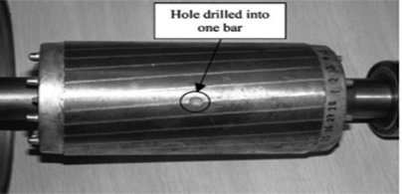](http://microcontrollerslab.com/wp-content/uploads/2018/12/3-types-of-faults-in-induction-motor.jpg)

Figure 2 Rotor Mass Unbalance Fault

#### Bearing Fault

In a three-phase induction motor, two sets of bearings are installed inside the motor housing to support the motor shaft. The main purposes of these bearings are to rotate the motor shaft freely and reduce friction. They consist of an outer and inner ring, which are known as races, and a set of rolling elements, which are known as balls. The balls are fixed on the inner and outer sides of the ring, and they reduce the friction of the shaft. To further reduce the friction, the solution is to apply lubrication to these balls. Sometimes the balls, outer, or inner ring of the bearing suffer damage due to any physical problem, and then the fault occurs. This fault is a bearing fault, and due to this fault, the motor jams totally or gets stuck. We can see the motor bearing fault in the figure below.

[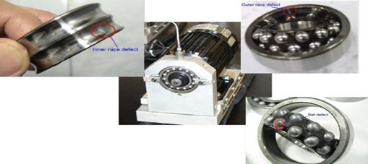](http://microcontrollerslab.com/wp-content/uploads/2018/12/4-types-of-faults-in-induction-motor.jpg)

Figure 3 The Motor Bearing Fault

### Environmental Faults in Three Phase Induction Motor

In motors, different faults could occur simultaneously, and in these faults, environmental faults are also very important. Induction motor surroundings, such as ambient temperature, moisture, etc., have an effect on the performance of induction motors. These factors reduce the performance of induction motors. Beside this, the vibration in the induction motor that could be due to any reason, such as a failed proper installation, also affects the performance of the induction motor. So during the installation of a three-phase induction motor, these factors should be kept in mind.

**THE THREE C’S OF IOT**

**Communication:** IoT communicates information to people and systems, such as state and health of equipment (e.g., It’s on or off, charged, full or empty) and data from sensors that can monitor a person’s vital signs. In most cases, we didn’t have access to this information before or it was collected manually and infrequently. For example, an IOT-enabled HVAC system can report if its air filter is clean and functioning properly. Almost every company has a class of assets it could track. GPS-enabled assets can communicate their current location and movement. Location is important for items that move, such as trucks, but it’s also applicable for locating items and people within an organization. In the healthcare industry, IoT can help a hospital track the location of everything from wheelchairs to cardiac defibrillators to surgeons. In the transportation industry, a business can deliver real-time tracking and condition of parcels and pallets. For example, Maersk can use sensors to track the location of a refrigerated shipping container and its current temperature

**Control and Automation**: In a connected world, a business will have visibility into a device’s condition. In many cases, a business or consumer will also be able to remotely control a device. For example, a business can remotely turn on or shut down a specific piece of equipment or adjust the temperature in a climate-controlled environment. Meanwhile, a consumer can use IoT to unlock their car or start the washing machine. Once a performance baseline has been established, a process can send alerts for anomalies and possibly deliver an automated response. For example, if the brake pads on a truck are about to fail, it can prompt the company to take the vehicle out of service and automatically schedule maintenance.

**Cost Savings:** Many companies will adopt IoT to save money. Measurement provides actual performance data and equipment health, instead of just estimates. Businesses, particularly industrial companies, lose money when equipment fails. With new sensor information, IoT can help a company save money by minimizing equipment failure and allowing the business to perform planned maintenance. Sensors can also be measuring items, such as driving behavior and speed, to reduce fuel expense and wear and tear on consumables. New smart meters in homes and businesses can also provide data that helps people understand energy consumption and opportunities for cost savings.

**Block Diagram:**

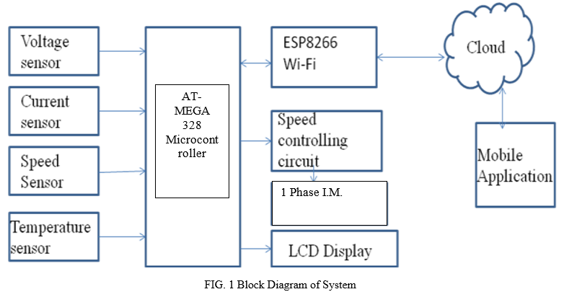

Figure 4 Block Diagram

**Conclusion:**

This paper presents the concept of Internet of Things for early detection and monitoring of motor system failures remotely. The system has been designed to combine various parameter measurements in real-time, improving the delectability of different faults. The monitoring of the motor system presents the measurement of different parameters namely vibrations, temperature, voltage and current consumption. The concept of IoT is presented here for remote monitoring and controlling the motor. The data received by the coordinator node is stored and graphically presented in real-time by means of a application developed in remote device. With the help of this device, it is very easy to have the real time parameters of the Induction motor which will help us in various aspects leading to the growth of the industry and increase working efficiency of motor.

**Future Scope:**

In the future lot of scope is there for IoT applications. Worldwide wide all overuse the IoT application for human life sophisticated. In 2025 millions of things connect to the cloud. A lot of research also done on IoT and it's more uses for human life's easiest purpose. Some research works on defense services for security and surveillance, some on automatic vehicle control and traffic signal control, some on the medical field for body control and health care, some on electronic devices, smart home, etc

**References:**

## [1]. Nitin Gore, Prof. A. V. Naik, “IOT Based Induction Motor Speed Control and Parameter Monitoring ISSN 2321-9653,2013

[2]. Keerthana p, vinoth g, senthil kumar r, rajesh s “Implementation of motor testing for single phase induction motor using IOT” (IJCESR) ISSN (PRINT): 2393-8374, (ONLINE): 2394-0697, volume-5, issue-2, 2018.

[3]. Aditya rayan Sharma, Jaikaran Singh “Protection of induction motor and monitioring”Journal of Advances in Electrical Devices Volume 2 Issue 1,MAT Journals 2017.

[4]. The research done by P.M.AKOTKAR, V.S.KARAL, Dr.A.U.JAWADEKAR on “Condition Monitoring Of Three Phase Induction Motor Based on

IOT” IJEEE Volume 3 Issue 4, August 2020.

[5]. Anurag Tiwari, Bharati Vidyapeeth “Prototype Health Monitoring of Induction Motor Using IOT” JEDR 2019 Volume 7, Issue 2

[6]. Ayushi Gajbiye, Prajakta Zodpe, Zamin Abbas, Hatim Patanwala, Christopher Paul, Prof. Pramod Gadge “Iot Based Condition Monitoring Of An Induction Motor “International Conference on Innovation & Research in Engineering, Science & Technology (ICIREST-19)

[7]. M. Ashmitha, D.J. Dhanusha, M.S.Vijitlin & G. Biju George “ Real Time Monitoring IoT Based Methodology for Fault Detection in Induction Motor”Irish Interdisciplinary Journal of Science & Research (IIJSR) Vol.5, Iss.2, April-June 2021

[8]. Kalpesh J Parekh , Ravi M Joshi “Analysis of the Induction Motor used in Temperature Controller Machine by Condition Based Monitoring System”IJSTE - International Journal of Science Technology & Engineering Volume 3 Issue 10 April 2017 ISSN (online).

[9] Ashwini B. Kaule,” IoT Based Monitoring and Speed Control of an Induction Motor”, et. al. International Journal of Engineering Research and Applications ISSN : 2248-9622, Vol. 10, Issue 11, ( Series -III) November 2020, pp.06-10

[10] F. Wang, S. Rosado, D. Boroyevich, “Open Modular Power System Controller Applications”, IEEE Power Electronics Specialist Conference, June 2003, Vol. 4, pp. 1792-1797Sumit Narwade, Prasad Kulkarni and C.Y.Patil ―Fault Detection of Induction Motor UsingCurrent and Vibration Monitoring‖. International Journal of Advanced Computer Volume-3 Number-4 Issue-13 December-2013.