**A RESEARCH ON DEEP LEARNING-BASED AUTOMATIC DETECTION OF BIKE RIDERS WITH NO HELMET**

**Puneeth S P*1, Siddartha K G*2, T C Deepak*3, Venkatesh U*4, Vinayak N Mattur*5**

*1Asst. Professor, Department of Information Science and Engineering, Bapuji Institute of Engineering and Technology, Davangere, Karnataka, India.

*2,3,4,5 Student, Department of Information Science and Engineering, Bapuji Institute of Engineering and Technology, Davangere, Karnataka, India.

# ABSTRACT

Now-a-days two wheelers is the most preferred mode of transport. It is highly desirable for bike riders . This paper uses image processing technique by which motorcyclists without helmet will be detected. In this project moving vehicles can be detected using the input as image or a video and then classified into motorcyclists and non-motorcyclists by background removal and based on size of the image being detected. If in case motorcyclist is detected without a helmet, the vehicle details with the person(s) on vehicle and the number plate is captured in the form of an image. An algorithm is designed to recognize number plates of motor cyclists using images or videos taken by camera. Recognition of number plates characters using image processing algorithms, storing in the database with the image as the proof with date and time recorded. A database will be designed with the proof stored with the offence to identify every offender accurately and arrest the suspect’s vehicle and hence imposing violation fine by sending mail to detected vehicle. This paper compares the Existing systems properties with the our project properties and In this paper our project is compared with five existing Systems and overcomes the drawbacks of it.

**Keywords:** motorcyclists without helmet, number plate recognition, image processing, Sending a Mail

# INTRODUCTION

A helmet is essential for preventing traumatic brain injuries caused by impact and even death in a fatal accident. The negligence of the biker to not wear a helmet due to personal and other reasons may end up in serious injuries if meet with an accident. To reduce the risk of any type of head injury or even death due to an accident bike riders must be encouraged to wear a helmet for their safety. And the law must be very strict to fine who fail to do so. A system through deep learning an automatic helmet detection system has been proposed.

At present in India bikers without a helmet are fined manually by pulling them at checkpoints and check their documents for identification such as RC book, license card, insurance, etc., then the police officials would asking them the reason for not wearing a helmet while driving a two-wheeler. Since wearing a helmet while driving is a law, their reasons would not be taken for justification. Then they will be issued a receipt for the fine they have received for not wearing a helmet. They will also be given a choice to pay the fine on the spot through a

debit/credit card or cash payment method or pay the fine in court within a particular period. So to eliminate the workload of the traffic officials and to implement strict law this proposed method can be used. So that bikers will be forced to wear the helmet while driving. This would also reduce the work of the traffic management department and provide safety for motorbike riders.

# LITERATURE SURVEY

• **Romuere R.V.e Silva, Kelson R.T. Aires, Rodrigo de M. S. Veras** “Detection of Helmet on MotorCyclists”[1] 

In this paper, the process of classification and descriptors are used to detect the vehicles and then detect the persons with 2 wheelers and detect if they are wearing the helmet or not. The processes used in this projects are:

**Vehicle segmentation and classification:**

**Detection of the background-**

A reference of the road as background is considered so that the motion of the vehicle can be detected with respect to the stable object (road).

**Segmentation of moving objects-**

Using background subtraction, the moving objects(vehicles) are differentiated with the background which gives only an image of the vehicles and the background will be eliminated.

**Vehicle classification-**

The vehicles are classified as motorcycles or non-motorcycles and a feature vector is obtained for each generated image and passed on to random forest classifier to categorize vehicle as motorcycle or a non- motorcycle.

**Detection of helmet:**

**Determining RoI-**

This step is performed so that only the region of interest is chosen which reduces the processing time and increases processing time.

**Extracting the features-**

A sub-window is formed in the above generated RoI and the main part of the image(head in this case)

is extracted and passed as input for the classifier to check if the biker has put on his helmet or not.

This project/paper does mainly deal with helmet detection. For it to be used in surveillance system, it

should be able to detect the number plate of the vehicle to impose fines on the rider which lacks in this project.

* **Lokesh Allamki, Manjunath Panchakshari, Ashish Sateesha, K S Pratheek** “Helmet detection using machine learning and Automatic Number Plate recognition”[2] 

This paper does the process of extracting the objects from the image using YOLO object detection and has 3 3segments in the entire process

* 1. **Helmet detection** - Annotated images are given to YOLOv3 model for training and the actual input for detection is given after training the model.
  2. **License plate Extraction** – once the person without helmet is detected then the class with respect to person and corresponding vehicle and its number plate is detected and the number plate is cropped and saved.
  3. **License plate recognition** – The extracted number plate detected previously is passed on to OCR(Optical Character Recognition), the module outputs the string of numbers and alphabets with the accuracy percentage of the string recognized.

This paper does not deal with the ability to detect the difference between motorcycle and a non- motorcycle and this project cannot be implemented for input as videos since the input given through OCR is images only.

# PROBLEM STATEMENT

There are several serious problems with the existing techniques for helmet detection in traffic incidents. Although current systems make use of targeted characteristics based on object recognition, LTP, and threshold segmentation, they suffer from a variety of issues. The elimination of backgrounds from greyscale photos presents a challenge for thresholding segmentation, which is implemented in OpenCV and Python. Even though the local ternary pattern is used in texture classification, it is limited by things like light variations and picture noise. Computer vision techniques such as object recognition are not always successful in identifying specific items under limited circumstances. These drawbacks reduce the overall efficacy of the systems in use, calling for a more sophisticated and reliable method of helmet detection. By utilizing cutting-edge techniques, the suggested system seeks to overcome these obstacles and provide real-time helmet detection with improved accuracy and precision.

# EXISTING SYSTEM

Many techniques have been used in the present helmet recognition systems landscape to recognize motorcycle riders wearing helmets in real-time or from input footage. However, under various circumstances, several current techniques have run into problems. Techniques like threshold segmentation, local ternary pattern (LTP), and object recognition-based focused features are frequently utilized in frameworks. Thresholding segmentation is a popular technique in OpenCV and Python that makes it easier to remove items from their backgrounds by assigning pixel values in proportion to predetermined thresholds. The local ternary pattern uses a values histogram to combine nearby pixels after thresholding. Notwithstanding its application in texture categorization, LTP encounters problems with illumination and noise in images. Although it is limited in some circumstances, object recognition—a computer vision approach for finding and identifying objects—has also been used.

# PROPOSED SYSTEM

The suggested system, which uses deep learning to automatically identify bike riders who are not wearing helmets, has several cutting-edge characteristics that make it dependable and effective for tracking traffic surveillance. Neural networks and deep learning are its foundation. when the system makes use of novel techniques, formulas, etc. Helmet detection is part of the system's design. When the system starts up, it looks for or detects an object. After that, the object's features are extracted and cross-checked against the reference databases, a pertained dataset. Real-time or test data is the term used to describe the extracted data. Using a feature descriptor—a method designed to characterize an object's features—the features are extracted. Cross-checking the test data with the reference data and output.

Feature Matchmaking is the process approach wherein the final classification of the item is determined by comparing its features with those of reference datasets, which are pre-trained. Deep Neural Network-classifier performs the final classification by comparing the features of test data and pre-trained datasets. This is used to identify an individual and the helmet. This can be used to identify bikers both with and without helmets.

# SYSTEM ARCHITECTURE

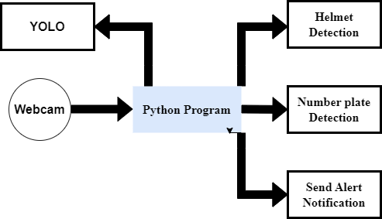

# IMPLEMENTATION

# Load the Haar cascade classifier for license plate detection

nPlateCascade = cv2.CascadeClassifier("haarcascades/haarcascade_russian_plate_number.xml")

# Parameters

frameWidth = 640

frameHeight = 480

minArea = 800 # Adjust the minimum area for more accurate detection

color = (255, 0, 255)

# Video capture setup

cap = cv2.VideoCapture(0)

cap.set(3, frameWidth)

cap.set(4, frameHeight)

cap.set(10, 150)

while True:

success, img = cap.read()

if not success:

break

# Convert frame to grayscale

imgGray = cv2.cvtColor(img, cv2.COLOR_BGR2GRAY)

# Detect license plates

numberPlates = nPlateCascade.detectMultiScale(imgGray, scaleFactor=1.1, minNeighbors=5)

# RESULTS

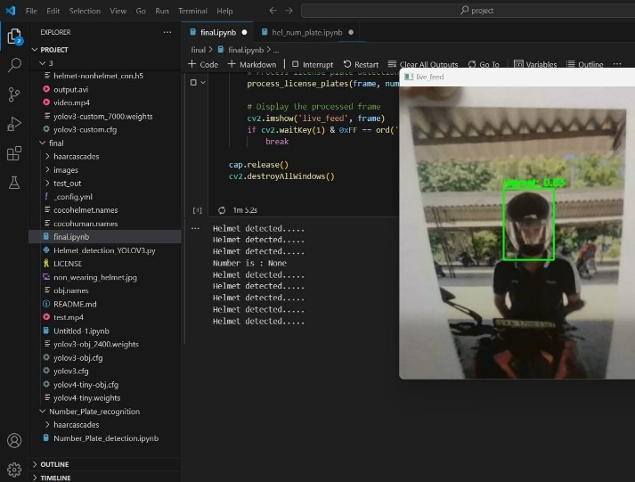 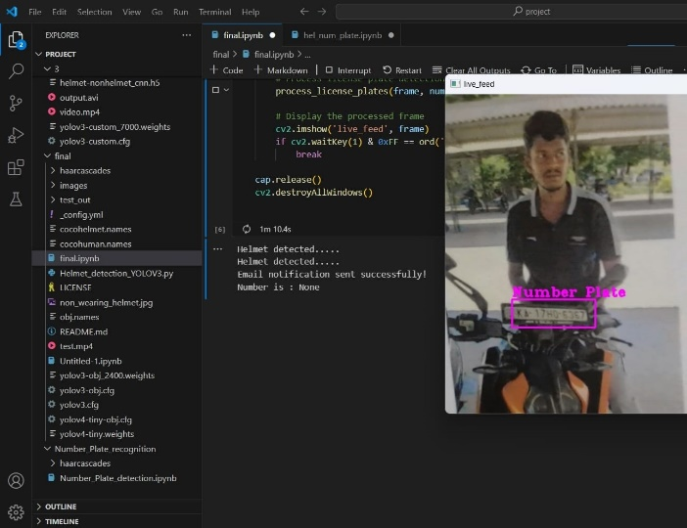

**Fig: Detection of Helmet Fig: Extracting the information from the number plate**

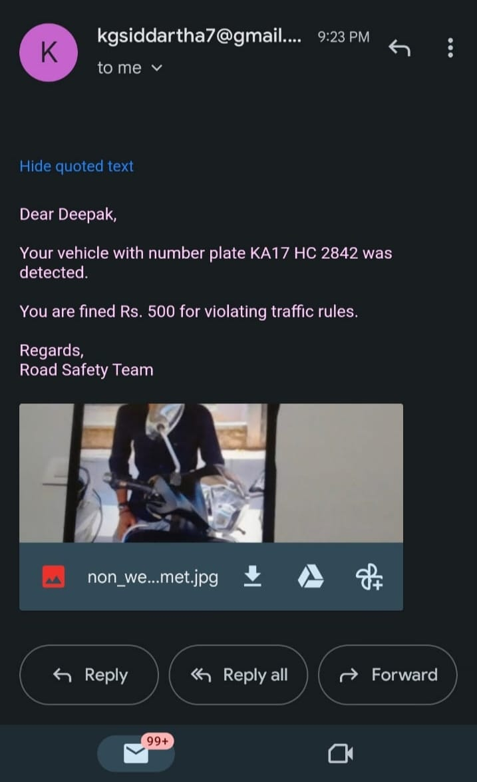 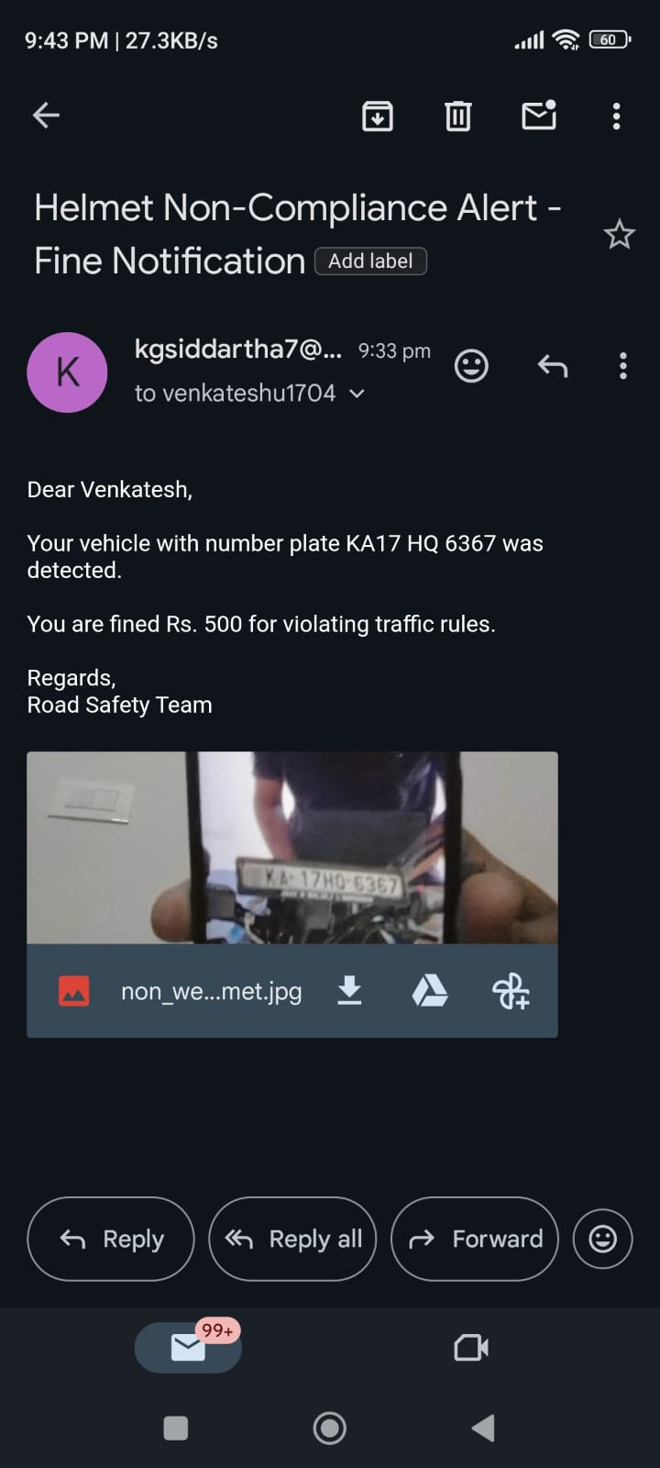

**Fig: Penalty to the Bike riders Who are not waiting the Helmet through E-mail**

# CONCLUSION

To improve roadway safety and assist in ensuring the implementation of helmet-wearing laws, the project set out to establish an extensive system for helmet recognition as well as number plate recognition that would also interface with a computerized email warning system. The goals were to identify and classify vehicles with related number plates, identify people riding without helmets, and send alerts via email to the proper authorities along with additional proof as soon as possible.

# REFERENCES

1. Detection of helmets on motorcyclists. By Remuera R.V.e Silva, Kelson R.T. Aires, Rodrigo de M. S. Veras,[2018].
2. Helmet Detection using Machine Learning and Automatic License Plate Recognition. By Lokesh Allamki, Manjunath Panchakshari, Ashish Sateesha, K S Pratheek(BNMIT, Bangalore).
3. Detecting motorcycle helmet use with deep learning. By Felix Wilhelm Sieberta, Hanhe Lin (Department of

Psychology and Ergonomics, Technische Universit¨at Berlin, Marchstraße 12, 10587 Berlin Germany),[2020].

1. A Hybrid Approach for Helmet Detection for Riders Safety using Image Processing, Machine Learning, Artificial Intelligence. By M.Swapna, Tahniyath Wajeeh, Shaziya Jabeen, Volume 182 – No. 37, January 2019.
2. C. Vishnu, Dinesh Singh, C. Krishna Mohan and Sobhan Babu Visual Intelligence and Learning Group (VIGIL), Department of Computer Science and Engineering Indian Institute of Technology Hyderabad, Kandi, Sangareddy-502285, India