**DAILY NEWS USING BLOCKCHAIN**

**Diwakar Talwar*1, Mr. Ajeet Singh*2**

*1UG Student of Department of Bachelor of Computer Applications, Shri Ramswaroop Memorial College of Engineering and Management Lucknow, Uttar Pradesh, India.

*2Assistant professor, Department of Bachelor of Computer Applications, Shri Ramswaroop Memorial College of Engineering and Management Lucknow, Uttar Pradesh, India.

**ABSTRACT**

The spread of misinformation and the erosion of trust in traditional media outlets have fuel the need of exploration of alternative models for news dissemination. Blockchain technology, with its emphasis on transparency and immutability, presents a potential solution. This paper examines the theoretical underpinnings of a blockchain-based news system, exploring its potential benefits (increased trust, combatting fake news) and drawbacks (scalability, censorship resistance). The paper concludes by analysing the current state of development and the challenges that need to be overcome before blockchain becomes a mainstream platform for daily news.

KEYWORDS**:** Blockchain, Daily News, Decentralization, Transparency, Trust

**Introduction: The Crisis of Trust in News**

The rise of social media and the decline of traditional gatekeepers have fundamentally altered the news landscape. Concerns about the proliferation of "fake news" and the erosion of trust in established media outlets have intensified the public's desire for reliable and verifiable information. Blockchain technology, with its core principles of decentralization, immutability, and transparency, offers a novel approach to news delivery.

A burgeoning body of research has investigated the disruptive potential of blockchain technology across various industries. Scholars like emphasize the transformative nature of blockchain for data security and privacy, while explore its potential to revolutionize governance models by fostering transparency and accountability. Within the media landscape, discuss the burgeoning role of blockchain in ensuring content provenance and combating misinformation. However, the specific application of blockchain for daily news dissemination necessitates further exploration. While some studies like [9] propose conceptual frameworks for blockchain-based news systems, a dearth of research exists on the practical implementation challenges and potential solutions.

**Blockchain: A Potential Game Changer**

Blockchain technology, underpinning cryptocurrencies like Bitcoin, offers a unique set of features that can be harnessed to enhance trust and transparency in daily news delivery. Here's how:

• **Enhanced Transparency:** Blockchain has the potential to provide a verifiable audit trail for news content, encompassing its origin, timestamps, and any modifications made. This transparency fosters trust between news providers and consumers. Users can effortlessly trace the origin of a news story and identify any edits or alterations made over time.

• **Improved Tamper-Proofing:** The cryptographic hashing function employed in blockchain inherently makes it challenging to alter or manipulate news content after publication. Any attempt to modify a block on the chain would necessitate altering all subsequent blocks, alerting network participants to the tampering attempt. This safeguards against the proliferation of misinformation and disinformation, as altering factual content would be readily detectable.

• **Decentralization:** Blockchain eliminates the requirement for a central authority, such as a government or media conglomerate, to control news dissemination. This empowers independent journalists and alternative news sources, fostering a more pluralistic media landscape. Decentralization also reduces the risk of censorship, as there is no single point of control over the network.

• **Content Provenance:** By meticulously tracking the origin of news content on the blockchain, users can effortlessly verify the credibility of sources. This empowers users to make informed decisions about the information they consume. Journalistic institutions and individual journalists can leverage blockchain to establish their reputation and build trust with audiences.

**Theoretical Framework**

A blockchain-based news system would leverage the distributed ledger technology inherent to blockchains. Every news article would be cryptographically hashed and stored on a tamper-proof public ledger. This would create an immutable record of the news item, making it virtually impossible to alter or delete content after publication. Additionally, timestamps on the blockchain would provide verifiable proof of authorship and publication time.

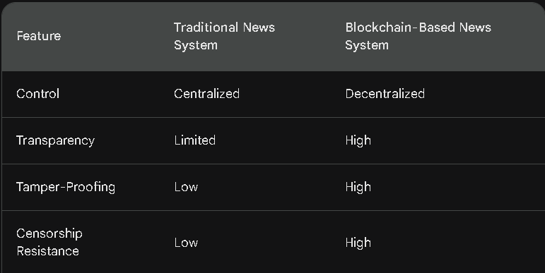

**Beyond Trust: Unveiling a Spectrum of Benefits**

* **Enhanced Trust:** By creating a verifiable record of news articles, blockchain can increase trust in news sources. Readers can be confident that they are consuming the original, unaltered content.
* **Combating Fake News:** The immutability of the blockchain makes it difficult to spread misinformation. Altered versions of news stories would be easily identifiable.
* **Transparency:** A blockchain-based system could provide greater transparency into the editorial process. Readers could potentially see the history of edits made to an article.
* **Empowering Journalists:** Blockchain could empower journalists by providing a platform that is resistant to censorship and manipulation.

**Challenges and Considerations: Navigating the Blockchain Maze**

• **Scalability Challenges:** Current blockchain platforms, particularly those employing Proof-of-Work consensus mechanisms, may not be equipped to handle the voluminous data associated with daily news operations. Processing and storing vast quantities of news articles, multimedia content, and user interactions can strain existing blockchain infrastructure.

• **Technical Complexity:** Integrating blockchain technology into existing news workflows necessitates technical expertise and significant infrastructure development. News organizations would need to invest in personnel with blockchain development skills and potentially revamp their content management systems to interact seamlessly with the blockchain.

• **Censorship Resistance Considerations:** While blockchain itself is resistant to censorship due to its decentralized nature, some posit that malicious actors could still manipulate content through economic incentives or misinformation campaigns. For instance, a group with a vested interest in suppressing a particular news story could attempt to spam the network with irrelevant transactions, hindering the processing of legitimate news content.

**Current State of Development**

Several startups and initiatives are exploring the use of blockchain in news. These projects are still in their early stages, focusing on areas like content provenance, micropayments for journalists, and decentralized news curation platforms.

**The Blockchain News Ecosystem: Taking Flight or Still in the Nest?**

* **Civil:** This platform empowers independent journalists through micropayments from readers, facilitated by the Civil token on the Ethereum blockchain.
* **Decentraland:** This virtual world allows users to create and curate decentralized news experiences, fostering a new model for news consumption.
* **Publica:** This platform focuses on fact-checking and verifying the provenance of news content using blockchain technology.

**Future Scope**

* WE can increase the number of nodes on the blockchain to make it more secure
* We can integrate AI for faster news report generation
* We can create a blockchain of our own to make the system fast
* We can introduce a e-voting and commenting that is anonymous and untraceable

While the potential of blockchain for daily news is promising, significant research efforts are needed to address technical limitations, economic models, and evolving legal landscapes.

**Future Research Directions**

Further research is needed to explore the following aspects of blockchain-based news systems:

* **Scalability solutions** to handle the high volume of news data.
* **Economic models** to incentivize journalists and validators within the decentralized network.
* **Development of dApps** that provide a user-friendly experience for accessing news content.

**Conclusion**

Blockchain technology holds promise for revolutionizing the way news is produced and consumed. However, significant technical and social challenges need to be addressed before blockchain becomes a mainstream platform for daily news. Further research and development are required to create a scalable, user-friendly, and censorship-resistant system that can earn the trust of both journalists and readers.

**Acknowledgement**

We are extremely thankful to Shri Ramswaroop Memorial College of Engineering and Management for giving us the resources and support that we need to finish this project.

In addition, we would like to sincerely thank our mentor, Mr. Ajeet Singh, for his constant encouragement, insightful counsel, and technical help. His expertise and encouragement have been crucial in overcoming obstacles and reaching goals.

We also want to convey our appreciation for every one of the college's workers and instructors who helped us grow as individuals.

I admire all of your assistance and motivation.

**References**

* **Scott Marks Blockchain for beginners**

ISBN- 9781386747499

* **ZARYAB AFSER (2020), “How I integrated Django with Blockchain and built a Decentralized Application (DAPP)”** AVAILABLE AT https://medium.com/coinmonks/how-i-integrated-django-with-blockchain-and-built-a-decentralized-application-dapp-f104ae551e12
* **"Machine learning, blockchain technology could help counter spread of fake news" (August 1, 2023):** Binghamton University: <https://www.sciencedaily.com/releases/2023/08/230801172011.htm>l This article explores how a combination of blockchain and machine learning could be used to combat the spread of misinformation in daily news
* **"Using Blockchain to Rein in the New Post-Truth World and Check the Spread of Fake News"** (ResearchGate)
* Binghamton University. (2023, August 1). Machine learning, blockchain technology could help counter spread of fake news. [ScienceDaily]. Retrieved from <https://www.sciencedaily.com/releases/2023/08/230801172011.htm>
* Pew Research Center: https://www.pewresearch.org/ (2023). State of the News Media. Retrieved from https://www.pewresearch.org/topic/news-habits-media/news-media-trends/state-of-the-news-media-project/
* Nakamoto, S. (2008). Bitcoin: A Peer-to-Peer Electronic Cash System