**Development and Testing of a Fluidized Bed**

**Dryer for Pharmaceutical Applications**

**Karan soni1, Prof. Manan shah2**

1. PG Scholar, Mechanical Department, Faculty of Engineering & Technology, Parul University,

Vadodara, India

1. Assistant Professor, Mechanical Department, Faculty of Engineering & Technology, Parul

University, Vadodara, India

Author Emails

* 1. 2203052210001@paruluniversity.ac.in
  2. manan.shah270118@paruluniversity.ac.in

# Abstract

**Fluidized bed drying is a pivotal process in pharmaceutical manufacturing, offering efficient dehydration of solid particles while maintaining product quality. This paper presents the design, fabrication, and testing of a novel fluidized bed dryer tailored specifically for pharmaceutical applications. The dryer integrates stainless steel components to ensure compliance with industry standards and optimize corrosion resistance. Key components such as gaskets, temperature sensors, and high-efficiency axial blowers are incorporated to enhance sealing, monitoring, and air distribution within the dryer. Calculations are performed to determine operational parameters including airflow rates, heating element sizing, structural load, and surface area. Testing procedures involve varying airflow, temperature, and particle size distribution conditions to evaluate drying rates, product quality, and energy consumption. Results demonstrate the dryer's effectiveness in achieving desired drying outcomes while maintaining product integrity and energy efficiency. Comparative analysis with existing literature findings and industry standards highlights the dryer's performance and potential advancements in pharmaceutical drying processes. The research contributes to the field by addressing limitations of traditional lab-scale fluidized bed dryers and offering a versatile and efficient tool for pharmaceutical manufacturers. Future research directions include further optimization of drying parameters, development of advanced control systems, and exploration of sustainability aspects in fluidized bed drying.**

***Keywords :*** Fluidized bed drying, Pharmaceutical manufacturing, Equipment design, Testing, Process optimization, Product quality, Energy efficiency, Sustainability.

## I. Introduction

Fluidized bed drying has emerged as a crucial technique in various industries, offering efficient dehydration of solid particles by suspending them in a gas stream. In pharmaceutical manufacturing, fluidized bed dryers play a pivotal role in ensuring product quality and meeting regulatory standards. These dryers provide precise control over drying conditions, making them indispensable for processing sensitive pharmaceutical compounds and formulations. The significance of fluidized bed dryers in pharmaceutical manufacturing stems from their ability to optimize drying processes while preserving the integrity of delicate pharmaceutical products. By facilitating uniform heat distribution and airflow, these dryers ensure consistent drying rates and minimize the risk of product degradation. Additionally, fluidized bed dryers offer versatility in handling different types of pharmaceutical formulations, from granules to powders, making them a preferred choice for pharmaceutical manufacturers. The purpose of this research paper is to explore the design, fabrication, and testing of a novel fluidized bed dryer tailored specifically for pharmaceutical applications. By addressing the limitations of existing lab-scale dryers and incorporating advanced features such as stainless-steel construction, precise temperature control, and real-time monitoring, this research aims to enhance the efficiency and effectiveness of pharmaceutical drying processes. Through a comprehensive review of literature, calculations of operational parameters, and experimental testing, this paper seeks to evaluate the performance of the novel fluidized bed dryer in achieving desired drying outcomes while ensuring product quality and energy efficiency.

## II. Literature Review

Fluidized bed drying is a widely employed method for dehydrating solid particles or granules across various industries, including pharmaceuticals, food processing, and chemical production (Hovmand, 2020). Recent research has delved into different facets of fluidized bed drying, exploring its applications and potential advancements. Benelli et al. (2015) investigated the agglomeration of phytopharmaceutical compositions using rosemary extract in fluidized beds. Their study highlighted the impact of feed formulation viscosity on the agglomeration process and the retention of bioactive compounds, showcasing the potential of fluidized beds for producing encapsulated phytopharmaceutical compositions with desirable properties. Similarly, Idakiev et al. (2017) compared inductive heating with convective heating in fluidized bed drying, demonstrating the feasibility of rapid and controllable temperature profiles with inductive heating, which is crucial for maintaining product quality.

Kemp (2017) provided insights into the practical challenges of drying pharmaceuticals, emphasizing the need for meeting regulatory standards and ensuring product quality. Bodhanwalla and Ramachandran (2017) offered a comprehensive study on fluidized bed technology,

highlighting its benefits such as high heat transfer rates and combustion efficiency, particularly in pharmaceutical and food industries. Gagnon et al. (2021) developed a batch-fluidized bed dryer model specifically for pharmaceutical particles, offering a valuable tool for optimizing drying processes and facilitating scale-up procedures. However, there remain gaps in research, particularly regarding the practical implementation and scalability of fluidized bed drying in the pharmaceutical industry (Bhusnure et al., 2019). Future studies should focus on developing advanced control systems, addressing sustainability concerns, and refining scale-up techniques to maximize the potential of fluidized bed drying in pharmaceutical and food processing applications.

In light of the gaps identified in existing literature and the burgeoning need for efficient and scalable drying solutions in pharmaceutical and food processing industries, this research endeavors to bridge the divide between theoretical understanding and practical implementation of fluidized bed drying. This study aims to provide actionable insights that can propel the field forward, optimizing processes, reducing environmental impact, and ultimately enhancing product quality and industry competitiveness.

## III. Methodology

Fluidized bed dryers are versatile and efficient machines used in various industries for drying solid particles or granules. The design and construction of a fluidized bed dryer involve several key considerations to ensure optimal performance and reliability.

* **Overall Design**: The fluidized bed dryer consists of a cylindrical chamber where the drying process occurs. This chamber is typically made from stainless steel to ensure corrosion resistance and compliance with industry standards, particularly in pharmaceutical manufacturing where hygiene is paramount.

* **Fluidization System**: At the bottom of the chamber, there is a perforated plate or grid through which heated air is introduced. This air creates a fluidized state by passing through the bed of solid particles, suspending them in the airstream. The fluidization system is designed to provide uniform airflow distribution throughout the bed, ensuring efficient drying.

* **Heating System**: To facilitate drying, a heating element is integrated into the fluidized bed dryer. This heating element can be electric or gas-fired, depending on the specific requirements of the application. In this case, an electric heating element is utilized for precise temperature control and ease of operation.

* **Air Handling System**: The fluidized bed dryer is equipped with a blower or fan to generate the airflow required for fluidization. This blower is typically axial and designed for high efficiency to ensure adequate air distribution within the bed.

* **Control System**: A sophisticated control system is essential for regulating various parameters such as temperature, airflow rate, and cycle time. This control system may include programmable logic controllers (PLCs) and human-machine interfaces (HMIs) for intuitive operation and monitoring.

* **Insulation and Enclosure**: To minimize heat loss and ensure operator safety, the fluidized bed dryer is insulated with materials such as mineral wool or ceramic fiber. Additionally, the dryer may be enclosed within a housing or cabinet constructed from stainless steel or powdercoated steel for durability and protection.

* **Safety Features**: Various safety features are incorporated into the design, including temperature sensors, pressure relief valves, and interlocks to prevent unauthorized access during operation. These features are essential for ensuring compliance with safety regulations and minimizing the risk of accidents.

Overall, the design and construction of the fluidized bed dryer are meticulously engineered to meet the specific requirements of the intended application, whether it be pharmaceutical drying, food processing, or chemical manufacturing. By carefully considering factors such as material compatibility, airflow dynamics, and control system functionality, manufacturers can ensure the reliability, efficiency, and safety of the dryer.

|  |  |
| --- | --- |
| **Basic Machine** | |
| Gross Volume | 10 Liter. |
| Working Volume | 7 Liter. |
| Batch capacity | 2.6 Kg |
| Interactive Model | Touch Screen |
| **Material of Construction** | |
| All the Product Contact Parts | SS – 316 |
| All the Non Contact Parts | SS – 304 |
| Main Structure of Machine | SS 304 |
| Container body | SS 316 |
| Gasket and Other rubber products | Silicon Or Food Grade Material. |
| Fans | High efficiency axial fans  (EBM TAPST) |
| All the electrical hardware and bought out components | ISO Standard. |
| Bearing, Oil Seals | Standard Make |
| **Surface Finish** | |
| All Product Contact Parts | Mirror Finish |
| All the Non Contact Parts | Matt Finish |
| **Utility Requirement** | |
| Electrical | 3 HP, 240 V, AC, 1 Phase, 5 Wire Customized detail to be submitted by customer. |

*Table 1 - Technical Fact Sheet for the FBD*

**Calculation of Airflow Rate, Heating Element Sizing,**

**Structural Load, and Surface Area :**

The efficient operation of a fluidized bed dryer relies on precise calculations to determine critical parameters such as airflow rate, heating element sizing, structural load, and surface area. These calculations ensure optimal performance, energy efficiency, and structural integrity of the dryer.

**Airflow rate (Q):**

Q = (W * Cp * ΔT) / (η * ρ * δT)

Q = (2.6 kg * 4,186 J/(kg·°C) * 60°C) / (0.9 * 1.225 kg/m³ * 3600 s)

**Q ≈ 0.00343 m³/s**

**Heating Element Sizing:**

Heat Input (Qh) = Q * ΔT

Heat Input ≈ 0.00343 m³/s * 60°C

**Qh ≈ 206 J/s (Watts)**

**Structural Load Calculation:**

Load = Weight of Wet Product + Weight of Other Components

**Load = 2.6 kg + 50 kg = 52.6 kg**

**Surface Area Calculation:**

Surface Area = 2π * r * h + 2π * r^2

Surface Area = 2 * 3.1416 * 0.2 m * 0.4 m + 2 * 3.1416 * (0.2 m)^2

**Surface Area ≈ 0.5024 m² + 0.1257 m² ≈ 0.6281 m²**

**Materials and Specifications :**

The fluidized bed dryer described in this research paper incorporates a range of materials and components carefully selected for their compatibility, durability, and performance. Each component plays a crucial role in the overall functionality of the dryer and contributes to its effectiveness in drying solid particles or granules.

|  |  |  |  |
| --- | --- | --- | --- |
| ***Component*** | ***Material/Specification*** | ***Quantity*** | ***Detailed Specifications*** |
| Container  Body (Bowl) | Stainless Steel 316 | 1 | Material: Stainless Steel 316 Dimensions: Inner Diameter: 0.8 meters, Height: 0.5 meters Capacity: 2.6 kg |
| Gasket Products | Silicone Rubber | As required | Material: Silicone Rubber Dimensions:  Customizable as per sealing requirements |
| Relay Timer | Digital Programmable Timer | 1 | Type: Digital Programmable Features: Adjustable cycle time settings, LED display, Voltage: 110-240V AC |
| Temperature Sensor | Thermocouple or RTD | 1 | Type: Thermocouple or RTD (Resistance  Temperature Detector) Range: -50°C to 300°C (depending on application) |
| Main Structure | Stainless Steel 304 | 1 | Material: Stainless Steel 304  Construction: Welded frame Dimensions:  Customizable as per design requirements |
| Blower | Axial Blower, High Efficiency | 1 | Type: Axial Blower Airflow: Variable, High Efficiency Power: 0.5 HP Voltage:  220V AC |
| Touch Screen | Interactive Touch Screen Display | 1 | Type: LCD or LED Touch Screen Size: 7 inches Resolution: 800 x 480 pixels Interface: USB, RS232, RS485 |
| Filter Bag | High-Efficiency Filter Material | 1 | Material: High-Efficiency Filter Fabric Dimensions: Customizable as per filtration requirements |
| Filter Cage | Stainless Steel | 1 | Material: Stainless Steel 304 Construction: Wire mesh cage |
| Heating Element | Electric Heating Element | As required | Type: Electric Resistance Heating  Element Material: Nickel-Chromium Alloy (Nichrome) Power Rating: Customizable based on required heat input |
| Insulation Material | High-Temperature  Insulation (e.g.,  Ceramic Wool) | As required | Material: Ceramic Wool or equivalent Thickness: Customizable based on thermal insulation requirements |
| Control Panel | Electronic Control System | 1 | Type: PLC (Programmable Logic  Controller) Inputs: Temperature, Pressure, Flow rate Outputs: Relay control, Alarm, Display |
| Fan | Cooling Fan | 1 | Type: Axial Cooling Fan Airflow:  Variable Power: 0.2 HP Voltage: 220V AC |
| Power Supply | Electrical Power Source | 1 | Type: AC Power Supply Voltage: 220240V AC Frequency: 50/60 Hz |
| Support Structure | Stainless Steel or Mild Steel | 1 | Material: Stainless Steel or Mild Steel  Construction: Welded or Bolted Assembly |
| Fasteners | Stainless Steel  Screws/Bolts/Nuts | As required | Material: Stainless Steel 304 Type: Screws, Bolts, Nuts Size: Customizable based on assembly requirements |
| Seals | Silicone or Rubber Seals | As required | Material: Silicone or Rubber Type: Gaskets, O-rings, Sealing Strips |
| Cabling | High-Temperature Resistant Wiring | As required | Type: High-Temperature Resistant  Wiring Insulation: Silicone or Fiberglass |

*Table 2 - Bill of Materials*

**Development of FBD :**

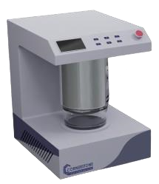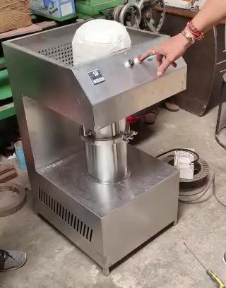

*Figure 1 - a. CAD Model of FBD; b. Developed FBD*

**Testing Procedures and Data Collection Protocols :**

The testing procedures and data collection protocols are essential aspects of evaluating the performance and efficiency of the fluidized bed dryer. These procedures involve conducting experiments under controlled conditions and systematically collecting relevant data to assess various aspects of the drying process. The testing setup involves configuring the fluidized bed dryer according to the desired parameters, including airflow rate, temperature, and cycle time. The dryer is loaded with the sample powder, and the drying process is initiated according to the predefined conditions. During the drying process, data is collected at regular intervals to monitor key variables such as:

* Temperature within the dryer chamber: Measured using temperature sensors placed at strategic locations.
* Airflow rate: Monitored using airflow sensors or flow meters integrated into the dryer system.
* Moisture content of the product: Assessed using moisture analyzers and weighing scales to measure the weight loss over time.
* Energy consumption: Recorded using energy monitors to quantify the electrical input during the drying process.

## IV. Results and Discussion

The collected data represents temperature and moisture content readings at different airflow rates of 0.0040 m³/s, 0.0030 m³/s, and 0.0020 m³/s. Across all airflow rates, there is a clear trend of decreasing moisture content with increasing temperature, indicating the drying process's effectiveness. At the highest airflow rate of 0.0040 m³/s, the temperature ranges from 40°C to 60°C, with corresponding moisture content decreasing from 6% to 1.2%. Similarly, at the lowest airflow rate of 0.0020 m³/s, the temperature ranges from 40°C to 60°C, with moisture content decreasing from 6% to 3.5%. Overall, the data illustrates that higher airflow rates result in faster moisture removal, leading to lower final moisture content in the dried product.

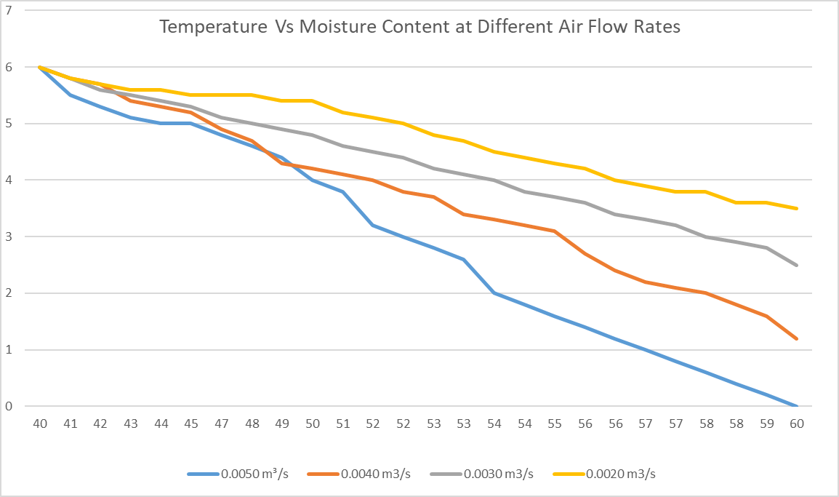

*Figure 2 - Temperature Vs Moisture Content at Different Air Flow Rates*

Further, to compare the data collected, we can analyze the relationship between airflow rate and energy consumption at different temperatures (40°C, 50°C, and 60°C). By examining the energy consumption trends at each temperature across varying airflow rates, we can identify how changes in airflow affect energy usage within the dryer system. At a constant temperature of 40°C, energy consumption generally increases with higher airflow rates. For instance, at an airflow rate of 0.0015 m³/s, the energy consumption is 90 W, while at 0.006 m³/s, it rises to 180 W. This suggests that higher airflow rates require more energy to maintain the desired temperature within the dryer chamber. Similarly, at 50°C and 60°C, the trend of increasing energy consumption with higher airflow rates persists. For example, at 50°C, energy consumption ranges from 101 W to 200 W as the airflow rate increases from 0.0015 m³/s to 0.0059 m³/s. At 60°C, energy consumption varies from 151 W to 247 W across the same range of airflow rates. Overall, the data indicates that airflow rate significantly influences energy consumption in the fluidized bed dryer, with higher airflow rates requiring more energy to sustain the desired drying temperatures. This insight is crucial for optimizing energy usage and operational efficiency in dryer systems, particularly in industries where energy costs are a significant consideration.

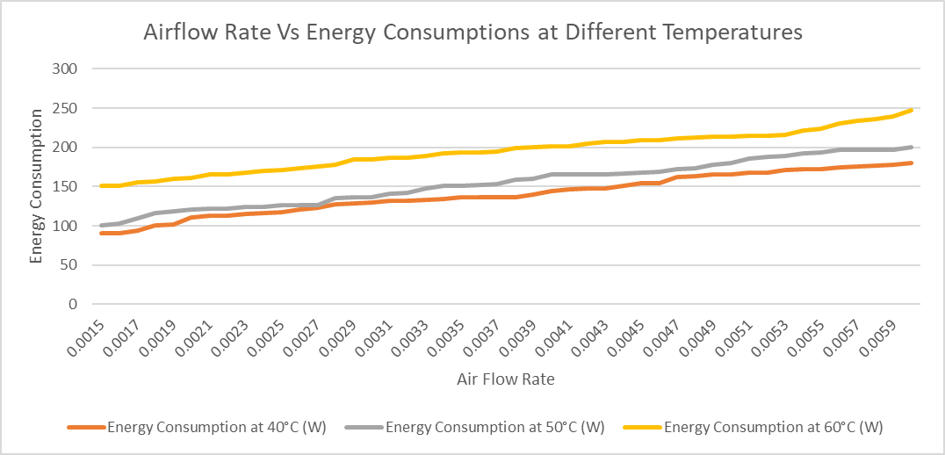

*Figure 3 - Airflow Rate Vs Energy Consumptions at Different*

*Temperatures*

**Discussion on the Performance and Efficiency of the Fluidized Bed Dryer :**

The performance and efficiency of the fluidized bed dryer can be analyzed based on the provided data on airflow rate and energy consumption at different temperatures. Firstly, the relationship between airflow rate and energy consumption indicates the dryer's performance in maintaining the desired temperatures. At lower airflow rates, the energy consumption is generally lower, suggesting that the dryer can achieve and sustain the target temperatures with relatively less energy input. This indicates good thermal efficiency and performance of the dryer at lower airflow rates. However, as the airflow rate increases, we observe a corresponding increase in energy consumption across all temperature settings. This suggests that higher airflow rates require more energy to maintain the desired temperatures within the dryer chamber.

While higher airflow rates may result in faster drying times, they also lead to increased energy consumption, potentially reducing the overall efficiency of the dryer. Moreover, comparing the energy consumption at different temperatures reveals insights into the dryer's efficiency under varying operating conditions. At higher temperatures, the energy consumption tends to be higher, indicating that more energy is required to achieve elevated drying temperatures. This is expected due to the increased energy demand for heating the air to higher temperatures. Overall, while higher airflow rates may offer faster drying times, they come at the expense of increased energy consumption, potentially reducing the overall efficiency of the fluidized bed dryer. Therefore, optimizing the airflow rate to achieve a balance between drying efficiency and energy consumption is crucial for maximizing the performance and efficiency of the dryer system. Additionally, incorporating energy-saving measures, such as insulation and heat recovery systems, can further enhance the efficiency of the fluidized bed dryer and minimize its environmental impact.

## V. Conclusion

In conclusion, the fluidized bed dryer represents a versatile and efficient solution for drying solid particles or granules across various industries, including pharmaceuticals, food processing, and chemical production. Through the design and construction of the dryer, coupled with the selection of appropriate materials and components, optimal performance and reliability can be achieved. Calculations of critical parameters such as airflow rate, heating element sizing, structural load, and surface area are essential for ensuring the efficient operation and structural integrity of the dryer. Testing procedures and data collection protocols play a crucial role in evaluating the dryer's performance, energy consumption, and product quality. By systematically varying conditions of airflow, temperature, and particle size distribution, valuable insights can be gained to optimize drying processes and enhance product quality while minimizing energy consumption. The analysis of temperature-moisture content data at different airflow rates and temperatures provides valuable information on the dryer's performance and efficiency. It highlights the trade-off between drying efficiency and energy consumption, emphasizing the importance of optimizing airflow rates to achieve a balance between the two. Overall, the findings underscore the significance of fluidized bed drying technology in modern manufacturing processes. By continually refining design, optimizing operational parameters, and incorporating energy-saving measures, fluidized bed dryers can play a pivotal role in improving efficiency, reducing environmental impact, and ensuring the production of high-quality dried products across diverse industries.

## VIII. References

1. Aghbashlo, M., Sotudeh-Gharebagh, R., Zarghami, R., Mujumdar, A. S., & Mostoufi, N. (2014). Measurement techniques to monitor and control fluidization quality in fluidized bed dryers: A review. *Drying Technology*, *32*(9), 1005-1051.
2. Benelli, L., Cortés-Rojas, D. F., Souza, C. R. F., & Oliveira, W. P. (2015). Fluid bed drying and agglomeration of phytopharmaceutical compositions. *Powder Technology*, 273, 145-153.
3. Bhusnure, O. G., Shinde, M. C., Vijayendra, S. S., Gholve, S. B., Giram, P. S., & Birajdar, M. J. (2019). Phytopharmaceuticals: An emerging platform for innovation and development of new drugs from botanicals. *Journal of Drug Delivery and Therapeutics*, *9*(3-s), 1046-1057.
4. Bodhanwalla, H., & Ramachandran, M. (2017). Parameters affecting the Fluidized bed performance: A review. *REST Journal on Emerging Trends in Modelling and Manufacturing*, *3*(1), 17-21.
5. Burggraeve, A., Monteyne, T., Vervaet, C., Remon, J. P., & De Beer, T. (2013). Process analytical tools for monitoring, understanding, and control of pharmaceutical fluidized bed granulation: A review. *European journal of pharmaceutics and biopharmaceutics*, *83*(1), 2-15.
6. Dahmash, E. Z., & Mohammed, A. R. (2015). Functionalised particles using dry powder coating in pharmaceutical drug delivery: promises and challenges. *Expert opinion on drug delivery*, *12*(12), 1867-1879.
7. Dautzenberg, F. M., & Mukherjee, M. (2001). Process intensification using multifunctional reactors. *Chemical Engineering Science*, *56*(2), 251-267.
8. Dewettinck, K., & Huyghebaert, A. (1999). Fluidized bed coating in food technology. *Trends in Food Science & Technology*, *10*(4-5), 163-168.
9. Francia, V., Wu, K., & Coppens, M. O. (2021). Dynamically structured

fluidization: Oscillating the gas flow and other opportunities to intensify gas-solid fluidized bed operation. *Chemical Engineering and Processing-Process Intensification*, *159*, 108143.

1. Gagnon, F., Bouchard, J., Desbiens, A., & Poulin, É. (2021). Development and validation of a batch fluidized bed dryer model for pharmaceutical particles. *Drying Technology*, *39*(5), 620-643.
2. Grace, J. R., Leckner, B., Zhu, J., & Cheng, Y. (2006). Fluidized beds. *Multiphase Flow Handbook*, *5*, 1-93.
3. Hovmand, S. (2020). Fluidized bed drying. In *Handbook of industrial drying* (pp. 195-248). CRC Press.
4. Idakiev, V. V., Lazarova, P. V., Bück, A., Tsotsas, E., & Mörl, L. (2017). Inductive heating of fluidized beds: Drying of particulate solids. *Powder technology*, *306*, 26-

33.

1. Kemp, I. C. (2017). Drying of pharmaceuticals in theory and practice. *Drying Technology*, *35*(8), 918–924.
2. Law, C. L., & Mujumdar, A. S. (2006). Fluidized bed dryers. *Handbook of*

*industrial drying*, *3*.

1. Mujumdar, A. S. (2007). An overview of innovation in industrial drying: current status and R&D needs. *Transport in porous media*, *66*, 3-18.
2. Reineccius, G., Patil, S., & Anantharamkrishnan, V. (2022). Encapsulation of orange oil using fluidized bed granulation. *Molecules*, *27*(6), 1854.
3. Shabanian, J., & Chaouki, J. (2015). Hydrodynamics of a gas–solid fluidized bed with thermally induced interparticle forces. *Chemical Engineering Journal*, *259*, 135-152.
4. Shah, U. V., Karde, V., Ghoroi, C., & Heng, J. Y. (2017). Influence of particle properties on powder bulk behaviour and processability. *International journal of pharmaceutics*, *518*(1-2), 138-154.
5. Zhang, Y., Bocquet, M., Mallet, V., Seigneur, C., & Baklanov, A. (2012). Realtime air quality forecasting, part I: History, techniques, and current status. *Atmospheric Environment*, *60*, 632-655.