**Surveillance Robot using IoT**

**Rachita Chaudhari1, Thete Pooja2, Vidhate Sanjana3,Mrs.T.S.Deshmukh4**

Department of Electronics & Telecommunication Engineering, MVP’s Karmaveer Baburao Ganpatrao Thakare College of Engineering, Nashik, India

**ABSTRACT**

The project involves the creation of a surveillance robot leveraging a Raspberry Pi Zero W as its core component and programmed using Python. Equipped with ultrasonic and sound sensors, the robot autonomously detects potential threats. Upon detection of an object by the ultrasonic sensor or sound by the audio sensor, the robot activates its camera to record video footage. This footage is then transmitted to a website portal for remote viewing and analysis. The portal integrates an AI module trained to identify violence and weapons within the video content. Leveraging machine learning techniques, the AI module enhances the robot's surveillance capabilities by providing real-time detection and alerting functionality. Through this integrated system, the surveillance robot offers a comprehensive solution for monitoring and responding to security threats in various environments.

**Keywords:** Surveillance robot, Raspberry Pi Zero W, Python programming, ultrasonic sensor, sound sensor, camera, video capture, website portal, AI module, violence detection, weapon detection, machine learning, security threats.

1. **INTRODUCTION**

In an era marked by technological advancement and evolving security concerns, the development of innovative surveillance solutions has become increasingly imperative. Our project endeavors to address this need through the creation of a sophisticated surveillance robot, empowered by cutting-edge technology and artificial intelligence (AI). This surveillance system aims to enhance security measures by leveraging the capabilities of the Raspberry Pi Zero W, a versatile single-board computer, in conjunction with sensors and AI algorithms. By integrating hardware and software components seamlessly, our project seeks to provide a comprehensive solution for real-time monitoring, threat detection, and response in diverse environments.

The primary aim of our project is to design and implement a surveillance robot equipped with advanced sensing capabilities and AI-driven analysis for detecting potential security threats. This includes the development of a hardware platform capable of capturing and processing sensor data, as well as a software framework for analyzing video footage and identifying suspicious activities. By harnessing the power of AI technology, our project aims to enhance the surveillance robot's ability to recognize and respond to security incidents proactively. Additionally, we aim to provide a user-friendly interface for remote monitoring and management, enabling stakeholders to access real-time information and take appropriate action as needed.

The surveillance robot will be built around the Raspberry Pi Zero W, a compact yet powerful computing platform known for its versatility and affordability. Key components of the robot include ultrasonic and sound sensors for detecting objects and audio cues, respectively, as well as a camera for capturing video footage. These sensors will work in tandem to monitor the robot's surroundings continuously, triggering the camera to record video when potential threats are detected.

The recorded video footage will be processed using AI algorithms specifically trained for violence and weapon detection. By analyzing the video content in real-time, the AI module will be able to identify suspicious behaviors and objects, alerting users to potential security risks. The surveillance robot will transmit the processed data to a website portal accessible to authorized users, providing a centralized platform for monitoring and analysis.

Overall, our project aims to develop a state-of-the-art surveillance system that combines hardware innovation, software expertise, and AI-driven intelligence to enhance security measures and promote safety in various environments. Through the integration of cutting-edge technology and thoughtful design, we aspire to contribute to the advancement of surveillance technology and its applications in safeguarding communities and assets.

1. **LITERATURE SURVEY**

1. IOT Based Surveillance Robot : The main objective behind this paper is to develop a robot to perform the act of surveillance in domestic areas. Nowadays robot plays a vital role in our day to day life activities thus reducing human labor and human error.[1] Robots can be manually controlled or can be automatic based on the requirement. The purpose of this robot is to roam around and provide audio and video information from the given environment and to send that obtained information to the user.

2. Intelligent surveillance robot : Security robot has become one of the most important research topics over the past decades. A number of robots have been designed to safeguard human life and wealth. This paper focuses on design and implementation of mobile robot with three subsystems: The obstacle avoidance, face recognition and detection leakage of combustible gases. [2] In the first subsystem, an implementation of artificial neural network on field programmable analog array has been used to control the motion of the robot.

3. Surveillance Robot controlled using an Android app: The robotics and automation industry which is ruled the sectors from manufacturing to household entertainments. It is widely used because of its simplicity and ability to modify to meet changes of needs. The project is designed to develop a robotic vehicle using android application for remote operation attached with wireless camera for monitoring purpose. [3] The robot along with camera can wirelessly transmit real time video with night vision capabilities. This is kind of robot can be helpful for spying purpose in war fields.

4. Surveillance Robot in Hazardous Place Using IoT Technology: This paper deals with human surveillance through the technology based on IoT featuring robotics using an Arduino UNO microcontroller that is controlled by a smartphone and a PC. The objective is to develop a spy robotic car which is suited to provide an act of continuous surveillance in hazardous environment. [4] The robot is capable to record the real-time streaming in day time and night time as well through wireless camera. Those movements of the robot are controlled manually at the user end. This robot reduces human intervention directly in a hazardous place where continuous supervision and security is necessary.

1. **METHODOLOGY AND DISCUSSION**

The methodology for developing the surveillance robot and its integrated AI module involves a systematic approach encompassing several key phases. Initially, the project requires comprehensive research to understand the requirements, existing technologies, and potential challenges associated with surveillance systems. This includes reviewing relevant literature, studying available hardware and software platforms, and identifying suitable methodologies for sensor integration, data processing, and AI-driven analysis.

Following the initial research phase, the project proceeds to the design and planning stage, where the architecture and specifications of the surveillance robot are defined in detail. This involves selecting the appropriate hardware components, such as the Raspberry Pi Zero W, ultrasonic sensor, sound sensor, and camera, based on factors like performance, cost, and compatibility. Additionally, the design phase includes outlining the software architecture, defining the communication protocols, and establishing the overall system requirements.

With the design in place, the project moves on to the implementation phase, where the surveillance robot and its AI module are developed according to the established specifications. This involves writing code in Python to interface with the hardware components, capture sensor data, and control the robot's behavior based on predefined rules and algorithms. The implementation also includes integrating existing AI models or developing custom machine learning algorithms for violence and weapon detection, using frameworks like TensorFlow or PyTorch.

Once the implementation is complete, the project enters the testing and evaluation phase, where the surveillance robot undergoes rigorous testing to assess its performance, reliability, and accuracy. This includes testing individual components, such as the sensors and camera, as well as testing the integrated system in simulated and real-world environments. The AI module is evaluated based on its ability to accurately detect violence and weapons in the surveillance footage, considering factors like detection rate, false alarm rate, and computational efficiency.

Throughout the testing phase, feedback is collected from users and stakeholders to identify any issues or areas for improvement. This feedback is used to refine the system and make necessary adjustments to enhance its functionality and usability. Additionally, the testing phase involves optimizing the performance of the surveillance robot and AI module, fine-tuning parameters, and addressing any identified bottlenecks or limitations.

Finally, once the surveillance robot and AI module have been thoroughly tested and validated, the project concludes with the deployment and dissemination phase. The surveillance robot is deployed in the target environment, whether it be a public space, commercial facility, or residential property, where it begins actively monitoring for security threats. Additionally, the findings, methodologies, and insights gained from the project are documented and disseminated through reports, presentations, and open-access repositories, contributing to the wider body of knowledge in the field of surveillance technology and AI-driven security systems.

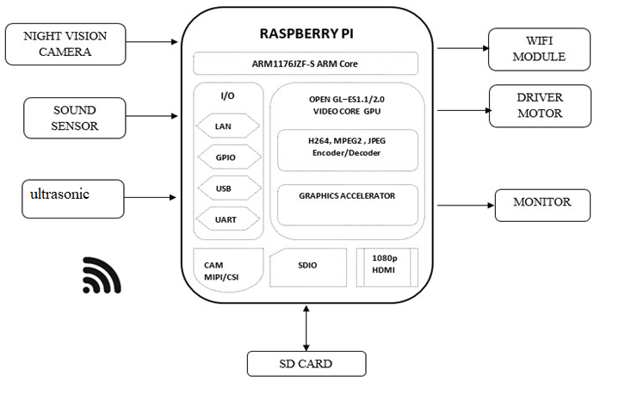

**Figure 1.** Architecture diagram

1. **Data Flow of the System**

The data flow within the surveillance system involves a series of interconnected processes that facilitate the capture, processing, analysis, and dissemination of information. Initially, data originates from the sensors integrated into the surveillance robot, namely the ultrasonic sensor and sound sensor, which continuously monitor the robot's surroundings for potential threats or anomalies. When an object is detected within the ultrasonic sensor's range or when the sound sensor picks up significant audio activity, a signal is triggered, prompting the camera to start recording video footage.

The recorded video data, along with sensor readings, is then transmitted to the Raspberry Pi Zero W, the central processing unit of the surveillance robot. Here, the data undergoes preprocessing, including formatting, compression, and noise reduction, to ensure its suitability for further analysis. The preprocessed data is then passed through the software pipeline, where it is analyzed by the AI module for violence and weapon detection.

The AI module employs pre-trained machine learning models or custom algorithms to analyze the video footage and identify potential instances of violence or the presence of weapons. This analysis involves object detection to identify relevant objects, such as firearms or aggressive gestures, as well as action recognition to identify violent behaviors or activities. The results of the analysis, including detected objects, actions, and associated confidence scores, are then passed back to the Raspberry Pi Zero W for further processing.

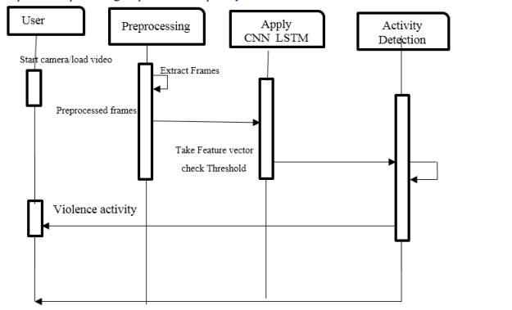

Upon receiving the results from the AI module, the Raspberry Pi Zero W performs post-processing tasks, such as filtering redundant detections, consolidating overlapping detections, and calculating overall threat levels based on the aggregated data. The processed information, along with any alerts or notifications generated based on predefined criteria, is then transmitted to the website portal for remote monitoring and analysis.

The website portal serves as a centralized interface for authorized users to access live video feeds, review recorded footage, and receive real-time alerts regarding security threats detected by the surveillance robot. Users can interact with the portal to view detailed reports, adjust system settings, and initiate response actions as necessary. Additionally, the portal may incorporate features for data visualization, trend analysis, and historical tracking to provide insights into security trends and patterns over time.

Overall, the data flow within the surveillance system enables seamless integration of sensor data, video footage, and AI-driven analysis to enhance situational awareness and facilitate proactive security management in various environments. By leveraging the capabilities of the Raspberry Pi Zero W, Python programming, and advanced machine learning techniques, the system provides a scalable and adaptable solution for addressing evolving security challenges.

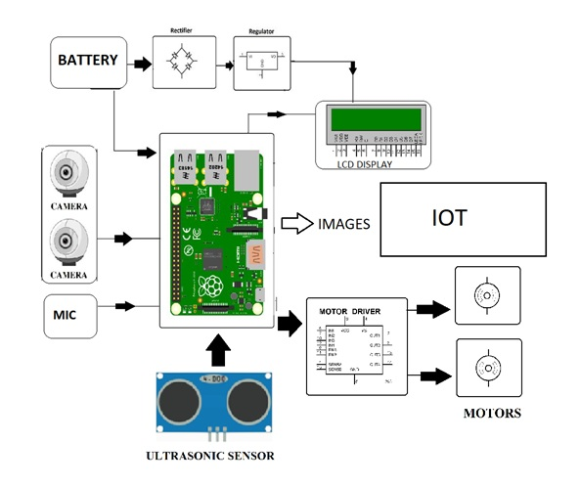

**Figure 2.** Data Flow diagram

1. **Algorithm**

Step 1: Preprocessing

Receive the video footage as input.

Preprocess the video frames to enhance clarity and remove noise.

Split the video into individual frames for analysis.

Step 2: Object Detection

Use a pre-trained object detection model (e.g., YOLO, SSD) to detect objects within each frame.

Filter the detected objects to focus on potential weapons or violent actions.

Classify detected objects based on predefined categories (e.g., firearm, knife, fist).

Step 3: Action Recognition

Apply action recognition techniques (e.g., optical flow, temporal convolutional networks) to identify violent actions within the video sequence.

Analyze the temporal evolution of object interactions and motion patterns to distinguish between benign and violent activities.

Step 4: Contextual Analysis

Incorporate contextual information to refine the detection results.

Consider factors such as scene context, object interactions, and spatial-temporal relationships.

Use domain-specific knowledge to assess the likelihood of violence or weapon presence based on situational cues.

Step 5: Decision Making

Aggregate the detection results from object detection and action recognition.

Calculate confidence scores for each detected instance of violence or weapon presence.

Apply decision thresholds to determine the significance of detected events.

Generate alerts or notifications for identified security threats based on predefined criteria.

Step 6: Post-processing

Post-process the detection results to remove redundant or spurious detections.

Perform spatial and temporal analysis to validate and consolidate the detected events.

Generate a summary report detailing the detected instances of violence and weapon presence.

Step 7: Output

Provide the processed video footage with annotated detections highlighting violent actions and weapons.

Output the summary report containing details of detected security threats.

Transmit alerts or notifications to designated recipients for immediate action.

Step 8: Update and Iteration

Continuously update and refine the AI module based on feedback and evaluation results.

Incorporate additional training data to improve detection accuracy and robustness.

Iterate on the algorithmic design to address emerging challenges and enhance performance over time.

1. **Advantages**

The surveillance robot project offers several distinct advantages that contribute to its effectiveness and utility in enhancing security and situational awareness. Firstly, the use of the Raspberry Pi Zero W as the core component of the surveillance system provides a compact, cost-effective, and versatile platform for deployment in diverse environments. Its small form factor allows for easy integration into robotic systems while offering sufficient computational power to support sensor data processing, video capture, and communication tasks.

Moreover, the utilization of Python programming language for software development enables rapid prototyping, iteration, and customization of the surveillance robot's functionality. Python's simplicity and readability make it accessible to a wide range of developers, facilitating the implementation of complex algorithms and logic for sensor data processing, event detection, and autonomous decision-making.

The inclusion of ultrasonic and sound sensors enhances the surveillance robot's ability to detect potential threats and anomalies in its environment. The ultrasonic sensor enables precise distance measurement, allowing the robot to identify nearby objects and obstacles, while the sound sensor detects auditory cues such as voices or unusual noises, providing additional context for threat assessment.

The integration of a camera module enables the surveillance robot to capture high-quality video footage of security incidents in real-time. This visual data serves as valuable evidence for post-incident analysis, forensic investigation, and decision-making, enabling authorities to identify perpetrators, assess damages, and take appropriate actions.

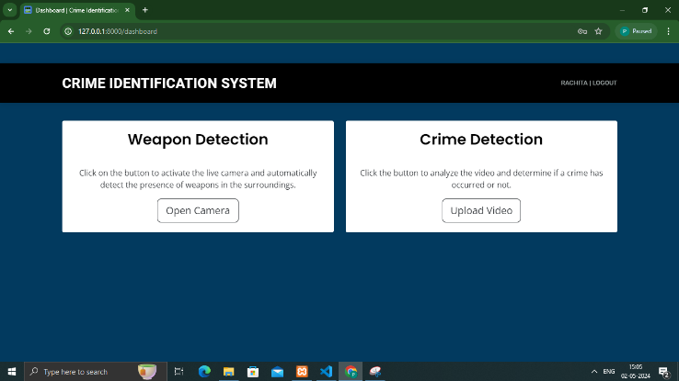

1. **Result**
   1. 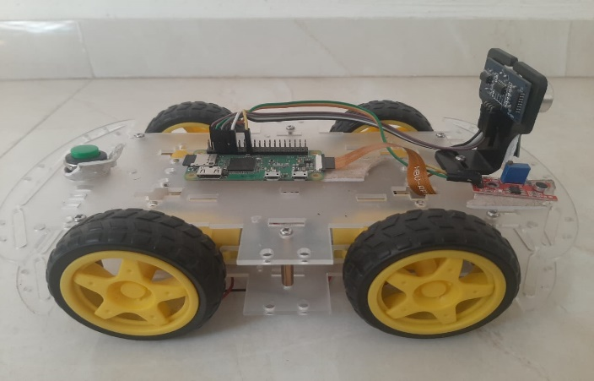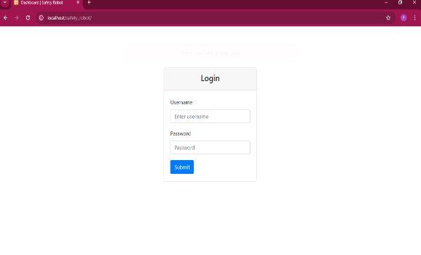**Screenshots**

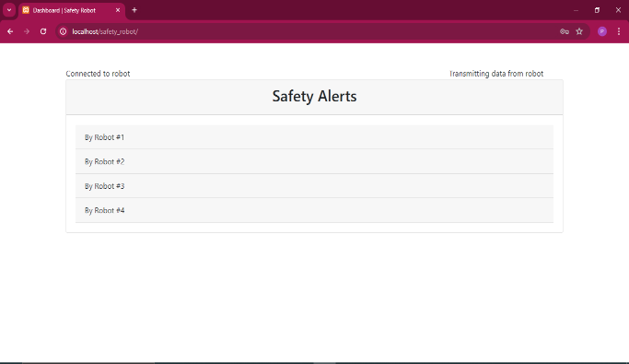

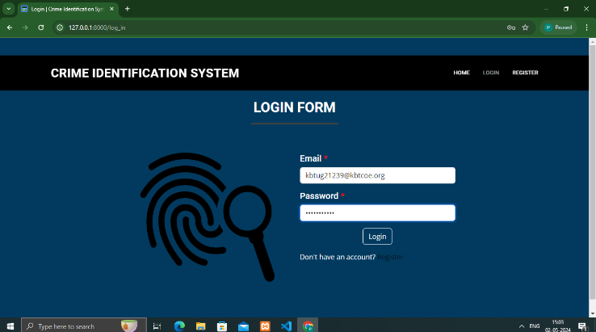

1. **Future Scope**

The future scope of the project encompasses several avenues for expansion, improvement, and application, leveraging emerging technologies and addressing evolving security challenges. Firstly, advancements in sensor technology could enable the integration of additional sensors into the surveillance robot, such as thermal imaging cameras for detecting heat signatures or LIDAR sensors for 3D mapping and object recognition. This expansion of sensor capabilities could enhance the robot's ability to detect and respond to a wider range of security threats, including those occurring in low-light or obscured environments.

Furthermore, ongoing developments in AI and machine learning present opportunities to enhance the intelligence and autonomy of the surveillance system. Future iterations of the project could incorporate more sophisticated AI algorithms capable of contextual understanding, anomaly detection, and adaptive decision-making. By leveraging deep learning techniques and reinforcement learning, the surveillance robot could become more adept at identifying subtle indicators of security threats and adapting its behavior in real-time to changing environments.

Moreover, advancements in edge computing and cloud technologies could enable the deployment of distributed surveillance networks, where multiple surveillance robots collaborate and share information in real-time. This networked approach could facilitate more comprehensive coverage of large areas and enable coordinated response strategies to security incidents. Additionally, cloud-based storage and processing capabilities could offload computational tasks from the robots themselves, allowing for scalability and resource optimization.

Another area of future exploration is the integration of predictive analytics and predictive maintenance techniques into the surveillance system. By analyzing historical data and patterns of security incidents, the system could forecast potential future threats and preemptively deploy resources to mitigate risks. Additionally, predictive maintenance algorithms could optimize the performance and reliability of the surveillance robots by predicting and preventing hardware failures before they occur, ensuring continuous operation and uptime.

Furthermore, the application of the surveillance system could extend beyond traditional security settings to encompass a wide range of industries and use cases. For example, the system could be deployed in industrial facilities to monitor equipment health and detect anomalies indicative of machinery malfunction or maintenance needs. Similarly, in healthcare settings, the system could be used for patient monitoring and fall detection, enhancing patient safety and well-being.

1. **Conclusion**

In conclusion, the Surveillance Robot project represents a significant leap forward in the realm of autonomous surveillance, effectively addressing the evolving challenges of security in diverse environments. The integration of cutting-edge technologies such as Raspberry Pi and IoT has resulted in the creation of a versatile and adaptive system capable of real-time monitoring, prompt response to security threats, and efficient data transmission for remote user interaction. The project's methodology, encompassing rigorous testing, deployment, and iterative refinement, has culminated in the development of a reliable and scalable surveillance solution. The bidirectional dataflow, orchestrated seamlessly within the system, ensures continuous communication between the robot, its sensors, and the central control interface. The user-friendly graphical user interface provides a practical means for users to monitor and control the robot remotely, enhancing the overall usability of the surveillance system. The project's focus on data security measures underscores its commitment to ensuring the confidentiality and integrity of sensitive information collected during surveillance operations.

1. **REFERENCES**

[1] V R Ratnaparkhe , Ashish U BokadeVideo surveillance robot control using smartphone and Raspberry pi -IEEE Conference PublicationIEEE Journals & Magazine Posted: 2016-04-01

[2] ANDREAS L. OPDAHL, AND CSABA VERES,Named Entity Extraction for Knowledge Graphs: A Literature Overview , 2019.

[3] OHIZAH ABD RAHMAN 1, KHAIRUDDIN OMAR,Application of Methods in robot: A Systematic Review,Department of Marketing, Department of Radiology, University of California,2020

[4] Changyong Yoon3 , Mignon Park4 , Hyukmin Eum , Jeisung LeeHuman action recognition for night vision using temporal templates with infrared thermal camera -IEEE Conference PublicationIEEE Journals & Magazine Posted: 2013-10-01

[5] https://www.hindawi.com/journals/acisc/2022/9970363/

[6] https://en.m.wikipedia.org/wiki/PatrolBot

[7] https://towardsdatascience.com/k-means-clustering-from-a-to-z-f6242a314e9a