**A RESEARCH ON RFID BASED SMART BUS TICKETING**

**Ranjana B Jadekar*1, Amith G M*2, Sahana K*3, Sanjana B R*4, Shrusti P S*5**

*1Asst. Professor, Department of Data Science and Engineering, Bapuji Institute of Engineering and Technology, Davangere, Karnataka, India.

*2,3,4,5 Student, Department of Information Science and Engineering, Bapuji Institute of Engineering and Technology, Davangere, Karnataka, India.

# ABSTRACT

Now-a-days The "IoT-Based Bus Ticket Management System" leverages the power of the Internet of Things (IoT) in conjunction with the ESP32 microcontroller, RFID card technology, and a MySQL database to streamline and enhance the efficiency of bus ticketing processes. This innovative system aims to modernize traditional ticketing systems by incorporating real-time data connectivity, secures identification methods, and centralized ticket management. ESP32 microcontroller acts as the core processing unit, facilitating seamless communication between RFID cards and the MySQL database. Each passenger is issued a unique RFID card that serves as their electronic ticket. The RFID cards are equipped with embedded sensors that interact with the ESP32, enabling swift and secure identification of passengers as they board or disembark from buses.

**Keywords:** IoT-Based, ESP32 microcontroller, RFID card technology, MySQL database, Real-time data connectivity, Centralized ticket management, Automatic fare deduction, Passenger traffic monitoring, Continuous connectivity, Security measures

# INTRODUCTION

Public transportation systems are vital components of urban infrastructure, ensuring the mobility of citizens. However, conventional bus ticketing processes often involve manual tasks, leading to inefficiencies and increased workload for conductors. To address these challenges, the "RFID Card Based Bus Ticket Management System" proposes an innovative solution leveraging ESP32 microcontroller, RFID card technology, MySQL database, and an Apache web server. The system aims to revolutionize ticketing processes, streamline passenger management, and, most importantly, alleviate the burdensome workload of conductors.

The MySQL database plays a pivotal role in storing and managing ticket-related information. Passenger details, journey history, and ticket statuses are efficiently organized, allowing for quick retrieval and analysis. This centralized approach enhances operational control and provides valuable insights into passenger trends, aiding in the optimization of bus routes and schedules.

Key features of the system include real-time ticket validation, automatic fare deduction, and the ability to monitor passenger traffic. The integration of IoT technologies ensures continuous connectivity, allowing for instant updates on ticket usage and bus occupancy. Additionally, the system incorporates security measures to protect passenger information and transaction data.

The "IoT-Based Bus Ticket Management System" represents a technological leap in the domain of public transportation. By combining ESP32, RFID cards, and MySQL, this system offers a reliable, efficient, and secure solution for modernizing bus ticketing processes, paving the way for enhanced passenger experiences and optimized operational management.

# LITERATURE SURVEY

1. **IoT in Public Transportation:** - Authors: T. Taleb and A. Kunz

* Paper: "Machine-to-Machine Communications: Architectures, Standards, and Applications," IEEE Communications Surveys & Tutorials, 2014.
* Proposed Solutions: Discusses architectures and standards for machine-to-machine (M2M) communications, relevant to IoT in public transportation.

2. **RFID Technology in Transportation:** - Authors: C. H. Lo and S. C. Lo

* Paper: "Design of an RFID-Based Automatic Vehicle Identification and Traffic Surveillance System," IEEE Transactions on Industrial Electronics, 2007.
* Proposed Solutions: Introduces an RFID-based automatic vehicle identification system, relevant to IoT in transportation.

3. **Smart Ticketing Systems:**

* Authors: M. S. Obaidat and A. Tantawi
* Paper: "Security analysis of smart-card ticketing systems," Computers & Security, 2007.
* Proposed Solutions: Discusses security aspects of smart-card ticketing systems, providing insights into potential solutions.

4. **Centralized Databases in Transportation:**

* Authors: A. D. Sarma, S. Weis, and D. W. Engels
* Paper: "RFID for the global supply chain," Communications of the ACM, 2002.
* Proposed Solutions: Discusses the use of RFID in the global supply chain, highlighting the importance of centralized databases.

5. **ESP32 Microcontroller in IoT:**

* Authors: A. J. Wang, Y. Wang, and Y. H. Tan
* Paper: "ESP32 as a Bluetooth Keyboard," IEEE Access, 2019.
* Proposed Solutions: Explores the capabilities of ESP32, relevant to its application in IoT-based systems.

6. **Web Servers in IoT Applications:**

* Authors: A. J. Jara, R. Bocci, and F. J. Lopez
* Paper: "Key Features, Applications, and Open Issues for Web of Things," Transactions on Emerging Telecommunications Technologies, 2014.
* Proposed Solutions: Discusses key features and applications of the Web of Things, relevant to IoT applications using web servers.

7. **Challenges in Conventional Ticketing Systems:**

* Authors: S. S. Dlay, R. M. Bicker, and H. S. Song
* Paper: "Automatic Fare Collection System Using RFID for Enhanced Public Transportation Systems," IEEE

Transactions on Intelligent Transportation Systems, 2006.

* Limitations Observed: Addresses challenges in conventional fare collection systems and proposes RFID-based solutions.

8. **Security in IoT-Based Systems:**

* Authors: R. Roman, J. Zhou, and J. Lopez
* Paper: "On the features and challenges of security and privacy in distributed internet of things," Computer Networks, 2013.
* Limitations Observed: Discusses challenges and potential security issues in distributed IoT systems.

# PROBLEM STATEMENTS

Traditional bus ticket management systems are marred by inefficiencies and limitations, often relying on manual processes, paper tickets, and decentralized data handling. These shortcomings contribute to challenges for both transit authorities and passengers, leading to issues related to accuracy, efficiency, and overall user experience. The current system's deficiencies include:

1. Manual Ticketing Processes: The reliance on manual ticketing processes, involving paper tickets and manual validation by bus conductors, leads to inefficiencies, longer boarding times, and a higher likelihood of errors.
2. Limited Transaction Tracking: The absence of real-time transaction tracking impedes the ability to monitor ticket sales, passenger counts, and revenue in real-time. This hampers dynamic decision-making for route optimization.
3. Conductor Workload: Bus conductors bear the burden of manual ticket validation, cash handling, and transaction recording. This not only increases the risk of errors but also diverts their attention from other critical tasks, such as passenger safety.
4. Ineffective Data Management: Lack of a centralized database results in inefficient data management. It hinders the ability to analyze historical ticketing data, make informed decisions, and optimize routes based on passenger demand.
5. Cash Handling Risks: Conventional systems involve cash transactions for ticket payments, exposing buses to theft risks and making conductors vulnerable to handling large sums of cash.

# EXISTING SYSTEM

This The conventional bus ticket management system typically relies on manual processes and paper-based ticketing. Bus conductors issue paper tickets to passengers, manually calculate fares, and keep track of transactions. This traditional approach, while widely used, has several limitations that impact efficiency, accuracy, and the overall experience for both passengers and bus conductors.

Limitations:

1. Manual Ticketing Processes: Conventional systems involve manual ticket issuance and validation by bus conductors. This manual process is time-consuming and prone to error. The reliance on manual ticketing increases the risk of ticketing errors, leading to discrepancies in fare collection and potential revenue loss.
2. Burden on Bus Conductors: Bus conductors bear the responsibility of managing ticket sales, validating tickets, and handling cash transactions manually. Conductors may experience increased workload, leading to stress and potential errors in ticket validation. Moreover, their attention is diverted from passenger assistance and safety.
3. Cash Handling Risks: Conventional systems involve cash transactions for ticket payments, making buses susceptible to theft and conductors vulnerable to handling large sums of cash. Risks associated with cash handling may compromise the safety of bus conductors and passengers and lead to revenue discrepancies.
4. Ineffective Communication: In the absence of real-time communication channels, there is a lack of efficient communication between buses and the central office. Timely information exchange is challenging, making it difficult to address operational issues, emergencies, or sudden changes in routes.

# PROPOSED SYSTEM

The proposed IoT-Based Bus Ticket Management System introduces a comprehensive solution that leverages cutting-edge technologies to address the shortcomings of traditional ticketing systems. The key components of the proposed system include RFID card technology, ESP32 microcontrollers, a centralized MySQL database, and an Apache web server.

Key Features of the Proposed System:

1. RFID Card Technology: Passengers are issued RFID cards embedded with unique identifiers, serving as electronic tickets. RFID cards enable secure and contactless identification during boarding and disembarking.
2. ESP32 Microcontroller: ESP32 serves as the central processing unit, facilitating seamless communication between RFID cards and the MySQL database. Enables real-time data synchronization, supporting automated ticket validation processes.
3. Centralized MySQL Database: Stores and manages ticket-related information, including passenger details, journey history, and ticket statuses. Ensures organized and secure data storage, facilitating efficient retrieval and analysis.
4. Apache Web Server: Provides a user-friendly web interface accessible to passengers and transit authorities. Passengers can access real-time information about routes, schedules, and ticketing. Transit authorities can monitor real-time data, track bus occupancy, and generate reports.
5. Automated Ticketing Processes: Automates the entire ticketing process, eliminating the need for manual ticket validation by conductors. RFID cards enable swift and secure identification, reducing boarding times and enhancing operational efficiency.
6. Real-time Passenger Tracking: RFID cards and real-time data synchronization enable accurate tracking of passenger movements. Transit authorities can monitor bus occupancy in real-time, allowing for dynamic route optimization based on demand patterns.
7. Efficient Data Management: The centralized MySQL database ensures organized and efficient data management. Provides real-time insights into ticket sales, passenger counts, and revenue for informed decisionmaking.

# SYSTEM REQUIREMENTS

**Hardware requirements**

This section specifies the minimum hardware configuration which is needed for the system.

* Processor -i3 or Higher
* RAM - 4GB or Higher
* Hard disk - 500 GB
* RFID scanner, RFID tag
* ESP32 kit
* Bread board
* Jumper wires

**Software requirements**

This section specifies the minimum software configuration required for the system.

|  |  |
| --- | --- |
| • Front end | - Bootstrap frame work |
| • Programming Language | - Arduino, PHP |
| • Operating System | - Windows 7 or Any Compatible |
| • IDE | - Arduino |

# SYSTEM DESIGN

ESP32 Microcontroller: Acts as the core processing unit responsible for handling communication between RFID cards and the MySQL database. RFID Cards: Each passenger is issued a unique RFID card containing embedded sensors for swift and secure identification

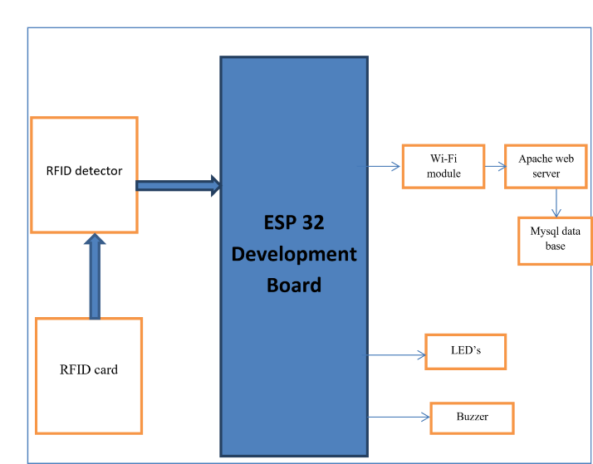

# IMPLEMETATION

Algorithm

**Algorithm for ESP32 Code**

Step1: Configuring the RFID reader for reading values

Reader will have 5 pins, VCC, GND and OUT, connect VCC to 3.5V, GND to ground and OUT pin to IO pin of ESP32. And turn on the kit, following steps should be followed to read the values.

Function ReadInfo( )

Begin

Value=ReadValues( pin number )

SendToTransamitter(value)

IntroduceDelay()

End of function

A function needs to be defined for reading values of voltage sensor with an average delay of 1 or 2 seconds. The read value must be sent to transmitter of base station for further transmission.

**Algorithm for coding using IDE** Step 1:

Launch Arduino IDE Step2:

Include all necessary header files Step 3:

Define constants Step 4:

Within setup () method initialize pin configurations Step 5:

Read sensor data from GPIOS , define this task in loop method as this method gets called repeatedly. Step 6:

Using digital write methods control the devices Step 7:

Close connection.

Pseudo code to read data from Reader

Function readData()

{

pinMode(33,INPUT)

Read bytes of info using loop

}

**Database connection Algorithm**

Step 1:

Call the function to establish connection with data base $conn=mysqli_connect

(‘hostname’,’username’,’password’,’databasename’); Step 2:

Make sure connection is successful, if not terminate the program If( not $conn )

{

Exit from function

}

Step 3:

Prepare the sql statement and run the query

$sql=select column names from table name [where condition]

$res=$conn->query ( $sql ) Step 4:

Make sure the transaction is successful, if so return the value otherwise terminate the program If( not $res )

{

Exit from function

}

Else Return $res Step 5:

Exit from the function

**Pseudocode**

function execute( $sql )

{

$conn=mysqli_connect('localhost','root','',hostel); if( !$conn ) { die(mysqli_connect_error());

}

$res=$conn->query( $sql ); if( !$res ) { die(mysqli_error($conn) ); } return ( $res

);

}

# RESULTS

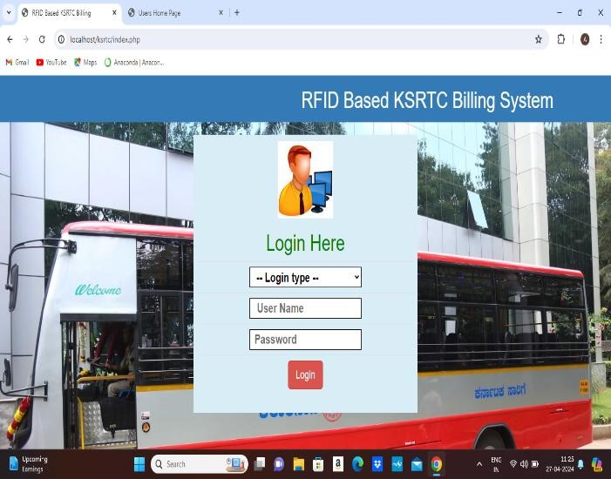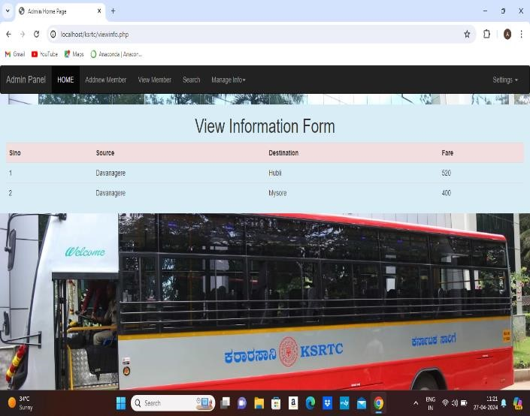

**Fig : LogIn Page Fig : Admin Home Page**

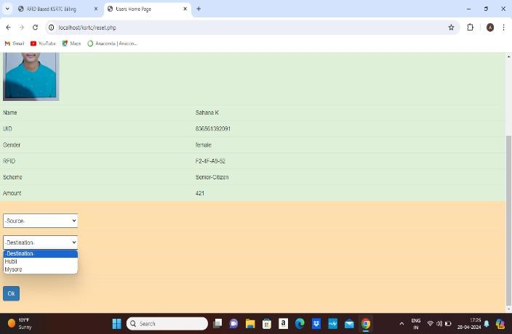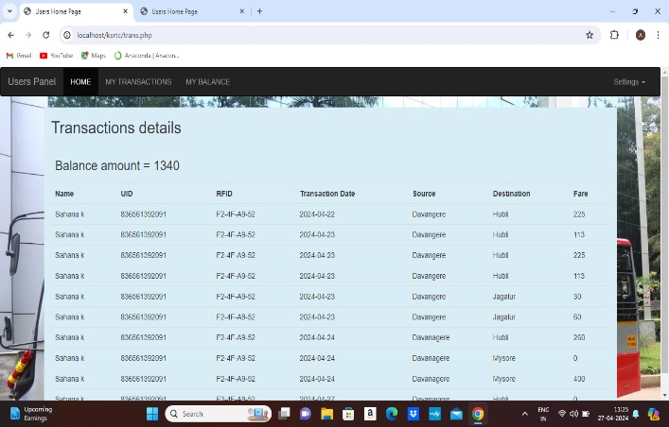

**Fig : Generation of Ticket Fig : Transaction Details**

# CONCLSION

The "RFID CARD Based Bus Ticket Management System" represents a significant advancement in modernizing and enhancing the efficiency of public transportation systems. By leveraging IoT technologies such as RFID cards, ESP32 microcontrollers, and a centralized MySQL database, the system streamlines ticketing processes, improves operational control, and enhances the overall passenger experience.

Through automated ticket validation, real-time monitoring of passenger traffic, and optimized resource utilization, the system offers tangible benefits such as reduced boarding time, improved service reliability, and cost savings for transportation authorities. Additionally, the implementation of robust security measures ensures the integrity and confidentiality of passenger data, mitigating risks associated with ticket fraud and unauthorized access.

# BIBILOGRAPY

1. T. Taleb and A. Kunz, "Machine-to-Machine Communications: Architectures, Standards, and Applications," IEEE Communications Surveys & Tutorials, 2014 [
2. C. H. Lo and S. C. Lo, "Design of an RFID-Based Automatic Vehicle Identification and Traffic Surveillance System," IEEE Transactions on Industrial Electronics, 2007
3. M. S. Obaidat and A. Tantawi, "Security analysis of smart-card ticketing systems," Computers & Security, 2007
4. A. D. Sarma, S. Weis, and D. W. Engels, "RFID for the global supply chain," Communications of the ACM, 2002 - Discusses RFID's role in the global supply chain, emphasizing the importance of centralized databases.
5. A. J. Wang, Y. Wang, and Y. H. Tan, "ESP32 as a Bluetooth Keyboard," IEEE Access, 2019 –
6. [A. J. Jara, R. Bocci, and F. J. Lopez, "Key Features, Applications, and Open Issues for Web of Things," Transactions on Emerging Telecommunications Technologies, 2014
7. S. S. Dlay, R. M. Bicker, and H. S. Song, "Automatic Fare Collection System Using RFID for Enhanced Public Transportation Systems," IEEE Transactions on Intelligent Transportation Systems, 2006
8. R. Roman, J. Zhou, and J. Lopez, "On the features and challenges of security and privacy in distributed internet of things," Computer Networks, 2013