**“Smart Bus Tracking System for Students Using RFID”**

***Miss. Komal Sukraj Dambre1, Miss. Yogita Sanjay Gend2, Miss. Prachi Atmaram Kadam3, Miss. Harshita Madhukar Shewale4, Prof. B.M.Gawale5***

1,2,3,4 UG Student, Department of Computer Engineering, LOGMIEER, Nashik

5Guided, Department of Computer Engineering LOGMIEER, Nashik

1komaldambre825@gmail.com, 2yogitasg278@gmail.com, 3prachikadam1711@gmail.com,

4harshitashewale27@gmail.com, 5gawalebharti@gmail.com

**Abstract:**

In many country, school buses are viewed as effortless options for parents to send their children to their schools. However, nowadays, parents are distressed regarding their wards because of more incidents of students going missing. In certain situations, for the school bus to arrive, pupils may have to wait for a prolonged period. Waiting for school buses to drop off/pick up the children in the morning and then in the afternoon is a waste of time, even for parents, peculiarly with the congestion at peak hours. Certain technologies are available that are employed to guarantee the security of the students, yet they fall short of providing parents with efficient services. The proposed work describes the design of a Bus Boarding Deboarding and Location Notifying System, capable of yielding effective services by providing the amenity to track the bus location using cutting-edge technologies like Global Positioning System (GPS) tracking and Radio Frequency Identification (RFID). The suggested system uses RFID, GPS, and GSM technologies to track pupils within a school bus. Through short messaging services, parents may stay updated on their child’s boarding/deboarding status, as well as monitor the bus route and estimate its arrival time. Safe and convenient school buses can cut back on the usage of private cars and eventually alleviate traffic congestion in cities, particularly during school hours. The suggested intelligent and secured tracking system for school buses allows parents to keep track of all buses.

***Keywords****:* ***Arduino, Global Positioning System (GPS), Monitoring, Radio Frequency Identification***

***(RFID), Vehicle Tracking, Global System for Mobile Communications (GSM) Using App, Mobile Application for Notification****.*

**INTRODUCTION**:

In today's fast-paced world, ensuring the safety and efficiency of student transportation is paramount. To address this need, we are excited to introduce our innovative Bus Tracking, Boarding, and Deboarding System with Location Notification. This system revolutionizes the way we manage student transportation, offering real-time tracking and notification features to enhance safety, streamline operations, and provide peace of mind to parents, guardians, and school administrators alike. The safe and reliable transportation of children to and from school via buses has become a growing concern for both parents and teachers in our fast-paced world. Bus delays often lead to extended waiting times for schoolchildren. On occasion, children accidentally board the wrong buses or disembark at the wrong stops, causing worry and inconvenience for parents. Even minor delays of the bus can be a source of frustration for parents. Furthermore, there have been recent reports of school buses transporting youngsters going missing. In one alarming instance, a bus was delayed due to an inexperienced driver who was unfamiliar with the routes. In a school near Salt Lake in Kolkata, as many as three school buses disappeared, leaving parents in a state of panic. Each bus carried around 40 children, and all three drivers had turned off their cell phones. Consequently, numerous parents rushed to the schools when their children did not return home at the usual time. However, this perplexing issue can be effectively addressed with the aid of modern technology. School bus tracking systems significantly enhance the security and peace of mind for schoolchildren and their parents.

While a few such products already exist in the market, the suggested system stands out as superior to its counterparts, thanks to its use of the Arduino UNO microcontroller. It also utilizes the MFRC522 RFID Reader, NEO-6M GPS module, and SIM800A GSM module, all of which are reasonably priced, thereby reducing the overall cost. Each child is uniquely identified by their RFID-tagged school ID card, and parents are promptly notified of their children’s boarding and disembarking status through a Global System for Mobile Communication (GSM) module. Parents receive notifications indicating whether their child has boarded the bus or not. Furthermore, the Global Positioning System (GPS) module sends real-time updates about the bus’s current location to the parents via Mobile Application.

**MOTIVATION & BACKGRAOUND :**

Existing systems commonly use GPS to track the bus's location and RFID for student authentication. Information is usually shared with parents through text messages or dedicated mobile apps. These systems can pinpoint the bus's location and alert parents when students get on or off using GPS and RFID tags. For example, Ben et al. introduced a system that combines RFID, GPS, and GPRS technologies. Each student carries a unique RFID card embedded in their school bag. When a student gets on or off the bus, a reader records the time, date, and location and sends this data to a secure server automatically. This process doesn't require any action from the driver or student.

Zonar and their team have created Zpass, a system designed specifically for school buses to keep a close eye on students. This system uses RFID technology with small cards that students carry. These cards have passive RFID chips that automatically record when students try to get on or off the bus as they pass through a special scanner. Zpass quickly gives accurate information and focuses on safety. Parents will get updates about their child's bus usage through a web browser with Zpass installed.

**MODULES :**

In the proposed system there are three modules for computation of task.

1. Admin Module
2. Service Module
3. User Module

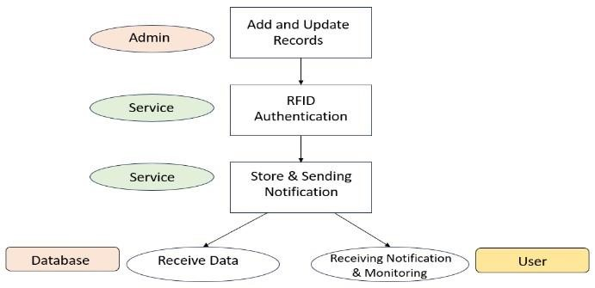

Fig1. Working Model

# Admin Module

This part of the system is where all the student and bus information is stored in a database. Whenever there are updates to this information, they are automatically shown on the website.

This website is directly connected to the database, allowing administrators to make real-time changes and track the entire system.

# Service Module

In this part, various IoT (Internet of Things) technologies are used in school buses to ensure student safety. RFID and fingerprint scanners are used for authentication, lasers are used for window safety, and GPS is used for tracking the bus in real-time. These technologies help provide a safe and secure environment for students, and GPS even alerts when the bus is nearing its destination.

# User Module

This is where the parents interact with the system through an android application. Parents can receive notifications about their child's current status, track the bus's location in real-time on a map, and access other information such as the driver's contact number. This application makes it easy for parents to stay updated and connected with their child's school transportation

**SYSTEM IMPLEMENTATION :**

The safe and reliable transportation of children to and from school on buses has become a matter of concern for parents and teachers in today’s busy world. Bus delays can often lead to long wait times for school children. Sometimes, children accidentally board the wrong buses or get off at the wrong stops. Even minor delays can cause anxiety for parents. Recent reports have highlighted instances of school buses transporting young children going missing. In one case, a bus was delayed due to an inexperienced driver who was unfamiliar with the routes. In another alarming incident. Through short messaging services, parents may stay updated on their child’s boarding/deboarding status, as well as monitor the bus route and estimate its arrival time.

**SYSTEM ARCHITECTURE :**

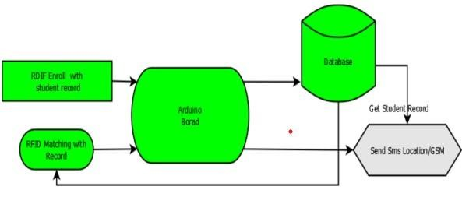Fig2. System Architecture

Fig

3

. Proposed System

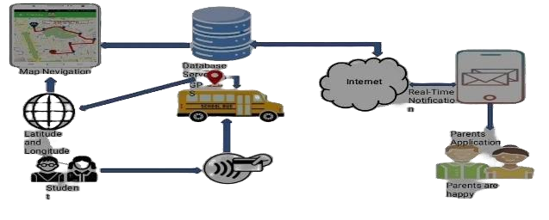

**RFID :**

RFID (radio frequency identification) is a form of [wireless c](https://www.techtarget.com/searchmobilecomputing/definition/wireless)ommunication that incorporates the use of electromagnetic or electrostatic coupling in the radio frequency portion of the electromagnetic spectrum to uniquely identify an object, animal or person. Every RFID system consists of three components: scanning anteena, a [transceiver a](https://www.techtarget.com/searchnetworking/definition/transceiver)nd a [transponder.](https://internetofthingsagenda.techtarget.com/definition/transponder) When the scanning antenna and transceiver are combined, they are referred to as an RFID reader or interrogator. There are two types of RFID readers -- fixed readers and mobile readers. The RFID reader is a network-connected device that can be portable or permanently attached. It uses radio waves to transmit signals that activate the tag. Once activated, the tag sends a wave back to the antenna, where it is translated into data. The transponder is in the RFID tag itself. The read range for RFID tags varies based on factors including the type of tag, type of reader, RFID frequency and interference in the surrounding environment or from other RFID tags and readers. Tags that have a stronger power source also have a longer read range.

**Arduino Uno :**

The Arduino UNO is a standard board of Arduino. Here UNO means 'one' in Italian. It was named as UNO to label the first release of Arduino Software. It was also the first USB board released by Arduino. It is considered as the powerful board used in various projects. Arduino.cc developed the Arduino UNO board. Arduino UNO is based on an ATmega328P [microcontroller.](https://www.javatpoint.com/microcontroller) It is easy to use compared to other boards, such as the Arduino Mega board, etc. The board consists of digital and analog Input/Output pins (I/O), shields, and other circuits. The Arduino UNO includes

6 analog pin inputs, 14 digital pins, a [USB c](https://www.javatpoint.com/usb-full-form)onnector, a power jack, and an ICSP (In -Circuit Serial Programming) header. It is programmed based on IDE, which stands for Integrated Development Environment. It can run on both online and offline platforms.

**RESULTS :**

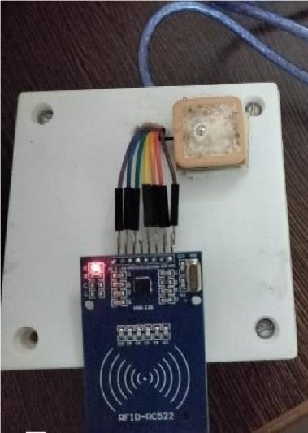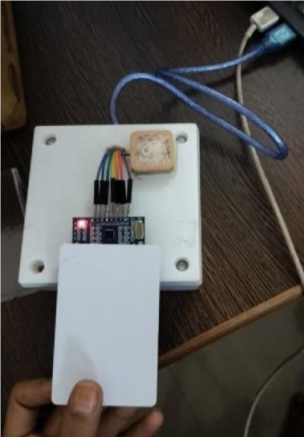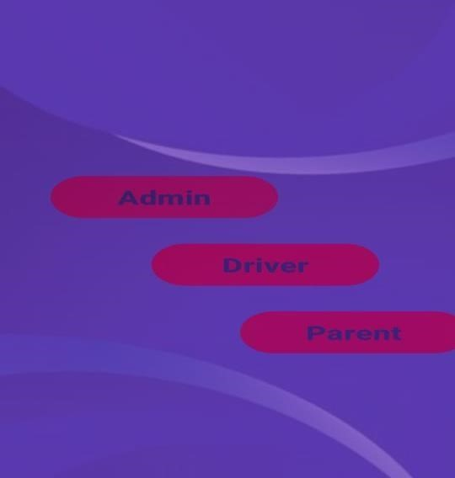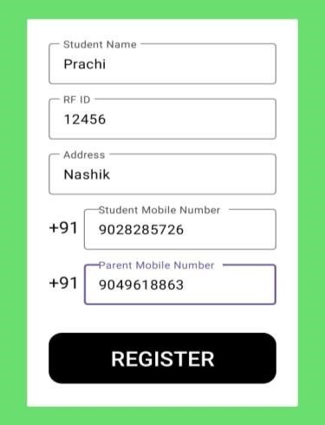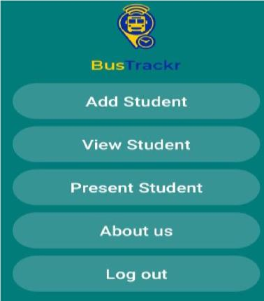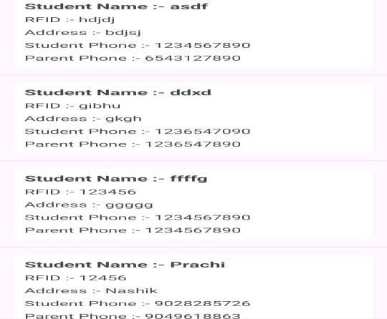

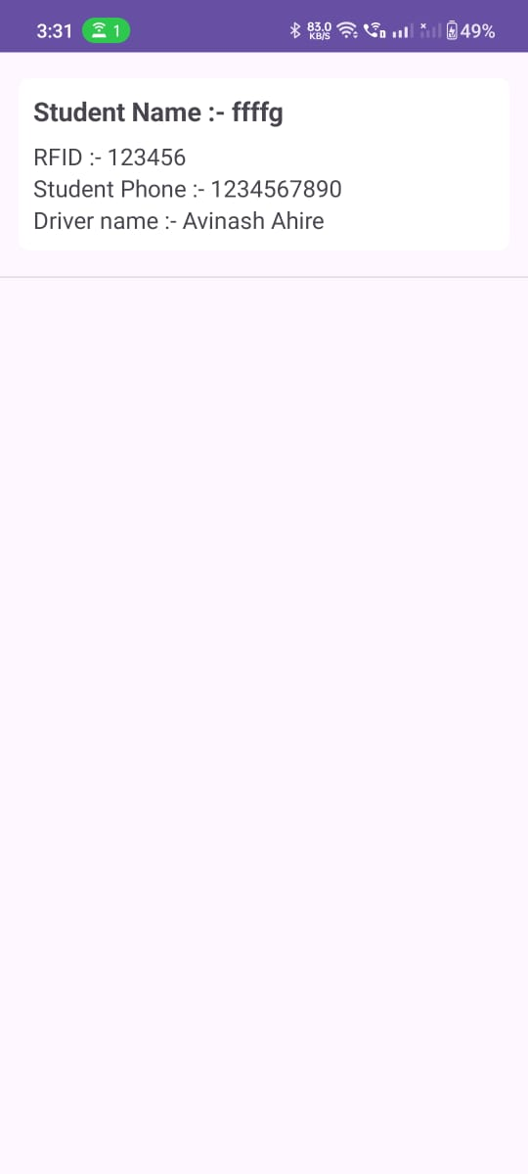



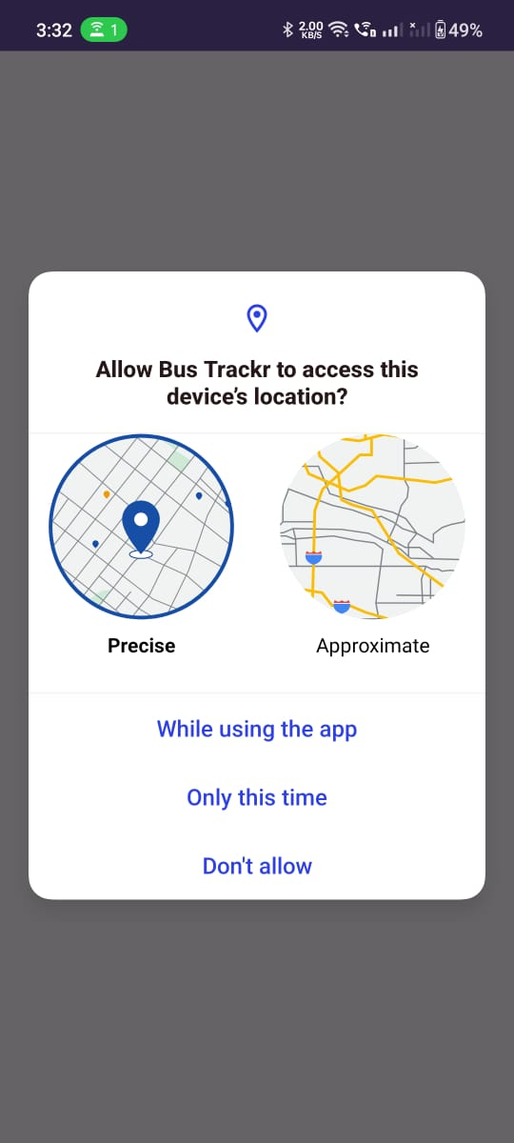

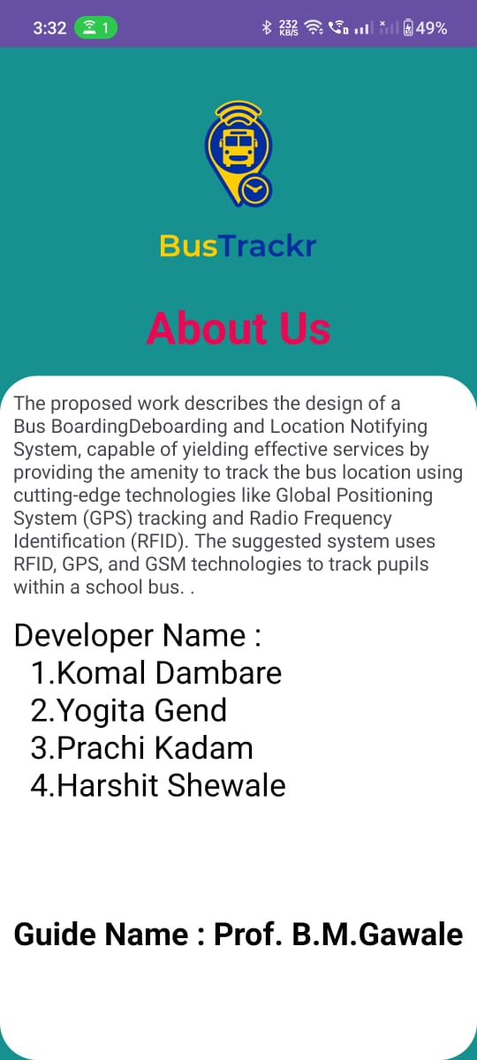

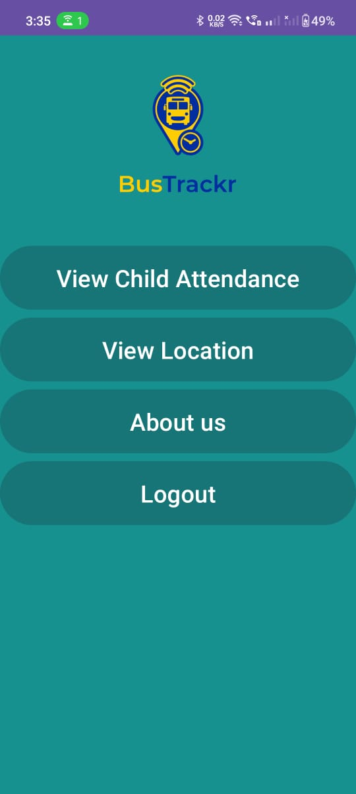

**CONCLUSION :**

*A smart tracking system for students using RFID offers numerous benefits in terms of efficiency, security, real-time tracking, data analysis, student safety, cost effective, time saving etc. By adopting least expensiv, yet most effective sensors the cost is maintained to a minimum, improving the working. Parents get notified about the student when the student in or out from the bus when the RFID card is scannedin the school bus.The GPS of the school bus will also keep the parent updated about the live location of the school bus, and the child travelli in it. To achieve accuracy for the location coordinates, the program has been constructed in such a way that it accepts GPS latitude and longitude data with a precision of a maximum of six digits, which aids in maintaining the accuracy of the position thus obtained.*

**REFERENCES:**

* Asif Ahmed, M M Rayhan Parvez, Md Hridoy Hasan, Fernez Narin Nur, Nazmun Nessa Moon, An Intelligent and Secured Tracking System for Monitoring School Bus,IEEE, ICCCI, Jan. 23 – 25, 2023.
* Devyani Bajaj, Neelesh Gupta, GPS Based Automatic Vehicle Tracking Using RFID,International Journal of Engineering and Innovative Technology (IJEIT) Volume 1, Issue1, January 2023, pp. 31-35.
* K.R. Prasannaa, M. Hemalatha, RFID GPS and GSM based logistics vehicle load balancing and tracking mechanism , International Conference on Communication Technology and System Design, 2022
* Dr. N. Dhanasekar, Chitra Valavan, S. Soundarya, IoT based Intelligent Bus Monitoring

System, International Journal of Engineering Research Technology, Volume 7, Issue11, 2023, pp.1-5.

* S. A. Salunke, Vitthal B. Jagtap, Avinash D Harale, Vehicle Tracking System for School Bus by Arduino, International Research Journal of Engineering and Technology,V olume 04 Issue 03, Mar -2020, pp.21
* Dr. M. V. Vyawahare, S. Lambat, M. Belsare, Kritika Latwe, Richa V., IOT Based School Bus Monitoring and Security System, International Journal of Innovative Science and Research Technology, Volume 4, Issue 3, March 2023, pp. 244-247.
* Ajit Jadhav, Ashish Shinde, Nilesh Nanavare, Ganesh Ranmode, A.B. Gavali, RFID Based Secure Smart School Bus System , IAETSD Journal for Advanced Research in Applied Sciences, Volume 5, Issue 3, MAR/2022, pp.127-134
* A. Nasneen Fathima, P. S. Nivedha, T. Sangavi, S. Selvalakshmi, Vehicle Tracking System for Children Safety Using RFID, GPS and GSM, International Journal for Trends in Engineering Technology, Volume 13 Issue 1 – MAY 2021, pp.16-20
* Ajay Hemant Jethwa, Vehicle Tracking System Using GPS and GSM Modem, International Journal of Recent Scientific Research, Vol. 6, Issue, 6, June, 2020, pp.4805-4808
* Tarneem M. Hamadto, Zakaria A. Adam, M.H.Elsayed, An Android Application of School Bus Tracker Based on RFID Technology, IEEE Xplore (ICC EEE), 2020.