# SUSTAINABILITY IN INDIAN MANUFACTURING INDUSTRIES

# SUBMITTED BY :- KHUSHI CHAUDHARY (21GSFC1010073)

# ISHIKA GAURAV (21GSFC1010053)

# 

# UNDER THE GUIDANCE OF:-DR. BHAVNA SHARMA

**ABSTRACT**

In the modern global industrial landscape, key actors in a variety of sectors now priorities sustainability above all else. With an emphasis on the relationship between lean manufacturing principles and sustainability, this study explores the assessment of sustainable manufacturing practices in the Indian manufacturing sector. This study used a survey methodology to get 345 insightful replies from four important sectors. Sustainable manufacturing practices were selected and a survey instrument was developed to assess their application within the Indian industrial sector, based on a thorough examination of the literature. In addition to examining the connection between lean manufacturing techniques and sustainable manufacturing activities, the study's conclusions provide insight into the tactics used by Indian industries to meet sustainability targets.

**INTRODUCTION**

A defining feature of the modern global industrial landscape is the increasing awareness of the pressing need for sustainability. Businesses and society at large are becoming more conscious of issues like resource depletion, social inequality, and climate change. As a result, producers all over the world are reviewing their operational plans to better conform to sustainable practices. This change is being viewed more and more as a strategic necessity for long-term viability and competitiveness, rather than just one motivated by regulatory compliance.

Sustainability significance has grown over time, moving from being a side issue to a key component influencing operational strategy in a variety of industries. Sustainability includes more than just reducing environmental effects; it also takes into account issues like social responsibility, ethical sourcing, and shock resistance. Manufacturers are realizing that adopting sustainable practices can lead to chances for innovation, cost savings, and market distinction in addition to mitigating risks. As a result, sustainability is more important to investors, consumers, and regulatory agencies.

The emergence of sustainable manufacturing as a vital domain for industrial transformation can be seen in this framework. It entails incorporating sustainability concepts into all phases of the production process, from sourcing and design to production and distribution. Eco-friendly product design, waste reduction, renewable energy adoption, resource efficiency, and circular economy tactics are just a few of the many activities that fall under the umbrella of sustainable manufacturing methods. Businesses can improve their brand reputation, lower operating expenses, and improve their environmental performance by adopting sustainable manufacturing practices.

Pay attention to the Indian Manufacturing Sector: With one of the fastest-growing economies globally, India has a tonne of potential for sustainable manufacturing. The Indian manufacturing sector encompasses a wide range of industries, including electronics, pharmaceuticals, automotive, and textiles. It is imperative to make sure that the nation's industrialization and urbanization are inclusive and sustainable as they progress. Therefore, researching sustainable manufacturing techniques in the Indian setting is important for policymakers, industry stakeholders, and society at large, in addition to being intellectually stimulating.

Investigating the Connection to Lean Manufacturing:

Additionally, this study aims to investigate how lean manufacturing principles relate to sustainability goals. Lean manufacturing has long been linked to increases in productivity and efficiency. It is based on ideas like waste reduction, continuous improvement, and value stream mapping. On the other hand, there is growing understanding that lean techniques, through lowering emissions, improving operational flexibility, and minimizing resource usage, can also contribute to sustainability. Gaining knowledge about the relationship between lean manufacturing and sustainable practices can help improve operational effectiveness as well as environmental performance.

**LITERATURE REVIEW**

The notion of sustainable manufacturing is thoroughly examined in the literature study, which also highlights important practices that are related to it. In order to minimize negative effects while optimizing efficiency and long-term viability, sustainable manufacturing incorporates economic, social, and environmental factors into the manufacturing process. Resource efficiency, waste reduction, adoption of renewable energy, green supply chain management, and stakeholder involvement are important aspects of sustainable manufacturing processes.

**RESEARCH METHODOLOGY**

Research methodology is a way to systematically solve the research problem. It may be understood as a science of studying how research is done scientifically. Abraham Kaplan defines research methodology in this way. Research methodology is "the description, explanation & Justification of various methods of conducting research"

###### Research Design

A research design is a step-by-step approach used by a researcher to conduct a scientific study. It includes various methods and techniques to conduct research so that a research problem can be handled efficiently. A researcher has a series of questions that he needs to find answers by conducting research. Type of this research is descriptive in nature

###### Descriptive Research

Descriptive research is defined as a research method that describes the characteristics of the population or phenomenon studied. This methodology focuses more on the “what” of the research subject than the “why” of the research subject. The descriptive research method primarily focuses on describing the nature of a demographic segment, without focusing on “why” a particular phenomenon occurs. In other words, it “describes” the subject of the research, without covering “why” it happens.

###### Sampling Design

The following factors have been decided within the scope of sample design:

1. **Universal Study –** The study was conducted to find out the difference of costumer behavior. The population for this research is employs, working in manufacturing industries.
2. **Sample Size –** Study has been conducted in Noida area. The sample size is 50 respondents.
3. **Sample Unit –** This research consisted of various individuals who are working in manufacturing industries .
4. **Sample Technique –** Convenient sampling technique has been used. .

**OBJECTIVES OF RESEARCH**

1. Research is an organized investigation of a problem where an investigator attempts to gain solution to a problem.
2. Evaluating present Practices .
3. Finding the main obstacles .

**DATA COLLECTION**

###### **PRIMARY DATA**

Primary data is the data that is collected for the first time through personal experiences or evidence, particularly for research. It is also described as raw data or first-hand information. The mode of assembling the information is costly, as the analysis is done by an agency or an external organization, and needs human resources and investment. The investigator supervises and controls the data collection process directly.

The data is mostly collected through observations, physical testing, mailed questionnaires, surveys, personal interviews, telephonic interviews, case studies, and focus groups, etc.

The primary data was collected by using a questionnaire.

###### **SECONDARY DATA**

Secondary data is a second-hand data that is already collected and rerecorded by some researchers for their purpose, and not for the current research problem. It is accessible in the form of data collected from different sources such as government publications, censuses, internal records of the organization, books, journal articles, websites and reports, etc.

This method of gathering data is affordable, readily available, and saves cost and time. However, the one disadvantage is that the information assembled is for some other purpose and may not meet the present research purpose not be accurate or may be accurate.

The secondary data was collected from internet/websites.

**PRESENTATION OF DATA COLLECTED**

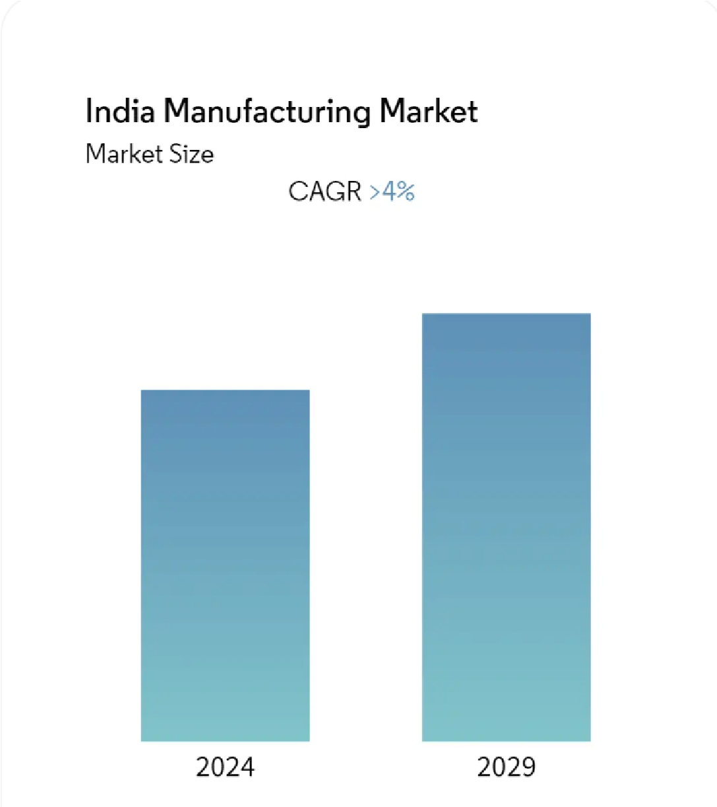

Study Period 2020 - 2029

Base Year For Estimation 2023

Forecast Data Period 2024 - 2029

Historical Data Period 2020 - 2022

CAGR > 4.00 %

Market Concentration Medium

India Manufacturing Sector Market Analysis

Lockdown limitations during COVID-19 posed serious issues for India's industrial sector, affecting supply chains, labour availability, and overall productivity. Nevertheless, despite these obstacles, a number of firms have established or plan to develop manufacturing facilities in India, making it a desirable location for foreign manufacturing endeavours.  
  
Over the forecast period, India's manufacturing industry is anticipated to increase at a CAGR of almost 4% (2023-2028). The industry employs about 20% of the labour force in the country and accounts for 16–17% of GDP. For this reason, the government is putting several programmes into place to increase industrial competitiveness.

Programmes like SAMARTH Udyog and Bharat 4.0 were introduced by the Ministry of Heavy Industries & Public Enterprises to improve the sector's competitiveness, especially in the capital goods market. Furthermore, government programmes like the Production Linked Incentive (PLI) programme and the National Manufacturing Policy seek to advance core manufacturing sectors in compliance with global standards and increase manufacturing's GDP share to 25% by 2025, respectively.  
  
In addition, India is expected to become a single market with the introduction of the Goods and Services Tax (GST), drawing in additional investors. According to the Indian Cellular and Electronics Association (ICEA), India might reach a GDP of USD 100 billion in laptop and tablet production by 2025 if legislative measures are implemented.

By incorporating cutting-edge production techniques and surveillance systems, the government's emphasis on creating smart cities and industrial corridors seeks to promote an atmosphere that is favourable to industrial expansion. India's industrial sector is anticipated to have increased productivity and efficiency as a result of this steady shift towards Industry 4.0.

Market Trends for the Manufacturing Sector in India

The Indian manufacturing sector is being impacted by several key trends, including a rise in public investment due to initiatives like "Make in India" and government programmes that encourage industrial growth. The government's efforts to support the industry are exemplified by the large investments made in the production of semiconductors, electronics and IT hardware, and incentives for businesses such as Samsung to shift their manufacturing operations to India.

It is anticipated that the introduction of production-linked incentive (PLI) schemes for a range of industries, such as advanced chemical cell batteries, technical textiles, and clothing made of man-made fibres, will draw significant investments and strengthen India's standing as a major global manufacturing hub. Throughout the projected period, it is expected that these activities will support demand and growth in the manufacturing sector.

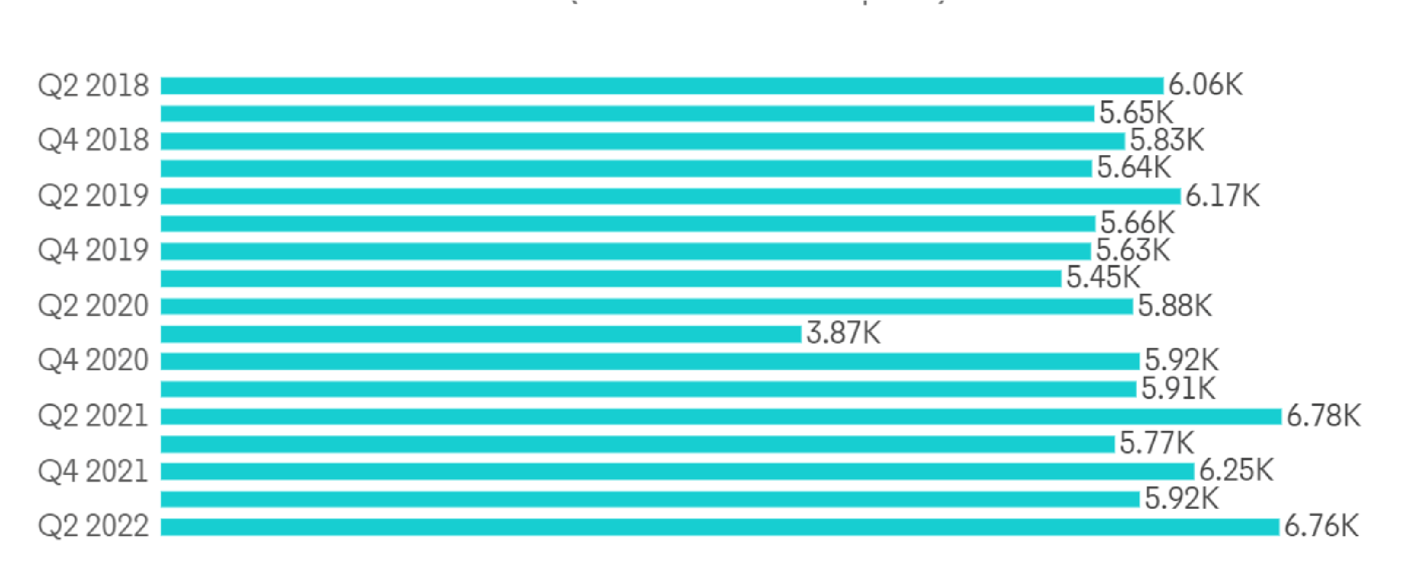

**LIMITATIONS**

1. The study is limited only to the certain area in Noida .
2. The study was taken only from the employees point of view.
3. The findings were drawn only on the basis of information provided by the respondents.

**CONCLUSION**

Finally, by utilizing lean manufacturing principles and taking a comprehensive approach to sustainability, Indian manufacturers can improve their competitiveness while simultaneously making a positive impact on environmental stewardship and societal well-being. This study provides insightful information about sustainable manufacturing practices within the Indian manufacturing sector and emphasizes the significance of incorporating environmental and social considerations into operational strategies.

**REFRENCES**

Government of India, Ministry of Environment, Forest and Climate Change (MoEFCCs):

    Website: http://moef.gov.in/

Provides information on environmental policies, regulations, and initiatives relevant to sustainability in Indian manufacturing industries.

Confederation of Indian Industry (CII):

     Website: https://www.cii.in/

Publishes reports, case studies, and best practices on sustainability and corporate social responsibility (CSR) in Indian manufacturing industries.

The Energy and Resources Institute (TERI):

Website: https://www.teriin.org/

Conducts research and advocacy on environmental sustainability, energy efficiency, and renewable energy adoption in the Indian manufacturing sector.

Federation of Indian Chambers of Commerce and Industry (FICCI):

Website: https://www.ficci.in/

Produces publications, policy briefs, and events related to sustainability, clean technology, and green manufacturing practices.

Indian Green Building Council (IGBC):

Website: https://www.igbc.in/

Offers resources, certification programs, and case studies on green building and sustainable construction practices in India.

Centre for Science and Environment (CSE):

Website: https://www.cseindia.org/

Conducts research and advocacy on environmental sustainability, pollution control, and sustainable development in India.

International Institute for Sustainable Development (IISD):

Website: https://www.iisd.org/

Publishes research papers, policy briefs, and articles on sustainable development, climate change, and industrial sustainability in India and globally.

Indian Institute of Technology (IIT) - Delhi, Bombay, Madras:

Websites: https://www.iitd.ac.in/, http://www.iitb.ac.in/, https://www.iitm.ac.in/

Academic institutions conducting research on sustainable manufacturing, environmental engineering, and technology innovation in India.

Academic Journals:

Journals such as the "International Journal of Sustainable Manufacturing" and "Journal of Cleaner Production" publish research articles, reviews, and case studies on sustainability in manufacturing, including studies focused on Indian industries.

Books:

"Sustainability in Indian Business: Cases and Developments" edited by Sanjay Sehgal and Vinay Kumar Nangia.

"Environmental Management: Text and Cases" by Bhavna Sharma and Varun Gupta.

"Sustainable Manufacturing: Challenges, Solutions and Implementation Perspectives" edited by A.K. Shukla and P. Bagchi.