**AI POWERED BOOK MY TRIP** **Simran Gupta*1 , Ms. Shagufta Siddiqui*2**

*UG Student of Department of, Shri Ramswaroop Memorial College of Engineering and Management Lucknow, Uttar Pradesh, India.

*2 Assistant professor, Bachelor of Computer Application, Shri Ramswaroop Memorial College of Management Lucknow, Uttar Pradesh, India.

**ABSTRACT** -. This research paper delves into the transformative potential of artificial intelligence (AI) integration within a "Book My Trip" website, aimed at revolutionizing the travel booking experience. Through a combination of advanced AI technologies such as personalized recommendation systems, and predictive analytics, the platform seeks to enhance user engagement, streamline the booking process, and optimize business operations. The study investigates the implementation process, evaluates the effectiveness of AI-powered features, and explores their impact on user satisfaction, conversion rates, and overall business performance. By analyzing real-world data and user feedback, this paper provides insights into the practical applications of AI in the travel industry and highlights the opportunities and challenges associated with its adoption in online booking platforms.

**KEYWORD-**booking, research, travel, AI, technology**.**

**INTRODUCTION-** This research paper delves into the transformative potential of artificial intelligence (AI) integration within a "Book My Trip" website, aimed at revolutionizing the travel booking experience. Through a combination of advanced AI technologies such as personalized recommendation systems, natural language processing (NLP), and predictive analytics, the platform seeks to enhance user engagement, streamline the booking process, and optimize business operations. The study investigates the implementation process, evaluates the effectiveness of AI-powered features, and explores their impact on user satisfaction, conversion rates, and overall business performance. By analyzing real-world data and user feedback, this paper provides insights into the practical applications of AI in the travel industry and highlights the opportunities and challenges associated with its adoption in online booking platforms.

**Background of the travel industry and the importance of online booking platforms**

The travel industry is one of the largest and most dynamic markets in the world. It comprises airlines, hotels, car rental companies, cruises, and various sightseeing and tourism services and destinations. Technological advancements and changing consumer behaviors have revolutionized the industry and have made the online booking platforms indispensable for both travelers and service producers. Predecessors of the online booking platforms consisted of travel agencies, and, later, people began making their bookings on end-service providers’ websites. With the fast development of the Internet and the digital age, people’s habits of researching and booking travel arrangements have changed radically. Online booking platforms have democratized access to travel information and service as a whole and significantly increased consumer convenience, flexibility, and choice. The importance of online booking platforms in the modern travel industry cannot be overstated. These platforms serve as centralized hubs where travelers can easily compare prices, access detailed information about destinations and accommodations, read reviews, and make reservations—all from the comfort of their homes or on the go via mobile devices. Moreover, online booking platforms enable travel businesses to reach a wider audience, optimize their distribution channels, and enhance operational efficiency.

**Purpose of the Research and Objectives of AI-Powered Book My Trip Website:**

-Enhance User Experience: The research seeks to leverage AI-powered features such as personalized recommendation systems, natural language processing (NLP) for customer interactions, and predictive analytics to create a more intuitive, seamless, and personalized booking experience for travelers. By understanding user preferences and behavior, the website aims to anticipate and fulfill their needs more effectively, thereby enhancing satisfaction and loyalty.

-Streamline Booking Process: Another objective is to streamline the booking process and reduce friction points by leveraging AI-driven automation and optimization techniques. By automating routine tasks, such as itinerary planning, pricing analysis, and reservation management, the website aims to simplify the booking process for users and improve overall efficiency.

-Optimize Business Operations: The research also aims to optimize business operations and decision-making through the use of AI-powered analytics and insights. By analyzing large volumes of data, including user behavior, market trends, and competitor strategies, the website seeks to identify opportunities for growth, optimize pricing and inventory management, and improve marketing effectiveness, ultimately driving revenue and profitability.

**LITERATURE VIEW-**

**Previous Studies on AI in E Commerce and Travel**

In the travel industry, previous studies have examined the role of AI in transforming the traveler journey, from trip planning and booking to post-travel engagement. Research has explored the effectiveness of AI-driven recommendation engines in providing personalized travel recommendations, optimizing itinerary planning, and enhancing overall trip satisfaction. Additionally, studies have investigated the use of NLP for improving customer interactions and support services, as well as the application of predictive analytics for predicting travel demand, optimizing pricing strategies, and identifying emerging trends. Overall, previous studies on AI in e-commerce and travel have demonstrated the significant potential of AI technologies to reshape industry dynamics, improve operational efficiency, and drive competitive advantage. By leveraging AI-driven insights and automation, businesses in both sectors can better understand customer needs, deliver personalized experiences, and stay ahead in an increasingly digital and competitive landscape.

**Case Studies of Successful AI Implementations in Similar Domain**

Booking.com: Booking.com, one of the world's largest online travel platforms, has successfully implemented AI-driven recommendation systems to enhance user experiences and drive bookings. By analyzing vast amounts of user data, including search history, booking behavior, and preferences, Booking. Om’s recommendation engine suggests personalized travel options, such as accommodations, destinations, and activities, to users. These recommendations are tailored to individual preferences, demographics, and past interactions, leading to increased user engagement, higher conversion rates, and improved customer satisfaction.

Airbnb: Airbnb, a leading online marketplace for vacation rentals and lodging, has leveraged AI technologies to improve both the guest and host experiences on its platform. One notable implementation is Airbnb's AI-powered search ranking algorithm, which uses machine learning to predict the likelihood of a guest booking a particular listing based on factors such as location, price, amenities, and past booking patterns. By prioritizing listings with higher predicted booking probabilities, Airbnb maximizes user satisfaction by presenting guests with relevant and desirable accommodation options while also helping hosts optimize their listing visibility and occupancy rates.

**-METHOLOGY**

**Overall Description of AI powered Book My Trip**.

AI powered BookMyTrip website cater to the needs of group travelers, corporate clients, and travel agents. Crucially, BookMyTrip website prioritize user experience and customer satisfaction above all else. Through intuitive interfaces, responsive design, and personalized recommendations, these platforms ensure that every step of the travel journey is seamless and enjoyable. The AI chatbot is seamlessly integrated into the BookMyTrip website, usually in the form of a chat interface accessible from any page of the website. Users can initiate

**Data Collection Methods And Analysis Techniques**.

User Interaction Tracking: Tour and travel booking websites often utilize user interaction tracking to collect data on user behavior, preferences, and engagement patterns. This includes tracking user clicks, page views, search queries, booking actions, and other interactions with the website. Tools such as Google Analytics, Adobe Analytics, and custom tracking scripts are commonly used to capture and analyze this data.

Booking History and Transaction Data: Booking websites collect and store data on user booking history, including details of past trips, accommodations, activities, and transactions. This data provides insights into user preferences, travel patterns, booking frequency, and spending habits. Analysis of booking history data can help identify trends, popular destinations.

**Function and features**

User Authentication and Management: This module handles user registration, login, and profile management. It allows users to create accounts, update their personal information, and manage their bookings.

Search and Booking Engine: The search and booking engine module enables users to search for hotels, tours, and other travel services based on their preferences such as destination, dates, budget, and preferences. It also facilitates the booking process, including selecting options, making reservations, and completing transactions.

Inventory Management: This module manages the inventory of available travel services, hotel rooms, and tour packages. It ensures that accurate information about availability, pricing, and amenities is presented to users.

Payment Gateway Integration: The payment gateway module integrates with payment processing services to facilitate secure online transactions. It supports various payment methods such as credit/debit cards, e-wallets, and online banking.

Customer Support and Communication: This module provides channels for customer support and communication, including live chat, email, and phone support. It enables users to seek assistance or inquire about their bookings at any time.

Analytics and Reporting: The analytics and reporting module tracks user interactions, bookings, and website performance metrics. It provides insights into user behavior, conversion rates, and revenue generation, which can be used for business analysis and optimization.

Social Media Integration: This module integrates with social media platforms to enable users to share their travel plans, experiences, and reviews with their social networks. It also allows for social login and authentication

Security and Data Privacy: This module implements security measures to protect user data, including encryption, secure sockets layer (SSL) certificates, and compliance with data protection regulations such as GDPR.

**RESULTS AND ANALYSIS**

**User Feedback and Satisfaction rating**

Quality Assurance: Feedback and ratings serve as indicators of service quality, allowing tour and travel companies to assess their performance and identify areas for improvement. Positive feedback and high satisfaction ratings indicate that customers are satisfied with their

experiences, while negative feedback and low ratings highlight areas where improvements are needed. Customer Engagement: Soliciting feedback and ratings demonstrates a commitment to customer satisfaction and engagement. By actively seeking input from customers, tour and travel companies can foster a sense of trust, transparency, and accountability, leading to stronger customer relationships and loyalty. Decision Making: User feedback and satisfaction ratings inform decision-making processes, such as product development, service enhancements, and marketing strategies. By analyzing feedback trends and patterns, tour and travel companies can prioritize initiatives that address customer needs and preferences, ultimately improve

**Pre-AI vs Post AI Implementation Booking website**

Before the integration of AI technologies, booking websites relied primarily on traditional methods of data analysis, user interaction tracking, and manual processes to facilitate bookings and provide services to customers. The performance of these websites was characterized by several key factors: Limited Personalization: Pre-AI booking websites often lacked the ability to deliver personalized recommendations and tailored experiences to users. Booking options were typically presented based on generic search criteria and user preferences, resulting in a less engaging and relevant booking experience. Manual Customer Support: Customer support and assistance were predominantly provided through manual channels, such as phone calls, emails, and live chat sessions with human agents. While these channels offered personalized assistance, they were often limited in availability.

Post-AI Implementation Performance:

With the integration of AI technologies, booking websites have experienced significant improvements in performance and functionality. The adoption of AI has enabled these websites to deliver more personalized, efficient, and seamless booking experiences for users. Key improvements include: Enhanced Personalization: AI-powered recommendation systems analyze user data, preferences, and behaviors to deliver personalized recommendations for destinations, accommodations.

**GROWTH OF BOOKING WEBSITE**

The growth of booking websites has been exponential over the past few years, driven by advancements in technology, changing consumer preferences, and increasing internet penetration worldwide. These platforms have transformed the way people plan and book their travel experiences, offering convenience, choice, and flexibility like never before. In recent years, the rise of artificial intelligence (AI) and machine learning has further transformed the tour and travel booking landscape. AI-powered recommendation systems analyze user data and preferences to deliver personalized travel suggestions and enhance the booking experience. Chatbots and virtual assistants provide instant customer support and assistance, improving user engagement and satisfaction. the growth booking websites over the past years has been remarkable, fueled by technological innovation, changing consumer behavior, and global connectivity. These platforms continue to evolve and adapt to meet the needs of

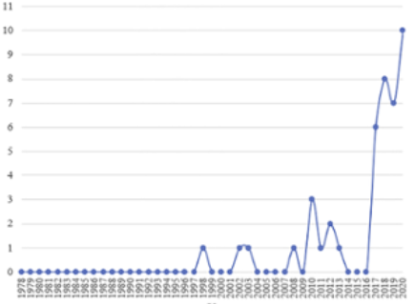

**FUTURE SCOPE**

Personalization and AI-driven Experiences: Book my Trip will increasingly leverage artificial intelligence (AI) and machine learning algorithms to deliver personalized travel experiences tailored to individual preferences, interests, and past behaviors. AI-powered recommendation systems will analyze user data to offer customized itinerary suggestions, accommodation options, and activity recommendations, enhancing the overall booking experience and driving user engagement. Virtual and Augmented Reality (VR/AR) Integration: The integration of virtual and augmented reality technologies will revolutionize the way travelers research and experience destinations, accommodations, and attractions. Tour and travel websites will offer immersive VR/AR experiences that allow users to explore destinations virtually, visualize accommodations in 3D, and preview tourist attractions before booking, providing a more immersive and interactive booking experience. Blockchain Technology for Secure Transactions: Blockchain technology will play a key role in enhancing security, transparency, and trust in tour and travel bookings. By leveraging blockchain-based payment systems and smart contracts, travel websites can streamline payment processing, reduce transaction fees, and mitigate fraud, providing travelers with greater peace of mind and confidence when booking their trips.

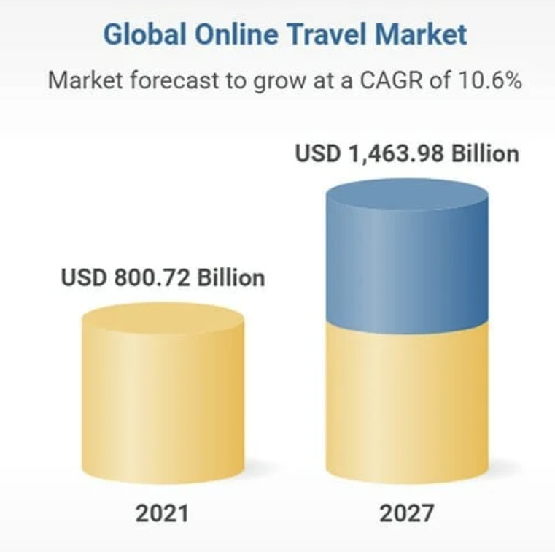

**CONCLUSION**

In conclusion, the implementation of AI technologies in the "Book My Trip" website has resulted in significant enhancements to the booking experience, user engagement, and business performance. The integration of AI-powered recommendation systems, chatbots, and dynamic pricing algorithms has transformed the website into a personalized, efficient, and customer-centric platform that meets the evolving needs and expectations of modern travelers.

**REFERENCES**

1-Dredge, S. (2018). The future of travel: how technology is shaping the way we holiday. The Guardian.

2-Buhalis, D., & Law, R. (2008). Progress in information technology and tourism management: 20 years on and 10 years after the Internet—The state of e Tourism research. Tourism Management, 29(4), 609-623.

3-Gretzel, U., Sigala, M., Xiang, Z., & Koo, C. (2015). Smart tourism: foundations and developments. Electronic Markets, 25(3), 179-188.

4-Wang, D., & Xiang, Z. (2019). The role of technology readiness in tourists' travel behavior. Journal of Travel Research, 58(8), 1338-1351.

5-Xiang, Z., Du, Q., Ma, Y., & Fan, W. (2017). A comparative analysis of major online review platforms: implications for social media analytics in hospitality and tourism. Tourism Management, 58, 51-65.

6-Sigala, M., & Christou, E. (2020). Sharing economy and collaborative consumption approaches to e Tourism: Opportunities and challenges for research and practice. Journal of Destination Marketing & Management, 17, 100409.

7-O'Connor, P. (2018). Artificial intelligence and big data disrupt the travel industry. Forbes.

8-Werthner, H., & Klein, S. (1999). Information technology and tourism—a challenging relationship. Vienna University of Technology, Austria.

9-Sheng, B. (2017). A review of tourism research literature in the context of artificial intelligence and big data analytics. Journal of Tourism Futures, 3(1), 49-61.

10-Tussyadiah, I. P., & Park, S. (2018). Consumer evaluation of hotel service robots. Journal of Hospitality and Tourism Technology, 9(2), 171-193.